Software Development Project Management Plan for Dhaka Subway Systems Automated Ticket Issuing System

SDPM Plan Version 2.1.0 approved

**Course Name: Software Development Project Management**

**Section: C**

**Department of Computer Science**

**American International University- Bangladesh (AIUB)**

Prepared By

|  |  |  |
| --- | --- | --- |
| **ID** | **Name** | **Date** |
| 18-36750-1 | AHMED, MD. NAHIAN | 03-12-2021 |
| 18-36752-1 | TURNY, TANIA TASMIM | 03-12-2021 |
| 18-36766-1 | MOMO, FARHABI MSTAFA | 03-12-2021 |
| 18-37847-2 | AHMMED, TANVIR | 03-12-2021 |

**INDEX**

**Revision History:** 3

**Introduction:** 4

**Process Model:** 4

**Quality Gate for each phase of software development:** 5

**List of Tasks (Work Breakdown Structure, WBS):** 5

**Estimation (Use the COCOMO81 model):** 5

**Schedule The Tasks:** 7

**List of Milestones:** 7

**Staffing Plan:** 7

**Monitoring and Controlling Mechanism:** 8

**Risk Management:** 9

**List of Deliverables:** 10

**Defect Tracking Process:** 11

**List of Matrices:** 11

**Post-Mortem:** 12

# **Revision History:**

|  |  |  |  |
| --- | --- | --- | --- |
| **Revision** | **Authors** | **Description** | **Date** |
| SDPM Plan V.1.0.0 | AHMED, MD. NAHIAN | Initial creation  of the system | 10/02/22 |
| SDPM Plan V.1.1.0 | TURNY, TANIA TASMIM | Planning for adding features in the system | 11/03/22 |
| SDPM Plan V.1.2.0 | MOMO, FARHABI MSTAFA | Formal editorial work | 25/04/22 |
| SDPM Plan V.2.0.0 | AHMMED, TANVIR | Revising and minor changes in features plan | 23/05/22 |
| SDPM Plan V.2.1.0 | NAHIAN,  TURNY,  MOMO,  TANVIR | Adding/removing or restoring resources | 22/07/22 |

# **Introduction:**

This is the software development project management plan for Dhaka Subway Systems Automated Ticket Issuing System. The project's purpose is to make automated ticket sales accessible to the general population. The many criteria that will be applied to the process model, task list, task calculation, deliverable process, and monitoring process of the specified application will be covered in this document. As part of the strategy planning, feasibility analysis, and project planning. All engineering and management tasks that must be transferred to the Dhaka metro system may be accomplished. This lists some potential project encountering issues.

# **Process Model:**

1. For this project, we choose the base model, that is waterfall model.
2. Waterfall model choosing reason:
3. It's collect all the requirement in the initial stage.
4. Waterfall is a sequential strategy that is simple to manage. Its iterative opponent is extremely adaptable, allowing for adjustments at any time.
5. Here implementation teams work to develop, code, implement, and test the solution based on the design.
6. To execute quality assurance tests before completing each phase.
7. Costs and timelines may be determined early on since the project scope is very stable.
8. Because its documentation defines in reasonable detail how every SME of the product or ability is required to accomplish the work, a project with extensive documentation and designs may lose essential personnel without too much difficulty.

That is the reason for choosing waterfall model.

1. Software development life cycle flow chart:

Requirement Analysis & Specification

Design

Coding & Unit Testing

Integration & System Testing

Maintenance

# **Quality Gate for each phase of software development:**

|  |  |
| --- | --- |
| **Work Project** | **QA Method** |
| Software Requirement Specification | Inspection, Spell Checker |
| Software Development Project Management Plan | Inspection, Spell Checker |
| Design Documentation | Inspection, Spell Checker |
| Test Schedule | Inspection, Spell Checker |
| Test Plan | Inspection, Spell Checker |
| Code | Code Inspection, Testing |
| Completed System | Inspection |
| Alpha Version | Inspection |
| Beta Version | Inspection |

# **List of Tasks (Work Breakdown Structure, WBS):**

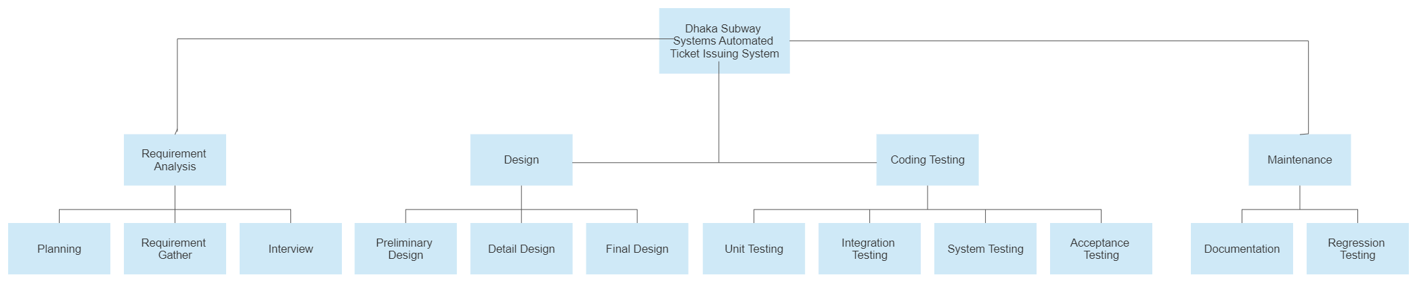

Figure: A fragment of an activity-based Work Breakdown Structure.

# **Estimation (Use the COCOMO81 model):**

COCOMO81 means Constructive Cost Estimation Model which was develop by Dr. Berry Boehm in 1981, that’s why it is call COCOMO81. We can evaluate the cost of a software by using this method.

COCMO81 applies three class of software projects.

* Organic Project
* Semi-Detached Project
* Embedded Project

We use Semi-detach projects because our project is mixed experience levels must meet a mix of rigid and less than rigid requirements.

**COCOMO81 Constants**

|  |  |  |  |
| --- | --- | --- | --- |
| System Type | c | k | t |
| Semi-detach | 3.0 | 1.12 | 0.35 |

|  |  |  |  |  |  |  |  |  |
| --- | --- | --- | --- | --- | --- | --- | --- | --- |
| **Project** | **Design** | | **Coding** | | **Testing** | | **Total** | |
| wm | (%) | wm | (%) | wm | (%) | wm | SLOC |
| Dhaka Subway Systems Automated Ticket Issuing System | 7.0 | (12) | 24.4 | (40) | 30.2 | (50) | 58.0 | 7000 |

For calculating COCMO81 the basic equation is:

Effort = c × (size)k

Development Time = 2.5 × (effort)t

Required Number of People = effort/Development Time

Estimation of development effort for Semi-detach:

**Effort = 3.0(Size)1.12 PM** (**PM: Person Months) [Size: kdsi]**

**= 3.0(7)1.12 PM**

= 26.52 PM

**Estimation of development time for Semi-detach:**

Development Time **= 2.5(Effort)0.35 Months**

**= 2.5(26.52)0.35 Months**

**= 7.9 Months**

**Required number of people for Semi-detach:**

**Total number of people required = Effort/ Development time**

**= 26.52/7.9**

**= 3.4**

**So, 4 engineers will have to work for 7.9 months = 241 days.**

# **Schedule The Tasks:**

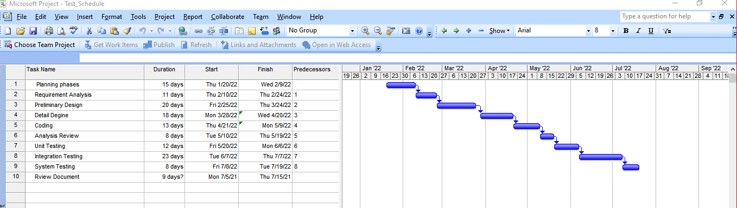

# **List of Milestones:**

|  |  |  |
| --- | --- | --- |
| **NO** | **Item** | **Milestone Date** |
| 1 | Planning phases | January 20, 2022 |
| 2 | Requirement Analysis | February 10, 2022 |
| 3 | Preliminary Design | February 25, 2022 |
| 4 | Detail Design | March 27, 2022 |
| 5 | Coding | April 21, 2022 |
| 6 | Integration Testing | May 10, 2022 |
| 7 | System Testing | May 20,2022 |
| 8 | Review Document | June 1,2022 |
| 9 | Deployment/Publish | June 16,2022 |

# **Staffing Plan:**

|  |  |  |
| --- | --- | --- |
| **Person** | **Assignment** | **Back Up** |
| Tania Tamim | Project Manager | Tanvir Ahmed |
| Tanvir Ahmed | Technical Lead | Farhabi Mostafa |
| Farhabi Mostafa | Development Lead | Nahian Ahmed |
| Nahian Ahmed | Test Lead | Hashinur Rashid |
| Tajin Mostafa | Team Lead | Hasibul Islam |
| Hasibul Islam | Recourse Manager | Abir Hasan |

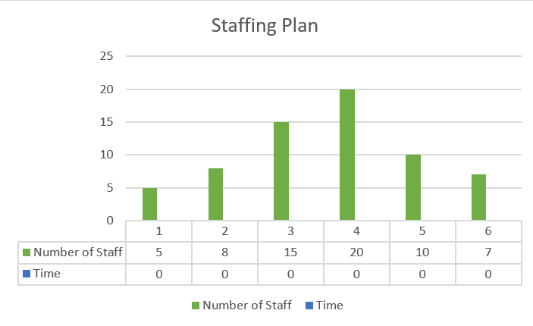

# **Monitoring and Controlling Mechanism:**

* Conduct weekly/biweekly project status meeting.
* Compare actual start date with planned start date.
* EVA (Earn Value Analysis).
* To delay a project need to follow some methodology.
* Product Manager always communicate with QA manage to check the product quality.

# **Risk Management:**

**Risk Table**

|  |  |  |  |  |
| --- | --- | --- | --- | --- |
| **Identify Risks** | **Category** | **Probability** | **Impact** | **RMMM** |
| Lack of training on tools and equipment | DE | 50% | 2 | Increase process tool training. |
| Large Number of users than plan | PS | 30% | 3 | Improve plan |
| Technology will not meet expectations | TE | 30% | 1 | More alert in technological issues |
| Customer will changes requirement | PS | 40% | 1 | Communicate with the customer on a regular basis, and confirm the requirements before beginning the implementation. |
| Inexperienced staff | ST | 20% | 1 | Expert training should be provided. |

# **List of Deliverables:**

|  |  |  |
| --- | --- | --- |
| **Item** | **Description** | **Date** |
| Details Requirement Document | Requirement Document means how the system should work | January 20, 2022 |
| Details Design Document | Software design is the process of transforming user requirements into a format that the programmer can use to code and implement software. | February25,2022 |
| Risk Analysis | Risk analysis is a technique for identifying software risks. | March 15,2022 |
| Development Project Management Plan | It specifies the start and end dates for each phase of the software development project. | April 21, 2022 |
| Test Plan | A Test plan is a document that outlines the steps involved in software testing. | May 10, 2022 |
| Quality Assurance Plan | The tools used to verify that a product fulfills the criteria defined in the software requirements specification are described in the Quality Assurance Plan. | May 25, 2022 |
| Verification | Verification is the process of reviewing a program to verify if it complies with the criteria. | June 10 , 2022 |

# **Defect Tracking Process:**

The defect tracking procedure is similar to bug tracking. We offer a variety of tools for detecting problems. However, we can use Jira Software in this project. This program serves as both a bug tracker and a project management tool. Bugs can also be found, recorded, and tracked. It also contains a mechanism that assigns the appropriate individual to the appropriate time.

Jira is a popular project management tool among developers. This is frequently used in industries because the techniques interfaces are appealing to developers and testers, and they are easy to use. It is very adaptable, and it caters to a variety of consumers. Jira, like any software, has various drawbacks. For example, the Agile technique is well-suited to this software because it fully supports the Agile method. As we are utilizing the Waterfall Model, it will be a little confusing. It features a convoluted user interface, a file upload limit, and even complicated migrations.

# **List of Matrices:**

* This project plan to collect following project matrix data.
* Actual task completion time.
* Total number of defects found.
* Number of defects/KLOC.
* Number of pages of documents produced.
* Number of files.
* Number of LOC lines of code produce per week.
* Time spend on system testing.
* Time spend on integration testing.

# **Post-Mortem:**

|  |  |  |  |
| --- | --- | --- | --- |
| **Items** | **Description** | **Review** | |
| **Good** | **Bad** |
| Requirement Analysis & Specification | Gathering and documenting requirements. Gather detailed information about the project's requirements at this stage. | The customer has the opportunity to give their requirements. | If adequate requirements and recommendations are not available, we will have difficulty creating the project. |
| Design | Design process in which progress is seen as flowing steadily downwards through the phases of conception. | There is just one and only one home for every bit of reasoning. Changes in one place can be used to extend the system. | Many aspects of the system must be altered as a result of a single conceptual change. It's not possible to readily expand the system. |
| Coding & Unit Testing | Coding is the process of creating source code based on the models, logic, and requirements established in the previous stages. | There will be more reusable code and debugging will be easier. Reduced testing and bug-fixing costs. | A developer's error could have far-reaching consequences for the entire system. |
| Integration & System Testing | Each device has been tested, it is integrated into a system. | It examines the behavior of individual components of a system as a whole. | It is extremely difficult to incorporate because having all of the modules ready before beginning testing is neither practicable nor advisable. |
| Maintenance & Release | The maintenance process involves providing software support and maintenance to ensure that it functions smoothly. | Maintenance Lower the entire cost of the company's equipment at every stage, from design and fabrication through operation and maintenance, to increase productivity. | Only once and Less time. |