

American International University-Bangladesh (AIUB)  
**Department of Computer Science  
Faculty of Science &Technology (FST)  
Summer 19_20**

**Section: H  
Group No: 7**

**University Admission Help Centre**

A Software Engineering project submitted

By

|  |  |  |
| --- | --- | --- |
| SN | Student Name | Student ID |
| 1 | Md Khalidur Rahman Milu | 18-36554-1 |
| 2 | MD. Nahian Ahmed | 18-36750-1 |
| 3 | Nafia Alam | 18-36552-1 |
| 4 | Somya Dhar | 18-36396-1 |
| 5 |  |  |

The project will be evaluated for the following Course Outcomes

|  |  |
| --- | --- |
| CO3: Choose appropriate software engineering model in a software development  environment | Total Marks |
|  |
| Project Background Analysis (problem, needs, goal, benefits, etc.)[5Marks] |  |
| Appropriate Process Model Selection and Argumentation with Evidence [5Marks] |  |
| Completeness, Spelling, Grammar and Organization of the Answer [5Marks] |  |
|  | |
| CO4: Explain the roles and their responsibilities in the software project  management activities | Total Marks |
|  |
| Content Knowledge (e.g. System Requirements, System Design)[5Marks] |  |
| Project Role identification and Responsibilities descriptions [5Marks] |  |
| Presentation Delivery and Defense[5Marks] |  |

**Problem significance:**

Many students face problems after completing their school/college or under graduation for further studies in universities. Many of us do not know how to reach the big universities; some face problems applying for scholarship. We will be here to help the students find out the best universities for them according to their grades and interests by providing them with all the information needed. We will help them know more about universities which help with permanent residency and scholarship variations. We will help them communicate with the members of the universities they choose to go to.

**Project objective and solution to the above mentioned problem:**

Our project’s main objective is to admit students into undergrad based on their HSC / A-Level results. This is kind of a huge problem as a freshman to get all the ideas so that's where we will be going to help them out. We will ask for all the required information from students so that we can gather ideas about them and will suggest them the best subjects & University. We will have email support/live chat/ call support for students to get the information they might need for their admission. Even they will get full ideas about subject overview, University ranking, research information from our system/website.

**Target group of users and their benefit:**

Our main target group of users is students. After completing HSC or A level, students can take help from us for admission in universities for under graduation. And also after completing under graduation or masters, they can take help for masters and PhD admission respectively. The students will be benefited by our software for admission in the best universities. Students will be provided with the university professors’ email address and contact details. They will also get help for writing motivation letters. In our software they will get university admission forms and websites of different universities. Most importantly they can make questions and queries by messaging us and can also make phone calls to our call centre. They can also make appointment with us by the software.

**Basic functionalities:**

Admission process is mission critical for any education institute. If it is executed professionally then satisfaction level of prospective students increases and it also helps in branding of the institute. Currently if students or parents are stuck while filling online forms there is no one available for them to help. So it increases frustration among students and parents. So instead of making process simpler with system it becomes tedious where hundreds of queries and no one is available to handle those queries.

In our software the basic functionalities are:

01. Software login

02. University website list.

03. University ranking.

04. University professors’ list and emails and contacts

05. University admission forms.

06. Registration box for further information collect.

07. Call centre

08. Appointment box

09. Scholarship box

10. Accommodation facilities of universities

11. Feedback for improving facilities

**System Features:**

**1. Software login**

**Functional Requirements**

1.1 This software will allow users to login with their given username and password.

1.2 Once the login is successful, the home page of the user account will be displayed.

1.3 If the username and password is inserted wrong, then ‘Forgot password’ option will be shown. A verification code will be sent if clicked.

1.4 After 4 attempts, system will give an instruction of process of recovery.

**Priority:** High

**Pre-condition:** Valid username and password must be given.

**Cross reference:** Not applicable

**2. University website list**

**Functional Requirements**

2.1 University list will be visible in the homepage.

2.2 Applicant will select the University name to view the university website.

2.3 It will help students to understand different university environments.

**Priority:** High

**Precondition:** Not applicable

**Cross reference:** 3

**3. University ranking**

**Functional requirements:**

3.1 User will find an option in the home page called university ranking.

3.2 By clicking on it, students will find options such as world ranking and country wise ranking and subject wise ranking.

3.3 Here student also find the link form proper validation University ranking.

3.4 University ranking will help them to understand the priorities of universities. This will make it easier to select which one to go for.

Priority: High

Pre-condition: Not applicable

Cross reference: Not applicable

**4. University professor's list with emails and contacts**

**Functional requirement**:

4.1 In this features user will find the various universities professors list for sending emails and application and motivation letter.

4.2 Not only professors user will find different Universities admission helper contacts.

4.3 As students will find contacts and emails they can directly communicate with them.

4.4 There will be a search box for searching faculties and professors by their name and university name.

**Priority:** low

**Precondition**: Must be register as an applicant in University admission.

**Cross reference**: 6

**5. University admission forms**

**Functional requirements:**

5.1 This software will allow users to fill up admission forms online.

5.2 Successful form submissions will be confirmed through email. After user submits the form, the system will send verification email to user's registered email so the user can verify the submissions.

5.3 If user needs to edit any information they have submitted then user can still edit that from the software.

**Priority:** High

**Pre-condition:** Valid email & Information needed

**Cross reference:** 6

**6. Registration box for Admission Help**

**Functional requirements:**

6.1 Considering All the points like the research, list, ranking, environment, accommodation User will choose a University.

6.2 If user will need every help from us then they will book an appointment in software

6.3 System/Admin will take rest care of the Users.

Priority: High

Precondition: Appointment needs to be booked from Software.

Cross reference: Not applicable

**7. Call centre**

**Functional Requirements**

7.1 This feature allows the students to contact our call centre representatives for any queries or information required.

7.2 All the calls will be recorded for security or further needs.

**Priority:** High

**Pre-condition:** Must be an applicant

**Cross reference:** Not applicable

**8. Appointment box**

**Functional Requirements**

8.1 This feature will gather information like the applicant’s name, contact number, address, email and preferable time given by them to create a schedule for them to make an appointment.

**Priority:** Low

**Pre-condition:** Email address or phone number

**Cross reference:** 6

**9. Scholarship box**

**Functional Requirements**

9.1 This feature will check the applicants’ previous grades to verify the ability to attain scholarships.

9.2 The scholarships given by the governments of different countries will be given.

9.3 A suggestion box will be given where the universities with scholarships according to their grades will appear.

**Priority:** High

**Pre-condition:** Previous academic grades

**Cross reference:** Not applicable

**10. Accommodation facilities of universities**

**Functional Requirements**

10.1 There are a range of student accommodation options; and where you choose to live will impact your student experience.

10.2 You can choose to live in halls, private accommodation or at home.

10.3 When deciding on where to live get advice from family and friends and try to attend accommodation open days.

10.4 Carefully research the costs and benefits of each option before making a decision.

**Priority:** High

**Pre-condition:** Applicant must select a university for admission

**Cross reference:** Not applicable

**11. Feedback for improving facilities**

**Functional Requirements**

11.1 Raise helpdesk calls/work orders against negative feedback.

11.2 Real-time feedback dashboard.

11.3 Configurable SMS/app notification/WhatsApp messages

**Priority:** Low

**Pre-condition:** Not applicable

**Cross reference:** Not applicable

**Software Development Process Model**

As our software is a help centre, as a result we will deal with students' problems. We know that problems cannot be constant. After a while or after some days new problems arise. So our software requirements may need to be modified later. For our ‘University Admission Help Centre' software project we will use agile software development model.

**Agile model is special because:**

In general, at the heart of Agile are iterative development, intensive communication, and early customer feedback. The models of this group focus more on delivering a functioning part of the application quickly. Nowadays, more than 70% of organizations employ this or that agile approach in their IT projects.

**Use cases:**

* Practically any startup initiatives, when end users’ early feedback is required.
* Most of the software projects in custom software development where business requirements cannot be confidently translated to detailed software requirements.
* Large projects are easy to divide into small functional parts and can be developed incrementally over each iteration.

Reason to use this agile model for our project: In our project there are a lot of functionalities. So we can divide in manageable scope of a time box. Accordingly, frequent releases are characteristic to the agile models. We also allow for continuous software improvement with easy fixes and changes, quick updates, and feature addition, and help to deliver applications that satisfy customers or applicants’ needs better. One of the greatest benefits of an agile model is improved product quality by doing more to software testing activities. By breaking down the project into manageable units, the project team can focus on high-quality development, testing, and collaboration.

Agile model for our team: Agile methods are considered lightweight processes and it is people-based rather than plan-based. In our project perspective there are more than enough people for a good collaboration. Our team mates are self organized and also they have decision making abilities. As we are from the same university and same department or batch so we have mutual trust and respect. We pay less attention to detailed software documentation (detailed requirement specification, detailed architecture description), and more to software testing activities.

Agile model for our customer: Agile is about working in close collaboration both across the team and with the customers. Our highest priority is to satisfy the customer or users through early and continuous delivery of valuable software. We will welcome changing requirements even late in development. In this model by focusing features on the needs of real users, each feature incrementally delivers value, not just an IT component.

Reason to not use other iterative methods and linear sequential models: In our project there is a fixed requirement and we need to modify the project based on applicant satisfaction .And also our project products are not highly critical. So there is no chance to work on linear sequential models. Other iterative methods might have been three to six months long of each iteration but in agile iteration lengths vary between one to four week and it does not exceed 30 days.

**Roles of agile model in the software project management activities:**

* Stakeholders: The stakeholders in an agile development project can perform a wide variety of roles individually, all of whom are materially affected by the outcome of the product or products being developed .They might be: Senior managers, Portfolio managers, Supervisors etc.
* Product owner: The product owner represents the stakeholders of the project. The role is primarily responsible for setting the direction for product development or project progress. The Product Owner understands the requirements of the project from a stakeholder perspective and has the necessary soft skills to communicate the requirements to the product development team.
* Team lead/Scrum master: The Team Lead or Scrum Master ensures team coordination and supports the progress of the project between individual team members. The Scrum Master takes the instructions from the Product Owner and ensures that the tasks are performed accordingly. Every development team needs a leader, and even though the Agile Method downplays the idea of centralized management, agile teams are no exception when it comes to leadership.
* Development team members: Team members play very important rules in agile project development model. Because development team members are responsible for designing and building the software products required by stakeholders. And development teams can also include professionals who are not involved in actual coding work, such as designers, business analysts, quality assurance engineers, and database engineers.
* Specialists: A project also requires several specialists. Agile development team specialists are experts in areas such as: business analytics, machine learning, cyber security, regulatory compliance, database administrators to design, build, and test databases, build masters to set up build scripts.

**UML Diagrams:**

**Use Case Diagram**

**Case study:**

An applicant first signs up by creating a profile and can login every time they open the software. They can manage their account where they can change any necessary information about themselves. Once they are logged in, they can search for the universities according to their preference. And after choosing they can fill out the admission forms of the university. If they have any queries they can contact our call centre which our call centre clerks will be handling! They have options to make appointments to visit us in our office too. Once they submit the forms, they have to complete the payment through cash or card. The system manages the payment procedure. Applicants can also give us a feedback on their experience so that our admin who works for our company can update the website as required.

**Diagram:**

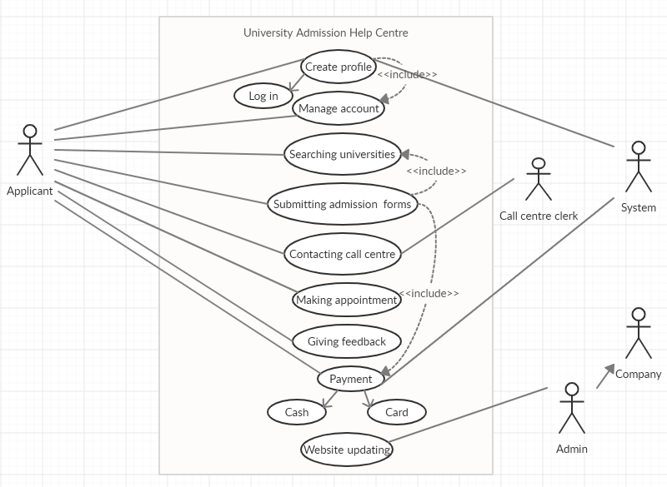

**ER Diagram**

**Case study:**

While creating a profile, applicants must provide their full name, address, phone number, email and date of birth. Their user id and age will be added by the system. Here, applicants, call centre clerk, admin, company and system are entities and ‘using’, ‘updates’, ‘works for’ and ‘calling’ are relationship sets. Call centre clerk works for the system and admin works for the company. Applicants use the system and call the call centre clerks.

**Diagram:**

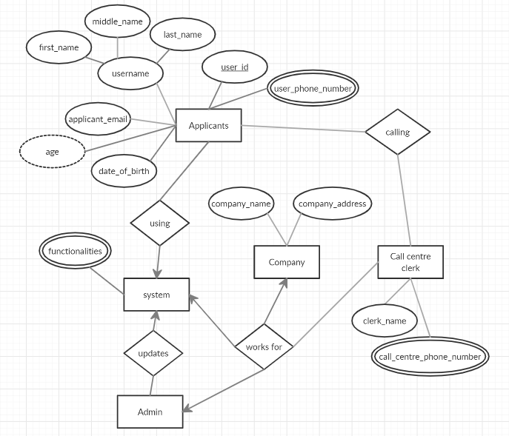

**Activity Diagram**

**Case study:**

Applicants are first asked if they already have an account or not. If yes, they are asked to log in. If their password is incorrect, they can retry and if still unsuccessful, the system checks it and the applicant can manage the account. They can then continue with the process if their log in is successful. If they do not have an account, they are asked to make one. After verifying account, applicant will search university for admission. If applicant can't feel any problem when applicant can take help from the software as he or she can call to the call centre. After that applicant will select university. Applicant can take appointment for to meet in office for admission help. And after that applicant can apply for scholarship. An applicant must submit admission form. When a student submit the admission form for the further process. Applicant will be asked for payment. Payment system will be verified the payment.

**Diagram:**

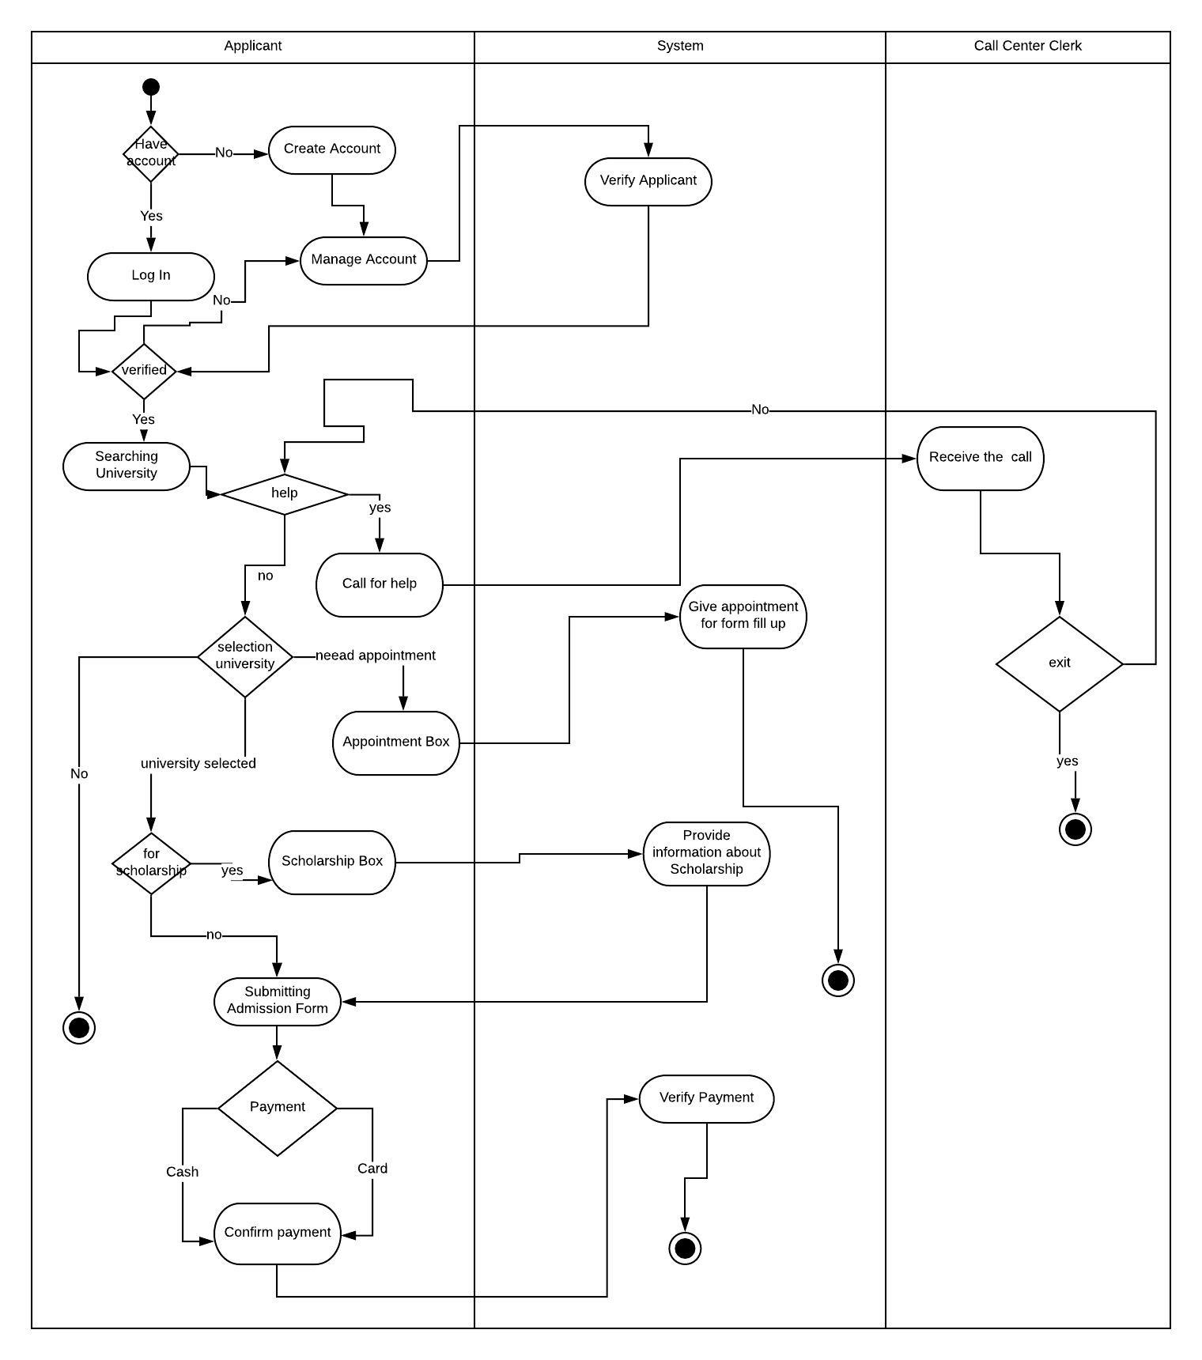

**Class Diagram**

**Case study:**

Our software development team will develop software software "university admission help centre". In our software project there are a lot of functionalities. For software development to e construct a lot of classes. In software will be an account class for work as signup or login or modify this system. Account class is inherited by applicant class, call centre clerk class and admin class. By inheritance this derived classes can be used functionality of account classes. In applicant can take maximum 1 appointment. Applicant can see ranking of all universities. Ranking generate class inherits university list. University list class also inherited by university accommodation class. Professor list class is an aggregation relationship with universities list class. University may have multiple professes work for admission process. An applicant and can apply in selected university.

**Diagram:**

