**Scientific Calculator Task**

**With jquery**

By

Ahmed Abd Elzaher

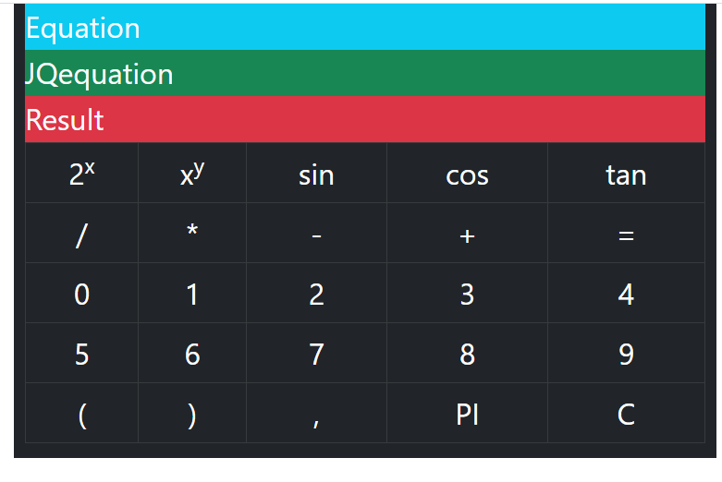

HTML Header of calculator code

<main class="container " >

      <section class="row ">

          <article class="**col-8 mx-auto   bg-dark text-light fs-2**"   >

           <div class="equation **bg-info**" style="**height**: 50px;">Equation</div>

          <div class="JQequation  **bg-success**" style="**height**: 50px;">JQequation</div>

          <div class="result  **bg-danger**" style="**height**:50px">Result</div>

HTML table of calculator code

<table class="**table table-bordered table-dark text-center**" >

<tr>

<td >2<sup>x</sup></td>

<td >x<sup>y</sup></td>

<td >sin</td>

<td >cos</td>

<td>tan</td>

</tr>

<!--second Row-->

<tr>

<td >/</td>

<td >*</td>

<td >-</td>

<td >+</td>

<td class="**execute**" >=</td>

</tr>

<!--third row-->

<tr >

<td>0</td>

<td>1</td>

<td>2</td>

<td>3</td>

<td>4</td>

</tr>

<!--fourth row-->

<tr >

<td>5</td>

<td>6</td>

<td>7</td>

<td>8</td>

<td>9</td>

</tr>

<!--fourth row-->

<tr >

<td>(</td>

<td>)</td>

<td>,</td>

<td >PI</td>

<td class="**clear**">C</td>

</tr>

</table>

</article>

</section>

</main>

Jquery code : click on general cell

///when you click the cell add text to Myequation div and equation div

$("tr td").on("click",function(){

var funcname=$(this).text();

switch(funcname)

{

case '2x':funcname="pow(2";jqfuncname="Math.pow(2";break;

case 'xy':funcname="pow(";jqfuncname="Math.pow(";break;

case 'sin':funcname="sin(";jqfuncname="Math.sin(";break;

case 'cos':funcname="cos(";jqfuncname="Math.cos(";break;

case 'tan':funcname="tan(";jqfuncname="Math.tan(";break;

case '=':funcname="";jqfuncname="";break;

case "PI":funcname="PI",jqfuncname="Math.PI";break;

default:jqfuncname=funcname;break;

}

*//Add the jquery function name to JQuery equation div text*

$(".JQequation").text($(".JQequation").text()+jqfuncname);

*// Add function name to the equation text div*

$(".equation").text($(".equation").text()+funcname);

});

Jquery code : click on “=“ cell

*//when "=" button is clicked*

    $(".execute").on("click",function()

    {

*//get the text from Myequation div*

        var $result=($(".JQequation").text());

*//get the mathimatical value of $result*

        var $Mathresult=eval($result);

*//display the result in result di*v

        $('.result').text(($Mathresult));

    });

Jquery code : click on “C“ cell

*//when you click "C" button clear the equation and result and JQequation divs*

$(".clear").on("click",function(){

$(".equation").text("");

$(".JQequation").text("");

$(".result").text("");

})

Jquery code : cursor and hover

*///Make cursor pointer on the cell*

$("tr td").css("cursor","pointer");

*///change color of the cell when hover*

$("tr td").hover(function(){

$("tr td").css("background-color","#212529");

$(this).css("background-color","#444");

})

Jquery Built in Math Functions

Math.pow(2,y) :calculate 2 to the power y

Math.pow(x , y) :calculate x to the power y

Math.cos(x) : calculate cos(x);

Math.sin(x) : calculate sin(x)

Math.tan(x) :calculate tan(x)

Math.PI :returns pi

Simple calculation code

Html:

 <div class="text-center">

    <input class="jqequation mt-5"><br>

    <button class="calculatejqequation mt-5">calculate equation</button>

    </div>

jquery:

<script>

        $(document).ready(function(){

//click calculatejqequation button

          $(".calculatejqequation").click(function(){

// get the value (the text) of the input

              var jqequation=$('.equation').val();

//alert the mathematical value of jqequation value

              alert (eval (jqequation));

          })    
        })  </script>

HTML Code explanation

1] create div which has “text-center” to align elements to center

2] create html input element of class=“jqequation”

where we write jquery function

has mt-5 (margin-top)

3] create button which calculate the equation when clicked

Has mt-5 (margin-top)

Jquery Code Explanation

When “caculatejqequation” button clicked:

1]Take the value in “JQequation” div store it in jqequation variable

2]Then alert(Mathematical Value of jqequation variable)

Add this code

Add button to calculate cos

Which adds to the “jqequation” input “Math.cos”

**HTML:**

    <button class="cos" >cos</button>

**jquery:**

$(".cos").on("click",function(){

              //get the value(text) from input save it in jqequation

              var jqequation=$('.jqequation').val();

              //Add "Math.cos(" to the input

              $(".jqequation").val(jqequation + "Math.cos(");

          })