Brad Test Filters

Author: Ahmed Ali

Date 16/01/2023

Problem Statement

drawing straight lines on the espresso display is not very smooth, the line appears wavy and the severity of this line wobble is varying based on speed, it gets worse the slower the speed is. Also, the wobble is very clear on diagonal line.

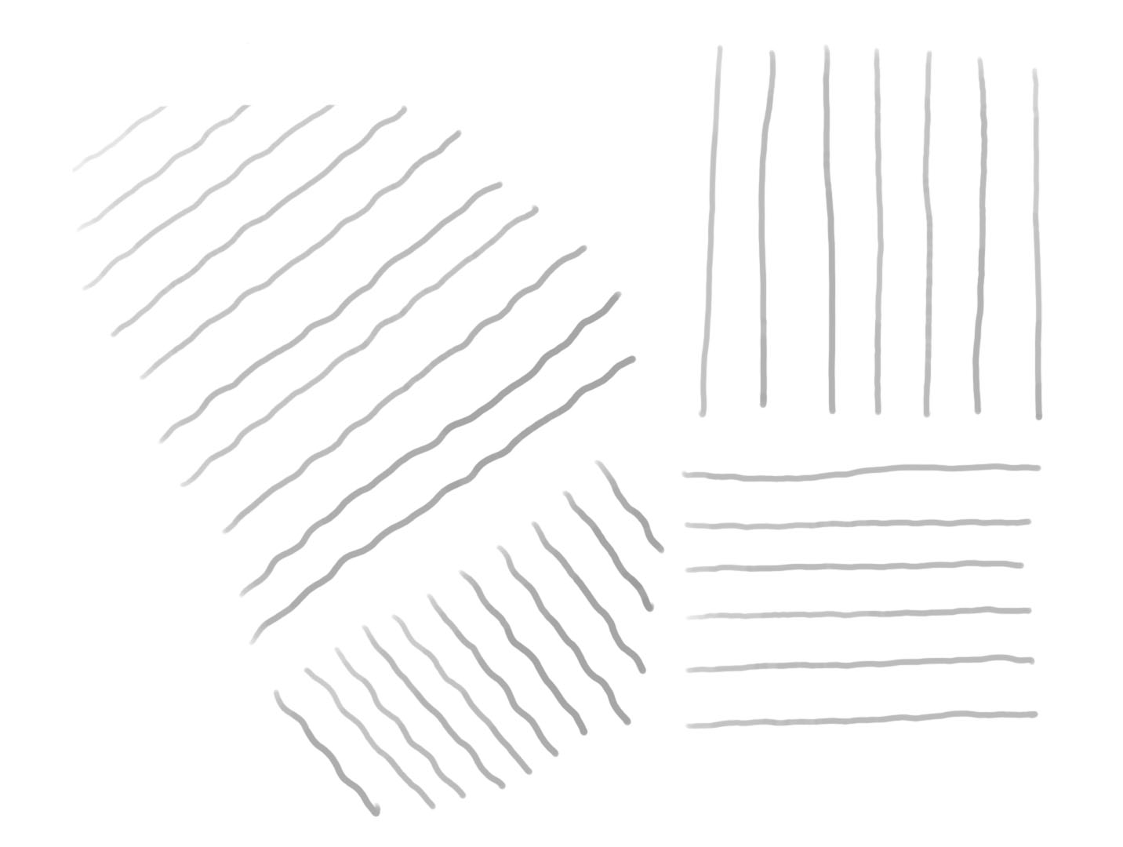

Line Sample

To tackle the problem, a hardware or software solution is to be carried out.
The data been received by the host as HID reports from the USB device does not include any filtration layer.
The results to be shown are in exploration of different types of filters implemented in the software space.

1) Moving Average

The moving average filter is a special case of the regular FIR filter. Both filters have finite impulse responses. The moving average filter uses a sequence of scaled 1s as coefficients, while the FIR filter coefficients are designed based on the filter specifications. They are not usually a sequence of 1s.

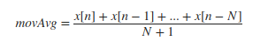

The moving average filter removes the high frequency components of the signal.

- The control parameter ( window size ) the larger the window size the stronger the filter.

Case A : Diagonal Stroke at Slow Velocity – Relatively Constant.

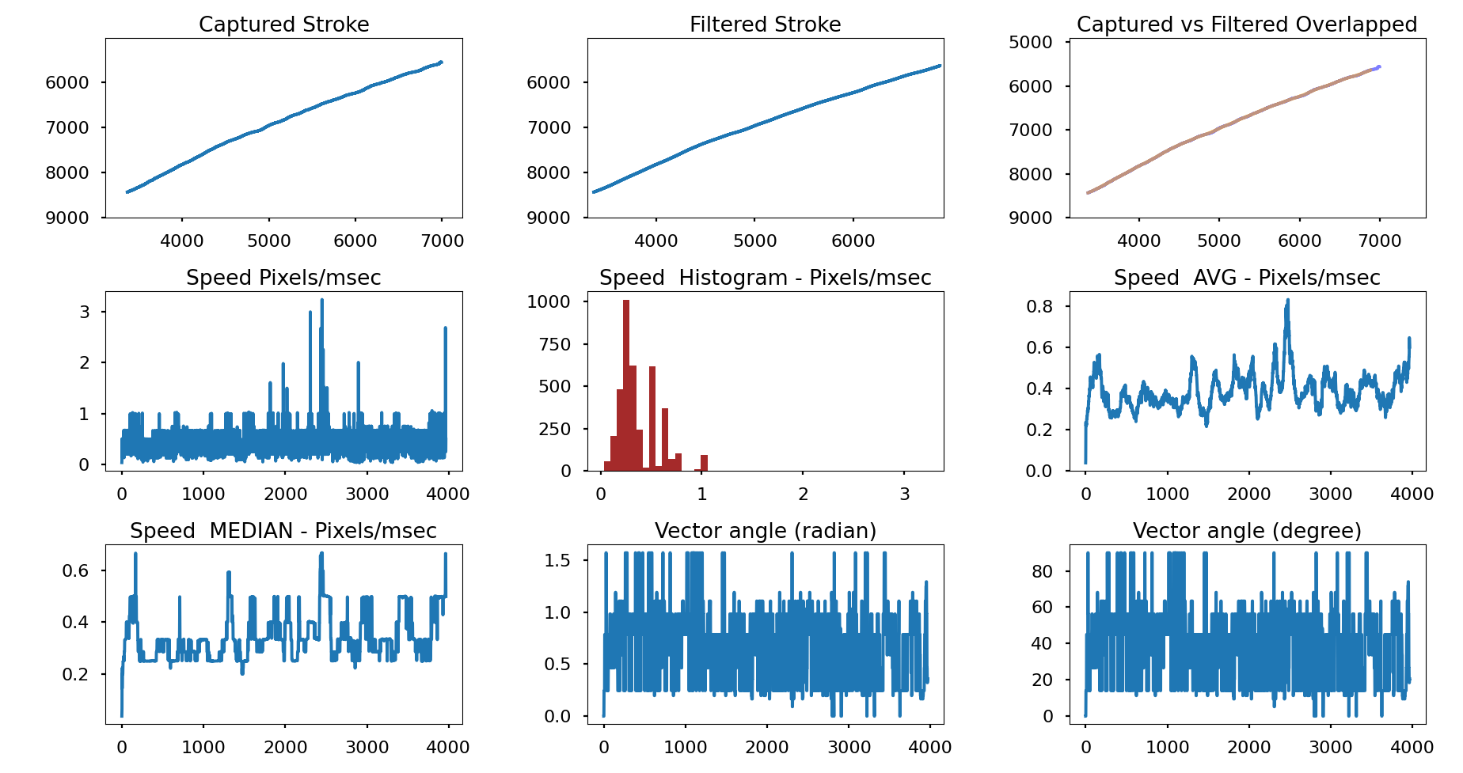

Moving Average – Window size = 200

Comments:
- Smoother stroke
- Minor lag

Case B : Diagonal Stroke at Slow Velocity – Relatively Constant.

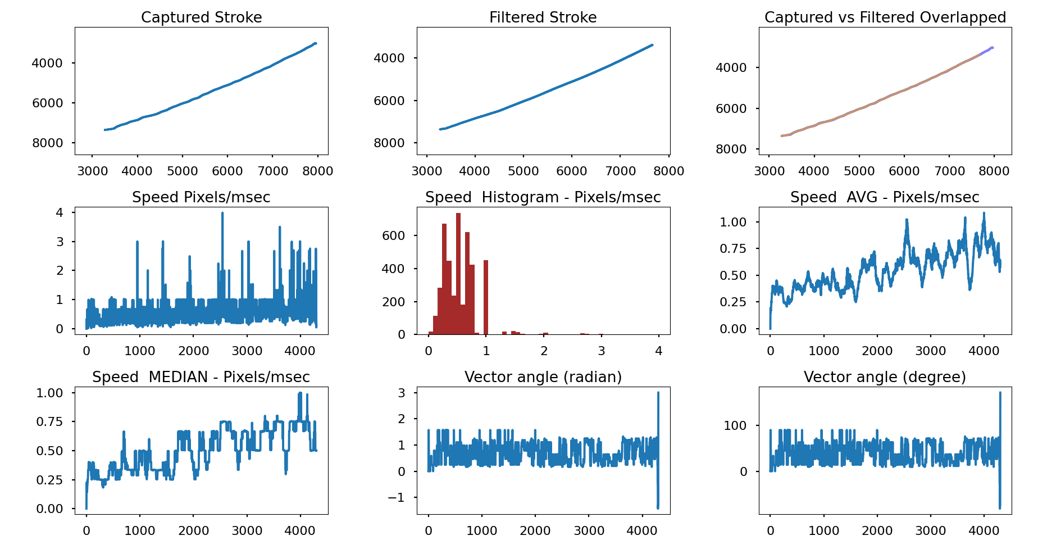

Moving Average – Window size = 500

Comments:
- Smoother stroke
- Minor lag
- Smoother than the 200 window size and more lag is added

- Case C : Diagonal Stroke at Variable Velocity – Transition from High to Low Velocity.

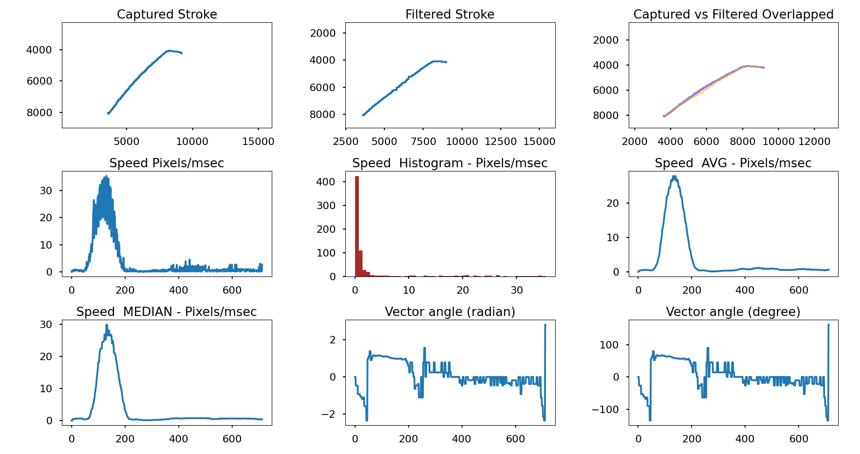

Moving Average – Window size = 200

Comments:
- More wobble to the stroke when transitioning to slow speed
- Lag added

- Case D : Circle Stroke at Slow Velocity – Relatively Constant.

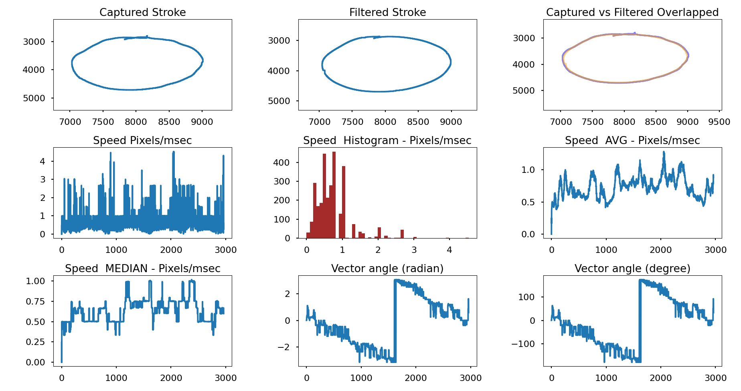
Moving Average – Window size = 200

Comments:
- Smoother stroke
- Minor lag
- small squiggles created

- Case E : Circle Stroke at High Velocity.

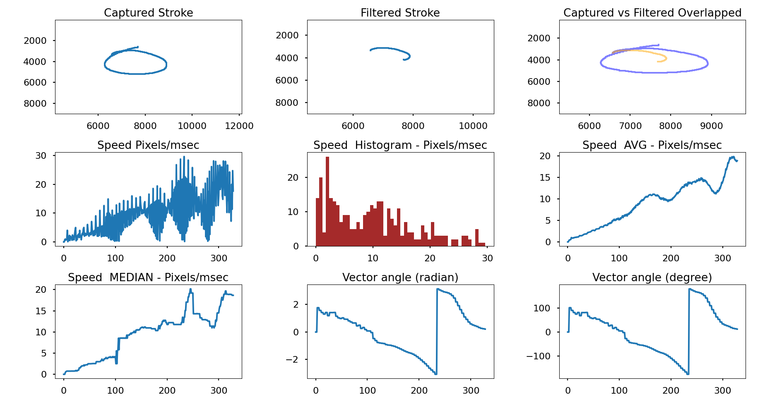

Moving Average – Window size = 200

Comments:
- Smoother stroke
- Major lag
- discontinued stroke

2) Low Pass Filter – (IIR)

A low-pass filter is a filter that passes signals with a frequency lower than a selected cutoff frequency and attenuates signals with frequencies higher than the cutoff frequency.

Filtered_point = Previous_point + (time_Constant * (Current_point – Previous_point) )

- The control parameter of the low pass filter is the time constant (RC or alpha), this determines the cutoff frequency of the filter the lower the values is the stronger the filter is.

Case A : Diagonal Stroke at Slow Velocity – Relatively Constant.

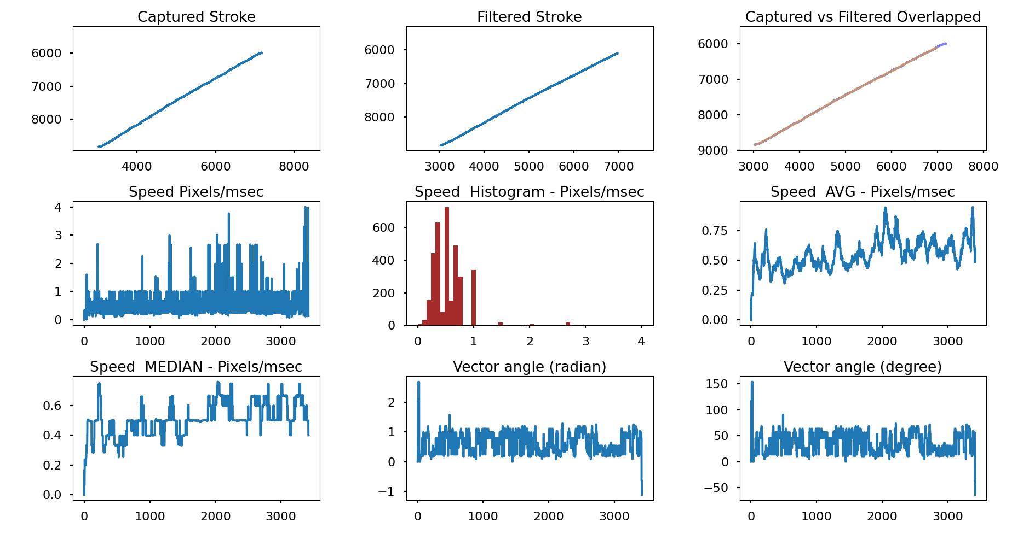
Low Pass Filter – Time Constant = 3/400

Comments:
- Smoother stroke / smaller time constant makes the stroke even smoother
- Minor lag / smaller time constant makes the lag major

- Case B : Diagonal Stroke at Variable Velocity – Transition from High to Low Velocity.

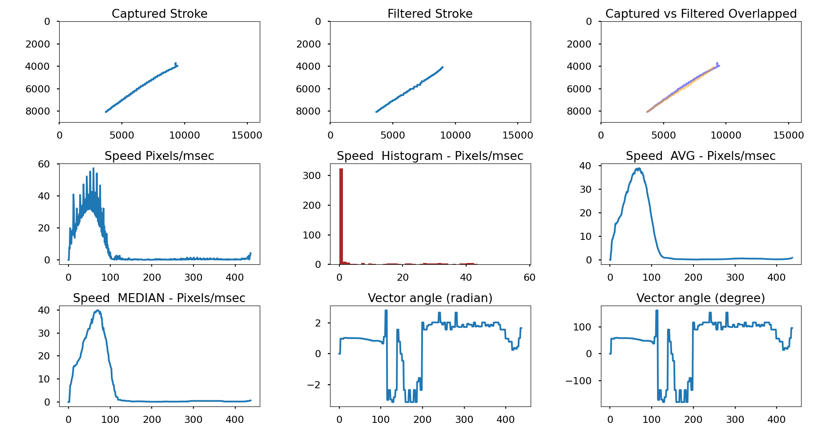

Low Pass Filter – Time Constant = 3/400

Comments:
- More wobble to the stroke when transitioning to slow speed
- Lag added

- Case C : Circle Stroke at Slow Velocity – Relatively Constant.

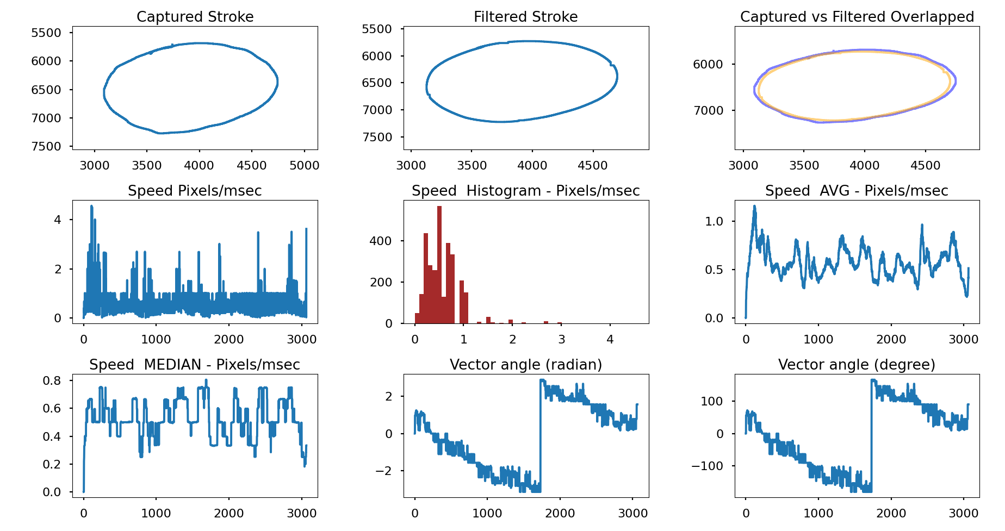

Low Pass Filter – Time Constant = 3/400

Comments:
- Smoother stroke
- Minor lag
- small squiggles created

- Case D : Circle Stroke at High Velocity – Relatively Constant.

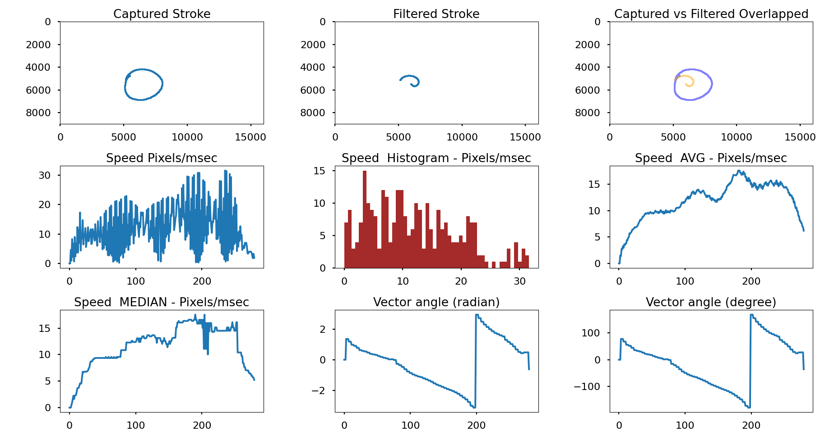

Low Pass Filter – Time Constant = 3/400

Comments:
- Smoother stroke
- Major lag
- discontinued stroke

3) Linear Kalman Filter

LKF uses a series of measurements observed over time, including statistical noise and other inaccuracies, and produces estimates of unknown variables that tend to be more accurate than those based on a single measurement alone, by estimating a joint probability distribution over the variables for each time frame.

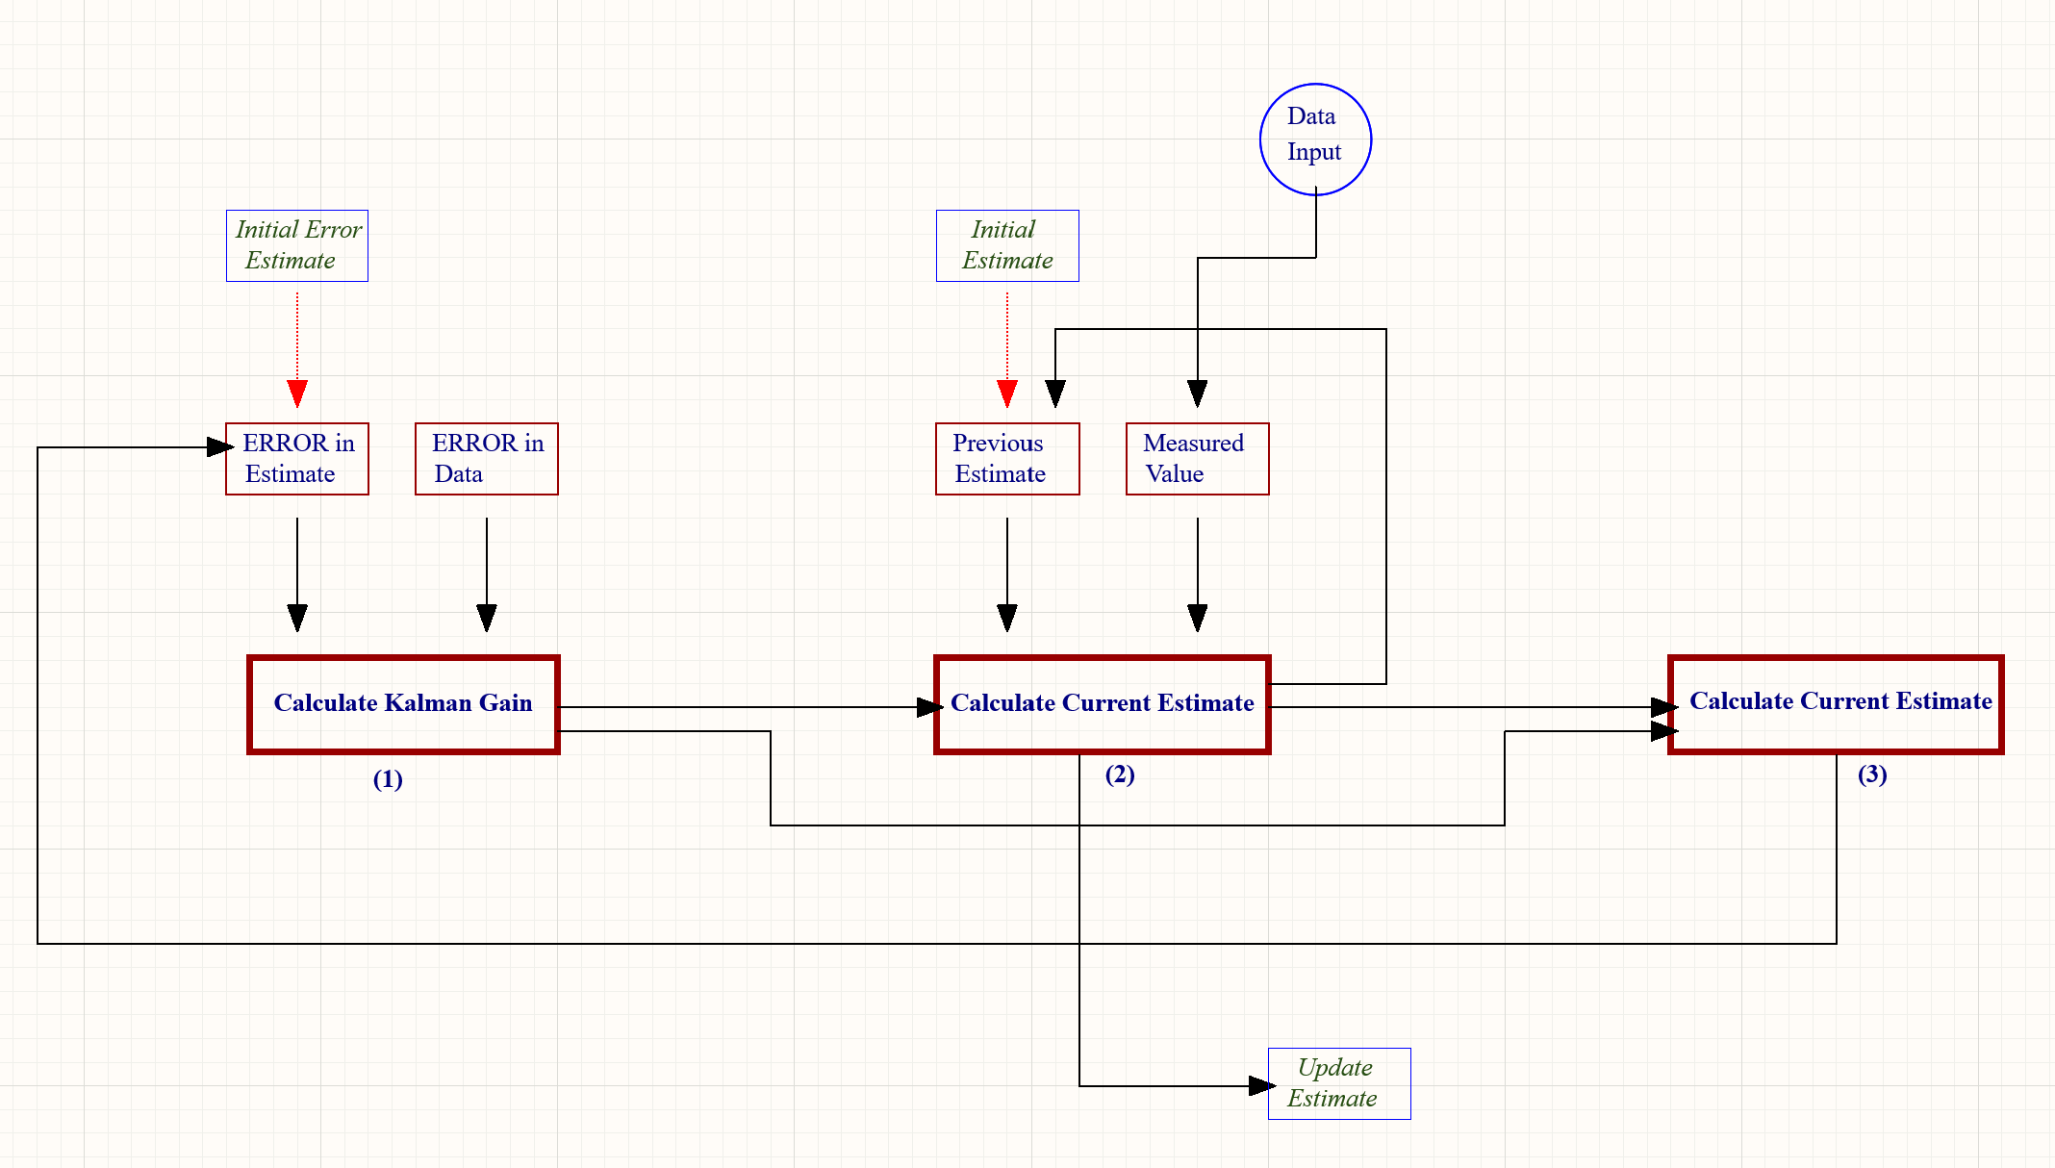

The three main iterative steps in the kalman filter model are:
1) calculating the kalman gain
2) calculating the current estimates
3) calculating the error in the estimate

- Steps
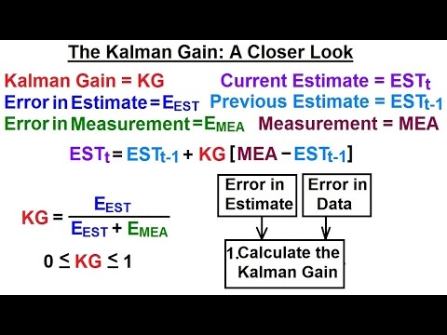
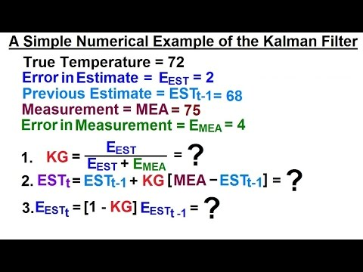

The control parameters:
- R matrix: Measurement noise covariance “Sensor Uncertainty”
- Q matrix: Process noise covariance

Case A : Diagonal Stroke at Slow Velocity – Relatively Constant.

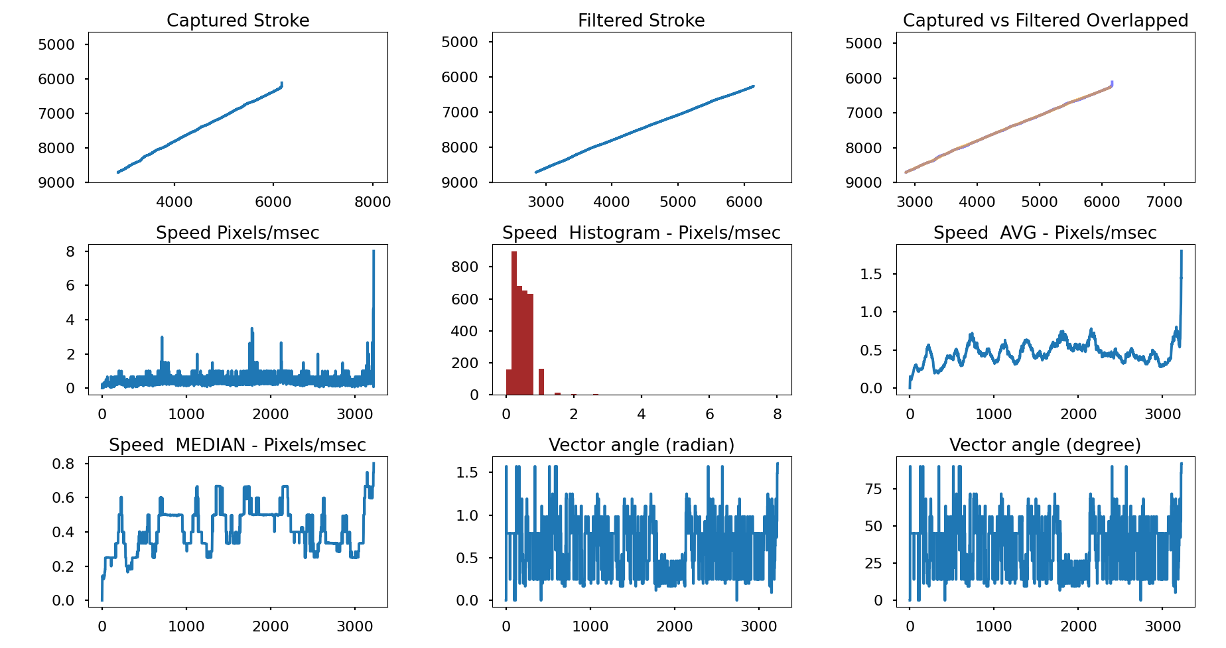
Linear Kalman Filter

Comments:
- Smoother stroke
- Minor lag

Case B : Diagonal Stroke at Variable Velocity – Transition from High to Low Velocity.

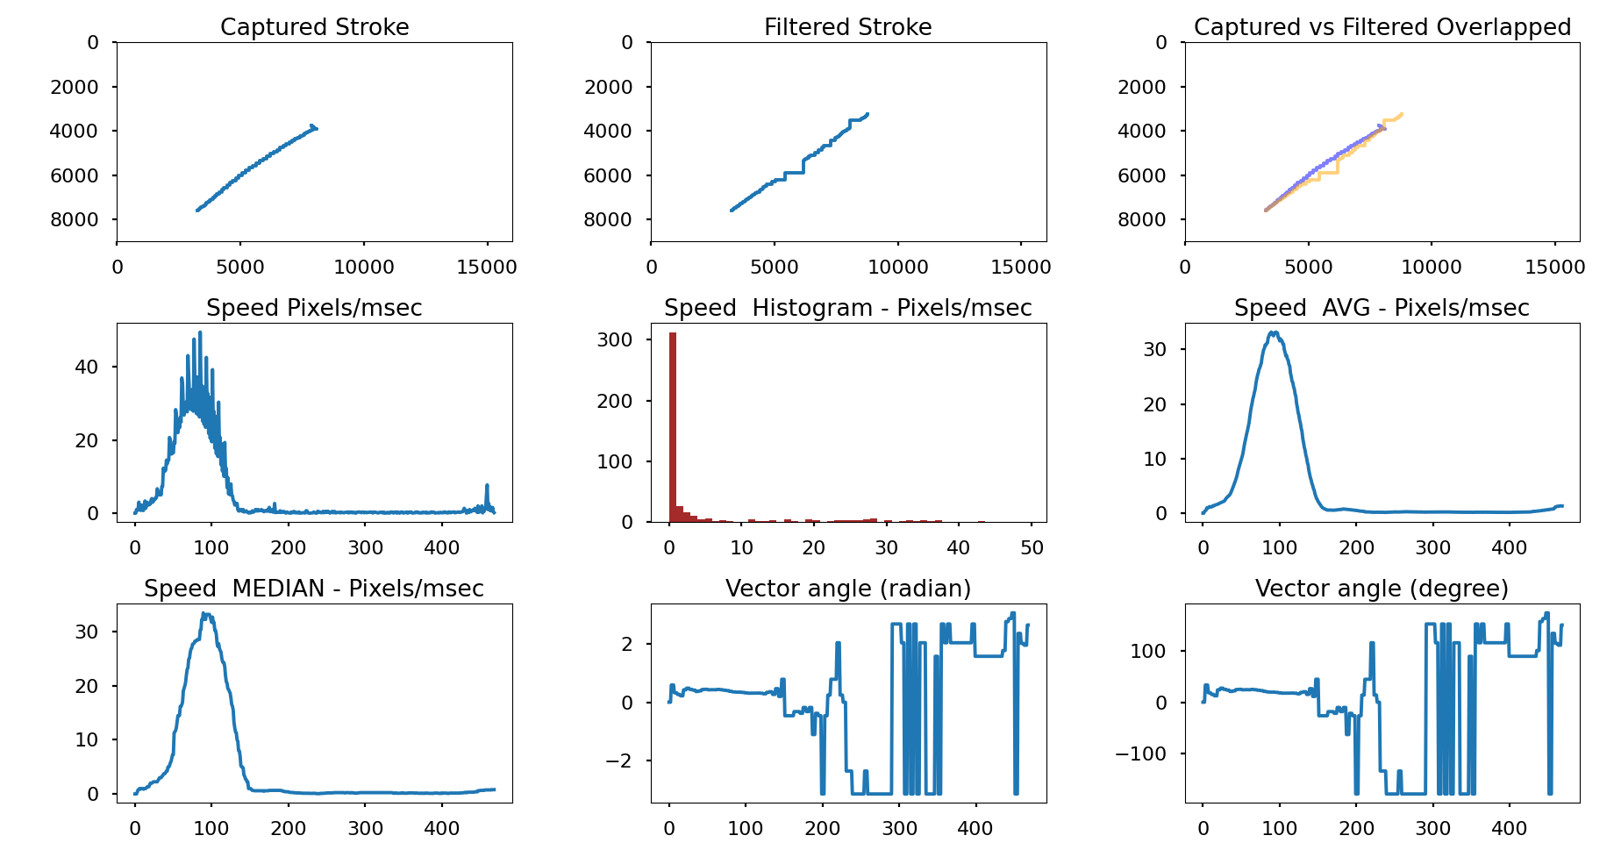

Linear Kalman Filter

Comments:
- More wobble to the stroke when transitioning to slow speed
- Lag added
- The stroke continues beyond the real position of the pen

Case C : Circle Stroke at Slow Velocity – Relatively Constant.

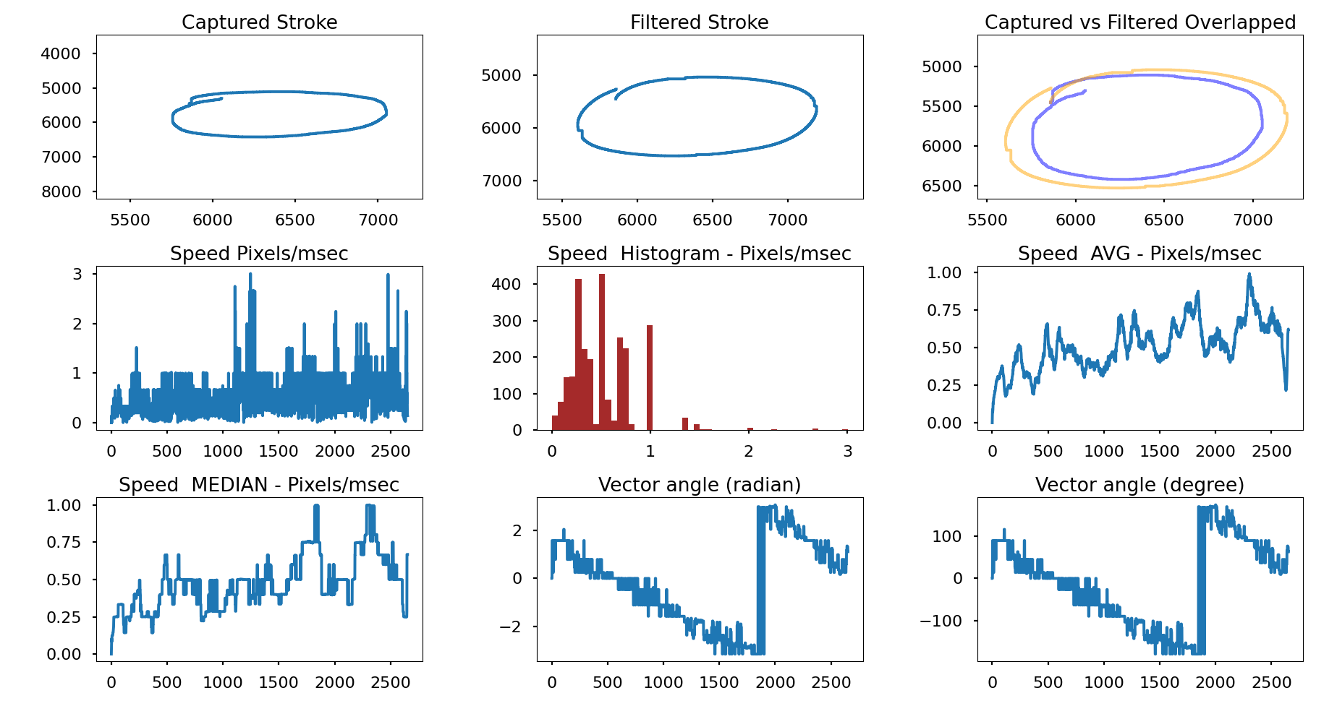
Linear Kalman Filter

Comments:
- Smoother stroke
- Minor lag
- small squiggles created
- Offset Stroke

Case D : Circle Stroke at High Velocity – Relatively Constant.

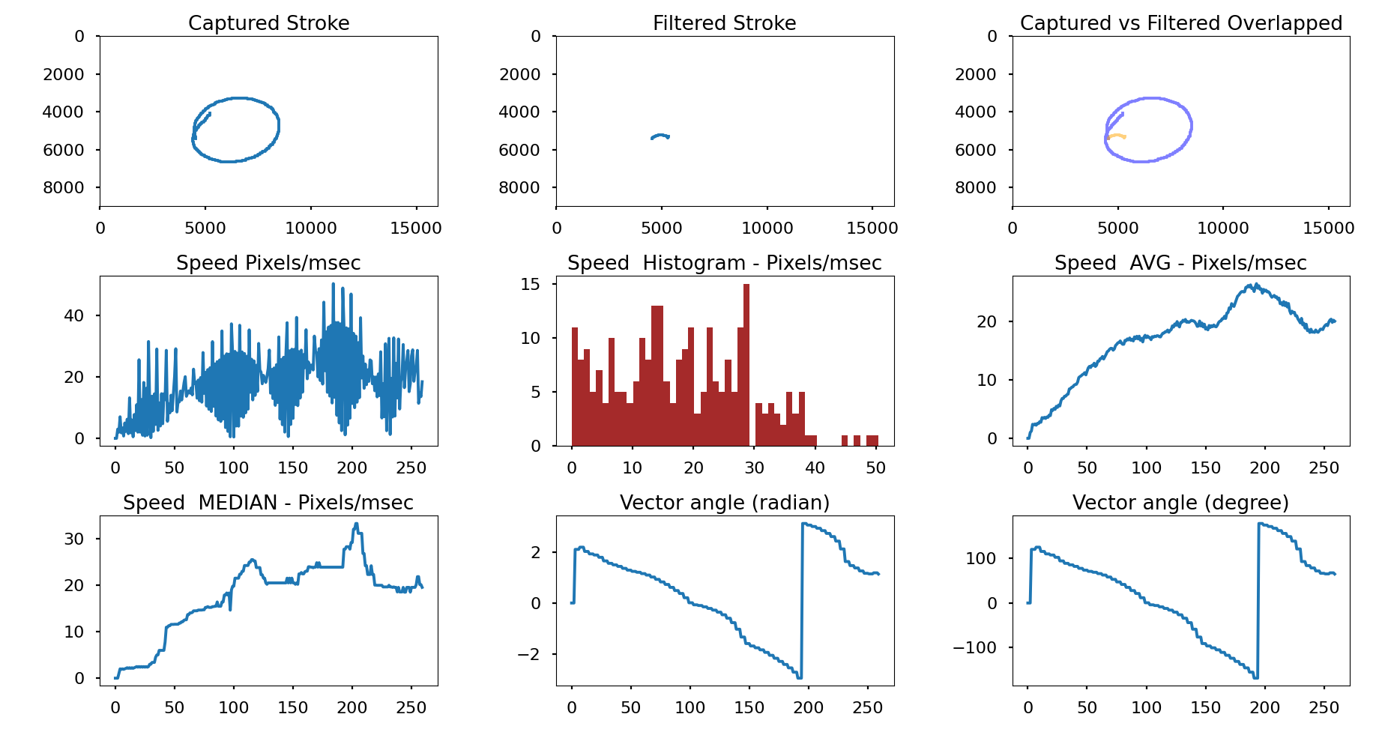

Linear Kalman Filter

Comments:
- Smoother stroke
- Major lag
- discontinued stroke

4) Extended Kalman Filter

Extende Kalman Filter is the nonlinear model of the Linear Kalman Filter, in this model the orientation measurement is taken into consideration to update the heading quicker.

The control parameters:
- R matrix: Measurement noise covariance
- Q matrix: Process noise covariance

- Case A : Diagonal Stroke at Slow Velocity – Relatively Constant.

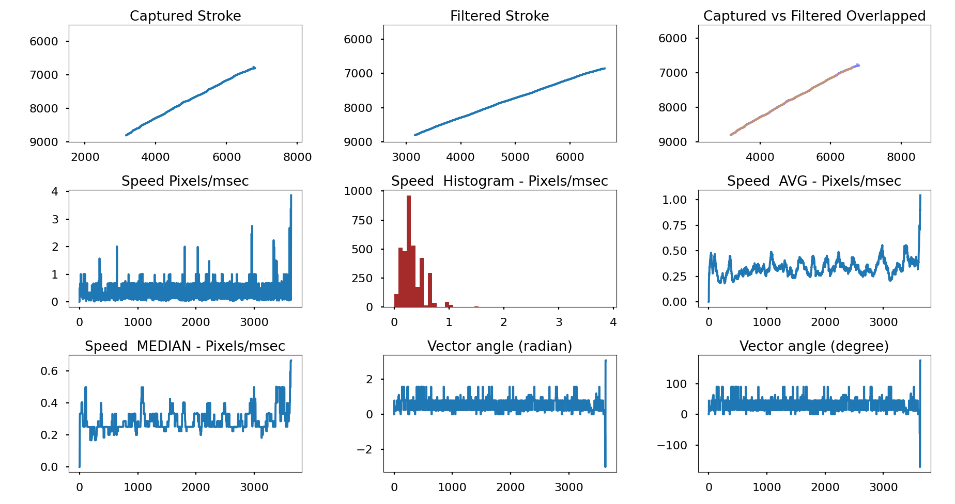
Extended Kalman Filter

Comments:
- Smoother stroke
- Minor lag

- Case B : Diagonal Stroke at Variable Velocity – Transition from High to Low Velocity.

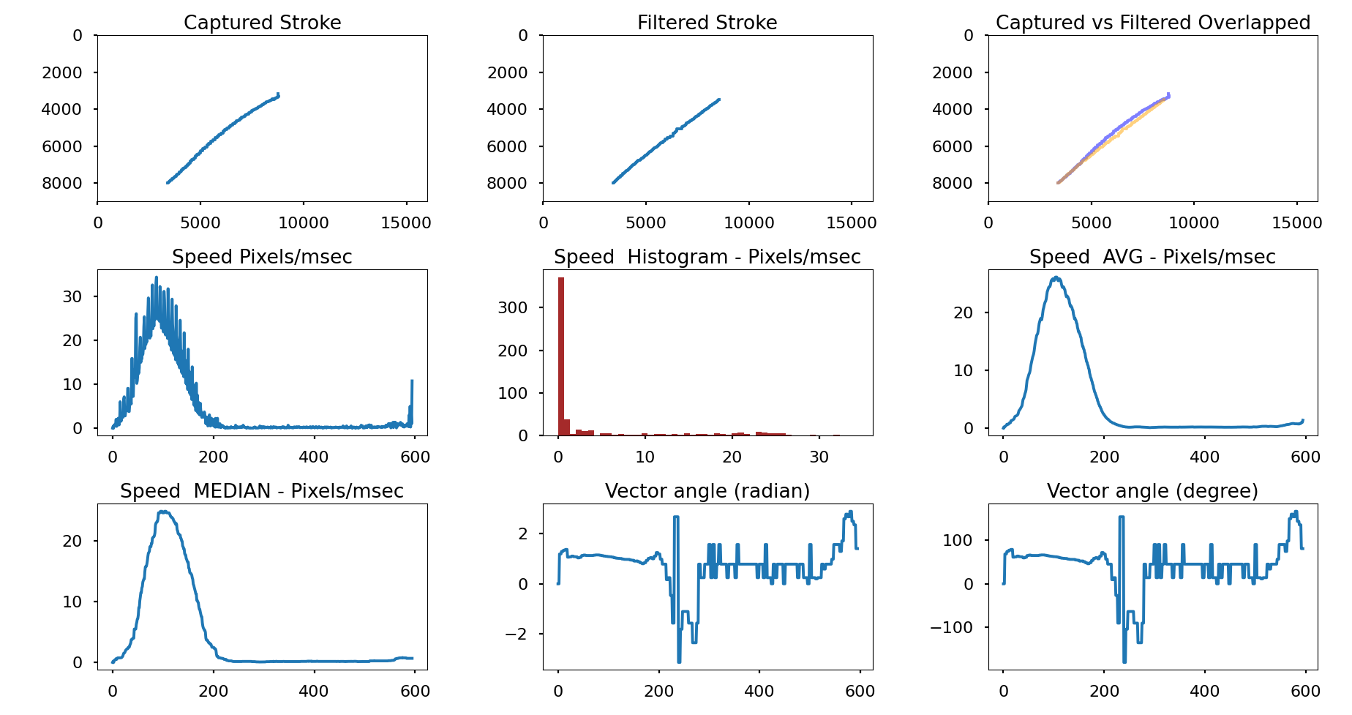
Extended Kalman Filter

Comments:
- More wobble to the stroke when transitioning to slow speed
- Lag added

- Case C : Circle Stroke at Slow Velocity – Relatively Constant.

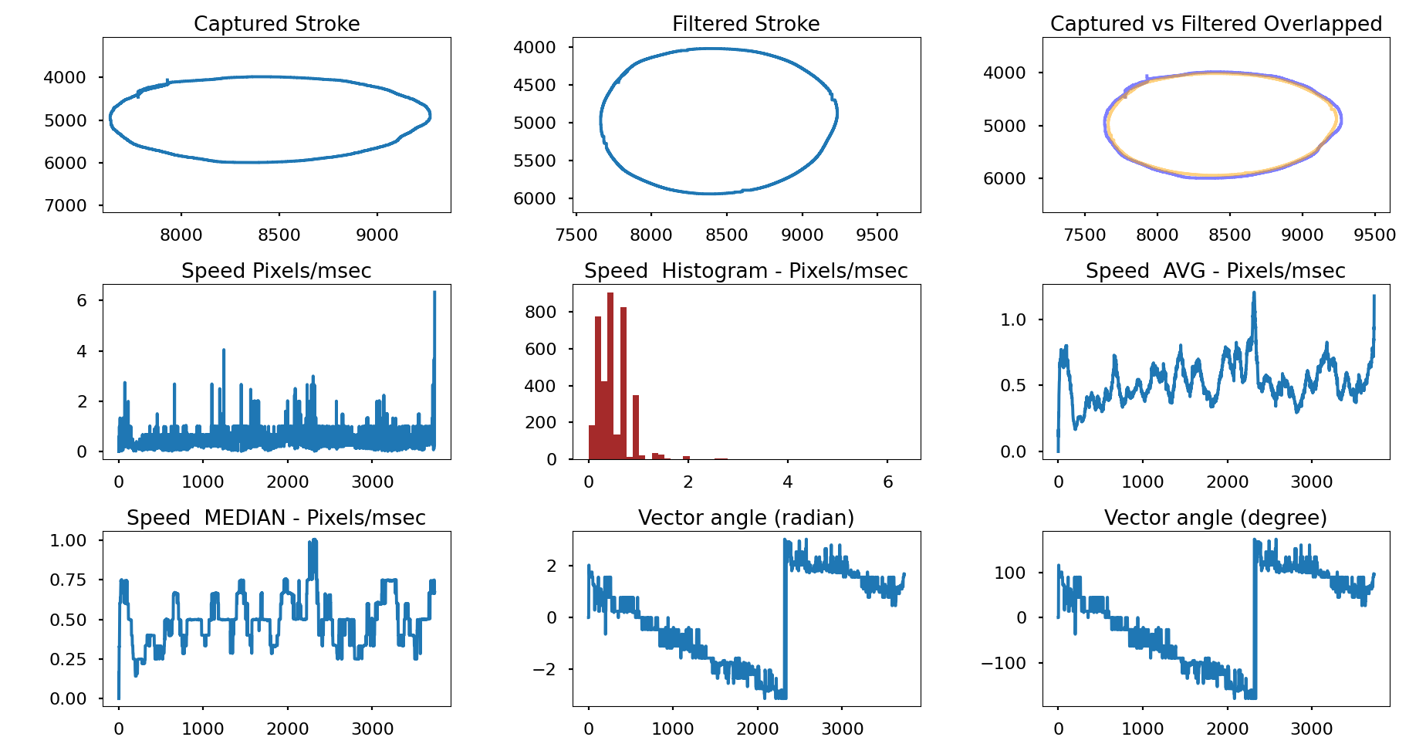
Extended Kalman Filter

Comments:
- Smoother stroke
- Minor lag
- small squiggles created

- Case D : Circle Stroke at High Velocity – Relatively Constant.

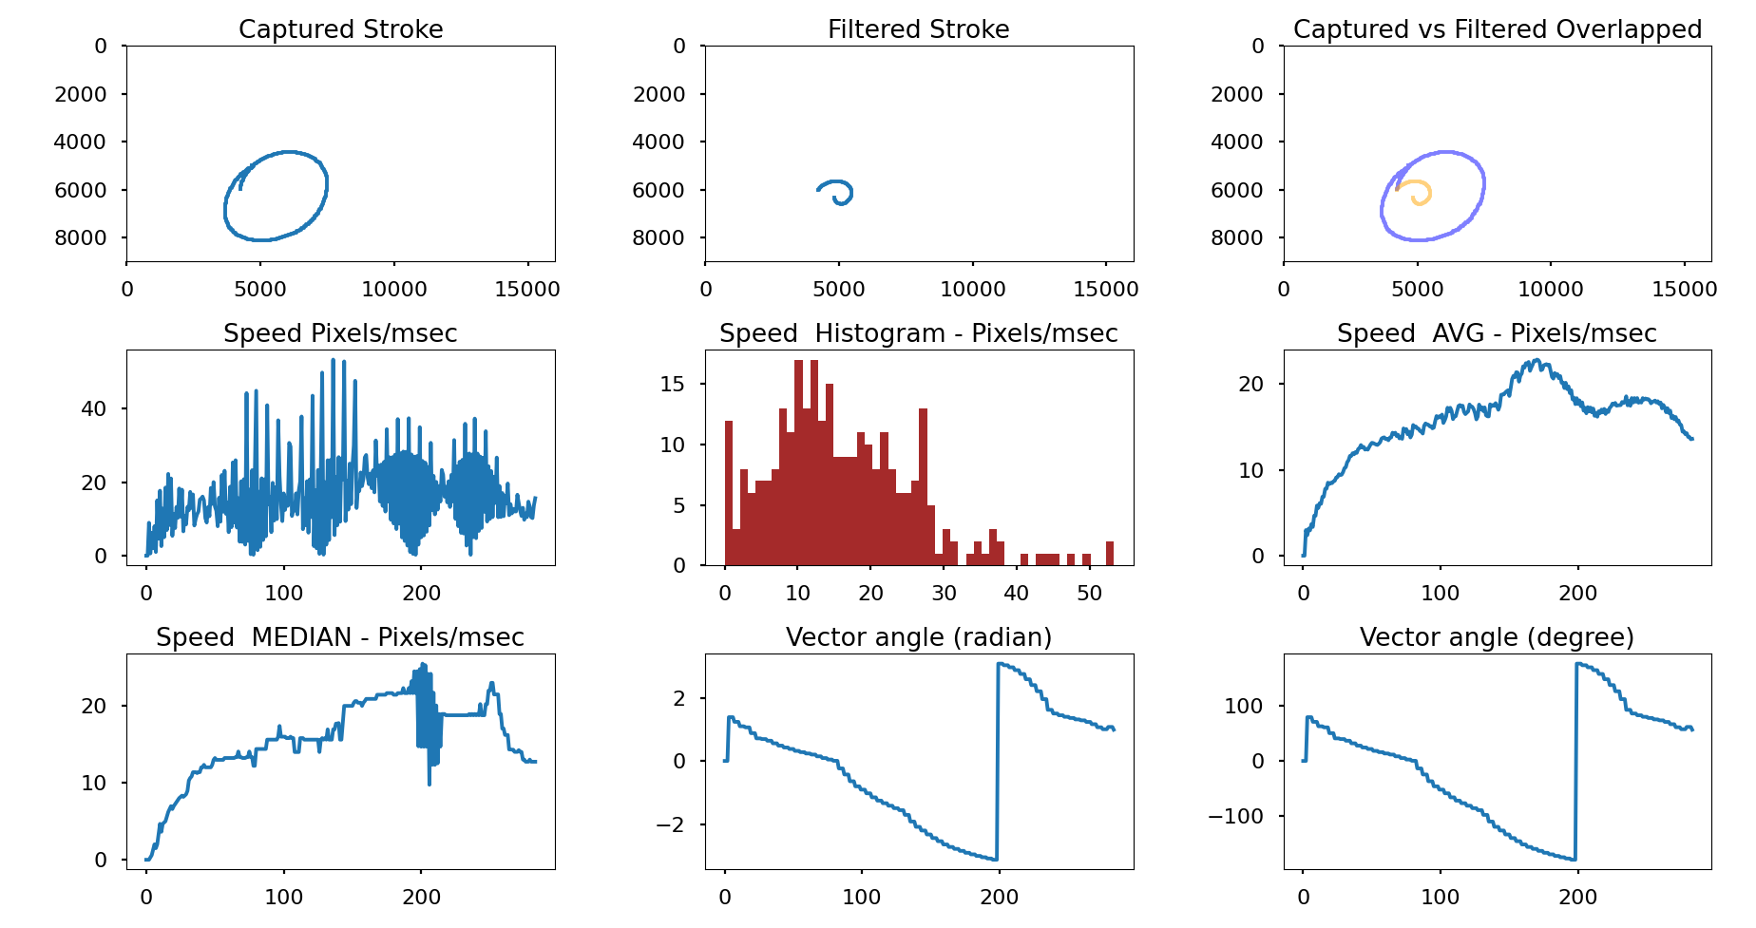

Linear Kalman Filter

Comments:
- Smoother stroke
- Major lag
- discontinued stroke

5) Moving Average with Velocity Threshold

Case A: Combination of Diagonal Stroke at Slow Velocity and Circle at High Velocity

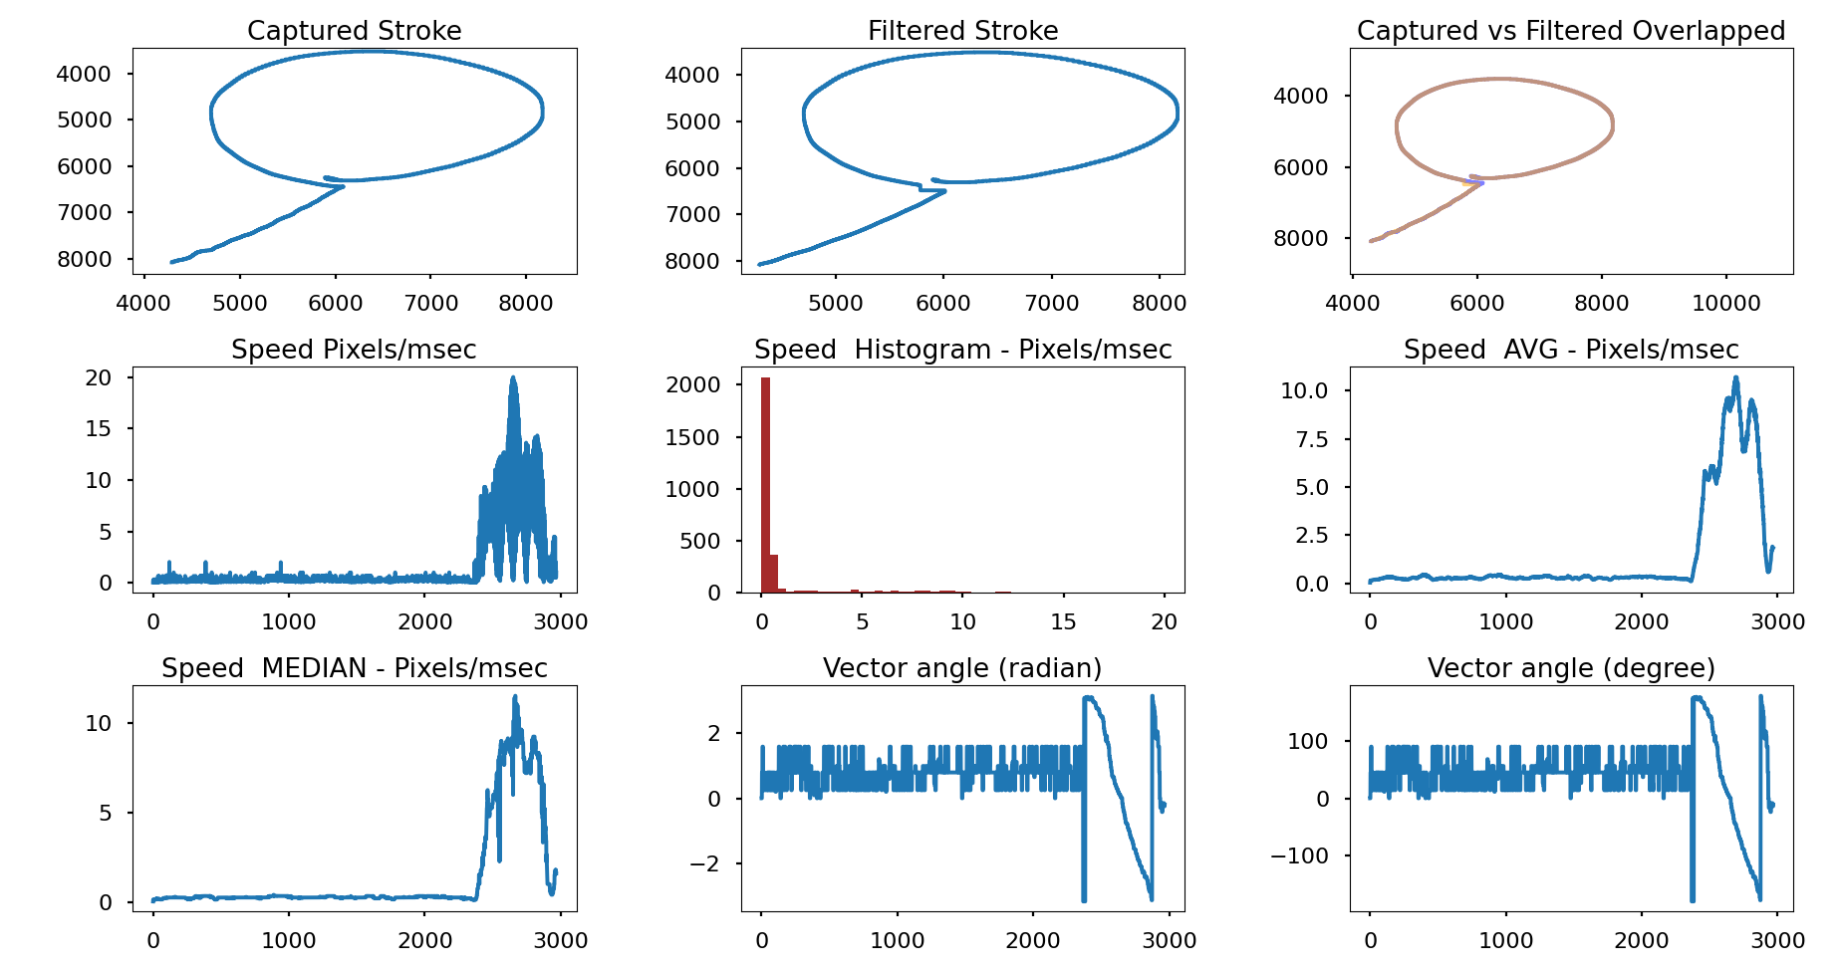
Window Size = 250 / Velocity Threshold = 2 (median)

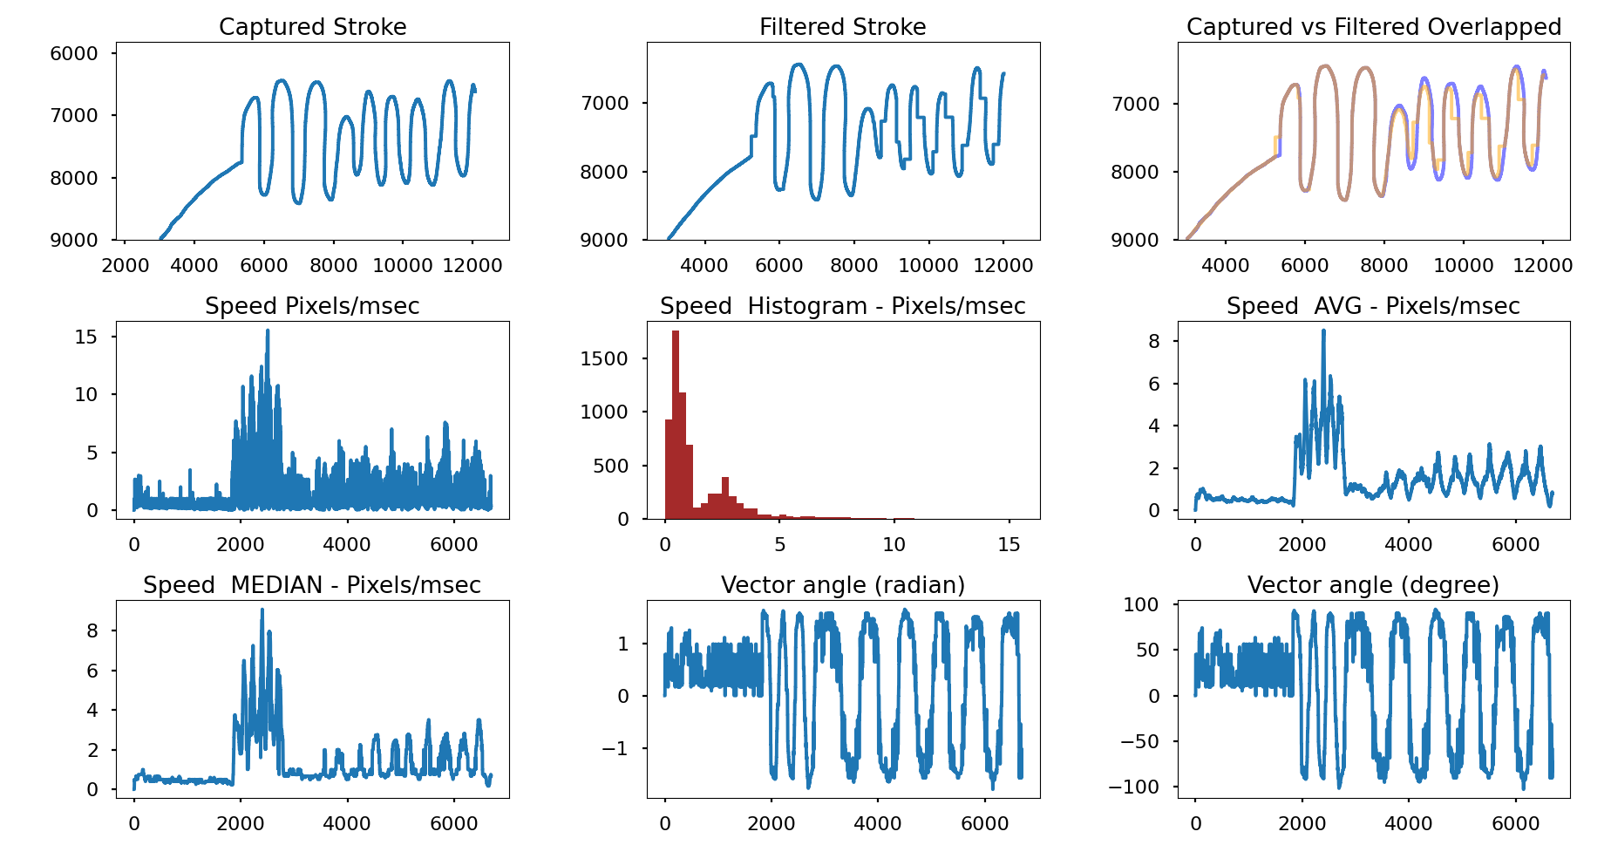
Case B: Stroke with Random Velocity

Window Size = 250 / Velocity Threshold = 2 (median)

Comments:
- This eliminates the issue of lag on high velocity
- smooth stroke on slow velocity
- switching off/on the filter when hitting the velocity threshold creates squiggles
- minor squiggles created

Summary:
- All filters have trade off between filter strength and the lag
- Squiggles are created in all filters when drawing curves (need investigation)
- Stroke velocity must be taken into consideration (huge improvement)
- An algorithm needs to be worked out to make the transitions around the threshold smooth

