**Espresso Multi-Display Touch Calibration Driver**

Copy the executable file to your preferred directory and make sure the file is executable.

On first time run, execute the script “./multiEspresso” then a calibration trial will be executed and it will prompt you to enter (y) if calibration is finished or (n) to re-try a different calibration trial. “See image below”.  
On each trial you would need to verify the calibration is correct by touching the displays.

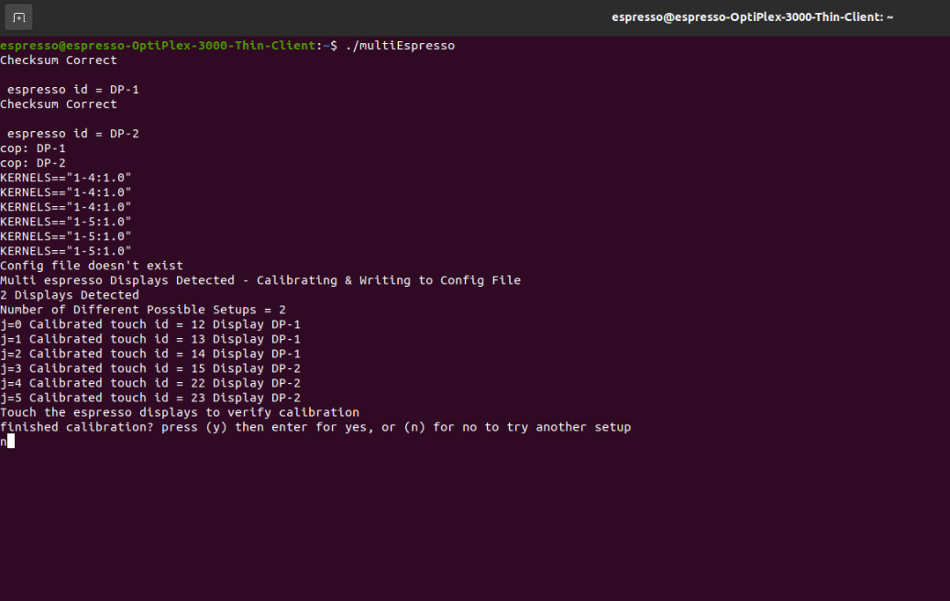

After running the calibration for the first time, the configuration settings will automatically be written to a config file at the same directory where the script is located (NOTE: make sure that the directory is given read&write permissions).

(NOTE: The calibration settings saved to the config file will assume that the physical setup “USB and Video Ports” will remain the same).

You can Auto-run the script on start after running the first calibration. “See image below”

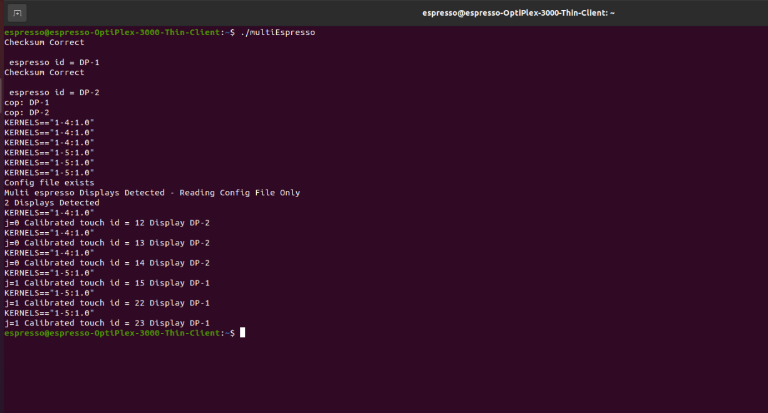

If you want to run the script to re-calibrate the displays, you would run the script with an argument like shown the image below “./multiEspresso -calibrate”.

This will force calibration mode and update the config file.

