

Faculty of Engineering Cairo University / Group 2

Student’s Website
Software Design Specification (SDS)
Version: 2.0
CM Identifier: SDS_G2_V_2.0

Revision History

Sl. No. | Prepared/  Modified by | E-mail | Version | Date | Approved by | Descriptions/  Remarks
1. | Ahmed Osama  Mohamed Ezzat  Mohamed Bassel  Nancy Alarabawy | Ahmedosama9777@aol.com | 1.0 | 04/09/2018
2. | Ahmed Osama  Mohamed Ezzat  Mohamed Bassel  Nancy Alarabawy | Ahmedosama9777@aol.com | 2.0 | 05/13/2018 |  | Sections 3,4 & 6 updated

Distribution list
Name | E-mail | Notes
Eng. Ali El Sedeek | alielseddeek@gmail.com

Table of Contents

1. Introduction 6
1.1 Purpose of this Document 6
1.2 Scope 6
1.3 Table of Acronyms and Definitions 6
1.4 References 6
1.5 Overview of Document 7
2. System Architecture 7
3. Design Models 8
3.1 Design Patterns Description 8
3.2 Class Diagrams 9
3.3 Interaction Diagrams 11
3.4 Activity Diagrams 25
4. Data Models 26
5. System Deployment 28
6. Traceability to Requirements 28

List of Tables

Table 1 Definitions 6
Table 2 Traceability Matrix 28

List of Figures

Figure 1 System Architecture 7
Figure 2.1 Model Class Diagram 9
Figure 2.2 Controller Class Diagram 10
Figure 3.1.1: SD1 Login Sequence 11
Figure 3.1.2: SD2 View Profile Sequence 12
Figure 3.1.3: SD3 Edit Profile Sequence Diagram 13
Figure 3.1.4: Add Project Sequence Diagram 14
Figure 3.1.5: SD5 View Project Diagram 15
Figure 3.1.6: SD6 Logout Diagram 16
Figure 3.1.7: SD7 GPA Calculator View Diagram 17
Figure 3.1.8: SD8 GPA Calculator Diagram 18
Figure 3.1.9: SD9 Post to Board Diagram 19
Figure 3.1.10: SD10 Comment to Post Diagram 20
Figure 3.1.11: SD11 View Timetable Diagram 21
Figure 3.1.12: SD12 Search User Diagram 22
Figure 3.1.13: SD13 View Search Result User Diagram 23
Figure 3.1.14: SD14 Change Picture User Diagram 24
Figure 3.2.1 Activity Diagram 25
Figure 4.1 ER (Attributes only) Diagram 26
Figure 4.2 ER (Relationship only) Diagram 27
Figure 5 System Deployment 28

Introduction

Purpose of this Document
The purpose of this document is to visualize, specify and construct models for the system and to show different aspects of the design processes.

Scope
The website is mainly concerned with constructing a platform for students to communicate and interact, and building modules that allow the user to find all things they might need at one place. We aim to provide our users with a combination of functionalities that make a student’s life easier starting with keeping an eye on his/her grades and being able to view their time table and transcript. They can also communicate with other students using a board to post announcements and inquiries, and will be able to interact on others’ posts by commenting on them. Also, they can construct a profile with all their formal information that they can link or refer to in their job application. Users can freely upload and download projects’ details and files from theirs or others’ profiles. Finally, they can use useful tools to calculate their upcoming GPA and arrange their tasks on the Calendar.

Table of Acronyms and Definitions

Term | Definition
CUFE | Cairo University Faculty of Engineering
GPA Calculator | Tool that calculates upcoming semester’s GPA
Timetable | Table of lectures and sections student enrolled in
Board | Place to add to posts and comment on posts

References
[1] The Object Primer 3rd Edition: Agile Model Driven Development with UML 2.
[2] Unified Modeling Language, Superstructure, V2.1.2

Overview of Document

This document shows the system architecture of our web app, then the different design models that explain how our system works starting with Class Diagrams to show our classes and their definitions, then sequence diagrams of each feature, followed by a comprehensive activity diagram to show all possible interactions with our website. Following, the document illustrates the deployment diagrams which model how the system will be deployed. Finally, the requirements traceability methodology with help of matrices design to keep track of user stories and designed elements.

System Architecture
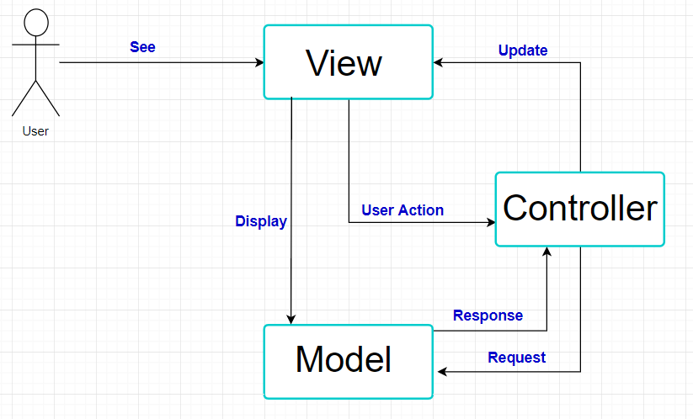
Figure 1 System Architecture

Design Models

Design Patterns Description

MVC
The website is being developed using Laravel which is MVC framework. We used this design pattern because we saw it was best to separate the project into 3 sections: models that deal with the database, views that is the UI (User Interface), and controllers that retrieve the inputs and connect the models with the views. This makes it more efficient, more readable and easier to evolve.

3.1.2 Observer
The website has the feature of adding a post, whenever a comment is added to the post a notification is sent to the users, therefore using observer in that area was best.

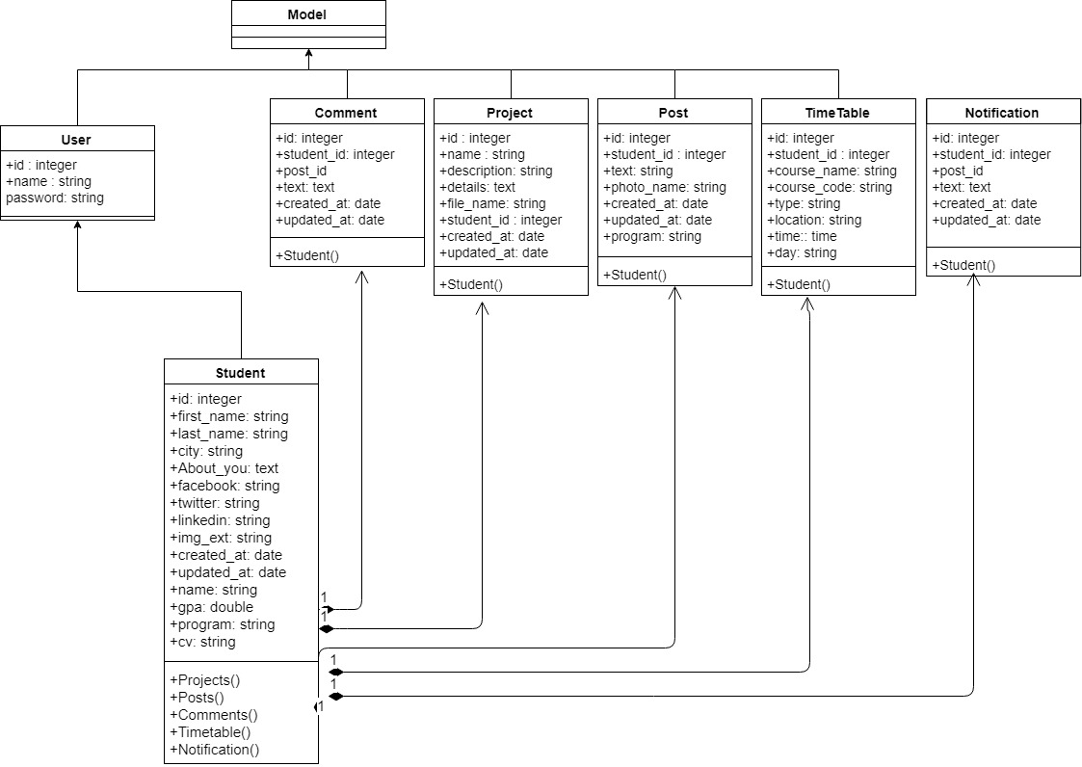
Class Diagrams

Figure 3.2.1 Model Class Diagram

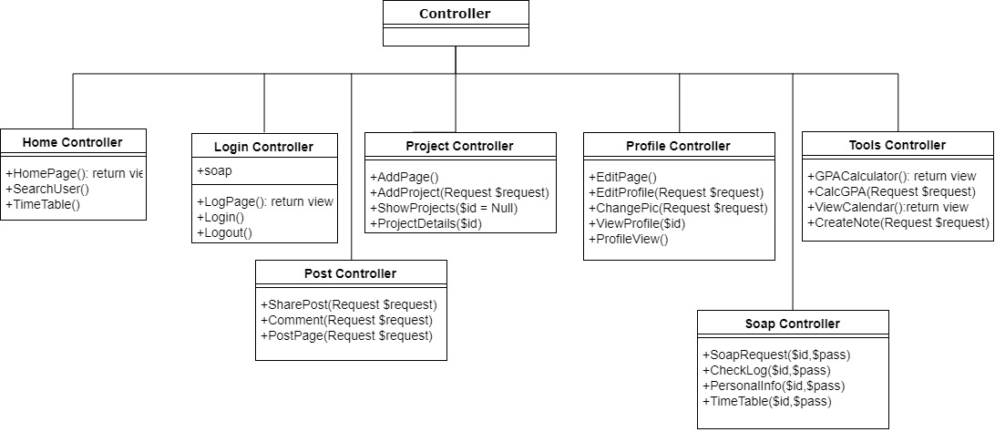

Figure 3.2.2 Controller Class Diagram

Interaction Diagrams

Login Diagram
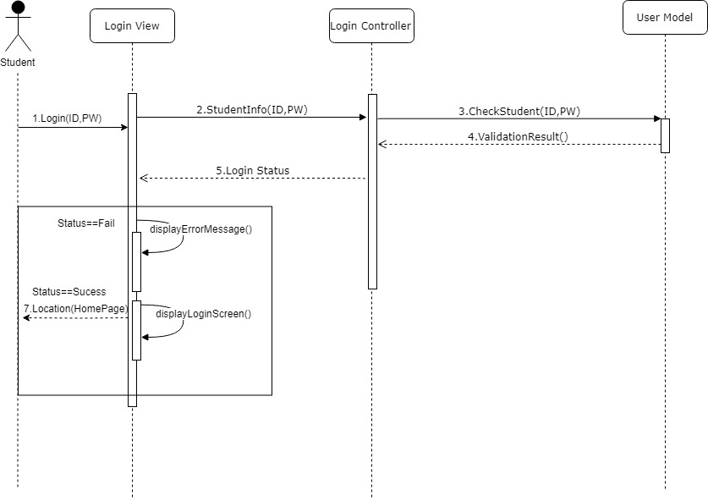
Figure 3.3.1: SD1 Login Sequence Diagram

View Profile Diagram

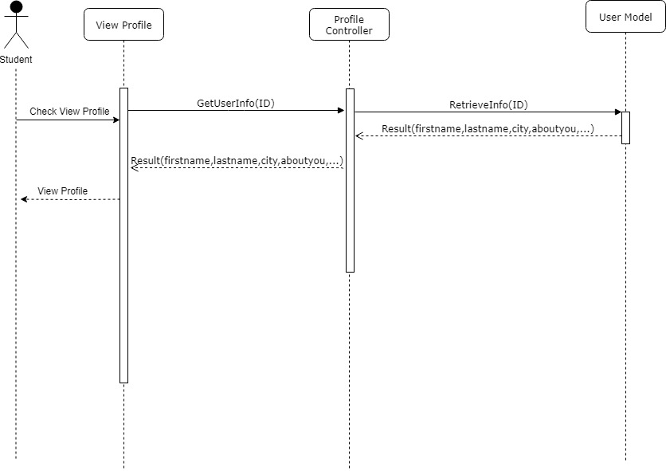

Figure 3.3.2: SD2 View Profile Sequence

Edit Profile Diagram
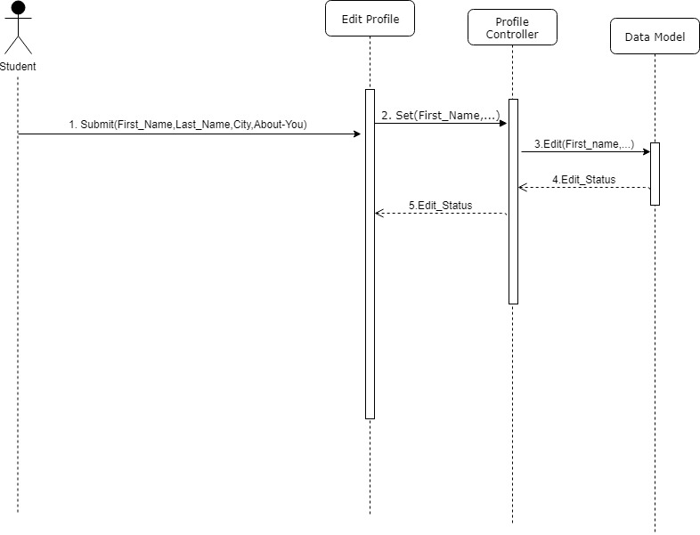
Figure 3.3.3: SD3 Edit Profile Sequence Diagram

3.3.4 Add Project Diagram
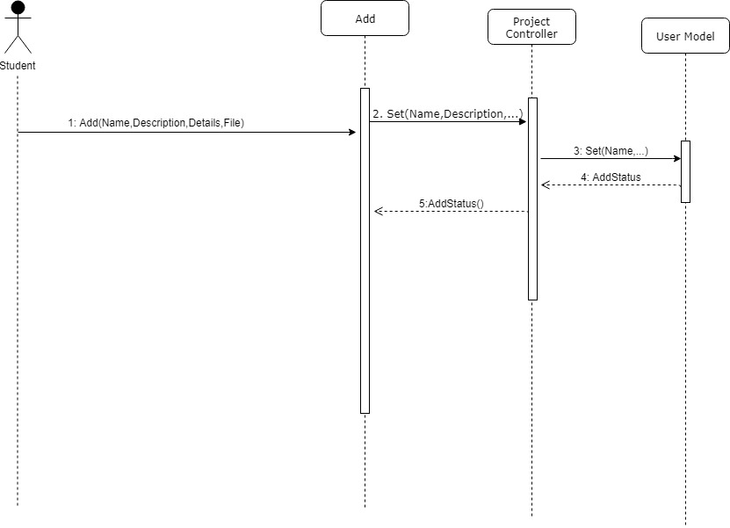
Figure 3.3.4: SD4 Add Project Sequence Diagram

3.3.5 View Project Diagram
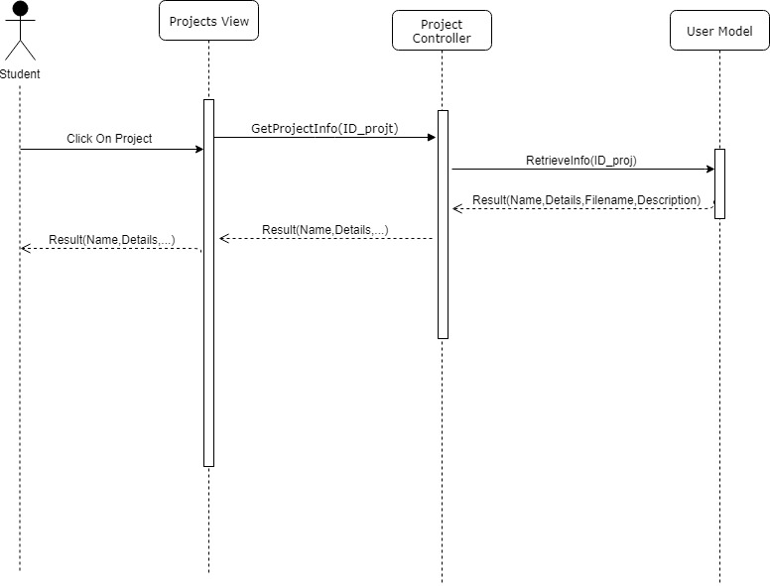
Figure 3.3.5: SD5 View Project Diagram

3.3.6 Logout Diagram

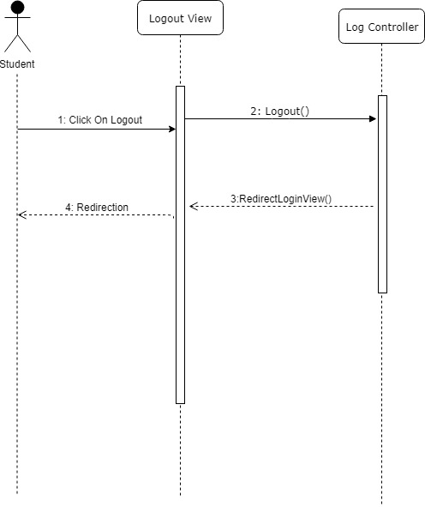
Figure 3.3.6: SD6 Logout Diagram

3.3.7 GPA Calculator View Diagram

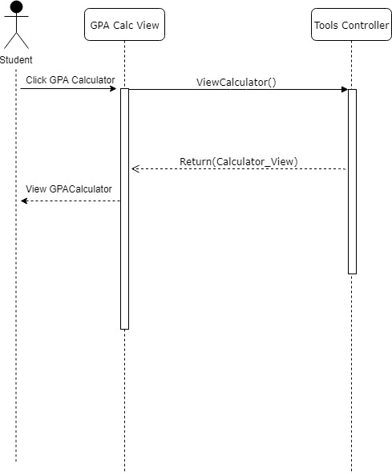

Figure 3.3.7: SD7 GPA Calculator View Diagram

3.3.8 GPA Calculator Diagram

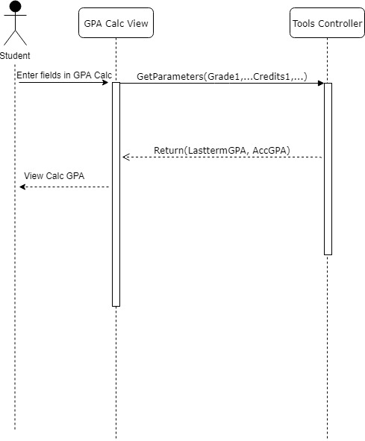

Figure 3.3.8: SD8 GPA Calculator Diagram

3.3.9 Post to Board Diagram

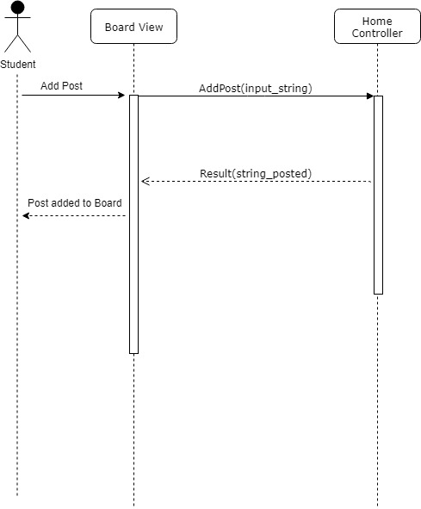
Figure 3.3.9: SD9 Post to Board Diagram

3.3.10 Comment to Post Diagram

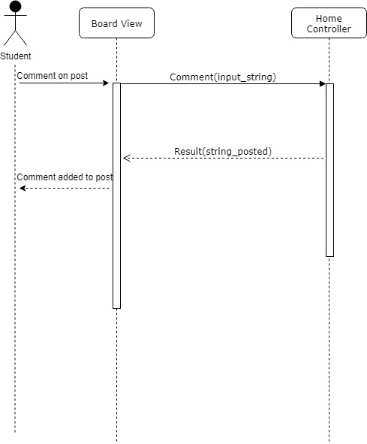
Figure 3.3.10: SD10 Comment to Post Diagram

3.3.11 View Timetable Diagram

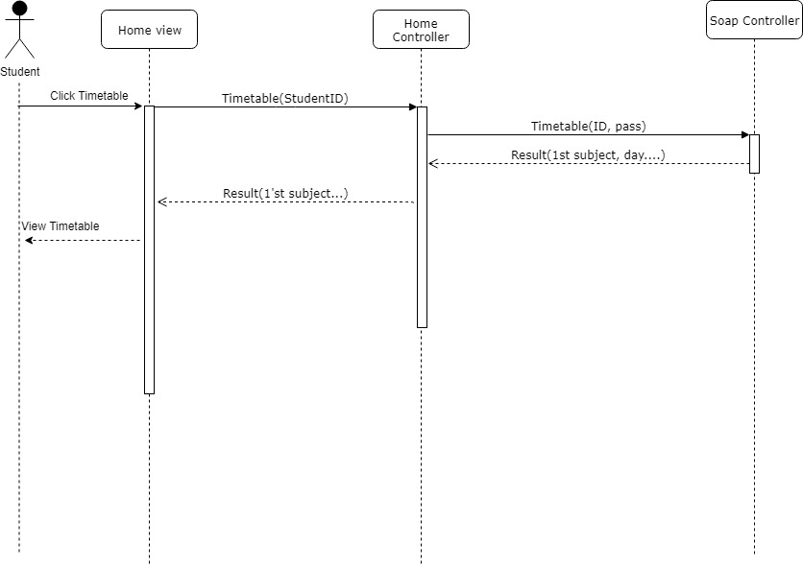
Figure 3.3.11: SD11 View Timetable Diagram

3.3.12 Search User Diagram

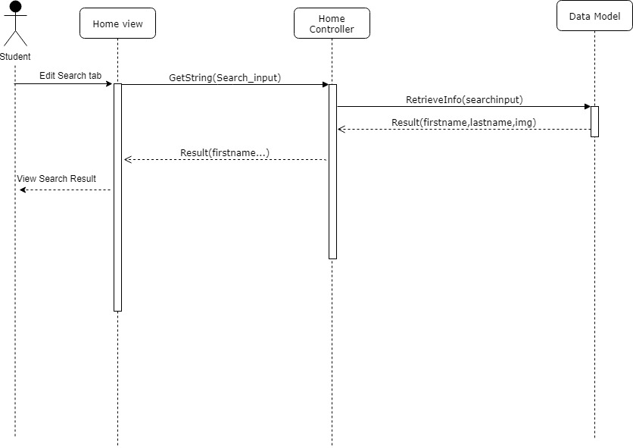

Figure 3.3.12: SD12 Search User Diagram

3.3.13 View Search Result User Diagram

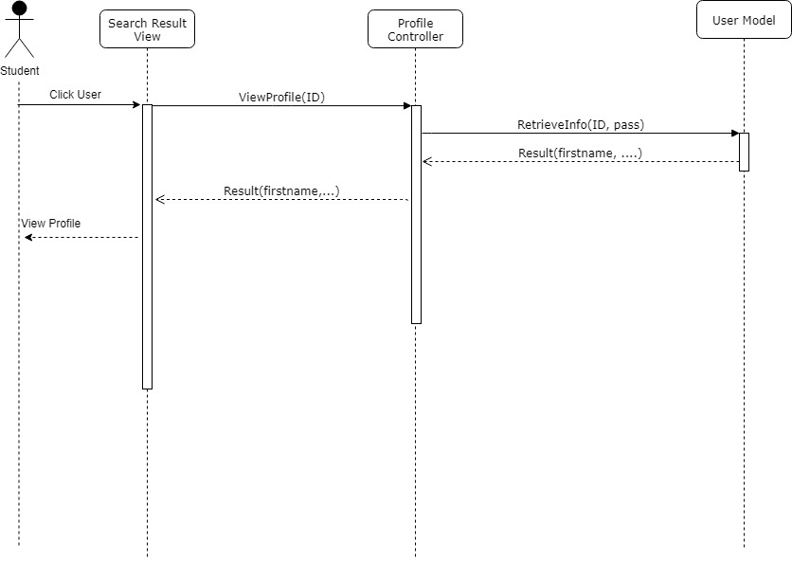

Figure 3.3.13: SD13 View Search Result User Diagram

3.3.14 Change Picture Diagram

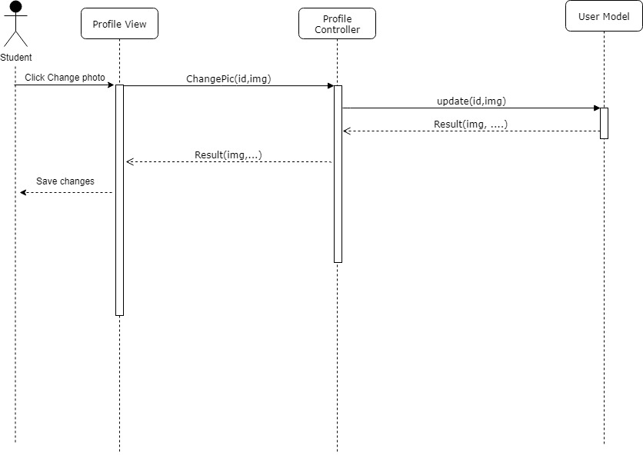

Figure 3.3.14: SD14 Change Picture User Diagram

Activity Diagrams

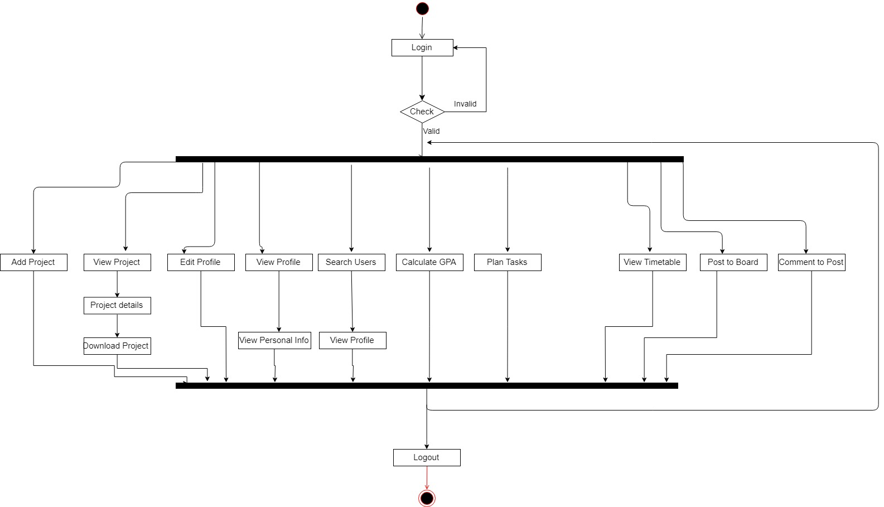
Figure 3.4 Activity Diagram

Data Models
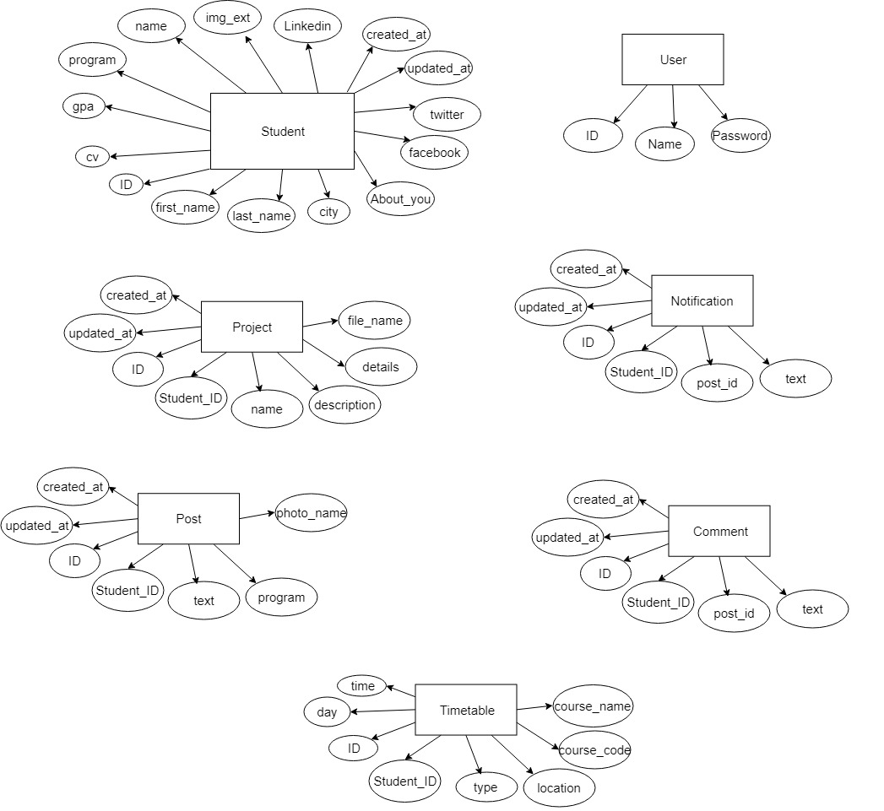

Figure 5.1 ER (Attributes only) Diagram

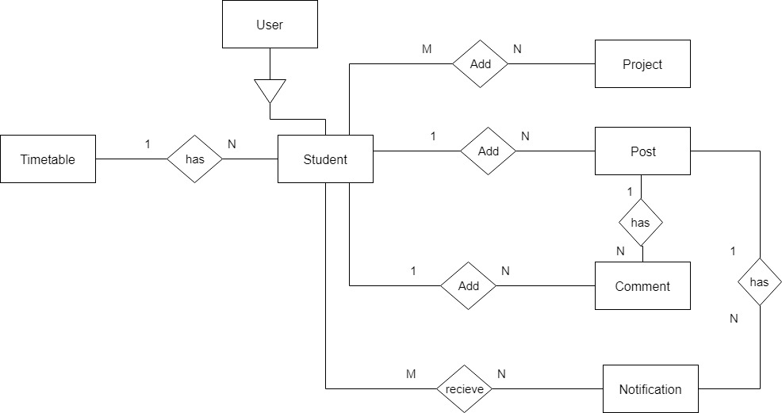

Figure 5.2 ER (relationships only) Diagram

System Deployment

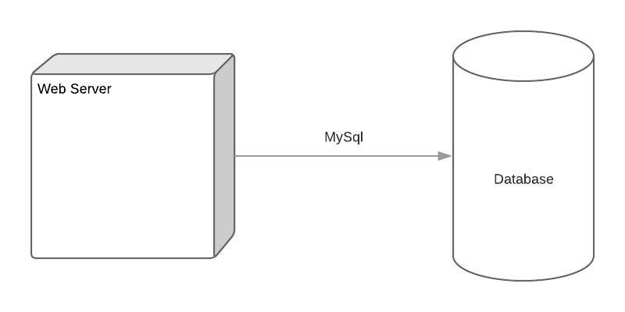
Figure 5 System Deployment

Traceability to Requirements

 | SD1 | SD2 | SD3 | SD4 | SD5 | SD6 | SD7 | SD8 | SD9 | SD10 | SD11 | SD12 | SD13 | SD14
US1 |  |  | ✓
US2 | ✓
US3 |  |  |  |  |  |  |  |  |  |  | ✓
US4 |  |  |  |  |  |  |  |  | ✓
US5 |  |  |  |  |  |  |  |  |  | ✓
US6 |  |  |  |  |  |  | ✓ | ✓
US7 |  |  |  |  |  |  |  | ✓
US8 |  |  |  |  |  | ✓
US9 |  |  |  |  |  |  |  |  |  |  |  | ✓
US10 |  | ✓ |  |  |  |  |  |  |  |  |  |  | ✓
US11 |  |  | ✓
US12 |  |  |  |  |  |  |  |  |  |  |  |  |  | ✓
US13 |  |  |  |  |  |  |  |  |  |  |  |  |  | ✓
US14 |  |  |  | ✓
US15 |  |  |  |  | ✓

