

Group 2

Students’ Website
User and Admin Guide
Version: 1.0

Revision History

Sl. No. | Prepared/  Modified by | E-mail | Version | Date | Approved by | Descriptions/  Remarks
1. | Ahmed Osama  Mohamed Bassel  Muhammed Ezzat  Nancy Alarabawy | Nanciie.arx@gmail.com | 1.0 | 05/13/2018

Table of Contents

1. Introduction 4
1.1. Purpose of this Document 4
1.2. Scope of Project 4
1.3. Release Information 4
1.4. Table of Acronyms and Definitions 4
1.5. References 4
1.6. Overview of Document 4
2. Target Platform 5
3. Installation Instructions 5
4. Getting started 5
5. Usage Instructions 5
6. Troubleshooting 16
7. Points of Contact 17

List of Tables

- Table of Definitions……………………………………………………………4

Introduction
In this document we will take you on a brief trip through our system so you can get acquainted to it and its features, to leave you with all you need to know to interact and use our system, and make best use of its features. First, we will introduce you to the system with all terms used in it, then we’ll take you point by point with the system’s specified platform, all instructions you need and lastly all the details you need to get started.

Purpose of this Document
We thought of writing this document to give a sense of orientation to our users when first using out system.

  - Scope of Project
The website is for CUFE students to use as communication platform. A user shall be able to login to the personal page that is customized to view information he/she selects, and shall be able to add projects and show projects details, view grades, transcript and timetable, and use its useful tool the GPA calculator.
  - Release Information
Version 1.0, Release Date: 05/09/2018

  - Table of Acronyms and Definitions
Term | Definition
CUFE | Cairo University Faculty of Engineering
GPA Calculator | Tool that calculates upcoming semester’s GPA
Task Planner | Tool with days in a table to organize plans and tasks
Board | Place to add to posts and comment on posts

  - References
[1] The Object Primer 3rd Edition: Agile Model Driven Development with UML 2.
[2] Unified Modeling Language, Superstructure, V2.1.2

  - Overview of Document
From this point the document is classified into threefold. A list of installation and usage instruction which is very short and easy, usage instruction are listed clearly with the aid of screenshots of how it should look, following you will find troubleshooting steps whenever you’re facing any problems with the website, then finally our points of contact so you can welcomely share your experience with us and contact us if you have any concerns.

Target Platform
Our system is accessible through any browser. No particular OS or software is needed.

Installation Instructions
You won’t go through any hassle when attempting to use our system, all you need to do is type in the URL and you will be directed to our website so you can start using it right away.

Getting started
As explained in the previous section, you will have the system up and running once you enter the URL and will be able to use it right away.

Usage Instructions
Our system has many features that we’ll gladly walk you through.

- Log in:
First thing you see when typing the URL is the Log in page, all you need at this point is to add your username and password that you typically use to log into your faculty account. Make sure to use your latest password.

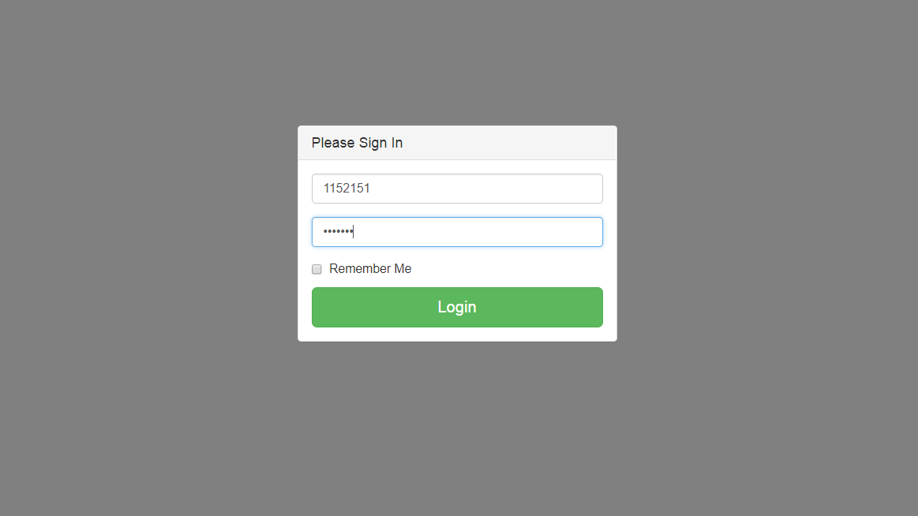

This will redirect you to the home of the website.

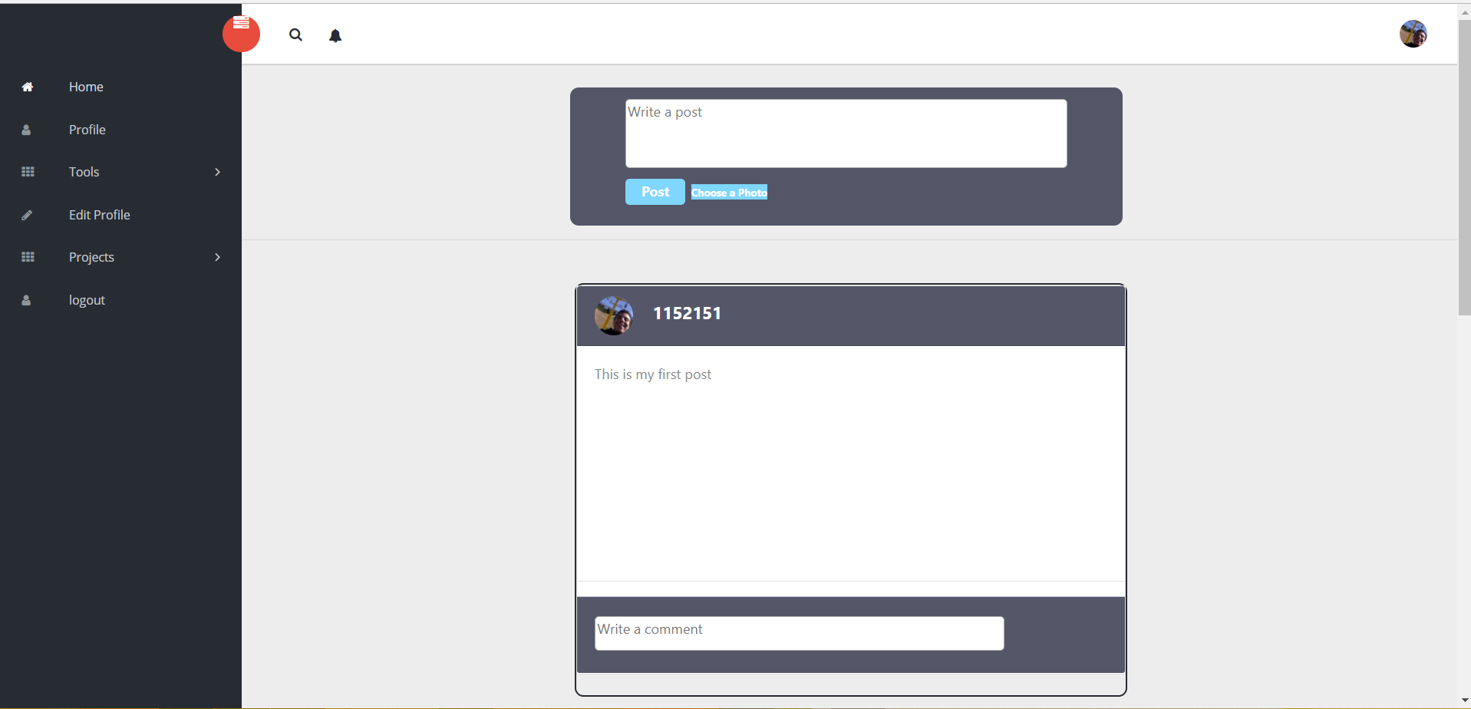

- Edit Profile:
To edit your profile and add the information you want, choose “Edit Profile” from the panel.

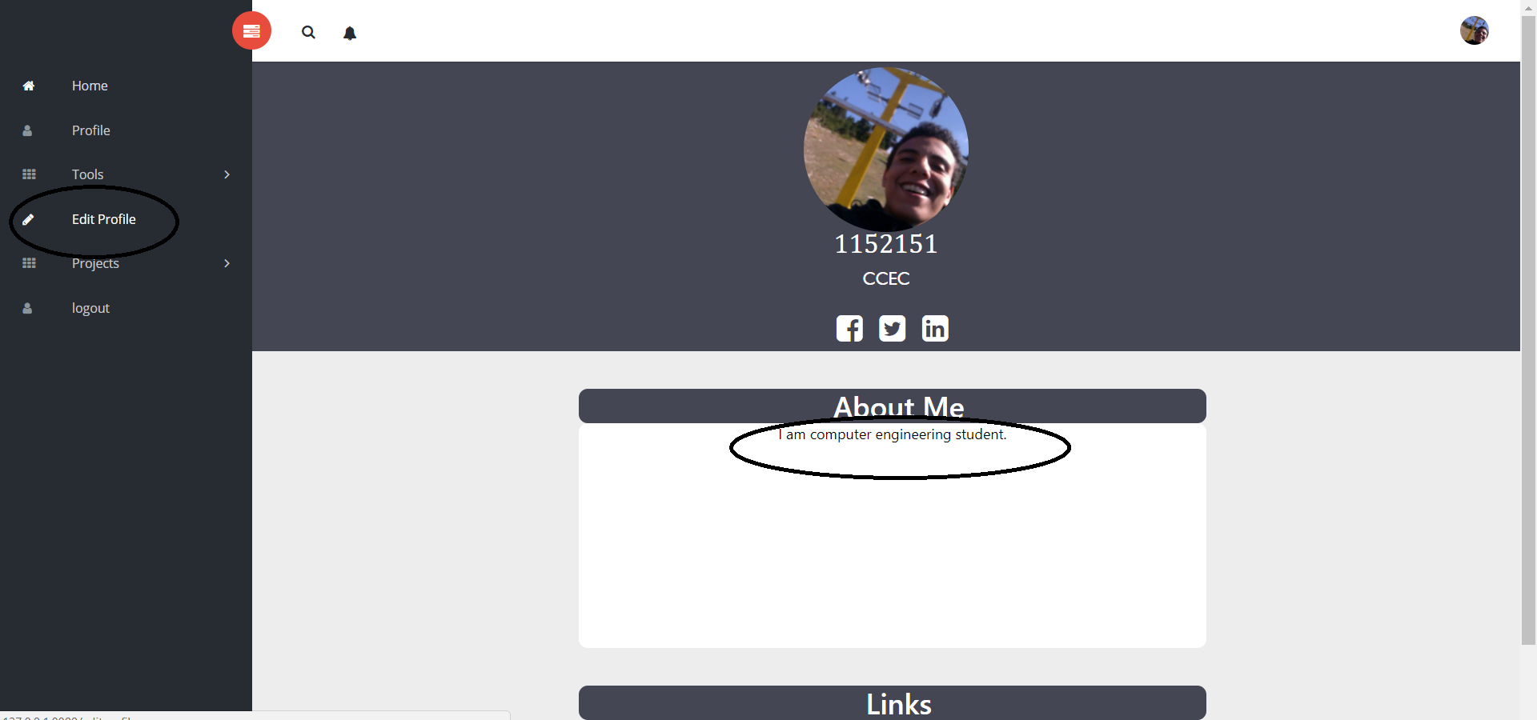

You can enter all the fields you want edited such as First Name, Last Name and City. You can also add your photo and add a small bio by filling the field “About You”. Finally, you can upload a Resume by clicking Add Resume.

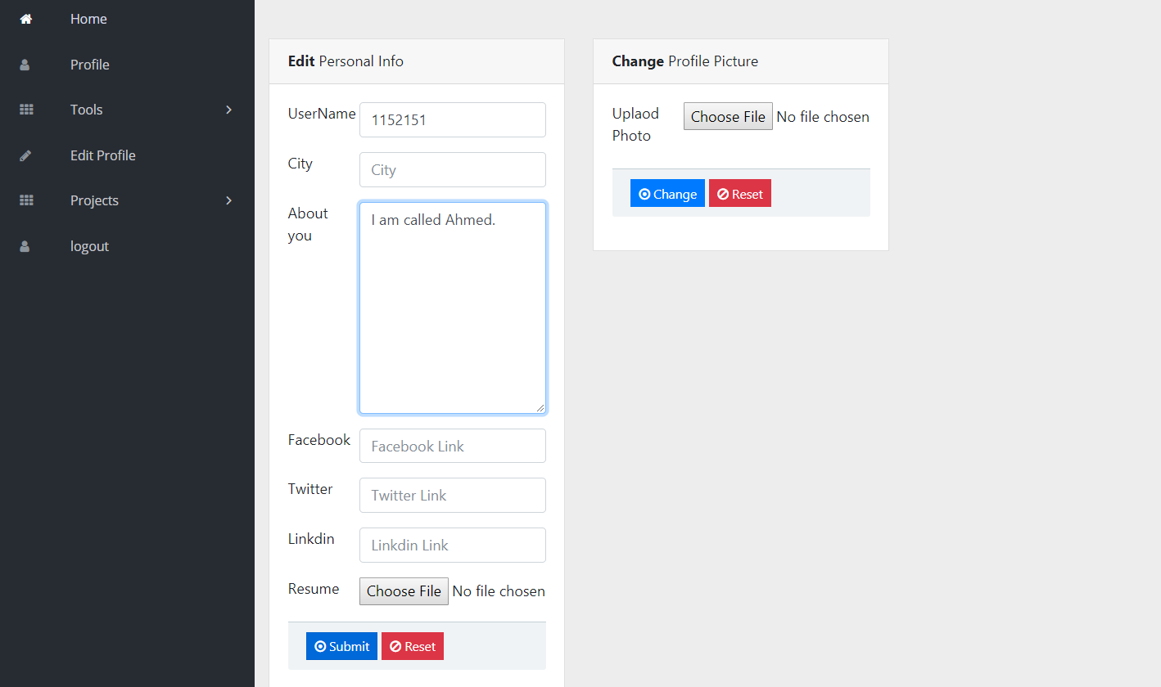

Click submit, changes are saved.

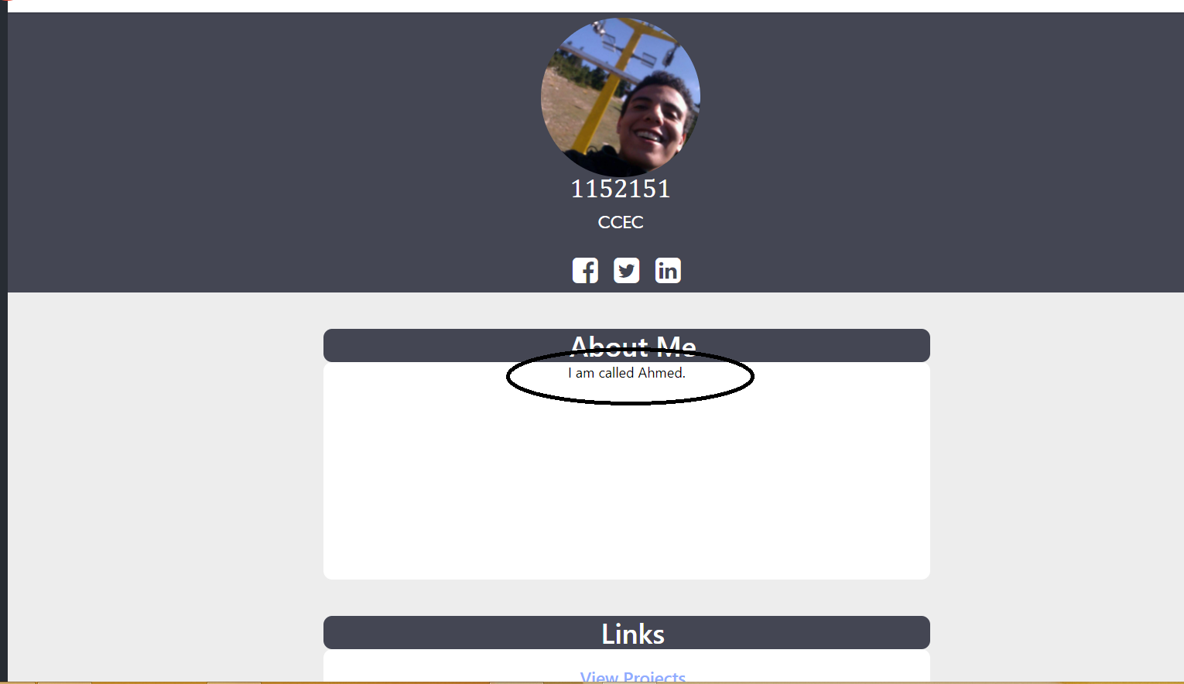

- View Profile:
From the panel, click “Profile”.
This will redirect you to your Profile where you can see how your info and photo is displayed.

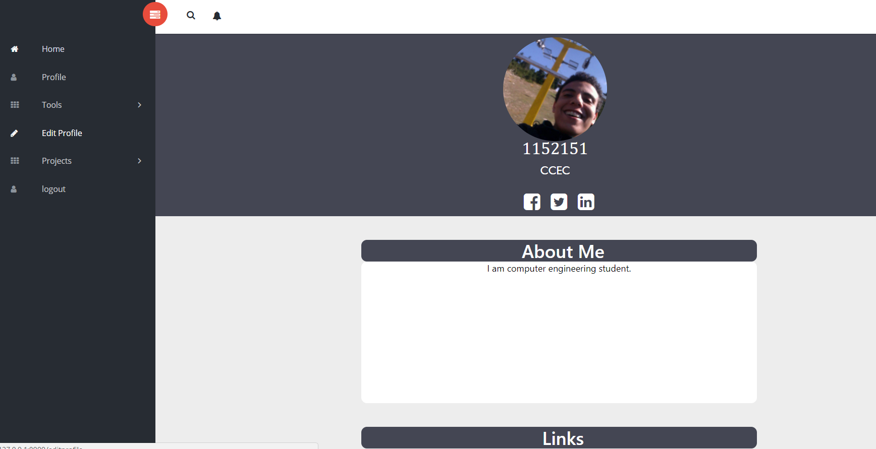

- Add Project:
From the panel, click “Projects” then choose “Add Project”.

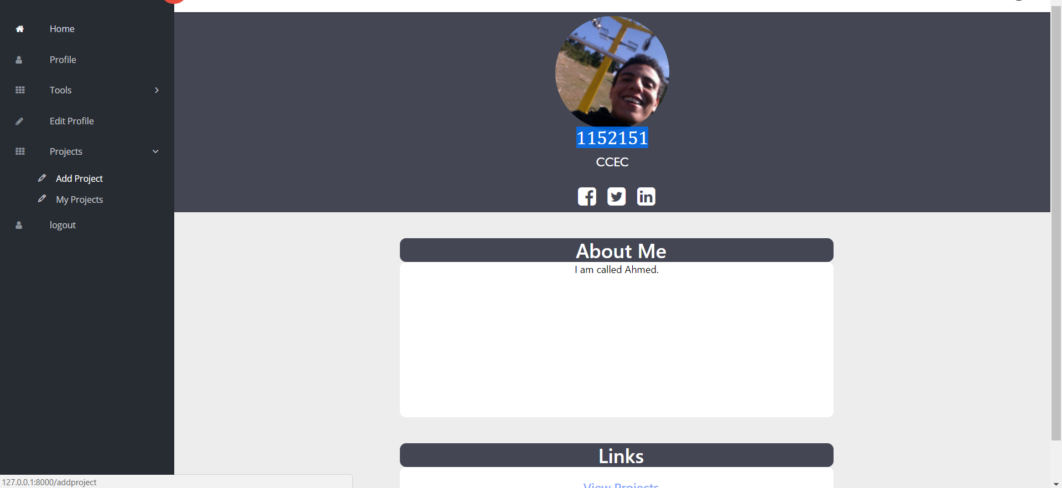

You will be redirected to a page where you can enter fields with Project name and details. You can also upload files related to the project. Then click “Add”.

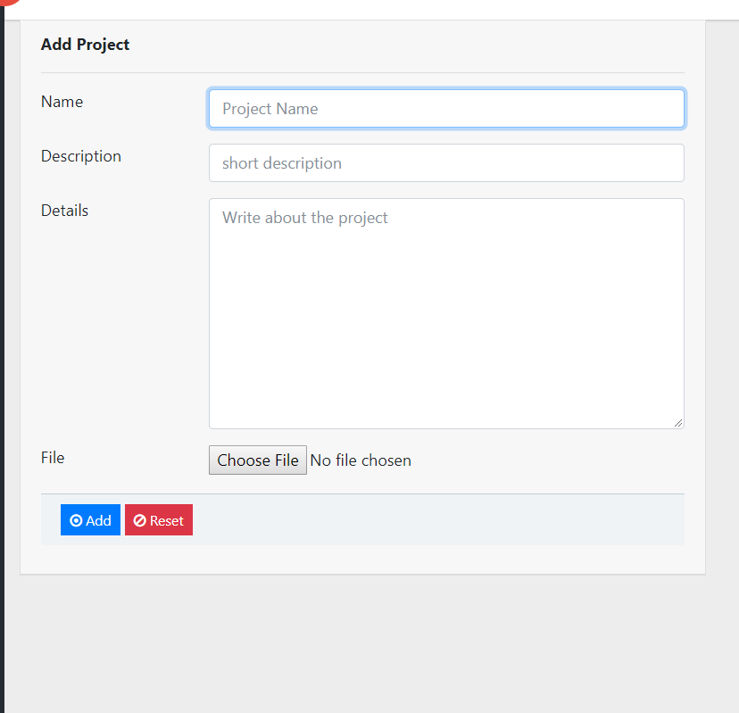

- View Projects:
From the panel, click “Projects” then choose “View Projects”.

You will be redirected to a page where you can view projects’ names and details.

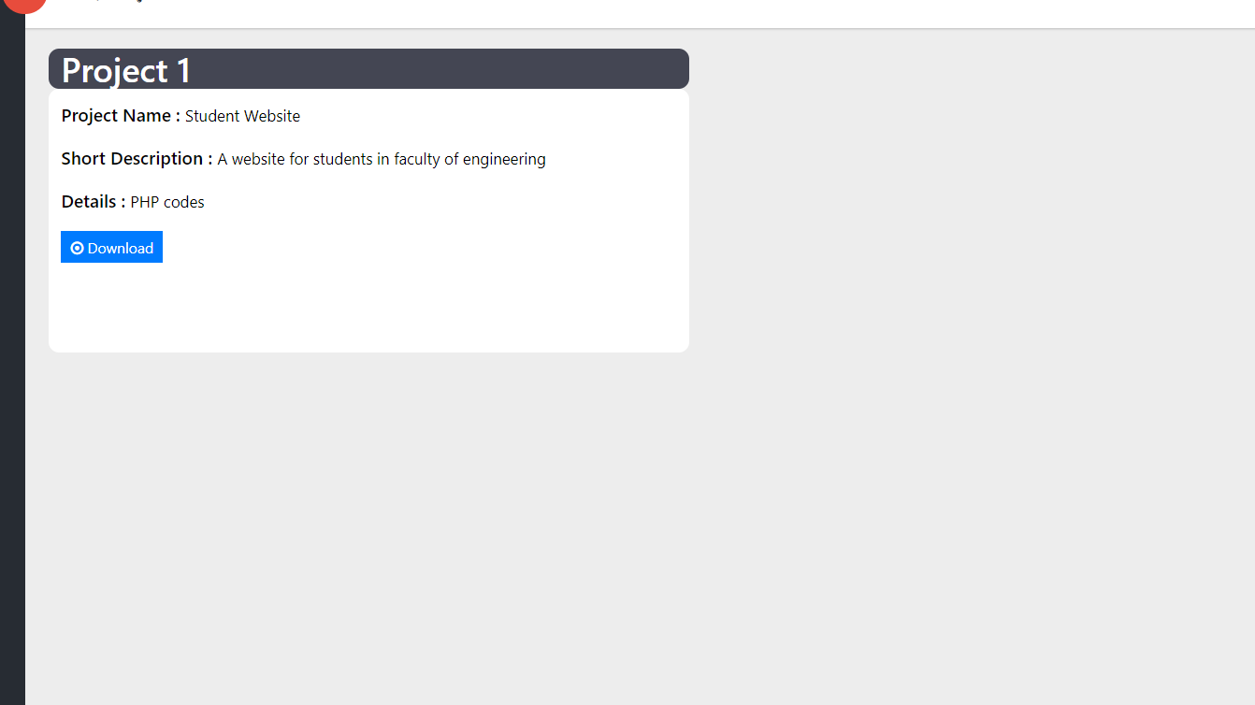

You can also download files related to the project.

- Search Users:
From Home, you can enter a specified ID in the search tab.

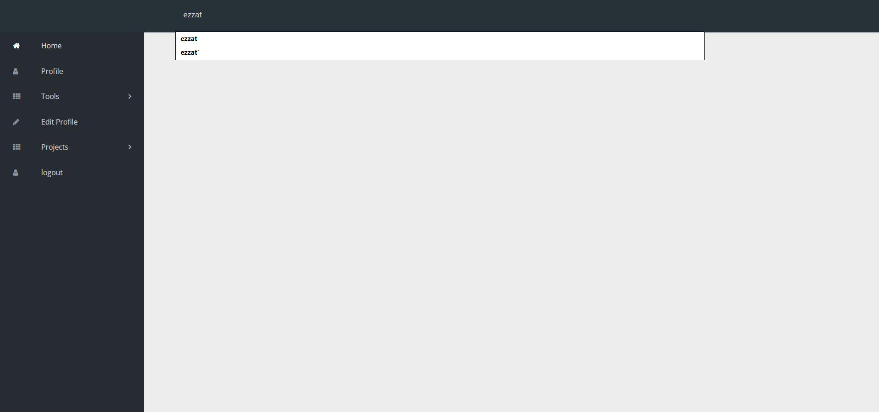

Strike Enter
A list of all possibilities will appear.

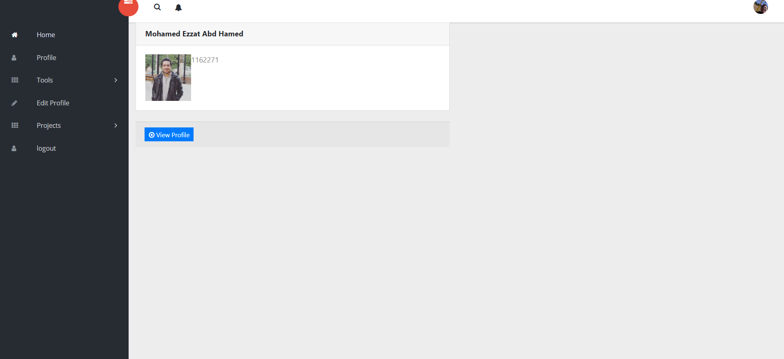

You can view the user’s profile by clicking “View Profile”.

- GPA Calculator:
From the panel, you’ll find “GPA Calculator” under “Tools”.

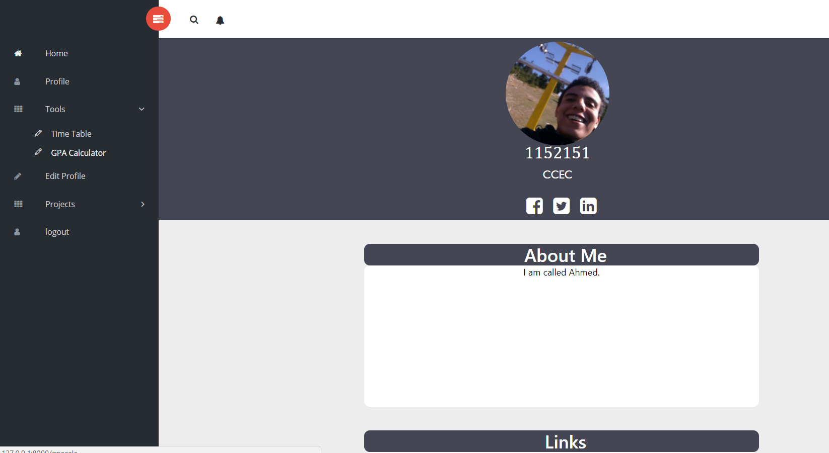
By clicking on the tool, you will find a form with Grades and Credit Hours fields so you can enter the grade you anticipate with its corresponding credit hours. Click submit.
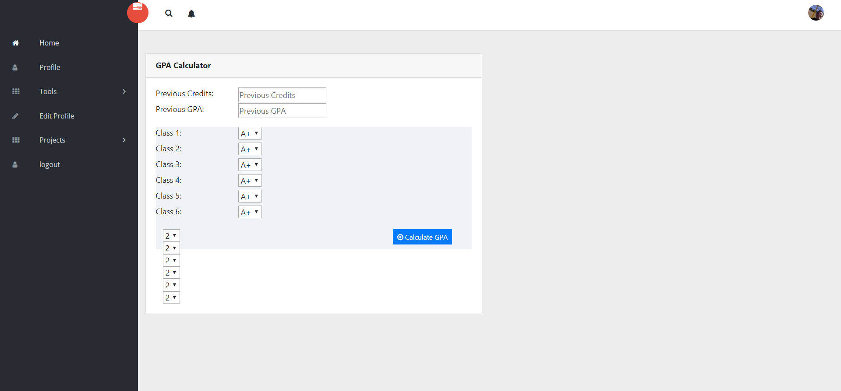

You will be directed to page with the result displayed as following.

- View Timetable:
From Tools select “Timetable”.
A list of your classes and their times will appear.
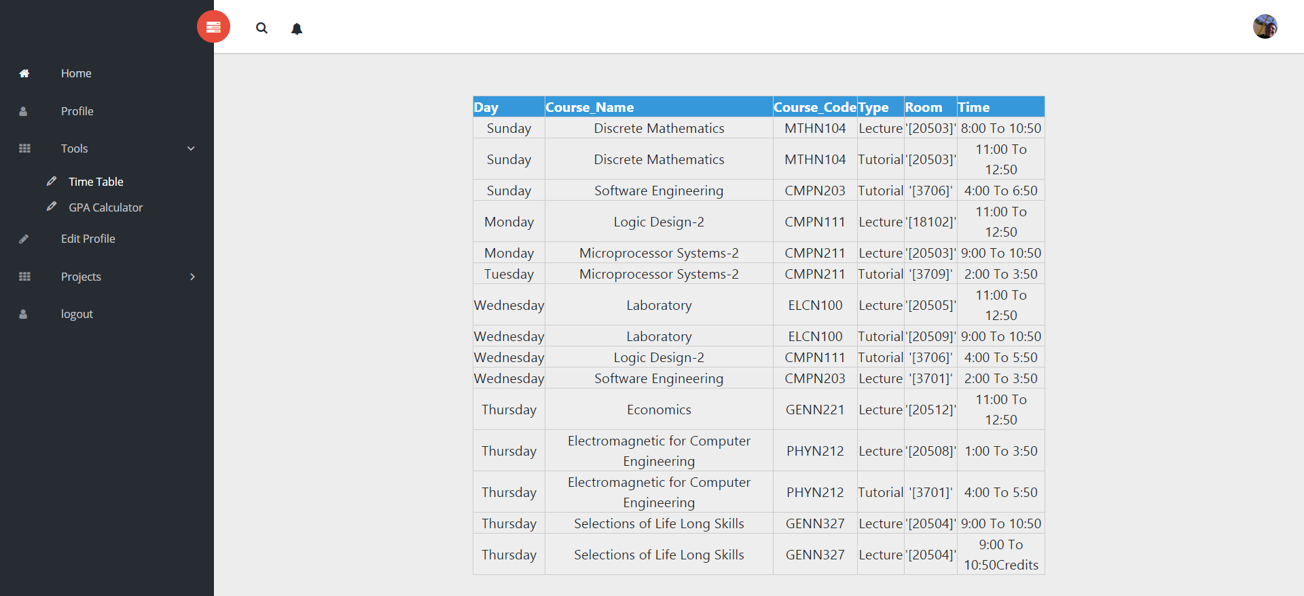

- Post on Board:
From Home, you can find the “Board” where you can type your post or add a photo.
Click Post
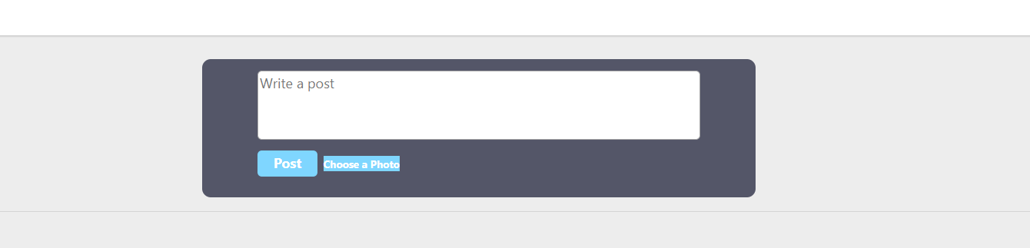

Your Post will be added to the Board after that.

- Comment on Post:
From Home, you can find the “Board” where you can type your post or add a photo.

Type in your desired comment in the comment section then click the button “Comment”

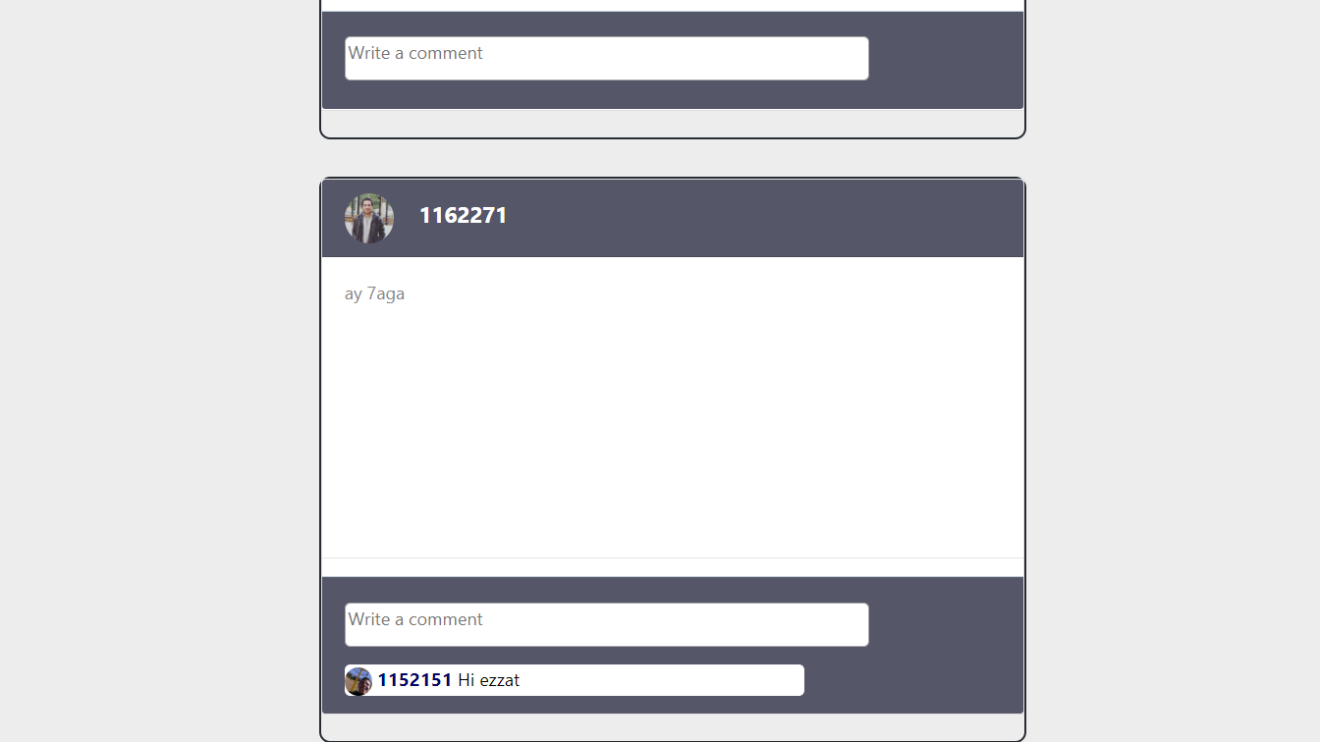

Your Comment will be added to the Post after that.

- Log out:
Finally, you can logout through the logout button.

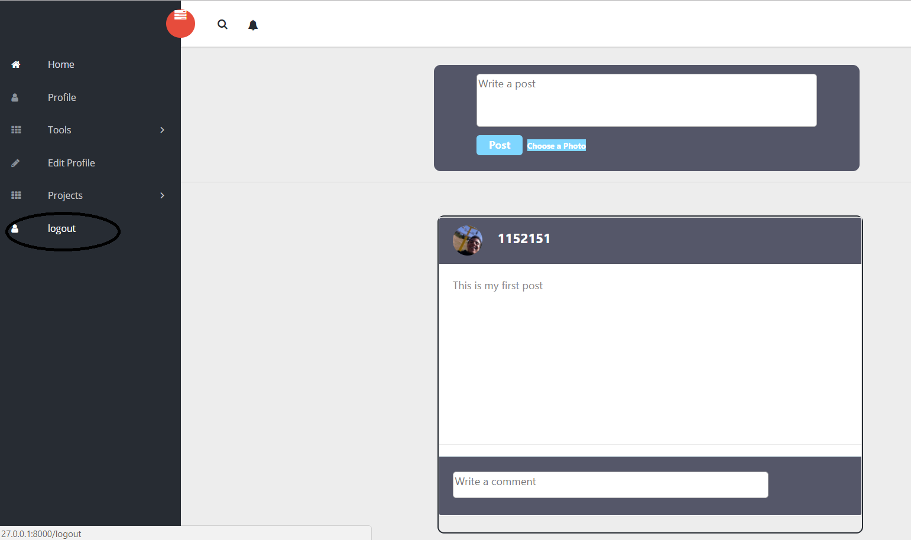

You will be redirected to the Log in page.

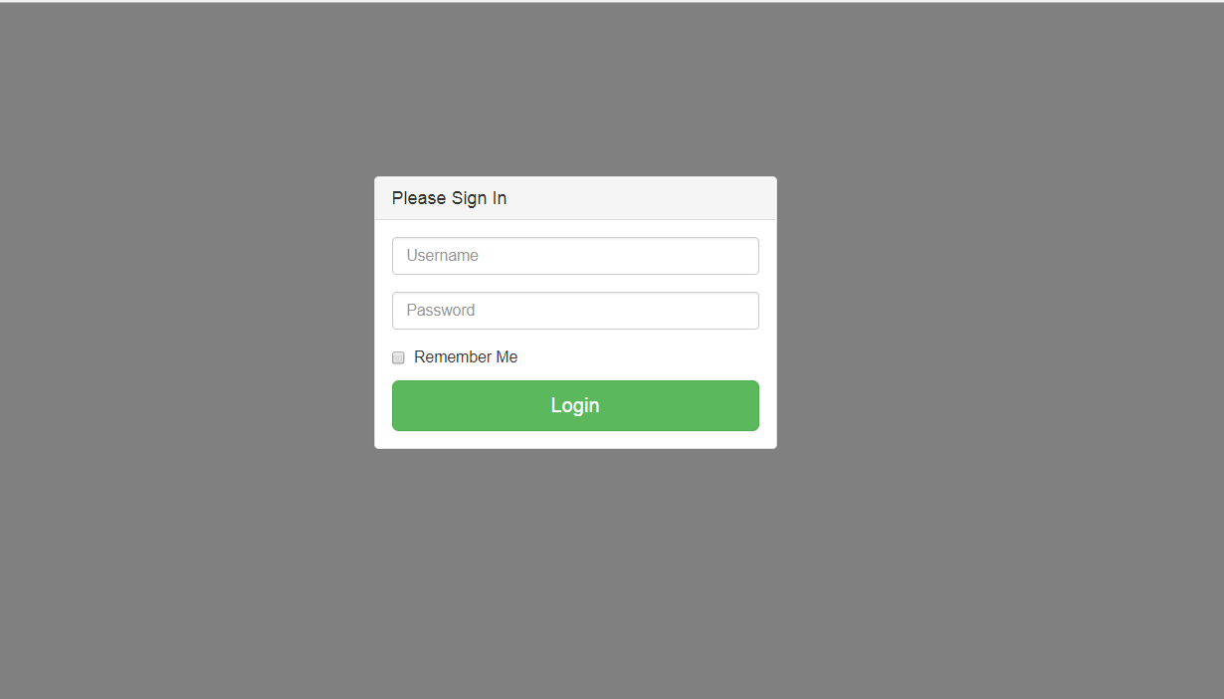

Troubleshooting
In case of not being able to log in, follow these simple steps to fix the problem right away:
- Check your internet connection. Make sure you’re connected to a stable strong internet connection.
- Check your account on Faculty’s site. If your account has been locked by the faculty you won’t be able to log in into the faculty’s site, so you can refer back to them.
- Reload page.

In case of data not being posted:
- Check your internet connection. Make sure you’re connected to a stable strong internet connection.
- If other features such as: Timetable and Personal info (Program & CV), and Log in if you tried to logout and re-login, there might be a problem with the main server. Check the main site and try again.
In case of project/photo/name not being uploaded:
- Check your internet connection. Make sure you’re connected to a stable strong internet connection.
- Site might be under maintenance. Try again later and if you still face that problem you can try contacting us, our contact info is listed below. You might find a message informing you of the error.

Points of Contact
We are here to support you!
Feel free to contact us on the following emails:
Ahmedosama9777@aol.com
Nanciie.arx@gmail.com
Your feedback is highly appreciated. Help us stay on top of our game by sending your feedback on the previous emails.

