# **CTF-7: Steganography**

I first tried to solve the problem with the traditional approach of LSB steganography trying to decode the message by concatenating the LSB of each pixel in the RGB channels, I tried to decode all the channels together and tried to decode each channel individually.

After multiple trials and workarounds, the result never made sense and it didn’t seem to have any meaning so I thought that maybe the message was encrypted as the output text from decoding seemed to be encrypted.

Also, throughout the whole process I was thinking of the **“HIDING”** key written in caps so I tried an online tool for decrypting steganographic images it asked for a password, this was the only word I had in mind so I tried it and VOILA it worked and the flag was: *Hello, the flag is CMPN{Spring2024}*

img = Image.open("pepo_evil.jpg")

width, height = img.size

msg = ''

for x in range(height):

    for y in range(width):

        r, g, b = img.getpixel((x, y))

        if r % 2 == 1:

            msg += '1'

        else:

            msg += '0'

        if g % 2 == 1:

            msg += '1'

        else:

            msg += '0'

        if b % 2 == 1:

            msg += '1'

        else:

            msg += '0'

*# Convert the message to a string*

msg = ''.join([chr(int(msg[i:i+8], 2)) for i in range(0, len(msg), 8)])

print(msg)

**Tools:**

1. [Aperi'Solve (aperisolve.com)](https://www.aperisolve.com/)
2. [Steganographic Decoder (futureboy.us)](https://futureboy.us/stegano/decinput.html)

# CTF-8: Morse Code

**Morse code** is a method used in telecommunication to encode text characters as standardized sequences of two different signal durations.

The flag in this problem was encoded using morse code and it was in the form of text after decoding the sent message using an online tool the following message was found:

THE RUSSIAN TERRORISTS ARE THE ONES WHO STARTED THIS, THEY ARE THE KEY. PLEASE YOU MUST EXTRACT ME

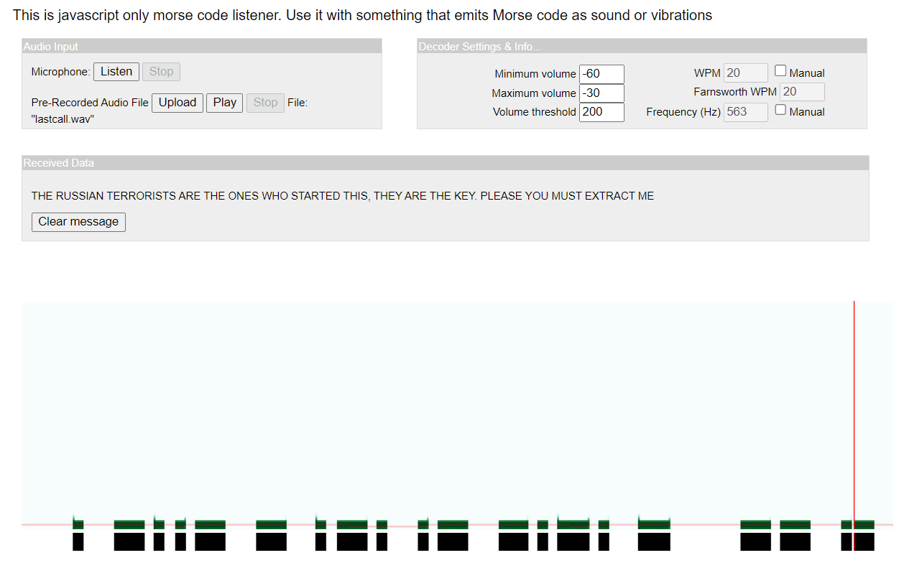

Figure CTF-8 Flag

**Tools:**

1. [DataBorder Morse Code Sound & Vibration Listener](https://databorder.com/transfer/morse-sound-receiver/)