# Lab 1: Introduction to Machine Learning and Environment Setup

## 1. Introduction

In this lab, we introduce the basics of Machine Learning (ML) and demonstrate how to set up a dedicated Python environment for ML experiments. We'll use the built-in `venv` module to create a virtual environment named `myenv_abdurrehman`, where we will install essential ML libraries.

## 2. Objectives

* Understand what Machine Learning is.
* Create an isolated virtual Python environment.
* Install foundational ML libraries such as numpy, pandas, matplotlib, and scikit-learn.
* Verify the environment setup with package installation.

## 3. Environment Setup Steps

1. Step 1: Open the Terminal of VS CODE
2. Step 2: Create a Virtual Environment

Run the following command to create a virtual environment  
`conda create -p .venv python=3.10 `

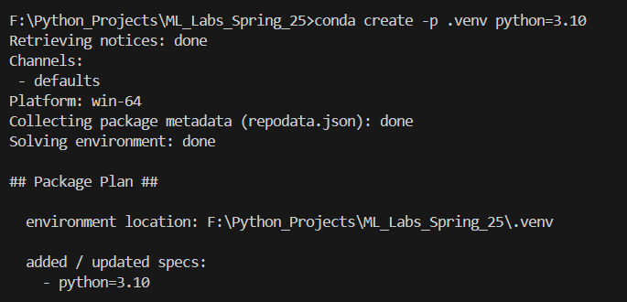

1. Step 3: Activate the Environment

Run the command below to activate the environment:  
`conda activate F:\Python_Projects\ML_Labs_Spring_25\.venv`

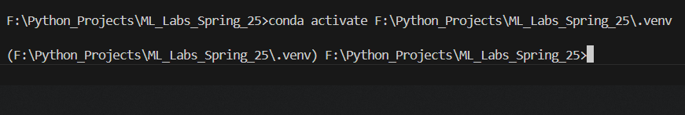

1. Step 4: Install Required Machine Learning Libraries

Use pip to install libraries:  
`pip install numpy pandas matplotlib scikit-learn`

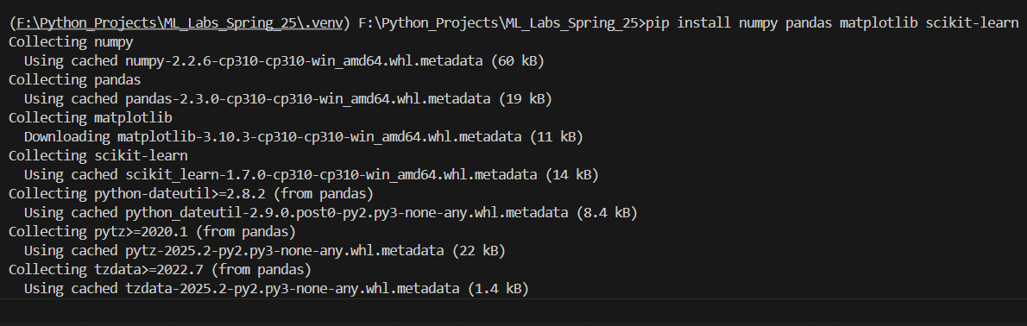

## 4. Conclusion

In this lab, you successfully created a Python virtual environment and installed key Machine Learning libraries. This setup ensures a clean, manageable, and reproducible workspace for all future ML projects.