Engineering 5865 Digital Systems
Final Exam (Winter 2004)
April 16, 2004, 9:00 – 11:30 AM EN – 1051 Instructor: Cheng Li

Part A: True / False Question 10 marks
Please indicate whether each of the following statement is true or false. One mark is given to each correct answer. No point is given to an incorrect answer or no answer.

( T F ) 1. Electromagnetic noise is caused by high voltage resources and can be mitigated by using high-μ ferromagnetic material.

( T F ) 2. Grounding is very important if the unit consists of analog and electromechanical parts.

( T F ) 3. If the propagation delay of a segment of wire is greater than the transmission time of a pulse to be sent, it can be considered to be a transmission line.

( T F ) 4. Generally speaking, the design methodology for digital hardware is bottom-up design and top-down implementation.

( T F ) 5. Redundant logic will not only help to reduce static hazard in the circuit, but also improve the circuit’s testability.

( T F ) 6. A failure is the manifestation of a fault.

( T F ) 7. As the technology migrates from 0.18 micron to 0.13 micron and beyond, interconnection delay is getting more significant relative to the standard cell delay.

( T F ) 8. Flip-flops, high gain OP amps and transducers producing low strength signals are vulnerable to noise.

( T F ) 9. One billion (10⁹) delta delays correspond to one nanosecond (10⁻⁹ ns).

( T F ) 10. Making the circuit production testable is as important as making it function correct.

Part B: Fill in Blanks 10 marks
Answer the following questions by filling in the blank to the right with the answer.

- The industry uses a metric called Failure in Time (FIT) to quantify and measure the effect of various perturbers. Give the definition of FIT
___________________________________________________

___________________________________________________
- What is the use of signal sensitivity list for process
___________________________________________________

___________________________________________________

- What is the main difference between a function and a procedure in VHDL
___________________________________________________

___________________________________________________

- What are the main differences between HDLs and software languages
___________________________________________________

___________________________________________________

Part C: Multiple Choice Questions 10 marks
For this question, please select the right answer. Each question is worth 2.5 marks.

- Among the system performance measures provided below, select the right term which is properly described by the definition:
    - The probability that the system operates correctly or capable of discontinuing its function in a manner not to disrupt operations of other systems.
__________________________
    - The probability that a failed system will be restored to an operational state within a specified period of time t.
__________________________
    - The probability that the system performance will be at, or above, some level L at the instance of time t.
__________________________
    - The conditional probability that the system will perform correctly throughout the interval [t₀, t], given that the system has been performing correctly at t₀.
__________________________
    - The probability that the system is operating correctly and is able to perform its designed function at the instant of time t.
__________________________

- Dependability
- Availability
- Safety
- Testability
- Reliability
- Maintainability
- Performability
- Observability
- Unreliability
- Recoverability
- Inability to answer

Part D: Short Answer / Calculation Questions 65 marks

- (5 marks) Sketch the curves of failure rate λ for digital hardware and software. Briefly describe their difference.

- (10 marks) Write in VHDL a dataflow description of a negative edge triggered D flip-flop which has generic parameters to specify the setup time and hold time. The two times are to be defaulted to 8 and 5 ns. If either the setup or hold times are violated, the flip-flop state should not be changed.

- (15 marks) Explain what the following VHDL code implements. Use diagrams where needed
ENTITY system IS
PORT ( in_data : IN BIT_VECTOR ( 3 DOWNTO 0 );
out_data : OUT BIT_VECTOR ( 3 DOWNTO 0 );
in_ready, out_receivedt : IN BIT;
in_received, out_ready : OUT BIT );
END system;

ARCHITECTURE behavioral OF system IS
SIGNAL buffer_full, buffer_picked : BIT := ‘0’;
SIGNAL word_buffer : BIT_VECTOR ( 15 DOWNTO 0);
BEGIN
a_talk: PROCESS ( )
VARIABLE count : INTEGER RANGE 0 TO 4 := 0;
BEGIN
WAIT UNTIL in_ready = ‘1’;
count := count + 1;
CASE count IS
WHEN 0 => NULL;
WHEN 1 => word_buffer ( 3 DOWNTO 0 ) <= in_data;
WHEN 2 => word_buffer ( 7 DOWNTO 4 ) <= in_data;
WHEN 3 => word_buffer ( 11 DOWNTO 8 ) <= in_data;
WHEN 4 => word_buffer ( 15 DOWNTO 12 ) <= in_data;
buffer_full <= ‘1’;
WAIT UNTIL buffer_picked = ‘1’;
buffer_full <= ‘0’;
count := ‘0’;
END CASE;
in_received <= ‘1’;
WAIT UNTIL in_ready = ‘0’;
in_received <= ‘0’;
END PROCESS a_talk;

b_talk: PROCESS ( )
BEGIN
IF buffer_full = ‘0’ THEN WAIT UNTIL buffer_full = ‘1’; END IF;
out_data <= word_buffer;
buffer_picked <= ‘1’;
WAIT UNTIL buffer_full = ‘0’;
buffer_picked <= ‘0’;
out_ready <= ‘1’;
WAIT UNTIL out_received = ‘1’;
out_ready <= ‘0’;
END PROCESS b_talk;

END behavioral;

------------- Write your answer here and on the next page -------------

- (15 marks) You are constructing a controller for a resistance welding machine (which uses 5000 A alternating current at 2V and 60 Hz to effect metal joining) using a displacement transducer, operational amplifiers, a microcomputer using 80C188 (operating at 25 MHz) and power transistors. Explain all measures you would take to minimize noise effect in this particular situation.

- (20 marks) Consider the following logic circuits. Determine the fewest test vectors for the following faults:
(a) Wire d SA1 (b) Wire g SA0 (c) Wire n SA0
All other wires and components are assumed to be fault free.

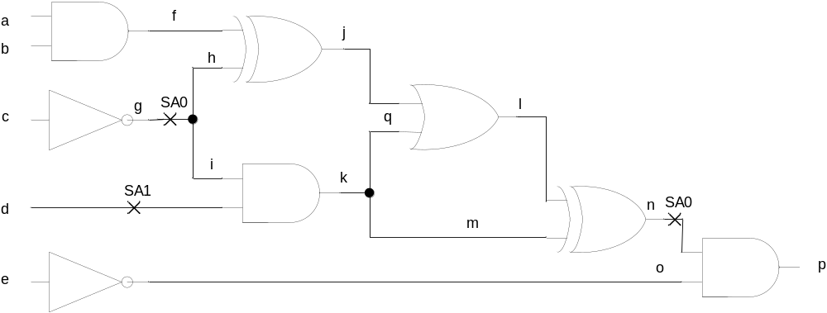

Part E Design Questions 55 marks
Question #1 [20 marks]
Using several instances of the T flip-flop and simple gates supplied below, which are available in the WORK library in dataflow architecture, design and implement a 4-bit binary up counter in VHDL. The code template is provided on next two pages. The counter should have an asynchronous RESET. The counter keeps counting when the active high input signal START is asserted. The counter should generate an active high DONE signal when a total of 10 clock cycles are counted. The entity declarations for the components are given below.
ENTITY t_ff IS PORT ( t, clk, rst : IN BIT; q, qb : OUT BIT ); END t_ff;
ENTITY and2 IS PORT ( i1, i2 : IN BIT; o1 : OUT BIT ); END and2;
ENTITY and3 IS PORT ( i1, i2, i3 : IN BIT; o1 : OUT BIT ); END and3;
ENTITY and4 IS PORT ( i1, i2, i3, i4 : IN BIT; o1 : OUT BIT ); END and4;
ENTITY or2 IS PORT ( i1, i2 : IN BIT; o1 : OUT BIT ); END or2;
ENTITY or3 IS PORT ( i1, i2, i3 : IN BIT; o1 : OUT BIT ); END or3;
ENTITY or4 IS PORT ( i1, i2, i3, i4 : IN BIT; o1 : OUT BIT ); END or4;
ENTITY xor2 IS PORT ( i1, i2 : IN BIT; o1 : OUT BIT ); END xor2;
ENTITY not1 IS PORT ( i1, i2 : IN BIT; o1 : OUT BIT ); END not1;

ENTITY counter4 IS
PORT ( reset, start, clk : IN BIT; done : OUT BIT );
END counter4;

ARCHITECTURE structural OF counter 4 IS
COMPONENT ___________ IS
PORT ( ____________________: IN BIT; __________________ : OUT BIT );
END COMPONENT;

COMPONENT ___________ IS
PORT ( ____________________: IN BIT; __________________ : OUT BIT );
END COMPONENT;

COMPONENT ___________ IS
PORT ( ____________________: IN BIT; __________________ : OUT BIT );
END COMPONENT;

COMPONENT ___________ IS
PORT ( ____________________: IN BIT; __________________ : OUT BIT );
END COMPONENT;

COMPONENT ___________ IS
PORT ( ____________________: IN BIT; __________________ : OUT BIT );
END COMPONENT;

COMPONENT ___________ IS
PORT ( ____________________: IN BIT; __________________ : OUT BIT );
END COMPONENT;

COMPONENT ___________ IS
PORT ( ____________________: IN BIT; __________________ : OUT BIT );
END COMPONENT;

_________________________________________________________________

_________________________________________________________________

_________________________________________________________________

_________________________________________________________________

_________________________________________________________________

_________________________________________________________________

_________________________________________________________________

_________________________________________________________________

_________________________________________________________________

_________________________________________________________________

_________________________________________________________________

BEGIN

c0: ____________ PORT MAP ( __________________________________ );

c1: ____________ PORT MAP ( __________________________________ );

c2: ____________ PORT MAP ( __________________________________ );

c3: ____________ PORT MAP ( __________________________________ );

c4: ____________ PORT MAP ( __________________________________ );

c5: ____________ PORT MAP ( __________________________________ );

c6: ____________ PORT MAP ( __________________________________ );

c7: ____________ PORT MAP ( __________________________________ );

c8: ____________ PORT MAP ( __________________________________ );

c9: ____________ PORT MAP ( __________________________________ );

c10: ____________ PORT MAP ( __________________________________ );

c11: ____________ PORT MAP ( __________________________________ );

c12: ____________ PORT MAP ( __________________________________ );

c13: ____________ PORT MAP ( __________________________________ );

c14: ____________ PORT MAP ( __________________________________ );

c15: ____________ PORT MAP ( __________________________________ );

_________________________________________________________________

_________________________________________________________________

_________________________________________________________________

_________________________________________________________________

END structural;
Question #2 [35 marks]
Design an 8-bit signed integer multiplier using the simple shift and add algorithm. The multiplicator and the multiplicand are represented in two’s complement form. The product from the multiplier is also required to be represented in two’s complement. Show the major components in the data path. Show the ASM chart of the control unit. You can assume that basic components such as the component which does two’s complement conversion, adder, shift register, register, FF, mux, demux, basic gates, and etc. are available for use. No VHDL code is required.

