EE 414/514
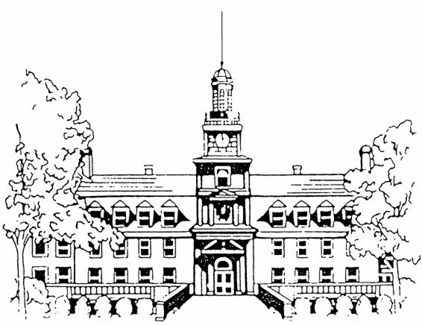
VHDL DESIGN

Dr. J.A. Starzyk

MIDTERM Tuesday, October 17, 2006

THIS IS A CLOSED BOOK EXAM

Name: Box #:

Note:
1) All scratch and problem papers must be turned in.
2) Estimated times required to complete problems are indicated.

Problem Weight Estimated Time Examiner' Use
(points) (minutes) only .
1 15 10

2 10 15

3 10 10

4 10 15

5 15 25 .

TOTAL 60 75

GOOD LUCK!!!
Problem 1

Check True or False next to each statement:

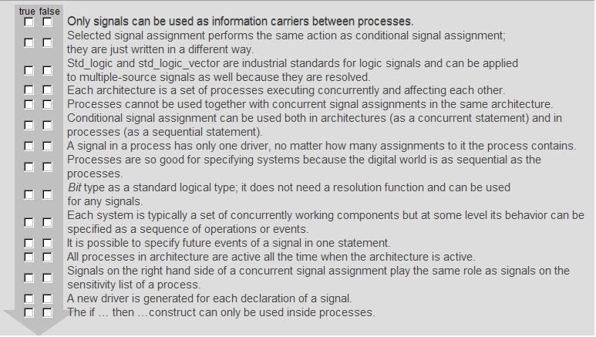

Problem 2

Correct the syntax for following VHDL code? Add missing statements, correct the syntax by writing next to the wrong statement a correct one and describe the reason why a statement is incorrect ?
The incorrect statements are marked in bold face

library IEEE;
--missing library

use IEEE.STD_LOGIC_ARITH.ALL;
use IEEE.STD_LOGIC_UNSIGNED.ALL;

entity MyInv is
port ( a : in std_logic;
a_a : in std_logic;
b_b : in std_logic;
a_1 : in std_logic_vector (2 downto 0);
b : out std_logic);
end entity;

architecture Behavioral of MyInv is
signal temp : in std_logic;

begin
p0: process (a,a_a,b)

variable temp1 : std_logic;
begin
if(a_1 ~="00") then
b <=0;
end if;
temp1 = not a and temp1;
temp = (temp1 nand a_a);
end p0;

p1:process (b_,p0)
variable temp2 : std_logic;
begin
temp2 := a_1 and b_;
temp := temp1 nand temp2;
b <= (temp2 nand temp2) and temp;

end p1;

end architecture;
Problem 3

Draw the output waveforms for the following code.

entity DELAY is
end DELAY;
architecture RTL of DELAY is
signal Clk1,Clk2,Clk3,Op1,Op2,Op3: bit;
begin
p0 : process
begin
Clk1<= '0','1' after 23ns,'0' after 28ns,'1' after 43ns,'0' after 63ns;
Clk2<='0','1' after 20ns,'0' after 25ns,'1' after 40ns,'0' after 60ns;
wait for 65ns;
end process;
p1 : process(Clk1,Clk2)
begin
Op1<=Clk1 nand Clk2 after 10 ns;
Op2<=transport Clk1 nand Clk2 after 10 ns;
end process;
Op3<=Op1 or Op2 after 5 ns;
end RTL;

Note: use the following clock waveform for your convenience

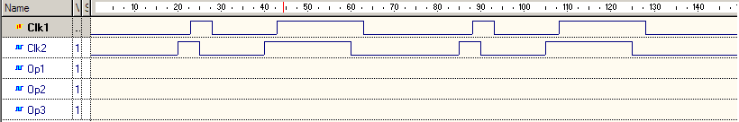

Problem 4

Draw the signal waveform for the following code. Assume that the entity sig_var is simulated with the input clock signal equal to CLK1 from the problem 3 and shown in the figure below. Use the plot on the next page.

library IEEE;
use IEEE.std_logic_1164.all;
entity sig_var is
port (
wave1 : out std_logic;
wave2 : out std_logic;
wave3 : out std_logic);
end entity;
architecture behv of sig_var is
signal inwave1,inwave2 :std_logic:='0';
signal wave4 :std_logic;
signal Clk1:std_logic;
begin
p0: process
begin
Clk1<= '0','1' after 23ns,'0' after 28ns,'1' after 43ns,'0' after 63ns;
wait for 65 ns;
end process;

proc1: process(Clk1)
begin
wave4 <= Clk1 ;
wave1<= wave4 ;
end process;

proc2: process(Clk1)
variable var_s1: std_logic;
begin
var_s1 := Clk1;
wave2 <= var_s1;
end process;
wave3 <= wave4 nand clk1;
end behv;

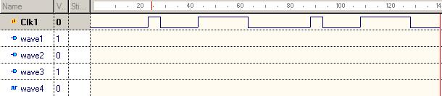

Problem 5

a) Implement the following design in structural VHDL by using component instantiation in the provided code following the figure.
b) Identify the circuit function by writing logical expression for OUT1 and OUT2?

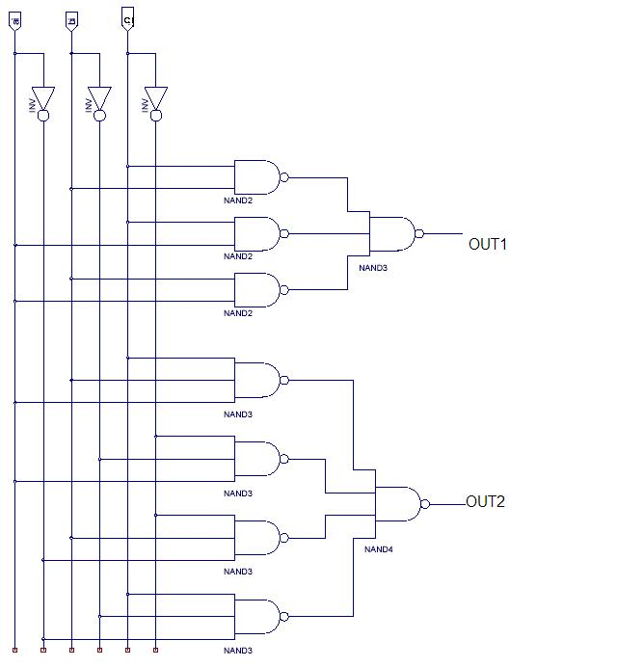

Hint: Define each gate as a component for

-----------------------------------------Inverter Component------------------------------------------
entity MyInv is
port ( a : in std_logic;
b: out std_logic );
end MyInv;

architecture RTL of MyInv is
begin
WRITE THE CODE HERE

end RTL;
-----------------------------------------Nand2 Component------------------------------------------
entity MyNand2 is
port (a: in std_logic;
b: in std_logic;
c: out std_logic );
end MyNand2;

architecture RTL of MyNand2 is
begin
WRITE THE CODE HERE

end RTL;

-----------------------------------------Nand3 Component------------------------------------------
entity MyNand3 is
port ( FILL HERE THE PORTS

);
end MyNand3;

architecture RTL of MyNand3 is
begin

d<=not(a and b and c);

end RTL;

-----------------------------------------Nand4 Component------------------------------------------
entity MyNand4 is
port ( FILL HERE THE PORTS

);
end MyNand4;
architecture RTL of MyNand4 is
begin
WRITE THE CODE HERE

end RTL;

-----------------------------------------Identify Component------------------------------------------

entity Identify is
port(
a : in std_logic;
b: in std_logic;
c: in std_logic;
Out1: out std_logic;
Out2: out std_logic);
end Identify;

architecture Behavioral of Identify is

component MyInv is
WRITE THE CODE HERE

end component;

component MyNand2 is
WRITE THE CODE HERE

end component;

component MyNand3 is
WRITE THE CODE HERE

end component;

component MyNand4
WRITE THE CODE HERE

end component;

begin
FILL IN COMPONENT INSTANTIATION

end Behavioral;

