Search for High-Mass Resonance Decaying to lepton pairs in pp Collisions at$\sqrt{s}$ = 13 TeV

S.S Abdel-Aziz¹, S. Elgammal², M. H. M. Soleiman¹, A. Qamesh^{1, 2}
*Department of Physics, faculty of science, Cairo University
²CTP,British university in Egypt

ABSTRACT
An updated search for heavy narrow resonances decaying to lepton pair (e⁺e⁻ and $μ$⁺$μ$⁻) have been performed by the CMS experiment is presented. The data set has been collected in pp collisions at$\sqrt{s}$ = 13 TeV at the LHC, with an integrated luminosity of 48 pb⁻¹ for the muon analysis and 42 pb⁻¹ for the electron analysis in 2015. The obtained mass spectrum didn’t reveal any evidence for Ź$⟶μ$⁺$μ$⁻ and Ź$⟶$ e⁺e⁻ productions.

INTRODUCTION

Even though the Standard Model(SM) comprises a wide range of physics and has proven to be successful in explaining many experimental results, it does not include gravity or explain the predominance of matter over anti-matter in the universe. Also, there is no candidate for dark matter in the theory. Dark matter makes up about 26% of all the matter in the universe, whereas known matter only contributes by 4% of the content of the Universe ⁽¹⁾. Many models of physics beyond the Standard Model have been introduced to solve these problems. A simple and eligible way of extending the SM gauge structure is to include an additional U(1) group, this requires an associated neutral gauge boson, labeled as Ź ⁽²⁻⁴⁾. One of the oldest (and simplest) gauge theories was introduced by H. Georgi and S.L. Glashow, in 1974 ⁽⁵⁾. Claiming that the minimal simple group which can contain the SM gauge groups is SU(5) which analogous to Isospin, and corresponds to a rotation in an internal space of five dimensions. (I.e. $SU\left(5\right)⊇ S{U(3)}_{C}×{S{U(2)}_{L}×U(1)}_{Y}$, where SU(3)_{C} is the gauge group of the strong interaction). Sequential SM (SSM) includes a neutral gauge boson
Ź_{SSM} with the same couplings to quarks and leptons as the Standard model Z boson, only it is heavier. This model is not gauge invariant, but it serves as a useful reference when comparing constraints from various sources, and is a benchmark in experimental Ź searches at the Large Hadron collider. Other models, such as the superstring-inspired E₆ model ⁽⁶⁾, have more complex group structure, this model invokes two extra U(1)/ symmetries that occur through the decomposition ⁽⁷⁾.
$E_{6}⊇ SO\left(10\right)×{U\left(1\right)}_{ψ}⊇ SU(5)×{{U\left(1\right)}_{χ}×U\left(1\right)}_{ψ}$ (1)
Where $SO\left(10\right)$ is the next simple Lie group, which contains $SU\left(5\right)$ with an additional ${U\left(1\right)}_{χ}$ group (i.e. $SO\left(10\right)⊇ SU(5)×{U\left(1\right)}_{χ}$) with a corresponding neutral gauge boson denoted as $Ź_{ψ}$, so $E_{6}$ will be
$E_{6}⊇ SO(10)×{U(1)}_{ψ}⊇ S{U(3)}_{C}×{S{U(2)}_{L}×U(1)}_{Y}×$ $U(1)$/ (2)
In the present work, a search for heavy resonances that decay into pairs of muons and electrons have been studied using a sample of proton-proton collisions at $\sqrt{s}$ = 13 TeV recorded by the Compact Muon Solenoid (CMS) detector at the Large Hadron Collider (LHC) during the first period of Run2 in 2015.This study is an extension of a previous analysis done by CMS dilepton group at $\sqrt{s}$ = 8 TeV at the LHC in 2012 ⁽⁸⁾, with an integrated luminosity of 20.6 fb⁻¹ The analysis in 2012 excludes at 95 % confidence level, a Sequential Standard Model Ź_{SSM} resonance lighter than 2770 GeV and a superstring-inspired $Ź_{ψ}$ lighter than 2430 GeV.
We start in section 1 by a brief review about the basic components of CMS detector, then in section 2 we give in details the main features of the selection used to identify the high p_{T} muons in Run2, while in section 3 we give the selections used to identify the electrons, then in section 4 we introduce the Expected background. Section 5 includes the invariant mass plots for data and background for both $μ$⁺$μ$⁻ and $e^{+}$ $e^{-}$ and finally the conclusion.

THE CMS EXPERIMENT

The main functions of the Compact Muon Solenoid (CMS experiment)⁽⁹⁾ are to identify and measure precisely the energy and direction of photons, electrons, muons and tau leptons, to measure the energy and the direction of jets, and to provide hermetic coverage for measuring missing transverse energy. In addition, good efficiency for photon and lepton identification as well as excellent background rejection against hadrons and jets are Achieved. At the heart of CMS sits a13 m long, 5.9 m Inner diameter, 4T superconducting solenoid. Within the field volume are the silicon pixel and strip tracker, the lead-tungstate (PbWO₄) crystal electromagnetic calorimeter (ECAL), and the brass/scintillator hadron calorimeter (HCAL). Muons are measured with detection planes made using three technologies: drift tubes (DT), cathode strip chambers (CSC), and resistive plate chambers (RPC). Extensive forward calorimetry complements the coverage provided by the barrel and endcap detectors. The coordinate system adopted by CMS has the origin centered at the nominal collision point inside the experiment, the y-axis pointing vertically upward, and the x-axis pointing radially inward toward the center of the LHC. Thus, the z-axis points along the beam direction, the azimuthal angle is measured from the x-axis in the x-y plane. The polar angle $θ$ is measured from the z-axis. Pseudorapidity is defined as $η=-ln⁡[tan⁡(θ/2)$].
Thus, the momentum and energy measured transverse to the beam direction, denoted by p_{T} and E_{T} respectively, are computed from the x and y components. The imbalance of energy measured in the transverse plane is denoted by$E_{T}^{miss}$and muons are measured within |$η$ |< 2.4. A more detailed description of the CMS detector can be found in the CMS technical design report ⁽¹⁰⁾.

MUON IDENTIFICATION AND EVENT SELECTION

The event selection criteria for Run2 is almost the same as the criteria that have been suggested in 2012 analysis using a fully compatible set of cuts, which are used as a criteria for muon identification ⁽⁸⁾. The efficiency of this identification set depends on the strength of these cuts. These identification criteria are applied on the muon candidates, and on the background.

The event selection criteria for each single muon
- To avoid events from beam backgrounds, we filter out events in which less than a quarter of the tracks in the silicon tracker are marked as being of high purity.
- The primary vertex must be located within |r|<2 cm and |z|<24 cm of the nominal interaction point (IP). This cut is particularly useful in rejecting cosmic ray muons triggering in empty bunch crossings, which can produce fake dimuons when traversing the detector near the IP.
- The relative $P_{T}$error ${{δP}_{T}}/{P_{T}}$is required to be less than 0.3, to suppress misreconstructed muons ⁽¹¹⁾.
- The moon’s transverse impact parameter with respect to the primary vertex, as measured by the tracker-only fit, must be less than 0.2 cm.
- The muon must be reconstructed as a “global” muon and a “tracker” muon, to avoid using muons, which are only Standalone Muons.
- The transverse momentum of a single muon must be at least 48 GeV, so as to be in the plateau of the single muon trigger efficiency.
- To choose the best track from tracker track to combine with stand-alone muon tracks, another cut applied by comparing the track separation in $η-ϕ$, this process is referred as track matching, where a quantity $∆R=\sqrt{{(∆η)}^{2}+{(∆ϕ)}^{2}}$is adjusted to be less than 0.3, where $∆η$ is equals $η_{Gen}-η_{Reco}$ ($η_{Reco}$ is the pseudorapidity of the reconstructed track, $η_{Gen}$is the pseudorapidity of the generated muon with respect to the interaction point in the tracker system), and $∆ϕ$ is equals $ϕ_{Gen}-ϕ_{Reco}$ ($ϕ_{Reco}$is the azimuthal angle of the reconstructed track, $ϕ_{Gen}$is the azimuthal angle of the generated muon with respect to the interaction point in the tracker system.).The cut on $∆R$ < 0.3 helps to distinguish isolated muons from the muons embedded in jets.
- The muon must pass a relative tracker-only isolation cut. That is; the sum of the p_{T} of all other tracks in a cone of $∆R$ < 0.3 around but not including the muon’s tracker track must be less than 10% of the muon’s p_{T} measured by the tracker. Tracks have to be within $∆z$ = 0.2 cm of the primary vertex with which the muon candidate is associated to be used in the calculation of the tracker isolation.
- The global muon track must have at least 6 tracker layers with hits in the fit, to guarantee a good p_{T} measurement, for which some minimal number of measurement points in the tracker is needed, and suppresses muons from decays in flight.
- The global muon track fit must include at least one hit from each of the pixel detector and the muon system. To further suppress muons from decays in flight.
- The tracker muon must be matched to segments in at least two muon stations.

The event selection criteria to form a dimuon
- We take two muons of opposite charge that pass the above selection criteria.
- In events with more than one opposite-sign dimuon, a tiny fraction of the entire sample, we keep only the one with the highest invariant mass.
- We perform a fit to a common vertex (using the Kalman filter formulation as implemented in CMSSW) to compute the kinematics of the dimuon system, particularly its invariant mass. This also serves to ensure that the two muons originate from the same vertex. As a guard against pile-up and as a check on reconstruction quality, we explicitly require that the vertex fit has $χ^{2}/d.o.f <$ 10. To reduce the background coming from cosmic ray muons that are in-time with the collision event and pass the primary vertex and impact parameter cuts, we require that the three-dimensional angle between the two muons’ momenta be less than $π-{0.02}^{rad}$.

ELECRON IDENTIFICATION AND EVENT SELECTION

The event selection criteria for Run2 to identify $e^{+}$ $e^{-}$pairs have been designed to get rid of the jet background. In order to discriminate the $e^{+}$ $e^{-}$ pairs of heavy resonances from jets, the event selection depends basically in the shower shape and isolation criteria, the new selections in Run2 is recommended by HEEP V6.0, it is an update of a previous selections in the same analysis at 8 TeV ⁽¹²⁾. A more detailed information about these selections is included in the references ⁽¹³⁻¹⁴⁾.
The electron identification criteria have been designed and mainly divided into 4 types of categories: Kinematic conditions, track matching conditions, Shower shape conditions, Isolation conditions.

Kinematic conditions
- The pesudorapidity $η_{sc}$ of the super cluster based on its position in the calorimeter with respect to 0,0,0.
- The transverse energy E_{T} of the GSF electron candidates, it is computed as the GSF energy of the electron candidate times $\sin{θ}$ where $θ$is the polar angle of the GSF electron candidate position in the ECAL with respect to the vertex position. A very tight on the transverse energy E_{T} is applied to identify two electron candidates coming from the hard interaction from the possible estimated background, and to eliminate the contribution of the underlying events produced from the soft interactions.
- An electron is classified as either golden (=0), big brem (=10), narrow (=20), showering =3$χ$ (where $χ$ is the number of clusters in the supercluster) or in $η$ cracks (=40). For electrons in the endcap, 100 is added to the classification code. High-energy electron ID does not make use of this classification scheme, except to distinguish between barrel and endcap electrons and, for barrel, to reject electrons in the 6 mm wide inter-modules cracks, with a cut of 0.036 in $η$.
Track matching conditions
- ${∆η}_{in}$ is the difference in $η$ between the track position as measured in inner layer, extrapolated to the interaction vertex and then extrapolated to the calorimeter and the $η$ of the supercluster (${∆η}_{sc}$).
- ${∆ϕ}_{in}$ is The difference in $ϕ$ between the track position as measured in inner layer, extrapolated to the interaction vertex and then extrapolated to the calorimeter and the $ϕ$ of the supercluster (${∆ϕ}_{sc}$).

Shower shape conditions
- $σ_{ηη}$ is defined by
$σ_{ηη}=\sum_{i}^{5×5}{ω_{i}}(η_{i}-{\overline{η}}_{5×5})/ \sum_{i}^{5×5}{ω_{i}}$ (3)
Where the index i runs over all the crystals in a $5×5$ matrix of crystals centered on the seed crystal, $η_{i}$ is the $η$ position of i^{th} crystal, ${\overline{η}}_{5×5}$ is the energy weighted mean $η$ of the $5×5$ block of crystals and $ω_{i}$ is weighted of the i^{th} crystal and is defined as
$ω_{i}=4.2+\ln{(E_{i}/E_{5×5})}$ (4)
Where $E_{i}$ and $E_{5×5}$are the energy of the i^{th} and $5×5$ block of crystal respectively.
- $E^{1×5}$and $E^{5×5}$ variables are defined as the fraction of deposited energy in the $5×5$ crystal matrix entered on the seed crystal, which is deposited in the $ϕ$ strip of the 5 crystals centered on the seed, or on the two highest energy $ϕ$ strips, respectively. These two variables are used in the barrel region.
- $σ_{iηiη}$ is the spread in $η$ of the energy deposited in the $5×5$ crystal matrix entered on the seed crystal, the cut on $σ_{iηiη}$ is used only in the endcap region and comparing to $σ_{ηη}$variable, the cut based on $σ_{iηiη}$ improves the performance around the cracks.
Isolation conditions
- $H/E={E_{HCAL}}/{E_{ECAL}}$ :It is the ratio of the deposits $E_{HCAL}$and $E_{ECAL}$ in the HCAL and ECAL calorimeters, respectively, ${ E}_{HCAL}$ being computed from the energy deposits in the HCAL within a cone of Radius ${∆R}_{Cone}=\sqrt{{\left({∆η}_{in}\right)}^{2}+{\left({∆ϕ}_{in}\right)}^{2}}$<0.1 around the HCAL supercluster direction. The ratio of hadronic to electromagnetic energy of an electron is used to discriminate election and jet, since at low energies, electrons will be fully contained in the electromagnetic calorimeter (ECAL) and deposit very little energy in the hadronic calorimeter (HCAL), while at high energies electrons will deposit most of the energy in the ECAL and the rest will contained in the HCAL.
- ECAL isolation (EM Isol.): The ECAL isolation variable E_{t} (ECAL iso) is the sum of the transverse energies, which are deposited in the ECAL of all rec-hits with energy noise cut contained in a cone of radius R=0.3 around the barycenter of the supercluster in the calorimeter excluding towers inside an inner cone of radius (R=0.045 in the barrel) and (R=0.070 in the endcap) or within an $η$ strip of $±$ 0.02.
- HCAL isolation (Had. Isol.): The HCAL isolation variable is the sum of the transverse hadronic energies of all the HCAL towers (with energy noise cut) in a cone of 0.03 radius centered on the electron supercluster position, excluding rec-hits in a cone of 0.15 radius.
- Track isolation (Tracker Isol.): Three important variables are defined as the following
- Number of isolated tracks N_{tr}: the number of tracks with p_{T} >1.5 GeV/c in a cone of 0.2 radius in $∆R$, in ($η$, $ϕ$) plane, entered on the electron’s track position at the primary vertex excluding tracks within an inner cone of 0.02 in $∆R$ to avoid including tracks of electrons from hard interaction, This avoids the complication due to severe external bremsstrahlung, photon conversion, and early showering in the tracker material. Tracks are required to have a dz to be within 0.1 of the elections track, where dz is defined as vertex position of the track as measured in the inner layer with respect to 0, 0, 0.
- Track pt: is the sum of the transverse momenta of the isolated tracks reconstructed with p_{T}>1.5 GeV/c.
- Track R_{PT}: is the sum of the transverse momenta of the isolated tracks reconstructed with p_{T}>1.5 GeV/c to the transverse momentum of the electron candidate E_{T}.
$R_{PT}=|\sum{\vec{p_{T}}|/E_{T}}$ (5)
The criteria applied on reconstructed electron candidates are designed to ensure high efficiencies for high-energy electrons, rejecting the QCD background. High Energy electrons are selected within the tracker acceptance (|$η$ |<2.4) using the criteria summarized in table 1.

Table 1: The selection criteria as recommended by HEEP electron selection V6.0
Variable | Barrel | Endcap
E_{T} | >35 GeV | >35 GeV
$η$ range | |$η|<$ 1.4442 | 1.566<|$η|<$ 2.5
Classification | =1 | =1
$${∆η}_{in}$$ | ${∆η}_{in}<$ 0.004 | ${∆η}_{in}<$ 0.006
$${∆ϕ}_{in}$$ | ${∆ϕ}_{in}<$ 0.06 | ${∆ϕ}_{in}<$ 0.06
H/E | n/a | < 0.03
$E^{2×5}$/$E^{5×5}$ | >0.94 or $E^{1×5}$/$E^{5×5}$ > 0.83 | n/a
EM+Has Depth 1 isolation | <$2+0.03×E_{T}+0.28×ρ$ | $<2.5+0.28×ρ$ for E_{T} <50  $<2.5+0.03×(E_{T}-50)+0.28×ρ$ elsewhere
Track Isol: Trk P_{T} | < 5 | < 5
Inner Layer Lost Hits | <= 1 | <= 1
|dxy| | < 0.02 | < 0.05

EXPECTED BACKGROUND

The dominant irreducible background to the dimuon signal comes from the Drell–Yan dimuon production, while the largest background following the Drell–Yan production comes from $t\overline{t}$ decays. The estimated calculations for the expected relative background rates from different processes using MC samples at $\sqrt{s}$ = 8 TeV shows that the $t\overline{t}$background rate represent 13 % of the total background expected ⁽¹³⁾. Processes that are $t\overline{t}$ like, where most of the time, both muons come from the same collision vertex rather than from heavy-flavor decay (e.g. Single top tW, dibosons, and Z$→ττ$) contribute another 5%. Dimuons in which one or both muons are missidentified or non-prompt, arising mostly from W+jets and multi-jet QCD processes, are expected to contribute less than 1%. Another type of background is coming from cosmic ray muons traversing the center of the detector that are reconstructed as pairs of muons of opposite sign. The rate of these events is not straightforward to model and depends significantly on the event selection during the analysis. The background estimation have been obtained for $t\overline{t}$ and $t\overline{t}$-like lepton-flavor symmetric backgrounds using the “$eμ$” method, in which the number of dimuon events is estimated from the electron-muon dilepton spectrum, as done by the high-energy electron pairs (HEEP) group ⁽¹⁵⁾, the other sources of backgrounds are studied by the Muon group in CMS collaboration based on the MonteCarlo simulation in the signal region ⁽¹⁶⁾ and they are summarized below:
- For dibosons and other charge-symmetric sources of prompt muons, examining the same-sign dimuon spectrum checks the agreement between data and simulation.
- For the background from jets, the rate is estimated from data, using events that fail isolation and identification cuts.
- For dimuons from cosmic ray events, studied by examining events rejected by anti-cosmics cuts, such as the transverse impact parameter cut.

Background from $t\overline{t}$ and other sources of prompt leptons using $eμ$ events
In order to demonstrate that the MonteCarlo simulation is a good representation of the data and backgrounds, we use the $eμ$ method in which the number of dimuon events is estimated from the electron-muon dilepton spectrum, as pioneered in CMS by the high-energy electron pairs (HEEP) group. The electron-muon events are selected such that the first object is a muon passing the high p_{T} muon identification criteria, and the second object is an electron passing the HEEP V5.1 selection (optimized for 25 ns). Both leptons are required to have p_{T} > 35 GeV, and the invariant mass of the opposite-sign pairs has to exceed 60 GeV. This method has been used to estimate the contributions from any process with two real leptons in the final state (i.e. $xy→μμ$) The dominant dilepton background in the tail of the $M_{μμ}$ distribution is due to fully leptonic $t\overline{t}$ decays, with smaller contributions from diboson such as (WW, WZ, ZZ) and tW, $\overline{t}$W productions. In the Z peak region, Z$→ττ$decays also contribute. The estimated number of events could be inferred directly from data using dilepton events with different lepton flavours, such as one electron and one muon ($eμ$ events), coming from the decays. The event kinematics is identical to those of dimuon decays so that, when correcting for the differences in acceptance and selection efficiencies between muons and electrons, the number of selected $eμ$ events should be twice that of $μμ$ events. There are two important corrections to go from this “generator level” to what we observe in the reconstructed dimuon and electron muon mass spectra, electrons and muons have different geometrical acceptances and also different reconstructions efficiencies and there are sources of reconstructed dimuons which have not been considered yet, for example those where one or both muons come from a jet. The first correction will be performed by taking into account the acceptance and the efficiency. The other correction is estimated through the fake rate method. This effect could be minimized by applying a tight cut on the angular distance between the two flavours $ΔR$<0.15. Since high energetic muons can produce bremsstrahlung and an associated super-cluster in the ECAL in the direction of the muon’s inner track, the selected muons can lead to fake electron candidates. Therefore, an electron veto is applied such that if there is a global muon with p_{T}>5 GeV within $ΔR$ <0.1of the electron.

Jet background estimation from data
Another contribution to the background comes from objects that are falsely identified as fake muons. The principal source of such background is the misidentification of jets as muons. The estimate of this type of background is based on the Fake Rate technique where the “fake rate” (FR) is defined as the number of muon objects passing high p_{T} muon ID over the number muon objects passing the fake rate pre-selection presented in table 2. This fake rate is derived from a sample of single muons. The difficulty in estimating the fake rate is that the single-muon sample has a large contamination from electroweak sources, such as W, Z and $t\overline{t}$ decays. We correct for the sample contamination due to electroweak sources based on the single-muon composition-fraction predictions from simulation.

Table 2: The selection criteria for the starting point of the fake rate calculation.
Variable | Cut value
|Z|  |dxy|  Nb. of Tracker Layer with Measurement  Nb. of Valid Pixel Hits | < 1.0  < 1.2  > 5  > 0

To estimate the QCD dijet background contribution, the fake rate estimated with respect to p_{T} and $η$ is applied to a sample of dimuons in which both muons fail to pass the full high p_{T} muon ID, and passing the fake rate pre-selection criteria given in table 2, then these events are further weighted twice by ”W=FR/(1-FR)”.
To estimate the W+jet background contribution, the fake rate is applied to a sample of di-muons in which one muon passes and the other fails the isolation criteria. These events are further weighted once by ”W=FR/(1-FR)”. The sample has a contamination from Drell–Yan and $t\overline{t}$ events, which is large at low $M_{μμ}$ and gets smaller as the mass increases. The contamination rate is evaluated using simulation, and subtracted from data. In order to avoid double counting, we also subtract the QCD dijet contribution estimated using the data-driven method discussed above.

RESULTS AND DISCUSSIONS
Dimuon invariant mass spectrum
The mass spectra in Figure 1 shows the opposite-sign dimuon invariant masses using data corresponding to an integrated luminosity of 48 pb⁻¹ with the overlaid predicted background in the SPRING 15 Monte Carlo datasets. The predicted background includes; Drell-Yan, $t\overline{t}$, single-top production in the tW channel (including $\overline{t}$W), diboson production ZZ + WZ+WW, and W+jet$→μμ$. The single-top production in the s and t-channels gives much smaller contribution compared to tW-channel ⁽⁸⁾ . The observed and the expected spectra are in agreement, as it is illustrated in the cumulative distribution shown in figure 2.
The measured $μ$⁺$μ$⁻ invariant mass spectra in figures 1 and 2 are found in agreement with the background from the standard model at this integrated luminosity of 48 pb⁻¹ with no evidence for any new observed heavy resonance.
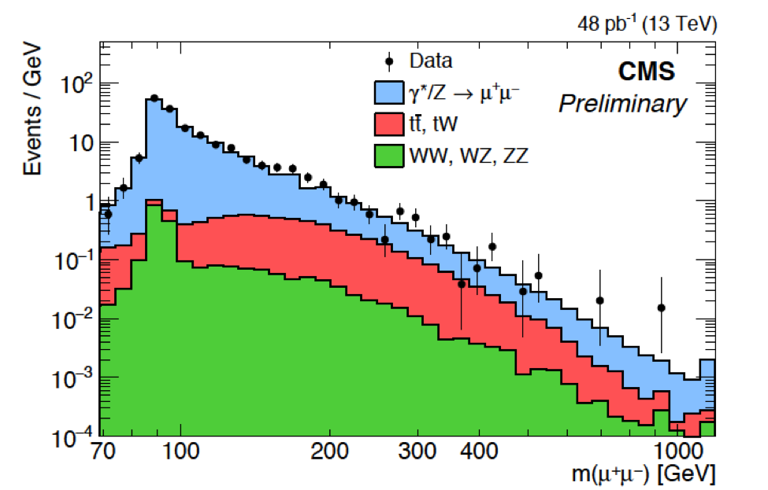
Figure 1: The opposite-sign dimuon invariant mass spectrum as predicted by Data and Monte Carlo datasets.
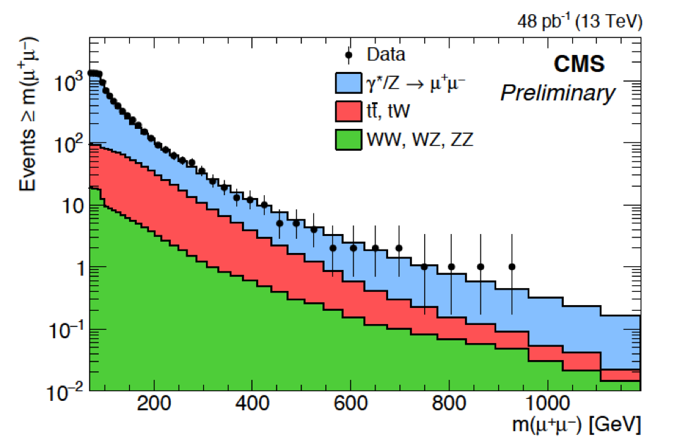
Figure 2: The cumulative distribution for the opposite-sign dimuon invariant mass spectrum as predicted by Data and Monte Carlo datasets.
Dielectron invariant mass spectrum
The observed mass spectra in Figure 3 shows the opposite-sign dielectron invariant masses using data corresponding to an integrated luminosity of 42 pb⁻¹ with the overlaid on the background predicted by the SPRING 15 Monte Carlo datasets: Drell-Yan, $t\overline{t}$, single-top production in the tW channel (including $\overline{t}$W), diboson production ZZ+WZ+WW, and W+jet$→μμ$. The single-top production in the s and t-channels gives much smaller contribution compared to tW-channel (as it was also in the Run1 analysis). The observed and the expected spectra are good in agreement, as is illustrated in the cumulative distribution shown in figure 4.
The measured e⁺e⁻ invariant mass spectra in figures 3 and 4 are found to be in agreement with expectations from the standard model at the integrated luminosity of 42 pb⁻¹ with no evidence for any new observed heavy resonance.

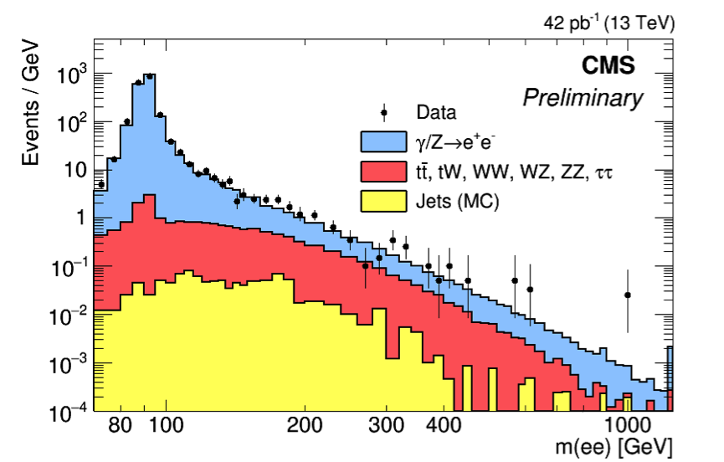
Figure 3: The opposite-sign dielectron invariant mass spectrum as predicted by Data and Monte Carlo datasets.
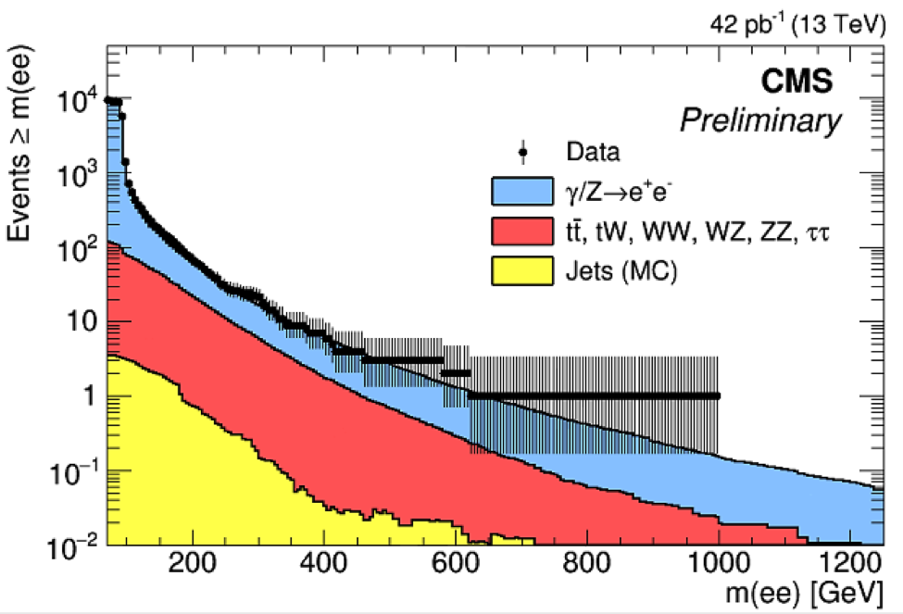
Figure 4: The cumulative distribution for the opposite-sign dielectron invariant mass spectrum as predicted by Data and Monte Carlo datasets.

CONCLUSION

The observed mass spectra didn’t reveal any evidence for Ź$⟶μ$⁺$μ$⁻ and Ź$⟶$ e⁺e⁻ productions.
A search for new high-mass narrow resonances decaying to dilepton pairs has been presented. It is based upon data samples corresponding to an integrated luminosity of 48 pb⁻¹ and 42 pb⁻¹ for both muons and electrons respectively collected at a center-of-mass energy of $\sqrt{s}$ = 13 TeV in 2015. Both the $μ$⁺$μ$⁻ and e⁺e⁻ invariant mass spectra have been found in agreement with the expectations from the standard model. These results have been announced and discussed in the LHCP conference 31 Aug-5 Sep 2015, Saint Petersburg (Russian Federation) ⁽¹⁷⁾ .

References
- Tara Shears, The standard model, Phil. Trans. R. Soc, (2012).
- P. Langacker, “The physics of heavy Ź gauge bosons”, Rev. Mod. Phys. 81 (2009) 1199, doi: 10.1103/Rev ModPhys.81.1199.
- A. Like, “The phenomenology of extra neutral gauge bosons”, Phys. Rept. 317 (1999) 143, doi: 10.1016/S0370-1573 (98) 00133-1.
- M. Cvetic and S. Godfrey, “Discovery and identification of extra gauge bosons in Electroweak Symmetry Breaking and New Physics at the TeV Scale” . World Scientific, (1995).
- Howard Georgi and S. L. Glashow, Phys. Rev. Lett, 32, 438, “Unity of All Elementary-Particle Forces”, (1974).
- J. L. Hewett and T. G. Rizzo, “Low-energy phenomenology of superstring inspired E(6) models”, Phys. Rept. 183 (1989) 193, doi:10.1016/0370-1573(89)90071-9.
- J. C. Collins and D. E. Soper, (Phys. Rev) D 16, 2219,Angular distribution of dileptons in high-energy hadron collisions, (1977).
- G. Alverson et al., “Search for High-Mass Resonances Decaying to Muon Pairs in pp Collisions at $\sqrt{s}$ = 8TeV”, CMS AN 2012/422 (2012).
- CMS Collaboration, “Technical design report“, volume 1:Detector performance and software, CERN LHC (2006).
- CMS Collaboration, “The CMS experiment at the CERN LHC”. JINST 3 S08004 (2008).
- Muon POG, Baseline muon selections for Run I, (https://twiki.cern.ch/twiki/bin/view/CMSPublic SWGuideMuonId).
- CMS Collaboration, “Search for physics beyond the standard model in dilepton mass spectra in proton-proton collisions at $\sqrt{s}$ = 8TeV ”. JHEP 04 025, doi: 10.1007/arXiv: 1412.6302 (2015).
- D. Evans et al., CMS Collaboration, “Search for high mass resonance production decaying into an electron pair in the CMS experiment”, CMS PAS EXO 2008-001 (2008).
- S. Bafoni et al., “Electron Reconstruction in CMS”, CMS NOTE 2006-040.
- D. Bandurin et al., “Study of Backgrounds to High-Mass Di-Electron (Drell–Yan) Final States”, CMS AN 2008/044, LHCC 2000-038, Vol.I, 200 (2008).
- CMC collaboration, “Strategy for High-Mass Resonances Decaying to Muon Pairs at$\sqrt{s}$ = 13TeV in Preparation of the Run2”, CMS AN-15-061S (2015).
- The 3rd Annual Large Hadron Collider Physics Conference (LHCP2015), Corinthia Hotel, St. Petersburg, CMS: First look at 13 TeV and highlights from the most recent analyses, SPAGNOLO, Paolo [https://indico.cern.ch/event/389531/session/3/contribution/1] (2015).

To whom correspondence should be addressed; E-mail: sayed\_saleh\_ssa@yahoo.com
E₆ is a linear Lie group of rank 6. In grand unification theories, E₆ appears as a possible gauge group which, after its breaking, gives rise to the $S{U(3)}_{C}×{S{U(2)}_{L}×U(1)}_{Y}$ gauge group.

