# Assignment 2

**CS 223 # Introduction to Database Systems**

|  |  |  |  |
| --- | --- | --- | --- |
| Announced Date: 28h May, 2020 | Due Date: 2nd Jul, 2020 | | Total Marks = 04 |
|  |  | Marks Obtained = | |

Lecturer Name: Mr. Afzal Hussain

**INSTRUCTION:**

* Report must be submitted using Arial font style with size of 11pt and 1.5 line spacing.
* Submit soft / hardcopy of report.
* Submit hardcopy personally to the Course / Module Leader of Database Systems.
* Ensure that your report is well organized and well structure.
* Plagiarism is STRICTLY PROHIBITED.
* Late submission will NOT be entertained and marks will be deducted.

**Question:** Draw an ER diagram for the following description. Illustrate the **entities**, **relationship, connectivity, attributes, Primary and Foreign Key**.

ABC Company has decided to store information about musicians who perform on its albums (as well as other company data) in a database. The company has hired you as a database designer to create ER model for the given requirements.

Each musician that records at ABC Company has an SSN, a name, an address, and a phone number. Each instrument used in songs recorded at Grooves has a unique identification number, a name (e.g., guitar, synthesizer, flute) and a musical key (e.g., C, B-flat, E-flat). Each album recorded on the Grooves label has a unique identification number, a title, a copyright date, a format (e.g., CD or MC), and an album identifier. Each song recorded at Grooves has a song identification number, title, an author and track’s duration. Each musician may play several instruments, and a given instrument may be played by several musicians. Each album has a number of songs on it, but no song may appear on more than one album. Each song is performed by one or more musicians, and a musician may perform a number of songs. Each album has exactly one musician who acts as its producer. A musician may produce several albums, of course.

**Answer:**

**Entities:**

Musician =>

Attributes => SSN, name, address, phone => PK => SSN

Instrument =>

Attributes => unique_identification_number, name, musical key =>

Primary Key => U_ID

Songs =>

Attributes => Song identification number, title, author, track's duration =>

Primary Key => S_ID

Foreign Key => album_identifier

Album =>

Attributes => unique_identification_number, title, copyright date, format , album identifier

Primary Key => U_ID

Foreign Key => SSN

**Cardinality constraint:**

musician -- many to many -- instrument

album --- one to many --- songs

song -- many to many -- musician

musician -- one to many -- album

**Relation Ship:**

musician -- can play -- instrument

album --- has --- songs

song -- composes -- musician

musician -- produces -- album

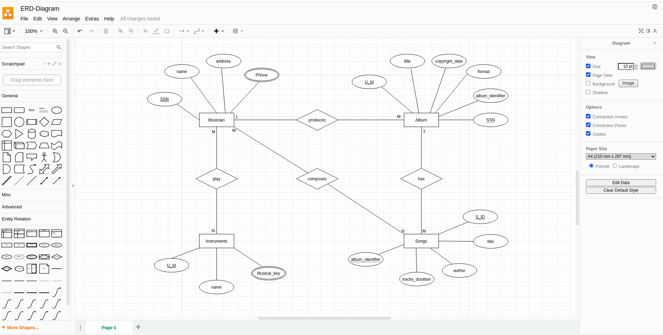

---------xXx---------