For the typical **University Course Registration System**, you have to:

* 1. Draw the**Use Case**Diagram

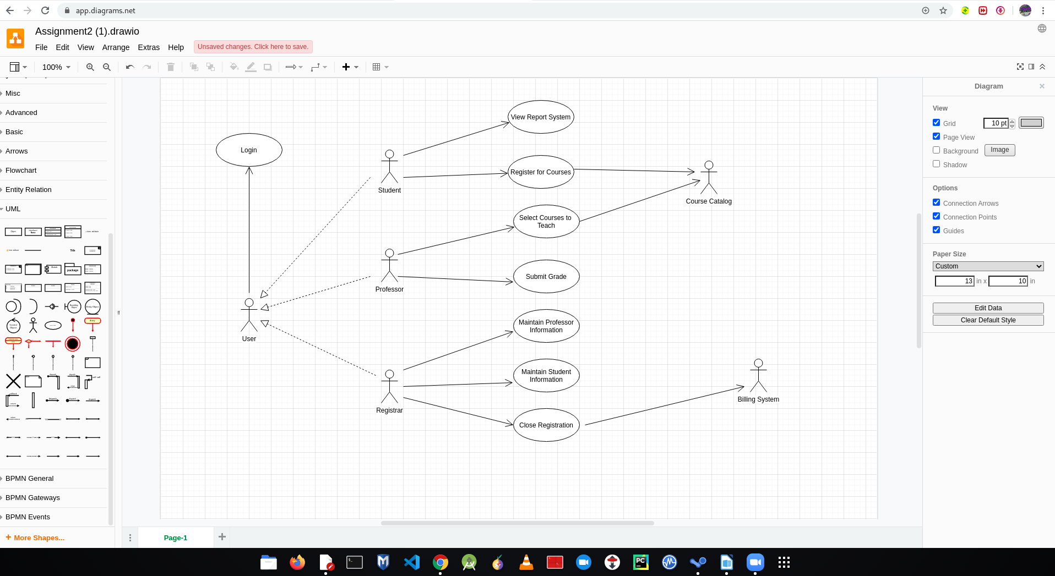

For the typical **University Course Registration System**, you have to:

* 1. Draw the **class** Diagram

