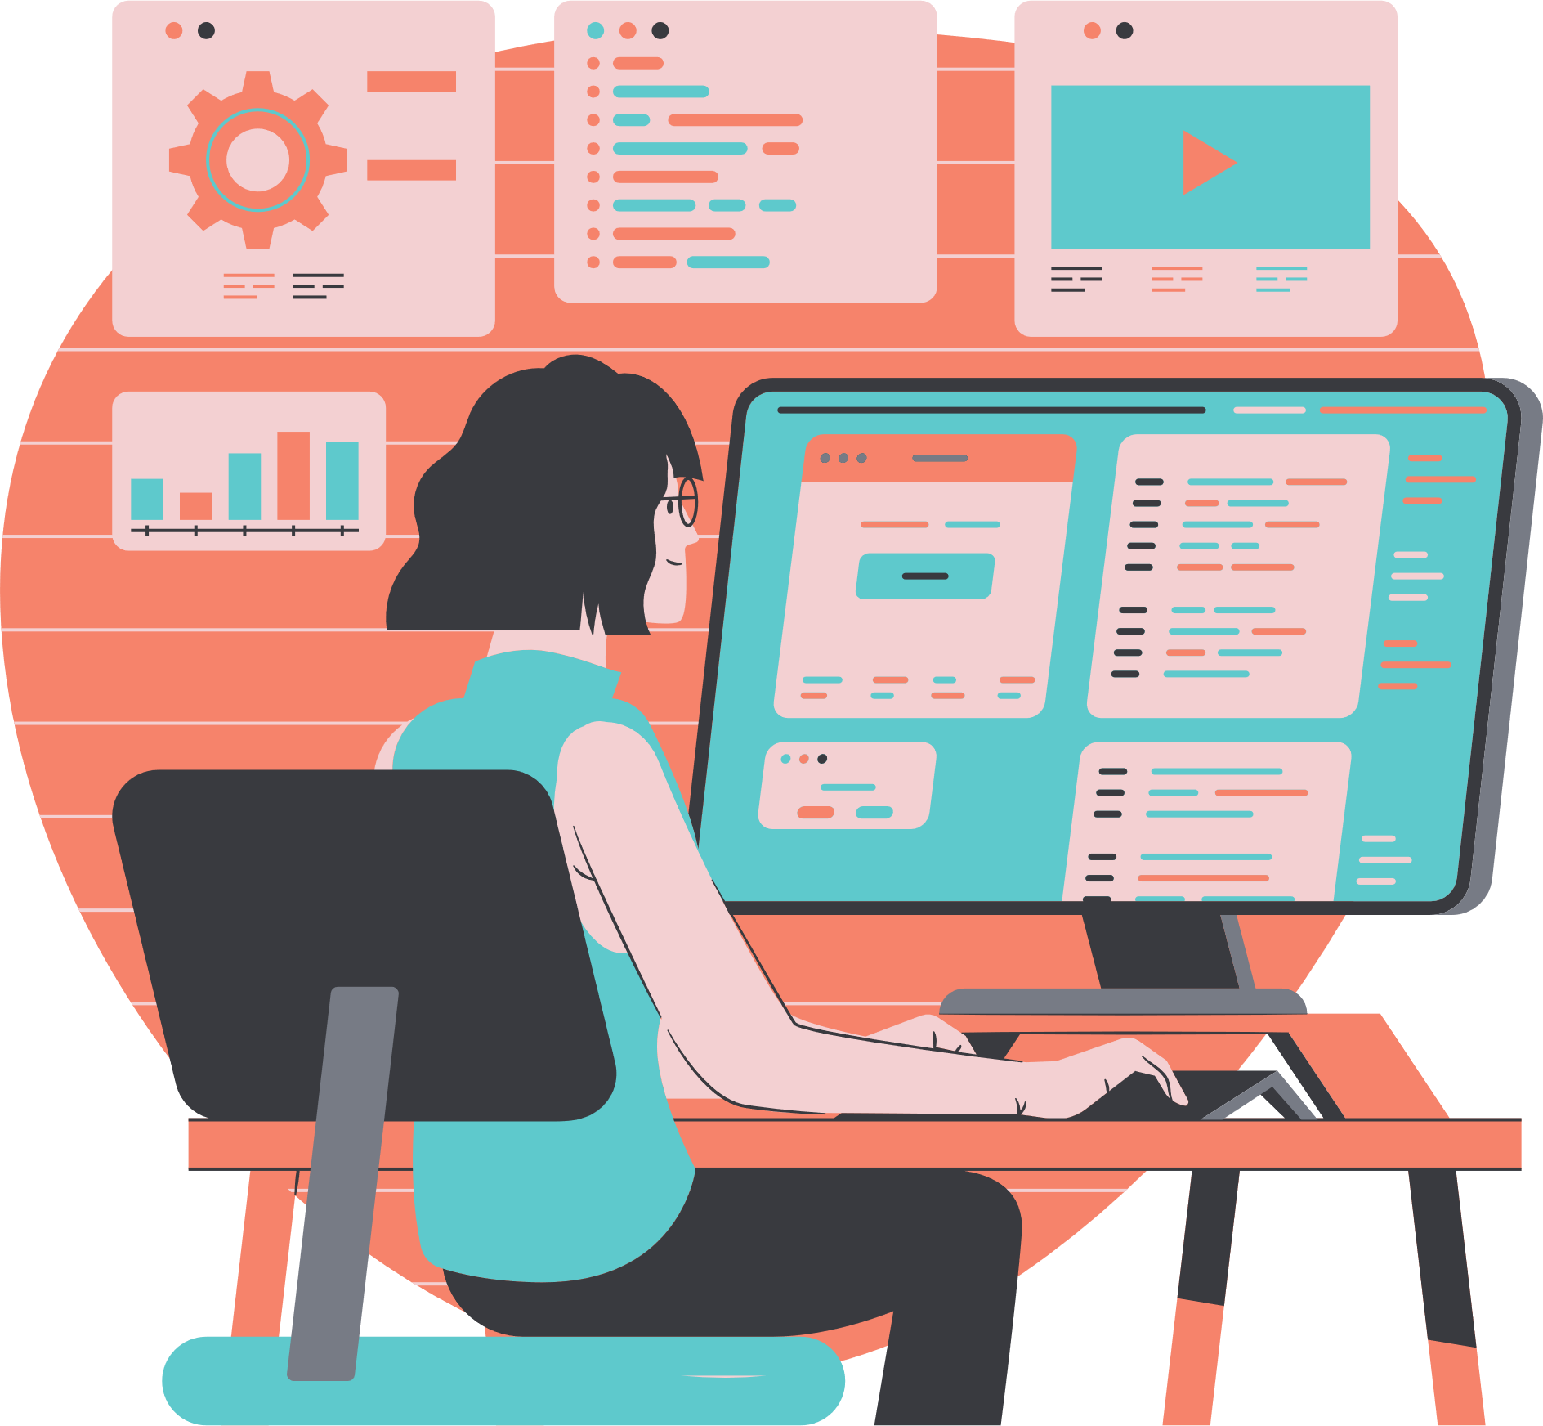

Design

Start

Error?

Coding

Testing

Design error?

End

Yes

No

Yes

No

**SOFTWARE**

**PROCESS MAP**