Lab3 - Ubuntu
Created by: Ahmed Sobhi El said Sharaf

Part 1:

13. Create a folder called myteam in your home directory and change its permissions to read only for the owner.

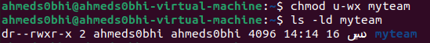

14.Log out and log in by another user

15. Try to access (by cd command) the folder (myteam)

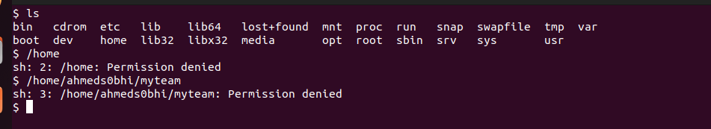
In case of log in with another user;
In case of switching;

16. Using the command Line
* Change the permissions of oldpasswd file to give owner read and write permissions and for group write and execute and execute only for the others (using chmod in 2 different ways)

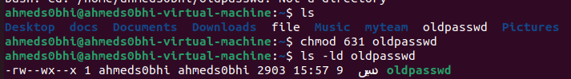

* Change your default permissions to be as above.

* What is the maximum permission a file can have, by default when it is just created? And what is that for directory.

Maximum permission for file by default is ( rw- rw- rw-)
Read and write without execute , 666

Maximum permission for directory by default is ( rwx rwx rwx)
Read, write and execute, 777

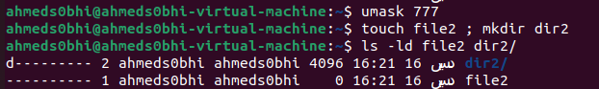
* Change your default permissions to be no permission to everyone then create a directory and a file to verify.

17. What are the minimum permission needed for:
* Copy a directory (permission for source directory and permissions for target parent directory)
The source directory: at least has read and write permission.
The target directory: at least has read and write permission.

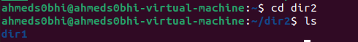

* Copy a file (permission for source file and and permission for target parent directory)
The source file: No permission needed.
The target directory: at least has read and write permission.

* Delete a file
To delete a file requires write permission on the file for unrestricted deletion.
and write/execute permission on the directory.
If there is no write permission on the file, override is requested.
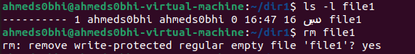

* Change to a directory
The minimum permission for change to a directory is the execution permission.
* List a directory content (ls command)
The minimum permission for list directory content is the read and execute permissions.

* View a file content (more/cat command)
The minimum permission for view file content is the read permission.

* Modify a file content
The minimum permission for modify is the write permission.

18. Create a file with permission 444. Try to edit in it and to remove it? Note what happened.

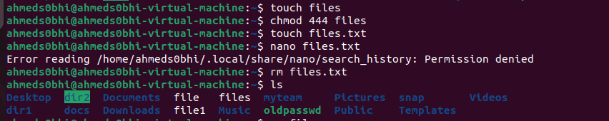

19. What is the difference between the “x” permission for a file and for a directory?

Execute in files: means the right to execute them, if they are programs , Files that aren`t programs should have no execute permission.

Execute in directories: allow you to enter the directory and access to the files inside it (e.g you can use cd)

Part 2:

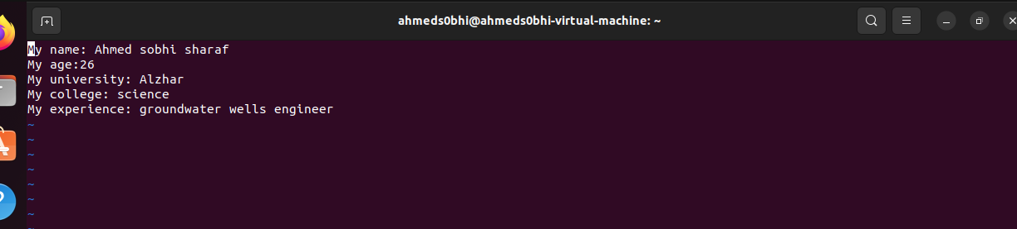
1. Using vi write your CV in the file mycv. Your CV should include your name, age, school, college, experience,...

2. Open mycv file using vi command then: Without using arrows state how to:
a. Move the cursor down one line at time.
Using (J) on the keyboard

b. Move the cursor up one line at time.
Using (k) on the keyboard

c. Search for word age
Using (:/age)
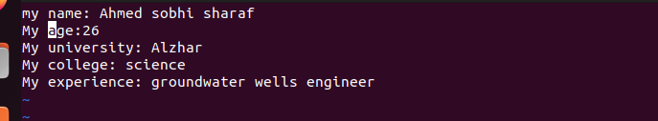

d. Step to line 5 (assuming that you are in line 1 and file is more than 5 lines).
Using (:5)

e. Delete the line you are on and line 5.

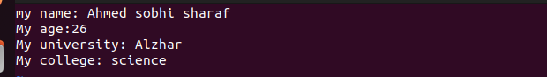

f. How to step to the end of line and change to writing mode in one-step.
Using (A) which append text to the end of the line

3. List the available shells in your system.
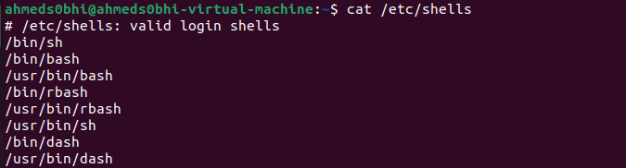

4. List the environment variables in your current shell.
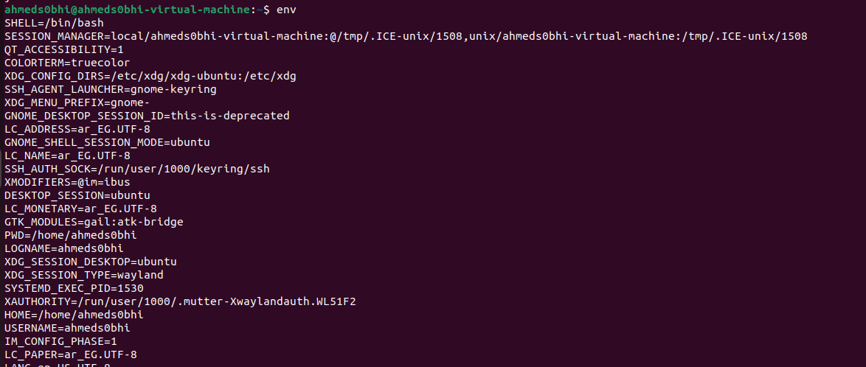
Using the (env) and (printenv) command

5. List all of the environment variables for the bash shell.

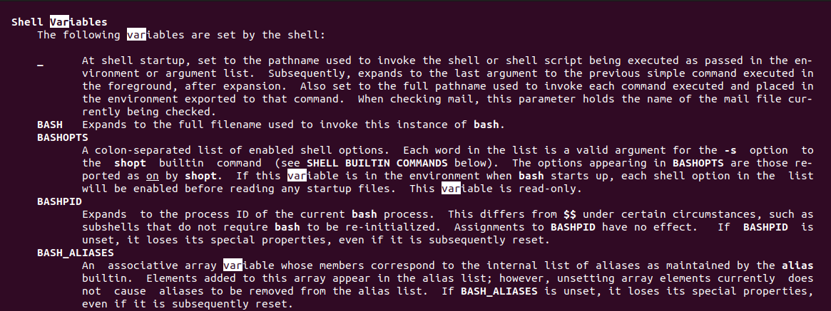
Using the (man bash) and we can search about (/var) to find the shell environment

6. What are the commands that list the value of a specific variable?

(Echo) $ variable_name
(Printenv) varirable_name

7. Display your current shell name.

8. State the initialization files of: sh, ksh, bash.
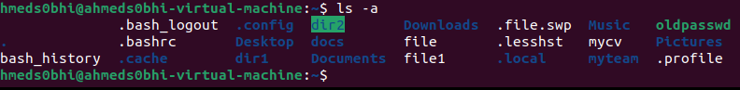
~/.profile

9. Edit in your profile to display date at login and change your prompt permanently.

First : Using (vi $HOME/.bashrc)
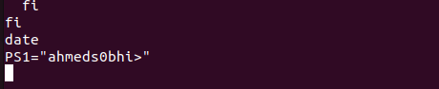

Close the terminal and opens it again

10. Execute the following command :
echo \ then press enter


What is the purpose of \ ?
It created a new line to tell the shell the current line is continuous for the previous

Notice the prompt ”>” what is that? and how can you change it from “>” to “:”.

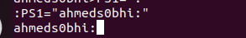
It is continuous prompt that waiting for continuous command

11. Create a Bash shell alias named ls for the “ls –l” command
