Lab5 - Ubuntu
Created by: Ahmed Sobhi El said Sharaf
1. Compress a file by compress, gzip, zip commands and decompress it again. State the differences between compress and gzip commands.
Compressing and decompressing a file using (compress& uncompress)
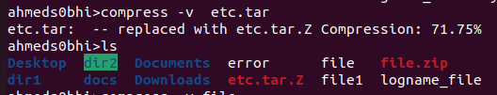

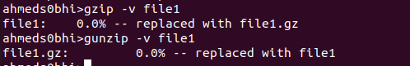
Compressing and decompressing a file using (gzip & gunzip)

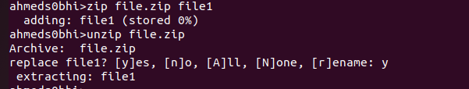
Compressing and decompressing a file using (zip & unzip)

The difference between the gzip and compress is gzip is modern than compress so it reduces the files better than compress with high percentage
2. What is the command used to view the content of a compressed file.
For compress command : zcat file_name.Z (if the file is text)
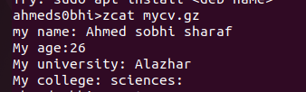
For gzip command : zcat file_name.gz

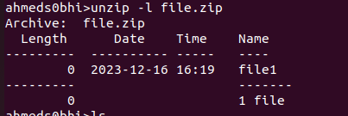
For zip command: unzip -l file_name.zip

3. Backup /etc directory using tar utility.
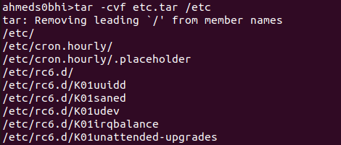

4. Starting from your home directory, find all files that were modified in the last two day.
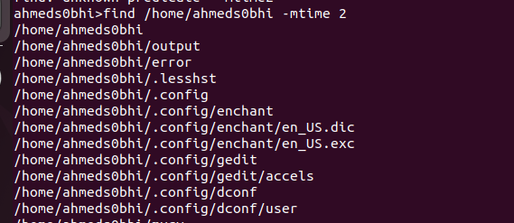

5. Starting from /etc, find files owned by root user.
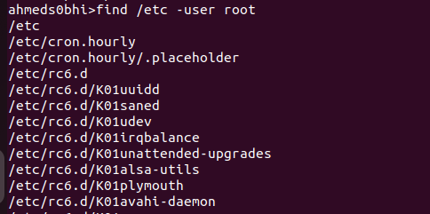

6. Find all directories in your home directory.
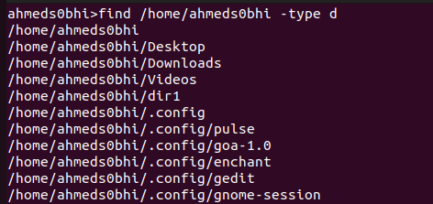

7. Write a command to search for all files on the system that, its name is “.profile”.
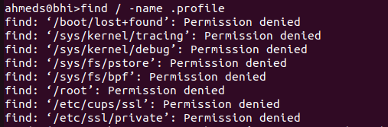

8. Identify the file types of the following: /etc/passwd, /dev/pts/0, /etc, /dev/sda
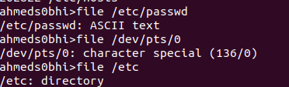



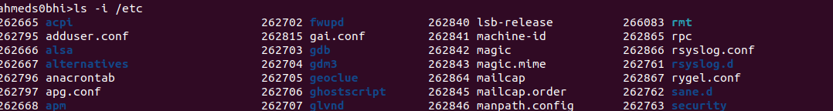
9. List the inode numbers of /, /etc, /etc/hosts.


10. Copy /etc/passwd to your home directory, use the commands diff and cmp, and Edit in the file you copied, and then use these commands again, and check the output.
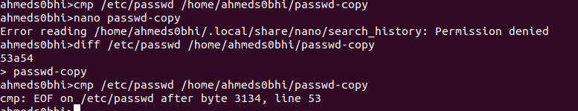

11. Create a symbolic link of /etc/passwd in /boot.
12. Create a hard link of /etc/passwd in /boot. Could you? Why?

