1. Install CentOS /RHEL
Done

2. What is the difference between cat and more command?
Cat: display the whole content of the file without any kind or organization
More; display the content of the file organized ( page by page)

3. What is the difference between rm and rmdir using man?
Rm; are used to delete or remove file or directory (and if it contains data we use rm -r)
Rmdir: used to delete empty directory.

4. Create the following hierarchy under your home directory:
a. Remove dir11 in one-step. What did you notice? And how did you overcome that?

I could not delete it using rmdir because it is used for empty dir, and terminal showed ‘dir1’ is not file or directory.
To remove directory contain data we used (rm -r) and take a step back (to be on dir1 not dir11) or delete every file or directory inside it.
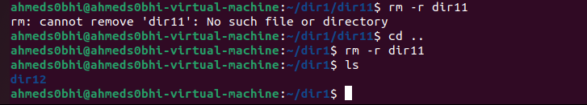

b. Then remove dir12 using rmdir –p command. State what happened to the hierarchy (Note: you are in your home directory).

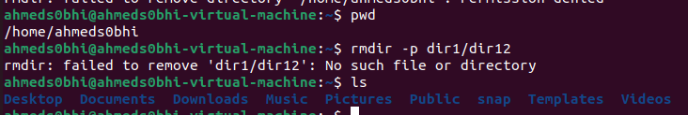
It removed itself and its parent (dir1)

c. The output of the command pwd was /home/user. Write the absolute and relative path for the file mycv

Absolute:

Relative:
Docs.mycv

5. Copy the /etc/passwd file to your home directory making its name is mypasswd.

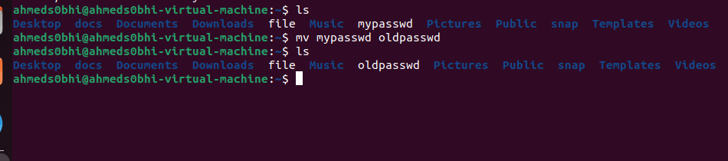
6. Rename this new file to be oldpasswd.

7. You are in /usr/bin, list four ways to go to your home directory

- Cd home
- Cd ~
- Cd ..
Cd ..
Cd home
- Cd / home

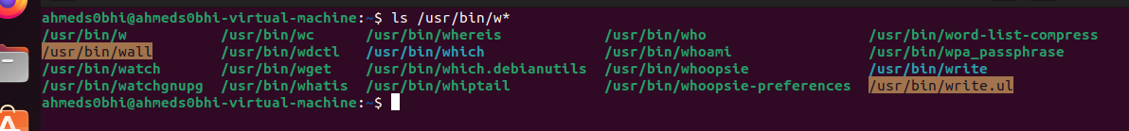
8. List Linux commands in /usr/bin that start with letter w

9. Display the first 4 lines of /etc/passwd

/etc/passwd -head 4
10. Display the last 7 lines of /etc/passwd
/etc/passwd -tail 7
11. Display the man pages of passwd the command and the file sequentially in one command.
Man passwd ; man file // or man -a passwd
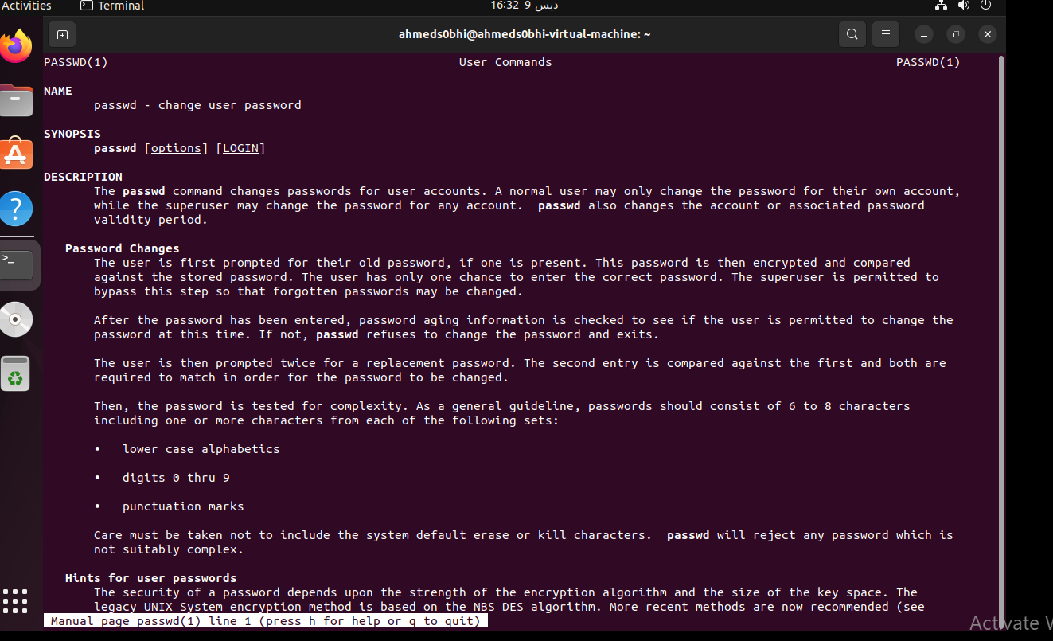

12. Display the man page of the passwd file.
Man passwd
Or man -s5 passwd

13. Display a list of all the commands that contain the keyword passwd in their man page.
