Lab4 - Ubuntu
Created by: Ahmed Sobhi El said Sharaf

1. List the user commands and redirect the output to /tmp/commands.list
2. Count the number of user commands
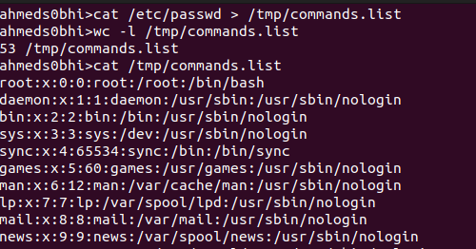

3. Get all the users names whose first character in their login is ‘g’.
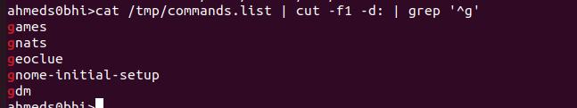

4. Get the logins name and full names (comment) of logins starts with “g”.
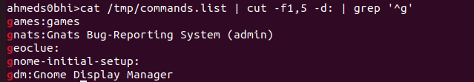

5. Save the output of the last command sorted by their full names in a file.


6. Write two commands: first: to search for all files on the system that named .bash_profile. Second: sorts the output of ls command on / recursively, Saving their output and error in 2 different files and sending them to the background.
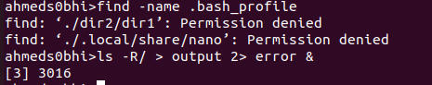

7. Display the number of users who is logged now to the system.


8. Display lines 7 to line 10 of /etc/passwd file
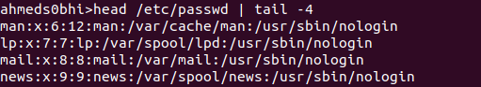

9. What happens if you execute:
* cat filename1 | cat filename2

It will result error because the pipeline expect argument not input

* ls | rm
It will result error because the rm that remove files needs specific file name to remove but ls list all files and directories not a specific file


* ls /etc/passwd | wc –l

It will display the number of the current user that logged in

10. Issue the command sleep 100.
11. Stop the last command.
12. Resume the last command in the background
13. Issue the jobs command and see its output.
14. Send the sleep command to the foreground and send it again to the background.
15. Kill the sleep command.
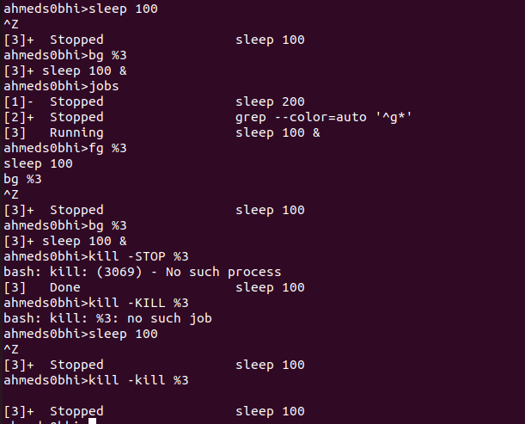

16. Display your processes only
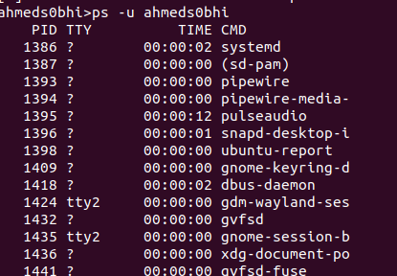

17. Display all processes except yours
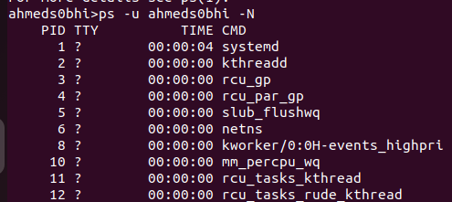

18. Use the pgrep command to list your processes only
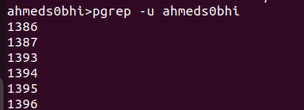

19. Kill your processes only.
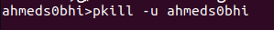

It will shutdown and go to the restart and I have to login again using my username and password

