Cairo University

Faculty of Engineering

Computer Architecture

Credit Hours System CMPN301

**Computer Architecture Project**

**Phase 1 Report**

**Team Members:**

**Ahmed Magdy Abdelaziz 1190200**

**Mahmoud Khaled Mahmoud 1190141**

**Ziad Ezzat Sedky 1190032**

**Ahmed Mohamed Saad Hussein 1190184**

Instructions Sequence: Instructions divided into 4 categories:

* Instructions with no operand
* Instructions with only one operands
* Instructions with only two operands
* Instructions with three operands

1. **Instructions with no operand: Divided into 3 groups as following:**
   * CLRC , SETC → For carry bit
   * RET , RTI → For Memory (SP to PC)
   * NOP
2. **Instructions with one operand: Divided into 2 Groups as following:**
3. **Read from register file and this divided into 4 Groups:**
   * OUT → Destination is OUT port
   * PUSH → Destination is Memory
   * JMP , JZ , JC → Destination is PC
   * CALL → Destination is PC and Memory
4. **Write into register file and this divided into 2 Groups:**
5. IN → Source is IN Port
6. POP → Source is Memory
7. **Instructions with two operands: Divided into 4 groups as following:**
   1. **Memory:**
      * LOAD
8. LDM → SRC will be immediate value
9. LDD → SRC will be any Register
   * + Store → STD
   1. **MOV**
   2. **NOT**
   3. **INC or DEC**
10. **Instructions with Three operands: Divided into 4 Groups as following:**
    1. **Adding :**
       * ADD → SRC2 will be from Register file
       * IADD → will read from Immediate value
    2. **SUB**
    3. **AND**
    4. **OR**

-----------------------------------------------------------------------------------------------

Instruction details:

Total Instruction → 32 bits

RDST & RSRC1 & RSRC2 → 3-bits , X → Don’t Care , IMM (16 bits immediate value)

**NOTE)** Colored bits means → will be read from Register File

1. **NOP** → **00 RDST RSRC1 RSRC2 X 00 XX IMM**
2. **SETC** → **00 RDST RSRC1 RSRC2 0 01 XX IMM**
3. **CLRC** → **00 RDST RSRC1 RSRC2 1 01 XX IMM**
4. **RET** → **00 RDST RSRC1 RSRC2 0 10 XX IMM**
5. **RTI** → **00 RDST RSRC1 RSRC2 1 10 XX IMM**

[31:30] → Identify one of four categories that mentioned above [19:18] → Select one operation from the selected category

[20] → Used only for Identify which operation will be done on the carry (SET , CLEAR) and for RTI and RET to identify restoring of PC only or PC and Flag registers

-----------------------------------------------------------------------------------------------

31:30 rd:rs1:rs2 20: 19:18 17:16

1. **OUT** → **01 RDST RSRC1 RSRC2 0 00 XX IMM**
2. **PUSH** → **01 RDST RSRC1 RSRC2 0 01 XX IMM**
3. **JZ** → **01 RDST RSRC1 RSRC2 0 10 10 IMM**
4. **JC** → **01 RDST RSRC1 RSRC2 0 10 01 IMM**
5. **JMP** → **01 RDST RSRC1 RSRC2 0 10 11 IMM**
6. **CALL** → **01 RDST RSRC1 RSRC2 0 11 11 IMM**
7. **IN** → **01 RDST RSRC1 RSRC2 1 00 XX IMM**
8. **POP** → **01 RDST RSRC1 RSRC2 1 01 XX IMM**

[31:30] → Select one of Categories mentioned above

[20] → Indicate Write operation or Read operation [19:18] → Select one Operation from this Category

[17:16] → Not be used for all except JMP to Select which JMP

NOTE: IN/OUT has same [19:18] Select between them by bit 20

-----------------------------------------------------------------------------------------------

1. **MOV** → **10 RDST RSRC1 RSRC2 X 00 0X IMM**
2. **NOT** → **10 RDST RSRC1 RSRC2 X 01 0X IMM ( ALU )**
3. **INC** → **10 RDST RSRC1 RSRC2 0 10 0X IMM ( ALU )**
4. **DEC** → **10 RDST RSRC1 RSRC2 1 10 0X IMM ( ALU )**
5. **LDM** → **10 RDST RSRC1 RSRC2 0 11 1X IMM ( ALU + Imm )**
6. **LDD** → **10 RDST RSRC1 RSRC2 0 11 0X IMM**
7. **STD** → **10 RDST RSRC1 RSRC2 1 11 0X IMM**

[31:30]→ Select one of four categories mentioned above [19:18]→ Select which operation from this category

Notes: INC/DEC have same [19:18] select Add or sub by bit 20 and

LDM/ LDD have same [19:18] we will select IMM or Reg by anding bit

[17] with [31] if 1 → REG and else IMM value (16-bits) , Store also has same [19:18] as LDM/LDD but we distinct it from LOAD

operations by bit [20]

-----------------------------------------------------------------------------------------------

1. **ADD** → **11 RDST RSRC1 RSRC2 X 00 0X IMM ( ALU )**
2. **IADD** → **11 RDST RSRC1 RSRC2 X 00 1X IMM ( ALU + Imm )**
3. **SUB** → **11 RDST RSRC1 RSRC2 X 01 0X IMM ( ALU )**
4. **AND** → **11 RDST RSRC1 RSRC2 X 10 0X IMM ( ALU )**
5. **OR** → **11 RDST RSRC1 RSRC2 X 11 0X IMM ( ALU )** [31:30]→ Select one of four categories mentioned above [19:18]→ Select one operations from this category

Notes: ADD/IADD have same [19:18] and we will difference between them by bit [17] anding with bit 31 and if 1 → IMM value will be used , else → REG will be used

|  |  |  |  |  |  |  |  |
| --- | --- | --- | --- | --- | --- | --- | --- |
| **INST** | **JMP_FLAG** | **WB** | **Mem_src** | **Sp_inc** | **Sp_dec** | **Mem_W** | **Alu_src** |
| NOP | **0** | **0** | **0** | **0** | **0** | **0** | **0** |
| SETC | **0** | **0** | **0** | **0** | **0** | **0** | **0** |
| CLRC | **0** | **0** | **0** | **0** | **0** | **0** | **0** |
| CALL | **1** | **0** | **1** | **1** | **0** | **1** | **0** |
| JZ | **depends->ZF** | **0** | **0** | **0** | **0** | **0** | **0** |
| JC | **depends->CF** | **0** | **0** | **0** | **0** | **0** | **0** |
| JMP | **1** | **0** | **0** | **0** | **0** | **0** | **0** |
| RET | **0** | **0** | **1** | **1** | **0** | **0** | **0** |
| RTI | **0** | **0** | **1** | **1** | **0** | **0** | **0** |
| POP | **0** | **1** | **1** | **1** | **0** | **0** | **0** |
| PUSH | **0** | **0** | **1** | **0** | **1** | **0** | **0** |
| IN | **0** | **1** | **0** | **0** | **0** | **0** | **1** |
| OUT | **0** | **0** | **0** | **0** | **0** | **0** | **0** |
| STD | **0** | **0** | **0** | **0** | **0** | **1** | **0** |
| IADD | **0** | **1** | **0** | **0** | **0** | **0** | **1** |
| LDM | **0** | **1** | **0** | **0** | **0** | **0** | **0** |
| LDD | **0** | **1** | **0** | **0** | **0** | **0** | **0** |
| ADD | **0** | **1** | **0** | **0** | **0** | **0** | **0** |
| MOV | **0** | **1** | **0** | **0** | **0** | **0** | **0** |
| NOT | **0** | **1** | **0** | **0** | **0** | **0** | **0** |
| INC | **0** | **1** | **0** | **0** | **0** | **0** | **0** |
| DEC | **0** | **1** | **0** | **0** | **0** | **0** | **0** |
| SUB | **0** | **1** | **0** | **0** | **0** | **0** | **0** |
| AND | **0** | **1** | **0** | **0** | **0** | **0** | **0** |
| OR | **0** | **1** | **0** | **0** | **0** | **0** | **0** |

|  |  |  |  |  |  |  |  |  |  |  |  |
| --- | --- | --- | --- | --- | --- | --- | --- | --- | --- | --- | --- |
| **INST** | **Alu_OP** | | | **Cin** | **M2R** | **SETC/CLRC** | | **RET/RTI** | | **Call** | **OUT_signal** |
| NOP | **1** | **0** | **0** | **0** | **0** | **0** | **0** | **0** | **0** | **0** | **0** |
| SETC | **1** | **0** | **0** | **0** | **0** | **1** | **1** | **0** | **0** | **0** | **0** |
| CLRC | **1** | **0** | **0** | **0** | **0** | **1** | **0** | **0** | **0** | **0** | **0** |
| CALL | **1** | **0** | **0** | **0** | **0** | **0** | **0** | **0** | **0** | **1** | **0** |
| JZ | **1** | **0** | **0** | **0** | **0** | **0** | **0** | **0** | **0** | **0** | **0** |
| JC | **1** | **0** | **0** | **0** | **0** | **0** | **0** | **0** | **0** | **0** | **0** |
| JMP | **1** | **0** | **0** | **0** | **0** | **0** | **0** | **0** | **0** | **0** | **0** |
| RET | **1** | **0** | **0** | **0** | **0** | **0** | **0** | **1** | **0** | **0** | **0** |
| RTI | **1** | **0** | **0** | **0** | **0** | **0** | **0** | **1** | **1** | **0** | **0** |
| POP | **1** | **0** | **0** | **0** | **1** | **0** | **0** | **0** | **0** | **0** | **0** |
| PUSH | **1** | **0** | **0** | **0** | **0** | **0** | **0** | **0** | **0** | **0** | **0** |
| IN | **1** | **0** | **0** | **1** | **0** | **0** | **0** | **0** | **0** | **0** | **0** |
| OUT | **1** | **0** | **0** | **0** | **0** | **0** | **0** | **0** | **0** | **0** | **1** |
| STD | **1** | **0** | **0** | **0** | **0** | **0** | **0** | **0** | **0** | **0** | **0** |
| IADD | **0** | **0** | **0** | **0** | **0** | **0** | **0** | **0** | **0** | **0** | **0** |
| LDM | **1** | **0** | **0** | **1** | **0** | **0** | **0** | **0** | **0** | **0** | **0** |
| LDD | **1** | **0** | **0** | **0** | **1** | **0** | **0** | **0** | **0** | **0** | **0** |
| ADD | **0** | **0** | **0** | **0** | **0** | **0** | **0** | **0** | **0** | **0** | **0** |
| MOV | **1** | **0** | **0** | **0** | **0** | **0** | **0** | **0** | **0** | **0** | **0** |
| NOT | **1** | **0** | **1** | **0** | **0** | **0** | **0** | **0** | **0** | **0** | **0** |
| INC | **0** | **0** | **1** | **0** | **0** | **0** | **0** | **0** | **0** | **0** | **0** |
| DEC | **0** | **1** | **0** | **0** | **0** | **0** | **0** | **0** | **0** | **0** | **0** |
| SUB | **0** | **1** | **1** | **0** | **0** | **0** | **0** | **0** | **0** | **0** | **0** |
| AND | **1** | **1** | **0** | **0** | **0** | **0** | **0** | **0** | **0** | **0** | **0** |
| OR | **1** | **1** | **1** | **0** | **0** | **0** | **0** | **0** | **0** | **0** | **0** |

**Schematic**

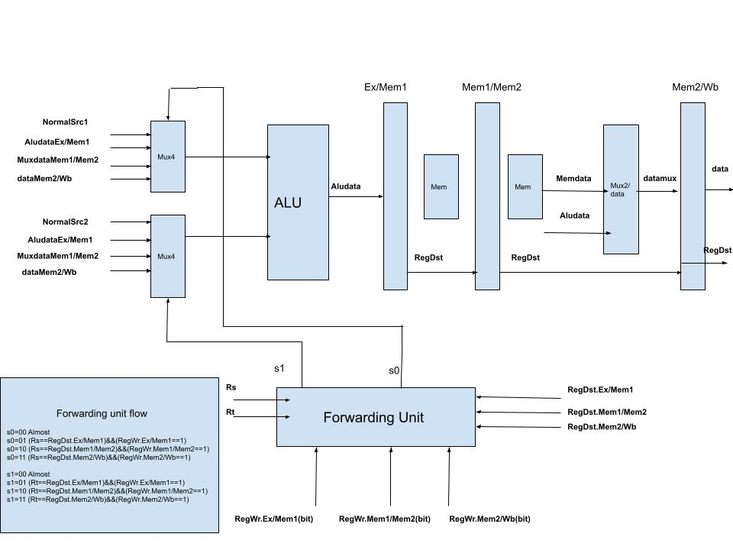**Design Link:** [**https://studcu-my.sharepoint.com/:u:/g/personal/14712019100076_stud_cu_edu_eg/EX7gOKrs7ppFqY_BOyfkJsIBsdNxneD2dT2Qljl11QvzxA?e=YyyezB**](https://studcu-my.sharepoint.com/:u:/g/personal/14712019100076_stud_cu_edu_eg/EX7gOKrs7ppFqY_BOyfkJsIBsdNxneD2dT2Qljl11QvzxA?e=YyyezB)

**Pipeline Registers Details**

**IF/ID REG (48 BITS):**

|  |  |  |  |  |
| --- | --- | --- | --- | --- |
| INPUT | BITS | **47-32** | **31-16** | **15-0** |
| Signal | PC+1 | INSTRUCTION | IMM/IN |

**ID/IE REG (88 BITS):**

|  |  |  |  |  |  |  |  |  |  |
| --- | --- | --- | --- | --- | --- | --- | --- | --- | --- |
| Input | BITS | 87-73 | 72-57 | 56-54 | 53-51 | 50-48 | 47-32 | 31-16 | 15-0 |
|  | SIGNAL | Controller Signals | PC + 1 | RSRC1 ADD | RSRC2 ADD | RDST ADD | RSRC1 Value | RSRC2 Value | IMM OR IN |

**Controller Signals:**

SET_CLEAR       <= Decode_Buffer_OUT(87 downto 86);

Write_back      <= Decode_Buffer_OUT(85);

MEM_SRC         <= Decode_Buffer_OUT(84);

SP_INC          <= Decode_Buffer_OUT(83);

SP_DEC          <= Decode_Buffer_OUT(82);

MEM_WRITE       <= Decode_Buffer_OUT(81);

Out_Signal      <= Decode_Buffer_OUT(80);

ALU_SRC         <= Decode_Buffer_OUT(79);

ALU_Operation   <= Decode_Buffer_OUT(78 downto 76);

CIN_Signal      <= Decode_Buffer_OUT(75);

CALL_Signal     <= Decode_Buffer_OUT(74);

MEM_TO_REG      <= Decode_Buffer_OUT(73);

**IE/MEM1 REG (65 BITS):**

|  |  |  |  |  |  |  |  |  |
| --- | --- | --- | --- | --- | --- | --- | --- | --- |
| Input | BITS | 64-49 | 48-41 | 40-25 | 24-9 | 8-6 | 5-3 | 2-0 |
|  | SIGNAL | PC+1 | Controller Signals | ALU_RESULT | RSRC2_VALUE | Rsrc1_add | Rsrc2_add | Rdst_add |

**Controller Signals:**

Write_back      <= EX_MEM1_Buffer(48);

MEM_SRC         <= EX_MEM1_Buffer (47);

SP_INC          <= EX_MEM1_Buffer (46);

SP_DEC          <= EX_MEM1_Buffer (45);

MEM_WRITE       <= EX_MEM1_Buffer (44);

Out_Signal      <= EX_MEM1_Buffer (43);

CALL_Signal     <= EX_MEM1_Buffer (42);

MEM_TO_REG      <= EX_MEM1_Buffer (41);

**Mem1/MEM2 REG (64 BITS):**

|  |  |  |  |  |  |  |  |  |
| --- | --- | --- | --- | --- | --- | --- | --- | --- |
| Input | BITS | 63-48 | 47-41 | 40-25 | 24-9 | 8-6 | 5-3 | 2-0 |
|  | SIGNAL | PC+1 | Controller Signals | READ_ADD | WRITE_DATA | Rsrc1_add | Rsrc2_add | Rdst_add |

**Controller Signals:**

WB_OUT <= BUFF_OUT(47);

MEM_TO_REG_OUT <= BUFF_OUT(46);

SP_INC_OUT <= BUFF_OUT(45);

SP_DEC_OUT <= BUFF_OUT(44);

MEMW_OUT <= BUFF_OUT(43);

OUT_SIG_OUT <= BUFF_OUT(42);

CALL_SIG_OUT <= BUFF_OUT(41);

**MemSt2/Wb REG (44 BITS):**

|  |  |  |  |  |  |  |  |  |  |
| --- | --- | --- | --- | --- | --- | --- | --- | --- | --- |
| Input | BITS | 43 | 42 | 41 | 40-25 | 24-9 | 8-6 | 5-3 | 2—0 |
|  | SIGNAL | Wb | M2r | outEn | Memst2 | Memst1 | RSRC1 Value | RSRC2 Value | Rdst |