**Name :** احمد سعيد على الخولى

**B.N:** 66

**Date :** 1 / 6 / 2020

**Topic:** artificial intelligence

**Github link :**

**Github page :**

**Application brief :**

Artificial Intelligence is the hot tech paradigm of the moment. It is the subject of a great deal of media hype, woes and mythologizing. It seems worthwhile, therefore, to try to set the scene, look at some definitions, and see where it is currently being applied.

It is very useful in our life, It has different applications that is very important in our daily life like social media.

**Screeshots :**

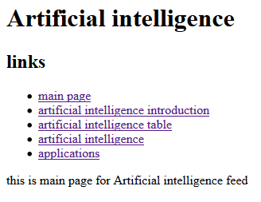

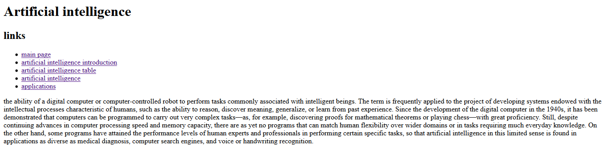

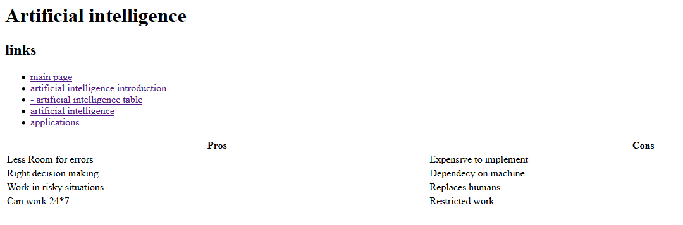

Source Code :

