***Part 1: Interactive Data Dashboard***

1. ***Provide*both*data sets that serve as the data source for the dashboard.***

Both Data sets are attached with the PA.

Data sources are:

1. Churn_clean.csv data file provided by WGU.

<https://access.wgu.edu/ASP3/aap/content/f9tjr8djg83jd8c3sdf8.zip>

1. USA population by state, 2019 census, used to get the population of each state.

<https://www.kaggle.com/peretzcohen/2019-census-us-population-data-by-state>

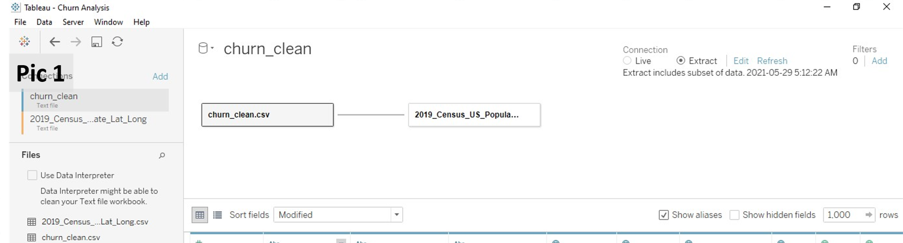

1. ***Provide step-by-step instructions to guide users through the dashboard installation.***

The project workbooks and their data sources (set1 and set2) are saved as a .twbx, (tableau packaged workbook) and they can open and see its contents using Tableau Reader or Tableau Desktop as following:

1. Download the “*Churn Analysis.twbx*” packaged file.
2. Open the file using Tableau Reader or Tableau Desktop applications.

File-> Open -> Browse-> (Pic 2)

1. Go to the Churn Analysis dashboard. (Pic 3)

*https://kb.tableau.com/articles/howto/sharing-workbooks-without-tableau-desktop*

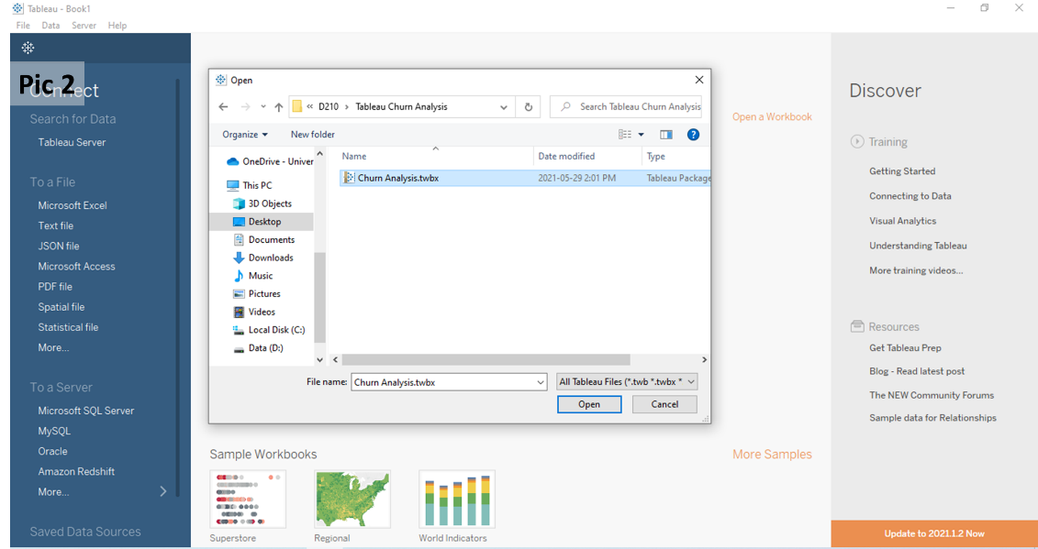

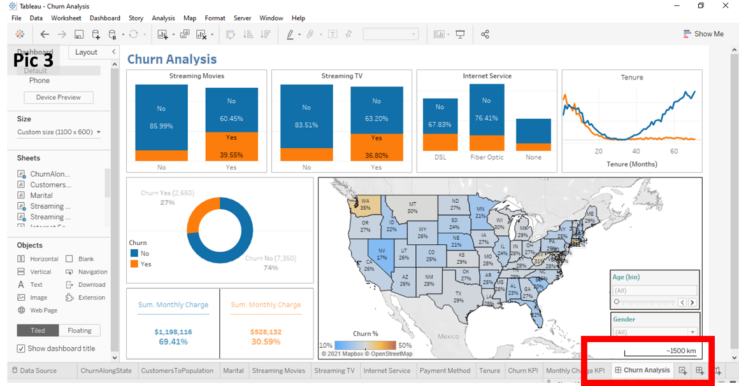

1. ***Provide instructions to help users navigate the dashboard.***

***Dashboard description*** (pic 4)***:***

1. The upper section of the dashboard contains four different data representations to summarize the data or display trends.
2. The lower left part contains two KPIs, Churn percentage and Monthly charge.
3. The lower right part is a map of the USA, at the state level of details colored by the customers' churn percentage. With two interactive filters on the lower right part of the map to change through gender and age of customers.

***Dashboard navigation Instructions:***

1. Hover over any state of the map (lower right) to display specific information on Tooltip.: (Name of the State, No. of Customers (according to selected filters values), Churn percentage for the state, State Population and Customers to Population percentage)
2. Use interactive filters to navigate different age and gender groups.
3. The filters are connected to all data representations (graphs and KPIs) of the dashboard.
4. Click on any state to select and display all metrics and information related to this specific state with graphs and KPIs.
5. DoubleClick on any white space of the map to unselect the individual states and return to Sum of all state’s mode.

