**Part 3: Reflection Paper**

C.  Write a reflection paper to demonstrate your understanding of data representation and reporting by doing the following:

**1.  Explain how the purpose and function of your dashboard align with the needs outlined in the data dictionary associated with your chosen data set.**

The company is interested in finding the main factors that may affect the churn probability (WGU-D210, 2021), therefore taking the right actions to deal with those factors. The analysis of the data would give the company and the stakeholders a good idea about these factors and the degree of their reliability.

The question to be asked is about recognizing which variables have a relationship with the customer's Churn and using these relationships to predict customers' churn probability.

the churn probability of each customer may depend on several factors such as customer satisfaction, service quality, and price. some of these factors may be more important than others. and more significant than others.

The objective of the data analysis is to identify these features from the given data variables and to give the stakeholders the insight to avoid the negative factors and to support the positive ones.

**2.  Explain how the variables in the additional data set enhance the insights that can be drawn from the data set you chose from the provided options.**

The additional data set is the US population by state, according to the 2019 census (Cohen, 2021), it has been used to compare the number of customers in each state to the total population.

Comparing the number of customers to the state population revealed a great potential of acquiring new customers as the percentage of Customers to Population is too low. (this percentage can be displayed by hovering over any state of the map (lower right) of the Dashboard).

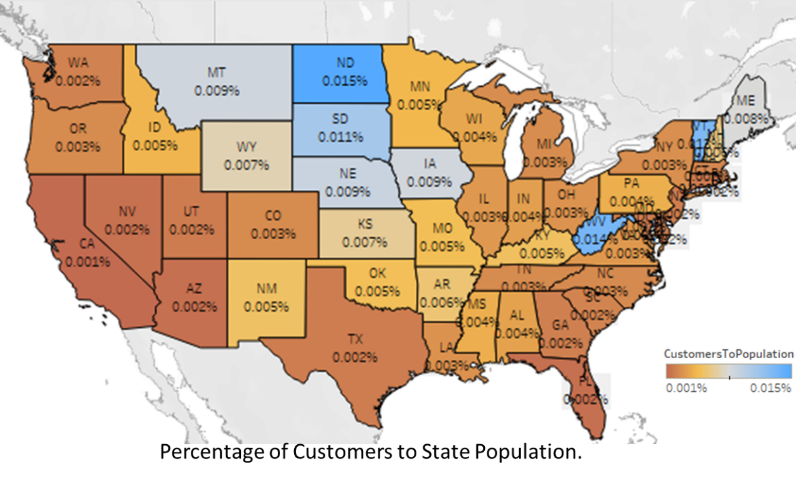

Figure (1): US map, percentage of customers Churn to state population.

**3.  Explain two different data representations from your dashboard and how executive leaders can use them to support decision-making.**

a- Streaming Movies:

Customers with no Streaming Movies service have a lower probability to Churn compared to customers who use this service (14% for no Streaming Movies customers to 39% for Streaming Movies customers)

This can be a very important note for the Senior Vice President for Customer Experience (SVP) as his/her key focus is to increase customer engagement with the company’s products and services thus improving recruitment and retention.

b- Tenure:

Customers with a high tenure number of months (35 months and above) are less likely to Churn compared to relatively newer customers (less than 35 months with the company).

This piece of information specifically can be interesting to the Executive Vice President of Sales (EVP), as he or she is interested to develop new products or refine the customer outreach promotions to current and future customers.

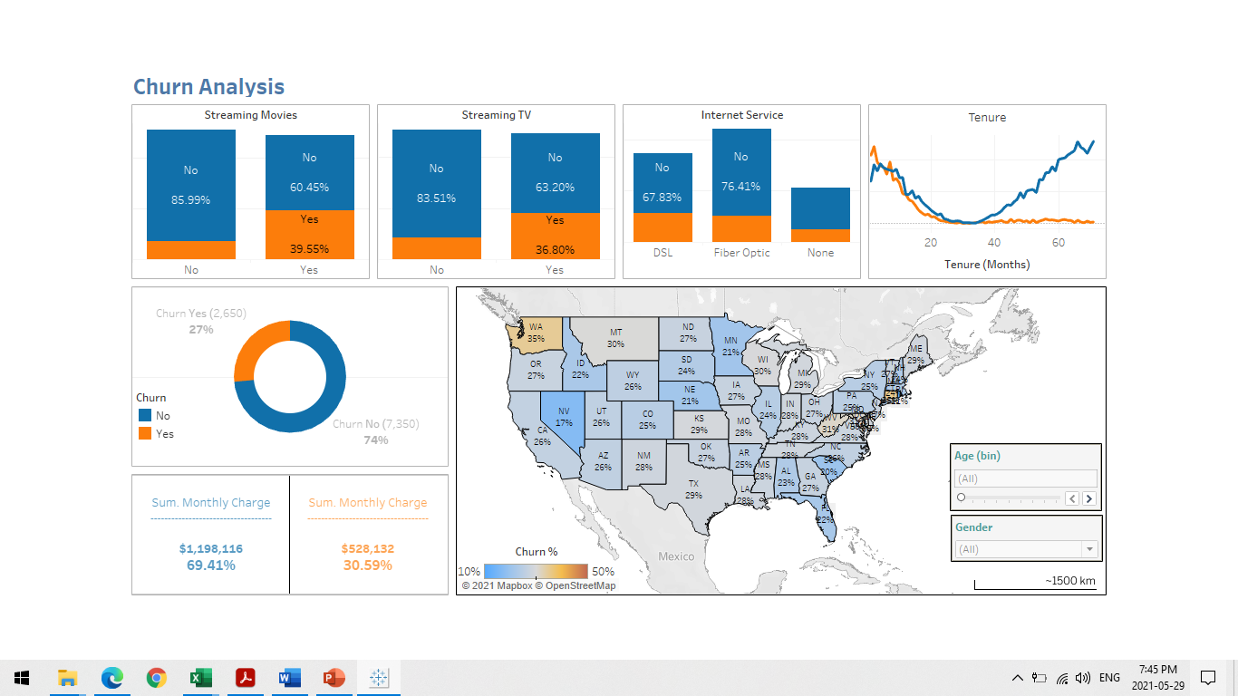

Figure (2): Data representation from the Dashboard.

**4.  Explain two interactive controls in your dashboard and how each enables the user to modify the presentation of the data.**

Two interactive filters on the lower right part of the map change through the gender and age of customers.

1. Age filter:

The Age variable is binned into 10 years categories, (except for 18-20), User can use the slider to choose a single band of age bands and the map and all other data representations would be modified accordingly.

1. Gender filter:

The Gender variable has 3 categories, Female, male, and nonbinary, User can use the dropdown list to choose one of the categories and the map and all other data representations would be modified accordingly.

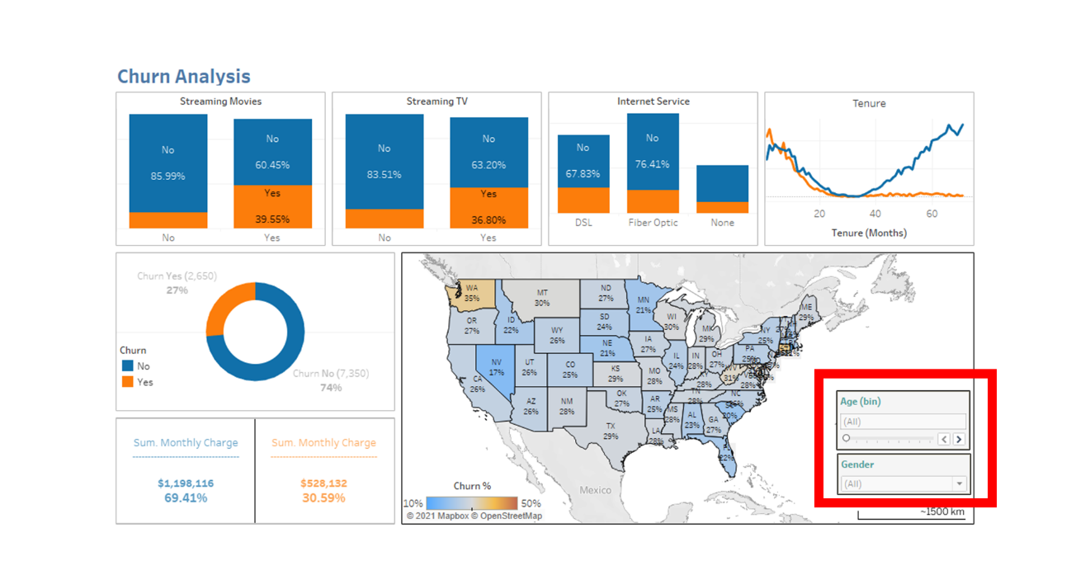

Figure (3): Churn Analysis Dashboard.

**5.  Describe how you built your dashboard to be accessible for individuals with colorblindness.**

Following the Web Content Accessibility Guidelines (WCAG 2.0 AA), The final Dashboard is ensured to be Perceivable and Understandable through the following steps:

1. Used text in titles, captions, and labels to describe visualizations and what they are showing. (Tableau help (a), 2021).
2. Used Tableau color-blind palette for selecting appropriate colors for visualizations that can be recognized by users with visual impairments (Tableau blog, n.d.).

For any color palette that has been used, I have considered providing enough contrast and assigning colors that differ from each other on the light-dark spectrum. (Tableau help (b), 2021)

**6.  Explain how two data representations in your presentation support the story you wanted to tell.**

The main purpose of the data visualization and the Dashboard of the Churn data set is to highlight some aspects that may affect the customers’ churn probability (negatively or positively).

Four variables have been studied regarding Churn (Streaming TV, Streaming Movies, DSL internet service, and customer Tenure).

The comparison between the Churn rate of each of these services could reveal the main idea of the presentations by highlighting the services that do not meet the customers’ expectations and increase the Churn rate or probability.

Similarly, the relationship between Churn rate with and Tenure in months revealed that customers with a high tenure number of months (35 months and above) are less likely to Churn compared to relatively newer customers (less than 35 months with the company), which means that the company must reconsider higher standards to ensure the satisfaction of new customers.

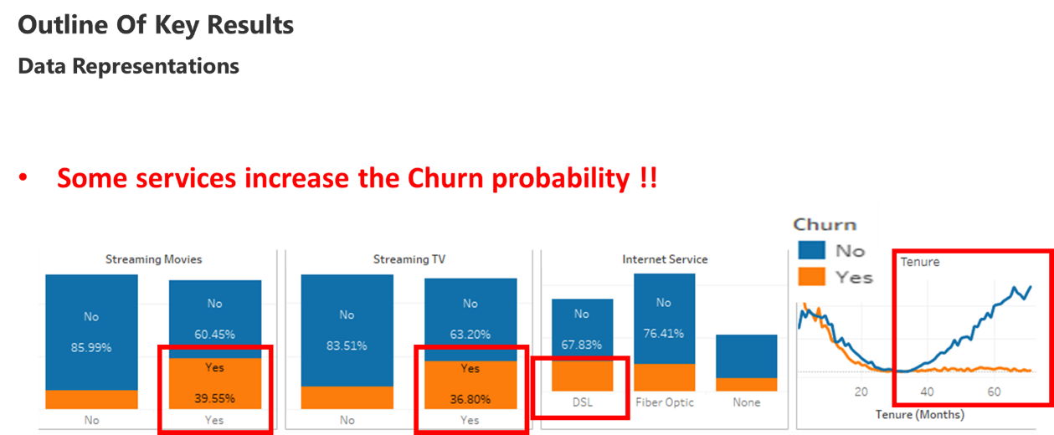

Figure (4): Slide 6 of the presentation.

**7.  Explain how you used audience analysis to adapt the message in your presentation.**

**Four Categories of the audience were expected to attend and participate in the presentation:**

1. Senior Vice President for Customer Experience (SVP)
2. Executive Vice President of Sales (EVP)
3. The panel of Regional Vice Presidents (Regional VP)
4. Team of data analysts

Each of them is supposed to be more interested in a different perspective on the data and in extracting different key results (WGU-D210, 2021).

The Dashboard and presentation were designed to take into consideration the key focus areas of the audience as much as possible.

A key focus of the SVP is to increase customer engagement with the company’s products and services thus improving recruitment and retention, The presentation revealed the relationships between customers Churn and some of the services provided by the company.

Executive Vice President of Sales (EVP) is interested to develop new products or refine the customer outreach promotions to current and future customers, The presentation revealed that customers with a high tenure number of months (35 months and above) are less likely to Churn compared to relatively newer customers (less than 35 months with the company), which means that the company must reconsider higher standards to ensure the satisfaction of new customers.

The EVP is interested in the broad categorization of customers and how these demographics play out across regions, and they can benefit from the analysis of customer number to state population percentage, as it shows great potential for new customers recruitment in all regions.

The short presentation could summarize the data analysis and translate it to specific business insights, offering actionable recommendations.

**8.  Describe how you designed your presentation for universal access by all audiences.**

Following the WCAG 2.0 AA principles (WCAG,2008): Perceivable, Understandable, practically in both presentation and dashboard, I used the following:

* Used text in titles and captions to describe the visualizations and what they are showing as much as possible but without falling into cluttering. (Tableau help (b), 2021)
* Used simple, easy-to-understand language. no jargon, acronyms, or abbreviations.
* Avoided using all capital letters (for example in headings or titles), because they can be difficult to read.
* Referred to controls and filters by labels, highlighted them with a contrasting color to make sure they are visible.
* Used Tableau color-blind palette for selecting appropriate colors for visualizations that can be recognized by users with visual impairments. (Tableau help (b), 2021)
* For any color palette that has been used, I have considered providing enough contrast and assigning colors that differ from each other on the light-dark spectrum. (Tableau help (a), 2021).

9.  Explain **two** elements of effective storytelling that you implemented in your presentation and how each element was intended to engage the audience.

1. (Know your Audience): focused on the audience's key interests, minimized additional stuff such as methodologies or technical description, minimized the number of visualizing, and used only the ones that serve in the storytelling. (Knaflic, C. N. 2016).
2. (Present conflict), translated into starting with highlighting a serious problem that would grab the audience's attention., the problem is the high rate of customer retention and the loss of the company’s revenue because of that, this problem is supposed to be of high interest to all the audience, specifically the executives. (Rose,2017)

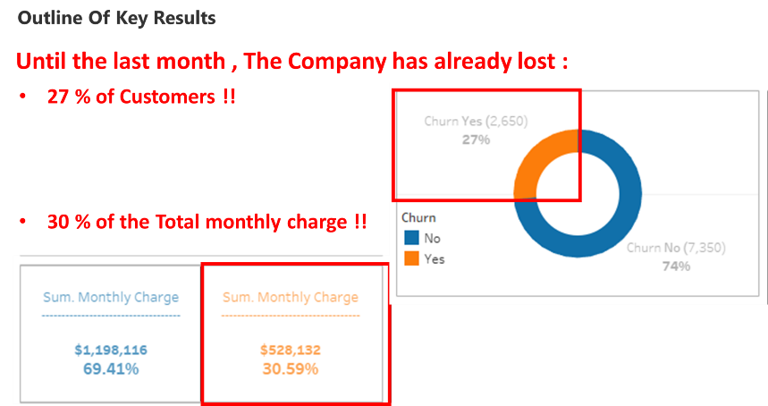

Figure (5): Slide 4 of the presentation.

**Link to the Panopto Presentation:**

[Mon May 31 2021 5:47:22 PM (panopto.com)](https://wgu.hosted.panopto.com/Panopto/Pages/Viewer.aspx?id=d9da069b-5aa1-482d-859b-ad3901880b46)

https://wgu.hosted.panopto.com/Panopto/Pages/Viewer.aspx?id=d9da069b-5aa1-482d-859b-ad3901880b46

**References:**

1. WGU. D210 Representation and Reporting (2021, May 31), Data Files and Associated Dictionary Files.

<https://access.wgu.edu/ASP3/aap/content/k8gj49f8sichedufutms.html>

1. Cohen. (2021). 2019 Census US Population Data by State

<https://www.kaggle.com/peretzcohen/2019-census-us-population-data-by-state>

1. Tableau Help (a). (Version: 2021.1). Best Practices for Designing Accessible Views.

<https://help.tableau.com/current/pro/desktop/en-us/accessibility_best_practice.htm>

1. Tableau blog (n.d.). 5 tips on designing colorblind-friendly visualizations.

<https://www.tableau.com/about/blog/examining-data-viz-rules-dont-use-red-green-together>

1. Tableau Help (b). (Version: 2021.1). Build Data Views for Accessibility.

https://help.tableau.com/current/pro/desktop/en-us/accessibility_overview.htm

1. WCAG. (2008 ,Dec 11).Web Content Accessibility Guidelines (WCAG) 2.0

<https://www.w3.org/TR/WCAG20/>

1. Rose.D. (2017) Learning Data Science: Tell Stories with Data, LinkedIn course

<https://www.linkedin.com/learning/learning-data-science-tell-stories-with-data/>

1. Knaflic, C. N. (2016). Storytelling with data: a data visualization guide for business professionals. John Wiley &amp; Sons, Inc.