## **PROJECT REPORT ON OBSTACLE AVOIDING ROBOT**

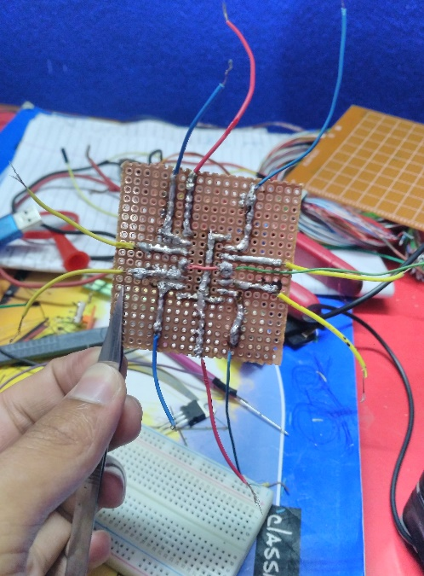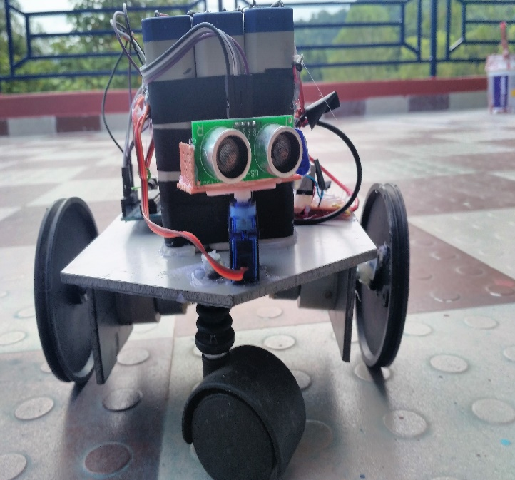

# **The Project was Constructed for the Participation in Intra school Robotics Exhibition,**

# **Motherland Secondary School-2075**

# **Prepared by:**

**Saugat Baral (+2 Science)**

**Ishan Subedi (+2 Science)**

# **Submitted to:**

**Respected Judges of Robotics Exhibition**

# **PREFACE**

We are extremely thankful to teachers and organizers of Intra school Robotics Exhibition in Motherland Secondary School for letting us participate in the competition. With an opportunity to extend our knowledge and capabilities of Robotics, we feel really fortuned to receive the platform. Gathering experiences from World Robot Olympiad, Pokhara-2075, we have attempted to present skills and build a worthy project. Our work speaks about autonomous obstacle avoiding robot capable of finding out its way. Several behaviors and possibilities of the machine were studied during its formation.

* *Team Members*

# **CONSTRUCTION**

* 1. Materials Used

1. Ultrasonic Sensor-1
2. Servo Motor-1
3. Gear Motors-2
4. Rechargeable Batteries-3
5. Motor Driver (L293D)-1
6. Transistor-1
7. Aluminum sheet-1

2.2 Circuit Diagram (Self Explanatory)

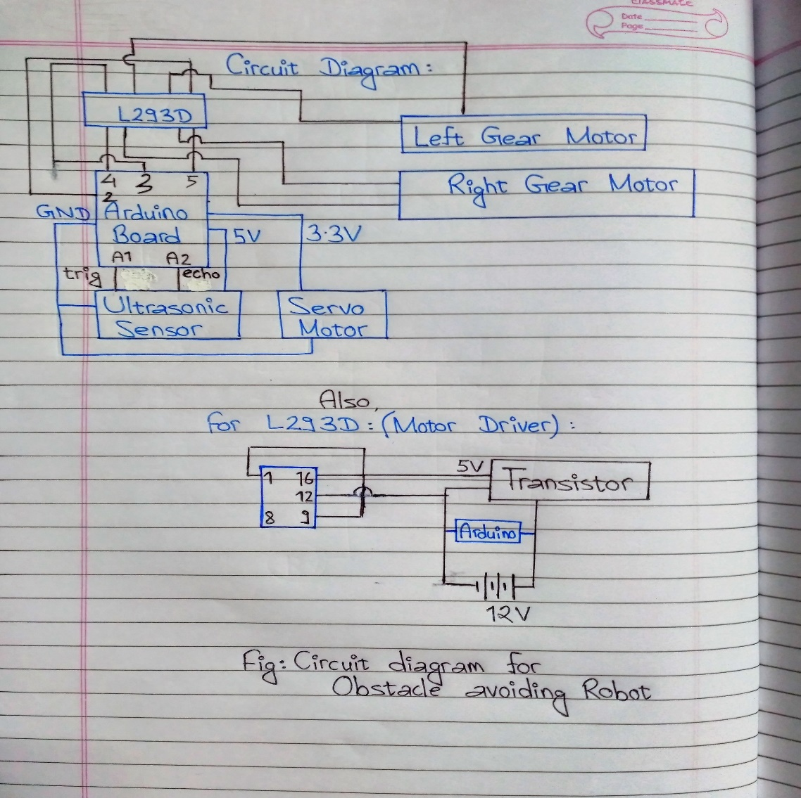

# **CODING WITH ARDUINO**

The Arduino was coded with C++ using various official libraries of the open source project as obtained from [www.arduino.cc](http://www.arduino.cc) .

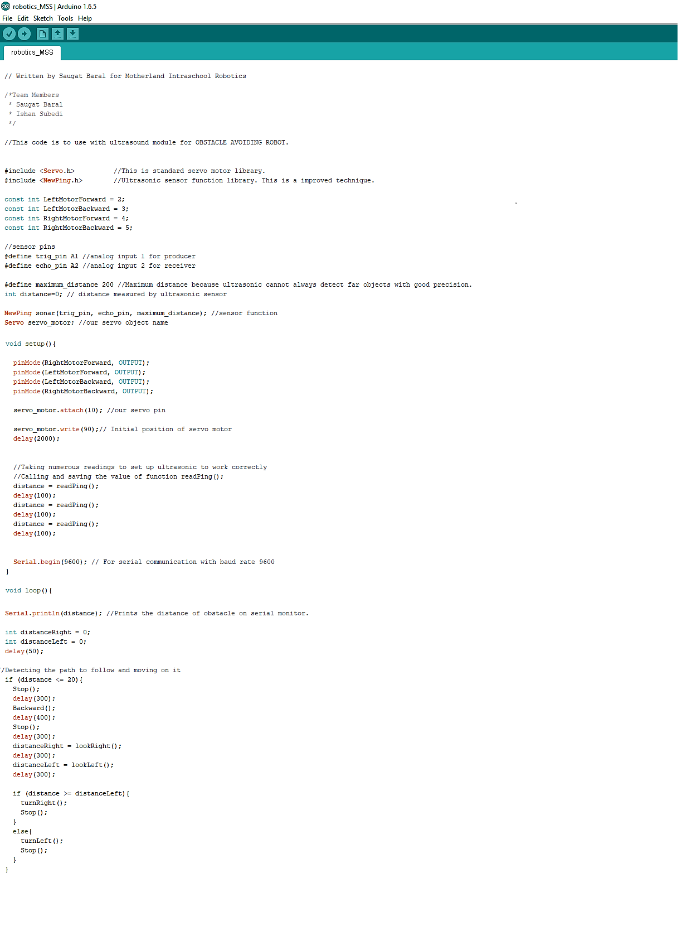

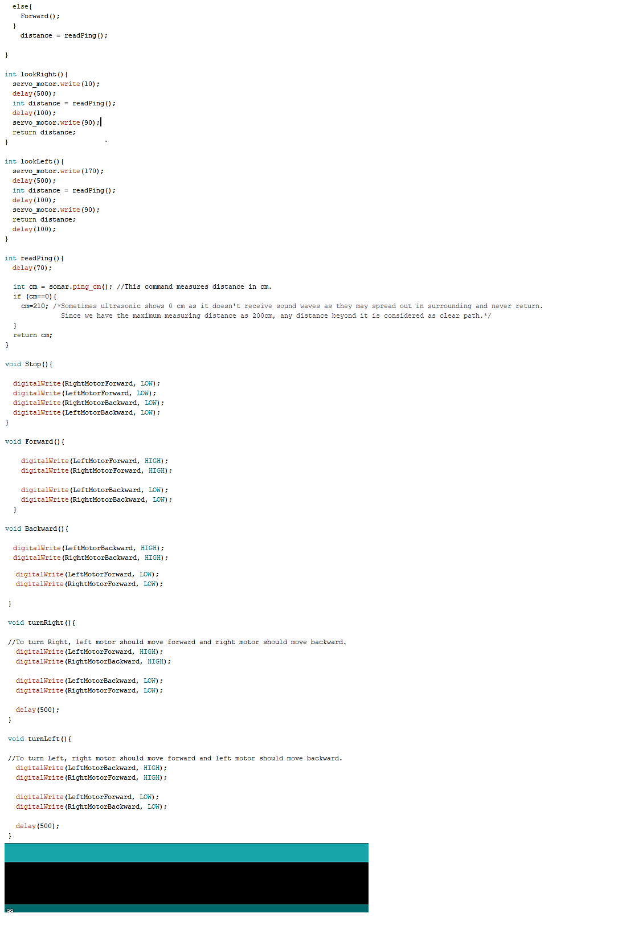

# **POSSIBILITIES THAT THE PROJECT CARRIES**

Firstly, the most influence carrying application of such machines is seen in space exploration where they can sense their environment around and act accordingly.

Secondly, self-driving vehicles could be constructed under same principle bringing out more comfort to individuals towards transportation.

Thirdly, several daily life machineries for home cleaning activities like Roomba have also been using same idea.

Fourthly, the interesting robot could be implemented as a medium of learning programming, electronics and sound waves practically in schools.

Similarly, on the part of developing an AI, such sensors come handy to make it more familiar with its surrounding.

# **THANK YOU !**