**FINAL YEAR PROJECT AND INTERNSHIP REPORT TEMPLATE [Title]** [bold, font 12]

**by**

**NAME**

**ID: XXX-XX-XXXX**

**AND**

**NAME**

**ID: XXX-XX-XXXX**

This Report Presented in Partial Fulfillment of the Requirements for the Degree of Bachelor of Science in Computer Science and Engineering [Font-14]

Supervised By

**Name[Font-14, Bold]**

Designation[Font-14]

Department of CSE

Daffodil International University

Co-Supervised By

**Name[Font-14, Bold]**

Designation[Font-14]

Department of CSE

Daffodil International University



**DAFFODIL INTERNATIONAL UNIVERSITY** [font-14, capital letter, bold]

**Dhaka, Bangladesh** [font-14, bold]

**December 2019**

**APPROVAL**[capital letter, Bold, Font-14, Alignment-middle]

This Project titled “**Title**”, submitted by *Name1* and *Name2* to the Department of Computer Science and Engineering, Daffodil International University, has been accepted as satisfactory for the partial fulfillment of the requirements for the degree of B.Sc. in Computer Science and Engineering and approved as to its style and contents. The presentation has been held on *date*.[**Font-12**]

**Board of Examiners**

**(Name)** [**Font-12, Bold**] **Chairman**

**Designation**

Department of CSE [**Font-12**]

Faculty of Science & Information Technology

Daffodil International University

**(Name) Internal Examiner**

**Designation**

Department of CSE

Faculty of Science & Information Technology

Daffodil International University

**(Name) External Examiner**

**Designation**

Department of -------

Jahangirnagar University

**Declaration**[capital letter, Bold, Font-14, Alignment-middle]

We hereby declare that, this project has been done by us under the supervision of **Name, Designation, Department of CSE** Daffodil International University. We also declare that neither this project nor any part of this project has been submitted elsewhere for award of any degree or diploma. [**Font-12**]

**Supervised by:**

**Name**

Designation

Department of CSE

Daffodil International University

**Co-Supervised by:**

**Name**

Designation

Department of CSE

Daffodil International University

**Submitted by:**

**(Name1)**

ID: -19-

Department of CSE

Daffodil International University

**(Name2)**

ID: -19-

Department of CSE

Daffodil International University

**ACKNOWLEDGEMENT  
[**capital letter, Bold, Font-16, Alignment-middle**]**

First we express our heartiest thanks and gratefulness to almighty God for His divine blessing makes us possible to complete the final year project/internship successfully.

We really grateful and wish our profound our indebtedness to **Supervisor Name**, **Designation**, Department of CSE Daffodil International University, Dhaka. Deep Knowledge & keen interest of our supervisor in the field of “*Field name*” to carry out this project. His endless patience ,scholarly guidance ,continual encouragement , constant and energetic supervision, constructive criticism , valuable advice ,reading many inferior draft and correcting them at all stage have made it possible to complete this project.

We would like to express our heartiest gratitude to -----, -----, andHead**,** Department of CSE, for his kind help to finish our project and also to other faculty member and the staff of CSE department of Daffodil International University.

We would like to thank our entire course mate in Daffodil International University, who took part in this discuss while completing the course work.

Finally, we must acknowledge with due respect the constant support and patients of our parents. [**Font-12**]

**Abstract**

**[**capital letter, Bold, Font-14, Alignment-middle**]**

[This is sample abstract] This report is intended as a guide for teachers and engineering students when conducting research is part of course-work requirements. Discussion includes a description of a literature search, the purpose of a literature review finding sources (especially for engineering) and a general strategy to help conduct an efficient and productive literature search. Using tools such as this report, students can become more pro-active about their research projects. Teachers can use this report, among other tools, to begin dialog with their students about expectations for research assignments. Two key steps in a literature search are: (i) finding sources; and (ii) synthesizing information. Each of these is addressed in two of the major sections in this report, as well as how the literature search relates to the entire research process. Then pertinent information is repeated in the summary section for convenience. An annotated reference list is included for ease in finding other useful guidance. [**Font-12**]

**Abstract should be between 200-300 words and a single paragraphs.**

**TABLE OF CONTENTS [**capital letter, Bold, Font-14, Alignment-middle**]**

|  |  |
| --- | --- |
| **CONTENTS[**Font-14, bold**]** | **PAGE** |
| Board of examiners**[**Font-12**]** | i |
| Declaration | ii |
| Acknowledgements | iii |
| Abstract | iv |
| **CHAPTER**[**Font-14, Bold**] |  |
| **CHAPTER 1: CHAPTER NAME [**Font-14, **Bold]** | **1-6** |
| 1.1 Infrastructure Mode**[**Font-12**]** | 1 |
| 1.2 | 2 |
| **APPENDIX** | **50-55** |
|  |  |
| **REFERENCES** | **56-57** |

**LIST OF FIGURES** [**Font-14, Bold**]

|  |  |
| --- | --- |
| **FIGURES**[**Font-12,Bold**] | **PAGE NO** |
| Figure 1: Cabling and Computer Hardware[**Font-12**] | 4 |
| Figure 2.1.1: Numbering according to sub sections | 11 |

**Instructions for figures:**

a. Caption of every figure must insert at the bottom of the figure with center alignment.

b. Figure’s number and description must need to be mentioned in the main documents about what it actually illustrates and what it explains.

c. Figure’s number must be sequenced according to the section numbers and arranges with sub sections accordingly if needed.

d. All the figures must need proper citation if it used from other resources.

**Sample:**

The following figure 1 shows basic multicast service.

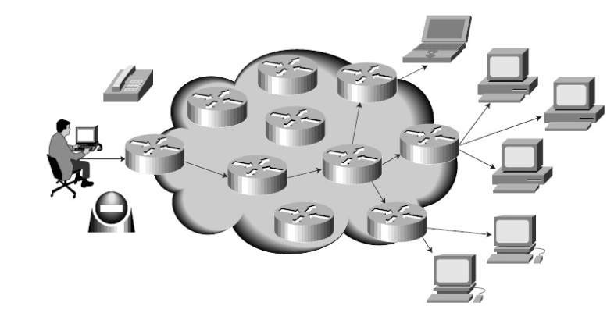

Figure 1: Basic multicast service [font-10, Alignment-center]

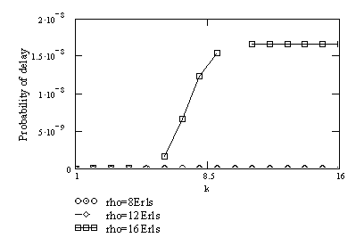

Figure 2.1.1: Probability of delay as a function of the fold number under different offered traffic (N=50, n=14, q= 5,[font-10, Alignment-center]

**LIST OF TABLES** [**Font-14, Bold**]

|  |  |
| --- | --- |
| **TABLES**[**Font-12,Bold**] | **PAGE NO** |
| Table 1: Cabling and Computer Hardware[**Font-12**] | 12 |
| Table 2.1: Numbering according to sub sections | 14 |

**Instructions for Table:**

1. Caption of every table must insert at the top of the table with center alignment.

2. Table’s number and description are must be mentioned in the main documents for what it actually shows and what it explains.

Table 1: The relationship between gaze targets and proxemics from case 1 **[font-10, Alignment-center]**

|  |  |  |  |  |  |  |
| --- | --- | --- | --- | --- | --- | --- |
|  | Objects | | | Persons | | |
| Proxemics Area | Time of Target | % | Avg. Dur. | Time of Target | % | Avg. Dur. |
|  |  |  |  |  |  |  |
|  |  |  |  |  |  |  |
|  |  |  |  |  |  |  |
|  |  |  |  |  |  |  |

**List of Figures and List of Tables must be in separate pages.**

**Chapter writing style:**

**CHAPTER 1**

**Introduction**

**Some Other Instructions:**

**Thesis/Project Size**: Minimum 30 page limit for Bachelor program

**Page Setup**: Left- 1.25"

Right-1.25"

Top: 1.0-1.25"

Bottom-1.0-1.25"

Orientation- Portrait

**Paragraph Line Spacing**: 1.5

**Column:** Single column

**Font**: Time New Roman

**Header**: Bold, Capital letter, Alignment-Center, Font-14

**Inner Text**: Font-12, Plain text

**Text Alignment:** Justify  
**Figure caption**: Font-10, Bottom, Center  
**Table caption**: Font-10, Top, Center

**Figure numbers for Appendix**: It should be mentioned according to Appendix number such as Figure A1, Figure B2 and so on.

**Reference**: Font-10

All references to books, papers, and other publications must be fully and correctly quoted. There are several methods of quoting references. One is to state the name of the author and a serial number in the main text with the full details of the reference in the Reference section of the report, for example:

In the text:

*....The analysis of the algorithms has been extensively reviewed by Yorozu et al. [1]*

*and will ....*

In the References section:

[1] Y. Yorozu, M. Hirano, K. Oka, and Y. Tagawa, “Electron spectroscopy studies on magneto-optical media and plastic substrate interface,” IEEE Transl. J. Magn. Japan, vol. 2, pp. 740–741, August 1987.

***Conference/Journal Papers:***

[1] Author1, Author2, and Author3, “Paper Title”, Conference/Journal, Volume, page number, Month and year.

**Example:**

[1] Y. Yorozu, M. Hirano, K. Oka, and Y. Tagawa, “Electron spectroscopy studies on magneto-optical media and plastic substrate interface,” IEEE Transl. J. Magn. Japan, vol. 2, pp. 740–741, August 1987.

***Books:***

[2] Author, Book Title, Edition/Volume, Publisher, Year, Page number

**Example:**

[2] T. H. Cormen, C. E. Leiserson, R. L. Rivest, C. Stein, Introduction to Algorithms, 3rd Edition, The MIT Press, 2009, pp. 120-122.

***Websites:***

[3] Name/Title of the Website, available at << https://URL>>, last accessed on Date at Time.

**Example:**

[3] Learn about Wikipedia, available at << http://www.wikipedia.org/>>, last accessed on 06-06-2019 at 12:00 PM.