Answer 1

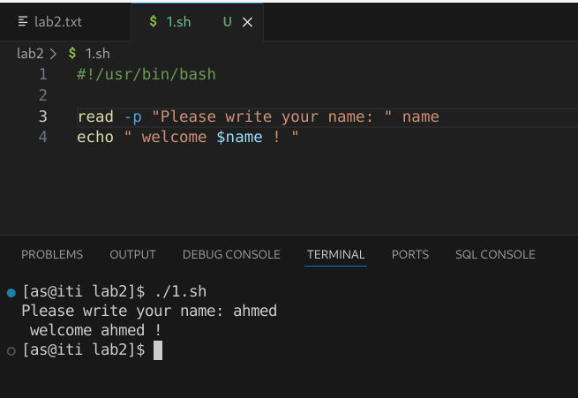Answer 2,a:

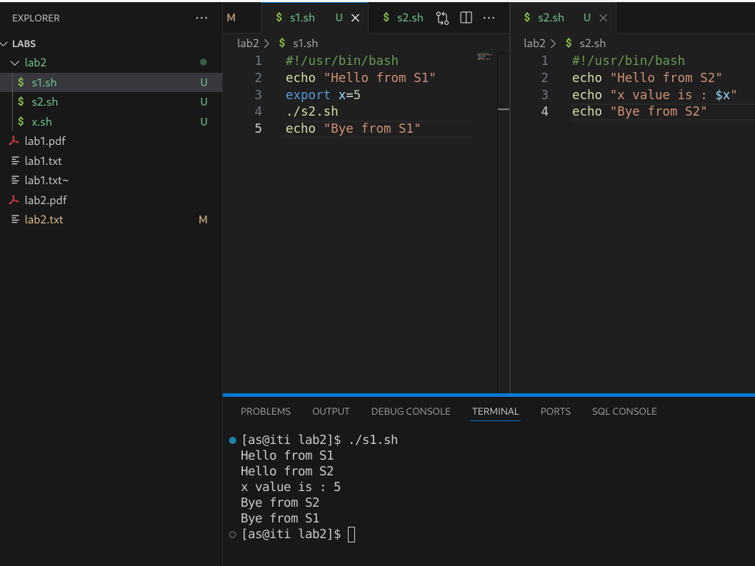Answer 2 ,b:

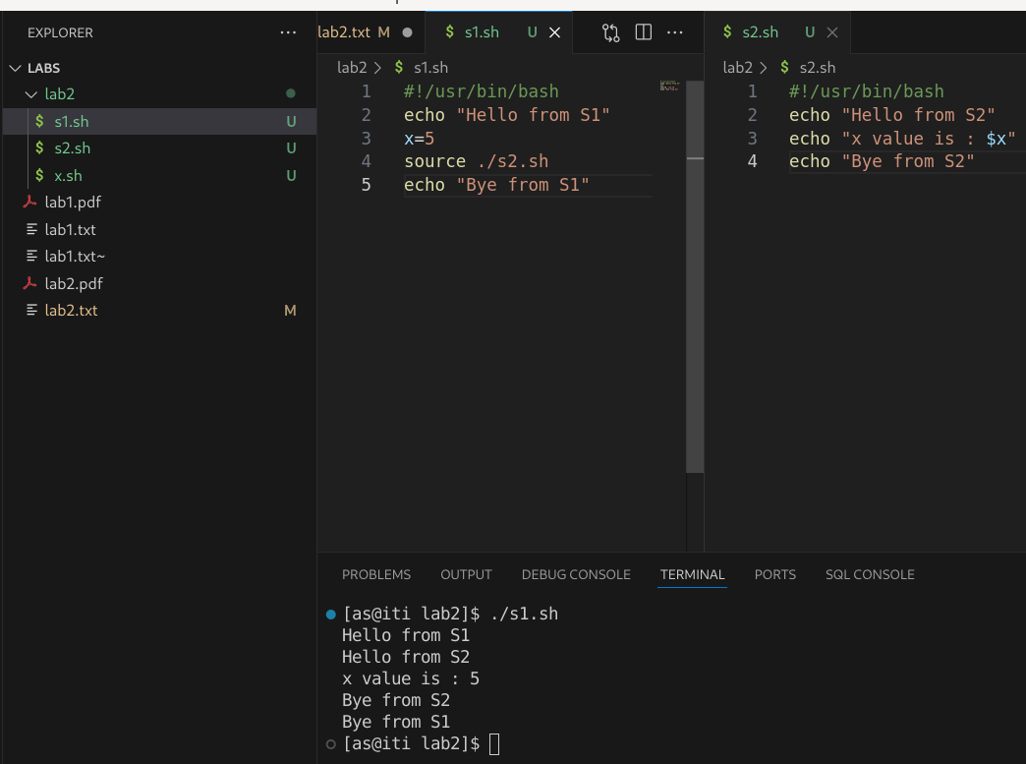

Answer 3,a:

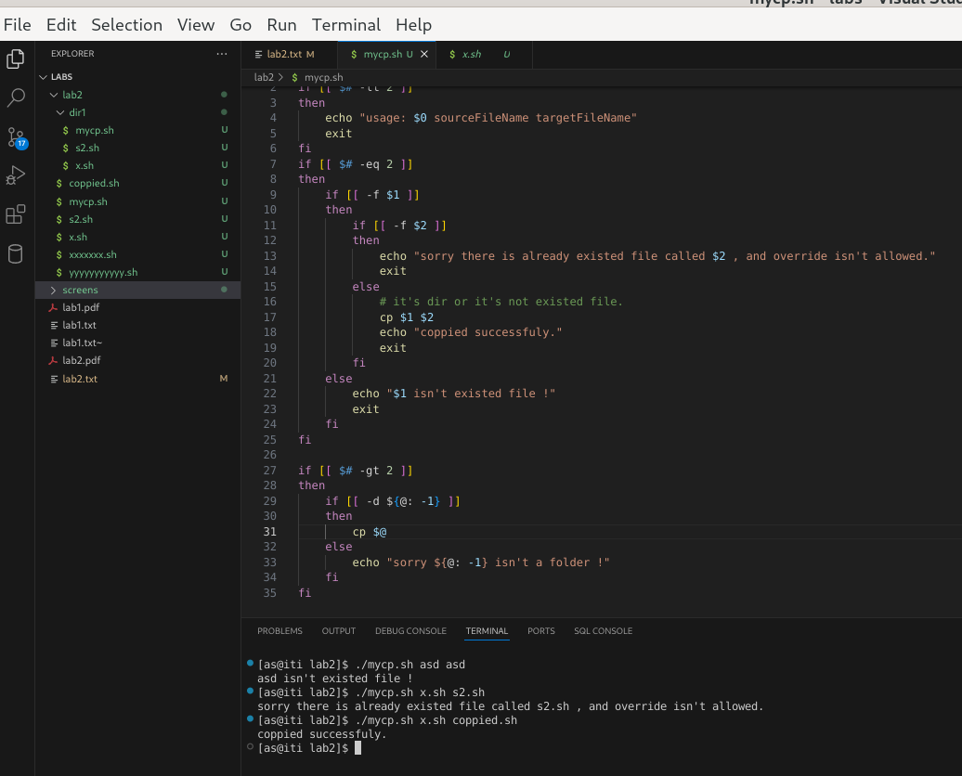

Answer 3,b:

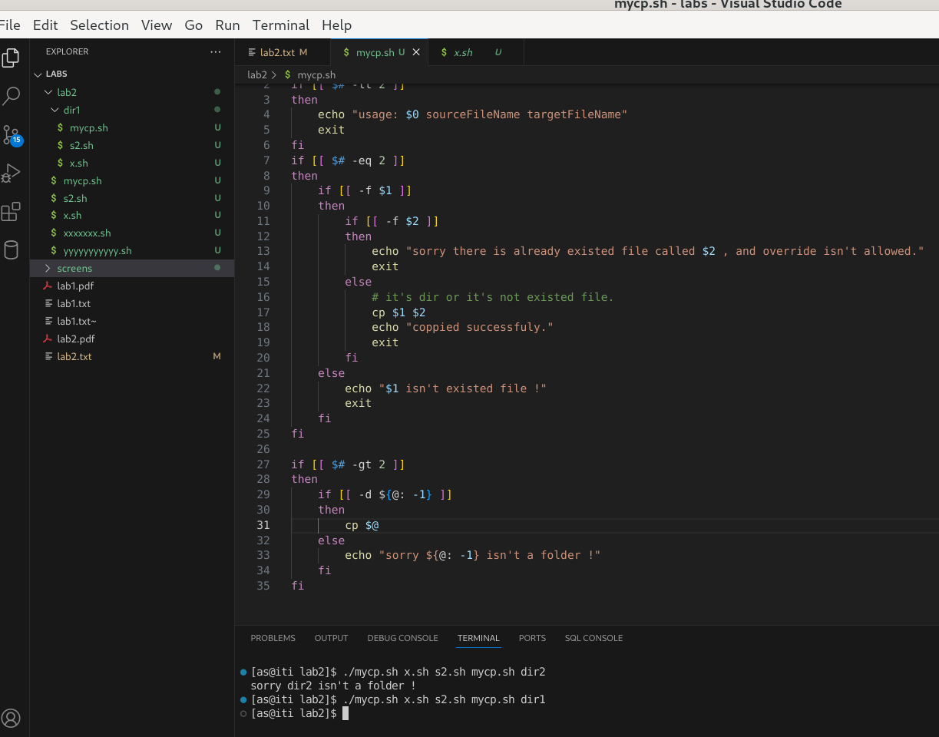

Answer 4:

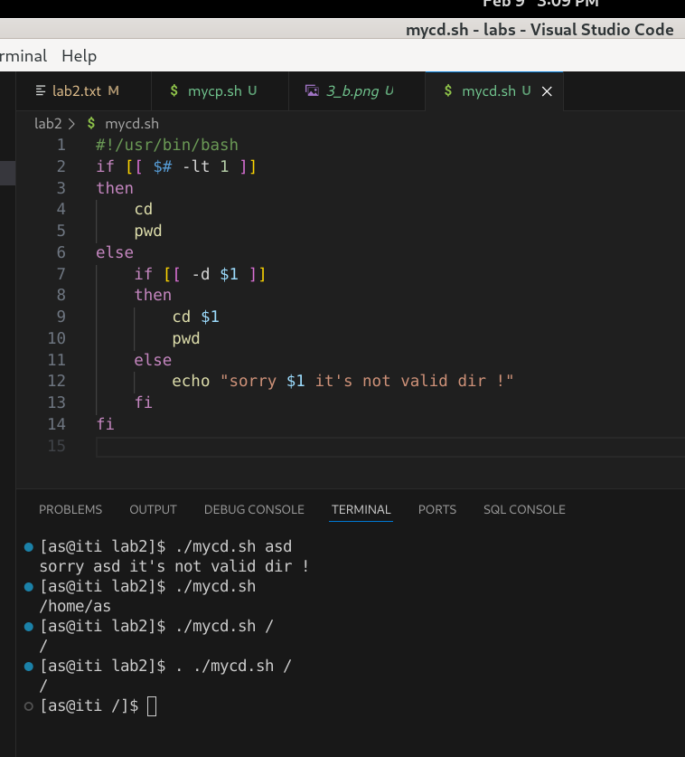

Answer 5:

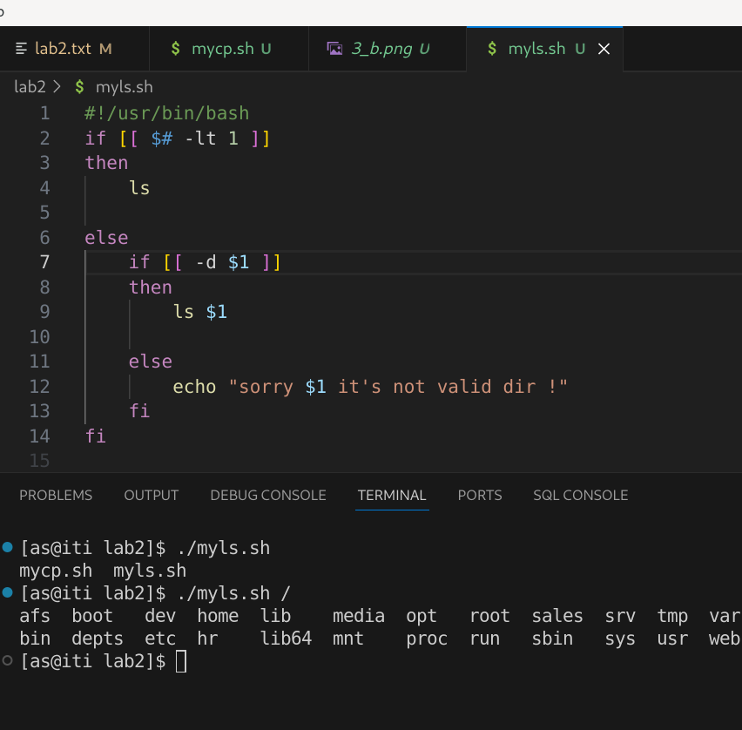  
Answer 6:

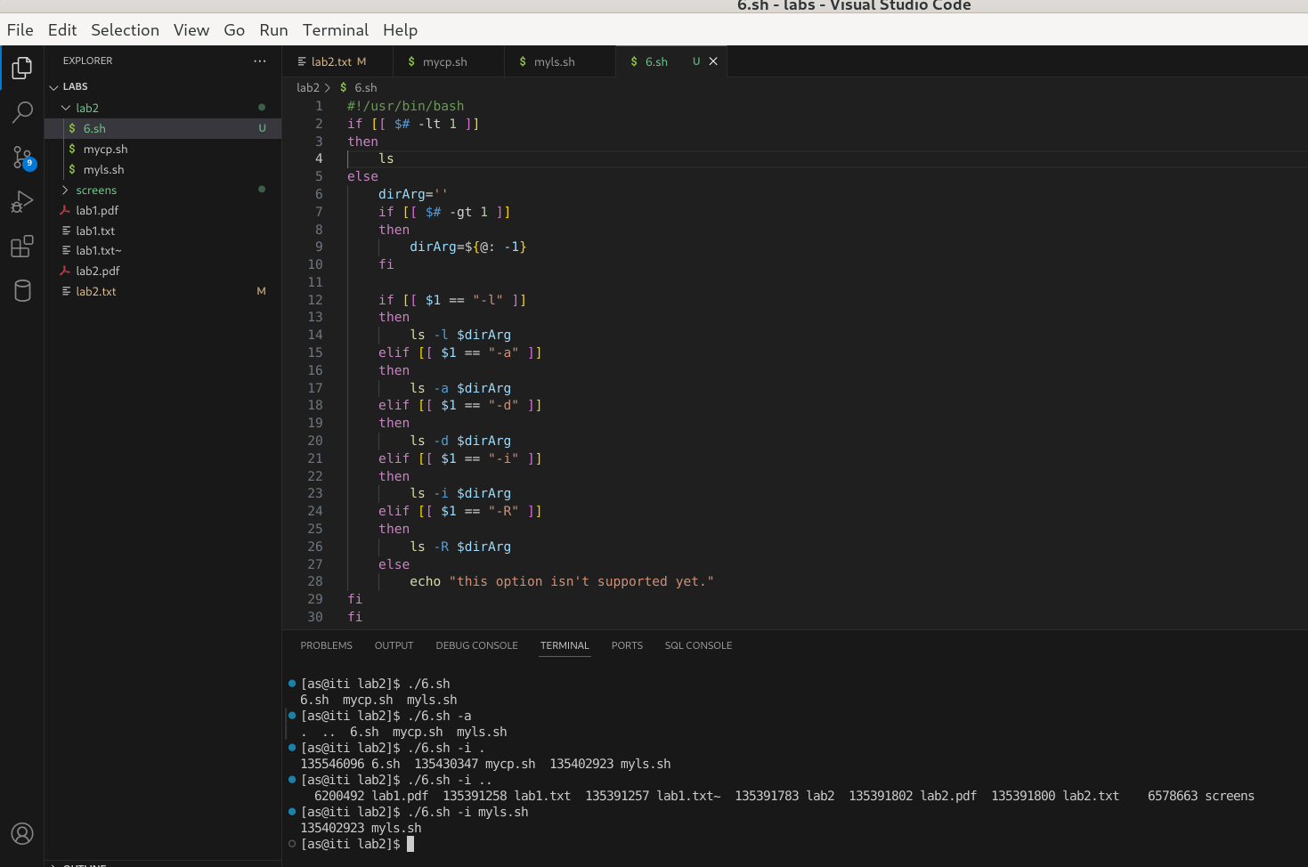

CODES:

=1===============================

#!/usr/bin/bash

read -p "Please write your name: " name

echo " welcome $name ! "

===============================

=2===============================

#!/usr/bin/bash

echo "Hello from S1"

export x=5

./s2.sh

echo "Bye from S1"

#!/usr/bin/bash

echo "Hello from S1"

x=5

source ./s2.sh

echo "Bye from S1"

#!/usr/bin/bash

echo "Hello from S2"

echo "x value is : $x"

echo "Bye from S2"

===============================

=3===============================

#!/usr/bin/bash

if [[ $# -lt 2 ]]

then

echo "usage: $0 sourceFileName targetFileName"

exit

fi

if [[ $# -eq 2 ]]

then

if [[ -f $1 ]]

then

if [[ -f $2 ]]

then

echo "sorry there is already existed file called $2 , and override isn't allowed."

exit

else

# it's dir or it's not existed file.

cp $1 $2

echo "coppied successfuly."

exit

fi

else

echo "$1 isn't existed file !"

exit

fi

fi

if [[ $# -gt 2 ]]

then

if [[ -d ${@: -1} ]]

then

cp $@

else

echo "sorry ${@: -1} isn't a folder !"

fi

fi

===============================

=4=============================

#!/usr/bin/bash

if [[ $# -lt 1 ]]

then

cd

pwd

else

if [[ -d $1 ]]

then

cd $1

pwd

else

echo "sorry $1 it's not valid dir !"

fi

fi

===============================

=5=============================

#!/usr/bin/bash

if [[ $# -lt 1 ]]

then

ls

else

if [[ -d $1 ]]

then

ls $1

else

echo "sorry $1 it's not valid dir !"

fi

fi

===============================

=6=============================

#!/usr/bin/bash

if [[ $# -lt 1 ]]

then

ls

else

dirArg=''

if [[ $# -gt 1 ]]

then

dirArg=${@: -1}

fi

if [[ $1 == "-l" ]]

then

ls -l $dirArg

elif [[ $1 == "-a" ]]

then

ls -a $dirArg

elif [[ $1 == "-d" ]]

then

ls -d $dirArg

elif [[ $1 == "-i" ]]

then

ls -i $dirArg

elif [[ $1 == "-R" ]]

then

ls -R $dirArg

else

echo "this option isn't supported yet."

fi

fi

===============================

https://github.com/ahmedsalah-iti/lab_bash

===============================