A Multistage Differential BJT Amplifier Simulation

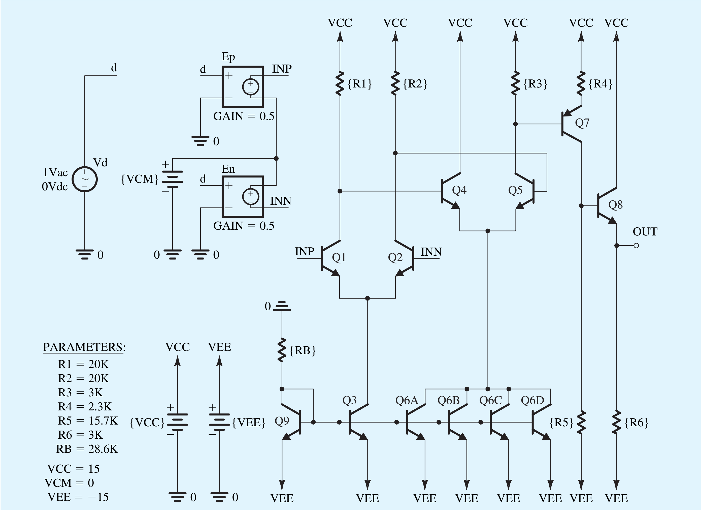

**Figure 1 Schematic capture of the op-amp circuit**

In this example, we will use parts Q2N3904 and Q2N3906 (from Fairchild Semiconductor) for the npn and pnp BJTs.

**Each student should supply a pdf report that has results and an OrCAD project files in .zip format.**

* **construct the circuit shown in Figure-1.**

In OrCAD, the common-mode input voltage **VCM** of the op-amp circuit is set to 0 V (i.e., to the average of the dc power-supply voltages **VCC** and **VEE**) to maximize the available input signal swing. **A bias-point** simulation is performed to determine the dc operating point.

* **Construct a table that shows the collector current for each transistor.**

To compute the large-signal differential transfer characteristic of the op-amp circuit, we perform a **dc-analysis simulation** in PSpice with the differential voltage input **Vd** swept over the range **–VEE** to **+VCC**, and we plot the corresponding output voltage **VOUT.**

* **Plot the resulting dc transfer characteristic.**

Repeat **dc analysis** is with **Vd** swept over the range −5mV to +5mV at increments of 10 μV.

* **Plot the resulting differential dc transfer characteristic. What is the gain of op-amp?**

To compute the **frequency response** of the op-amp circuit and to measure its differential gain **Ad** and its 3-dB frequency **fH** in OrCAD, we set the differential input voltage **Vd** to be a 1-V ac signal (with 0-V dc level), perform an **ac-analysis simulation**.

* **Plot the output voltage magnitude VOUT versus frequency.**

Notes:   
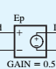 This voltage controlled voltage source that can be found in OrCAD under **ANALOG lib** with name **E.**