Contents

OBJECTIVE 2

EQUIPMENTS: 2

READING 2

Introduction: 2

EXPLORATIONS 2

Exercise 1: Creating new Project 2

**Steps:** 3

Exercise 2: DC Bias Point Analysis 4

**Steps:** 4

Exercise 3: DC Analysis 7

**Steps:** 7

Exercise 4: AC Analysis 8

**Steps:** 9

Exercise 5: Transient Analysis 10

**Steps:** 10

References: 11

NOTES 12

OBJECTIVE**:**

The objective of this Lab is to introduce students with the Cadence/OrCAD family of Electronic Design Automation (EDA) software that provides a complete design flow from schematic entry to circuit simulation through to PCB layout.

# EQUIPMENTS:

You will need a Computer or Laptop with OrCAD16.5 or Later installed

# READING

The material on which this Lab concentrates, is presented in chapter-1 to chapter-7 of the text “Analog Design and Simulation using OrCAD Capture and PSpice [1st Ed.]”

# Introduction:

The Cadence/OrCAD family of Electronic Design Automation (EDA) software provides a complete design flow from schematic entry to circuit simulation through to PCB layout. The circuit is drawn using the Capture or Capture CIS schematic editor and circuit simulations are performed using PSpice. The schematic diagram is translated into a printed circuit board design using Cadence Allegro or PCB Editor which has replaced OrCAD Layout. In this lab, we will learn how to create a new project in OrCAD, draw a circuit using Capture CIS and simulate the circuit using PSpice. Different types of simulations will be covered including: DC Bias Point Analysis, DC Analysis, AC Analysis, Parametric Sweep and Transient Analysis.

# EXPLORATIONS

## Exercise 1: Creating new Project

You will create a new PSpice project and name it **exercise_1**. The project will be created in a folder called, for example, “**C:\Lab1\ Exercises”** and will be configured with the simple five default libraries.

### **Steps:**

1. Select **File > New > Project**. Enter **exercise_1** for the Name and select Analog or Mixed A/D for project type. In Location, enter “C:\Lab1\ Exercises” or you can use your own folder location. Check your entries with and then click on OK.
2. In the Create PSpice Project window, select Create based upon existing project option and then from the underneath combo box select simple.opj. Finally, when you finish click on OK.
3. The Project Manager window will appear. Expand exercise_1.dsn folder by double clicking on it to open the SCHEMATIC1 folder.
4. Double click on SCHEMATIC1 to open PAGE1 and double click on PAGE1 to open up the schematic page.
5. When you first open the schematic page, you will see some preplaced text and two voltage sources preplaced. Delete the sources and text by drawing a box around the sources and text and pressing the delete key.
6. Now we want to draw the resistor network shown in Figure 1

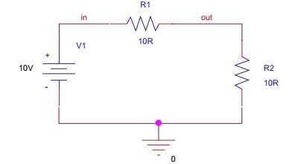

Figure Simple resistor circuit

1. To place a resistor, select **Place > Part** and select an R from the analog.olb library. Double click on the R and the resistor will attach to the cursor. From release 16.0 onwards, when you double click on a part or click on the Place Part Icon, the menu will remain open. When you place the first resistor in the schematic, another resistor will be attached to the cursor; press R on the keyboard to Rotate and place the second resistor. To exit place part mode, press escape. Whenever a part is selected, there is an rmb context menu for place part options.  
    P is the hotkey to place a part or you can select the Place Part icon.
2. For R1 and R2, double click on the default resistor value of 1k and change its value to 10 R.
3. Place the voltage source, which can be found in the source library. Change its voltage to 10 V.
4. To place a ground symbol, Place > Ground (or press G) or click on the icon  or and select the 0 V symbol from the capsym.olb library.
5. To draw a wire**, Place > Wire** (or select the wire icon  or press W).You can always zoom in by pressing the ’I’ key on the keyboard, or ’O’ for zoom out.

**NOTE** : To exit wire mode, press escape (Esc) on the keyboard or press W on the keyboard, which toggles wire mode on and off. If you make a mistake you can always select the undo icon .

## Exercise 2: DC Bias Point Analysis

When you connect a battery or a power supply to a circuit, the circuit voltages and currents effectively settle down to what is known as a DC steady-state condition. This is also known as the operating point or bias point of a circuit under steady-state conditions. In PSpice, the bias point analysis calculates the node voltages and currents through the devices in the circuit. For example, for a simple common emitter transistor amplifier, the bias point analysis will calculate the base, emitter and collector bias voltages, and the base, collector and emitter quiescent currents.

The calculated bias point voltages and currents are also used as a starting point for the other circuit analysis calculations. For example, when you run a transient (time) or an AC (frequency) analysis, PSpice automatically runs a bias point analysis first. However, the bias point analysis can be turned off for special cases in which a DC steady-state solution cannot be found. This is especially useful in the case of an oscillator which relies on the fact that it has no steady-state condition.

### **Steps:**

1. The circuit in Figure 2 is based upon the resistor circuit in Exercise 1. Add a 1n capacitor, from the analog library, in parallel with R2.
2. With the circuit drawn, a **PSpice simulation profile** needs to be set up. The settings are accessed from the top toolbar, **PSpice > New Simulation Profile**. This is where the different analysis types for DC, AC, transient and bias point are selected. By default, Bias Point is selected.

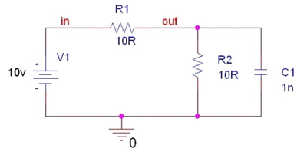

Figure RC circuit.

1. To run the simulation, select **PSpice > Run** or select the play button 
2. After a simulation is run, the bias voltage, current and power values can be displayed on the schematic. In Capture, select **PSpice > Bias Points > Enable** or select the bias display icons
3. Delete the 0 V volt symbol and resimulate. A warning message will appear asking you to check the session log, which is normally open at the bottom of the screen in Capture. You may have to expand the window upwards to see the complete message. If the session log is not visible, it can be found from the top toolbar, **Window >Session Log** and should contain the following message:  
   WARNING [NET0129] Your design does not contain a Ground (0) net.
4. In the RC circuit, reconnect the ground symbol and resimulate. There should be no errors. In the **capsym** library there are other ground symbols, as shown. For PSpice simulations, make sure that you select the ground symbol with the 0 showing. The other symbols can be placed in the circuit to show the difference between ground connections as long as there is a 0 V node in the circuit.



1. Create a bias point simulation profile based upon the initial bias point: **PSpice > New Simulation Profile** or click on the icon  and enter **bias** for the simulation Name and click on **Create**.
2. A dialog box in will appear telling you that a simulation profile of the same name already exists. New projects already include a default bias point simulation profile called **Bias**. Click on OK and Capture will automatically present you with a new name of bias1 (Figure 2.23). Click on Create.
3. The simulation settings window will appear . If not already set by default, select the Analysis type to Bias Point. Click on Apply but do not exit.
4. Under the **Options** tab, select Output File in the Category: box and uncheck(**NOBIAS**) and check (**LIST**) . Click on OK.
5. Run the simulation. When PSpice launches, select **View > Output file**. The output file shows a summary of the resistors, capacitor and voltage source used in the circuit. The output voltages and currents are not reported in the output file.
6. Create another new PSpice simulation profile, but this time the bias point simulation settings will be inherited from the previous bias1 point simulation profile. In the New Simulation window, enter bias2 for the Name. Click on the pull down Inherit From menu select bias1 and click on Create. In the simulation settings, you will see that Bias Point analysis is selected. Select Options > Output file and you will see that LIST is checked and (NOBIAS) is unchecked. Close on OK to close the new simulation profile. You now have created three bias point simulation profiles: bias, bias1 and bias2.
7. If it is not already displayed, open the Project Manager window by either selecting **Window > <project path> \schematic1.opj** file or clicking on the icon.
8. In the Project Manager window, expand the **PSpice Resources > Simulation Profiles**. The three bias point analysis simulation profiles that have been created are listed in the Project Manager and are also displayed on the left-hand side of the top toolbar in which a pull-down menu lists the simulation profiles, bias, bias1 and bias2. Note that bias2 is selected, which appears in the Project Manager with a red icon to its left. This indicates that this is the current or active profile. You can select another profile in the pull-down list or alternatively select the profile in the Project Manager and **rmb > Make Active**.
9. 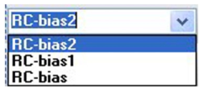Select bias1 in the pull-down profile list and note the change in the Project Manager Simulation Profiles section. Bias1 is now the active profile.
10. Run the simulation based on any simulation profile you want and see results.

## Exercise 3: DC Analysis

The DC analysis calculates the circuit’s bias point over a range of values when sweeping a voltage or current source, temperature, a global parameter or a model parameter. The swept value can increase in a linear or a logarithmic range or can be a list of increasing values.

This is useful for example if you want to see the circuit response for a change in the supply voltage or to see how a change in a resistor value affects the circuit response. The DC sweep also allows for nested sweeps such that one of two variables is kept constant while sweeping the other variable. For example, the characteristic transistor IC-VCE curve plots the collector current against the collector-emitter voltage for fixed values of base current. The DC sweep will then contain two variables, the collector-emitter voltage VCE and the base current IB. The base current is the secondary sweep while the VCE is the primary sweep. The collector current IC is recorded by successive voltage sweeps of the collector-emitter voltage VCE for stepped values of base current producing a series of curves.

### **Steps:**

1. Create new project, call it Exercise_3 and save it.
2. Open the schematic page and draw the circuit in Figure 3. The transistor can be found in the bipolar library. In the Place Part menu, select the Add Library icon  This will open up the Browse File window. Scroll along or, alternatively, type in **bipolar.olb** in the File name field. Select **bipolar.olb** and click on Open.

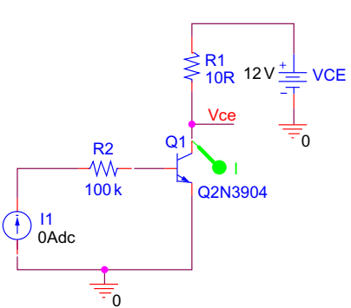

Figure Transistor circuit.

1. The bipolar library will now be added to the list of libraries in the Place Part menu. Select the bipolar library and type in Q2N3904 (not case sensitive) in the Part box . Double click on the q2n3904 transistor and place in the schematic page.
2. Place the rest of the components as shown in Figure 3
3. You will set up a nested DC sweep where the VCE will be the primary sweep and the base current the secondary sweep.
4. Create a simulation profile, PSpice > New Simulation Profile, and select the Analysis type to DC Sweep. For the Primary Sweep, which is shown by default, select the Sweep variable to be a voltage source and name the source Vce. The Sweep type is Linear with a Start value of 0 V, an End value of 12 V and an Increment of 0.1 V. Click on Apply but do not exit the Simulation Profile.
5. In the Options box, select the Secondary Sweep. The Sweep variable is the current source I1. The Sweep type is Linear with a Start value of 40u, an End value of 200u and an Increment of 40u. Make sure the Secondary Sweep box is checked and click on OK.
6. Place a current marker on the collector pin of the transistor and simulate.
7. You should see the characteristic curves of a normal npn transistor.
8. Select **Plot > Axis Settings > YAxis**, change the Data Range to User Defined and enter a range from 0 mA to 40 mA. Click on OK and see the change.
9. Select **Plot > Axis Settings > YGrid** and uncheck Automatic and set the Major Spacing to 10 m. Click on OK and see the change.
10. Select **Plot > Axis Settings > XGrid** and uncheck both Major and Minor Grids to None. Click on OK and see the change.
11. Select **Plot > Axis Settings > YGrid** and uncheck both Major and Minor Grids to None. Click on OK and see the change.
12. Select **Plot > Label> Text**,change the font color to silver and add the base currents. Click on OK and see the change.

## Exercise 4: AC Analysis

The AC analysis is used to calculate the frequency and phase response of a circuit by frequency sweeping an AC source connected to the circuit. The AC sweep analysis is a linear analysis and calculates **what is known as the small signal response** of a circuit over a range of frequencies by replacing any non-linear circuit device models with linear models. **The DC bias point analysis is run prior to the AC analysis** and is used to effectively linearize the circuit around the DC bias point**. It must be noted** that the AC analysis **does not take into** account effects such as clipping. You will have to run a transient analysis to determine these effects.

To perform an AC analysis, the independent voltage source VAC or current source IAC from the source library is used. However, any independent voltage source which has an AC property attached to the part can be used as an input to the circuit.

### **Steps:**

1. Create new project, call it Exercise_4 and save it.
2. Open the schematic page and draw the circuit of the LPF in Figure 4. The VAC source can be found in the source library.

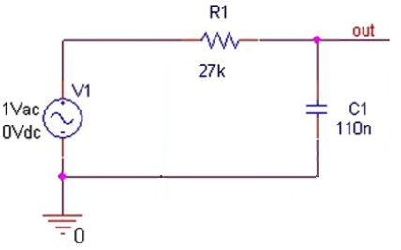

Figure RC LPF

1. To set up an AC analysis, a PSpice simulation profile needs to be created:   
   **PSpice > New Simulation Profile**. The Analysis type is set to AC Sweep/Noise and has been set up for a logarithmic frequency sweep starting from 1 Hz to   
   100 kHz. You have the choice to sweep the frequency linearly over the whole range or logarithmically either in decades or in octaves. Create a PSpice simulation profile to perform a logarithmic sweep from 1 Hz to 100 kHz in steps of 100 points per decade.
2. Place a VdB voltage marker, which will automatically calculate the output voltage in dB: **PSpice > Markers > Advanced > dB Magnitude of Voltage**.
3. Run the simulation and you should see the LPF filter response. What we need to do now is to determine the frequency at -3dB point and compare it to the value calculated from the formula: 1/ (2πRC).
4. To manually add a trace to the cursor, Select **Trace > Add Trace** and the Add Traces window will appear and in the right-hand side of Add Traces under Analog Operators and Functions, select DB().Then, select the variable you want to display from the list of Simulation Output Variables. At the bottom of the window in the Trace Expression box, you should see something like that DB(V(out)) based on the variable you have chosen. The DB function automatically calculates the DB of V(out).
5. Turn on the cursor, Trace > Cursor > Display and place the cursor near the -3dB point and for a more accurate reading, zoom in until you get the exact point.

## Exercise 5: Transient Analysis

Transient analysis calculates a circuit’s response over a period of time defined by the user. The accuracy of the transient analysis is dependent on the size of internal time steps, which together make up the complete simulation time known as the Run to time or Stop time. However, as mentioned in Exercise 2, a DC bias point analysis is performed first to establish the starting DC operating point for the circuit at time t = 0. The time is then incremented by one predetermined time step at which node voltages and current are calculated based on the initial calculated values at time t = 0. For every time step, the node voltages and currents are calculated and compared to the previous time step DC solution. Only when the difference between two DC solutions falls within a specified tolerance (accuracy) will the analysis move on to the next internal time step. The time step is dynamically adjusted until a solution within tolerance is found.

### **Steps:**

1. Create new project, call it Exercise_5 and save it.
2. Open the schematic page and draw the circuit in Figure 5. The transistor can be found in the bipolar library. In the Place Part menu, select the Add Library icon  This will open up the Browse File window. Scroll along or, alternatively, type in bipolar.olb in the File name field. Select bipolar.olb and click on Open.
3. Add a VSIN source from the source library and don't confuse it with VAC, adjust its parameters as shown in Figure 5.
4. Create a PSpice simulation profile called transient and select Analysis type: to Time Domain (Transient) and enter a Run to time of 10m, which will display 10 cycles of the sinewave.
5. Place a voltage marker on nodes “out” and “in”and run the simulation. You should see the resultant waveforms, which is lacking in resolution.
6. Compare the two waveforms and calculate the gain and compare it to its theoretical value [Gain = Rc/Re].
7. In the simulation profile, to increase resolution and you have to decrease decrease the time step. To do this you can enter the **Maximum step size = 10u.**

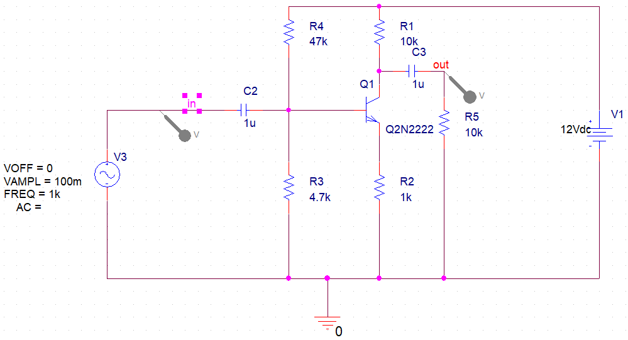

Figure Common Emitter Amplifier

1. Try to change the values of R1, R5 and R2 to see its effect on the gain.
2. Try to increase the Amplitude of Voltage source and notice its effect on the output signal.
3. To display each signal on separate graph from **Trace > Delete All Traces** to delete all existing traces. Then, from **Trace > Add Trace** choose **V(out)** from the list of simulation output variables.
4. From **Plot> Add plot to window** will add new blank plot. Then, from **Trace > Add Trace** choose **V(in)** from the list of simulation output variables.

**At last, you have seen several ways in which simulation makes a difference!**

# References:

1. Analog Design andSimulation using OrCAD® Capture and PSpice® [2nd Ed].

# NOTES