ECE 3rd year Laboratory   
LAB #1  
Analog Design and Simulation   
using OrCAD® Capture and PSpice®

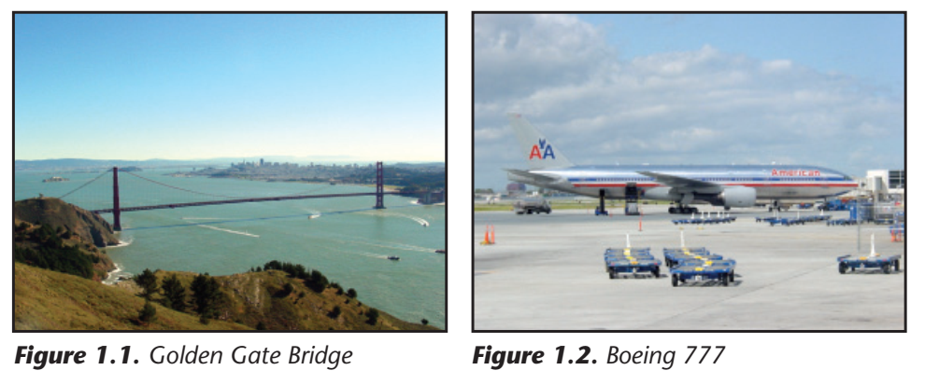

What do the Golden Gate Bridge and the Boeing 777 pictured in **Figure 1.1** and **Figure** 1.2 have in common? Both of them were built with no prototypes. In other words, they were right the first time. How was this possible? Sufficient Engineering Analysis OR Simulation  
 was done prior to construction to guarantee that each piece of each product would function properly. Why perform this level of engineering analysis? To do otherwise, the cost is too high.