**INTERSYMBOL INTERFERENCE**

# OBJECT

The effects of restricted bandwidth in baseband data transmission will be studied. Measurements relative to intersymbol interference, using the eye pattern and the response of the data transmission system to one pulse, will be made.

# THEORETICAL BACKGROUND

# Understanding Eye Diagrams:

# An eye diagram is a common indicator of the quality of signals in high-speed digital transmissions. An oscilloscope generates an eye diagram by overlaying sweeps of different segments of a long data stream driven by a master clock. The triggering edge may be positive or negative, but the displayed pulse that appears after a delay period may go either way; there is no way of knowing beforehand the value of an arbitrary bit. Therefore, when many such transitions have been overlaid, positive and negative pulses are superimposed on each other. Overlaying many bits produces an eye diagram, so called because the resulting image looks like the opening of an eye.

# https://www.mathworks.com/help/comm/ref/2dcolor.png

Figure 1 an example of eye diagram

In an ideal world, eye diagrams would look like rectangular boxes. In reality, communications are imperfect, so the transitions do not line perfectly on top of each other, and an eye-shaped pattern results. On an oscilloscope, the shape of an eye diagram will depend upon various types of triggering signals, such as clock triggers, divided clock triggers, and pattern triggers. Differences in timing and amplitude from bit to bit cause the eye opening to shrink.

**How an eye diagram is constructed?**

A properly constructed eye should contain every possible bit sequence from simple alternate 1’s and 0’s to isolated 1’s after long runs of 0’s, and all other patterns that may show up weaknesses in the design. Eye diagrams usually include voltage and time samples of the data acquired at some sample rate below the data rate.  
 In **Figure 2,** the bit sequences 011, 001, 100, and 110 are superimposed over one another to obtain the final eye diagram.

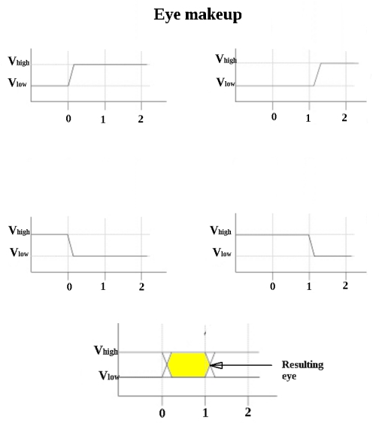

Figure 2 eye diagram construction example

A perfect eye diagram contains an immense amount of parametric information about a signal, like the effects deriving from physics, irrespective of how infrequently these effects occur. If a logic 1 is so distorted that the receiver at the far end can misjudge it for logic 0, you will easily discern this from an eye diagram. What you will not be able to detect, however, are logic or protocol problems, such as when a system is supposed to transmit a logic 0 but sends a logic 1, or when the logic is in conflict with a protocol.

**What is jitter?**  
Although in theory eye diagrams should look like rectangular boxes, the finite rise and fall times of signals and oscilloscopes cause eye diagrams to actually look more like the image in Figure 3a. When high-speed digital signals are transmitted, the impairments introduced at various stages lead to timing errors. One such timing error is “jitter,” which results from the misalignment of rise and fall times (Figure 3b).

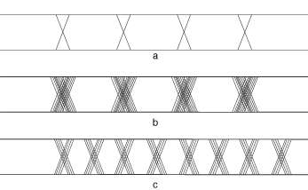

Figure 3(a) Finite rise and fall times cause eye diagrams to look like this image rather than like a rectangle. (b) Jitter results from the misalignment of rise and fall times. (c) Although the absolute timing error or jitter margin is less than that in image b

Jitter occurs when a rising or falling edges occur at times that differ from the ideal time. Some edges occur early, some occur late. In a digital circuit, all signals are transmitted in reference to clock signals. The deviation of the digital signals as a result of reflections, intersymbol interference, crosstalk, PVT (process-voltage-temperature) variations, and other factors amounts to jitter. Some jitter is simply random. In **Figure 3c,** the absolute timing error or jitter margin is less than that in Figure 3b, but the eye opening in Figure 2c is smaller because of the higher bit rate. With the increase in bit rate, the absolute time error represents an increasing portion of the cycle, thus reducing the size of the eye opening. This may increase the potential for data errors. As can be seen in **Figure 4,** an eye diagram can reveal important information. It can indicate the best point for sampling, divulge the SNR (signal-to-noise ratio) at the sampling point, and indicate the amount of jitter and distortion. Additionally, it can show the time variation at zero crossing, which is a measure of jitter.  
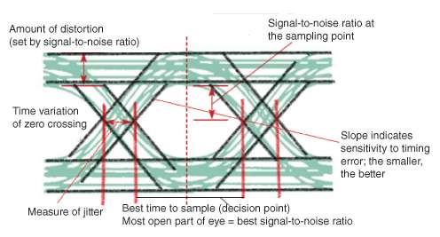

Figure 4An eye diagram can help you interpret a signal and determine the best time for making a measurement.

Eye diagrams provide instant visual data that engineers can use to check the signal integrity of a design and uncover problems early in the design process. Used in conjunction with other measurements such as bit-error rate, an eye diagram can help a designer predict performance and identify possible sources of problems.

## Inter Symbol Interference

This is a form of distortion of a signal, in which one or more symbols interfere with subsequent signals, causing noise or delivering a poor output.

### **Causes of ISI**

The main causes of ISI are:

* Multi-path Propagation
* Non-linear frequency in channels

Figure 5a introduces the filtering aspects of a typical digital communication system. There are various filters (and reactive circuit elements such as inductors and capacitors) throughout the system in the transmitter, in the receiver, and in the channel. At the transmitter, the information symbols, characterized as impulses or voltage levels, modulate pulses that are then filtered to comply with some bandwidth constraint. For baseband systems, the channel (a cable) has distributed reactance that distort the pulses. Some bandpass systems, such as wireless systems, are characterized by fading channels, that behave like undesirable filters manifesting signal distortion. When the receiving filter is configured to compensate for the distortion caused by *both* the transmitter and the channel, it is often referred to as an *equalizing filter* or a *receiving/equalizing filter.* Figure 5b illustrates a convenient model for the system, lumping all the filtering effects into one overall equivalent system transfer function

$$H( f ) = H_{t} \left( f \right)H_{c} \left( f \right)H_{r}( f )$$

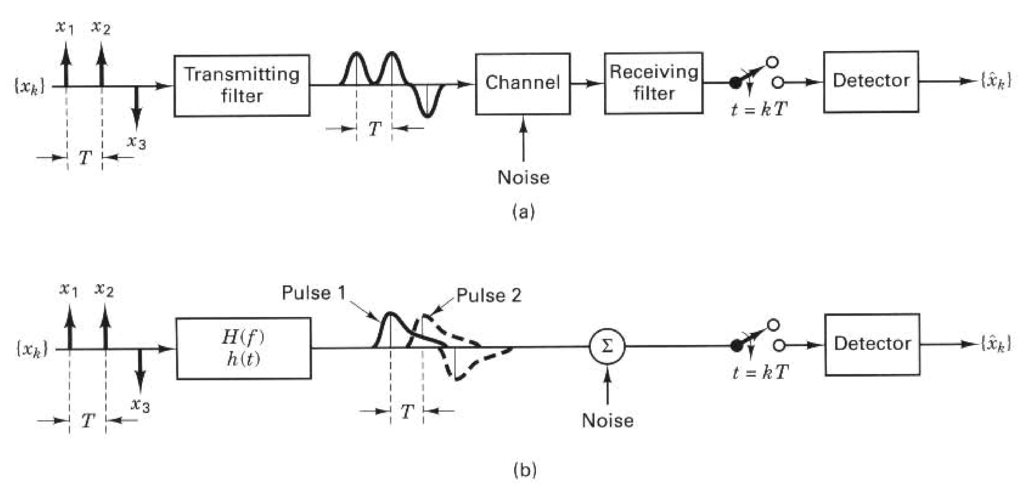

Figure 5 Intersymbol interference in the detection process, (a) Typical baseband digital system, (b) Equivalent model.

where $H_{t} \left( f \right)$ characterizes the transmitting filter, $H_{c} \left( f \right)$ the filtering within the channel, and $H_{r} \left( f \right)$ the receiving/equalizing filter. The characteristic $H\left( f \right)$, then, represents the composite system transfer function due to all the filtering at various locations throughout the transmitter / channel / receiver chain. In a binary system with a common PCM waveform, such as NRZ-L, the detector makes a symbol decision by comparing a sample of the received pulse to a threshold; for example, the  
detector in Figure 5 decides that a binary one was sent if the received pulse is positive, and that a binary zero was sent, if the received pulse is negative. Due to the effects of system filtering, the received pulses can overlap one another as shown in Figure 5b. The tail of a pulse can “ smear" into adjacent symbol intervals, thereby interfering with the detection process and degrading the error performance; such interference is termed intersymbol interference (ISI). Even in the absence of noise, the effects of filtering and channel-induced distortion lead to ISI.  
Sometimes Hc( f ) is specified, and the problem remains to determine Ht(f) and Hr(f), such that the ISI is minimized at the output of Hr( f ).

Nyquist investigated the problem of specifying a received pulse shape so  
that no 1SI occurs at the detector. He showed that the theoretical minimum system bandwidth needed in order to detect Rs symbols/s, without ISI, is R/2 hertz. This occurs when the system transfer function H( f ) is made rectangular, as shown in Figure 6a. For baseband systems, when H( f ) is such a filter with single-sided bandwidth 1/2T (the ideal Nyquist filter ), its impulse response, the inverse Fourier transform of H( f ) is of the form h( t) = sinc ( t/ T ), shown in Figure 6b. This sine (t/T) shaped pulse is called the ideal Nyquist pulse; its multiple lobes comprise a mainlobe and sidelobes called pre- and post-mainlobe tails that are infinitely long. Nyquist established that if each pulse of a received sequence is of the form sine (t/T ), the pulses can be detected without ISI. Figure 6b illustrates how ISI is avoided . There are two successive pulses, h(t ) and h( t - T). Even though h(t ) has long tails, the figure shows a tail passing through zero amplitude at the instant (t - T ) when  
 h (t - T ) is to be sampled, and likewise all tails pass through zero amplitude when any other pulse of the sequence h(t - k T ), k = ±1, ±2, . . . is to be sampled. Therefore, assuming that the sample timing is perfect, there will be no ISI degradation introduced. For baseband systems, the bandwidth required to detect *1/T*

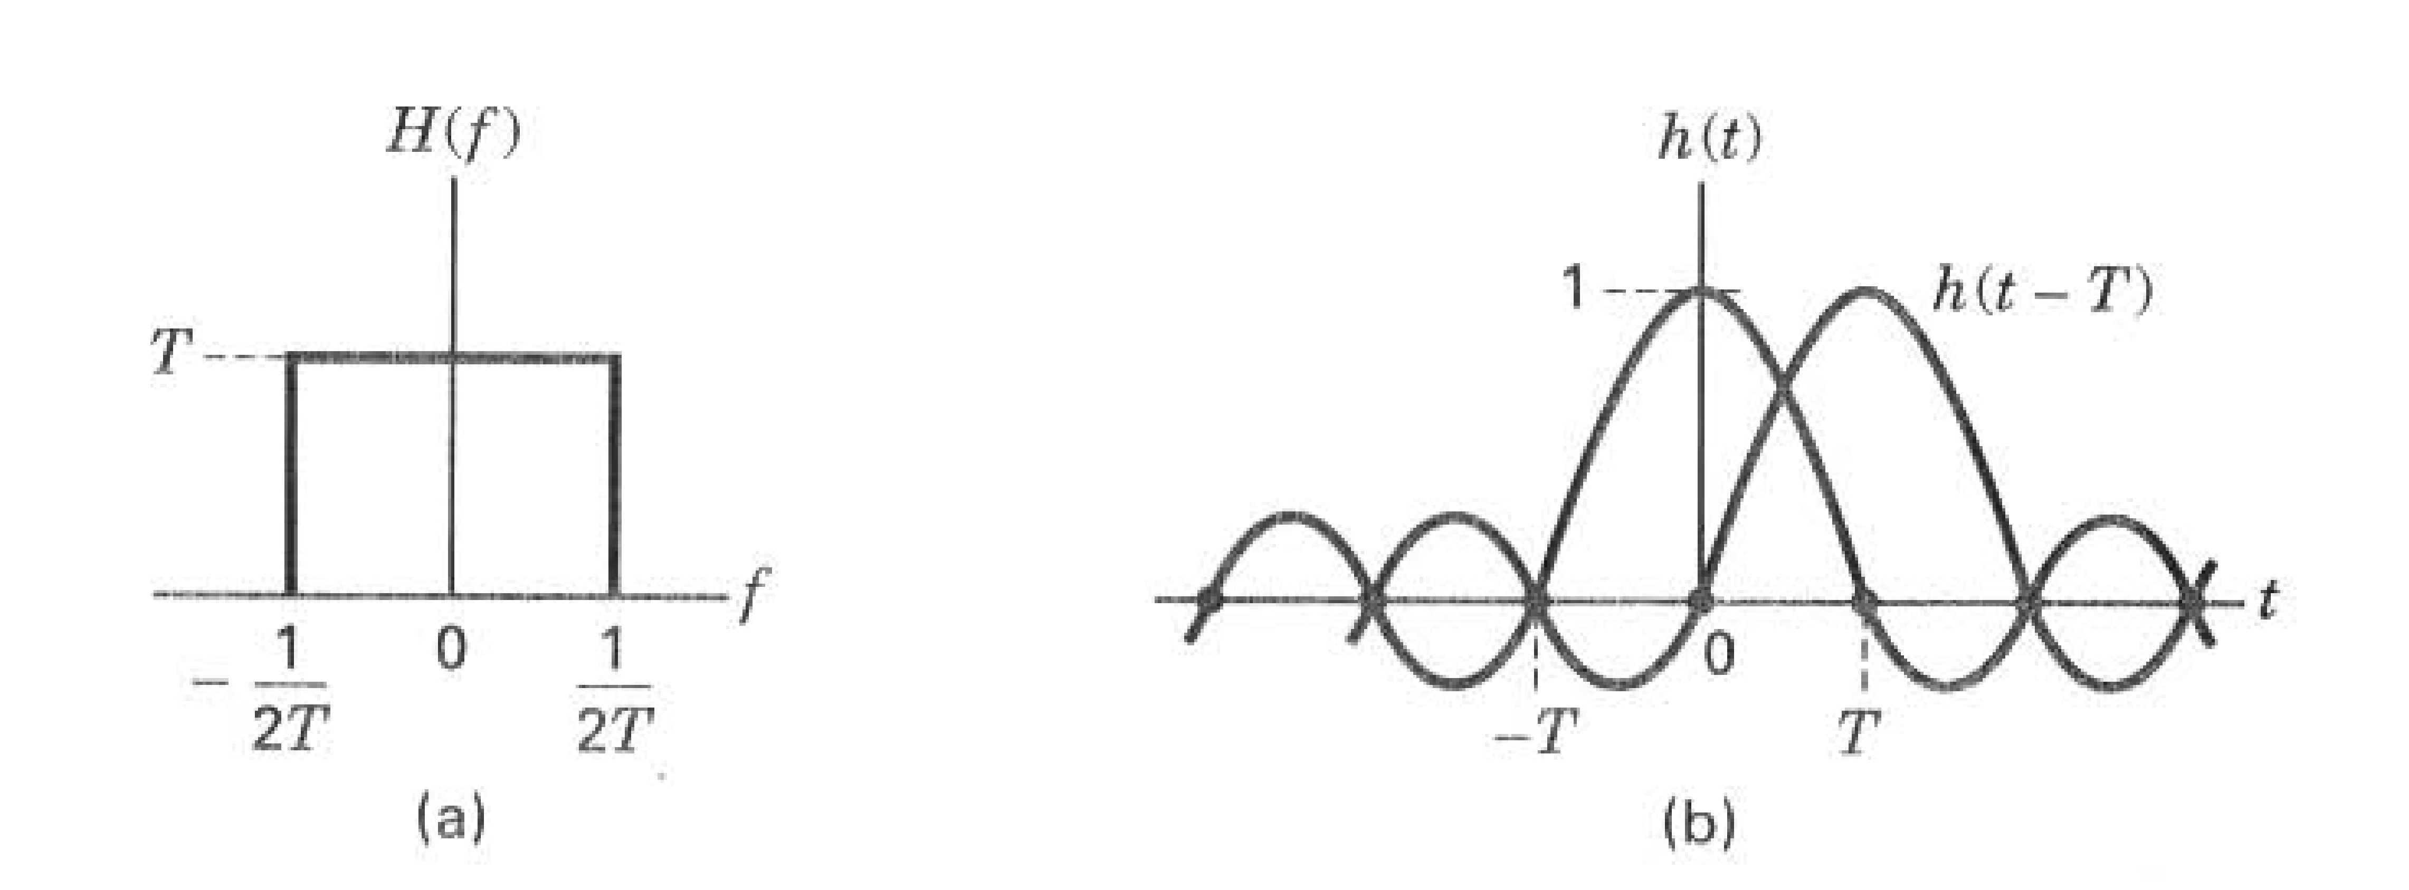

Figure 6 Nyquist channels for zero ISI. (a) Rectangular system transfer function H{ f ). (b) Received pulse shape h{ t ) = sine ( t / T ).

such pulses (symbols) per second is equal to 1/2T; in other words, a system with bandwidth W = 1/2T = Rs/ 2 hertz can support a maximum transmission rate of 2W = 1IT = Rs symbols/s ( Nyquist bandwidth constraint) without ISI. Thus, for ideal Nyquist filtering (and zero ISI), the maximum possible symbol transmission rate per hertz, called the symbol-rate packing, is 2 symbols/s/Hz. It should be clear from the rectangular shaped transfer function of the ideal Nyquist filter and the infinite length of its corresponding pulse, that such ideal filters arc not realizable; they can only be approximately realized. The names “ Nyquist filter” and “ Nyquist pulse’1 are often used to describe the general class of filtering and pulse shaping that satisfy zero ISI at the sampling points. A Nyquist filter is one whose frequency transfer function can be represented by a rectangular function convolved with any real even-symmetric frequency function. A Nyquist pulse is one whose shape can be represented by a sine ( t / T ) function multiplied by another time function. Hence, there are a countless number of Nyquist filters and corresponding pulse shapes. Amongst the class of Nyquist filters, the most popular ones are the raised cosine and the Root-raised cosine, treated below.

**The Raised-Cosine Filter**Earlier, it was stated that the receiving filter is often referred to as an equalizing filter, when it is configured to compensate for the distortion caused by both the transmitter and the channel. In other words, the configuration of this filter is chosen so as to optimize the composite system frequency transfer function H(f ), showen in Equation (3.77). One frequently used H (f ) transfer function belonging to the Nyquist class (zero IS1 at the sampling times) is called the raised-cosine filter It can be expressed as

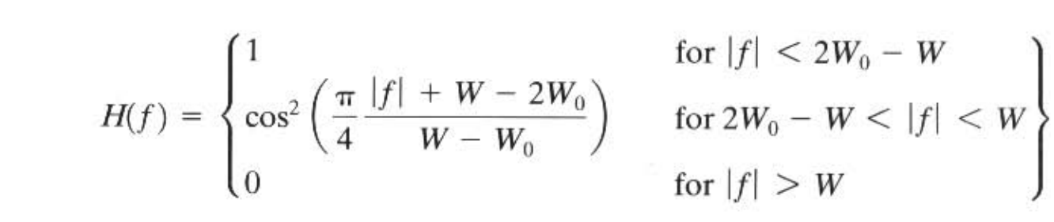

where W is the absolute bandwidth and Wo = 1/2T represents the minimum Nyquist bandwidth for the rectangular spectrum and the -6-dB bandwidth (or halfamplitude point) for the raised-cosine spectrum. The difference W- Wo is termed the “ excess bandwidth,” which means additional bandwidth beyond the Nyquist minimum (i.e., for the rectangular spectrum, W is equal to Wo). The roll-off factor is defined to be  
 r = (W - W0)/W0, where 0 < r <1. It represents the excess bandwidth divided by the filter-6-dB bandwidth (i.e., the fractional excess bandwidth).

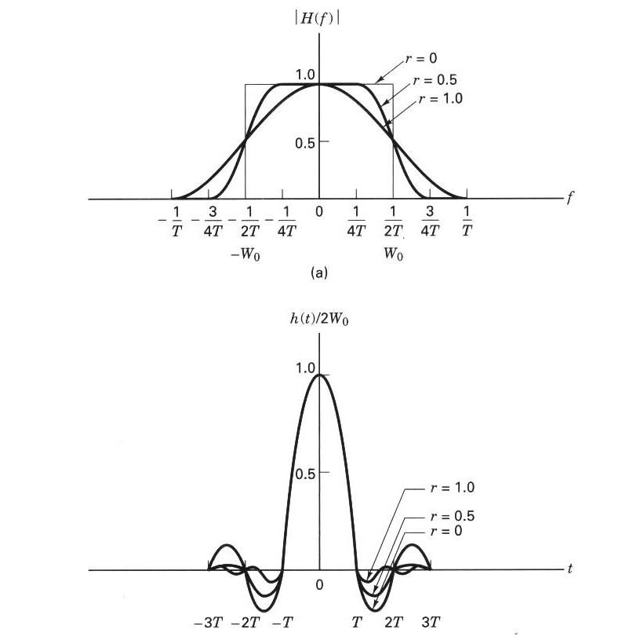

Figure 7 Raised-cosine filter characteristics, (a) System transfer function, (b) System impulse response.

For a given Wo, the roll-off r specifies the required excess bandwidth as a fraction of Wo and characterizes the steepness of the filter roll off. The raised-cosine characteristic is illustrated in Figure 7a for roll-off values of r , r =0.5, and r =1. The r = 0 roll-off is the Nyquist minimum-bandwidth case. Note that when r = 1, the required excess bandwidth is 100%, and the tails are quite small. A system with such an overall special characteristic can provide a symbol rate of R, symbols/s using a bandwidth of hertz (twice the Nyquist minimum bandwidth), thus yielding a symbol-rate packing of 1 symbol/s/Hz. The corresponding impulse response for the H( f ) of Equation above is

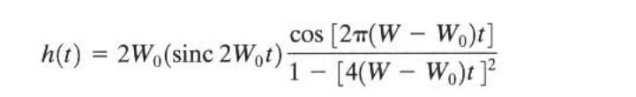

and is plotted in Figure 3.17b for r= 0. r ~ 0.5, and t = 1. The tails have zero value at each pulse-sampling time, regardless of the roll-off value.

We can only approximately implement a filter described by Equation above since, strictly speaking, the raised cosine spectrum is not physically realizable (for the same reason that the ideal Nyquist filter is not realizable). A realizable filter must have an impulse response of finite duration and exhibit a zero output prior to the pulse turn-on time.

Recall that the raised-cosine frequency transfer function describes the composite H ( f ) that is the “ full round trip" from the inception of the message (as an impulse) at the transmitter, through the channel , and through the receiving filter. The filtering at the receiver is the compensating portion of the overall transfer function to help bring about zero ISI with an overall transfer function, such as the raised cosine. Often this is accomplished by choosing (matching) the receiving filler and the transmitting filter so that each has a transfer function known as a rootraised cosine (square root of the raised cosine). Neglecting any channel-induced ISI, the product of these root-raised -cosine functions yields the composite raisedcosine system transfer function. Whenever a separate equalizing filter is introduced to mitigate the effects of channel-induced ISI, the receiving and equalizing filters together should be configured to compensate for the distortion caused by both the transmitter and the channel so as to yield an overall system transfer function characterized by zero ISI.

Let's review the trade-off that faces us in specifying pulse-shaping filters. The larger the filter roll-off, the shorter will be the pulse tails (which implies smaller tail amplitudes). Small tails exhibit less sensitivity to timing errors and thus make for small degradation due to ISI Notice in Figure 7b, for r = 1, that timing errors can still result in some ISI degradation. However, the problem is not as serious as it is for the case in which r = 0, because the tails of the h( t ) waveform are of much smaller amplitude for = 1 than they are for r = 0. The cost is more excess bandwidth. On the other hand, the smaller the filter roll-off, the smaller will be the excess bandwidth, thereby allowing us to increase the signaling rate or the number of users that can simultaneously use the system. The cost is longer pulse tails, larger pulse amplitudes, and thus, greater sensitivity to timing errors.

# EXPERIMENTAL DEVELOPMENT

## SIMULATION SCHEME PRESENTATION

In this section, the performances of a baseband data transmission scheme will be investigated using the eye pattern method. The block scheme of the data transmission system simulated using Simulink is presented in Figure 8.

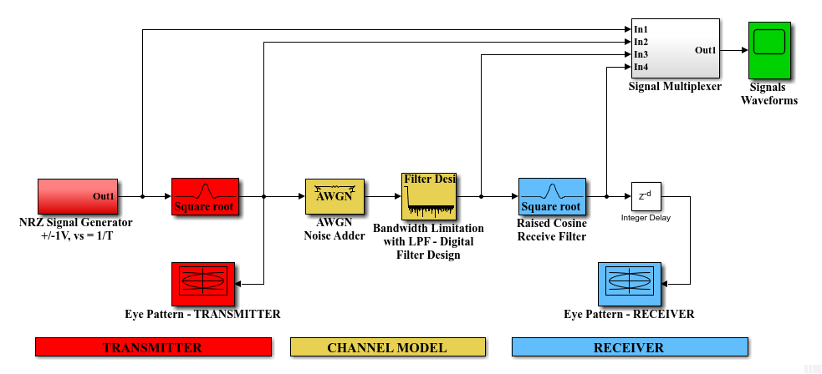

Figure 8 Data transmission system performance evaluation using Simulink.

The above scheme includes three main sections: the transmitter part (these blocks are marked with red), the channel model (the yellow blocks), and the receiver part (the blue blocks).

In the transmitter, a double polarity (+1/-1 V) NRZ signal is generated. This NRZ signal carries a sequence of L random bits. The symbol interval (equal to the bit interval) is denoted by T. Therefore, the signaling speed is given by vs = 1 / T. Then, the NRZ signal is filtered by a root raised–cosine filter (this transmit filter forms together with the receive counterpart the overall characteristic that minimizes the ISI). The roll-off factor of the RC filter is denoted as R. The output filtered signal can be analyzed using the eye pattern – transmitter block. Considering that this signal is not affected yet by the noise and channel distortions the eye pattern will show a wide open eye.

The channel model includes a noise adder and a LPF bandwidth limiter. The additive white Gaussian noise (AWGN) block adds a random noise with the power PN to the input NRZ signal with the power PS = 1W. The parameter that controls the noise power is the signal-to-noise ratio denoted by SNRdB = 10 log10 (PS / PN) [dB]. For example, a SNRdB = 0 dB specifies a noise power of PN = PS = 1W. the LPF bandwidth limiter restricts the bandwidth of the transmitted signal between 0 Hz and the cut-off frequency f1.

The receiver part includes a RC filter (identical to the transmitter one) and an eye-pattern analyzer. The eye-pattern in the receiver will be compared with the transmitter one to notice how the channel affects the system performances (the receiver eye closure).

## SIMULATION PROCEDURE

Download the Matlab/Simulink files from the website <https://github.com/ahmedsaleh99/ISI-LAB> Copy the content of the downloaded archive into the folder MATLAB/Work (or the corresponding working directory). Open Matlab using the icon placed on the desktop.

Next, open the initialization/configuration file ISI_init.m (you have to do this BEFORE opening the simulation model file RRC_filters_dec_2019.slx). This initialization file fixes the scheme parameters, as following:

* + - * The data sequence length (in number of bits, or NRZ symbols):

L = 1000;

* + - * The data symbol interval (seconds) and signaling speed (Bauds):

T = 1e-3;

vs = 1/T;

* + - * The root RC filter group delay (in no. of symbols; DO NOT CHANGE THIS VALUE!):

G = 4;

* + - * The roll-off factor (alfa = the bandwidth excess factor for Raised-Cosine filters):

R = 0.6;

* + - * The filter up-sampling factor (DO NOT CHANGE THIS VALUE!):

N = 20;

* + - * The cut-off frequency (*f*1) of the channel LPF limitting the bandwidth (the LPF transition band is between *f*1 and *f*2):

f1 = 0.7 * vs; f2 = 1.1 * f1;

* + - * The channel signal-to-noise ratio (in decibells):

SNRdB = 10;

Every time when you run a new simulation (with new parameters), you should start by running the ISI_init.m file first. Next, open the simulation model file RRC_filters_dec_2018.slx and run this one, too. Analyze the eye-pattern diagrams from the transmitter and receiver. It is recommended to change only one parameter for each new simulation. Change one parameter and analyze the changes in the receiver eye-pattern.

**IMPORTANT NOTE**: When you change the symbol interval T or the cut-off frequency f1 you have to open the FDA Tool block (used for Bandwidth Limitation with LPF – Digital Filter Design) and press the Design Filter button. This button can be activated by emulating the selection of a different value for any parameter (for example you can change the Response Type from Lowpass to Raised-cosine and then, back to Lowpass).

# QUESTIONS

1. Which are the main causes of the errors in data transmission?
2. Does the filter response present intersymbol interference if the signaling speed is half of that for which the filter was designed?
3. Which are the data sequences that will provide a maximum for the intersymbol interference in the response of the analyzed filter?
4. Why is it not possible to realize a bandlimited data transmission system without intersymbol interference?
5. Which are the advantages of the raised cosine characteristics?