What We Have Done So Far
1. Project Vision & Design
- Established a clear project vision: an interactive educational platform that makes physics concepts easier to understand through simulations.
- Identified key features and discussed a modular design that allows new experiments to be added in the future.
- Explored initial UI/UX concepts and created mockups to visualize the platform and improve the learning experience.
2. Technical Foundation & Team Collaboration
- Outlined a full-stack architecture using React, Spring Boot, Maven, and REST APIs, with AWS considered for cloud deployment.
- Set up a shared GitHub repository and introduced a branch-based workflow for collaborative development.
- Organized project tasks and progress tracking using Trello.
- Discussed team responsibilities and adopted Scrum to support iterative development and continuous improvement.
3. Initial Development & Preparation
- Started working on physics-based calculation functions as the first step toward building interactive simulations.
- Introduced code testing and Git commit practices to support code quality and collaboration.
- Began preparing the project structure for future frontend and backend integration.

Development Methodology – Scrum
We decided to use Scrum, an Agile framework, to organize our development process and improve teamwork.
By working in short development cycles called Sprints, we can regularly check our progress, receive feedback, and make improvements throughout the project.
Our Proposed Scrum Workflow
- Sprint Planning: Set goals and select tasks from the Product Backlog.
- Sprint Development: Implement features, test code, and collaborate through GitHub.
- Daily Scrum: Hold short check-ins to discuss progress and identify problems.
- Sprint Review: Review completed work and gather feedback.
- Sprint Retrospective: Reflect on our teamwork and discuss improvements for the next Sprint.
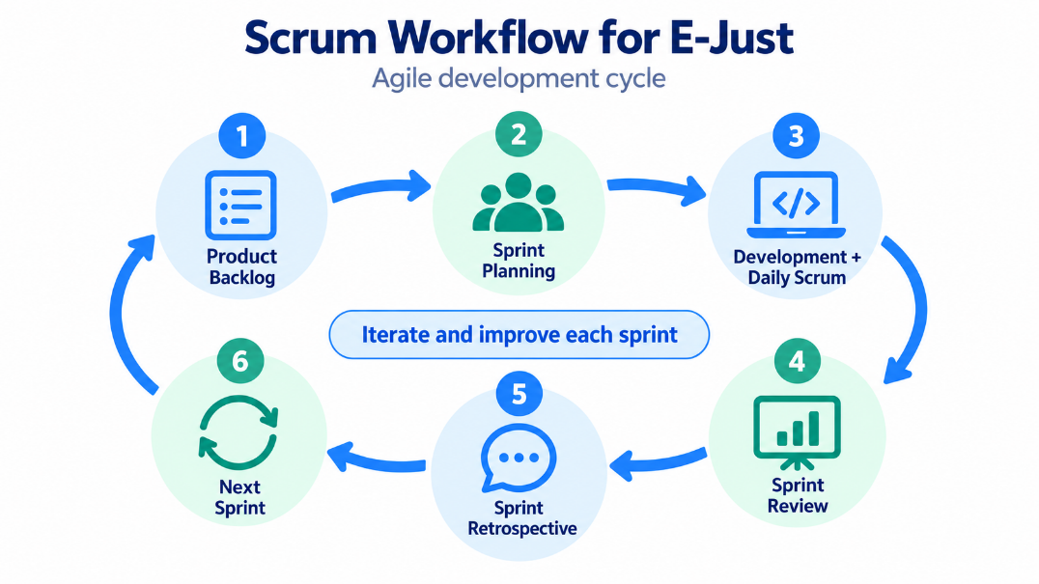
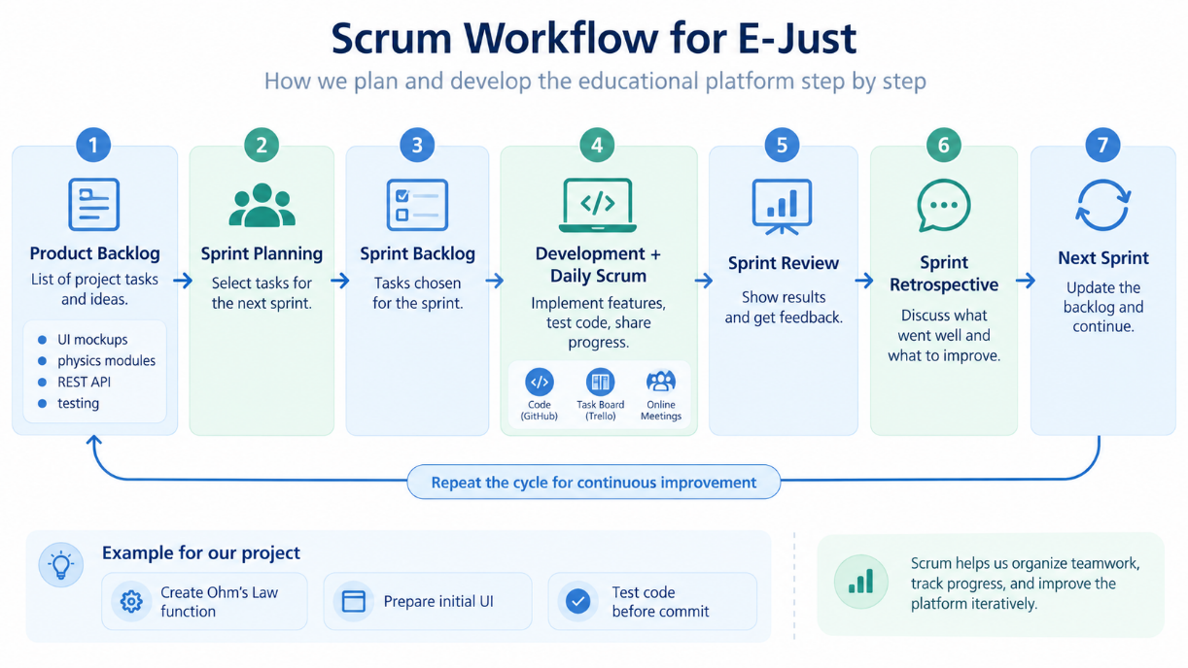
Team Responsibilities
Our team consists of Ahmed, Ali, Omar, and Ayaka.
Scrum includes three main responsibilities:
- Product Owner: Manages the Product Backlog and prioritizes tasks.
- Scrum Master: Supports the Scrum process and helps remove obstacles.
- Developers: Work together on design, implementation, testing, and integration.

