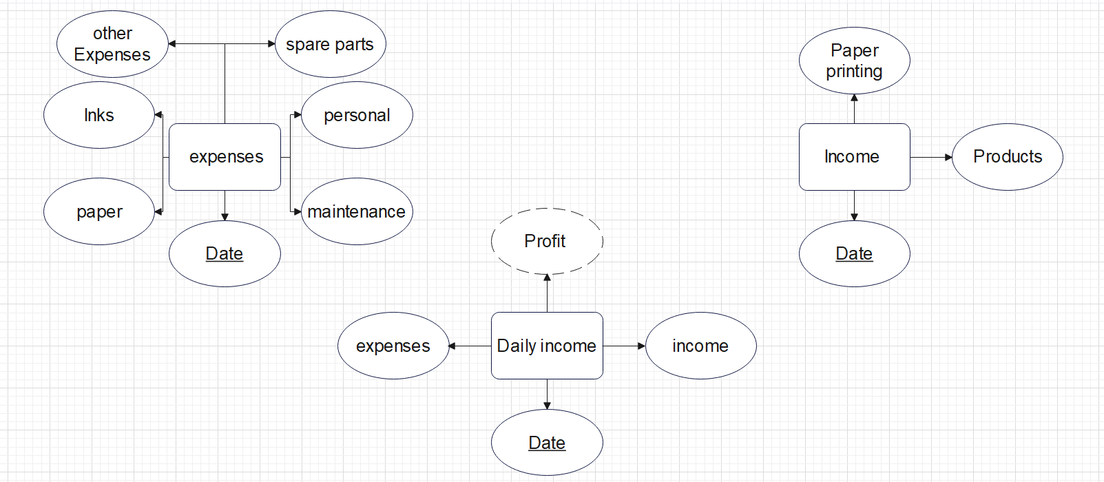

Income(Date , Products , Paper printing )

Expenses(Date , maintenance ,personal , spare parts , other Expenses , Inks , paper)

Daily income(Date , income , expenses )