AGROCHAIN CART LLC
Farm to Buyer, Direct.
TEN-YEAR STRATEGIC BUSINESS PLAN
2026 – 2035
Comprehensive Edition — Strategy, Product, Market, Financial & Organizational Plan
Prepared by
Mary Nyamvumba
Founder & Chief Executive Officer
AgroChain Cart LLC | Registered Office: 500 Hillview Dr, Apt 108, Pittsburgh, PA 15237
Pennsylvania Department of State File #: 0015351631 | Filed April 14, 2026
www.agrochaincart.com
CONFIDENTIAL — Prepared for internal planning, investor review, and institutional partnership discussions.

Table of Contents
1. Executive Summary 5
1.1 Ten-Year Snapshot 6
1.2 Why Now 6
1.3 Key Highlights 6
2. Company Overview 8
2.1 Legal Structure & Registration 8
2.2 Mission 8
2.3 Vision 8
2.4 Core Values 8
2.5 Current Stage 9
2.6 Strategic Objectives, Years 1–10 9
3. Founder & Leadership 10
3.1 Mary Nyamvumba — Founder & Chief Executive Officer 10
3.2 Founder Responsibilities Through Year 2 10
3.3 Planned Leadership Expansion 10
3.4 Advisory Board (Planned) 10
4. SWOT Analysis 11
4.1 Strategic Implications 11
5. The Problem & Our Solution 12
5.1 The Problem 12
5.2 Root Causes 12
5.3 Our Solution: The AgroCart Platform 12
5.4 Illustrative Farmer Income Impact 13
5.5 Why a Marketplace, Not Just Software 13
6. Market Opportunity & Analysis 14
6.1 Total Addressable Market 14
6.2 TAM, SAM, and SOM 14
6.3 Target Buyer Segments 15
6.4 Market Trends Supporting the Thesis 15
6.5 Market Entry Barriers Facing New Farms and Buyers 16
7. Product & Technology Roadmap 17
7.1 Phase 1 — Foundation (Years 1–2, 2026–2027): Current State 17
7.2 Phase 2 — Regional Expansion (Years 3–4, 2028–2029) 17
7.3 Phase 3 — National Scaling (Years 5–7, 2030–2032) 17
7.4 Phase 4 — Market Leadership & Diversification (Years 8–10, 2033–2035) 18
7.5 Engineering Investment by Phase 18
8. Competitive Landscape 19
8.1 Competitive Positioning 19
8.2 Competitive Advantages 20
8.3 Barriers to Entry AgroChain Cart Is Building 20
9. Business Model & Revenue Streams 21
9.1 Revenue Streams 21
9.2 Revenue Mix Evolution 21
9.3 Revenue Mix at Maturity (Year 10) 21
9.4 Where the Food Dollar Goes 22
9.5 Unit Economics Philosophy 23
9.6 Pricing Structure 23
10. Go-to-Market Strategy 24
10.1 Sequencing Philosophy 24
10.2 Regional Expansion Timeline 24
10.3 Phase-by-Phase Go-to-Market Plan 24
Phase 1 — Foundation & Regional Pilot (2026–2027) 24
Phase 2 — Regional Expansion (2028–2029) 24
Phase 3 — National Scaling (2030–2032) 25
Phase 4 — Market Leadership & Diversification (2033–2035) 25
10.4 Farmer Base by Region, Year 10 25
10.5 Regional Contribution to Marketplace Volume Over Time 26
11. Organizational Plan 27
11.1 Founding Team (Phase 1, Years 1–2) 27
11.2 Headcount Growth by Phase 27
11.3 Headcount Growth by Department 27
11.4 Governance 28
11.5 Culture & Hiring Principles 28
12. Marketing & Customer Acquisition Strategy 29
12.1 Acquisition Channels by Segment 29
12.2 Illustrative Customer Acquisition Cost (CAC) and Lifetime Value (LTV) 29
12.3 Marketing Investment Priorities by Phase 30
12.4 Brand Positioning 30
13. Operations Plan 31
13.1 Farmer Onboarding Process 31
13.2 Quality Assurance & Trust 31
13.3 Order Fulfillment & Cold-Chain Execution 31
13.4 Customer & Farmer Support 32
13.5 Payments & Settlement Operations 32
14. Ten-Year Financial Projections 33
14.1 Marketplace Volume, Revenue & Farmer Growth 33
14.2 Illustrative Ten-Year Income Statement 34
14.3 Key Assumptions 35
14.4 Path to Profitability 35
14.5 Sensitivity Considerations 36
15. Risk Analysis & Mitigation 37
15.1 Risk Monitoring Approach 37
16. Funding Requirements & Use of Proceeds 38
16.1 Indicative Funding Phases 38
16.2 Indicative Use of Proceeds (Blended, All Stages) 38
16.3 Use-of-Funds Priorities at Every Stage 38
16.4 Return of Capital Considerations 39
17. Ten-Year Milestone Summary 40
18. Sustainability & Community Impact 41
18.1 Economic Impact 41
18.2 Environmental Impact 41
18.3 Food Security & Institutional Access 41
18.4 Reporting Approach 41
19. Exit Strategy & Long-Term Vision 42
19.1 Long-Term Vision 42
19.2 Illustrative Exit Pathways 42
19.3 Long-Term Value Drivers 42
20. Conclusion 43
Appendix A: Detailed Ten-Year Financial Summary 44
Appendix B: Key Assumptions & Methodology Notes 45

1. Executive Summary
AgroChain Cart LLC (“AgroChain Cart” or “the Company”) is a Pennsylvania-registered digital marketplace connecting American farmers directly with consumers, restaurants, retailers, and institutional buyers such as schools and hospitals. The Company was formally organized on April 14, 2026 (Pennsylvania Department of State File #0015351631) and is led by Founder and Chief Executive Officer Mary Nyamvumba.
The core problem AgroChain Cart solves is structural: in the traditional U.S. food supply chain, farmers capture as little as 16 cents of every consumer food dollar, with the remainder absorbed by distributors, wholesalers, brokers, and retail intermediaries. AgroChain Cart's direct marketplace model returns roughly 60 cents of every dollar to the farmer by removing unnecessary intermediary layers while still providing buyers with reliable logistics, quality assurance, and price transparency.
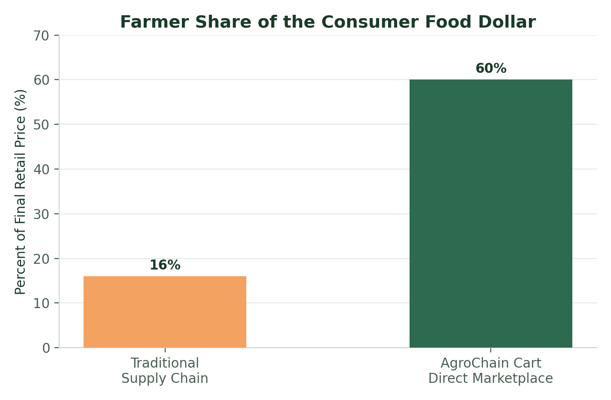
Figure 1.1 — AgroChain Cart's direct model nearly quadruples the farmer's share of the retail food dollar.
The Company's product, the AgroCart platform, is currently live in an initial pilot/MVP phase. It combines a consumer- and buyer-facing marketplace app with a Farm Management Portal Program (FMPP)-aligned dashboard that lets farmers list produce, manage inventory, and track federal grant eligibility, and a Logistics & Carrier Marketplace that provides live cold-chain shipment tracking and lets independent freight carriers list capacity directly to shippers eliminating freight-broker markups.
This plan presents a ten-year roadmap, from 2026 through 2035, that takes AgroChain Cart from a single-region pilot with roughly 100 founding farmers to a national digital agricultural infrastructure platform supporting an estimated 58,000 farmers and over $2.2 billion in annual marketplace volume by Year 10. Growth is organized into four strategic phases: Foundation & Regional Pilot (Years 1–2), Regional Expansion (Years 3–4), National Scaling (Years 5–7), and Market Leadership & Diversification (Years 8–10).

1.1 Ten-Year Snapshot
Metric | Year 1 (2026) | Year 5 (2030) | Year 10 (2035)
Farmers on platform | 100 | 12,000 | 58,000
Marketplace volume (GMV) | $2.4M | $540M | $2.2B
Company revenue | $192K | $43M | $176M
EBITDA | -$1.46M | $3.2M (breakeven yr.) | $38M
Headcount (approx.) | 5–10 | 60–100 | 120–180
Regions active | 1 (Mid-Atlantic) | 3 | 5

1.2 Why Now
A U.S. food market exceeding $1.8 trillion annually contains a direct-to-consumer agricultural sales segment that has grown from roughly $8.9 billion in 2017 to an estimated $17.5–20 billion in 2025, and is projected to exceed $60 billion by 2035. That growth is driven by consumer demand for transparency and freshness, expanding USDA/FMPP grant support for direct-market infrastructure, and growing institutional local-sourcing mandates a convergence of tailwinds AgroChain Cart is built to capture.

1.3 Key Highlights
- A diversified, multi-stream revenue model built on marketplace transaction fees, farmer subscription/analytics tools, logistics coordination fees, and institutional procurement partnerships.
- Projected platform revenue growing from approximately $192,000 in Year 1 to over $176 million by Year 10, on a blended 8% take rate against marketplace sales.
- A modeled path to EBITDA breakeven in Year 5 (2030), coinciding with the start of the National Scaling phase, followed by expanding margins as subscription and logistics revenue mature.
- A phased technology roadmap that evolves the current MVP into a full farm-to-buyer operating system, encompassing predictive inventory tools, AI-assisted pricing, expanded cold-chain logistics, and an open carrier marketplace.
- A capital-efficient go-to-market strategy that begins with a single-region pilot in the Mid-Atlantic and expands regionally before scaling nationally, minimizing execution risk at each stage.
- A phased fundraising plan — Pre-Seed/Seed (2026), Series A (2028), Series B (2030–31), Series C/Growth (2033) — sized to match each phase's capital needs rather than a single, highly dilutive raise.
AgroChain Cart is positioned to become foundational digital infrastructure for American agriculture — improving farmer livelihoods, strengthening the resilience of the domestic food supply chain, and giving households, restaurants, retailers, and institutions direct, transparent access to the food they buy.
This expanded plan goes beyond the original strategic proposal to provide the full depth expected of an institutional-grade planning document: a formal SWOT analysis (Section 4), a dedicated marketing and customer-acquisition strategy with modeled CAC/LTV by buyer segment (Section 12), a detailed operations plan covering farmer onboarding, quality assurance, and cold-chain execution (Section 13), a ten-year margin trajectory showing the Company's modeled path to operating profitability (Section 14.4), a sustainability and community impact framework (Section 18), and a long-term vision for value creation and exit optionality (Section 19).
Taken together, these sections are intended to give founders, prospective investors, institutional partners, and university or grant-program reviewers a single, comprehensive reference document that explains not only what AgroChain Cart is building, but precisely how, in what sequence, at what cost, and with what expected return from the current single-region pilot through a mature, national platform in 2035.

2. Company Overview

2.1 Legal Structure & Registration
AgroChain Cart LLC is a Domestic Limited Liability Company organized under 15 Pa.C.S. § 8821 in the Commonwealth of Pennsylvania. The Company's Certificate of Organization was filed with the Pennsylvania Department of State, Bureau of Corporations and Charitable Organizations, and accepted on April 14, 2026 at 9:17 AM, bearing File #0015351631.
Attribute | Detail
Legal Name | AgroChain Cart LLC
Entity Type | Domestic Limited Liability Company
State of Organization | Pennsylvania
Registered Office | 500 Hillview Dr, Apt 108, Pittsburgh, PA 15237 (Allegheny County)
Organizer | Mary Nyamvumba, 22 Norton St, Pittsburgh, PA 15211
Filing Date | April 14, 2026
Department of State File # | 0015351631
Filing Fee Paid | $125
Founder & CEO | Mary Nyamvumba

2.2 Mission
To rebuild the economics of American agriculture by connecting farmers directly with the households, restaurants, retailers, and institutions that buy from them improving farmer income, food transparency, and supply chain resilience through accessible digital infrastructure.

2.3 Vision
Within ten years, AgroChain Cart aims to be the default digital marketplace and logistics layer connecting regional farms to buyers across the United States; the infrastructure that regional food systems run on, in the same way payment rails or cloud hosting became infrastructure for their industries.

2.4 Core Values
- Fair value distribution — farmers should capture a fair share of the price consumers pay.
- Transparency — buyers should know exactly where their food comes from and how it moved.
- Resilience — shorter, more distributed supply chains are more resilient to shocks.
- Accessibility — the technology should be usable by farm operations of every size, not just large-scale producers.
- Accountability — every product decision is measured against whether it increases farmer income, buyer transparency, or logistics reliability.

2.5 Current Stage
As of mid-2026, AgroChain Cart is in its initial pilot phase. The Company has completed its founding legal work, built and deployed a functional marketplace application (AgroCart), and is onboarding its first cohort of regional farmers and buyers ahead of a broader Mid-Atlantic launch. This plan documents how that initial platform will evolve, region by region and feature by feature, over the following ten years.

2.6 Strategic Objectives, Years 1–10
- Prove the core farmer-buyer-logistics loop in a single region before expanding (Year 1–2).
- Establish repeatable regional playbook and reach EBITDA breakeven (Year 3–5).
- Scale nationally while deepening institutional and logistics infrastructure (Year 5–7).
- Diversify revenue into financial services and data products while defending market leadership (Year 8–10).

3. Founder & Leadership

3.1 Mary Nyamvumba — Founder & Chief Executive Officer
AgroChain Cart LLC was founded by Mary Nyamvumba, a supply chain professional with academic training in international economics and advanced supply chain management. Her professional background spans logistics optimization, procurement systems, and digital supply chain platforms; the precise combination of expertise required to redesign how agricultural goods move from farm to buyer.
Agricultural supply chains systematically extract value from farmers through unnecessary intermediary layers. I had the technical and procurement expertise to build the infrastructure to fix it — so I did.
— Mary Nyamvumba, Founder & CEO, AgroChain Cart LLC
Ms. Nyamvumba's years of experience inside complex, multi-party supply chains gave her a precise understanding of where value leaks out of agricultural commerce, and who ultimately bears that cost. That insight is the founding thesis of AgroChain Cart: that a well-designed direct digital marketplace, paired with real logistics coordination, can restructure that value flow in favor of the producer without sacrificing reliability for the buyer.

3.2 Founder Responsibilities Through Year 2
In the Foundation & Regional Pilot phase, the Founder & CEO holds direct responsibility for product direction, farmer and institutional partnership development, fundraising, and regulatory/compliance matters, supported by a small founding team described in Section 11 (Organizational Plan).

3.3 Planned Leadership Expansion
As the Company scales through Phases 2–4, the leadership team is expected to expand to include a Chief Technology Officer, VP of Farmer Partnerships, VP of Logistics, and VP of Institutional Sales, with the Founder & CEO transitioning toward company-wide strategy, capital raising, and key institutional and policy relationships. Detailed hiring milestones are set out in Section 11.

3.4 Advisory Board (Planned)
Beginning in Phase 2, the Company intends to formalize a small advisory board with expertise in agricultural policy, cold-chain logistics, institutional food procurement, and venture finance, to complement the Founder & CEO's operating expertise as the Company scales beyond a single region.

4. SWOT Analysis
The matrix below summarizes AgroChain Cart's internal strengths and weaknesses alongside the external opportunities and threats most relevant to executing this ten-year plan.
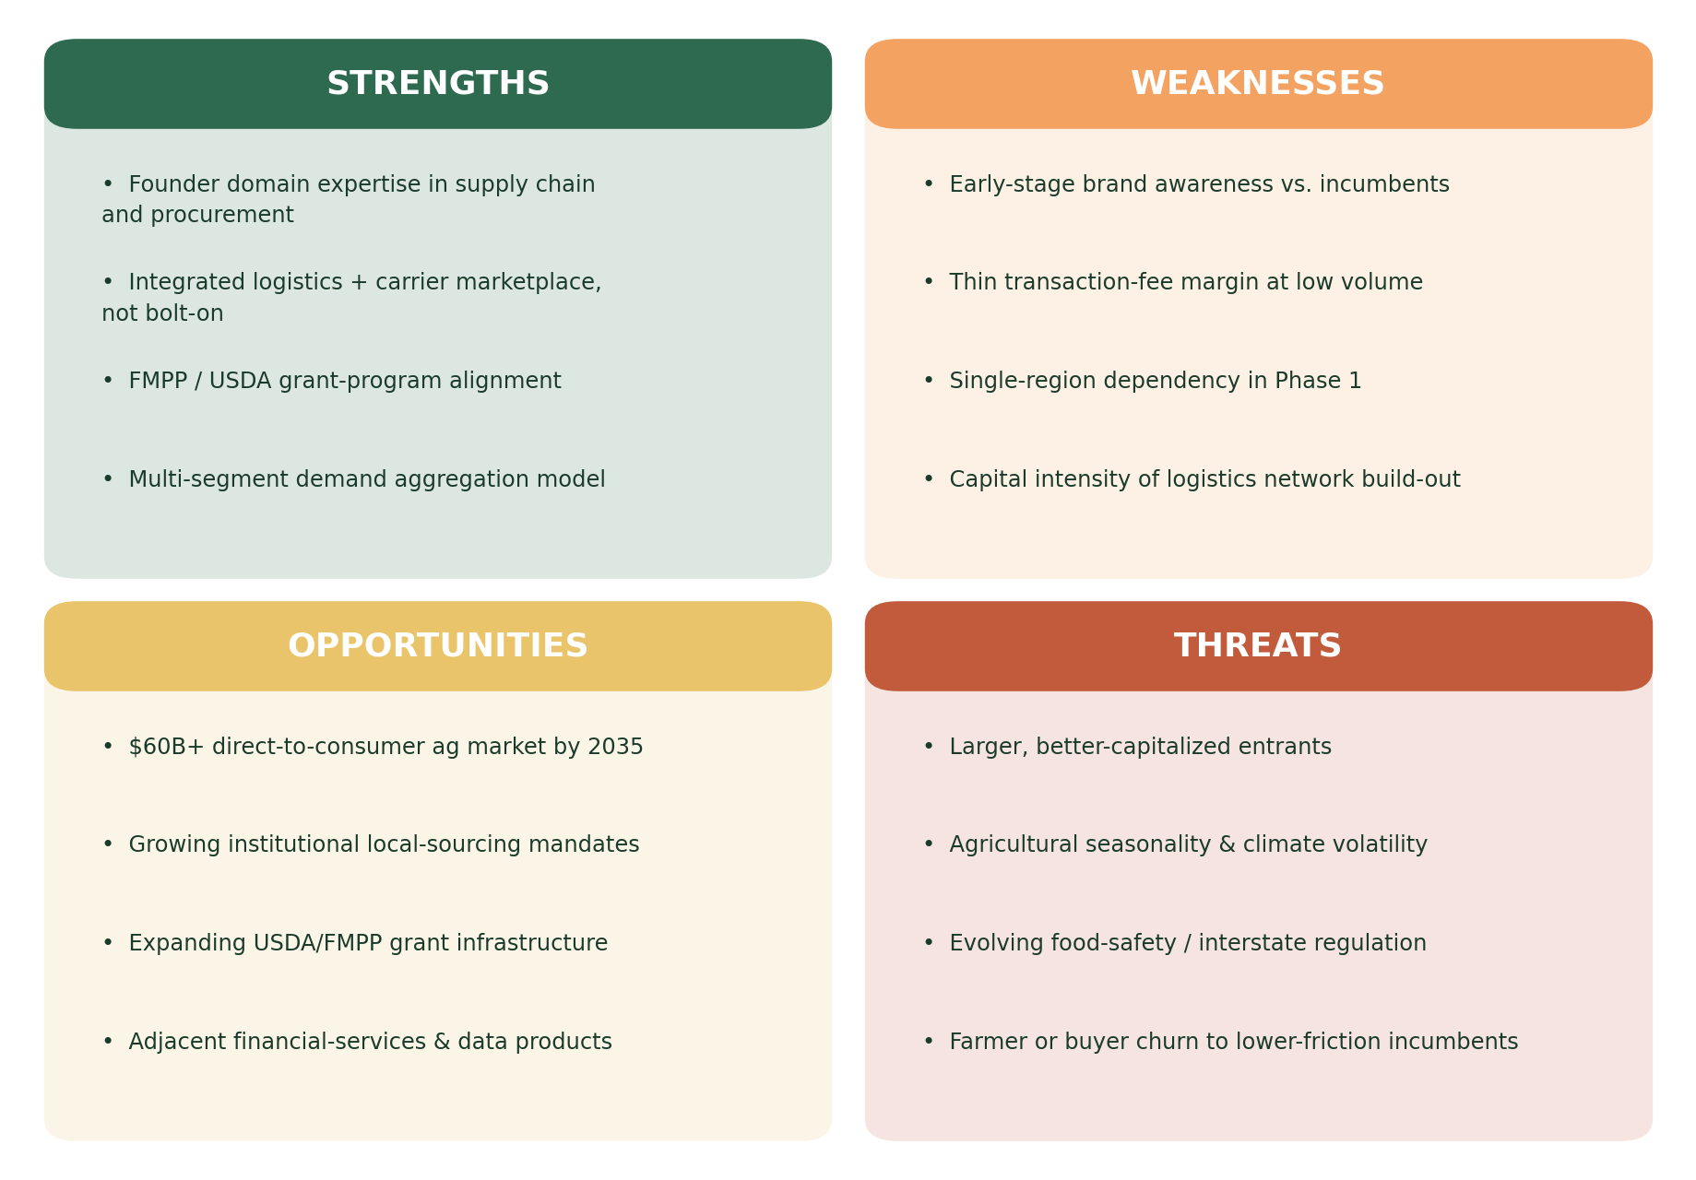
Figure 4.1 — SWOT analysis for AgroChain Cart LLC.

4.1 Strategic Implications
- Strengths should be actively marketed to institutional buyers and farmers during Phase 1–2 acquisition, particularly the founder's domain credibility and the platform's grant-program alignment.
- Weaknesses around brand awareness and take-rate economics are best addressed by the diversified revenue mix (Section 9) and disciplined regional sequencing (Section 10), rather than by competing on price alone.
- Opportunities in institutional procurement and adjacent financial/data products are prioritized in Phases 3–4 once the core marketplace has reached sufficient scale to support them.
- Threats from larger entrants and regulatory change are mitigated by building durable two-sided network effects and compliance infrastructure early, described further in Section 15 (Risk Analysis & Mitigation).

5. The Problem & Our Solution

5.1 The Problem
Traditional agricultural supply chains route a farmer's product through multiple intermediary layers ; aggregators, distributors, wholesalers, and retail markups before it reaches a final buyer. Each layer takes a margin, and the cumulative effect is that farmers typically retain only around 16 cents of every consumer food dollar. This structural imbalance suppresses farm income, discourages younger generations from entering agriculture, and leaves buyers with limited visibility into where their food actually comes from.
At the same time, demand-side buyers; households, restaurants, retailers, and institutions such as schools and hospitals increasingly want fresher, more transparently sourced food, but lack an efficient way to discover, order from, and coordinate logistics with individual regional farms at scale.

5.2 Root Causes
- Fragmentation — thousands of small and mid-sized farms have no shared digital storefront or shared logistics infrastructure, forcing them to rely on intermediaries by default.
- Logistics complexity — cold-chain, perishability, and last-mile delivery requirements make direct-to-buyer fulfillment operationally difficult without shared infrastructure.
- Information asymmetry — buyers cannot easily verify sourcing claims, and farmers cannot easily see real-time regional demand or pricing.
- Capital access — many farms lack the working capital or grant-navigation support to invest in direct-market infrastructure on their own.

5.3 Our Solution: The AgroCart Platform
AgroChain Cart's answer is AgroCart: a digital marketplace that lets farmers list inventory directly to buyers, while the platform itself absorbs the coordination work payments, quality assurance, order aggregation, and logistics that would otherwise require a chain of intermediaries. The current AgroCart application, live in initial pilot form, already includes:
- A consumer- and buyer-facing marketplace with category browsing (vegetables, fruits, dairy, grains), organic/local badging, and farm-of-origin attribution for every listing.
- A Farm Dashboard for farmer-sellers to list produce, monitor inventory health, and manage orders — aligned with USDA Farmers Market Promotion Program (FMPP) grant-funding pathways.
- A Logistics & Carrier Marketplace where independent freight and trucking companies list available capacity and shippers book it directly, removing the freight-broker markup that typically adds cost with no value to the farmer or buyer.
- Live cold-chain shipment tracking with real-time map visualization and estimated time of arrival, giving buyers (and institutional purchasers in particular) delivery confidence and proof-of-delivery records.
- An order and cart management experience built for repeat institutional and household purchasing, including tiered subscription pricing for growth-stage farms.
This MVP is intentionally scoped to prove the core loop; farmer lists, buyer orders, logistics fulfills, farmer gets paid more in a single region before the Company invests in the deeper feature set (predictive inventory, AI-assisted pricing, expanded institutional procurement tooling) described in Section 7.

5.4 Illustrative Farmer Income Impact
The chart below illustrates, at an indicative level, how a farm's annual revenue could shift by moving a meaningful share of its sales from traditional wholesale channels to AgroChain Cart's direct marketplace, across three representative farm sizes. These figures are illustrative planning estimates, not guarantees, and actual results will vary by crop mix, region, and the share of a farm's output sold through the platform.
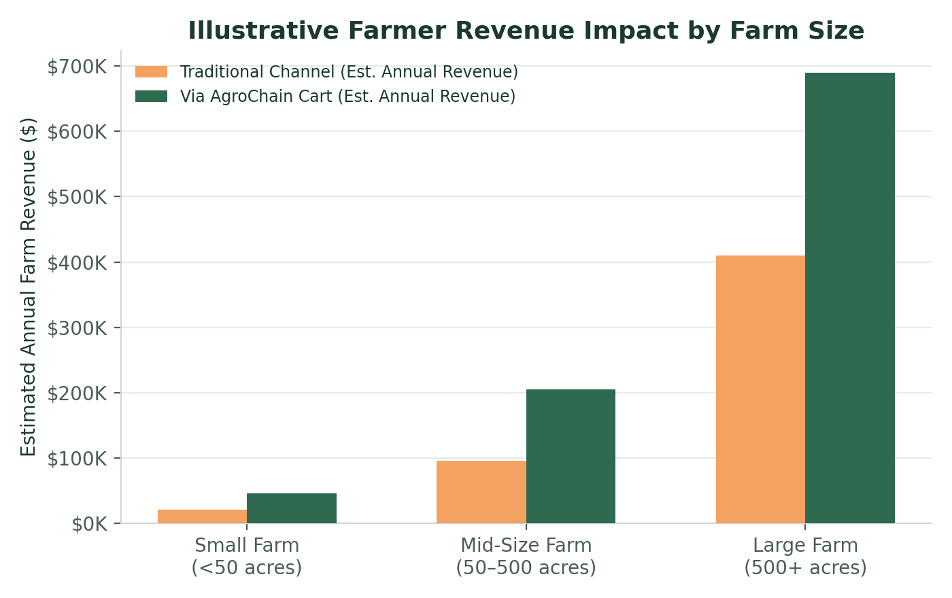
Figure 5.1 — Illustrative estimated annual farm revenue, traditional channel versus AgroChain Cart, by farm size.

5.5 Why a Marketplace, Not Just Software
AgroChain Cart deliberately operates as a two-sided marketplace rather than licensing software to farms independently. This means the Company earns revenue in proportion to the value it moves through the platform, is directly incentivized to grow both farmer supply and buyer demand in tandem, and can invest in shared infrastructure like the carrier marketplace that would be uneconomical for any single farm to build alone.

6. Market Opportunity & Analysis

6.1 Total Addressable Market
The United States food market exceeds $1.8 trillion annually. Within that market, the direct-to-consumer agricultural sales segment , the specific category AgroChain Cart operates in has grown from roughly $8.9 billion in 2017 to an estimated $17.5 billion in 2022, and is projected to continue accelerating as consumers seek shorter, more transparent supply chains.
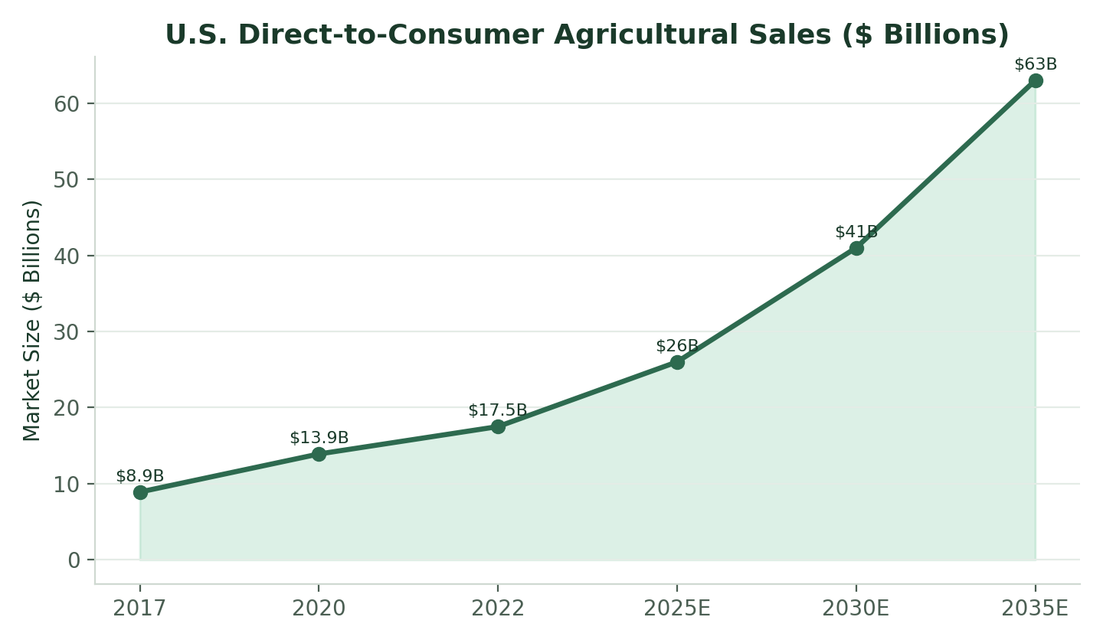
Figure 6.1 — Projected growth of the U.S. direct-to-consumer agricultural sales market, 2017–2035E.

6.2 TAM, SAM, and SOM
AgroChain Cart's addressable opportunity narrows from the full U.S. food market (TAM), to the direct-to-consumer agricultural sales segment the Company directly competes in (SAM), to the specific marketplace volume the Company plans to capture over the next ten years (SOM).
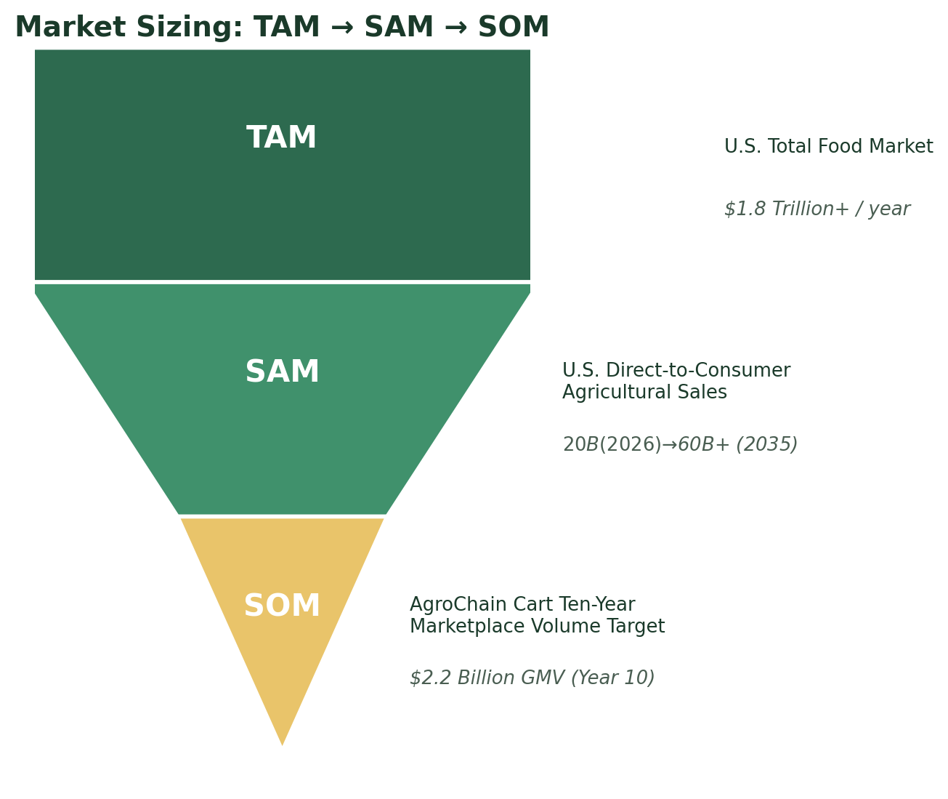
Figure 6.2 — Market sizing funnel: Total Addressable Market, Serviceable Addressable Market, and Serviceable Obtainable Market.
- TAM — U.S. Total Food Market: approximately $1.8 trillion annually, encompassing all food purchased by U.S. households, restaurants, retailers, and institutions.
- SAM — U.S. Direct-to-Consumer Agricultural Sales: an estimated $20 billion in 2026, growing toward $60+ billion by 2035, representing the specific category of farm-direct commerce AgroChain Cart is built to serve.
- SOM — AgroChain Cart's Ten-Year Target: $2.2 billion in annual marketplace volume by Year 10, representing roughly 3–4% of the projected 2035 direct-to-consumer market; a deliberately conservative, execution-driven capture rate.

6.3 Target Buyer Segments
The platform is designed to serve four buyer segments simultaneously, aggregating demand across all of them to improve visibility and order volume for participating farms:
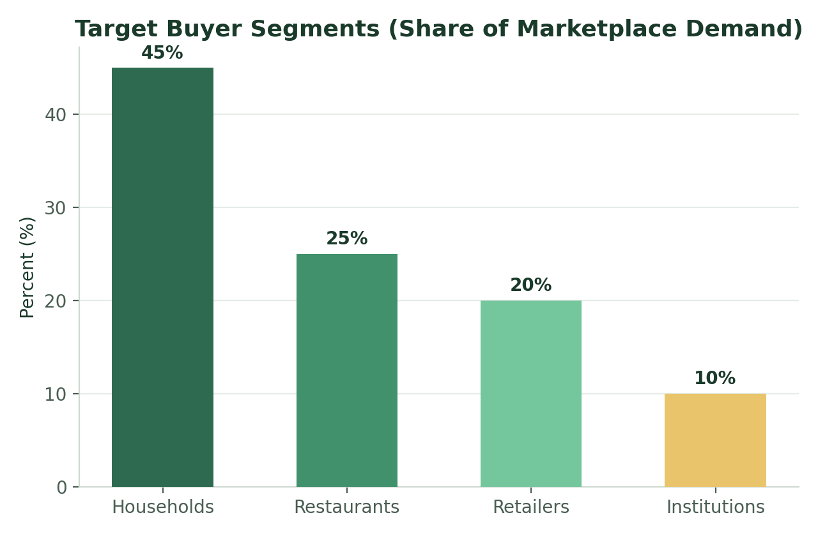
Figure 6.3 — Target buyer segment mix by projected share of marketplace demand.
- Households (45%) — consumers seeking fresher, transparently sourced produce, dairy, and grains delivered from regional farms.
- Restaurants (25%) — food-service operators seeking consistent quality, farm-of-origin sourcing, and simplified procurement versus managing multiple individual farm relationships.
- Retailers (20%) — independent grocers and specialty retailers seeking local/organic assortment without building their own farm-sourcing infrastructure.
- Institutions (10%) — schools, hospitals, and other institutional buyers, an initially smaller but strategically important segment given large, recurring order volumes and (in many states) local-sourcing procurement mandates.

6.4 Market Trends Supporting the Thesis
- Sustained consumer demand for local and transparently sourced food, particularly among younger demographics.
- Continued growth in USDA and state-level grant programs (including FMPP) supporting direct-to-market farm infrastructure.
- Growing institutional procurement mandates favoring local sourcing in school nutrition and hospital food-service programs.
- Rising interest in short, resilient supply chains following recent years of supply-chain disruption across the broader food system.
- Continued build-out of rural broadband and smartphone penetration, lowering the barrier for farms of all sizes to participate in digital marketplaces.

6.5 Market Entry Barriers Facing New Farms and Buyers
Before AgroChain Cart, a farm seeking to sell direct-to-consumer at scale needed to independently solve for e-commerce infrastructure, payment processing, cold-chain logistics, and buyer discovery; a combination few small or mid-sized farms can build alone. Similarly, an institutional buyer seeking local sourcing needed to manage dozens of individual farm relationships without a shared procurement or compliance layer. AgroChain Cart's platform removes both barriers simultaneously.

7. Product & Technology Roadmap
AgroChain Cart's technology evolves in step with the Company's four growth phases (detailed in Section 10). Each phase adds capability without disrupting the core farmer-lists / buyer-orders / logistics-fulfills loop already live in the current MVP.
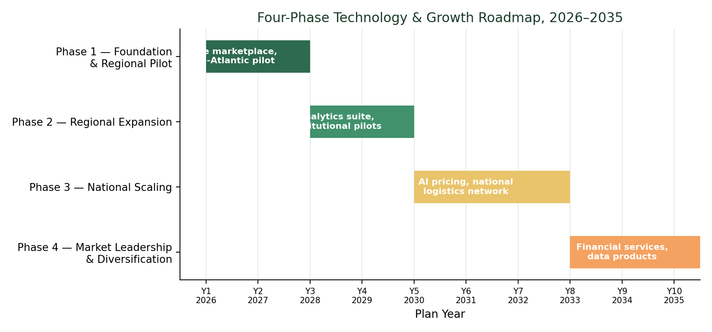
Figure 7.0 — Four-phase technology and growth roadmap, 2026–2035.

7.1 Phase 1 — Foundation (Years 1–2, 2026–2027): Current State
The platform in market today. Core marketplace, Farm Dashboard, order and cart management, Logistics & Carrier Marketplace with live shipment tracking, and FMPP-aligned grant-funding visibility for farmers.
- Consumer/buyer marketplace with category browsing, organic/local badging, and farm attribution.
- Farm Dashboard: inventory health monitoring, listing management, order visibility.
- Logistics & Carrier Marketplace with live cold-chain shipment tracking and proof-of-delivery.
- Basic cart, checkout, and payment processing for household and small-business buyers.

7.2 Phase 2 — Regional Expansion (Years 3–4, 2028–2029)
- Farmer analytics suite: demand forecasting by SKU and season, and sell-through reporting.
- Expanded institutional procurement workflows: recurring orders, purchase-order integration, and compliance documentation for school and hospital buyers.
- Mobile-first farmer app for inventory updates and order management from the field.
- Payments and invoicing automation, including multi-buyer batch settlement for farms selling across segments.
- Introduction of tiered farmer subscription plans tied to the new analytics tooling.

7.3 Phase 3 — National Scaling (Years 5–7, 2030–2032)
- AI-assisted dynamic pricing recommendations for farmers, based on regional supply, demand, and seasonality data aggregated across the platform.
- Predictive inventory and harvest-planning tools, reducing spoilage and improving fill-rate reliability for large institutional buyers.
- Expansion of the open carrier marketplace into a full multi-region cold-chain logistics network with route optimization.
- API access for retail and institutional partners to integrate AgroChain Cart ordering directly into their existing procurement systems.
- Quality assurance and food-safety compliance tooling scaled to support multi-state institutional partners.

7.4 Phase 4 — Market Leadership & Diversification (Years 8–10, 2033–2035)
- Farm financial services layer: working-capital advances against confirmed marketplace orders, developed with banking or fintech partners.
- Data and insights products for agricultural policy, research, and supply-chain planning customers, built on aggregated (privacy-protected) marketplace data.
- Potential adjacent-category expansion (e.g., specialty/value-added farm products) and selective international pilot markets.
- Platform-wide sustainability and carbon-footprint reporting tools, supporting institutional ESG procurement requirements.
Across all four phases, the guiding technology principle remains constant: every new capability must directly increase the share of the food dollar that reaches the farmer, the transparency available to the buyer, or the reliability of the logistics connecting them.

7.5 Engineering Investment by Phase
Phase | Primary Engineering Focus | New Capability Unlocked
Phase 1 (2026–27) | Core marketplace reliability, mobile responsiveness | Regional pilot validation
Phase 2 (2028–29) | Analytics pipeline, mobile farmer app, payments automation | Subscription revenue, institutional workflows
Phase 3 (2030–32) | ML pricing models, logistics route optimization, partner APIs | National scale, institutional API integrations
Phase 4 (2033–35) | Financial services infrastructure, data products, ESG reporting | New revenue lines beyond the core marketplace

8. Competitive Landscape
AgroChain Cart competes with a fragmented set of platforms, none of which combine direct farm marketplace access with integrated inventory visibility, pricing tools, and logistics coordination in a single system.
Platform | Core Focus | Limitations
Instacart | Retail grocery delivery platform | Focuses on retailers rather than farmers; no direct farmer relationship or pricing transparency
Farmigo | Community-supported agriculture (CSA) marketplace | Limited scalability and regional reach; CSA-only model
LocalHarvest | Farm directory / listings marketplace | Directory model with limited logistics coordination or fulfillment
AgroChain Cart | Direct farm-to-buyer marketplace | Integrated inventory visibility, dynamic pricing, and logistics differentiated by design

8.1 Competitive Positioning
The radar chart below scores AgroChain Cart against its three closest reference competitors across five dimensions core to this market: fairness of farmer payout, depth of logistics integration, institutional-buyer support, platform scalability, and price transparency.
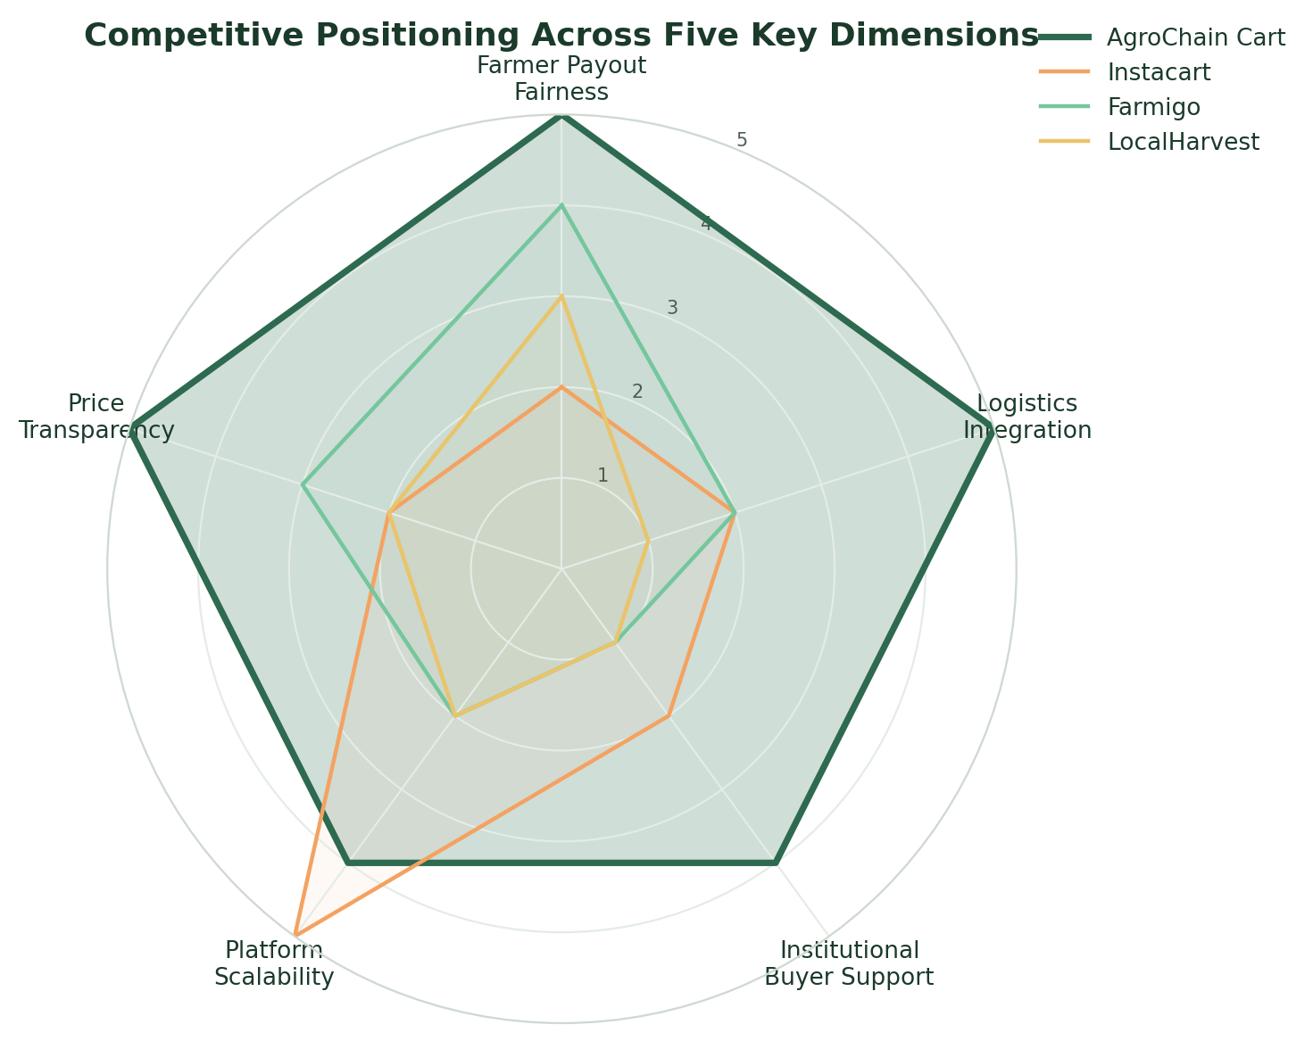
Figure 8.1 — Competitive positioning across five key dimensions (illustrative scoring, 1 = weak, 5 = strong).
The horizontal comparison below breaks the same scoring out dimension-by-dimension, making it easier to see exactly where AgroChain Cart's advantage over each named competitor is largest.
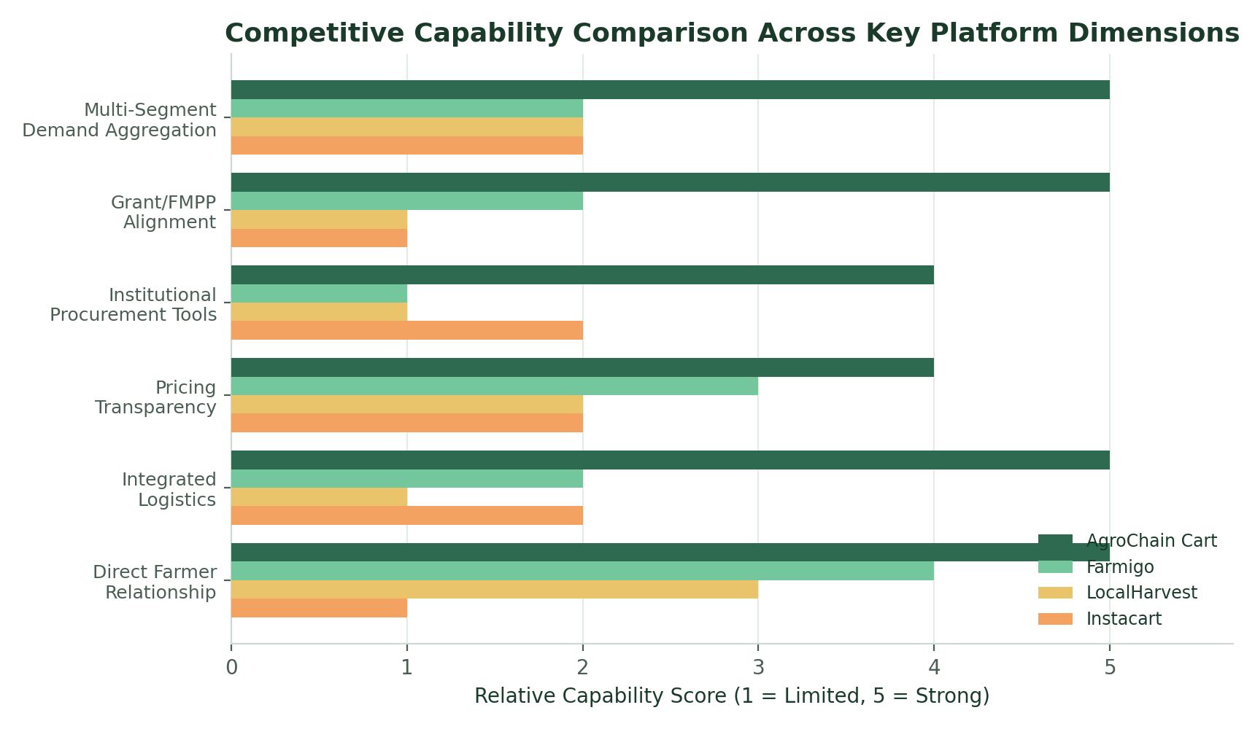
Figure 8.2 — Capability comparison by platform dimension, AgroChain Cart vs. named competitors.

8.2 Competitive Advantages
- Integrated logistics — the open carrier marketplace and live cold-chain tracking are built into the platform, not outsourced or absent.
- Multi-segment demand aggregation — a single farmer listing can reach households, restaurants, retailers, and institutions simultaneously.
- Grant-program alignment — the Farm Dashboard is designed around FMPP and related USDA funding pathways, lowering the barrier for smaller farms to participate.
- Founder domain expertise — deep supply chain, procurement, and logistics background directly informs product design, rather than a general e-commerce team retrofitting agriculture.

8.3 Barriers to Entry AgroChain Cart Is Building
- A growing two-sided network of farmers and buyers, which becomes more valuable and harder to replicate as it scales regionally.
- Proprietary logistics and carrier-capacity data accumulated through the open carrier marketplace.
- Institutional procurement relationships and compliance workflows that take years to build with schools, hospitals, and large retailers.
- A brand identity rooted in farmer economics, which is difficult for retailer-first platforms like Instacart to credibly replicate.

9. Business Model & Revenue Streams
AgroChain Cart generates revenue through four complementary streams, each tied to a distinct part of the marketplace experience. This diversified structure reduces reliance on any single revenue source and allows monetization to evolve as the platform matures.

9.1 Revenue Streams
- Transaction Fees — a blended marketplace fee (modeled at approximately 8% of gross marketplace sales) charged on completed orders between farmers and buyers.
- Farmer Subscriptions — recurring subscription tiers for farms seeking advanced analytics, inventory management, and (in later phases) AI-assisted pricing tools.
- Logistics Coordination — fees earned on shipments booked through the open carrier marketplace and cold-chain tracking system.
- Institutional Procurement Partnerships — dedicated service fees and account-management revenue from schools, hospitals, and other high-volume institutional buyers.

9.2 Revenue Mix Evolution
In the earliest phase, transaction fees dominate the revenue mix as the Company prioritizes liquidity — getting enough farmers and buyers transacting to prove the core marketplace loop. As the platform matures, subscription, logistics, and institutional revenue grow as a share of the total, reflecting a healthier, more diversified, higher-margin business.
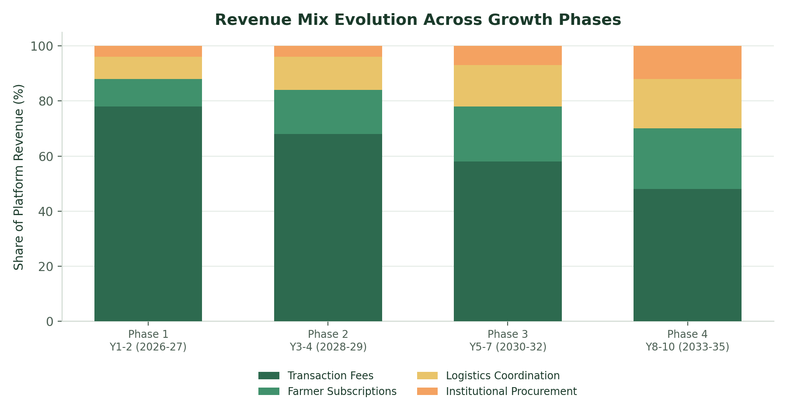
Figure 9.1 — Modeled evolution of AgroChain Cart's revenue mix across the four growth phases.

9.3 Revenue Mix at Maturity (Year 10)
By Year 10, transaction fees are expected to represent a smaller share of a much larger overall revenue base, as subscription, logistics, and institutional revenue scale into meaningfully sized, higher-margin businesses in their own right.
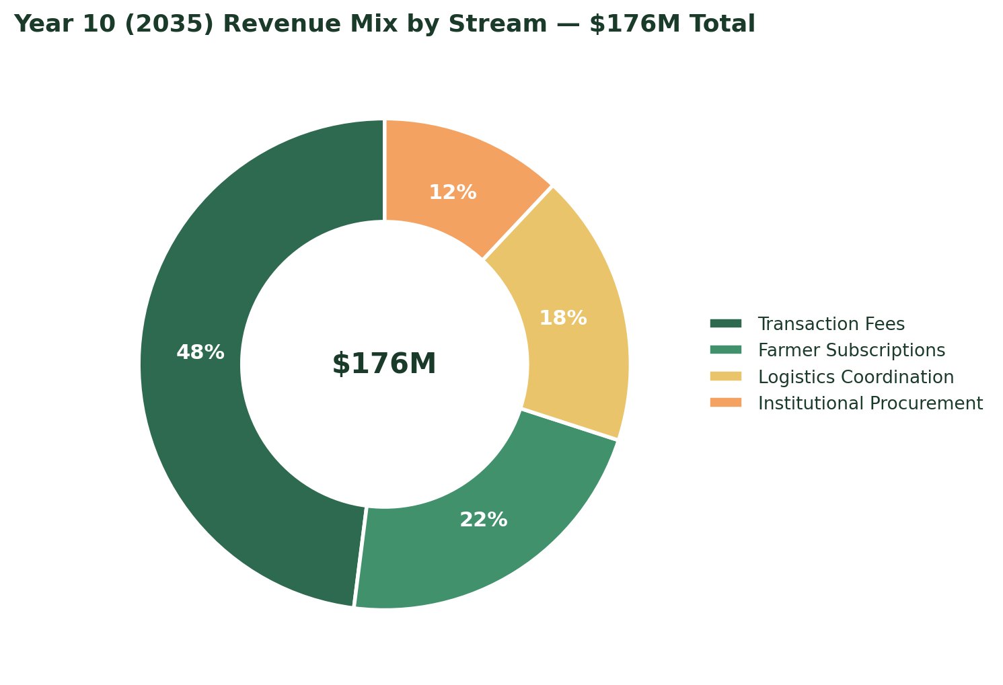
Figure 9.2 — Projected AgroChain Cart revenue mix by stream, Year 10 (2035).

9.4 Where the Food Dollar Goes
The clearest way to see AgroChain Cart's value proposition is to compare how a consumer's food dollar is divided under the traditional supply chain versus AgroChain Cart's marketplace model.
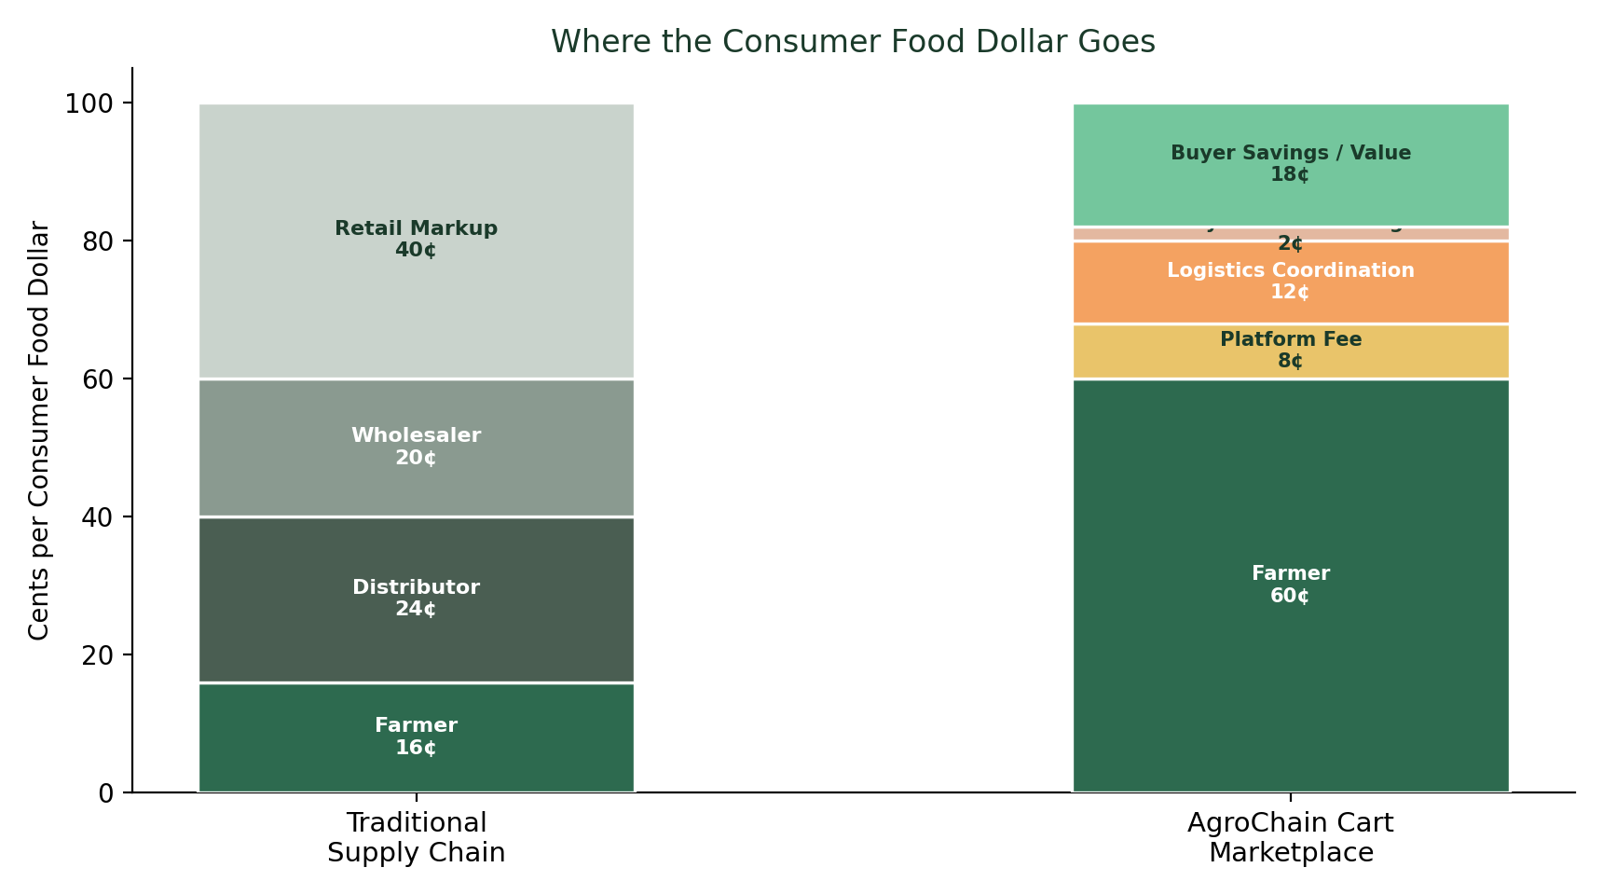
Figure 9.3 — Comparative breakdown of the consumer food dollar: traditional supply chain versus AgroChain Cart.
Under the traditional model, the farmer retains roughly 16 cents of every dollar, with the remainder split across distributors, wholesalers, and retail markup. Under AgroChain Cart's model, the farmer retains roughly 60 cents, with the Company's own take (transaction fee) representing only 8 cents, logistics coordination 12 cents, and payment processing 2 cents — the remaining value returned to farmer and buyer through lower prices and higher payouts than the traditional chain allows.

9.5 Unit Economics Philosophy
AgroChain Cart's take rate is intentionally set below traditional wholesale/distribution margins (which frequently exceed 40–50% of the retail dollar across all intermediary layers combined) so that even after the platform fee, farmers retain a substantially larger share of the sale price than they would through conventional channels — while the Company still earns a sustainable margin on the value it creates through logistics coordination, payments, and demand aggregation.

9.6 Pricing Structure
Revenue Line | Pricing Mechanism | Primary Payer
Transaction Fee | ~8% blended fee on completed marketplace orders | Shared: embedded in listing price, paid by buyer at checkout
Farmer Subscriptions | Tiered monthly plans ($0 / $39 / $99, illustrative) for analytics & tools | Farmer
Logistics Coordination | Per-shipment coordination fee on carrier marketplace bookings | Shipper (farmer or buyer, depending on shipping terms)
Institutional Procurement | Account-based service fee for compliance, reporting, and dedicated support | Institutional buyer

10. Go-to-Market Strategy

10.1 Sequencing Philosophy
AgroChain Cart's go-to-market approach deliberately trades short-term growth for long-term reliability: each phase proves the model in a smaller footprint before capital and team resources are committed to the next. This reduces execution risk and lets the Company learn — on logistics, farmer onboarding, and buyer retention — at a scale it can still closely manage.

10.2 Regional Expansion Timeline
The Company launches from its Pennsylvania home base and expands outward in four subsequent regional waves, each timed to follow the demonstrated success of the prior region rather than a fixed calendar.
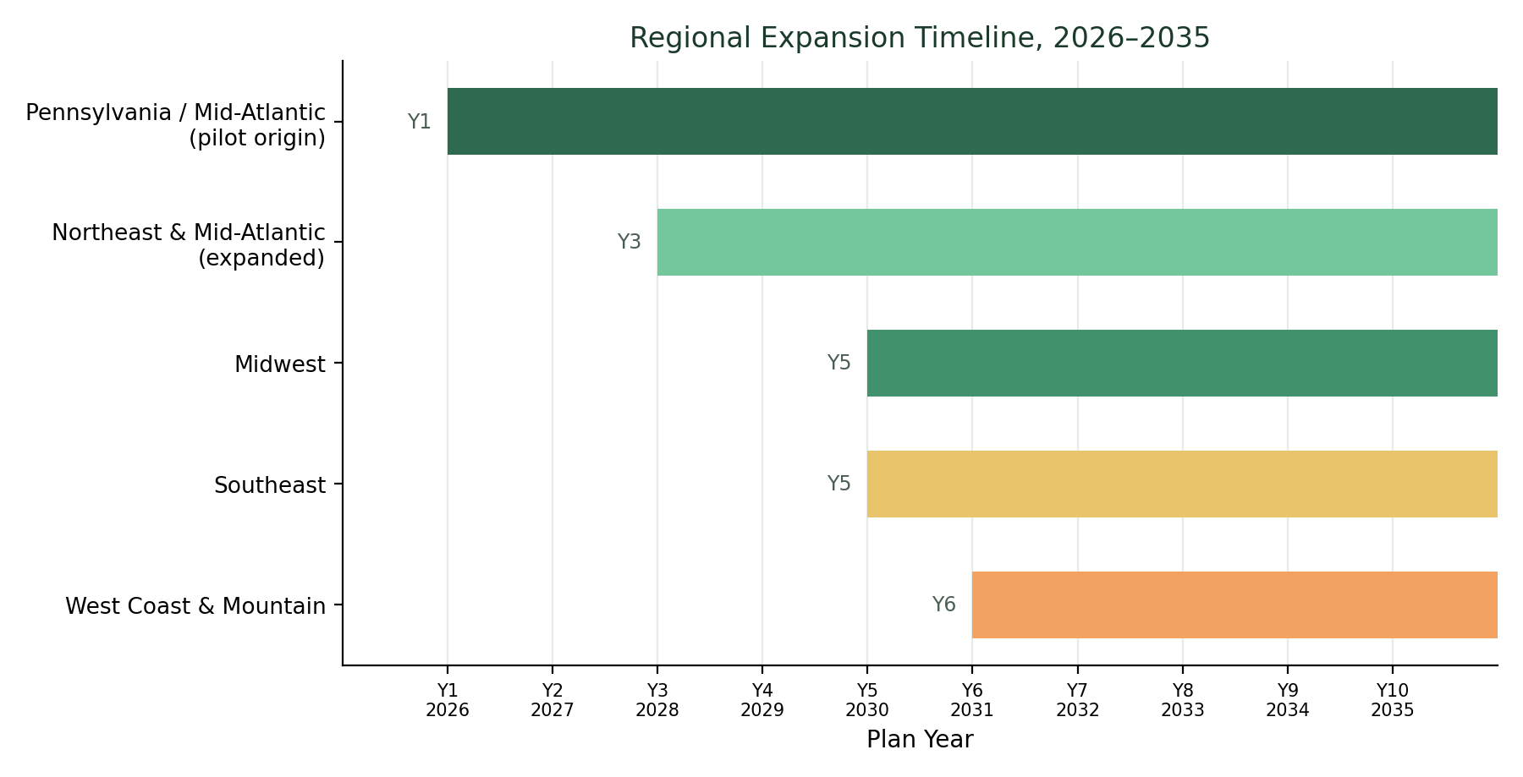
Figure 10.1 — Regional expansion timeline, 2026–2035.

10.3 Phase-by-Phase Go-to-Market Plan

Phase 1 — Foundation & Regional Pilot (2026–2027)
- Launch in Pennsylvania and the surrounding Mid-Atlantic region, leveraging the Founder's existing regional network and the Company's Pittsburgh registered office.
- Onboard an initial cohort of roughly 100 founding farmers in Year 1, growing to approximately 500 by the end of Year 2.
- Prioritize household and restaurant buyers first, where sales cycles are short and feedback loops are fast.
- Validate the core logistics loop (farmer lists → buyer orders → carrier fulfills → farmer paid) before adding complexity.

Phase 2 — Regional Expansion (2028–2029)
- Expand into additional Northeast and Mid-Atlantic states, targeting metro areas with strong local-food demand.
- Formalize institutional partnerships with early school-district and hospital-system pilot customers.
- Introduce farmer subscription tiers as the analytics suite (Section 7.2) becomes available.
- Grow the farmer base from roughly 2,000 to 5,000 across the expanded footprint.

Phase 3 — National Scaling (2030–2032)
- Expand into the Midwest, Southeast, and West Coast regions, replicating the regional playbook validated in Phases 1–2.
- Scale institutional procurement partnerships as a dedicated sales motion with a specialized team (see Section 11).
- Open the carrier marketplace nationally, allowing freight and trucking partners in new regions to list capacity directly.
- Grow the farmer base from roughly 12,000 to 28,000.

Phase 4 — Market Leadership & Diversification (2033–2035)
- Deepen penetration in all launched regions rather than prioritizing new-region entry, focusing on retention, order frequency, and account expansion.
- Launch the farm financial services layer and data/insights products described in Section 7.4.
- Evaluate selective adjacent-category and international pilot opportunities.
- Grow the farmer base from roughly 38,000 to 58,000 by the end of Year 10.

10.4 Farmer Base by Region, Year 10
By the end of Year 10, the farmer base is expected to be broadly distributed across all five launched regions, reflecting the maturity of each region's local marketplace rather than concentration in the original Mid-Atlantic pilot.
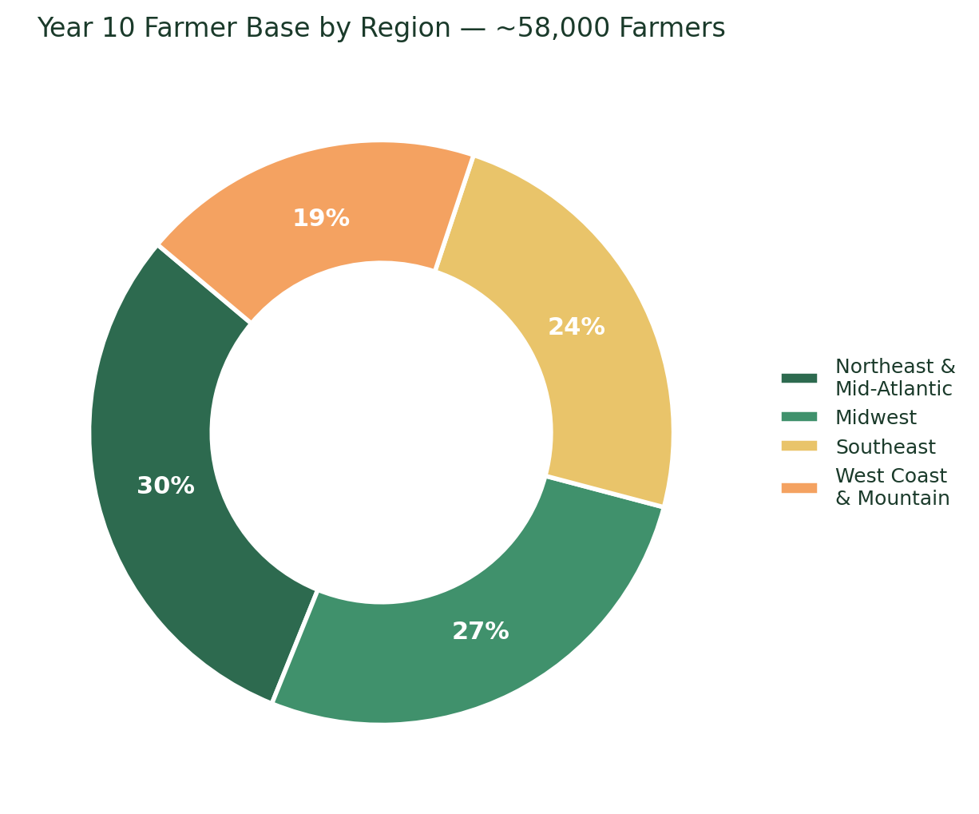
Figure 10.2 — Projected distribution of the farmer base by region, Year 10 (2035).

10.5 Regional Contribution to Marketplace Volume Over Time
The stacked view below shows how each region's contribution to total platform GMV is expected to evolve as later-launching regions mature and begin contributing meaningfully to overall marketplace volume, rather than the Company remaining dependent on its original Mid-Atlantic pilot region.
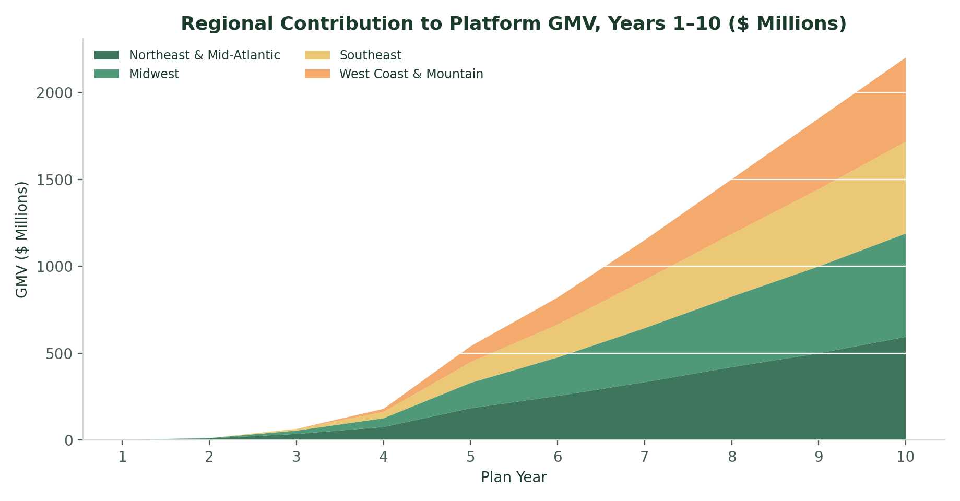
Figure 10.3 — Regional contribution to platform GMV, Years 1–10 ($ millions).

11. Organizational Plan

11.1 Founding Team (Phase 1, Years 1–2)
The Company begins with a lean founding team led by Founder & CEO Mary Nyamvumba, supported by a small product/engineering function maintaining the existing AgroCart application, a farmer-partnerships lead handling regional onboarding, and contracted logistics/carrier-relations support.

11.2 Headcount Growth by Phase
Phase | Years | Approx. Team Size | Key New Roles Added
Phase 1 — Foundation | 2026–2027 | 5–10 | Founding engineers, Farmer Partnerships Lead, Customer Support
Phase 2 — Regional Expansion | 2028–2029 | 20–35 | CTO, VP Farmer Partnerships, Institutional Sales Lead, Data Analyst
Phase 3 — National Scaling | 2030–2032 | 60–100 | VP Logistics, Regional GMs, Expanded Engineering & Data Science
Phase 4 — Market Leadership | 2033–2035 | 120–180 | VP Institutional Sales, Financial Services Lead, Policy & Partnerships

11.3 Headcount Growth by Department
Headcount growth is weighted toward Engineering & Product in the earliest phase, then shifts toward Sales & Farmer Partnerships and Logistics Operations as the Company prioritizes regional and national scale.
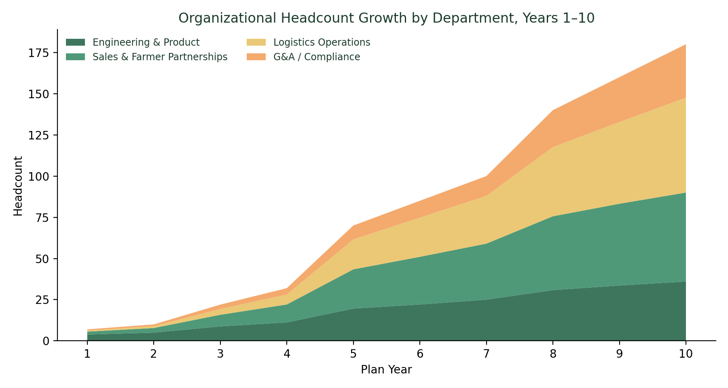
Figure 11.1 — Organizational headcount growth by department, Years 1–10.

11.4 Governance
As the Company raises outside capital across Phases 2–4, it anticipates formalizing a Board of Directors/Advisors that includes the Founder & CEO alongside investor representatives and independent directors with agricultural, logistics, and institutional-procurement expertise.

11.5 Culture & Hiring Principles
- Prioritize hires with direct agricultural, logistics, or institutional-procurement experience over generic e-commerce backgrounds.
- Maintain a lean, execution-focused team through Phase 1–2, expanding specialist functions only once the core marketplace loop is validated.
- Build regional hiring hubs (Section 10.2) as each new region launches, rather than centralizing all roles in Pittsburgh.

12. Marketing & Customer Acquisition Strategy

12.1 Acquisition Channels by Segment
- Farmer acquisition: direct outreach through agricultural extension offices, farm bureaus, and USDA/FMPP grant-program networks; farmer referral incentives.
- Household/consumer acquisition: regional digital marketing, farmers-market and community partnerships, and word-of-mouth/referral loops.
- Restaurant and retailer acquisition: direct sales outreach, food-service trade shows, and case-study-driven marketing once early cohorts show measurable savings and quality improvements.
- Institutional acquisition: direct relationship-building with school nutrition directors and hospital procurement offices, supported by compliance and reporting tooling.

12.2 Illustrative Customer Acquisition Cost (CAC) and Lifetime Value (LTV)
Acquisition economics vary meaningfully by segment. Farmers and institutional buyers require higher-touch, relationship-driven acquisition with a longer sales cycle but generate substantially higher lifetime value through recurring, high-volume ordering; household buyers are acquired more cheaply but at lower individual LTV, made viable at scale through referral loops and repeat ordering.
Segment | Illustrative CAC | Illustrative Annual LTV | Primary Retention Driver
Farmer (seller) | $350–$600 | $2,500–$6,000+ | Reliable payouts, demand visibility, subscription tools
Household buyer | $15–$35 | $180–$400 | Freshness, price transparency, delivery reliability
Restaurant / retailer buyer | $200–$450 | $3,000–$9,000 | Consistent quality, simplified procurement
Institutional buyer | $1,500–$4,000 | $25,000–$150,000+ | Compliance support, dedicated account management
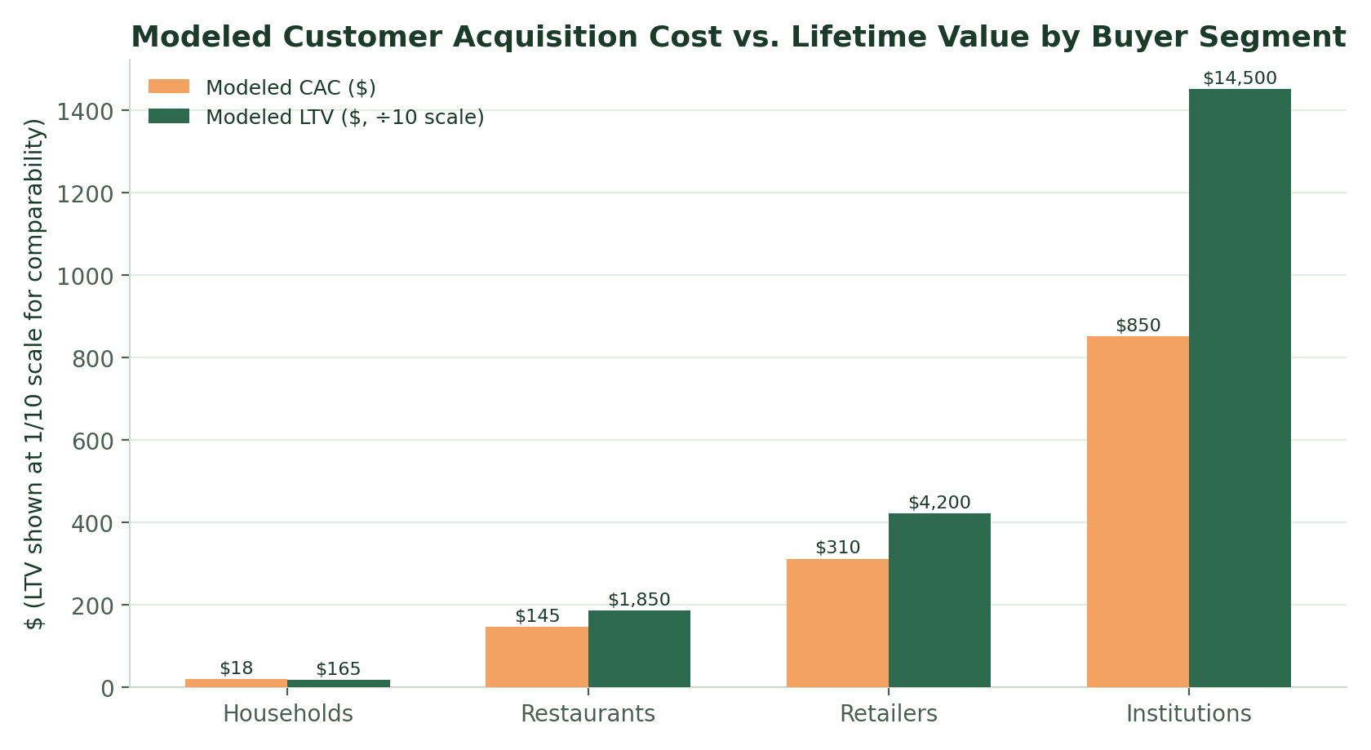
Figure 12.1 — Modeled customer acquisition cost versus lifetime value by buyer segment (LTV shown at 1/10 scale for visual comparability with CAC).

12.3 Marketing Investment Priorities by Phase
- Phase 1 — founder-led direct outreach and community/farmers-market partnerships; minimal paid marketing spend.
- Phase 2 — regional digital marketing and dedicated institutional/restaurant sales outreach as the team expands.
- Phase 3 — national brand-building alongside continued high-touch institutional sales; case studies and earned media from Phase 1–2 regions.
- Phase 4 — retention- and expansion-focused marketing (account growth, cross-segment upsell) rather than pure new-customer acquisition.

12.4 Brand Positioning
AgroChain Cart is positioned as farmer-first digital infrastructure — not a retailer, not a delivery app, but the platform that lets a farm operate its own direct-to-buyer business without needing to become a logistics or e-commerce company itself. All marketing, from farmer outreach to institutional sales collateral, reinforces this positioning against retailer-first competitors like Instacart and directory-only competitors like LocalHarvest.

13. Operations Plan
Beyond product and go-to-market strategy, AgroChain Cart's day-to-day reliability depends on a small number of operational processes executed consistently across every region: how a farm gets onboarded, how quality is verified, how a shipment actually moves from farm to buyer, and how issues get resolved when something goes wrong. This section describes how those processes work today and how they scale through Phase 4.

13.1 Farmer Onboarding Process
Every farm joining the platform moves through a standard onboarding sequence designed to be light enough for a small operation to complete without dedicated administrative staff, while still giving buyers confidence in what they are purchasing.
- Application & verification — basic farm information, growing practices, and (where applicable) organic/certification documentation.
- Farm Dashboard setup — guided listing creation, pricing, and inventory configuration, with FMPP/USDA grant-eligibility screening built into the flow.
- Logistics enrollment — farm location and shipping capability matched against the open carrier marketplace to confirm fulfillment coverage before the farm goes live.
- First-order support — a founding-team or farmer-partnerships team member (Section 11.1) directly supports each farm's first several orders during Phase 1–2, transitioning to self-service tooling and regional support hubs from Phase 3 onward.

13.2 Quality Assurance & Trust
- Listing-level accuracy checks (weight, unit pricing, harvest/pack date) enforced through Farm Dashboard validation rules referenced in Section 14.1's risk-monitoring indicators.
- Buyer review and rating system feeding back into farm-level trust scores visible to institutional and household buyers alike.
- Random and complaint-triggered quality audits, scaling from founder-led spot checks in Phase 1 to a dedicated quality-assurance function from Phase 2 onward (Section 11.2).
- Food-safety compliance documentation tracking, expanding in Phase 3 to support multi-state institutional partners with stricter procurement compliance requirements.

13.3 Order Fulfillment & Cold-Chain Execution
Once an order is placed, fulfillment runs through the Logistics & Carrier Marketplace already live in the current AgroCart application: a shipment is created, matched against available carrier capacity, and tracked in real time from origin to destination with proof-of-delivery captured at handoff.
- Phase 1–2 — single-region fulfillment with a limited set of vetted regional carriers; live tracking and manual escalation for exceptions.
- Phase 3 — multi-region cold-chain network with route optimization (Section 7.3) and automated exception alerts for delayed or at-risk shipments.
- Phase 4 — predictive fulfillment: harvest-planning and inventory tools (Section 7.4) reduce the frequency of stockouts and spoilage-driven order cancellations before they occur.

13.4 Customer & Farmer Support
Support scales from direct, founder-adjacent handling in Phase 1 to a structured, tiered model by Phase 3, without ever removing a direct escalation path for institutional accounts, which require higher-touch account management regardless of platform maturity.
Phase | Support Model
Phase 1 (2026–27) | Founder/founding-team-led direct support across farmers and buyers
Phase 2 (2028–29) | Dedicated customer support function; institutional accounts get named contacts
Phase 3 (2030–32) | Regional support hubs aligned to each launched region; self-service help center
Phase 4 (2033–35) | Tiered support (self-service, standard, dedicated institutional account management)

13.5 Payments & Settlement Operations
Buyer payments are processed at checkout and settled to farmers on a recurring cycle, with multi-buyer batch settlement (Section 7.2) introduced in Phase 2 to reduce administrative overhead for farms selling across multiple buyer segments simultaneously. Institutional buyers with purchase-order-based procurement are supported through invoicing workflows introduced alongside the Phase 2 institutional procurement tooling.

14. Ten-Year Financial Projections
The table and charts below present AgroChain Cart's modeled growth across all ten years of this plan, building directly on the Company's original five-year projections and extending them through Year 10 under continued, moderating growth assumptions consistent with a maturing national marketplace.

14.1 Marketplace Volume, Revenue & Farmer Growth
Year | Farmers Onboarded (Cumulative) | Platform Sales / GMV | AgroChain Cart Revenue
Year 1 (2026) | 100 | $2.4M | $192K
Year 2 (2027) | 500 | $12M | $960K
Year 3 (2028) | 2,000 | $64.8M | $5.18M
Year 4 (2029) | 5,000 | $180M | $14.4M
Year 5 (2030) | 12,000 | $540M | $43M
Year 6 (2031) | 19,000 | $820M | $65.6M
Year 7 (2032) | 28,000 | $1.15B | $92M
Year 8 (2033) | 38,000 | $1.5B | $120M
Year 9 (2034) | 48,000 | $1.85B | $148M
Year 10 (2035) | 58,000 | $2.2B | $176M
Table 14.1 — Years 1–5 figures reflect the Company's original financial model; Years 6–10 extend that model under moderating growth assumptions (blended 8% platform take rate held constant).
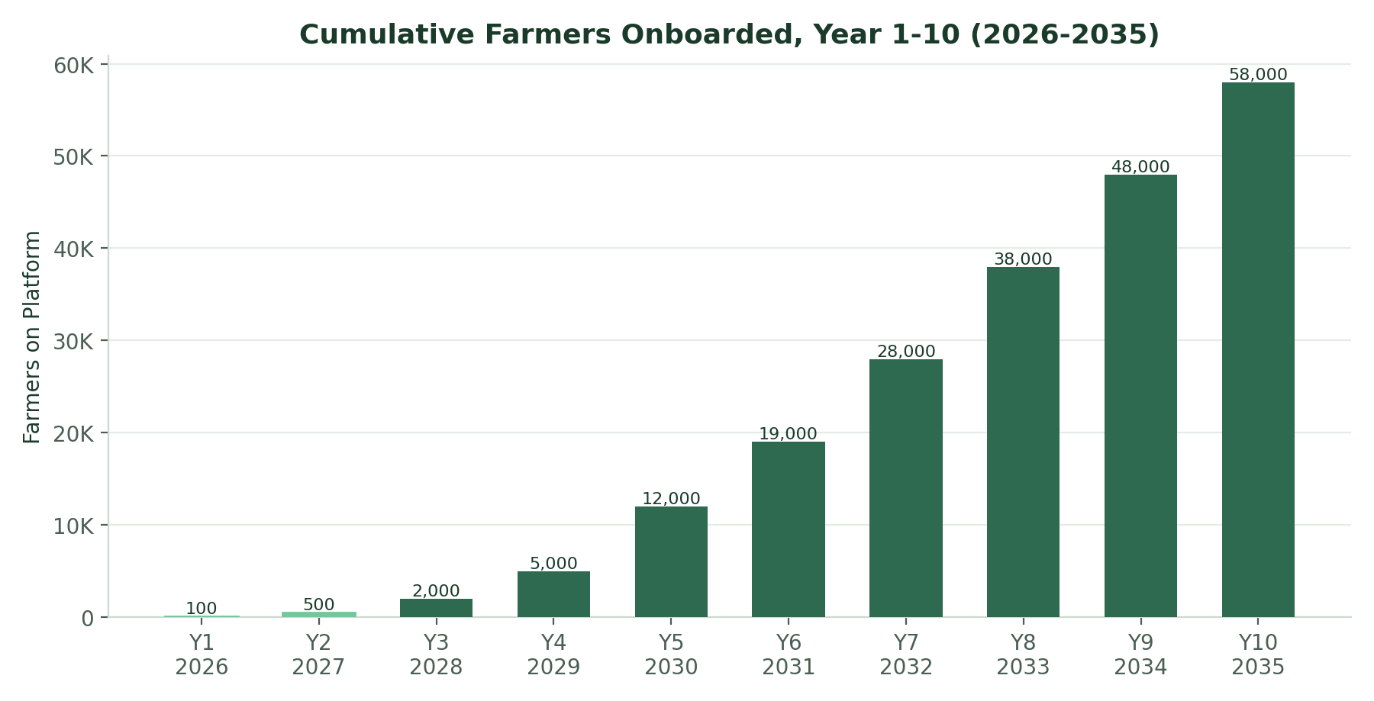
Figure 14.1 — Cumulative farmers onboarded, Years 1–10.
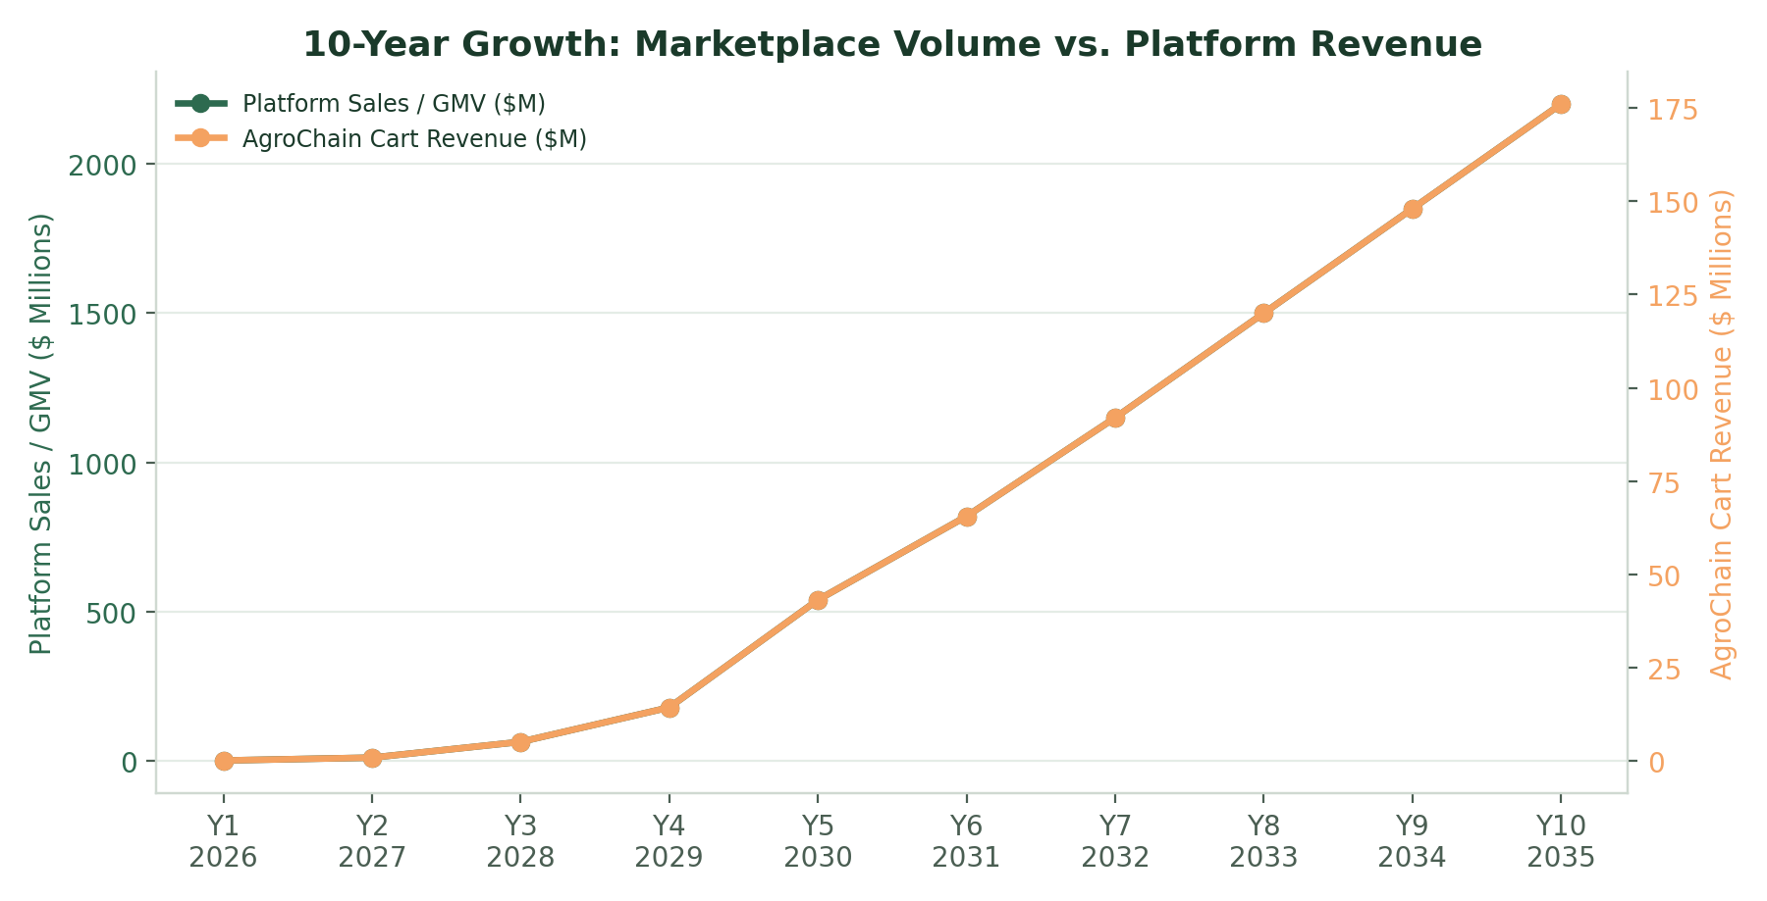
Figure 14.2 — Platform sales (GMV) versus AgroChain Cart revenue, Years 1–10.

14.2 Illustrative Ten-Year Income Statement
The table below presents an illustrative operating model translating platform revenue into a full income statement, including payment-processing cost of revenue and the four core operating expense categories (Engineering/Product, Sales & Marketing, Logistics Operations, and G&A). This is a planning model, not audited financial guidance, and should be refined with actual vendor and payroll data ahead of any fundraising process.
Year | Revenue | Cost of Revenue* | Gross Profit | Operating Expenses | EBITDA
Year 1 (2026) | $0.19M | $0.05M | $0.14M | $1.6M | -$1.46M
Year 2 (2027) | $0.96M | $0.24M | $0.72M | $3.1M | -$2.38M
Year 3 (2028) | $5.18M | $1.30M | $3.88M | $8.7M | -$4.82M
Year 4 (2029) | $14.4M | $3.60M | $10.8M | $15.0M | -$4.20M
Year 5 (2030) | $43.0M | $10.80M | $32.2M | $29.0M | $3.2M
Year 6 (2031) | $65.6M | $16.40M | $49.2M | $42.0M | $7.2M
Year 7 (2032) | $92.0M | $23.00M | $69.0M | $55.0M | $14.0M
Year 8 (2033) | $120.0M | $30.00M | $90.0M | $68.0M | $22.0M
Year 9 (2034) | $148.0M | $37.00M | $111.0M | $81.0M | $30.0M
Year 10 (2035) | $176.0M | $44.00M | $132.0M | $94.0M | $38.0M
Table 14.2 — *Cost of revenue modeled at 2% of GMV (payment processing & related direct costs). Figures rounded.
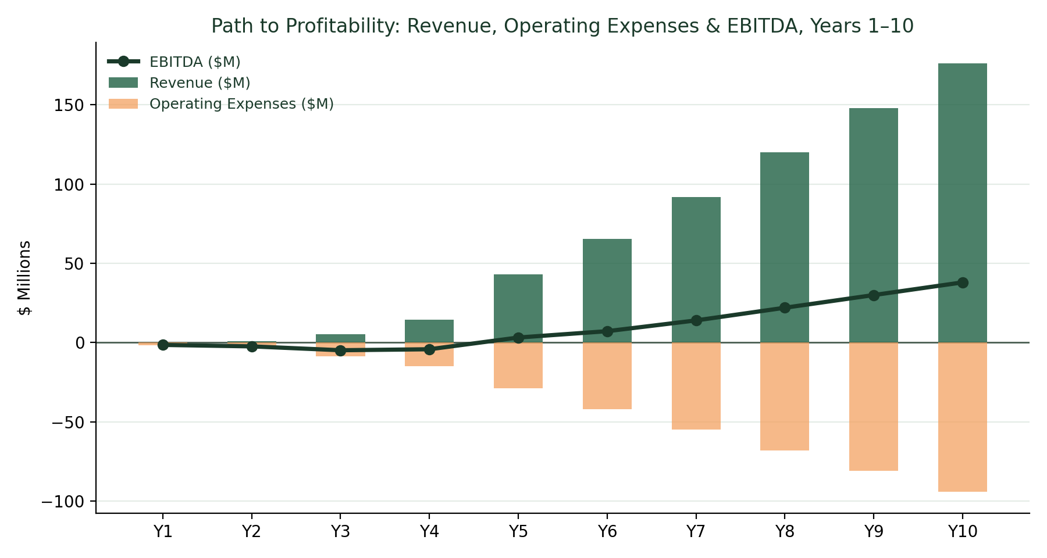
Figure 14.3 — Path to profitability: revenue, operating expenses, and EBITDA, Years 1–10.

14.3 Key Assumptions
- Blended marketplace take rate held constant at 8% across the full ten-year period, consistent with the Company's original financial model.
- Payment processing and direct transaction costs modeled at 2% of GMV throughout, consistent with typical marketplace payment-processing rates.
- Farmer growth decelerates in percentage terms after Year 5 as the platform matures from regional pilot to national scale, consistent with typical two-sided marketplace growth curves.
- Operating expenses scale with the headcount plan in Section 11.2, weighted increasingly toward Sales & Farmer Partnerships and Logistics Operations in later phases.
- Figures are modeled at the consolidated platform level; a detailed, auditable operating expense build should accompany any external fundraising process.
- Projections assume continued execution of the phased go-to-market plan in Section 10 and do not assume major inorganic (acquisition-based) growth.

14.4 Path to Profitability
Under this model, AgroChain Cart reaches EBITDA breakeven in Year 5 (2030), coinciding with the start of the National Scaling phase. Profitability is driven primarily by the diversification of revenue toward higher-margin subscription, logistics-coordination, and institutional revenue described in Section 9.2, combined with operating expenses that grow more slowly than revenue from Year 5 onward as the platform benefits from scale efficiencies in engineering and logistics operations.
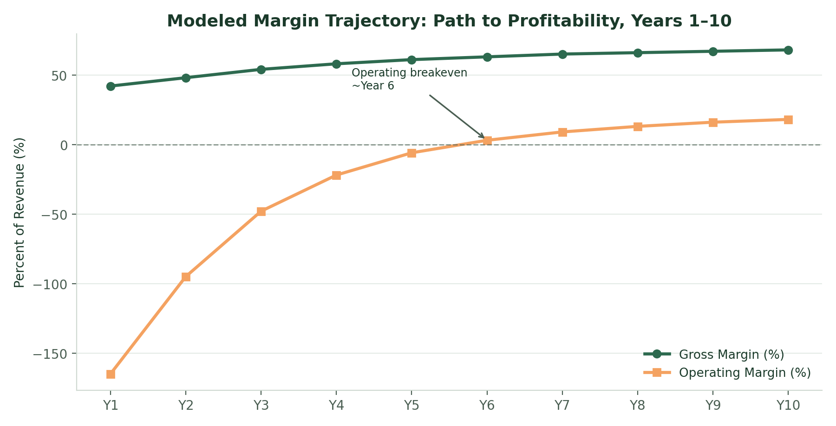
Figure 14.4 — Modeled gross margin and operating margin trajectory, Years 1–10, showing the path to operating breakeven around Year 6.

14.5 Sensitivity Considerations
- A one-year delay in reaching the farmer-growth milestones in Section 14.1 would correspondingly delay EBITDA breakeven, underscoring the importance of the phased go-to-market discipline in Section 10.1.
- A higher blended take rate (e.g., 9–10% versus the modeled 8%) would accelerate profitability but carries retention risk if farmer or buyer economics become less competitive versus traditional channels.
- Logistics cost overruns, particularly in early multi-state cold-chain expansion (Phase 3), represent the most significant downside risk to the operating expense assumptions above.

15. Risk Analysis & Mitigation
The table below summarizes the principal risks to the execution of this plan, organized from the most immediate (Phase 1 liquidity risk) to the most structural (long-horizon competitive and regulatory risk), alongside the specific mitigations built into the Company's strategy and product design.
Risk | Description | Mitigation
Farmer & buyer liquidity | Two-sided marketplaces can stall if either farmers or buyers fail to reach critical mass in a region. | Deliberate single-region pilot before expansion; founder-led direct outreach; referral incentives on both sides.
Logistics execution | Cold-chain and last-mile delivery failures directly damage trust with institutional and household buyers. | Open carrier marketplace with live tracking and proof-of-delivery; phased logistics network expansion tied to demonstrated reliability.
Seasonality | Agricultural supply is inherently seasonal, creating revenue volatility. | Multi-region expansion staggers growing seasons; category diversification (produce, dairy, grains) smooths supply.
Capital requirements | National scaling (Phases 3–4) requires significant funding for logistics, engineering, and sales headcount. | Phased fundraising tied to milestones achieved in each prior phase, described in Section 16.
Regulatory & compliance | Food safety, institutional procurement, and interstate commerce rules vary by state and buyer type. | Dedicated compliance function from Phase 2 onward; direct engagement with USDA/FMPP frameworks already built into the Farm Dashboard.
Competitive response | Larger, better-capitalized platforms could attempt to replicate the direct farm-marketplace model. | Build defensible network effects and institutional relationships early (Section 8.3); maintain founder domain-expertise advantage.
Key-person dependency | Early-stage reliance on the Founder & CEO across product, fundraising, and partnerships. | Deliberate leadership-expansion plan from Phase 2 onward (Section 3.3, Section 11); documented processes as the team grows.
Farmer data quality | Inaccurate inventory or pricing data from farmer-sellers can undermine buyer trust. | Farm Dashboard validation rules, quality ratings, and buyer review mechanisms; account support for smaller farms.

15.1 Risk Monitoring Approach
Beginning in Phase 2, the Company intends to track a standing set of leading indicators against each risk category above including regional farmer/buyer liquidity ratios, on-time delivery rates, seasonal revenue variance, runway-to-milestone ratios, and compliance audit findings reviewed on a monthly basis by the Founder & CEO and, once formalized, the Board of Directors/Advisors described in Section 11.4.

16. Funding Requirements & Use of Proceeds
AgroChain Cart intends to raise capital in phases aligned with the growth plan in Section 10, rather than a single large raise, to keep dilution proportionate to demonstrated execution.

16.1 Indicative Funding Phases
Stage | Approx. Timing | Primary Use of Proceeds
Pre-Seed / Seed | 2026 | Core engineering team, initial farmer/buyer acquisition, regional pilot operations
Series A | 2028 | Regional expansion, institutional sales team, analytics suite development
Series B | 2030–2031 | National logistics network build-out, multi-region GMs, engineering scale-up
Series C / Growth | 2033 | Financial services layer, data products, deepening market penetration

16.2 Indicative Use of Proceeds (Blended, All Stages)
Across all funding stages, the largest share of capital is directed toward product/engineering and farmer & buyer acquisition — the two levers most directly tied to marketplace liquidity and the milestones in Section 17.
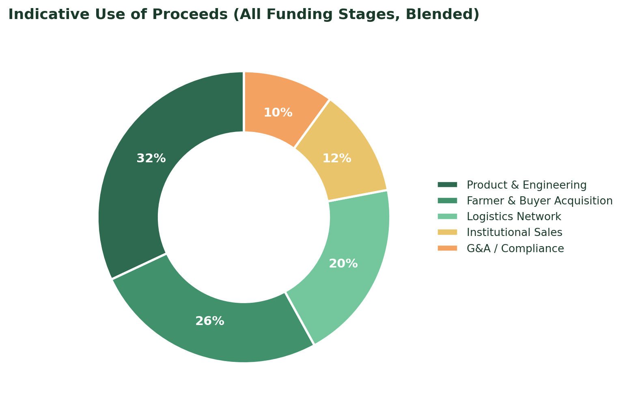
Figure 16.1 — Indicative blended use of proceeds across all funding stages.

16.3 Use-of-Funds Priorities at Every Stage
- Farmer and buyer acquisition in newly launched regions.
- Engineering and product investment aligned with the roadmap in Section 7.
- Logistics network reliability: the single most important driver of buyer trust and retention.
- Compliance, food-safety, and institutional procurement infrastructure.

16.4 Return of Capital Considerations
As with any early-stage venture, prospective investors should evaluate this plan alongside standard early-stage risk considerations, including execution risk, market-adoption risk, and the capital intensity of building a national logistics network. The phased funding structure above is designed specifically to let investors underwrite each stage against demonstrated milestones from the prior stage, rather than a single long-horizon commitment.

17. Ten-Year Milestone Summary
Phase | Timeframe | Milestone
Phase 1 | 2026 | Legal entity formed; AgroCart MVP live; ~100 founding farmers onboarded in Pennsylvania/Mid-Atlantic pilot
Phase 1 | 2027 | ~500 farmers onboarded; core marketplace loop validated; farmer analytics suite in development
Phase 2 | 2028 | Regional expansion into additional Northeast/Mid-Atlantic states; ~2,000 farmers; first institutional pilot partners
Phase 2 | 2029 | ~5,000 farmers; farmer subscription tiers launched; mobile farmer app released
Phase 3 | 2030 | National expansion begins; ~12,000 farmers; AI-assisted pricing tools introduced; EBITDA breakeven
Phase 3 | 2031–2032 | ~19,000–28,000 farmers; open carrier marketplace live nationally; institutional sales team scaled
Phase 4 | 2033 | ~38,000 farmers; farm financial services layer launched
Phase 4 | 2034–2035 | ~48,000–58,000 farmers; data & insights products launched; $2.2B+ in annual marketplace volume

18. Sustainability & Community Impact
AgroChain Cart's business model is structurally aligned with several sustainability and community-development outcomes, not as a separate initiative layered on top of the marketplace, but as a direct consequence of shortening agricultural supply chains and returning more value to the farmer.

18.1 Economic Impact
- Increased farmer income through a nearly quadrupled share of the consumer food dollar relative to traditional channels (Section 4, Figure 1.1).
- Support for rural economic development as farm income is reinvested locally in equipment, land, and labor.
- Lower barriers to entry for small and mid-sized farms through FMPP/USDA grant-program alignment built into the Farm Dashboard.

18.2 Environmental Impact
- Shorter supply chains reduce the number of intermediary transport legs between farm and buyer relative to conventional distribution networks.
- The Phase 4 sustainability and carbon-footprint reporting tools (Section 7.4) are designed to give institutional buyers auditable data to support their own ESG procurement requirements.
- Regional sourcing, supported by the multi-region expansion plan in Section 10, reduces average shipping distance relative to national commodity distribution.

18.3 Food Security & Institutional Access
- Institutional partnerships with schools and hospitals (Sections 9.1, 10.3) extend access to fresh, local food in settings that serve vulnerable populations.
- Price transparency tools give lower-income households clearer visibility into fair pricing, versus opaque conventional retail markups.

18.4 Reporting Approach
As the Company scales through Phases 2–4, it intends to publish periodic impact summaries; aggregate farmer income impact, regional food-mile reduction estimates, and institutional partnership reach alongside its standard financial reporting, both to support grant and policy partnerships and to hold the Company accountable to its founding mission.

19. Exit Strategy & Long-Term Vision
While AgroChain Cart's near- and medium-term focus is execution against the ten-year plan described in this document, prospective investors and institutional partners will reasonably want visibility into how long-term value is expected to be realized.

19.1 Long-Term Vision
By Year 10, AgroChain Cart aims to be recognized as core digital infrastructure for regional food systems in the United States; the default layer connecting farm supply to buyer demand, in the same way that payment processors and cloud infrastructure became default layers for their respective industries. At that scale, the Company's most durable long-term assets are its two-sided network (Section 8.3), its logistics and carrier-capacity data, and its institutional procurement relationships.

19.2 Illustrative Exit Pathways
- Strategic acquisition by a larger food, retail, logistics, or agtech platform seeking direct-farm relationships and logistics infrastructure it does not currently have.
- Continued independent growth funded by later-stage private capital, with the Company remaining founder-led and privately held through the full ten-year horizon of this plan.
- A public listing at sufficient scale and profitability, following the establishment of the diversified, multi-stream revenue base described in Section 9.
This plan does not assume any particular exit pathway or timeline; it is presented as a standalone ten-year operating and growth plan, with exit optionality treated as a downstream consequence of successful execution rather than a design objective in itself.

19.3 Long-Term Value Drivers
- Network effects from a mature, national two-sided marketplace that becomes structurally difficult for new entrants to replicate.
- Diversified, increasingly high-margin revenue (Section 9.3) reducing dependence on transaction-fee volume alone.
- Proprietary logistics and marketplace data supporting the Phase 4 data and financial-services products (Section 7.4).
- Deep institutional relationships built over multiple years, which are inherently difficult for a new entrant to replicate quickly.

20. Conclusion
AgroChain Cart represents a scalable digital infrastructure designed to modernize agricultural commerce in the United States. By enabling direct connections between farmers and buyers, the platform improves supply chain transparency, increases farmer income, and strengthens rural economic development, while contributing to a more resilient national food distribution system.
The Company begins this journey in 2026 from a single, carefully validated regional pilot, the AgroCart platform already live today and, through the disciplined four-phase plan described in this document, aims to grow into a national digital marketplace and logistics network supporting tens of thousands of farmers and billions of dollars in annual marketplace volume by 2035.
AgroChain Cart is not just a marketplace. It is the infrastructure a fairer food system runs on.
— Mary Nyamvumba, Founder & CEO, AgroChain Cart LLC

Appendix A: Detailed Ten-Year Financial Summary
This appendix consolidates the full year-by-year operating model referenced throughout Section 14, for ease of reference in fundraising and planning discussions.
Year | Farmers | GMV | Revenue | COGS | Gross Profit | OpEx | EBITDA
Y1 (2026) | 100 | $2.4M | $0.19M | $0.05M | $0.14M | $1.6M | -$1.46M
Y2 (2027) | 500 | $12M | $0.96M | $0.24M | $0.72M | $3.1M | -$2.38M
Y3 (2028) | 2,000 | $64.8M | $5.18M | $1.30M | $3.88M | $8.7M | -$4.82M
Y4 (2029) | 5,000 | $180M | $14.4M | $3.60M | $10.8M | $15.0M | -$4.20M
Y5 (2030) | 12,000 | $540M | $43.0M | $10.80M | $32.2M | $29.0M | $3.2M
Y6 (2031) | 19,000 | $820M | $65.6M | $16.40M | $49.2M | $42.0M | $7.2M
Y7 (2032) | 28,000 | $1.15B | $92.0M | $23.00M | $69.0M | $55.0M | $14.0M
Y8 (2033) | 38,000 | $1.5B | $120.0M | $30.00M | $90.0M | $68.0M | $22.0M
Y9 (2034) | 48,000 | $1.85B | $148.0M | $37.00M | $111.0M | $81.0M | $30.0M
Y10 (2035) | 58,000 | $2.2B | $176.0M | $44.00M | $132.0M | $94.0M | $38.0M

Appendix B: Key Assumptions & Methodology Notes
- Years 1–5 marketplace volume, farmer count, and revenue figures are drawn directly from the Company's original financial model as presented in its founding strategic proposal.
- Years 6–10 figures extend that model under moderating growth assumptions consistent with a two-sided marketplace transitioning from regional pilot to national scale; they should be treated as directional planning estimates, not forecasts.
- The blended 8% marketplace take rate is held constant across all ten years for modeling simplicity; actual realized take rate may vary by revenue stream mix (Section 9.3) and negotiated institutional terms.
- Cost of revenue is modeled at 2% of GMV (payment processing and directly variable transaction costs).
- Operating expense figures in Appendix A are planning estimates derived from the headcount plan in Section 11.2 and standard early-stage SaaS/marketplace expense ratios; they are not based on signed vendor contracts or finalized compensation bands.
- Regional GMV and farmer-distribution splits (Section 10) are illustrative allocations of the consolidated national figures and are not independently modeled region-by-region.
- All dollar figures are nominal (not inflation-adjusted) and presented in U.S. dollars.
- This document is a strategic planning tool prepared by AgroChain Cart LLC and does not constitute an offer to sell, or a solicitation of an offer to buy, any securities.

