
TERRAVISION ANALYTICS
See Every Acre. Know Every Risk. Act Before It's Too Late.
TEN-YEAR STRATEGIC BUSINESS PLAN
Fiscal Years 2026 – 2035
Featuring the AgriCortex Platform
Edge-Native Geospatial Intelligence for Agriculture and Food Security
Gideon Olawale Sodipo
Founder & Chief Executive Officer
Prepared: June 2026
Status: Confidential — For Internal and Investor Use Only

Table of Contents

1. Executive Summary 3
1.1 The Opportunity 3
1.2 How to Use This Plan 4
2. Company Overview 4
2.1 Origin Story 4
2.2 Mission 4
2.3 Vision 4
2.4 Company Timeline 5
2.5 What the Company Has Already Built 5
2.6 Legal Structure and Governance 6
2.7 Current Customers and Trust Signals 6
3. Leadership 6
3.1 Founder and CEO: Gideon Olawale Sodipo 6
3.2 Values That Shape How the Company Operates 7
4. AgriCortex: Flagship Product Deep Dive 7
4.1 Current Status: Development and Testing Phase 7
4.2 Path to General Availability 8
4.3 AgriCortex Product Roadmap, Years 1 Through 5 9
5. Market Analysis 9
5.1 Target Markets 9
5.2 Market Sizing 9
5.3 Competitive Landscape 10
5.4 Key Market Risks 10
6. Business Model and Revenue Strategy 10
6.1 Revenue Streams 11
6.2 Pricing Philosophy 11
6.3 Go-to-Market Strategy 12
7. Ten-Year Strategic Roadmap 12
7.1 Phase I: Foundation and Commercial Launch, 2026 to 2027 12
7.2 Phase II: Scaled Growth, 2028 to 2029 12
7.3 Phase III: National and International Expansion, 2030 to 2032 12
7.4 Phase IV: Platform Maturity and Diversification, 2033 to 2035 13
8. Ten-Year Financial Plan 13
8.1 Revenue, Costs, and Profitability Summary, FY2026 to FY2035 13
8.2 Key Assumptions 15
8.3 Headcount Plan 15
8.4 Funding Requirements 16
9. Operations Plan 16
9.1 Technology Infrastructure 16
9.2 Data Sources and Partnerships 16
9.3 Security and Compliance Roadmap 17
9.4 Organizational Development 17
10. Risk Analysis and Mitigation 17
11. Key Milestones and Success Metrics 18
11.1 Milestone Timeline 18
11.2 Core KPIs to Track Annually 18
12. Conclusion 19

1. Executive Summary
TerraVision Analytics was founded in 2018 inside a USDA research lab by Gideon Olawale Sodipo, working alongside a small group of USDA remote-sensing researchers who shared a conviction that agricultural decision-making was being held back by stale, low-resolution data. What started as a research collaboration has grown into an edge-native geospatial intelligence company that fuses satellite imagery, drone telemetry, IoT sensor networks, and applied AI into decision-ready agricultural intelligence for federal agencies, agribusiness corporations, and food-security organizations.
The company's track record over its first eight years is a meaningful part of the story this plan tells. In 2020, TerraVision won its first USDA NASS contract and deployed its edge-native platform across 12 million acres of Midwest cropland. By 2022, it had closed a $28 million Series A, expanded into 14 federal and state agencies, and was processing more than 500 million daily AI inference events. In 2024, the company achieved FedRAMP Moderate authorization, a milestone that unlocked broader federal procurement, and scaled to 2.4 billion acres under surveillance while opening its REST and GraphQL APIs publicly. Heading into 2026, the company is building on that foundation rather than starting from zero.
This ten-year business plan, covering fiscal years 2026 through 2035, sets out the strategic, operational, and financial roadmap for the next phase of the company's growth, centered on AgriCortex, TerraVision's flagship operational platform. AgriCortex is currently in development and active pilot testing, and represents the productization of the company's core capabilities into a unified dashboard purpose-built for USDA program offices and enterprise agricultural intelligence workflows. It is the mechanism through which the company intends to convert its existing federal trust and data infrastructure into a scaled, repeatable commercial product.
Over the plan horizon, TerraVision Analytics will move through four phases: Foundation and Commercial Launch (2026 to 2027), in which AgriCortex exits pilot testing and reaches general availability across federal and enterprise accounts; Scaled Growth (2028 to 2029), in which the company broadens its sensor and data partner network and diversifies revenue across government, enterprise, and insurance customers; National and International Expansion (2030 to 2032), marked by full USDA enterprise deployment and entry into allied markets including Canada, the European Union, and parts of Latin America; and Platform Maturity and Diversification (2033 to 2035), in which the company extends into adjacent domains such as water resources, forestry, and climate-risk insurance analytics.
Financially, the plan projects growth from an estimated $2.1 million in FY2026 revenue, reflecting the transitional period around AgriCortex's commercial launch, to a projected $185 million or more in FY2035 revenue. The company is expected to reach cash-flow breakeven in FY2029 and to sustain EBITDA margins above 30 percent by FY2032, supported by a largely fixed-cost edge and cloud infrastructure base that was already substantially built out during the company's first growth phase.

1.1 The Opportunity
Climate volatility, food-security policy mandates, and a persistent gap between what farmers and agencies need to know and what legacy survey methods can tell them have created sustained demand for trustworthy, field-level agricultural intelligence. TerraVision's edge-native architecture, which processes data at the sensor before it ever has to round-trip to the cloud, gives the company a structural latency and resilience advantage in rural and federal deployments where connectivity is often inconsistent. That advantage, combined with eight years of federal relationship-building and a FedRAMP Moderate authorization already in hand, positions TerraVision well ahead of newer entrants chasing the same market.

1.2 How to Use This Plan
This document is intended to guide internal resource allocation, support investor and strategic-partner conversations, and serve as a working basis for federal contracting pursuit. It should be revisited at least annually and re-forecast against actual results as AgriCortex moves from pilot testing into general availability.

2. Company Overview

2.1 Origin Story
TerraVision Analytics began in 2018 as a research collaboration inside a USDA laboratory. Gideon Olawale Sodipo, working with a group of USDA remote-sensing researchers, set out to combine decades of accumulated expertise in satellite and aerial sensing with what was then a fairly radical idea: that edge AI, not just cloud computing, belonged in every field. That founding insight, that intelligence needed to live close to the land rather than depend entirely on distant data centers, has remained the technical thread running through everything the company has built since.
The company's growth since then has not been linear hype followed by a slow grind. It has been a steady sequence of earned milestones: a first federal contract that proved the model could work at meaningful scale, a Series A that validated investor confidence in the underlying technology, a federal security authorization that very few companies of TerraVision's age manage to achieve, and a public API that opened the platform to a broader ecosystem of developers and partners.

2.2 Mission
To democratize geospatial intelligence by delivering real-time, AI-powered insights that enable every farmer, agency, and agribusiness to make data-informed decisions, preserving resources, increasing yields, and securing the global food supply.

2.3 Vision
A world where satellite imagery, drone telemetry, and edge AI seamlessly connect every acre of farmland to a living digital twin, empowering humanity to anticipate risks, adapt to climate change, and nourish a growing planet. By 2035, TerraVision intends for AgriCortex to be the standard operating dashboard for USDA field intelligence, and for the broader TerraVision platform to be the default geospatial intelligence layer underpinning food-security decisions across North America.

2.4 Company Timeline
Year | Milestone
2018 | Founded by Gideon Olawale Sodipo and a team of USDA researchers, born inside a USDA research lab combining remote-sensing expertise with a vision for edge AI in agriculture.
2020 | First USDA NASS contract awarded. Deployed the edge-native platform across 12 million acres of Midwest cropland, delivering weekly sub-field crop condition reports.
2022 | Closed a $28 million Series A. Expanded to 14 federal and state agencies. Crossed 500 million daily AI inference events.
2024 | Achieved FedRAMP Moderate compliance. Scaled to 2.4 billion acres under surveillance. Released the public REST and GraphQL API.
2026 | AgriCortex enters final pilot testing ahead of general availability, building on the company's existing federal infrastructure and trust.
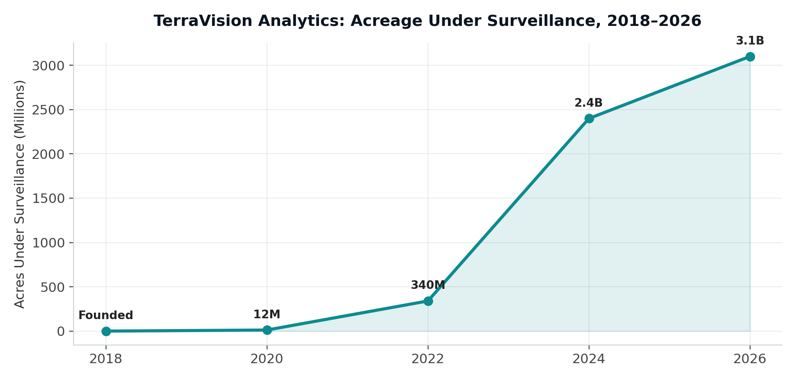
Figure 1: Acres under TerraVision surveillance, 2018 to 2026.

2.5 What the Company Has Already Built
It is worth being explicit about how much groundwork already exists going into this plan, since it changes the shape of the next ten years considerably. The public platform fuses six integrated capability pillars, all of which are live today rather than aspirational:
- Multispectral Earth Observation, fusing Sentinel-2, Landsat-9, PlanetScope, and private SAR archives into time-series composites at 3 to 10 meter resolution with near-daily revisit.
- On-device AI inference, running quantized deep learning models at the edge on NVIDIA Jetson and Raspberry Pi CM4 nodes, delivering sub-200 millisecond inference per image tile without a cloud round-trip.
- A live GIS dashboard built on MapLibre GL and PostGIS, supporting vector tile overlays, real-time telemetry, NDVI heat maps, and administrative boundary queries.
- Predictive climate modeling using CMIP6-downscaled weather ensembles combined with ENSO teleconnections, producing 14-day irrigation windows and 90-day drought-risk probabilities.
- Pest and disease sentinel models, trained on more than four million annotated crop-disease images, capable of detecting early blight, fall armyworm, and viral infection up to 14 days before visible symptoms.
- Automated intelligence reports, scheduled as PDF and API briefs with county-level yield estimates, drought-risk scores, and recommendations formatted for USDA FAS, RMA, and FSA workflows.
This is delivered through a three-tier architecture. Tier 1 collects data through ruggedized field edge nodes that harvest multispectral, soil, weather, and UAV data with offline-capable local buffering. Tier 2 processes that data through edge AI inference and regional aggregation. Tier 3 delivers it through cloud-synchronized GIS dashboards and reporting tools for analysts in Washington and elsewhere.

2.6 Legal Structure and Governance
TerraVision Analytics is organized as a Delaware C-Corporation, structured to support both venture investment and federal contracting eligibility. The board includes founder, investor, and federal-policy-adjacent representation, reflecting the dual commercial and public-sector nature of the business. Given the company's existing FedRAMP Moderate authorization, the governance and compliance infrastructure needed for expanded federal work is materially further along than it would be for a typical early-stage company.

2.7 Current Customers and Trust Signals
The company's customer base already includes USDA NASS, with the relationship dating back to the original 2020 contract, alongside 14 federal and state agencies brought on through the 2022 expansion. On the commercial side, Cargill AgriScience and Pioneer Hi-Bred have both engaged with the platform, with independent data-officer review validating the company's REST API, PostGIS data model, GraphQL layer, and Kafka streaming integration. These relationships form the anchor base from which AgriCortex's commercial rollout will expand over the plan period.

3. Leadership

3.1 Founder and CEO: Gideon Olawale Sodipo
Gideon Olawale Sodipo founded TerraVision Analytics in 2018 alongside a team of USDA researchers and continues to lead the company as Chief Executive Officer. His founding thesis, that food security is best protected by giving decision-makers a shared, real-time, AI-powered view of the land, has shaped both the technical architecture and the go-to-market posture of the company since its earliest days.
“Food security is the defining challenge of our century. We built TerraVision to give every decision-maker, from a smallholder in Nigeria to a policy desk in Washington, the same crystal-clear, AI-powered view of the land. Intelligence is our product; resilience is our promise.”
That quote, drawn from the company's own about page, captures something important about how the company positions itself: not purely as a federal contractor, and not purely as an agribusiness vendor, but as an intelligence provider whose product is meant to be useful at every scale, from a single smallholder farm to a national policy desk. That dual orientation, global and local at once, is a thread this plan carries through the market expansion strategy in later sections.

3.2 Values That Shape How the Company Operates
The company organizes its culture around four stated values, each of which has direct implications for how this plan should be executed.
- Relentless Innovation: pushing the boundaries of what AI and geospatial data can achieve, with constant refinement of models and edge infrastructure rather than treating any release as final.
- Radical Integrity: transparency in data, methods, and results, which is treated as the foundation of trust with federal partners, farmers, and the public, and which matters enormously in a sector where bad data can affect real livelihoods.
- Impact at Scale: a belief that every line of code, every satellite image, and every edge node should be dedicated to a measurable difference in global food security, not just incremental product metrics.
- Collaborative Spirit: working directly with agronomists, policymakers, and communities to make sure the technology actually meets people where they are, rather than imposing a one-size-fits-all dashboard.
These values are reflected throughout the operational and go-to-market sections of this plan, particularly in the emphasis on transparent model accuracy reporting, continued co-development with USDA program offices, and a deliberate choice to keep the company's technical and policy teams working closely together rather than treating compliance as an afterthought.

4. AgriCortex: Flagship Product Deep Dive
AgriCortex is TerraVision Analytics' flagship operational platform and the centerpiece of this plan. Importantly, it is not being built from scratch. It draws on eight years of accumulated satellite, drone, and sensor infrastructure, a FedRAMP Moderate authorization already achieved at the company level, and relationships with 14 federal and state agencies established well before AgriCortex's own development began. What AgriCortex represents is the productization of that infrastructure into a single, federal-grade operational dashboard, currently in development and active testing ahead of general availability.

4.1 Current Status: Development and Testing Phase
As of mid-2026, AgriCortex is in closed pilot testing with design-partner accounts. The platform, branded internally and in pilot deployments as the AgriCortex USDA Platform, is undergoing iterative validation of its sensor network management, alerting, analytics, and reporting modules ahead of a planned general-availability launch.
Functional areas already built and under test include the following.
- Sensor Network Management: registration and live monitoring of field-deployed sensors across soil moisture, temperature, pH, and NPK nutrient classes, plus weather-station sensors, each tracked with a unique sensor ID and live status.
- Data Export Engine: multi-format export across PDF report, CSV, Excel workbook, GeoJSON, and KML formats, across configurable date ranges, supporting downstream GIS and BI tooling that customers already rely on.
- Policy Report Generator: structured report generation for drought response, flood management, crop-yield outlook, food security, subsidy allocation, and pest management briefs, aligned to the actual workflows used inside USDA program offices.
- Analytics Report Generator: sensor-network summaries, yield-prediction reports, weather analysis, pest-activity reports, and irrigation-efficiency reporting, available across 7-day, 30-day, quarterly, and annual windows.
- Alerting and Notification Framework: configurable email, SMS, and push notification channels, organized by alert category, including drought, pest outbreak, and flood-warning events.
- Integrated Data Sources: live connections already established in testing to the NOAA Weather API and the USDA Cropland Layer, with an extensible connector framework built to support additional federal and commercial data sources as they are added.
- Machine Learning Operations Controls: configurable auto-retraining triggers, either volume-based or time-based, along with minimum accuracy thresholds and automated alerting when model performance drifts.
- Enterprise Administration: role- and region-based user management, two-factor authentication, session-timeout controls, and IP allowlisting, all built to meet the security expectations of federal customers from day one.
- API and Systems Integration: REST API access, webhook notifications, and native ArcGIS integration, so the platform fits into the GIS infrastructure agencies and agribusinesses already operate.

4.2 Path to General Availability
Milestone | Target Window | Description
Closed pilot completion | Q3 2026 | Conclude design-partner testing with USDA NASS and at least one commercial agribusiness account, finalizing core module quality assurance.
Security and compliance hardening | Q3 to Q4 2026 | Penetration testing and SOC 2 Type I readiness, building on the company's existing FedRAMP Moderate baseline rather than starting from zero.
Limited general availability | Q1 2027 | Controlled rollout to additional federal program offices, including FSA and RMA, plus three to five enterprise design partners.
Full general availability | Q3 2027 | Public commercial launch of AgriCortex as a standalone subscription product alongside the core TerraVision platform.
Extended FedRAMP scope for AgriCortex module | FY2028 | Formal extension of the company's existing FedRAMP authorization to cover AgriCortex specifically, supporting broader USDA agency adoption.

4.3 AgriCortex Product Roadmap, Years 1 Through 5
- Year 1, 2026: Complete pilot testing, harden security and reliability, and ship version 1.0 with sensor management, alerting, exports, and reporting modules.
- Year 2, 2027: Add a mobile field-companion app, expand machine learning auto-retraining to support customer-specific model fine-tuning, and launch self-serve onboarding for mid-market agribusiness.
- Year 3, 2028: Introduce a carbon and ESG monitoring module and supply-chain risk scoring, extend FedRAMP scope to AgriCortex, and open a sensor-source marketplace to third-party hardware vendors.
- Year 4, 2029: Launch insurance-grade actuarial data products for crop insurers and reinsurers, and add multi-language support for Canadian and Latin American pilots.
- Year 5, 2030: Complete full international localization, add water-resources and forestry monitoring modules, and make AgriCortex the unified front end for all TerraVision data products.

5. Market Analysis

5.1 Target Markets
Segment | Description | Primary Buyer
Federal Agencies | USDA (NASS, FSA, RMA, FAS), state departments of agriculture, food-security programs | Program directors, geospatial analytics leads
Large Agribusiness | Grain traders, seed and input companies, vertically integrated producers | Chief data officers, VP operations
Crop Insurance and Reinsurance | Actuarial risk scoring, claims verification, yield-loss substantiation | Underwriting and claims leadership
Mid-Market Producers and Cooperatives | Regional farm cooperatives and large independent operations | Operations managers, agronomists
International Public Sector | Allied food-security agencies in Canada, the EU, and Latin America | Ministries of agriculture, NGOs

5.2 Market Sizing
TerraVision estimates a serviceable addressable market for U.S. federal and commercial agricultural intelligence spend, covering satellite and drone analytics, precision-agriculture software, and crop-risk data services, growing from roughly $3.4 billion today toward $8 to 9 billion by 2035. That growth is driven by climate-risk pressure, ongoing digitization of crop insurance, and continued federal modernization mandates. The company's near-term serviceable obtainable market is concentrated in USDA program offices and the top fifty North American agribusinesses by acreage under management, with insurance and international public-sector buyers becoming meaningful contributors from Year 4 onward.
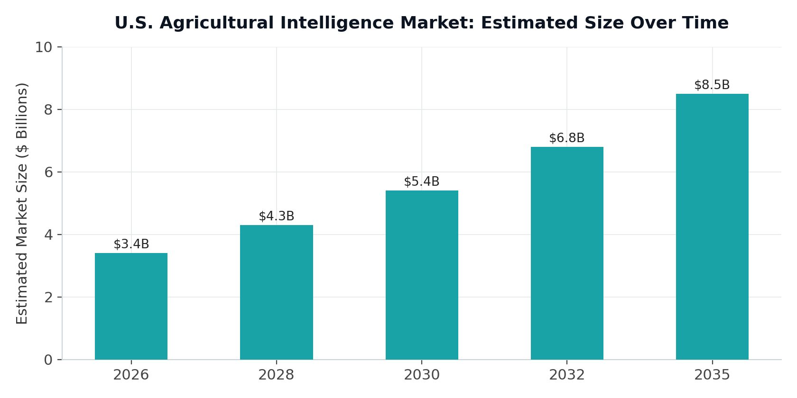
Figure 2: Estimated U.S. agricultural intelligence market size, 2026 to 2035.

5.3 Competitive Landscape
Competitors fall into three broad categories. The first is cloud-only precision-agriculture platforms, which tend to struggle with latency and reliability in rural deployments where connectivity is inconsistent. The second is pure satellite-imagery providers, who supply raw data without decision-ready analytics layered on top. The third is legacy GIS and agronomy consultancies, which tend to be services-heavy and difficult to scale. TerraVision's differentiation rests on its edge-native architecture, its fusion of satellite, drone, and IoT sensor inputs into a single pipeline, its existing FedRAMP Moderate authorization, and AgriCortex's purpose-built alignment to actual federal program workflows. That combination is not currently offered as a single, federally-oriented product by any direct competitor the company has identified.

5.4 Key Market Risks
- Federal budget cycles and continuing-resolution dynamics can delay procurement timelines, even for agencies already using the platform.
- Commoditization pressure as satellite-imagery providers expand further into analytics and try to move up the value chain.
- Data privacy and farmer trust concerns around aggregation of private-sector field data, which the company's Radical Integrity value is meant to actively manage rather than treat as a side issue.
- Climate-model and AI-model accuracy risk in extreme or non-stationary weather years that fall outside historical training distributions.

6. Business Model and Revenue Strategy

6.1 Revenue Streams
Revenue Stream | Description | Target Share by 2035
AgriCortex SaaS Subscriptions | Tiered annual subscriptions, Standard, Professional, Enterprise, and Federal, priced per acreage tier and seat count | 45%
Federal Systems Integration | Multi-year USDA, FSA, and RMA enterprise contracts, custom integration, and dedicated support | 25%
Data Licensing and API | Usage-based access to processed imagery, model outputs, and risk scores for third-party integration | 15%
Insurance and Actuarial Data Products | Yield-loss verification and risk-scoring data feeds for crop insurers and reinsurers | 10%
Professional Services and Hardware | Edge-node deployment, sensor installation, custom model training | 5%
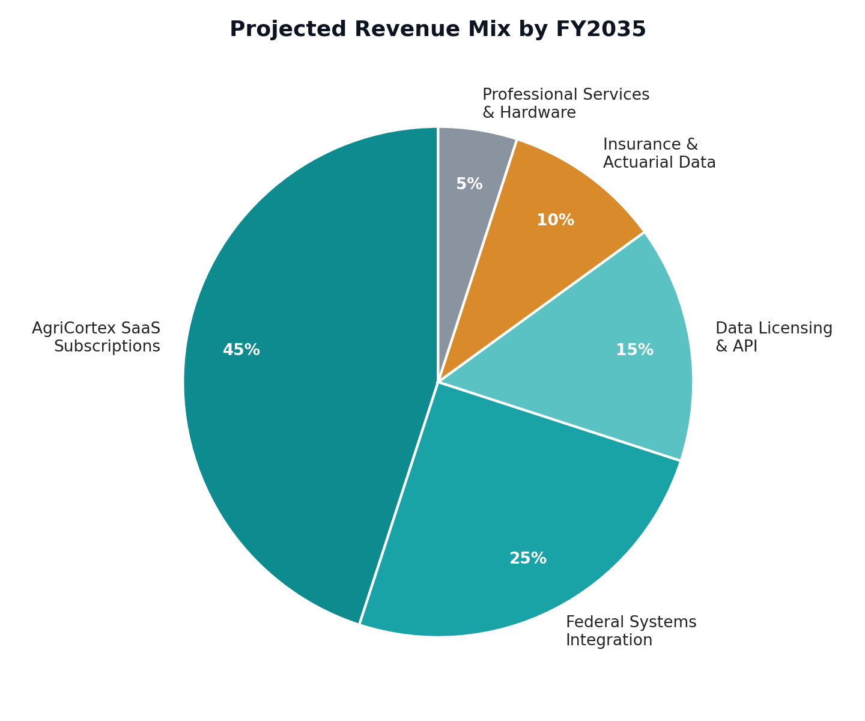
Figure 3: Projected revenue mix by FY2035.

6.2 Pricing Philosophy
AgriCortex follows a tiered SaaS pricing model anchored to monitored acreage and module access, while federal contracts are priced through multi-year fixed-price or cost-plus structures suited to the contracting vehicles the company already has access to through its existing FedRAMP authorization. Enterprise and insurance customers are offered usage-based data-licensing add-ons layered on top of base subscriptions, which keeps a predictable recurring-revenue core while still letting the company capture upside from high-volume data consumers.

6.3 Go-to-Market Strategy
- Deepen the existing USDA relationship: extend from NASS, where the company has worked since 2020, into FSA and RMA program offices, using the existing federal infrastructure and procurement track record.
- Convert pilot relationships into anchor accounts: turn the existing Cargill AgriScience and Pioneer Hi-Bred engagements into multi-year contracts and public case studies that other enterprise buyers can reference.
- Build channel partnerships with agronomy and GIS consultancies to reach mid-market and cooperative customers without a large direct sales motion.
- Enter the insurance vertical starting Year 4, using the company's accumulating yield-prediction accuracy data as the credibility foundation for actuarial partnerships.
- Pursue international expansion from Year 5 through government-to-government food-security partnerships, building on the company's existing federal relationships as reference points.

7. Ten-Year Strategic Roadmap

7.1 Phase I: Foundation and Commercial Launch, 2026 to 2027
Objective: move AgriCortex from pilot to general availability, convert existing relationships into anchor contracts, and establish a repeatable sales motion.
- Complete AgriCortex pilot testing and security hardening, reaching general availability by Q3 2027.
- Convert at least three anchor accounts, at minimum one federal and two enterprise, into multi-year contracts.
- Build out customer success, sales, and federal-contracting capture functions.
- Achieve SOC 2 Type I and extend the company's FedRAMP authorization to cover the AgriCortex module specifically.

7.2 Phase II: Scaled Growth, 2028 to 2029
Objective: scale acreage under monitoring beyond the existing 2.4 billion acre base, diversify revenue across verticals, and reach operating breakeven.
- Expand the sensor and satellite partner network, and broaden edge-hardware compatibility beyond current NVIDIA Jetson and Pi CM4 support.
- Complete extended FedRAMP scope for AgriCortex and expand across additional USDA program offices.
- Launch the insurance and actuarial data product line.
- Reach company-wide cash-flow breakeven, targeted for FY2029.

7.3 Phase III: National and International Expansion, 2030 to 2032
Objective: achieve full USDA enterprise-wide deployment and enter allied international markets.
- Complete full USDA enterprise rollout across NASS, FSA, RMA, and FAS.
- Launch carbon and ESG monitoring and supply-chain risk modules.
- Enter Canadian, EU, and select Latin American public-sector markets.
- Open a second data-processing region to support international latency and data-residency requirements.

7.4 Phase IV: Platform Maturity and Diversification, 2033 to 2035
Objective: cement TerraVision as the default geospatial intelligence layer for North American agriculture, and expand into adjacent climate-risk domains.
- Expand into water-resources and forestry monitoring verticals.
- Pursue strategic partnerships or acquisitions in climate-risk insurance analytics.
- Evaluate public listing or strategic acquisition readiness as a long-term capital event.
- Sustain EBITDA margins above 30 percent on a mature, largely fixed-cost infrastructure base.

8. Ten-Year Financial Plan
The projections below are illustrative planning estimates built on phase-based growth assumptions: pilot-to-general-availability conversion in 2026 and 2027, accelerating SaaS and federal-contract growth through 2029, scaled international and insurance-vertical contribution from 2030, and margin maturation through 2035. All figures are in U.S. dollars, expressed in millions unless otherwise noted, and should be re-forecast annually against actual results.

8.1 Revenue, Costs, and Profitability Summary, FY2026 to FY2035
FY | Revenue ($M) | Gross Margin % | Operating Costs ($M) | EBITDA ($M) | EBITDA %
2026 | 2.1 | 55% | 4.8 | (3.6) | —
2027 | 6.4 | 60% | 8.9 | (5.1) | —
2028 | 15.8 | 64% | 15.2 | (5.1) | —
2029 | 31.5 | 67% | 24.0 | (3.1) | —
2030 | 52.0 | 70% | 34.8 | 1.6 | 3%
2031 | 78.5 | 71% | 47.0 | 8.7 | 11%
2032 | 108.0 | 72% | 59.0 | 18.8 | 17%
2033 | 138.0 | 73% | 67.0 | 33.7 | 24%
2034 | 163.0 | 74% | 73.0 | 47.6 | 29%
2035 | 185.0 | 75% | 78.0 | 60.8 | 33%
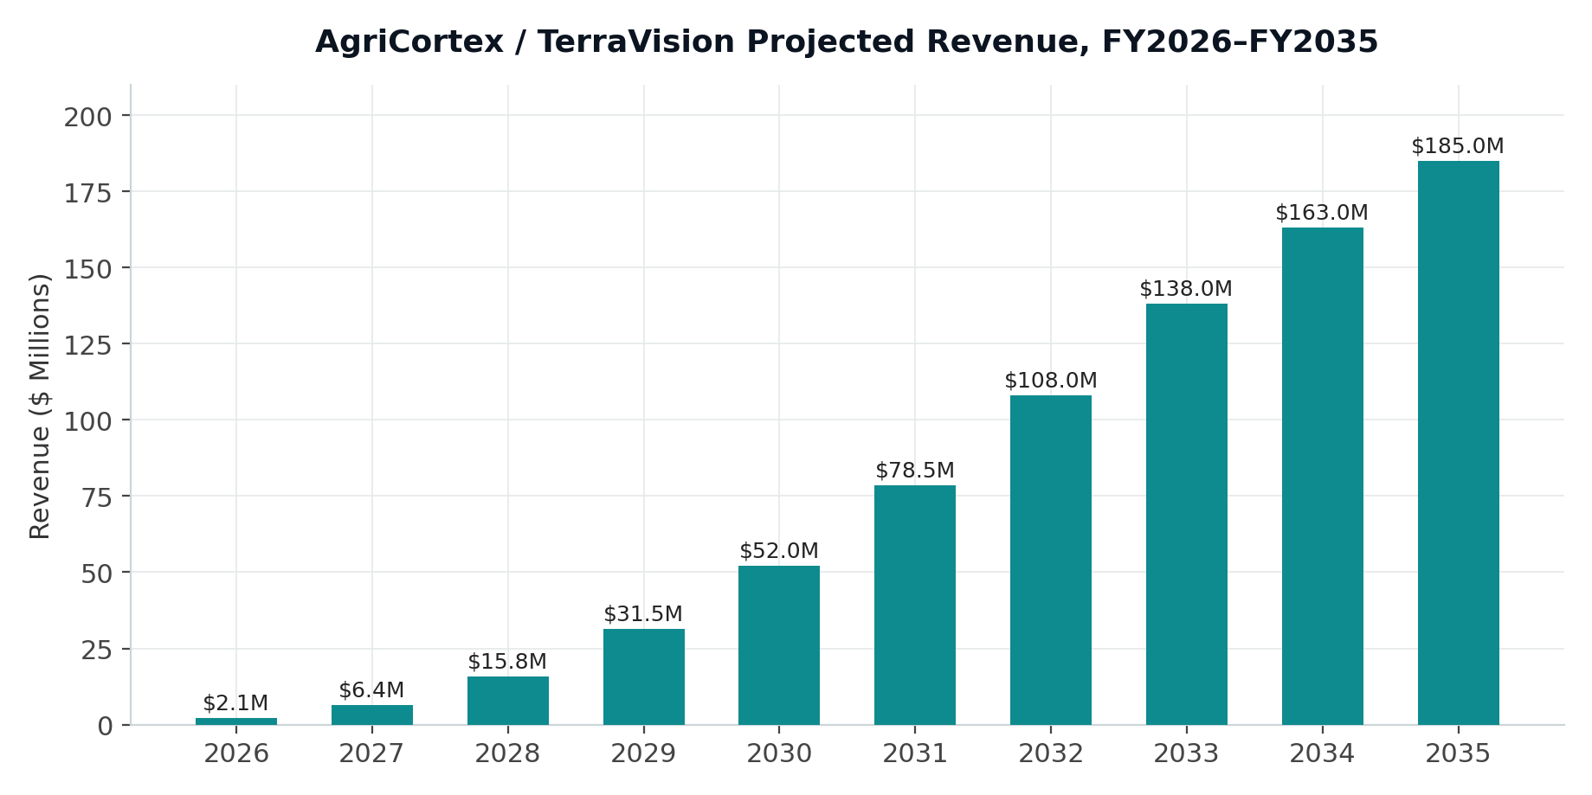
Figure 4: Projected revenue, FY2026 to FY2035.
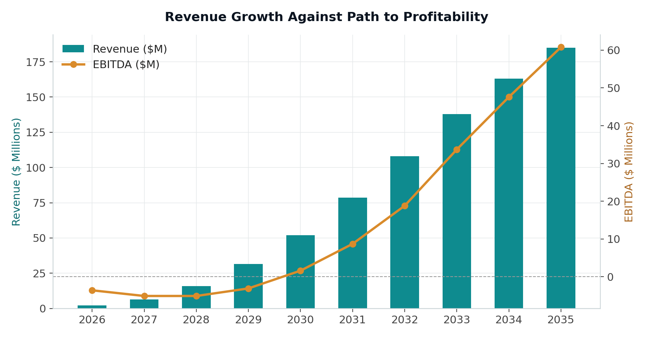
Figure 5: Revenue growth against the path to EBITDA profitability.
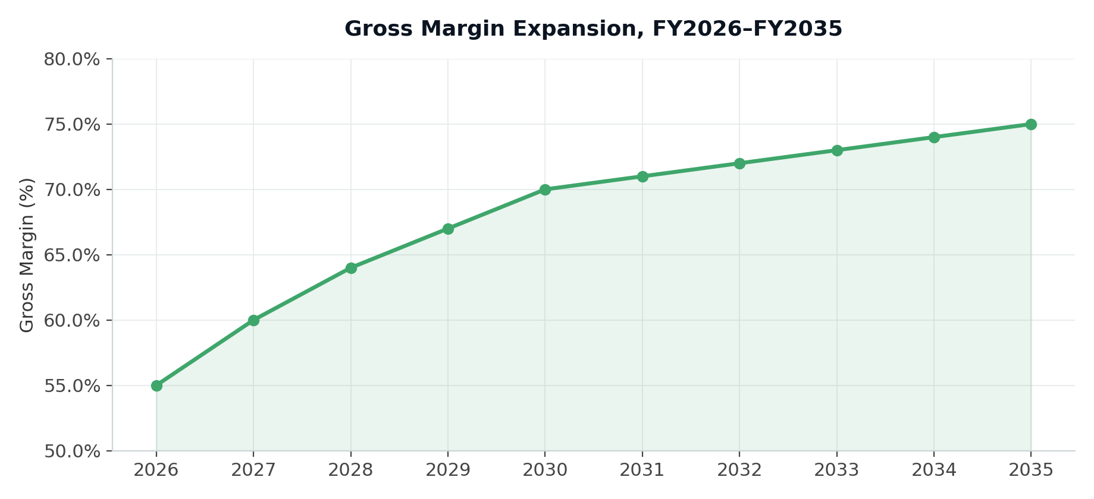
Figure 6: Gross margin expansion over the plan period, reflecting the shift toward software and data licensing as infrastructure costs amortize.

8.2 Key Assumptions
- Revenue growth is driven primarily by AgriCortex SaaS adoption following general availability in Q3 2027, with federal multi-year contracts providing revenue stability from FY2028 onward, building on the company's existing 14-agency federal footprint.
- Gross margin improves steadily as edge-hardware costs amortize across an already substantial deployed base, and as the platform mix shifts toward software and data licensing.
- Operating cost growth is front-loaded in 2026 through 2029 to fund AgriCortex's launch and go-to-market buildout, then moderates as a share of revenue from FY2030 as the company scales.
- Cash-flow breakeven is targeted for FY2029, with sustained EBITDA profitability from FY2030 onward.
- No revenue is assumed from speculative or unannounced acquisitions. Expansion-market revenue from international and insurance segments is conservatively phased starting FY2029 and FY2030.

8.3 Headcount Plan
FY | Engineering and ML | Sales and GTM | Customer Success | G&A / Ops | Total
2026 | 18 | 6 | 4 | 7 | 35
2027 | 32 | 14 | 9 | 12 | 67
2028 | 48 | 24 | 16 | 18 | 106
2029 | 65 | 36 | 26 | 25 | 152
2030 | 82 | 48 | 36 | 32 | 198
2032 | 110 | 70 | 55 | 45 | 280
2035 | 150 | 95 | 80 | 65 | 390
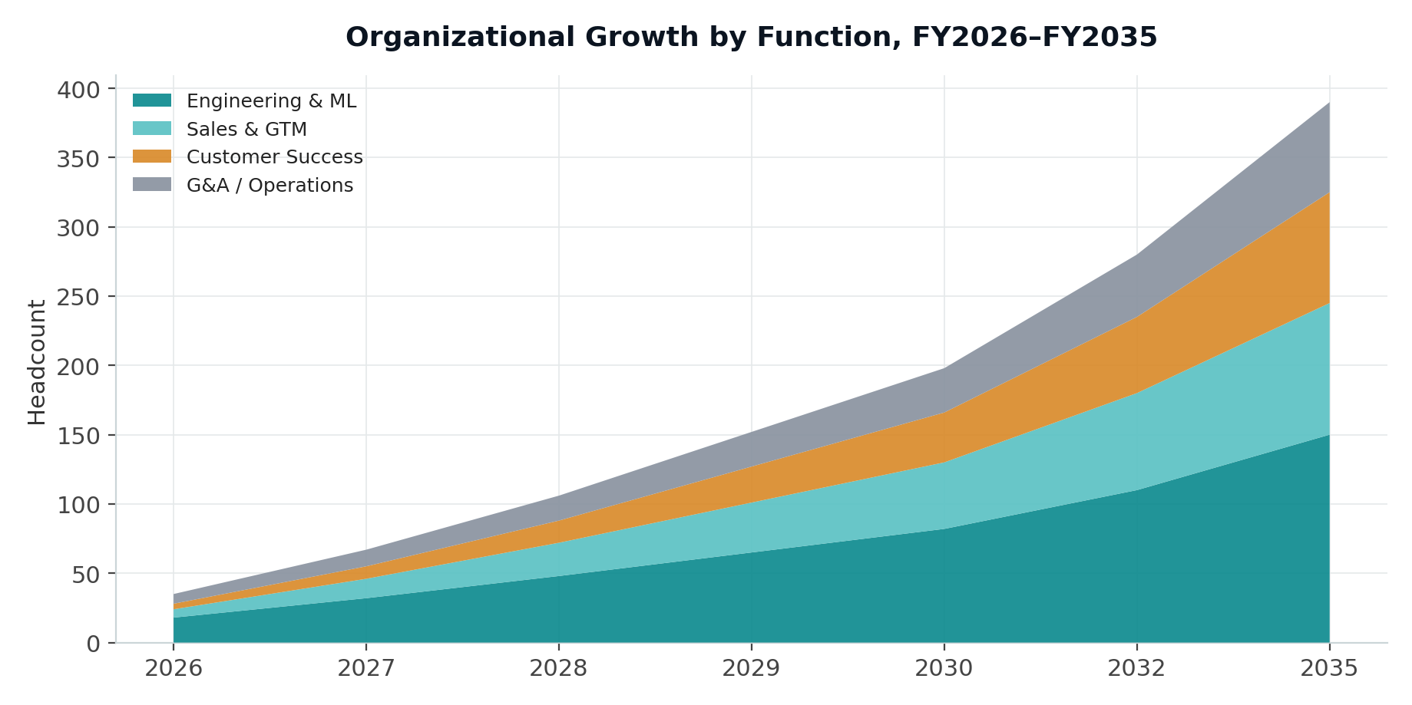
Figure 7: Organizational growth by function, FY2026 to FY2035.

8.4 Funding Requirements
TerraVision Analytics anticipates a staged capital plan to fund the roadmap above. A funding round in 2026, in the range of $8 to $12 million, would support the AgriCortex general-availability launch and the federal-contracting capture effort tied to extending the company's existing FedRAMP authorization. A larger round in 2028, in the range of $25 to $35 million, would fund the extended FedRAMP scope, headcount scale, and entry into the insurance vertical. From 2030 onward, international expansion is expected to be funded either through a growth-equity round or through positive operating cash flow, since government contract revenue, often multi-year and structured as cost-reimbursable or fixed-price, is expected to materially reduce dilutive capital needs as the decade progresses.

9. Operations Plan

9.1 Technology Infrastructure
The platform's three-tier architecture, moving from field edge nodes through regional processing to a cloud-synchronized dashboard, will scale through the plan period via expansion of edge-hardware partnerships, additional satellite-data licensing agreements, and continued growth of the cloud infrastructure, including PostGIS, Kafka streaming, and the GraphQL and REST API layers already supporting 500 million daily inference events as of the 2022 milestone.

9.2 Data Sources and Partnerships
- Satellite: Sentinel-2, Landsat-9, PlanetScope, and private SAR archive licensing, with additional commercial satellite partnerships to be evaluated as resolution and revisit-frequency needs grow.
- Weather and climate: the NOAA Weather API, already live in AgriCortex testing, and CMIP6-downscaled ensemble data, with a potential ECMWF partnership to support international expansion.
- Federal data: the USDA Cropland Layer, already live in testing, with planned expansion to additional USDA, FSA, and RMA data sources as those federal partnerships continue to mature.
- GIS interoperability: native ArcGIS integration, ensuring the platform fits into the federal and enterprise GIS infrastructure customers already operate rather than asking them to replace it.

9.3 Security and Compliance Roadmap
Milestone | Target | Significance
SOC 2 Type I | FY2026 | Baseline enterprise trust signal for new commercial customers, complementing the existing FedRAMP Moderate authorization.
SOC 2 Type II | FY2027 | Required for larger enterprise and insurance contracts.
Extended FedRAMP scope for AgriCortex | FY2028 | Brings the AgriCortex module formally under the company's existing FedRAMP Moderate authorization.
CMMC readiness assessment | FY2029 | Positions the company for DoD-adjacent food-security contracting.
International data-residency compliance, GDPR-aligned | FY2030 | Required for EU and Canada public-sector expansion.

9.4 Organizational Development
The organization is expected to scale from roughly 35 people in 2026 to an estimated 390 people by 2035, with engineering and machine learning remaining the largest function throughout in order to sustain the company's core technical differentiation, while sales, customer success, and operations scale in proportion to support federal and enterprise account growth.

10. Risk Analysis and Mitigation
Risk | Likelihood | Impact | Mitigation
Federal procurement delays from budget cycles or continuing resolutions | Medium | High | Diversify revenue across federal, enterprise, and insurance verticals, and leverage the existing FedRAMP authorization for faster procurement cycles.
AI and ML model accuracy degradation in extreme weather years | Medium | Medium | Continuous auto-retraining framework and minimum-accuracy alerting, already built into AgriCortex.
Cybersecurity incident involving sensitive federal or farm data | Low to Medium | High | Existing FedRAMP Moderate baseline, two-factor authentication, IP allowlisting, and ongoing penetration testing.
Competitive entry from large cloud or satellite incumbents | Medium | Medium | Defend the edge-native latency and resilience advantage, and deepen federal workflow alignment as a switching-cost moat.
Key talent retention in a competitive AI labor market | Medium | Medium | Competitive equity compensation and a mission-driven culture built around food security, reflected in the company's stated values.
Customer concentration risk from early reliance on a small number of anchor accounts | Medium | Medium | Active pipeline diversification across verticals from Phase I onward, building on the existing 14-agency federal base.

11. Key Milestones and Success Metrics

11.1 Milestone Timeline
Year | Primary Milestone
2026 | AgriCortex pilot completion, SOC 2 Type I, initial funding round closed.
2027 | AgriCortex general availability, three or more anchor multi-year contracts signed.
2028 | Extended FedRAMP scope for AgriCortex, second funding round closed, insurance vertical launched.
2029 | Cash-flow breakeven reached, full USDA program-office expansion underway.
2030 | International market entry through Canada and EU pilots, EBITDA-positive.
2032 | USDA enterprise-wide deployment complete, EBITDA margin above 17 percent.
2035 | $185 million or more in revenue, EBITDA margin above 33 percent, strategic review of next capital event.

11.2 Core KPIs to Track Annually
- Total acreage under active monitoring, building from the existing 2.4 billion acre base.
- AgriCortex annual recurring revenue and net revenue retention.
- Federal contract value under management and pipeline-to-award conversion rate.
- Model accuracy, including yield-prediction error margin and pest and disease early-detection lead time.
- Customer concentration, measured as the percentage of revenue from the top five accounts.
- Gross margin and EBITDA margin trend against plan.

12. Conclusion
TerraVision Analytics enters 2026 in a stronger position than most companies preparing a ten-year plan. Eight years of federal relationship-building, a $28 million Series A, a FedRAMP Moderate authorization, and 2.4 billion acres already under surveillance are not assumptions; they are facts the company can build on. AgriCortex, currently in development and active pilot testing, is the mechanism for converting that foundation into a scaled commercial product with a clear, near-term path to general availability.
The plan outlined in this document charts a path from pilot validation through federal-scale deployment, international expansion, and platform diversification, with the goal of making TerraVision the default geospatial intelligence layer for North American agriculture by 2035. Under Gideon Olawale Sodipo's continued leadership, and grounded in the values of relentless innovation, radical integrity, impact at scale, and a collaborative spirit that the company has held since its founding, this plan is meant to be a working document rather than a fixed one.
It should be reviewed and re-forecast at minimum annually, and updated immediately following major capital events, federal contract awards, or material shifts in the competitive or regulatory landscape.

