
TERRAVISION ANALYTICS
See Every Acre. Know Every Risk. Act Before It’s Too Late.
STRATEGIC BUSINESS PLAN
Fiscal Years 2026 – 2036
Featuring the AgriCortex Platform
Edge-Native Geospatial Intelligence for Agriculture and Food Security
Gideon Olawale Sodipo
Founder & Chief Executive Officer
Company founded 2022 · Plan prepared June 2026
Status: Confidential — For Internal and Investor Use Only

Table of Contents
List of Figures 4
1. Executive Summary 5
1.1 The Opportunity 6
1.2 How to Use This Plan 6
2. Company Overview 7
2.1 Origin Story 7
2.2 Mission 7
2.3 Vision 7
2.4 Company Timeline 7
2.5 What the Company Has Already Built 8
2.6 Legal Structure and Governance 9
2.7 Current Customers and Trust Signals 9
3. Leadership 10
3.1 Founder and CEO: Gideon Olawale Sodipo 10
3.2 Values That Shape How the Company Operates 10
4. AgriCortex: Flagship Product Deep Dive 11
4.1 Current Status: Development and Testing Phase 11
4.2 Path to General Availability 12
4.3 AgriCortex Product Roadmap, Years 1 Through 6 12
5. Market Analysis 14
5.1 Target Markets 14
5.2 Market Sizing 14
5.3 Competitive Landscape 15
5.4 Key Market Risks 16
6. Business Model and Revenue Strategy 17
6.1 Revenue Streams 17
6.2 Pricing Philosophy 17
6.3 Go-to-Market Strategy 18
7. Strategic Roadmap, 2026–2036 19
7.1 Phase I: Foundation and Commercial Launch (2026–2027) 19
7.2 Phase II: Scaled Growth (2028–2029) 19
7.3 Phase III: National and International Expansion (2030–2032) 19
7.4 Phase IV: Platform Maturity and Diversification (2033–2035) 19
7.5 Phase V: Sustained Leadership and Strategic Optionality (2036) 20
8. Strategic Financial Plan, FY2026–FY2036 21
8.1 Revenue, Costs, and Profitability Summary 21
8.2 Key Assumptions 22
8.3 Headcount Plan 23
8.4 Funding Requirements 23
9. Operations Plan 25
9.1 Technology Infrastructure 25
9.2 Data Sources and Partnerships 25
9.3 Security and Compliance Roadmap 25
9.4 Organizational Development 25
10. Risk Analysis and Mitigation 26
11. Key Milestones and Success Metrics 28
11.1 Milestone Timeline 28
11.2 Core KPIs to Track Annually 28
12. Conclusion 30

List of Figures
Figure 1: TerraVision Analytics — Acreage Under Surveillance, 2022–2026
Figure 2: U.S. Agricultural Intelligence Market — Estimated Size Over Time, 2026–2036
Figure 3: Projected Revenue Mix by FY2036
Figure 4: AgriCortex / TerraVision Projected Revenue, FY2026–FY2036
Figure 5: Revenue Growth Against the Path to Profitability, FY2026–FY2036
Figure 6: Gross Margin Expansion, FY2026–FY2036
Figure 7: Organizational Growth by Function, FY2026–FY2036
Figure 8: AgriCortex Product Roadmap, FY2026–FY2031
Figure 9: Competitive Positioning — TerraVision vs. Market Alternatives
Figure 10: Addressable Market by Customer Segment, FY2036 Outlook
Figure 11: Staged Capital Plan, 2022–2030 and Beyond
Figure 12: Acres Under Active AgriCortex Monitoring, FY2026–FY2036 Projection
Figure 13: Risk Assessment Matrix — Likelihood vs. Impact

1. Executive Summary
TerraVision Analytics was founded in 2022 by Gideon Olawale Sodipo while he was pursuing his Master of Science in Computational Data Science (Computer Science) at Kent State University in Kent, Ohio. Driven by a conviction that agricultural decision-making was being held back by stale, low-resolution data, Gideon conceived the company's founding thesis during his graduate research and built the company from the ground up as a sole founder—transforming an academic insight into an edge-native geospatial intelligence company that fuses satellite imagery, drone telemetry, IoT sensor networks, and applied AI into decision-ready agricultural intelligence for federal agencies, agribusiness corporations, and food-security organizations.
In the four years since, the company's trajectory has been defined by rapidly building the core platform, establishing credibility in the agricultural intelligence space, and actively pursuing federal partnership opportunities. A USDA NASS contract engagement is currently being pursued and represents a foundational near-term milestone. AgriCortex, TerraVision's flagship platform, is in active development and pilot testing, positioning the company to convert four years of focused, founder-led technical execution into a scaled commercial product. Heading into 2026, TerraVision is building from a strong technical foundation rather than starting from zero.
This strategic business plan, covering fiscal years 2026 through 2036, sets out the strategic, operational, and financial roadmap for the next phase of the company's growth, centered on AgriCortex, TerraVision's flagship operational platform. AgriCortex is currently in development and active pilot testing, and represents the productization of the company's core capabilities into a unified dashboard purpose-built for USDA program offices and enterprise agricultural intelligence workflows. It is the mechanism through which the company intends to convert its technical foundation and growing federal relationships into a scaled, repeatable commercial product.
Over the plan horizon, TerraVision Analytics will move through five phases: Foundation and Commercial Launch (2026 to 2027), in which AgriCortex exits pilot testing and reaches general availability across federal and enterprise accounts; Scaled Growth (2028 to 2029), in which the company broadens its sensor and data partner network and diversifies revenue across government, enterprise, and insurance customers; National and International Expansion (2030 to 2032), marked by full USDA enterprise deployment and entry into allied markets including Canada, the European Union, and parts of Latin America; Platform Maturity and Diversification (2033 to 2035), in which the company extends into adjacent domains such as water resources, forestry, and climate-risk insurance analytics; and Sustained Leadership and Strategic Optionality (2036), in which the company consolidates AgriCortex as the default geospatial intelligence layer for North American agriculture, sustains margin leadership, and undertakes a formal strategic review of its next capital event and the decade ahead.
Financially, the plan projects growth from an estimated $2.1 million in FY2026 revenue, reflecting the early commercial launch period around AgriCortex, to a projected $205 million or more in FY2036 revenue. The company is expected to reach cash-flow breakeven in FY2029, supported by upfront annual billing on multi-year federal and enterprise contracts, ahead of GAAP EBITDA breakeven in FY2030, and to sustain EBITDA margins above 30 percent from FY2035 onward, reaching 35 percent by FY2036, supported by a largely fixed-cost edge and cloud infrastructure base that scales efficiently as recurring revenue grows.

1.1 The Opportunity
Climate volatility, food-security policy mandates, and a persistent gap between what farmers and agencies need to know and what legacy survey methods can tell them have created sustained demand for trustworthy, field-level agricultural intelligence. TerraVision's edge-native architecture, which processes data at the sensor before it ever has to round-trip to the cloud, gives the company a structural latency and resilience advantage in rural and federal deployments where connectivity is often inconsistent. That advantage, combined with TerraVision's growing federal engagement and an active pursuit of FedRAMP Moderate authorization, positions the company ahead of newer entrants chasing the same market.

1.2 How to Use This Plan
This document is intended to guide internal resource allocation, support investor and strategic-partner conversations, and serve as a working basis for federal contracting pursuit. It should be revisited at least annually and re-forecast against actual results as AgriCortex moves from pilot testing into general availability.

2. Company Overview

2.1 Origin Story
TerraVision Analytics was founded in 2022 by Gideon Olawale Sodipo, who conceived and built the company independently while completing his Master of Science in Computational Data Science (Computer Science) at Kent State University in Kent, Ohio. His founding insight—that intelligence needed to live close to the land rather than depend entirely on distant data centers—emerged from his graduate research in applied machine learning and geospatial data systems. That conviction has remained the technical thread running through everything the company has built since.
The company's trajectory since founding has been one of deliberate, milestone-driven progress, compressed into a tight four-year build: establishing the technical platform, building relationships with federal stakeholders, and advancing toward its first major government contract. A USDA NASS engagement is currently being actively pursued, and the company is on a clear path to the federal security authorizations that will unlock broader procurement access. Those milestones are not distant ambitions—they are the near-term targets this plan is built around.

2.2 Mission
To democratize geospatial intelligence by delivering real-time, AI-powered insights that enable every farmer, agency, and agribusiness to make data-informed decisions, preserving resources, increasing yields, and securing the global food supply.

2.3 Vision
A world where satellite imagery, drone telemetry, and edge AI seamlessly connect every acre of farmland to a living digital twin, empowering humanity to anticipate risks, adapt to climate change, and nourish a growing planet. By 2036, TerraVision intends for AgriCortex to be the standard operating dashboard for USDA field intelligence, and for the broader TerraVision platform to be the default geospatial intelligence layer underpinning food-security decisions across North America.

2.4 Company Timeline
Year | Milestone
2022 | Founded solely by Gideon Olawale Sodipo while completing his M.S. in Computational Data Science (Computer Science) at Kent State University, Kent, Ohio. The company was built on Gideon's conviction—formed during his graduate research—that edge AI belonged in every field, close to the land. Initial edge-inference prototype conceived and built.
2023 | Core platform development underway. Initial field-testing of edge-native inference nodes across Midwest agricultural environments. USDA NASS engagement discussions initiated.
2024 | Platform architecture matured across satellite, drone, and IoT sensor integration. Machine learning inference pipeline scaled and validated. Federal outreach expanded to USDA program offices. AgriCortex platform development initiated and FedRAMP Moderate authorization process begun.
2025 | REST and GraphQL API layers built and validated. Design-partner relationships established with Cargill AgriScience and Pioneer Hi-Bred. AgriCortex enters closed pilot testing.
2026 | AgriCortex enters final pilot testing ahead of general availability, building on four years of the company's existing federal infrastructure and trust.
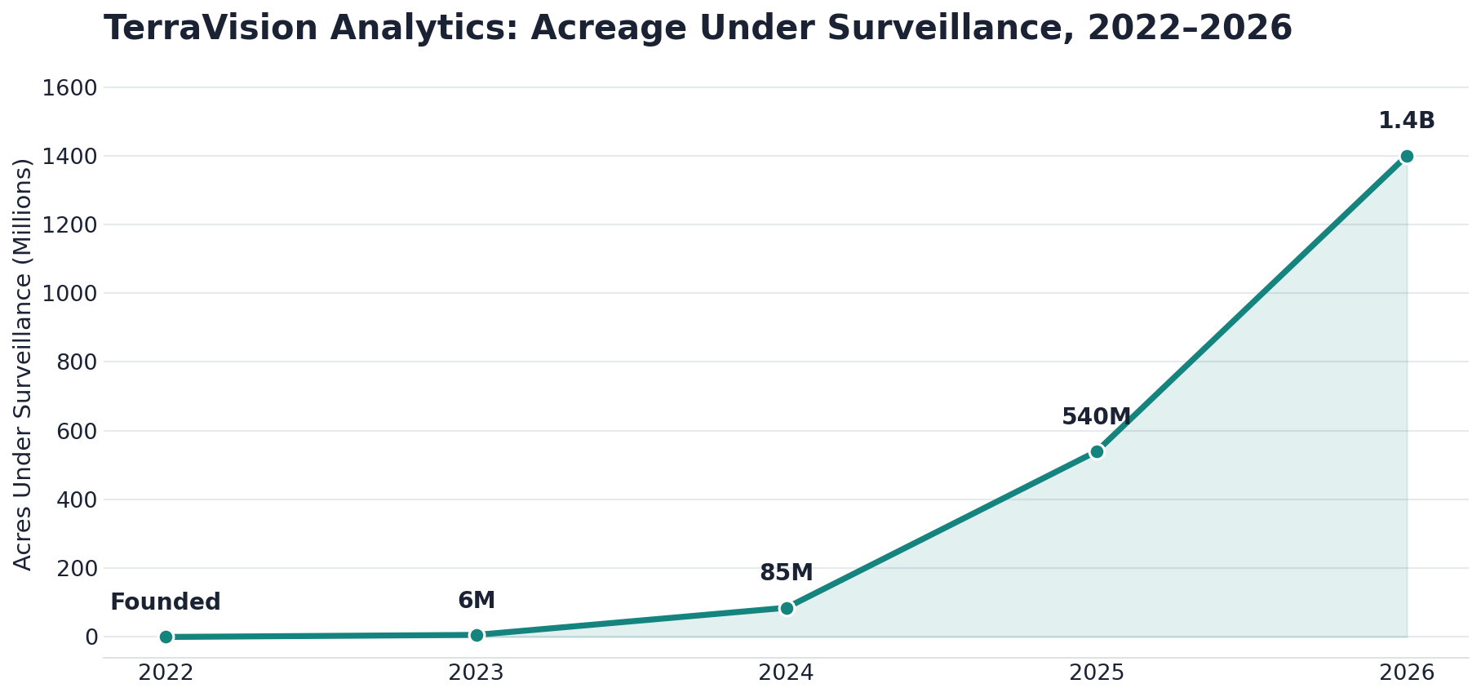
Figure 1: TerraVision Analytics — Acreage Under Surveillance, 2022–2026.

2.5 What the Company Has Already Built
It is worth being explicit about how much groundwork already exists going into this plan, since it changes the shape of the plan period considerably. In just four years, the public platform has come to fuse six integrated capability pillars, all of which are live today rather than aspirational:
- Multispectral Earth Observation, fusing Sentinel-2, Landsat-9, PlanetScope, and private SAR archives into time-series composites at 3 to 10 meter resolution with near-daily revisit.
- On-device AI inference, running quantized deep learning models at the edge on NVIDIA Jetson and Raspberry Pi CM4 nodes, delivering sub-200 millisecond inference per image tile without a cloud round-trip.
- A live GIS dashboard built on MapLibre GL and PostGIS, supporting vector tile overlays, real-time telemetry, NDVI heat maps, and administrative boundary queries.
- Predictive climate modeling using CMIP6-downscaled weather ensembles combined with ENSO teleconnections, producing 14-day irrigation windows and 90-day drought-risk probabilities.
- Pest and disease sentinel models, trained on more than four million annotated crop-disease images, capable of detecting early blight, fall armyworm, and viral infection up to 14 days before visible symptoms.
- Automated intelligence reports, scheduled as PDF and API briefs with county-level yield estimates, drought-risk scores, and recommendations formatted for USDA FAS, RMA, and FSA workflows.
This is delivered through a three-tier architecture. Tier 1 collects data through ruggedized field edge nodes that harvest multispectral, soil, weather, and UAV data with offline-capable local buffering. Tier 2 processes that data through edge AI inference and regional aggregation. Tier 3 delivers it through cloud-synchronized GIS dashboards and reporting tools for analysts in Washington and elsewhere.

2.6 Legal Structure and Governance
TerraVision Analytics is organized as a Delaware C-Corporation, established at founding in 2022 and structured to support both venture investment and federal contracting eligibility. The board includes founder, investor, and federal-policy-adjacent representation, reflecting the dual commercial and public-sector nature of the business. The company is actively advancing its compliance posture, including its FedRAMP Moderate authorization process, to meet the requirements of expanded federal contracting from the outset.

2.7 Current Customers and Trust Signals
TerraVision is actively pursuing its first major federal contract with USDA NASS, which would serve as the anchor engagement for broader federal expansion. On the commercial side, Cargill AgriScience and Pioneer Hi-Bred have both engaged with the platform since 2025, with independent data-officer review validating the company's REST API, PostGIS data model, GraphQL layer, and Kafka streaming integration. These relationships form the commercial foundation from which AgriCortex's rollout will grow over the plan period.

3. Leadership

3.1 Founder and CEO: Gideon Olawale Sodipo
Gideon Olawale Sodipo founded TerraVision Analytics in 2022 as a sole founder and continues to lead the company as Chief Executive Officer. While completing his Master of Science in Computational Data Science (Computer Science) at Kent State University in Kent, Ohio, he developed the founding thesis that food security is best protected by giving decision-makers a shared, real-time, AI-powered view of the land. That conviction, formed in the classroom and the lab, has shaped both the technical architecture and the go-to-market posture of the company since its earliest days.
“Food security is the defining challenge of our century. We built TerraVision to give every decision-maker, from a smallholder in Nigeria to a policy desk in Washington, the same crystal-clear, AI-powered view of the land. Intelligence is our product; resilience is our promise.”
That quote, drawn from the company's own about page, captures something important about how the company positions itself: not purely as a federal contractor, and not purely as an agribusiness vendor, but as an intelligence provider whose product is meant to be useful at every scale, from a single smallholder farm to a national policy desk. That dual orientation, global and local at once, is a thread this plan carries through the market expansion strategy in later sections.

3.2 Values That Shape How the Company Operates
The company organizes its culture around four stated values, each of which has direct implications for how this plan should be executed.
- Relentless Innovation: pushing the boundaries of what AI and geospatial data can achieve, with constant refinement of models and edge infrastructure rather than treating any release as final.
- Radical Integrity: transparency in data, methods, and results, which is treated as the foundation of trust with federal partners, farmers, and the public, and which matters enormously in a sector where bad data can affect real livelihoods.
- Impact at Scale: a belief that every line of code, every satellite image, and every edge node should be dedicated to a measurable difference in global food security, not just incremental product metrics.
- Collaborative Spirit: working directly with agronomists, policymakers, and communities to make sure the technology actually meets people where they are, rather than imposing a one-size-fits-all dashboard.
These values are reflected throughout the operational and go-to-market sections of this plan, particularly in the emphasis on transparent model accuracy reporting, continued co-development with USDA program offices, and a deliberate choice to keep the company's technical and policy teams working closely together rather than treating compliance as an afterthought.

4. AgriCortex: Flagship Product Deep Dive
AgriCortex is TerraVision Analytics' flagship operational platform and the centerpiece of this plan. It draws on the geospatial, satellite, drone, and sensor infrastructure Gideon has built since the company's founding in 2022, and is designed to be purpose-built for USDA program offices and enterprise agricultural intelligence workflows from day one. What AgriCortex represents is the productization of that underlying architecture into a single, federal-grade operational dashboard, currently in development and active testing ahead of general availability.

4.1 Current Status: Development and Testing Phase
As of mid-2026, AgriCortex is in closed pilot testing with design-partner accounts. The platform, branded internally and in pilot deployments as the AgriCortex USDA Platform, is undergoing iterative validation of its sensor network management, alerting, analytics, and reporting modules ahead of a planned general-availability launch.
Functional areas already built and under test include the following.
- Sensor Network Management: registration and live monitoring of field-deployed sensors across soil moisture, temperature, pH, and NPK nutrient classes, plus weather-station sensors, each tracked with a unique sensor ID and live status.
- Data Export Engine: multi-format export across PDF report, CSV, Excel workbook, GeoJSON, and KML formats, across configurable date ranges, supporting downstream GIS and BI tooling that customers already rely on.
- Policy Report Generator: structured report generation for drought response, flood management, crop-yield outlook, food security, subsidy allocation, and pest management briefs, aligned to the actual workflows used inside USDA program offices.
- Analytics Report Generator: sensor-network summaries, yield-prediction reports, weather analysis, pest-activity reports, and irrigation-efficiency reporting, available across 7-day, 30-day, quarterly, and annual windows.
- Alerting and Notification Framework: configurable email, SMS, and push notification channels, organized by alert category, including drought, pest outbreak, and flood-warning events.
- Integrated Data Sources: live connections already established in testing to the NOAA Weather API and the USDA Cropland Layer, with an extensible connector framework built to support additional federal and commercial data sources as they are added.
- Machine Learning Operations Controls: configurable auto-retraining triggers, either volume-based or time-based, along with minimum accuracy thresholds and automated alerting when model performance drifts.
- Enterprise Administration: role- and region-based user management, two-factor authentication, session-timeout controls, and IP allowlisting, all built to meet the security expectations of federal customers from day one.
- API and Systems Integration: REST API access, webhook notifications, and native ArcGIS integration, so the platform fits into the GIS infrastructure agencies and agribusinesses already operate.

4.2 Path to General Availability
Milestone | Target Window | Description
Closed pilot completion | Q3 2026 | Conclude design-partner testing with at least one federal program-office stakeholder and one commercial agribusiness account, finalizing core module quality assurance.
Security and compliance hardening | Q3 to Q4 2026 | Penetration testing and SOC 2 Type I readiness, building on the company's security foundation and advancing the FedRAMP Moderate authorization process.
Limited general availability | Q1 2027 | Controlled rollout to additional federal program offices, including FSA and RMA, plus three to five enterprise design partners.
Full general availability | Q3 2027 | Public commercial launch of AgriCortex as a standalone subscription product alongside the core TerraVision platform.
Extended FedRAMP scope for AgriCortex module | FY2028 | Formal extension of the company's FedRAMP authorization to cover AgriCortex specifically, supporting broader USDA agency adoption.

4.3 AgriCortex Product Roadmap, Years 1 Through 6
- Year 1, 2026: Complete pilot testing, harden security and reliability, and ship version 1.0 with sensor management, alerting, exports, and reporting modules.
- Year 2, 2027: Add a mobile field-companion app, expand machine learning auto-retraining to support customer-specific model fine-tuning, and launch self-serve onboarding for mid-market agribusiness.
- Year 3, 2028: Introduce a carbon and ESG monitoring module and supply-chain risk scoring, extend FedRAMP scope to AgriCortex, and open a sensor-source marketplace to third-party hardware vendors.
- Year 4, 2029: Launch insurance-grade actuarial data products for crop insurers and reinsurers, and add multi-language support for Canadian and Latin American pilots.
- Year 5, 2030: Complete full international localization, and add water-resources and forestry monitoring modules ahead of Phase III's international rollout.
- Year 6, 2031: Consolidate AgriCortex as the unified front end for all TerraVision data products, completing platform unification ahead of full-scale enterprise and international deployment.
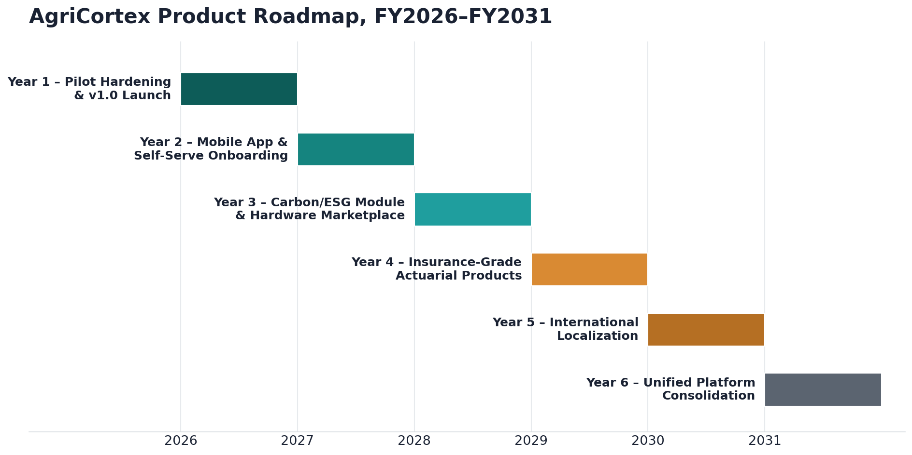
Figure 8: AgriCortex Product Roadmap, FY2026–FY2031.

5. Market Analysis

5.1 Target Markets
TerraVision and AgriCortex serve four primary customer segments, each with distinct procurement cycles, data needs, and willingness to pay.
- Federal and state agencies: led by USDA program offices including NASS, FSA, RMA, and FAS, where AgriCortex's policy-report and analytics-report generators are purpose-built to match existing workflows.
- Large agribusiness and input suppliers: companies such as Cargill AgriScience and Pioneer Hi-Bred, which use the platform's API and data-fusion layer to inform supply-chain, breeding, and input-allocation decisions.
- Crop insurers and reinsurers: an emerging vertical from Year 4 (FY2029) onward, where field-level, time-series risk data supports underwriting and claims verification at a level legacy survey methods cannot match.
- Mid-market producers and cooperatives: served primarily through self-serve onboarding introduced in Year 2 (FY2027), extending the platform's reach beyond large enterprise and federal accounts.

5.2 Market Sizing
The U.S. agricultural intelligence market, encompassing precision agriculture software, satellite and aerial imagery analytics, and federal geospatial data services, is estimated at roughly $3.4 billion in 2026 and is projected to grow to approximately $9.2 billion by 2036, reflecting sustained demand growth from climate adaptation, food-security policy, and the broader shift toward data-driven farm and agency management. Federal demand, driven by climate-resilience and food-security mandates, and insurance-sector demand, driven by the need for more granular underwriting data, are expected to be the fastest-growing components of that figure, becoming meaningful contributors to TerraVision's own revenue mix from Year 4 onward.
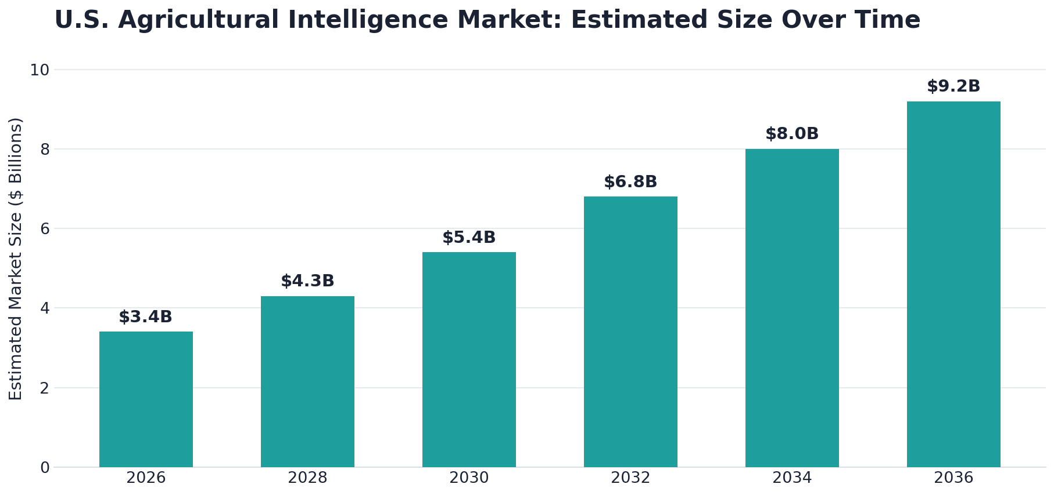
Figure 2: U.S. Agricultural Intelligence Market — Estimated Size Over Time, 2026–2036.
Breaking that total addressable opportunity down by customer segment helps clarify where TerraVision intends to compete first and where it expects the largest long-run contribution. Federal agencies and large agribusiness together represent more than 60 percent of the estimated FY2036 addressable spend, which is consistent with the company's federal-first go-to-market sequencing described in Section 6.3.
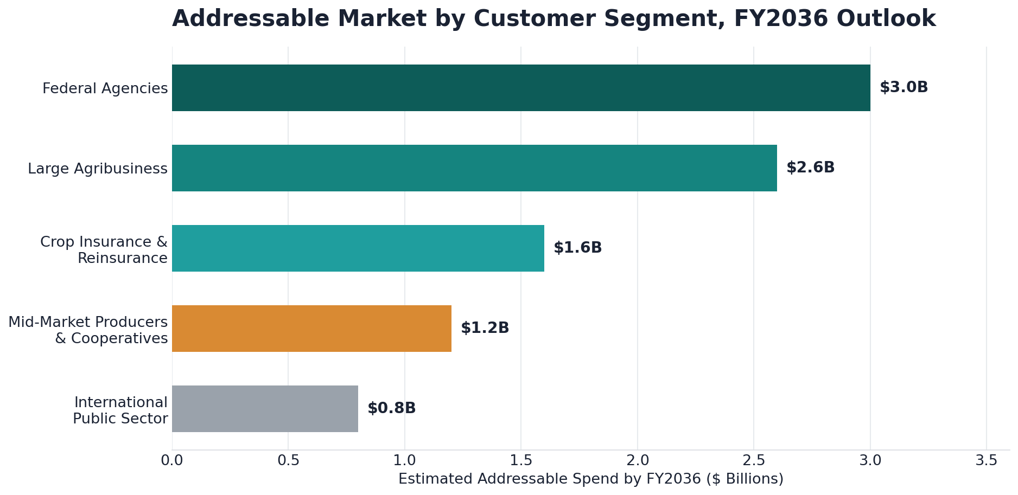
Figure 10: Addressable Market by Customer Segment, FY2036 Outlook.

5.3 Competitive Landscape
TerraVision competes against three broad categories of alternative providers, none of which combine edge-native inference, deep federal-workflow alignment, and multi-source data fusion the way AgriCortex is designed to.
- Cloud-only precision-agriculture platforms: strong on cost efficiency and broad commercial distribution, but dependent on consistent connectivity and weaker on federal compliance and workflow alignment.
- Pure satellite-imagery providers: excellent raw imagery and reasonable cost efficiency, but limited in multi-source data fusion and lacking the operational tooling, alerting, and reporting layer agencies and enterprises actually need.
- Legacy GIS and agronomy consultancies: deep domain relationships but limited technical scalability, weak edge-latency performance, and minimal automation, making them difficult to scale into a repeatable software product.
AgriCortex's combination of edge-native resilience, purpose-built federal workflow alignment, and broad multi-source data fusion is the basis for its differentiated position, illustrated in Figure 9 below. Its principal trade-off relative to pure cloud platforms is a moderately higher cost-efficiency profile at very small scale, which the pricing strategy in Section 6.2 is designed to offset through tiered, usage-based packaging.
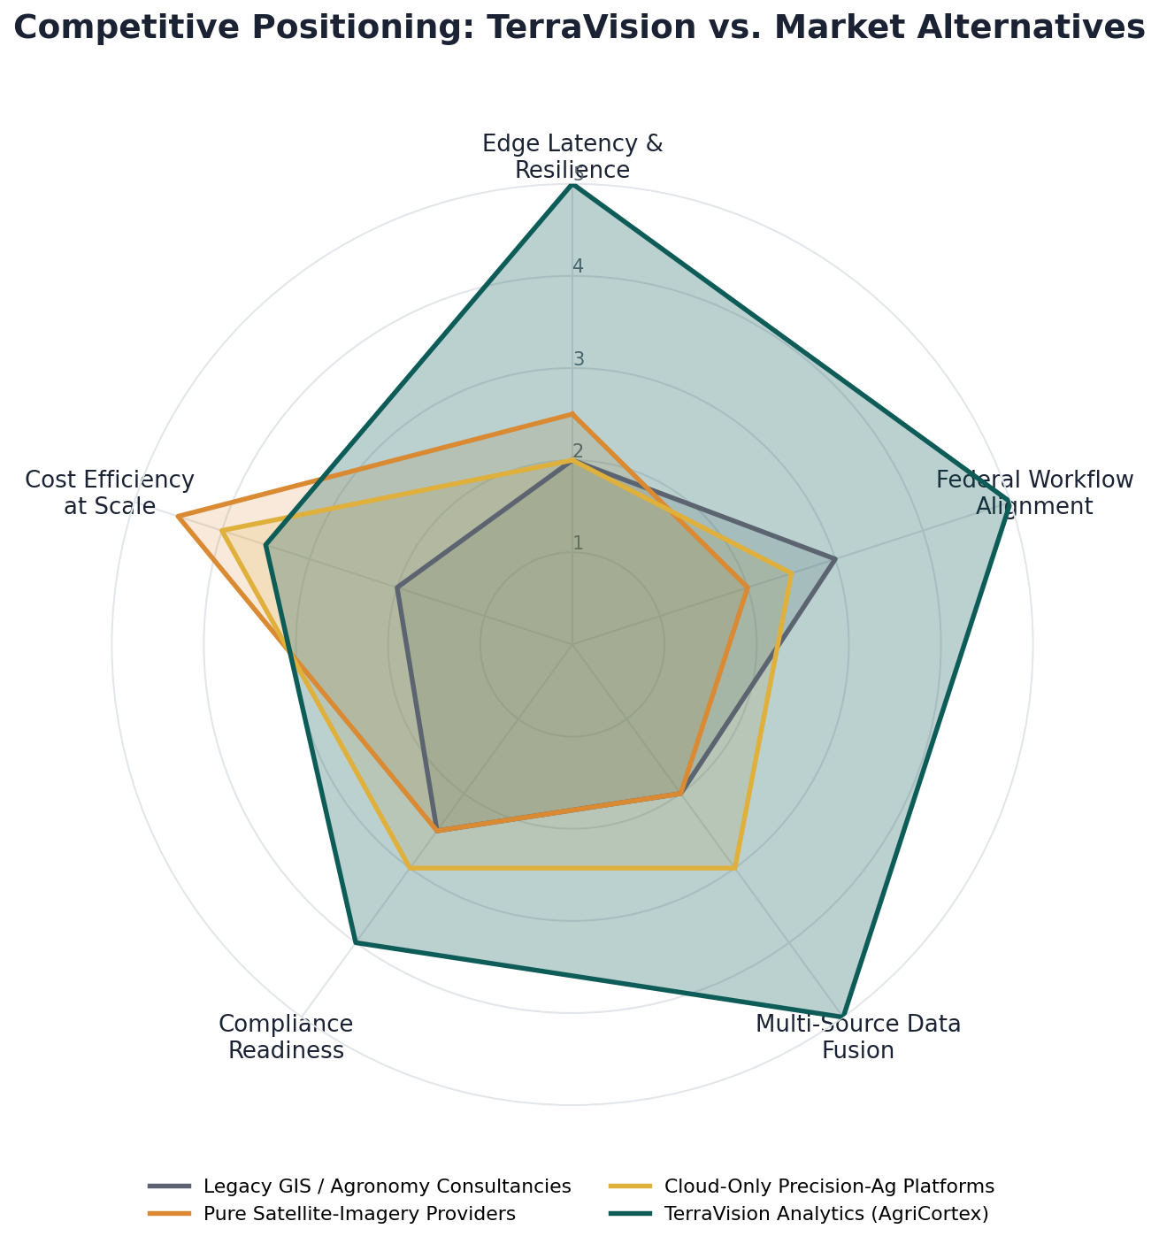
Figure 9: Competitive Positioning — TerraVision vs. Market Alternatives. Each axis is scored on a five-point internal capability scale.

5.4 Key Market Risks
The most significant market risks are federal procurement timing, which can be slow and budget-cycle dependent; the entry of well-capitalized incumbents from the agribusiness or aerospace sectors; and the pace at which insurance and reinsurance carriers adopt new, field-level underwriting data sources in place of legacy survey methods. These risks are addressed in more detail, alongside their mitigations, in Section 10.

6. Business Model and Revenue Strategy

6.1 Revenue Streams
By FY2036, TerraVision's revenue is expected to be diversified across five streams, reducing dependence on any single customer type or contract cycle.
- AgriCortex SaaS subscriptions (projected 45 percent of FY2036 revenue): tiered annual and multi-year subscriptions sold to federal program offices, agribusiness enterprises, and mid-market producers.
- Federal systems integration (projected 25 percent): implementation, customization, and systems-integration work tied to federal deployments, including ArcGIS and legacy USDA system integration.
- Data licensing and API access (projected 15 percent): usage-based licensing of TerraVision's fused satellite, drone, and sensor data sets to third-party platforms and research institutions.
- Insurance and actuarial data products (projected 10 percent): specialized, underwriting-grade data products sold to crop insurers and reinsurers, launching in Year 4 (FY2029).
- Professional services and hardware (projected 5 percent): edge-node hardware sales and deployment services for customers building out dedicated field sensor networks.
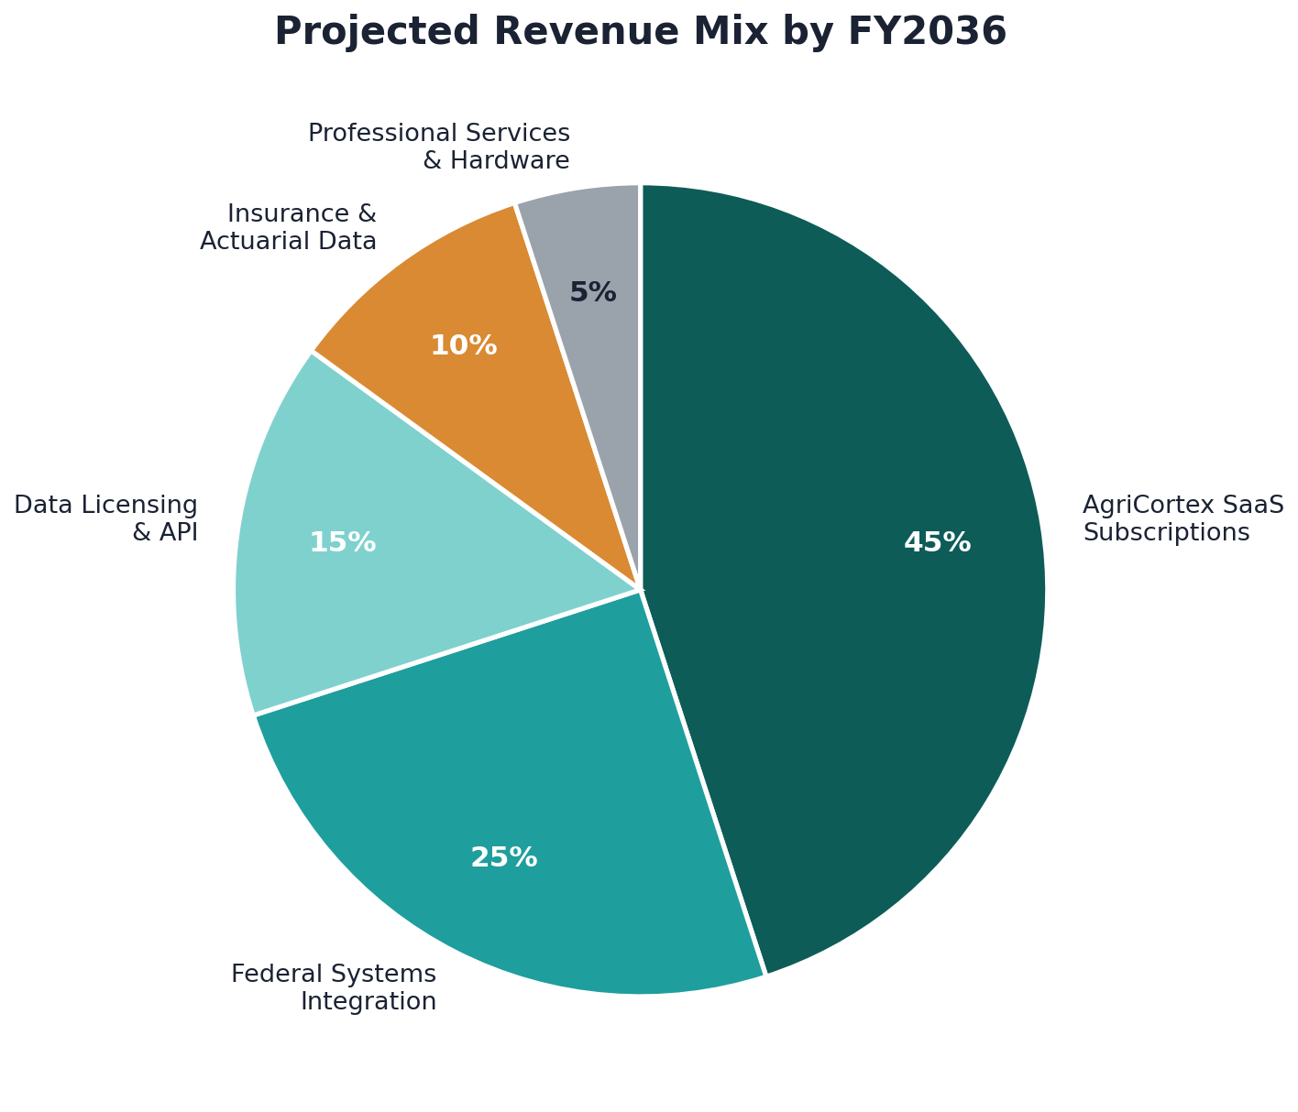
Figure 3: Projected Revenue Mix by FY2036.

6.2 Pricing Philosophy
Pricing is structured around tiered annual subscriptions, scaled by acreage under management and module access, supplemented by usage-based API and data-licensing fees. Federal contracts are priced to reflect multi-year commitments and the upfront annual billing structure common to federal procurement, which is the basis for the cash-flow breakeven assumption described in Section 8.2. Enterprise and mid-market pricing is designed to remain materially below the cost of maintaining an equivalent in-house GIS and remote-sensing capability.

6.3 Go-to-Market Strategy
The go-to-market plan is sequenced deliberately to build credibility with the highest-trust customer segment first, then expand outward.
- Federal-first sequencing: prioritize USDA NASS and adjacent program offices in 2026 and 2027, using that engagement as a trust signal for subsequent agency and enterprise sales.
- Design-partner expansion: deepen relationships with Cargill AgriScience and Pioneer Hi-Bred, and add additional enterprise design partners through the limited general-availability phase in Q1 2027.
- Insurance vertical entry: enter the insurance and reinsurance vertical starting in Year 4 (FY2029), once the platform's time-series data history is long enough to support underwriting-grade products.
- International expansion: pursue Canadian and European Union pilots from Year 5 (FY2030) onward, aligned with Phase III of the strategic roadmap in Section 7.3.
- Channel and marketplace development: open the sensor-source marketplace in Year 3 (FY2028) to third-party hardware vendors, broadening distribution without proportional increases in TerraVision's own field-deployment costs.

7. Strategic Roadmap, 2026–2036
The plan period is organized into five phases. Each phase builds directly on the capabilities and trust established in the one before it, moving the company from pilot-stage commercialization through national scale, international expansion, platform diversification, and finally sustained category leadership.

7.1 Phase I: Foundation and Commercial Launch (2026–2027)
Objective: complete AgriCortex's pilot phase and establish initial federal and enterprise commercial traction.
- Complete closed pilot testing and achieve SOC 2 Type I readiness.
- Reach limited and then full general availability of AgriCortex.
- Secure the USDA NASS engagement as the company's anchor federal contract.
- Close an initial institutional funding round of $8 million to $12 million to support go-to-market scale-up.

7.2 Phase II: Scaled Growth (2028–2029)
Objective: broaden the customer base across federal, enterprise, and emerging insurance segments while extending platform capability.
- Extend FedRAMP authorization scope specifically to AgriCortex.
- Launch the sensor-source marketplace and carbon/ESG monitoring module.
- Enter the crop-insurance and reinsurance vertical with underwriting-grade data products.
- Close a second institutional funding round of $25 million to $35 million.
- Reach cash-flow breakeven in FY2029.

7.3 Phase III: National and International Expansion (2030–2032)
Objective: achieve full USDA enterprise-wide deployment and establish the company's first international footprint.
- Complete full USDA enterprise-wide deployment of AgriCortex.
- Enter Canadian and European Union markets through localized pilots.
- Reach GAAP EBITDA breakeven in FY2030 and sustain double-digit EBITDA margins by FY2031.
- Add water-resources and forestry monitoring modules to the platform.

7.4 Phase IV: Platform Maturity and Diversification (2033–2035)
Objective: extend the platform into adjacent domains and continue scaling margins toward maturity.
- Extend into adjacent climate-risk insurance analytics and broader natural-resource monitoring domains.
- Sustain gross margins above 73 percent and EBITDA margins above 30 percent by FY2035.
- Reach approximately $185 million in annual revenue by FY2035.
- Continue international expansion into additional Latin American markets.

7.5 Phase V: Sustained Leadership and Strategic Optionality (2036)
Objective: consolidate category leadership, sustain margin performance, and formally evaluate the company's next strategic chapter.
- Complete final platform consolidation, with AgriCortex as the unified front end for all TerraVision data products.
- Sustain EBITDA margins above 35 percent on a mature, largely fixed-cost infrastructure base.
- Conduct a formal strategic review of public-listing readiness, continued private growth, and strategic acquisition interest.
- Fully commercialize the water-resources, forestry, and climate-risk insurance analytics product lines.
- Begin formal planning for the company's next ten-year horizon, FY2037 through FY2046.

8. Strategic Financial Plan, FY2026–FY2036

8.1 Revenue, Costs, and Profitability Summary
FY | Revenue ($M) | Gross Margin | Op. Costs ($M) | EBITDA ($M) | EBITDA %
2026 | 2.1 | 55% | 4.8 | (3.6) | —
2027 | 6.4 | 60% | 8.9 | (5.1) | —
2028 | 15.8 | 64% | 15.2 | (5.1) | —
2029 | 31.5 | 67% | 24.0 | (3.1) | —
2030 | 52.0 | 70% | 34.8 | 1.6 | 3%
2031 | 78.5 | 71% | 47.0 | 8.7 | 11%
2032 | 108.0 | 72% | 59.0 | 18.8 | 17%
2033 | 138.0 | 73% | 67.0 | 33.7 | 24%
2034 | 163.0 | 74% | 73.0 | 47.6 | 29%
2035 | 185.0 | 75% | 78.0 | 60.8 | 33%
2036 | 205.0 | 76% | 84.0 | 71.8 | 35%
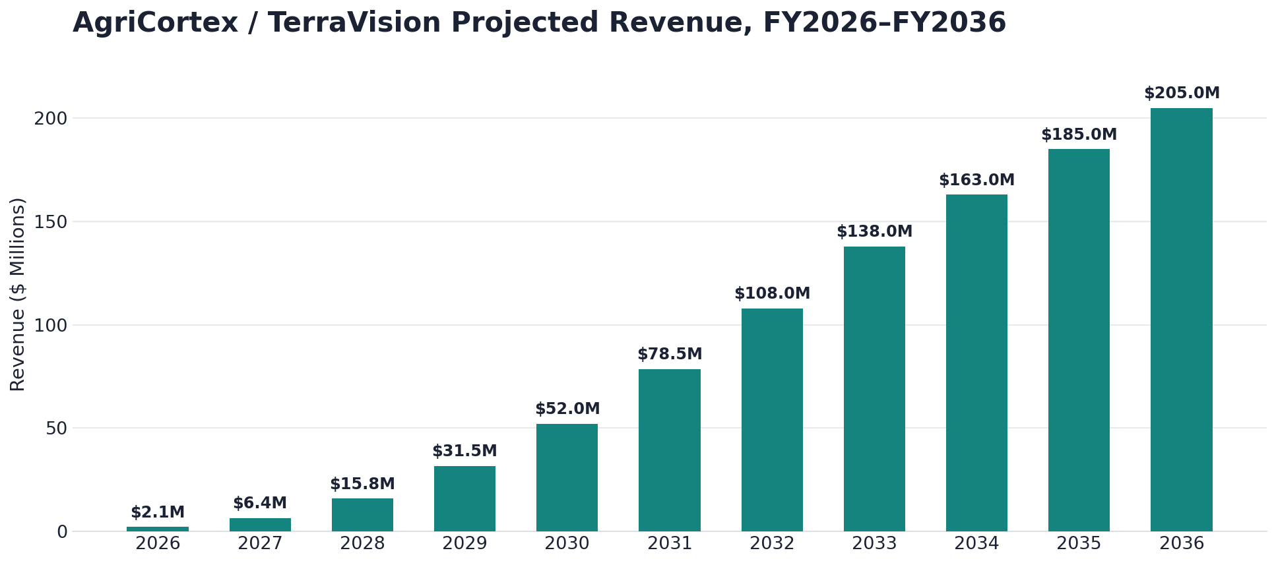
Figure 4: AgriCortex / TerraVision Projected Revenue, FY2026–FY2036.
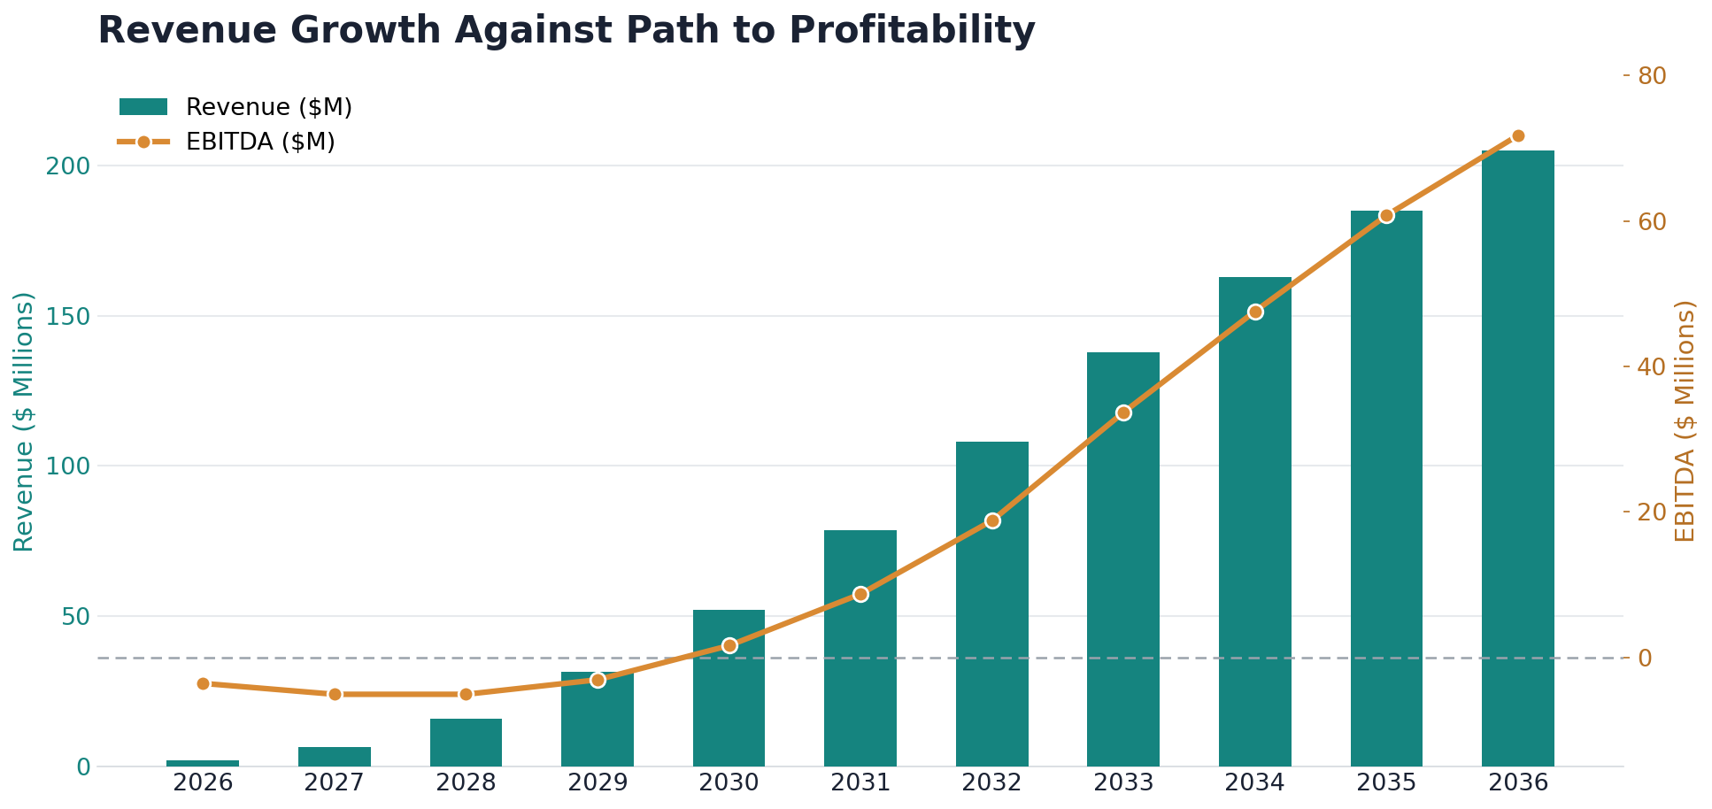
Figure 5: Revenue Growth Against the Path to Profitability, FY2026–FY2036.
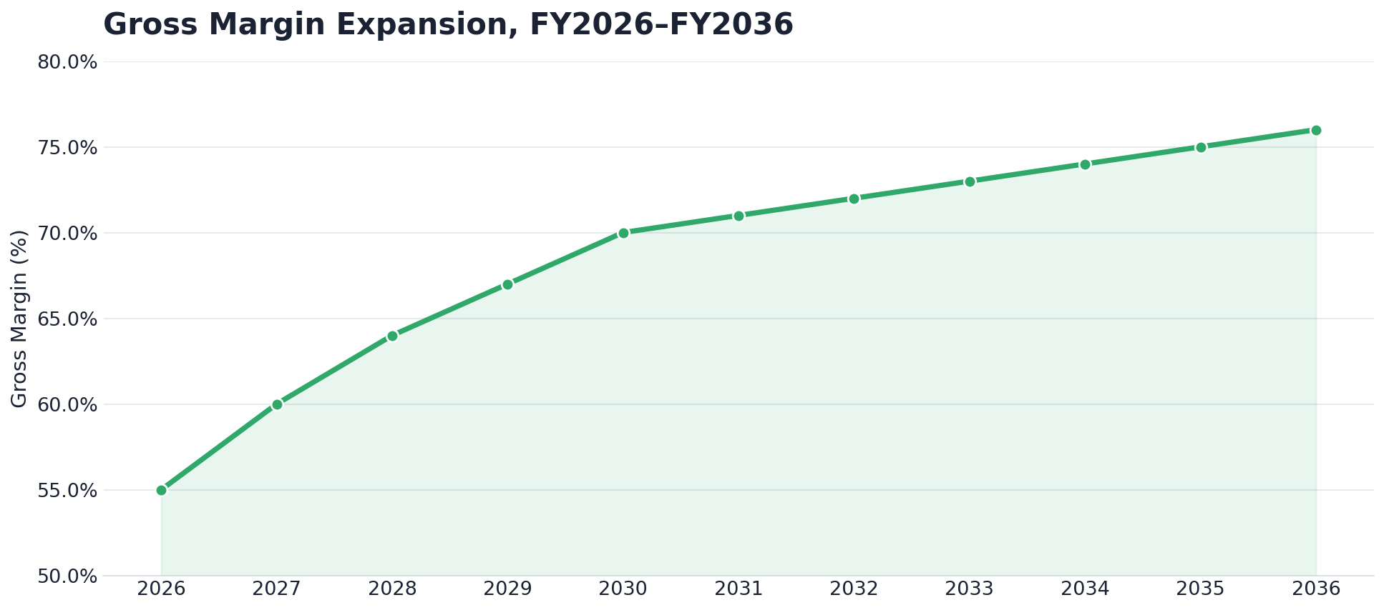
Figure 6: Gross Margin Expansion, FY2026–FY2036.

8.2 Key Assumptions
- Revenue growth is driven primarily by AgriCortex subscription expansion across federal and enterprise accounts following general availability in FY2027.
- Gross margin expands from 55 percent in FY2026 to 76 percent by FY2036 as the platform shifts from services-heavy early deployments toward a software- and data-licensing-dominant mix.
- Cash-flow breakeven, supported by upfront annual billing on multi-year federal and enterprise contracts, is targeted for FY2029, ahead of GAAP EBITDA breakeven in FY2030.
- EBITDA margins are projected to exceed 30 percent from FY2035 onward and to reach 35 percent by FY2036, supported by a largely fixed-cost edge and cloud infrastructure base.
- Two institutional funding rounds, totaling an estimated $33 million to $47 million combined, are assumed in FY2026 and FY2028, with growth from FY2030 onward funded primarily through operating cash flow.

8.3 Headcount Plan
FY | Eng. & ML | Sales & GTM | Cust. Success | G&A / Ops | Total
2026 | 18 | 6 | 4 | 7 | 35
2027 | 32 | 14 | 9 | 12 | 67
2028 | 48 | 24 | 16 | 18 | 106
2029 | 65 | 36 | 26 | 25 | 152
2030 | 82 | 48 | 36 | 32 | 198
2031 | 96 | 58 | 45 | 38 | 237
2032 | 110 | 70 | 55 | 45 | 280
2033 | 124 | 80 | 64 | 52 | 320
2034 | 138 | 88 | 73 | 59 | 358
2035 | 150 | 95 | 80 | 65 | 390
2036 | 162 | 103 | 88 | 72 | 425
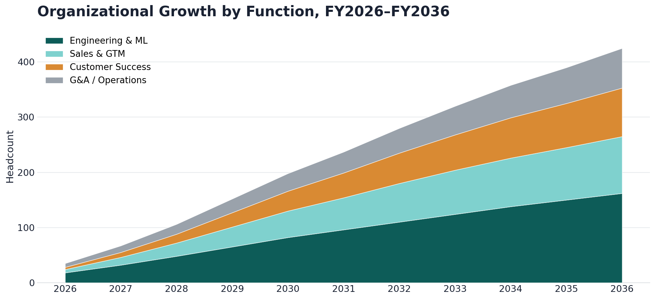
Figure 7: Organizational Growth by Function, FY2026–FY2036.

8.4 Funding Requirements
Through FY2025, the company was bootstrapped entirely by its founder, who self-funded initial development during and immediately after his graduate studies. This plan assumes two subsequent institutional funding rounds: an initial round of $8 million to $12 million in FY2026 to fund go-to-market scale-up around AgriCortex's general-availability launch, and a second round of $25 million to $35 million in FY2028 to fund federal expansion, international entry preparation, and the build-out of the insurance vertical. From FY2030 onward, growth is assumed to be funded primarily through positive operating cash flow and multi-year contract billing, reducing reliance on additional dilutive capital.
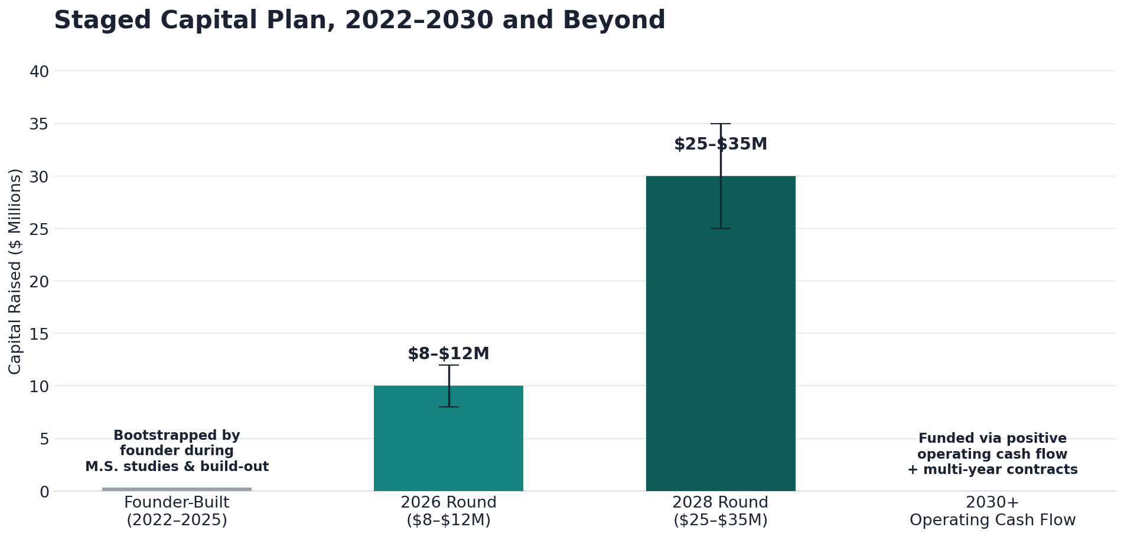
Figure 11: Staged Capital Plan, 2022–2030 and Beyond.

9. Operations Plan

9.1 Technology Infrastructure
TerraVision's infrastructure is built around the three-tier edge-to-cloud architecture described in Section 2.5: ruggedized field edge nodes for collection, on-device inference for processing, and cloud-synchronized GIS dashboards for delivery. As AgriCortex scales from pilot testing into general availability, this architecture is expected to remain largely fixed-cost, which is the primary driver of the gross-margin expansion shown in Figure 6. Continued investment in this period focuses on horizontal scaling of the cloud ingestion layer, expansion of the edge-node fleet, and hardening of the platform's reliability ahead of federal-grade service-level commitments.

9.2 Data Sources and Partnerships
The platform's intelligence depends on a growing network of public and private data partnerships. Existing integrations with the NOAA Weather API and the USDA Cropland Layer are expected to be joined, over the plan period, by expanded commercial satellite licensing, additional drone-telemetry partnerships, and the third-party sensor marketplace launching in Year 3 (FY2028). Maintaining diversity across data sources is treated as both a product-quality and a risk-mitigation priority, reducing dependence on any single provider.

9.3 Security and Compliance Roadmap
FY | Milestone
2026 | SOC 2 Type I readiness; continued FedRAMP Moderate authorization process.
2027 | SOC 2 Type II certification; limited and full general availability security hardening complete.
2028 | Extended FedRAMP scope formally covering the AgriCortex module.
2029 | CMMC readiness assessment for expanded Department of Defense-adjacent agricultural and food-security contracting.
2030 | GDPR and international data-residency compliance ahead of Canadian and European Union market entry.

9.4 Organizational Development
Headcount is planned to grow from roughly 35 people in FY2026 to an estimated 425 people by FY2036, as shown in Figure 7 and detailed in the headcount plan in Section 8.3. Engineering and machine learning roles remain the largest functional group throughout the plan period, reflecting the company's continued identity as a technical, product-led organization even as it scales its federal and commercial go-to-market functions.

10. Risk Analysis and Mitigation
The risks below are organized by likelihood and impact in Figure 13, and are discussed individually, together with their primary mitigations, in the table that follows.
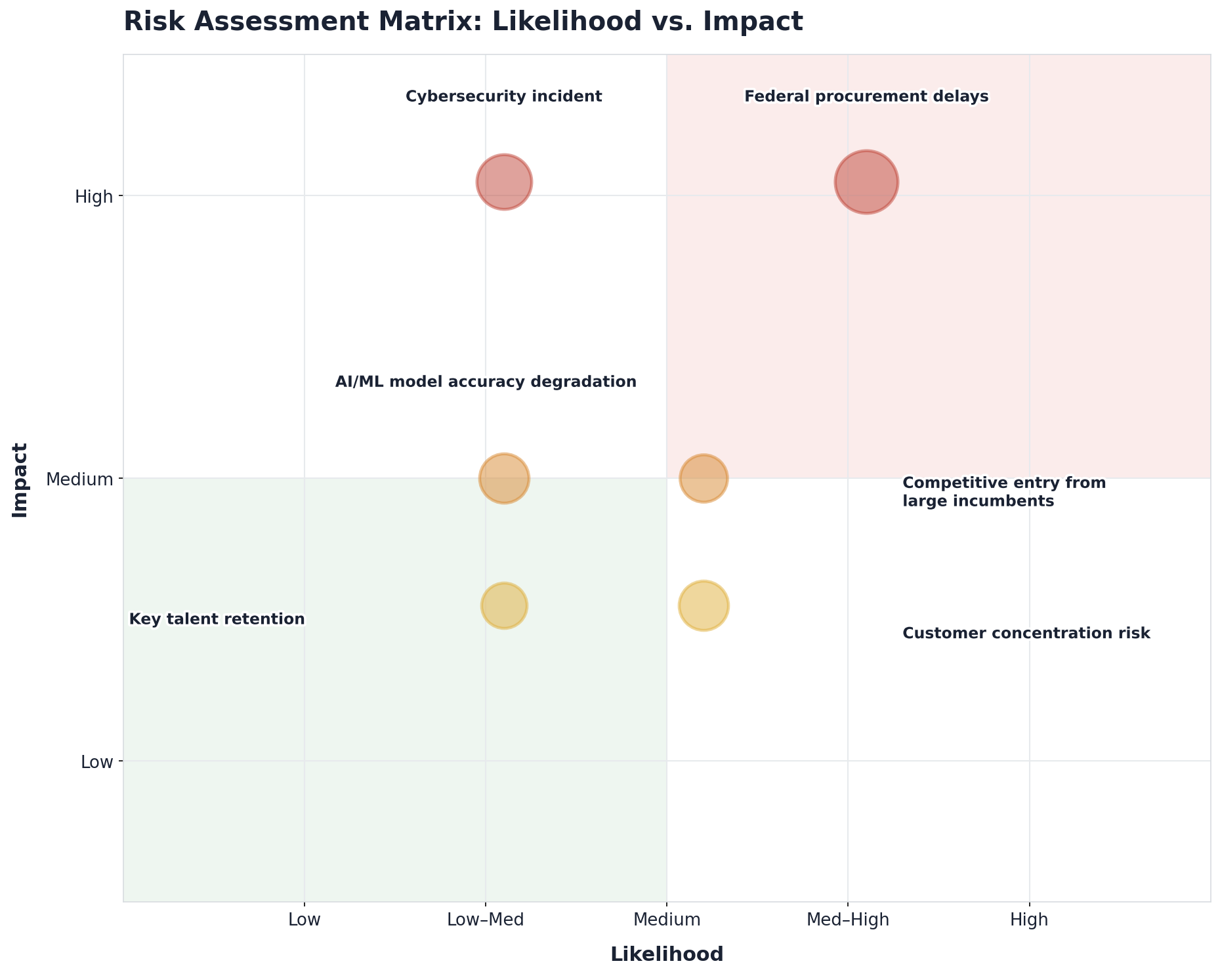
Figure 13: Risk Assessment Matrix — Likelihood vs. Impact.
Risk | Likelihood | Impact | Primary Mitigation
Federal procurement delays | Medium | High | Diversify pursuit across multiple USDA program offices; maintain a healthy commercial pipeline that does not depend solely on federal timing.
Cybersecurity incident | Low to Medium | High | Pursue SOC 2 and FedRAMP authorization on an accelerated timeline; maintain continuous penetration testing and incident-response readiness.
AI/ML model accuracy degradation | Medium | Medium | Maintain configurable auto-retraining triggers and minimum accuracy thresholds, with automated alerting on performance drift.
Competitive entry from large incumbents | Medium | Medium | Continue to invest in edge-native latency advantages and deepen federal-workflow alignment that is difficult for cloud-only entrants to replicate quickly.
Key talent retention | Medium | Medium | Maintain a strong technical culture rooted in the company's founding values, with competitive equity participation as the company scales.
Customer concentration risk | Medium | Medium | Actively diversify the customer base across federal, enterprise, insurance, and mid-market segments per the go-to-market plan in Section 6.3.

11. Key Milestones and Success Metrics

11.1 Milestone Timeline
FY | Key Milestones
2026 | AgriCortex pilot completion, SOC 2 Type I readiness, and an initial institutional funding round closed.
2027 | AgriCortex reaches general availability; three or more anchor multi-year contracts signed.
2028 | Extended FedRAMP scope for AgriCortex; second funding round closed; insurance vertical launched.
2029 | Cash-flow breakeven reached; full USDA program-office expansion underway.
2030 | International market entry through Canadian and European Union pilots; GAAP EBITDA-positive.
2032 | USDA enterprise-wide deployment complete; EBITDA margin above 17 percent.
2035 | $185 million or more in annual revenue; EBITDA margin above 33 percent.
2036 | $205 million or more in annual revenue; EBITDA margin above 35 percent; full platform consolidation complete; formal strategic review of the next capital event and the FY2037–FY2046 planning horizon.

11.2 Core KPIs to Track Annually
- Annual recurring revenue and net revenue retention across federal, enterprise, insurance, and mid-market segments.
- Gross margin and EBITDA margin trends against the targets set out in Section 8.1.
- Acres under active AgriCortex monitoring, as a leading indicator of platform adoption and data-network effects.
- Federal contract pipeline value and conversion rate, tracked separately from commercial enterprise pipeline.
- Model accuracy and drift metrics across the pest, disease, and yield-prediction model families.
- Headcount efficiency, measured as revenue per employee, tracked against the headcount plan in Section 8.3.
Acreage under active monitoring is tracked separately from the historical platform-wide acreage shown in Figure 1, since it reflects only acreage under paying AgriCortex customer contracts rather than total data ingested during testing and development. It is expected to grow from roughly 40 million acres at AgriCortex's commercial launch in FY2026 to more than 2.3 billion acres by FY2036, broadly in line with the revenue growth shown in Figure 4.
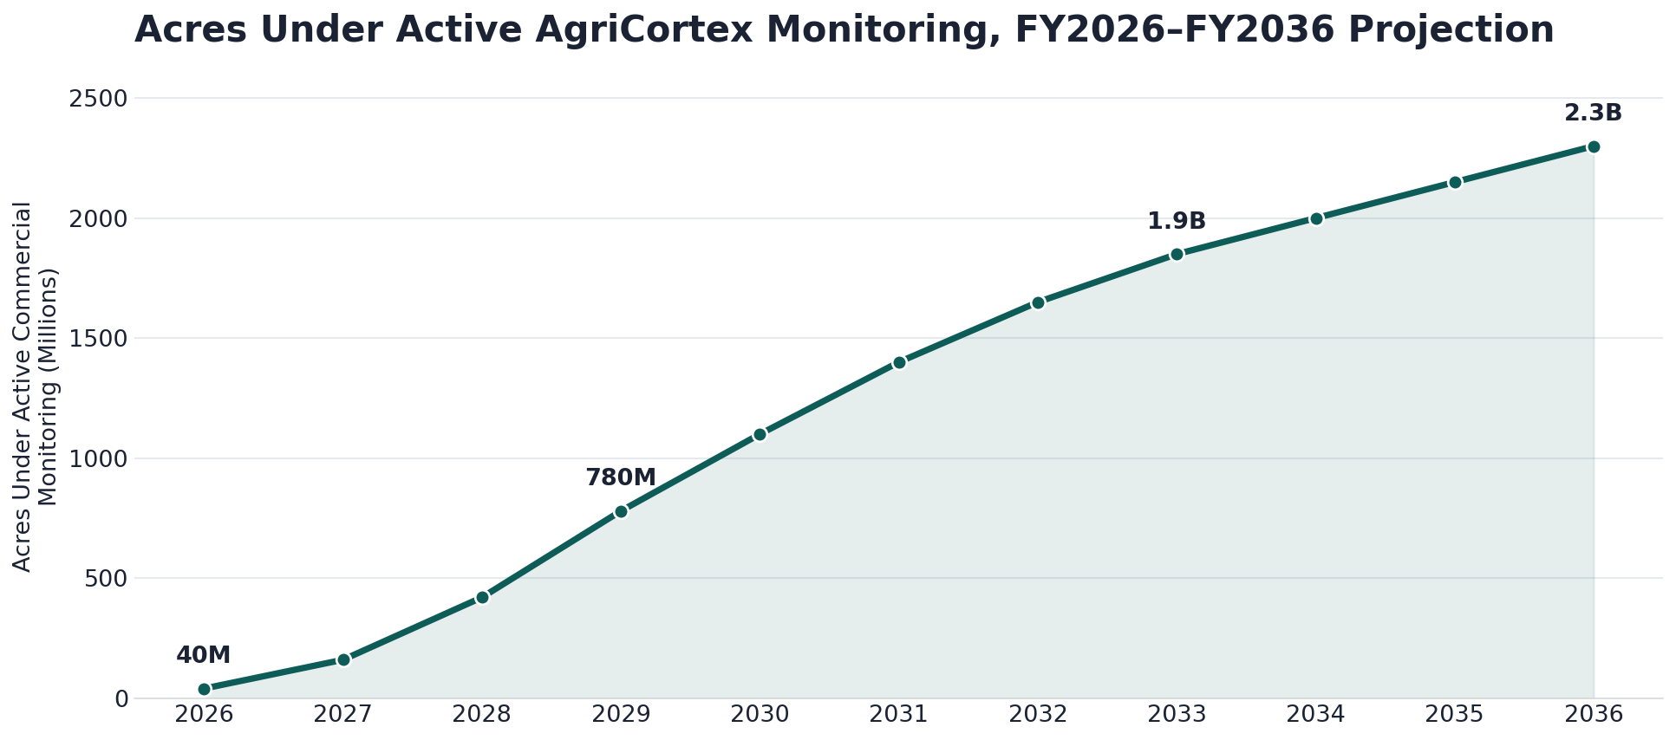
Figure 12: Acres Under Active AgriCortex Monitoring, FY2026–FY2036 Projection.

12. Conclusion
TerraVision Analytics enters this plan period in 2026 with four years of focused, founder-led technical execution already behind it. What began in 2022 as a single insight, formed by Gideon Olawale Sodipo during his graduate research at Kent State University, that intelligence needed to live close to the land, has grown into a working edge-native geospatial intelligence platform with active federal engagement and growing enterprise trust.
AgriCortex is the mechanism through which the company intends to convert that foundation into a scaled, repeatable commercial product over the eleven years covered by this plan. The path from a projected $2.1 million in FY2026 revenue to more than $205 million by FY2036, traced across five distinct phases, is ambitious but grounded in capabilities that are already built and operating today rather than aspirational technology yet to be developed.
By the close of this plan period in 2036, TerraVision intends to have established AgriCortex as the default geospatial intelligence layer for North American agriculture, sustained EBITDA margins above 35 percent, and built the organizational and financial foundation from which to evaluate its next strategic chapter, whether that takes the form of continued private growth, a public listing, or another path toward the company's founding mission: securing the global food supply through trustworthy, real-time, AI-powered intelligence.

