

**QuickBite:**

**Food Delivery App:**

**Group Members:**231663_Syed Ali Adan Naqvi  
231591_Ahmed Ameer

**Description:**

The Flutter based app QuickBite is a way to make ordering easy. Enabling users to browse through menus effortlessly, make up orders and also pay, all from the comfort of your own home or anywhere you want. The app frees you from all the hassles associated with ordering food through usual means, creating modern and easy to use digital solutions to your problems.

**Target Audience:**

* Busy Professionals
* In Dorms or Apartments
* People used to not going outside much

**Benefits/Use:**

* **Convenience:** You can order food without calling or visiting restaurants.
* **Time Saving:** There is a streamlined ordering process that helps minimise waiting times.
* **Variety:** Have access to a tonne of restaurants and various cuisines.
* **Customization:** Add-ons and special instructions on tailor orders.
* **Real-Time Tracking:** Keep in touch with order and delivery status.

**Features:**

* **User Authentication**: Login and sign up with security.
* **Menu Browsing & Search:** Browse interesting restaurant menus, search for specific items.
* **Add-On Customization:** Add more the ingredients or a preference in meals.
* **Checkout Process:** Smooth hassle-free checkout using integrated payment.
* **Order Tracking:** Order preparation and delivery status real time updates.
* **User Profile & Settings:** User Information, order history and preferences management.
* **Dark Mode/Light Mode Toggle:** Allow for greater usability by your users, by switching between light and dark themes when needed.

**Flowchart Diagram:**

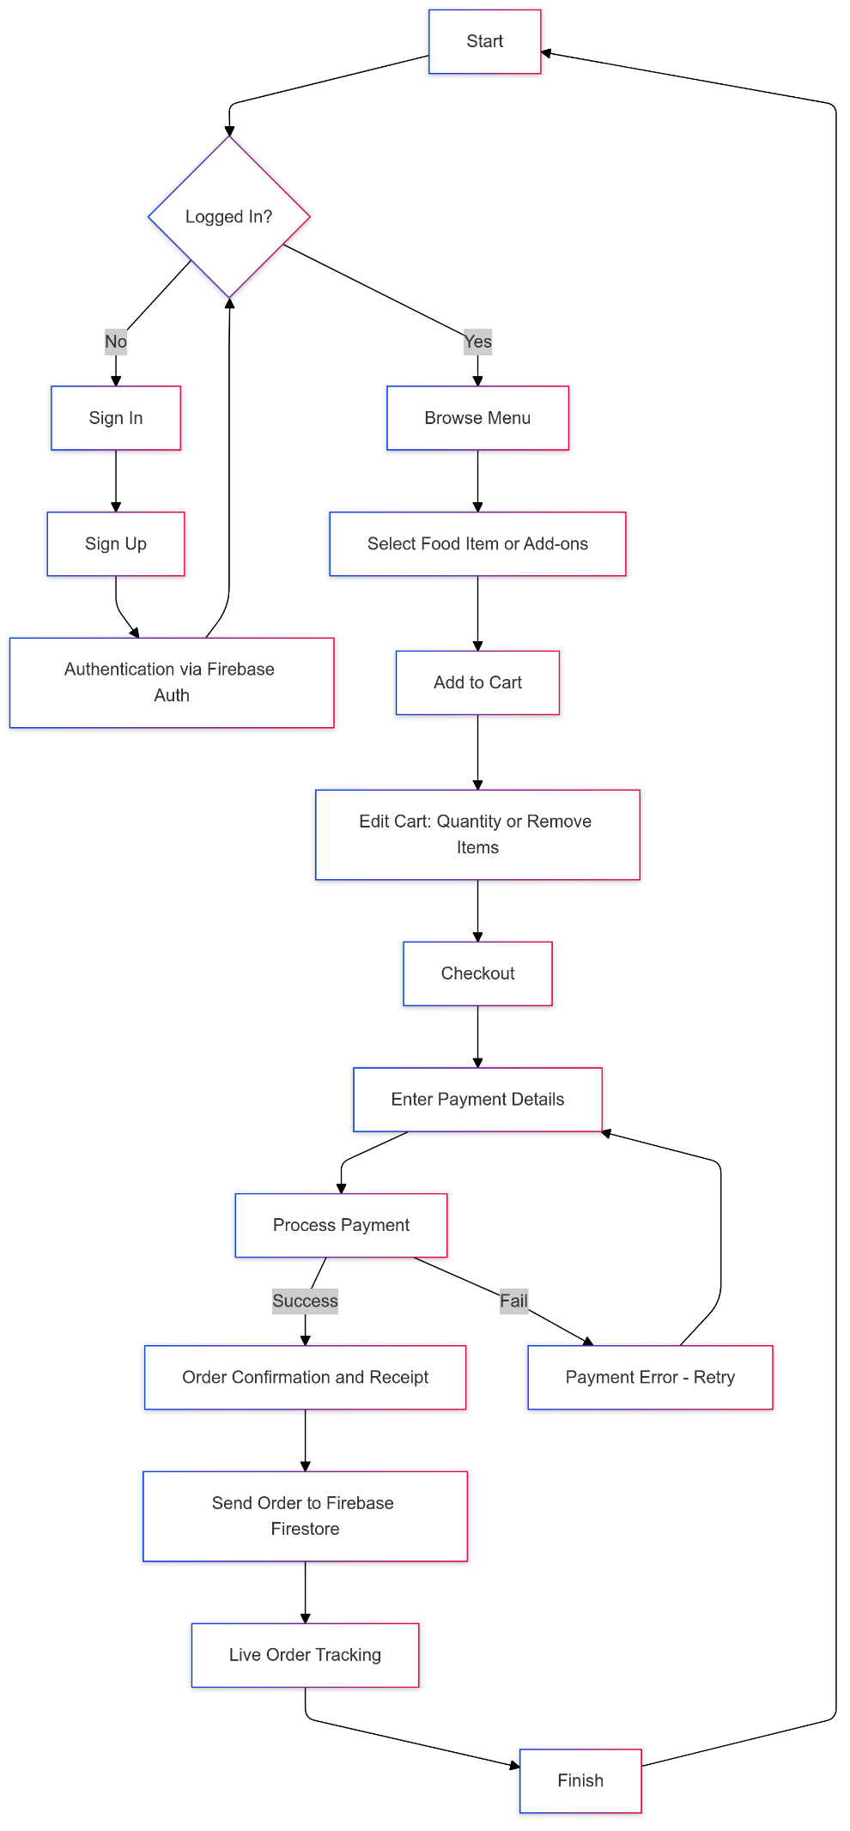

**Tools Used:**

* **Flutter/Dart:** Aframework for cross platform building app.
* **Firebase:** Authentication. Database management, and real time updates in backend.
* **Provider:** A state management solution that handles data efficiently and updates UI.

**Unique Aspects:**

* Prioritize the code organisation and maintainability.
* Updates using firebase in real time for an optimised user experience.
* Dark Mode support for better usability as a good user interface.

**Conclusion:**

This proposal describes a food delivery app that satisfies functional, user centric criteria, offering convenience, efficiently and customization, which make it a suitable answer for contemporary food ordering requirements.