

**Project Name: AUTOMOBILE SHOWROOM MANAGEMENT**

**SYSTEM**

**Course name: OBJECT ORIENTED PROGRAMMING 1**

**Course Instructor: SHAZZAT HOSSAIN**

**Semester: FALL 2017-18**

**Date of Submission: 30 DECEMBER, 2017**

**Group Members:**

|  |  |  |
| --- | --- | --- |
| **Name** | **ID** | **SECTION** |
| **SAYMON,AKTHER HAMID** | **16-32203-2** | **B1** |
| **SAKIB,AHMED SHAHRIAR** | **16-32170-2** | **A** |
| **RAFID SHAHRIAR** | **16-32208-2** | **A** |

**Table of Contents: Page no.**

Functionalities and user description……………………………..………………………………………………………. **3**

GUI design ………………………………………………………………………………………………………………….……...… **4**

Exported bill design ………………………..………………………………………………………………………….……...… **7**

Proposed classes and resources ……………………….………………………………………………………….…....... **8**

Project structure (source code) …………………………………………………………………………………………..… **9**

Entity-Relationship diagram ………………………………………………………………………………………………... **15**

Database Tables and Relationship schema…………………………….……………………………….…………..…**16**

Conclusion………..………………………………………………………………………………..…….……..………………….. **16**

**Target Users of this application:**

**->**Salespersons of a showroom (ex- Manager).

**Functionalities:**

1. **User Access:**

* **User can sign in to the system .**
* **User can register for access .**
* **User can sign out from the system .**

1. **User Control :**

* **Check inventory.**
* **Check order history.**
* **Check customer history.**
* **Create an order form.**
* **Generate a bill (which is saved in pdf format).**
* **Check revenue.**
* **User can sort multiple data from data table in ascending and descending order.**
* **User can search specific data(along with the row) from the table .**

**GUI DESIGN:**

1. **Log In Page**

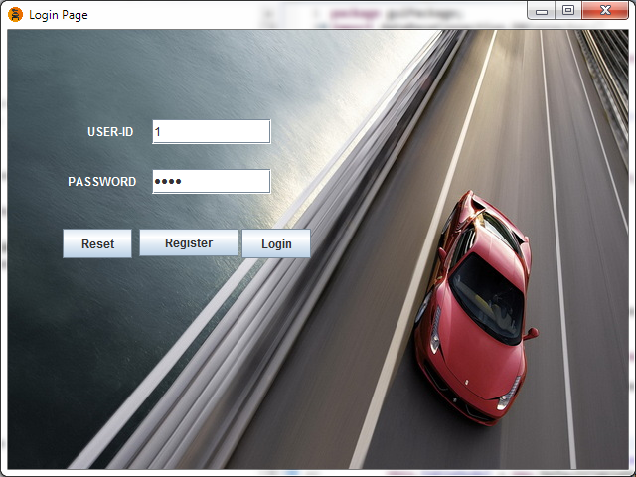

1. **Sign up Page**

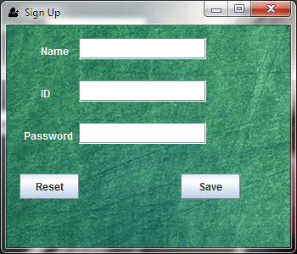

1. **Main Menu**

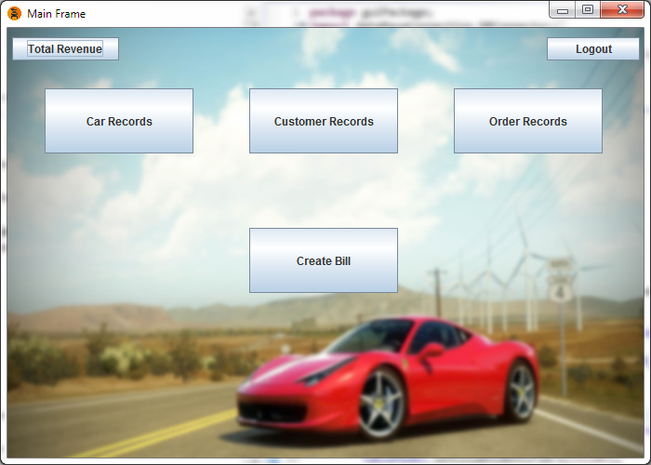

1. **Order Records**

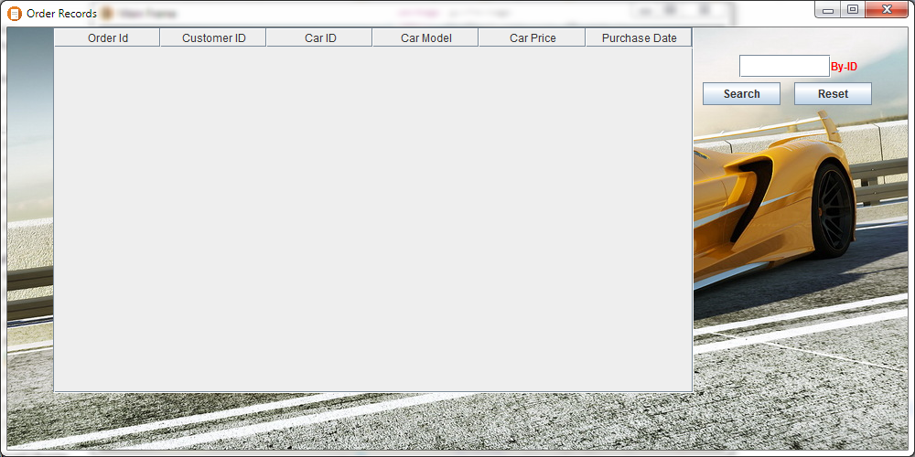

1. **Car records**

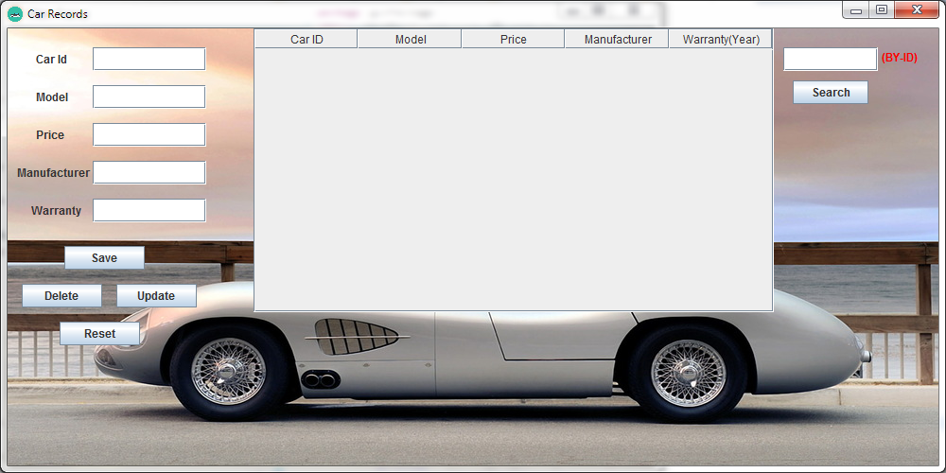

1. **Customer records**

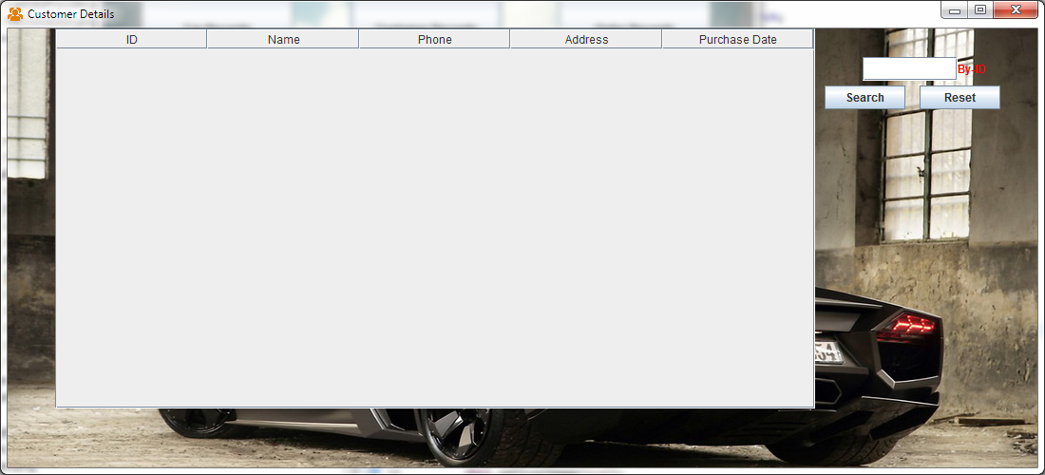

1. **Order Form**

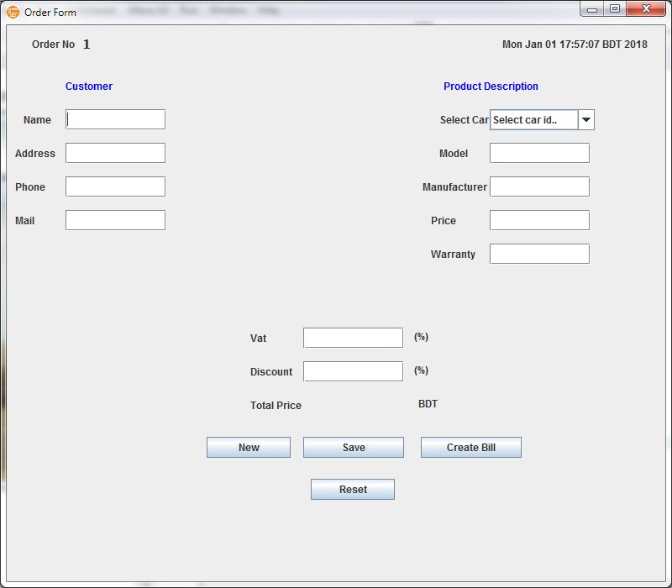

1. **Revenue**

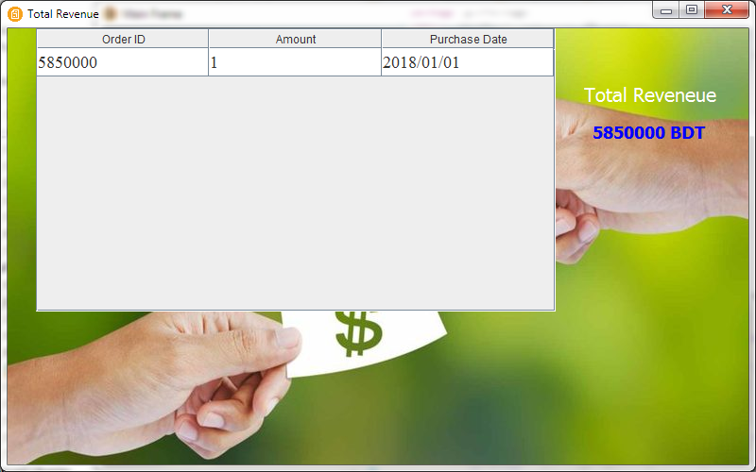

**Exported Order Form(pdf Format):**

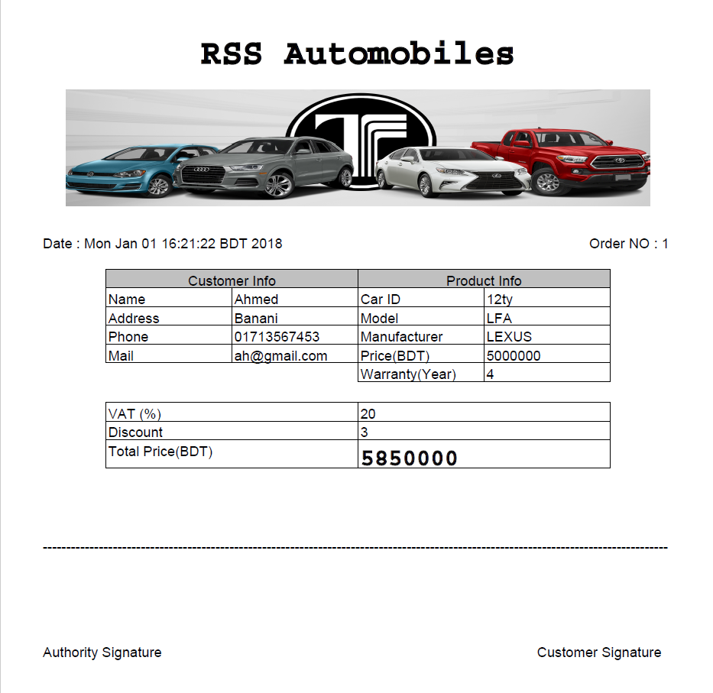

**Proposed Classes for this application:**

**Car:**

Car class has id, model, price, manufacturer and warranty attributes.

**Customer:**

Customer has id, name, phone, address and purchase date attributes.

**Order:**

Order has id, customer id, car id, car model , car price and purchase date attributes where customer id , purchase date belong to CUSTOMER class and car id , model ,price belong to CAR class.

**Login**

It is a separate class from Car, Customer, Revenue and Order which is used only for user access control.

**Revenue:**

This class is connected to the ORDER class. It has Order ID, Amount, Purchase date attributes where Order Id belongs to ORDER class and Purchase date belongs to CUSTOMER class.

**Resources:**

* IDE for Project : Eclipse , Intellij idea .
* External archives : mysql.jar , iTextpdf.jar .
* <https://erdplus.com/> for ER diagram .
* <https://creately.com/> for DB Relational schema .

**Project Structure:**

This project is divided into three packages :

**A.guiPackage:**

1.Car

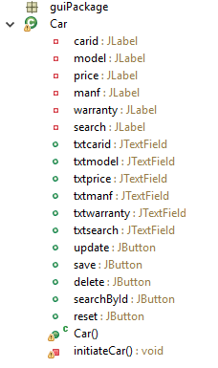

2.Customer

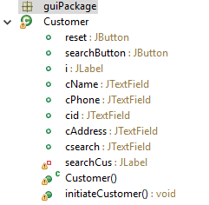

3.LoginPage

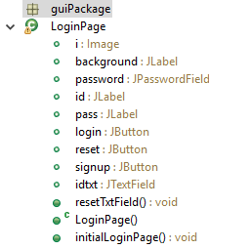

4.Main Frame



5.Order

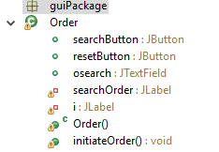

6.Selectionpage

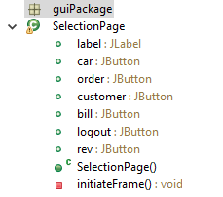

7.Order Form

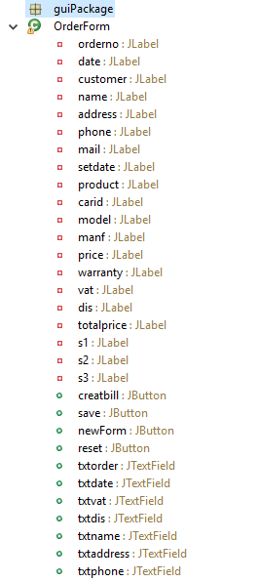

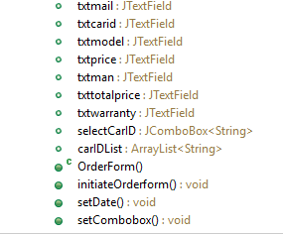

8.Sign Up Page

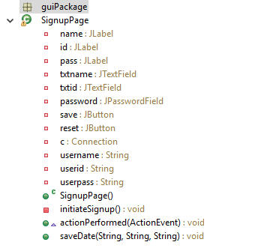

9.Total Revenue

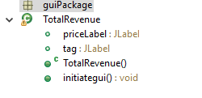

10.Main:

A Main class with main method to run the program in a single thread.

**B.Event Handling**

1.Car Event

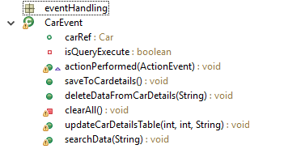

2.Customer Event

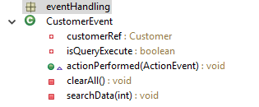

3.Expore Pdf

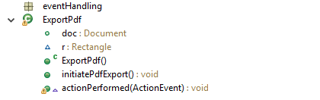

4.Login Event Handling

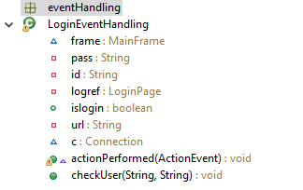

5.Order Event

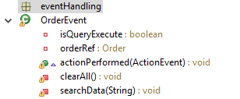

6.Order Form Event

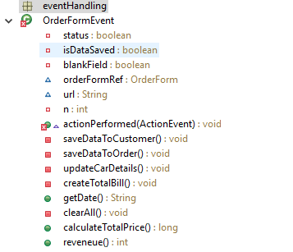

7.Selection Page Event

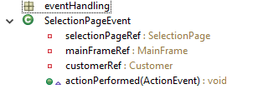

**C.Database connection**

1. CarDataProvider:

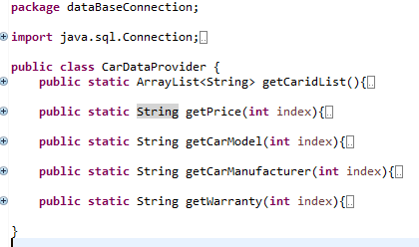

2.DBConnector

Class with necessary method to register driver .

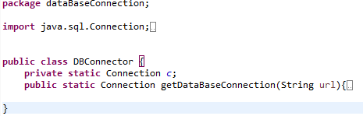

**Entity-Relationship Diagram**

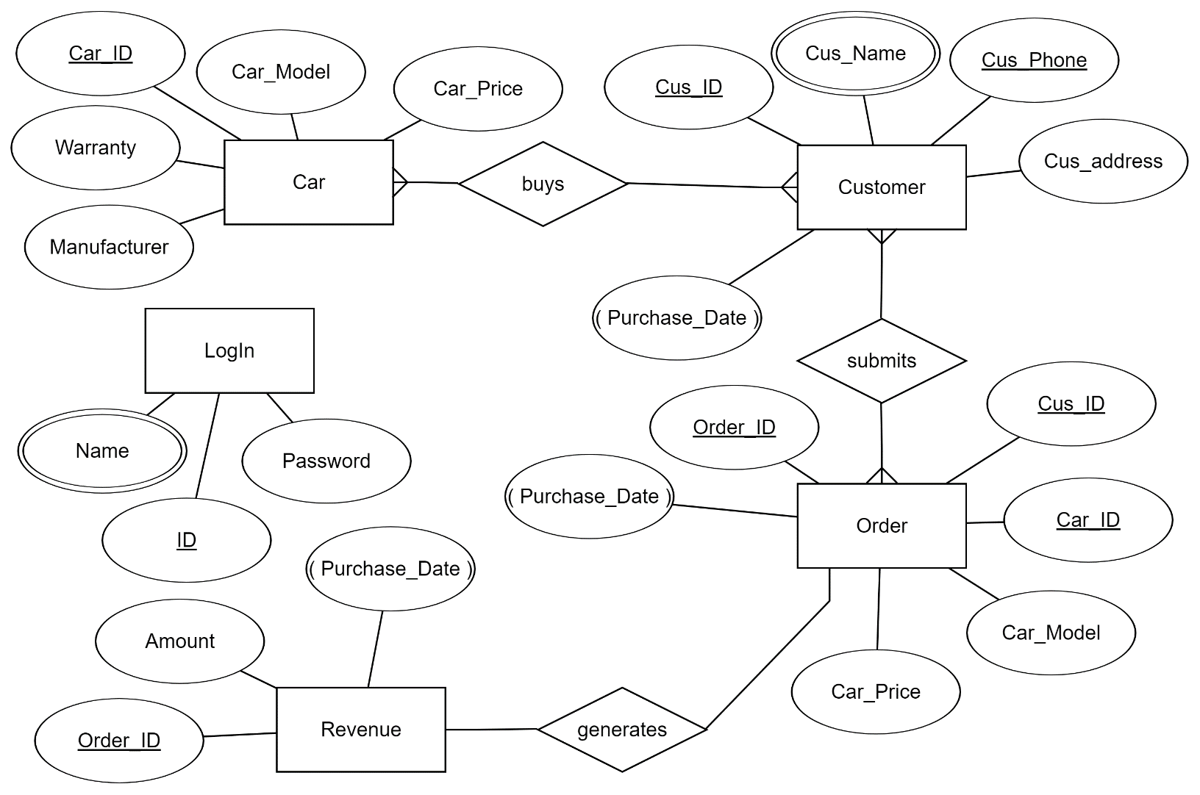

**DATABASE CONTENTS (TABLES):**

**CAR**

|  |  |  |  |  |
| --- | --- | --- | --- | --- |
| CAR_ID | CAR MODEL | CAR PRICE | MANUFACTURER | WARRANTY |

**CUSTOMER**

|  |  |  |  |  |
| --- | --- | --- | --- | --- |
| CUSTOMER ID | CUSTOMER NAME | CUSTOMER PHONE | CUSTOMER ADDRESS | PURCHASE DATE |

**ORDER**

|  |  |  |  |  |  |
| --- | --- | --- | --- | --- | --- |
| ORDER ID | CUSTOMER ID | CAR ID | CAR MODEL | CAR PRICE | PURCHASE DATE |

**LOGIN**

|  |  |  |
| --- | --- | --- |
| ID | NAME | PASSWORD |

**REVENUE**

|  |  |  |
| --- | --- | --- |
| ORDER ID | AMOUNT | PURCHASE DATE |

**Database Relationship Diagram:**

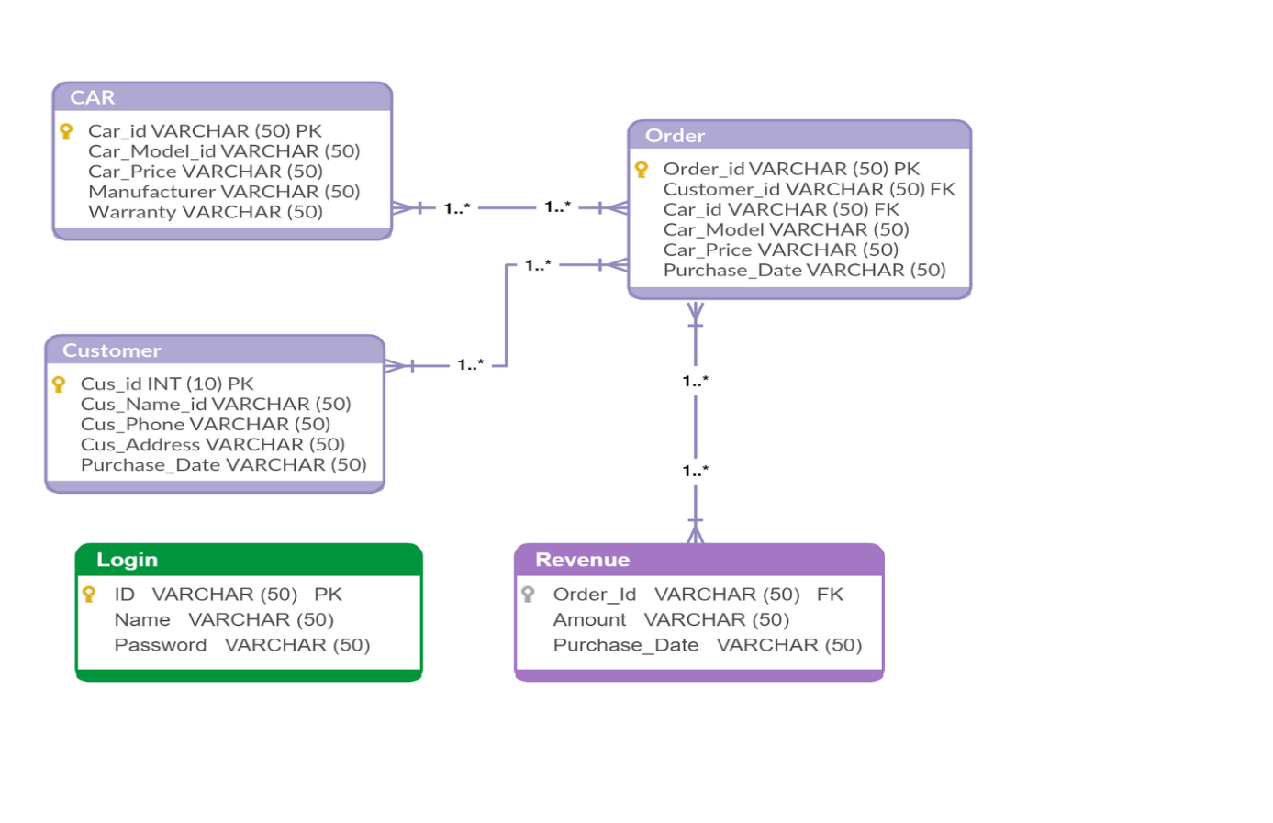**Conclusion:**

Due to insufficient time there may be some bugs ,error (mainly in order Form)remained in the application and the application lacks of some efficient features .