**DBMS Assignment 1**

Task 1:

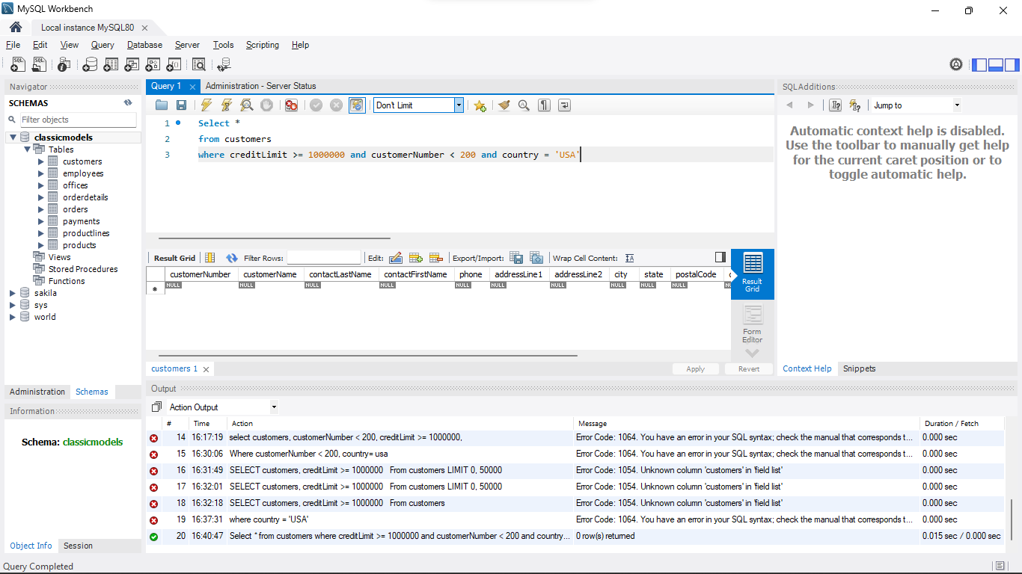

Task 2:

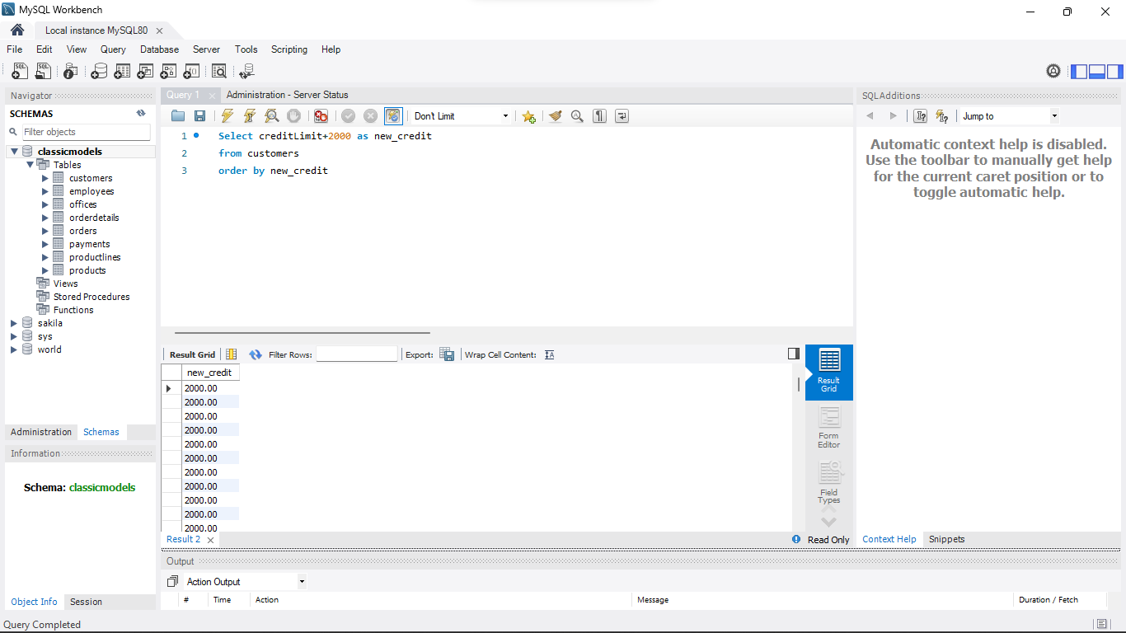

Task 3:

Diego Freyre, Susan Nelson, Micheal Holz.

