**DBMS Assignment 1**

REGEXP report:

REGEXP is the operator used when performing regular expression pattern matches. RLIKE is the synonym.

It also supports a number of metacharacters which allow more flexibility and control when performing pattern matching.

The backslash is used as an escape character. It’s only considered in the pattern match if double backslashes have used.

 Its not case sensitive.

Task 1:

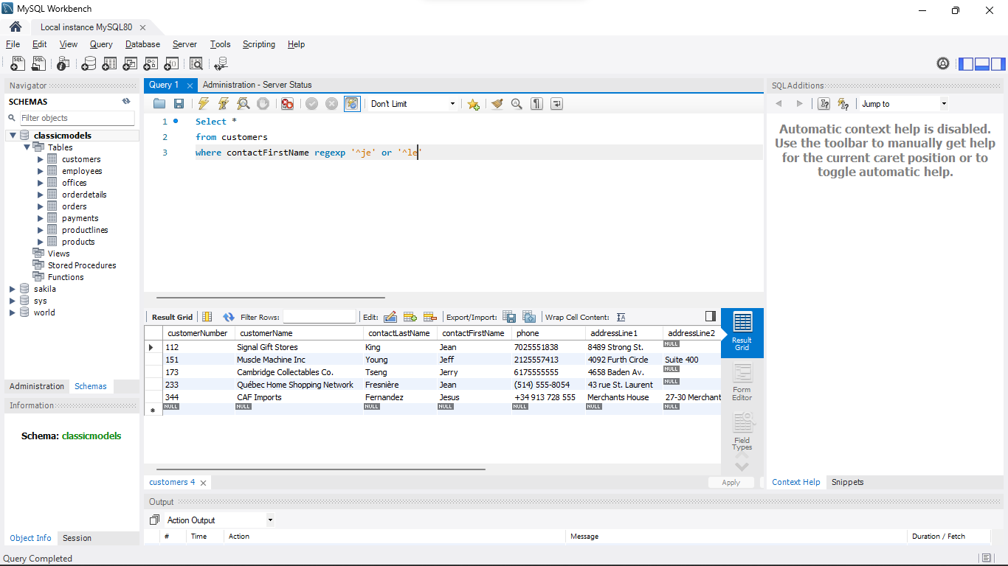

Task 2:

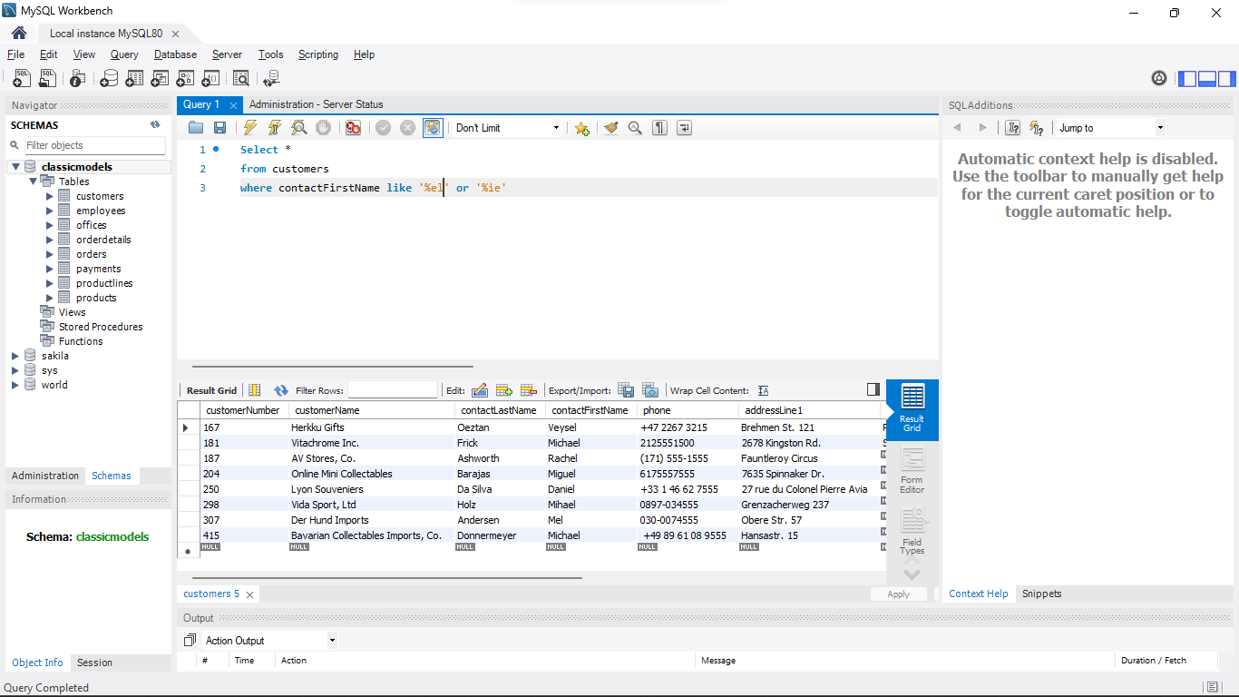

Task 3:

