Cairo University  
Faculty of Computers and Information



**CS251**

**Software Engineering II**

Android Monitoring Theft

Software Design

November 2016

Contents

Instructions [To be removed] 3

Team 3

Document Purpose and Audience 3

System Models 3

I. System Decomposition 3

II. Class diagrams 6

Important Algorithm 7

III. Sequence diagrams 8

Class - Sequence Usage Table 9

IV. Physical Entity-Relationship Diagram 10

V. User Interface Design 10

VI. Bonus: State Diagram and OCL 12

Ownership Report 12

Policy Regarding Plagiarism: 12

References 12

Authors 12

# Team

|  |  |  |  |
| --- | --- | --- | --- |
| **ID** | **Name** | **Email** | **Mobile** |
| 20146001 | Ahmed Samir Shawky |  |  |
|  | Habiba Bahaa |  |  |
|  | Sara Sedky |  |  |
|  | Alaa Sameh |  |  |
|  | Ahmed Mohammed |  |  |
|  | Ahmed Mustafa |  |  |

# 

# Document Purpose and Audience

* **This document is software design specifications.**
* **The expected audience are (software developers, software testers, project owner)**

# System Models

## I. System Decomposition

* **Provide and describe a figure that depicts the overall system decomposition.**

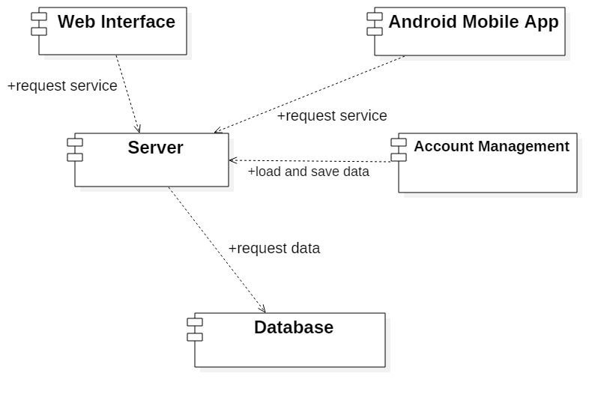

## II. Class diagrams

* **Class diagram provides a description about the internal structure of the system, classes that made the system and the relationships between them**
* **Each class provides some operations that represent the functionality of the system.**

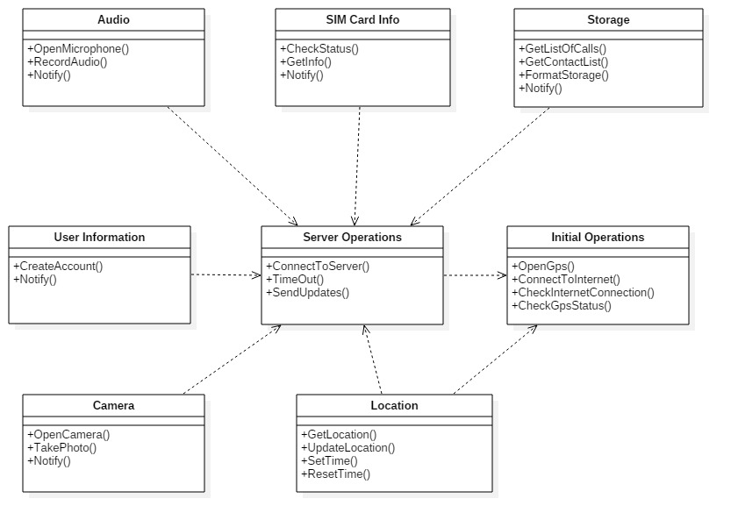

## 

* 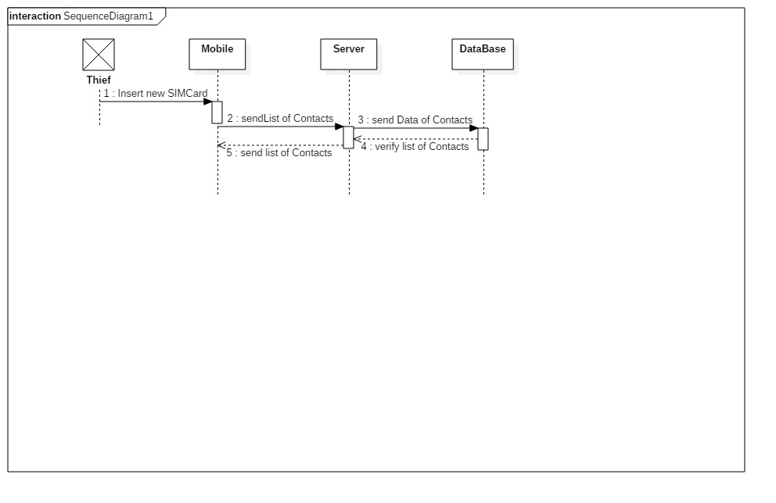 **List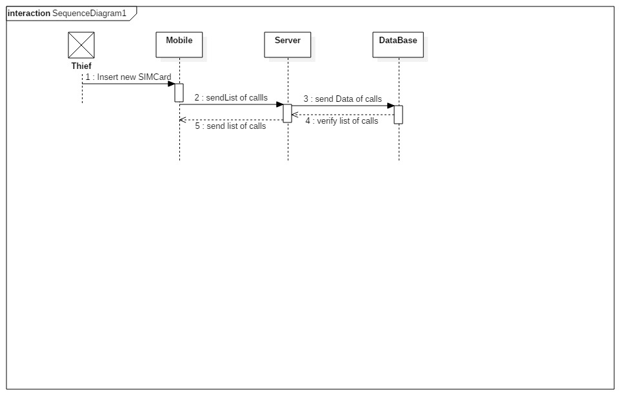 Sequence diagrams for all requirements. Provide for each Sequence an ID.**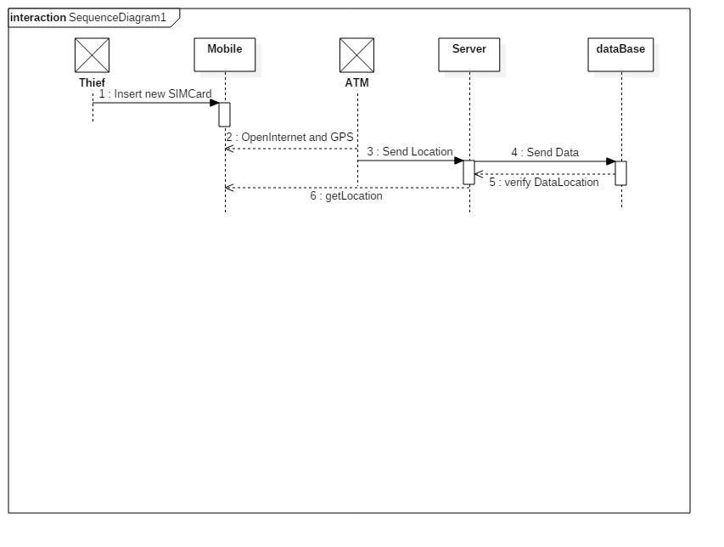
* 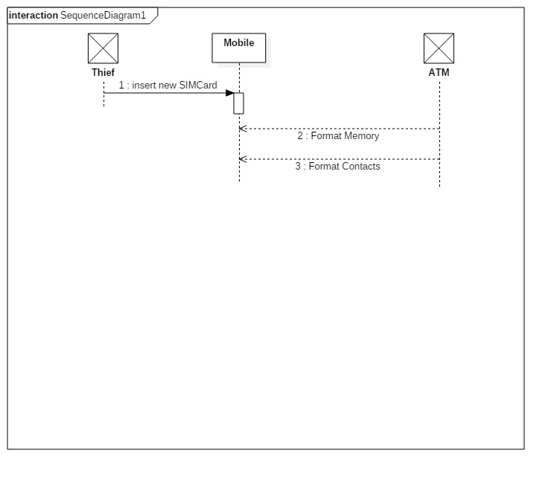
* **Usually each use case is represented by a sequence diagram or more.**
* **Overall, all the diagrams should represent all requirements and possible flows.**
* **Make sure that each object in the sequence diagram has a corresponding class in the class description table above. If not, it will be REJECTED.**
* **Put actual function calls with proper parameters and return types corresponding to class diagrams.**

## V. User Interface Design

* **Use a prototyping tool like** [**https://app.moqups.com**](https://app.moqups.com) **or a GUI builder to build your interface.**
* **Develop a prototype for each screen / page that your application will have and relate them to each other showing which one leads to which one.**
* **For each screen specify the buttons, menus, etc. that will be on it and their functions.**
* **An example is shown below.**
* **Screen 1 – Login Screen (example)**
* **1)Web interface**
* **Sign in :**

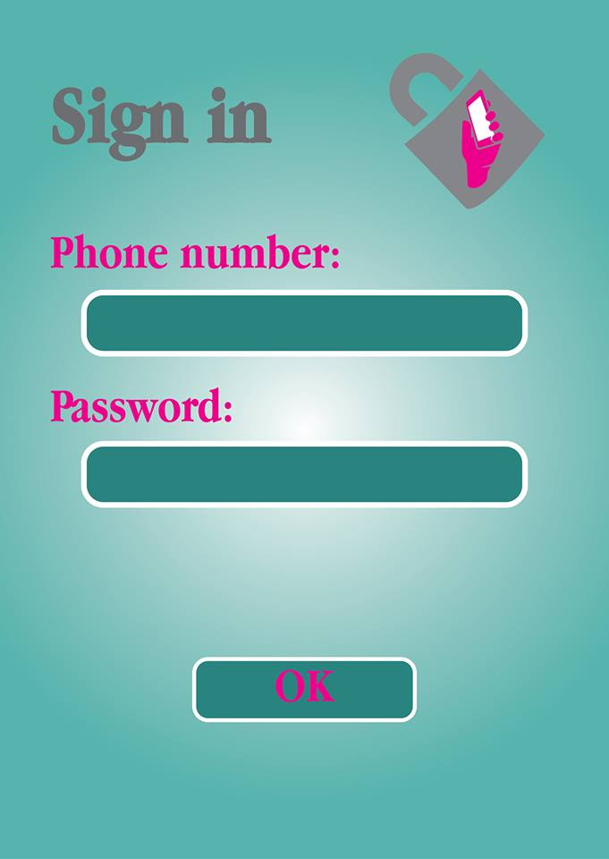

* **Profile account :**

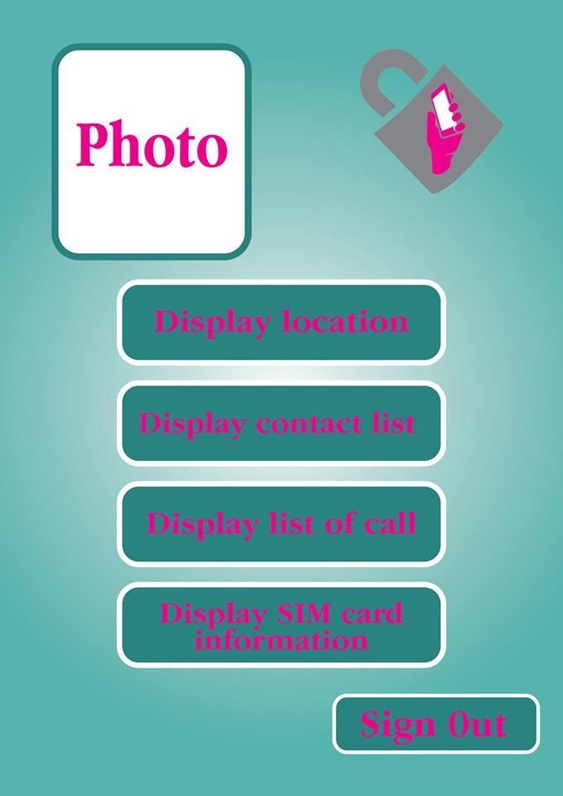

**2)Andorid Interface**

**.Sgin Up**

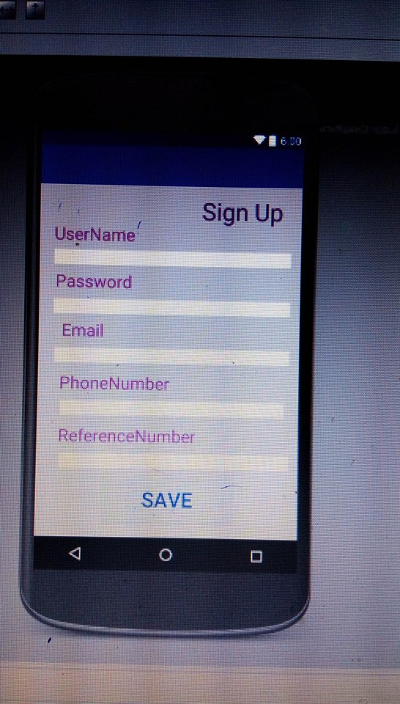

**|**

* **aaaaaaaaaaaaaaaaaaaa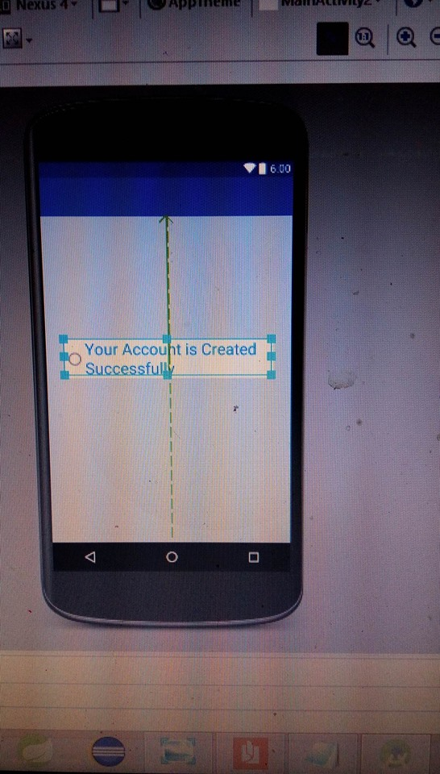aaallllxs**