Dual Active Bridge (DAB) Converter
The DAB is a DC to DC converter. It takes a DC voltage from the battery and gives a different DC voltage at the output. Power can flow in both directions, so it can charge and discharge the battery.

Main parts
- Battery and input capacitor: the DC source on the left. The capacitor smooths the input voltage.
- Primary H-bridge: four IGBTs on the left side. They turn the DC into a square wave (AC).
- Inductor: placed in series with the transformer. It controls how much power is transferred.
- Transformer: gives isolation and steps the voltage up or down by its turns ratio.
- Secondary H-bridge: four IGBTs on the right side. They turn the AC back into DC.
- Output capacitor and resistor: the capacitor smooths the output and the resistor is the load.

How it works
A pulse generator makes signal [A]. A NOT block makes [B], which is the opposite of [A]. These drive the primary bridge, so its two legs switch in opposite states and make a square wave.
Signal [C] is the same as [A] but delayed by a small time (the phase shift, set by the .075 gain block). A NOT block makes [E], the opposite of [C]. These drive the secondary bridge.
Because the two bridges are shifted in time, a voltage difference appears across the inductor and current flows through it. This is how power moves from one side to the other. A bigger phase shift means more power. If the shift is reversed, the power flows the other way. The simulation runs in discrete mode with a 1 µs step.

DAB Input voltage vs output voltage

The table below shows the ideal output for different input voltages, using the design point of 75 V in and 100 V out (transformer ratio about 1 : 1.33 , 10 kHz). And phase about (0.075 x (1/(2pi5000))) The output follows the input times the ratio.

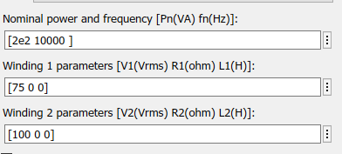
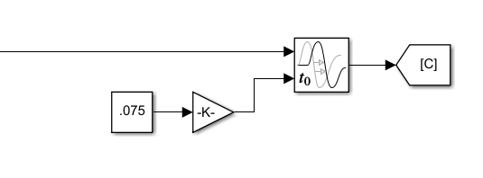

bat voltage (Vdc) | DAB Output voltage (Vdc)
24 | 26.7
48 | 62.2
60 | 83.6
80 | 118.3
100 | 132
120 | 164
150 | 198.6
200 | 271
250 | 332

- due to transformer back charge the battery the battery voltge is higher than what we set

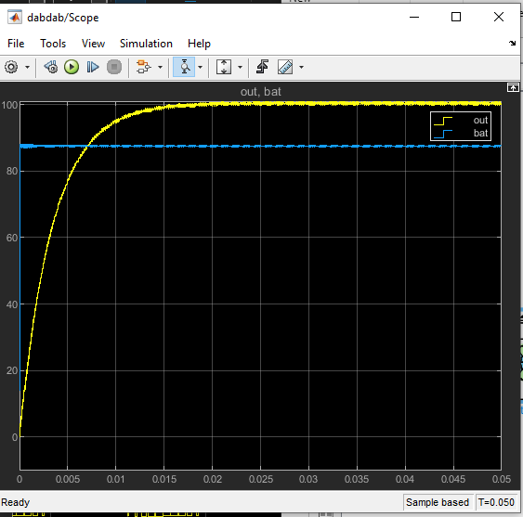

The Inverter
The inverter is a psudo sinusoidal (SPWM) DC to AC converter. It takes DC from the battery and produces an AC voltage across the load.

Main parts
- the DC source. - the dab in full system -
- capacitors: they share the DC voltage and keep the DC bus stable.
- Full H-bridge: four IGBTs, two on the left leg and two on the right leg.
- Resistor: the load.
- Sine generators, triangle (carrier) generators and comparators: they create the switching signals.
- Voltage sensor and scopes: used to look at the output and the gate signals.How it works
This uses sinusoidal PWM (SPWM). A sine wave (the wanted output) is compared with a high-frequency triangle wave. When the sine is higher than the triangle, the comparator output is 1, otherwise 0. This gives signal [A]. A second comparator does the same with the second reference and gives signal [B].
[A] and [B] drive the gates of the IGBTs in the two legs. The bridge switches the battery voltage across the load in positive and negative pulses. The pulse width follows the sine wave, so after filtering the load sees an AC sine-like voltage.
