Online Blood Bank

System App

Phase #1

Team #5

|  |  |  |
| --- | --- | --- |
| Member Name | Member Roll # | Primary Responsibility |
| Khan Bibi | 22F-3330 | Responsible for making Use case diagram, class diagram and allotting/briefing tasks to the members |
| Mahira Fatima | 22F-3385 | Filled 3 use-case description templates i.e(Login, Verify Password, Display Error) and also helped in use case diagram itself |
| Ahmed Subhan | 22F-3336 | Filled 3 use-case description templates i.e(Register, View Donor details, Contact Donor) and played a role in constructing class diagram |
| Tabinda Sandhu | 22L-6889 | Filled 3 use-case description templates i.e(Find compatible donors, Request Specific Blood type, Make Important Announcements) |
| Roail Shahid | 22L-6949 | Filled 3 use-case description templates i.e(Manage Donor Database, Manage blood inventory, Track donation history) |

Contents

1. Use-Case Diagram 1

2. Use-Case Description Templates 2

2.1 LOGIN 2

2.2 VERIFY PASSWORD 3

2.3 DISPLAY ERROR 4

2.4 REGISTER 5

2.5 PROFILE MANAGEMENT 6

2.6 TRACK DONATION HISTORY 7

2.7 FIND COMPATIBLE DONORS 8

2.8 REQUEST SPECIFIC BLOOD TYPE 9

2.9 VIEW CONTACT DETAILS OF DONORS 10

2.10 CONTACT DONOR 11

2.11 MANAGE DONOR DATABASE 12

2.12 MANAGE BLOOD INVENTORY 12

2.13 MAKE IMPORTANT ANNOUNCEMENTS 12

3. Analysis Class Diagram 13

# Use-Case Diagram

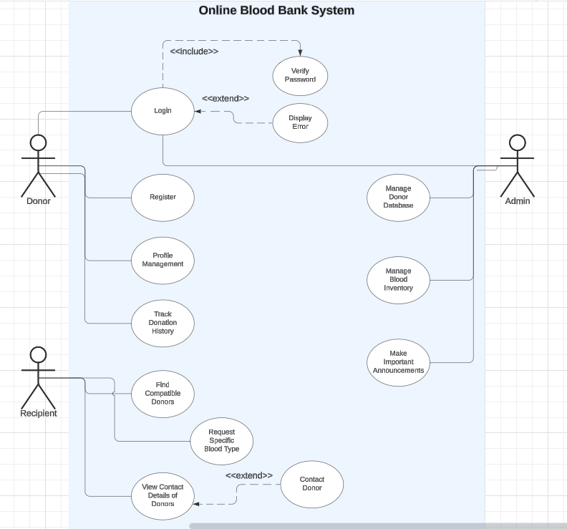

# Use-Case Description Templates

## LOGIN

|  |  |  |  |
| --- | --- | --- | --- |
| **Identifier** | | UC-01 | |
| **Name** | | User Login | |
| **Summary** | | Allows users (Donor, Recipient, Admin) to log into the system by entering their username and password. | |
| **Priority** | | High | |
| **Actors** | | Donor, Recipient, Admin | |
| **Pre-condition(s)** | | User must be registered and not already logged in. | |
| **Post-condition(s)** | | User is logged into the system if the correct username and password are provided. | |
| **Typical Course of Action** | | | |
| **S#** | **Actor Action** | | **System Response** |
| **1** | User selects the login option. | |  |
| **2** |  | | System displays login form. |
| **3** | User enters username and password. | |  |
| **4** |  | | System verifies the credentials. |
| **Alternate Course of Action** | | | |
| **S#** | **Actor Action** | | **System Response** |
| **5** | If verification fails, the system displays an error message. | |  |
| **6** |  | | User re-enters login credentials or chooses to recover the password. |

## VERIFY PASSWORD

|  |  |  |  |
| --- | --- | --- | --- |
| **Identifier** | | UC-02 | |
| **Name** | | Verify Password | |
| **Summary** | | Validates the user-entered password against the stored password in the system's database. | |
| **Priority** | | High | |
| **Actors** | | System | |
| **Pre-condition(s)** | | User has entered a username and password. | |
| **Post-condition(s)** | | User is either allowed to log in or an error message is displayed. | |
| **Typical Course of Action** | | | |
| **S#** | **Actor Action** | | **System Response** |
| **1** |  | | System retrieves the hashed password for the provided username from the database. |
| **2** |  | | System compares the entered password against the retrieved hashed password. |
| **3** |  | | If the passwords match, the system proceeds with login. |
| **Alternate Course of Action** | | | |
| **S#** | **Actor Action** | | **System Response** |
| **4** |  | | If the passwords do not match, the system triggers an error message. |
|  |  | |  |

## DISPLAY ERROR

|  |  |  |  |
| --- | --- | --- | --- |
| **Identifier** | | UC-03 | |
| **Name** | | Display Error Message | |
| **Summary** | | Displays an error message when login fails due to incorrect credentials or other login errors. | |
| **Priority** | | Medium | |
| **Actors** | | System | |
| **Pre-condition(s)** | | An error condition occurs during the login process. | |
| **Post-condition(s)** | | Error message is displayed to the user. | |
| **Typical Course of Action** | | | |
| **S#** | **Actor Action** | | **System Response** |
| **1** |  | | System determines an error condition has occurred (incorrect credentials, missing information, etc.) |
| **2** |  | | System displays an appropriate error message to the user advising them of the issue. |
| **Alternate Course of Action** | | | |
| **S#** | **Actor Action** | | **System Response** |
| **3** |  | | User may attempt to re-enter credentials or use the password recovery feature. |
| **4** | User tries to login again. | |  |

## REGISTER

|  |  |  |  |
| --- | --- | --- | --- |
| **Identifier** | | UC-04 | |
| **Name** | | Register | |
| **Summary** | | Register the new donor | |
| **Priority** | | High | |
| **Actors** | | Donor | |
| **Pre-condition(s)** | | Donor does not have an account | |
| **Post-condition(s)** | | The user is successfully registered in the system and can log in | |
| **Typical Course of Action** | | | |
| **S#** | **Actor Action** | | **System Response** |
| **1** |  | | Display the registration page |
| **2** | Donor enters the details required | |  |
| **3** | Presses the create Account button | |  |
| **4** |  | | Verifies the details provided |
| **5** |  | | Registers the donor |
| **6Alternate Course of Action** | | | |
| **S#** | **Actor Action** | | **System Response** |
| **6** | User provides incomplete or invalid information | |  |
| **7** |  | | System displays an error message and requests corrections |
| **8** |  | | Ask the user to re-enter the details |
| **9** | Enter details | |  |
|  |  | |  |

## PROFILE MANAGEMENT

|  |  |  |  |
| --- | --- | --- | --- |
| **Identifier** | | UC-05 | |
| **Name** | | Profile Management | |
| **Summary** | | This use case allows the donor to update and manage their personal information and preferences. | |
| **Priority** | | Medium | |
| **Actors** | | Donor | |
| **Pre-condition(s)** | | The donor must be logged in. | |
| **Post-condition(s)** | | The donor’s profile is updated with the new information. | |
| **Typical Course of Action** | | | |
| **S#** | **Actor Action** | | **System Response** |
| **1.** | Donor selects "Profile Management" | | System retrieves and displays the donor's current profile. |
| **2.** | Donor updates profile details | | |  | | --- | |  |  |  | | --- | | System saves the updated information and confirms the changes. | |
| **Alternate Course of Action** | | | |
| **S#** | **Actor Action** | | **System Response** |
| **1.** | Donor enters invalid information | | System prompts an error message asking for correct details. |

## TRACK DONATION HISTORY

|  |  |  |  |
| --- | --- | --- | --- |
| **Identifier** | | UC-06 | |
| **Name** | | Track Donation History | |
| **Summary** | | This use case allows donors to track their previous blood donations. | |
| **Priority** | | Medium | |
| **Actors** | | Donor | |
| **Pre-condition(s)** | | The donor must be logged into the system and have previously donated blood. | |
| **Post-condition(s)** | | The donor can view a list of their past donations, including the date and type of blood donated. | |
| **Typical Course of Action** | | | |
| **S#** | **Actor Action** | | **System Response** |
| **1.** | Donor selects "Track Donation History" option | | System retrieves the donation history for the donor. |
| **2.** | Donor views donation history | | System displays donation details (date, blood type, etc.). |
| **Alternate Course of Action** | | | |
| **S#** | **Actor Action** | | **System Response** |
| **1.** | Donor has no prior donations | | System displays a message stating "No donation history found.” |

## FIND COMPATIBLE DONORS

|  |  |  |  |
| --- | --- | --- | --- |
| **Identifier** | | UC-07 | |
| **Name** | | Find Compatible Donors | |
| **Summary** | | The system will allow users to search for donors with a specific blood type, sorted by nearest address. | |
| **Priority** | | High | |
| **Actors** | | Patient, Doctor, Admin | |
| **Pre-condition(s)** | | 1. The system contains registered donors with different blood types. 2. The donor's location information is up to date. | |
| **Post-condition(s)** | | A list of compatible donors is displayed, sorted by proximity. | |
| **Typical Course of Action** | | | |
| **S#** | **Actor Action** | | **System Response** |
| **1** | Patient/Doctor requests a blood type. | | System searches the database for donors with the specified type. |
|  |  | |  |
| **2** | Patient/Doctor requests location-based sorting. | | System sorts the donors based on the nearest address. |
|  |  | |  |
| **3** | Patient/Doctor selects a donor. | | System provides the contact details of the selected donor. |
| **Alternate Course of Action** | | | |
| **S#** | **Actor Action** | | **System Response** |
| **1** | No compatible donors are found in the specified area. | | System shows a message that no compatible donors are available. |

## REQUEST SPECIFIC BLOOD TYPE

|  |  |  |  |
| --- | --- | --- | --- |
| **Identifier** | | UC-08 | |
| **Name** | | Specific Blood Type | |
| **Summary** | | If no compatible donor is found for a specific blood type, the user can place a special request to notify potential donors. | |
| **Priority** | | Medium | |
| **Actors** | | Patient, Doctor, Admin | |
| **Pre-condition(s)** | | There is no available donor for the required blood type in the system already. | |
| **Post-condition(s)** | | A special request is placed, and notifications are sent to potential donors. | |
| **Typical Course of Action** | | | |
| **S#** | **Actor Action** | | **System Response** |
| **1** | Patient/Doctor selects the option to request blood. | | System provides a form to enter the blood type and other details. |
|  |  | |  |
| **2** | Patient/Doctor submits the special request. | | System records the request and sends notifications to potential donors. |
| **Alternate Course of Action** | | | |
| **S#** | **Actor Action** | | **System Response** |
| **1** | Donor already becomes available after request | | System updates the status and notifies the requester of a match. |

## VIEW CONTACT DETAILS OF DONORS

|  |  |  |  |
| --- | --- | --- | --- |
| **Identifier** | | UC-09 | |
| **Name** | | View contact details of all donors | |
| **Summary** | | This use case allows the Recipient to view the contact details of donors who are compatible with the required blood type. | |
| **Priority** | | Medium | |
| **Actors** | | Recipient | |
| **Pre-condition(s)** | | * The Recipient must be logged in. * The Recipient has searched for and identified compatible donors. | |
| **Post-condition(s)** | | The Recipient views the contact details of a compatible donor. | |
| **Typical Course of Action** | | | |
| **S#** | **Actor Action** | | **System Response** |
| **1** | Recipient selects "View Contact Details of Donors" | |  |
| **2** |  | | System displays a list of compatible donors |
| **3** | Recipient selects a specific donor from the list | |  |
| **4** |  | | System shows the contact details of the selected donor |
| **5** | Recipient reviews the contact information | |  |
| **6** |  | | System allows the Recipient to view the donor's details |
| **Alternate Course of Action** | | | |
| **S#** | **Actor Action** | | **System Response** |
| **7** | Recipient cancels the operation | |  |
| **8** |  | | System closes the donor detail view |
| **9** | No compatible donors are available | |  |
| **10** |  | | System displays a message indicating no matches found |

## CONTACT DONOR

|  |  |  |  |
| --- | --- | --- | --- |
| **Identifier** | | UC-10 | |
| **Name** | | Contact donor | |
| **Summary** | | This use case allows the Recipient to contact a compatible donor directly after viewing their contact details. | |
| **Priority** | | Medium | |
| **Actors** | | Recipient | |
| **Pre-condition(s)** | | * The Recipient must be logged in. * The Recipient has viewed the contact details of a compatible donor. | |
| **Post-condition(s)** | | The Recipient contacts the donor via the provided contact details. | |
| **Typical Course of Action** | | | |
| **S#** | **Actor Action** | | **System Response** |
| **1** | Recipient selects "Contact Donor" option | |  |
| **2** |  | | System displays available contact methods (e.g., email, phone) |
| **3** | Recipient initiates contact (e.g., sends an email or makes a call) | |  |
| **4** |  | | System confirms the contact has been initiated or records the message |
| **5** | Recipient completes the communication | |  |
| **6** |  | | System updates the contact history |
| **7** |  | |  |
| **Alternate Course of Action** | | | |
| **S#** | **Actor Action** | | **System Response** |
| **8** | Recipient cancels the operation | |  |
| **9** |  | | System discards any unsent messages |
| **10** | Contact method is unavailable | |  |
| **11** |  | | System displays an error or fallback option |

## MANAGE DONOR DATABASE

|  |  |  |  |
| --- | --- | --- | --- |
| **Identifier** | | UC-11 | |
| **Name** | | Manage Donor Database | |
| **Summary** | | This use case allows the Admin to manage the donor database by adding, updating, or deleting donor information as necessary. | |
| **Priority** | | High | |
| **Actors** | | Admin | |
| **Pre-condition(s)** | | * The Admin must be logged in. * The system must be connected to the database. | |
| **Post-condition(s)** | | The donor information is updated in the system. | |
| **Typical Course of Action** | | | |
| **S#** | **Actor Action** | | **System Response** |
| **1** | Admin selects the "Manage Donor Database" option | |  |
| **2** |  | | System displays a list of current donors |
| **3** | Admin chooses to add, update, or delete a donor | |  |
| **4** |  | | System allows the Admin to perform the action |
| **5** | Admin saves the changes | |  |
| **6** |  | | System updates the donor database accordingly |
| **Alternate Course of Action** | | | |
| **S#** | **Actor Action** | | **System Response** |
| **7** | Admin cancels the operation | |  |
| **8** |  | | System discards any unsaved changes. |
| **9** | Database is unavailable | |  |
| **10** |  | | System displays an error message |

## MANAGE BLOOD INVENTORY

|  |  |  |  |
| --- | --- | --- | --- |
| **Identifier** | | UC-12 | |
| **Name** | | Manage Blood Inventory | |
| **Summary** | | This use case allows the Admin to manage the blood inventory by adding, updating, or removing blood stock details. | |
| **Priority** | | High | |
| **Actors** | | Admin | |
| **Pre-condition(s)** | | * The Admin must be logged in. * The system must be connected to the blood inventory database. | |
| **Post-condition(s)** | | The blood inventory is updated in the system. | |
| **Typical Course of Action** | | | |
| **S#** | **Actor Action** | | **System Response** |
| **1** | Admin selects the "Manage Blood Inventory" option | |  |
| **2** |  | | System displays the current blood stock levels |
| **3** | Admin adds, updates, or removes blood stock | |  |
| **4** |  | | System allows the Admin to perform the action |
| **5** | Admin saves the changes | |  |
| **6** |  | | System updates the blood inventory accordingly |
|  |  | |  |
|  |  | |  |
| **Alternate Course of Action** | | | |
| **S#** | **Actor Action** | | **System Response** |
| **7** | Admin cancels the operation | |  |
| **8** |  | | System discards any unsaved changes. |
| **9** | Database is unavailable | |  |
| **10** |  | | System displays an error message |

## MAKE IMPORTANT ANNOUNCEMENTS

|  |  |  |  |
| --- | --- | --- | --- |
| **Identifier** | | UC-13 | |
| **Name** | | Make Important Announcements | |
| **Summary** | | The admin can post important announcements, such as upcoming blood drives or emergency needs. | |
| **Priority** | | Medium | |
| **Actors** | | Admin | |
| **Pre-condition(s)** | | Admin is logged into the system. | |
| **Post-condition(s)** | | Announcement is posted and visible to all users. | |
| **Typical Course of Action** | | | |
| **S#** | **Actor Action** | | **System Response** |
| **1** | Admin selects the option to make an announcement. | | System provides a form to enter the announcement details. |
|  |  | |  |
| **2** | Admin submits the announcement. | | System displays the announcement to all users and sends notifications. |
| **Alternate Course of Action** | | | |
| **S#** | Actor Action | | System Response |
| **1** | NULL | |  |

# Analysis Class Diagram

