**Online Blood Bank**

**System App**

**Phase #2**

**Team #5**

|  |  |  |
| --- | --- | --- |
| **Member Name** | **Member Roll #** | **Primary Responsibility** |
| **Khan Bibi** | **22F-3330** | Responsible for making ER diagram and activity, sequence, and state diagrams of 1 use case (profile Management), and allotting tasks |
| **Mahira Fatima** | **22F-3385** | Responsible for making all diagrams of 3 use-cases (Login, Verify Password, Display Error) |
| **Ahmed Subhan** | **22F-3336** | Responsible for making all diagrams of 3 use-cases (Register, View Donor details, Contact Donor) |
| **Tabinda Sandhu** | **22L-6889** | Responsible for making all diagrams of 3 use-cases (Find compatible donors, Request SpecificBlood type, MakeImportant Announcements) |
| **Roail Shahid** | **22L-6949** | Responsible for making all diagrams of 3 use-cases (Manage Donor Database, Manage blood inventory, Track donation history) |

Table of Contents

1. ER Diagram 6

2. Sequence Diagram 7

• Profile Management 7

• Login 7

• Verify Password 9

• Display Error 10

• Register 11

• Find Compatible Donor 12

• Request Specific Blood type 13

• View Contact Details of Donors 14

• Contact Donor 15

• Make Important Announcements 16

• Track Donation History 17

• Manage Donor Database 18

• Manage Blood Inventory 19

3. Activity Diagram 19

• Profile Management 19

• Login 21

• Verify Password 22

• Display Error 23

• Register 24

• Find Compatible Donor 25

• Request Specific Blood type 26

• View Contact Details of Donors 27

• Contact Donor 28

• Make Important Announcements 29

• Track Donation History 30

• Manage Donor Database 31

• Manage Blood Inventory 31

4. State Diagram 32

• Profile Management 33

▪ View Profile 33

▪ Edit Profile 34

▪ Delete Profile 35

• Login/verify Password/Display error 36

• Register 37

• Find Compatible Donor 38

• Request Specific Blood type 39

• View Contact Details of Donors 40

• Contact Donor 40

• Make Important Announcements 41

# **ER Diagram**

# **Sequence Diagram**

## Profile Management

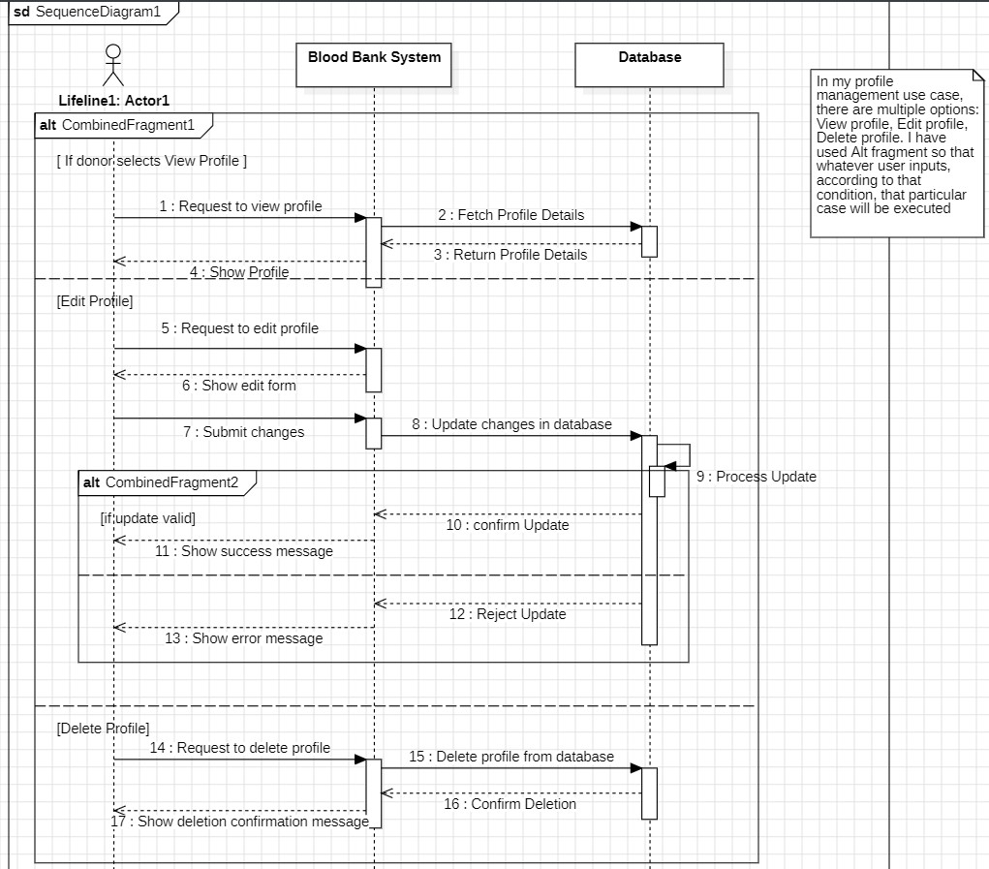

## Login

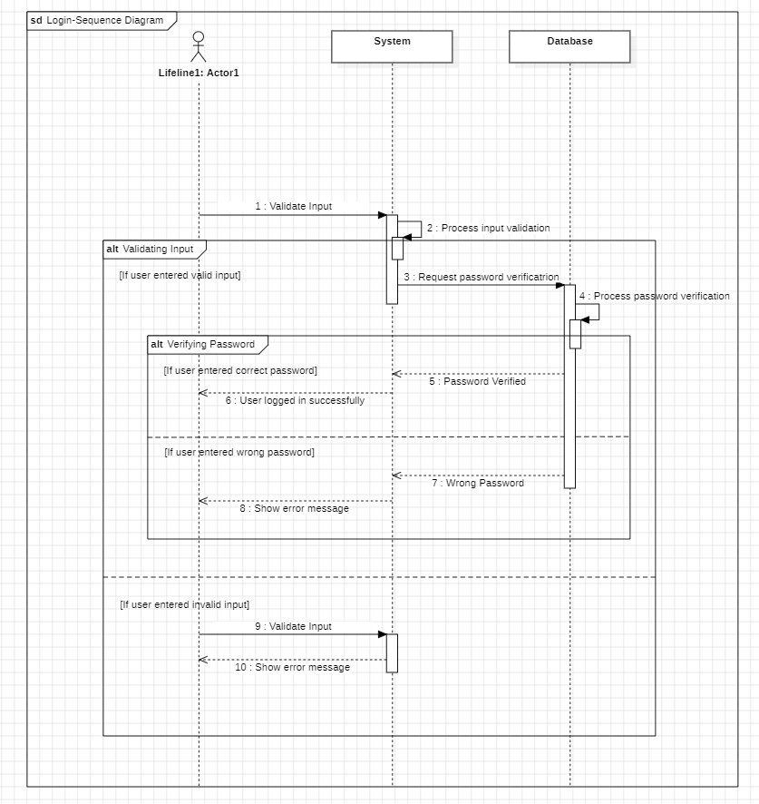

## Verify Password

## Display Error

## Register

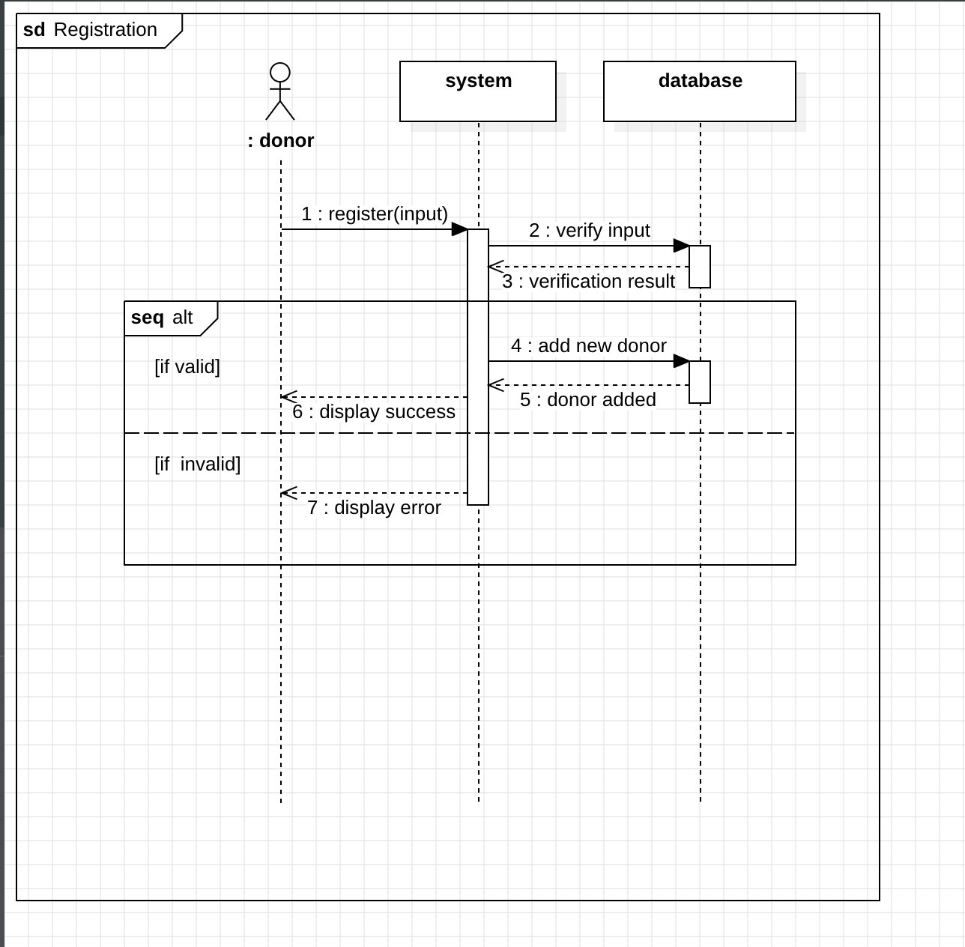

## Find Compatible Donor

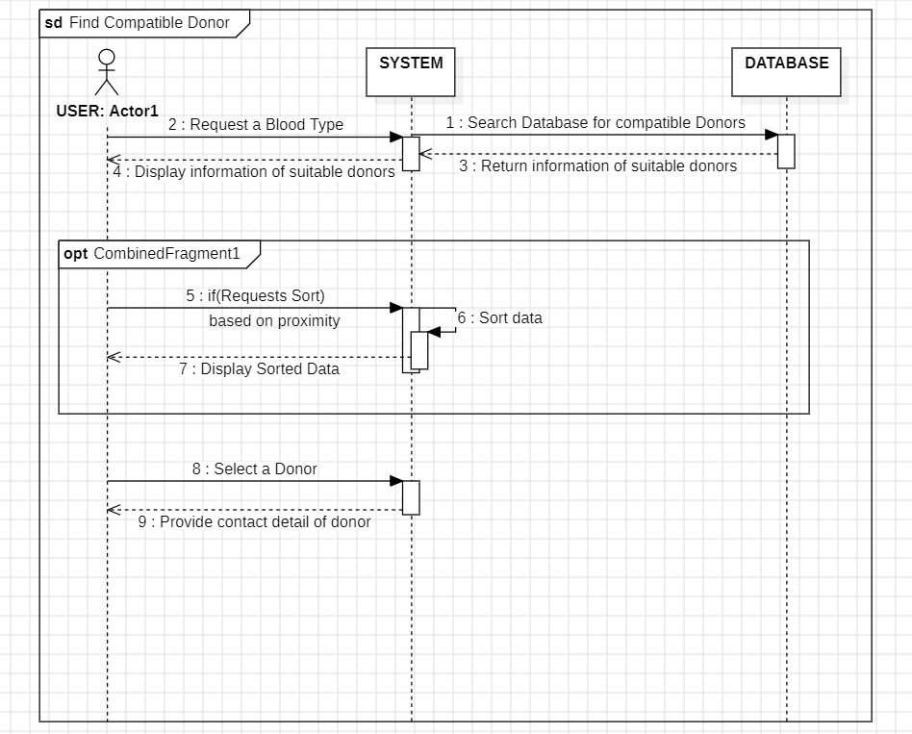

## Request Specific Blood type

## View Contact Details of Donors

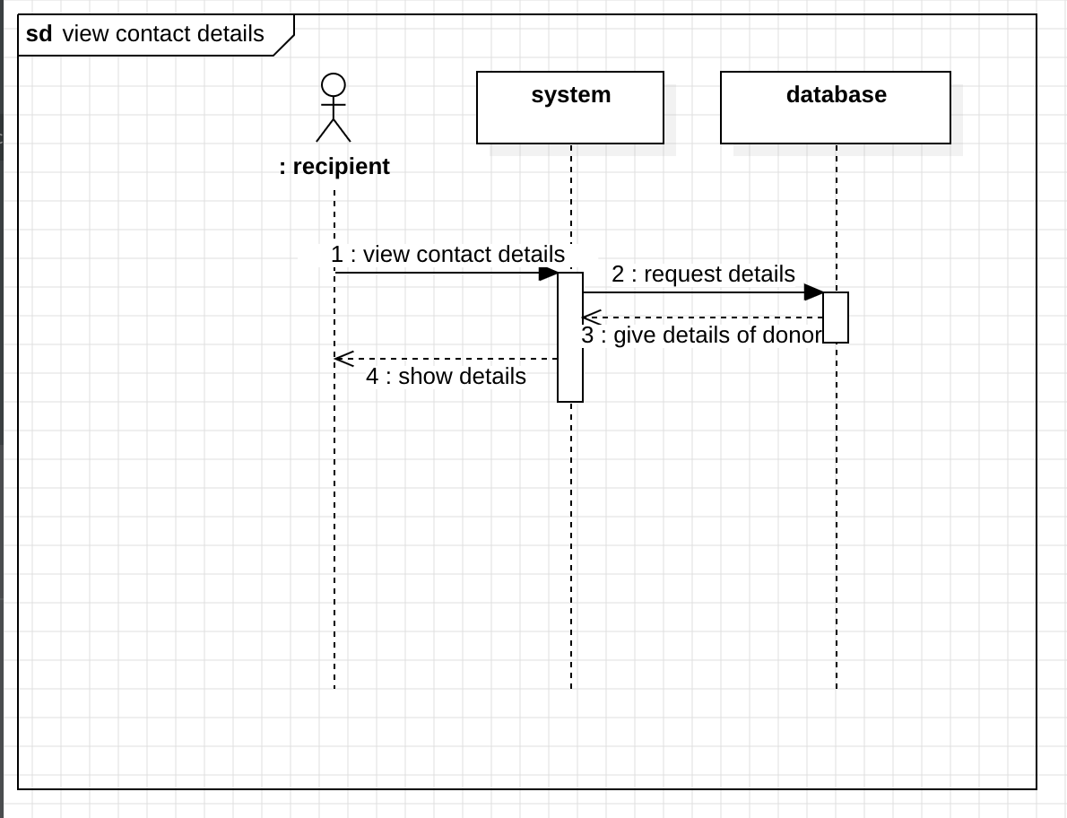

## Contact Donor

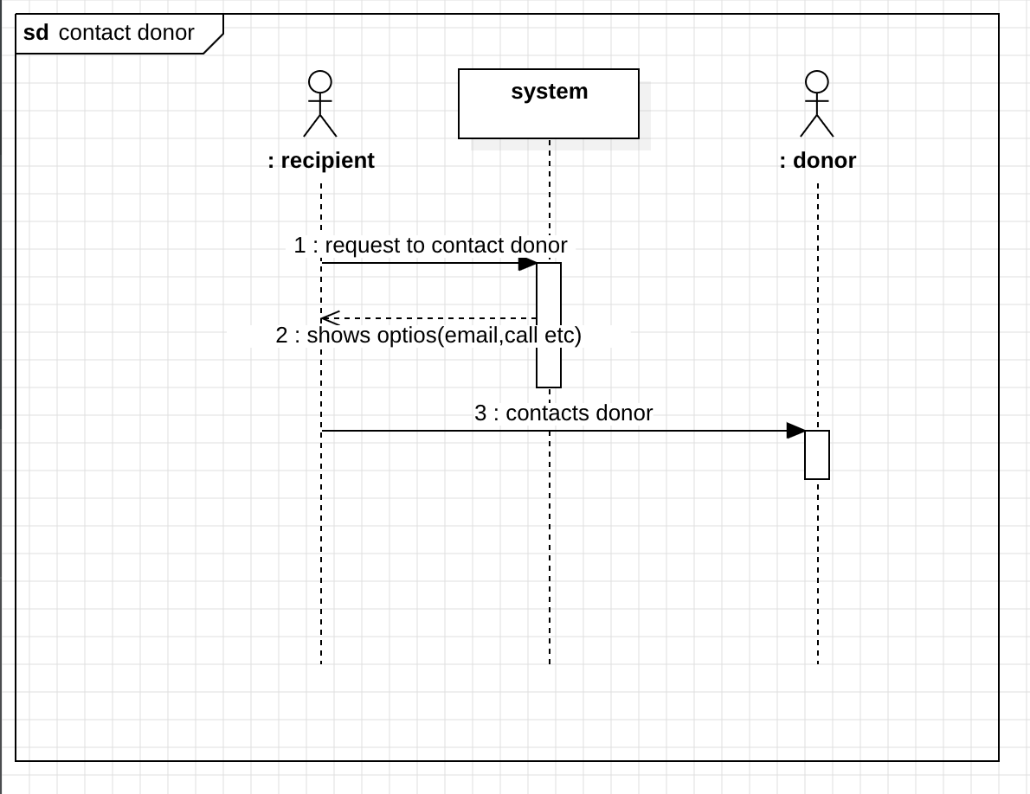

## Make Important Announcements

### Track Donation History

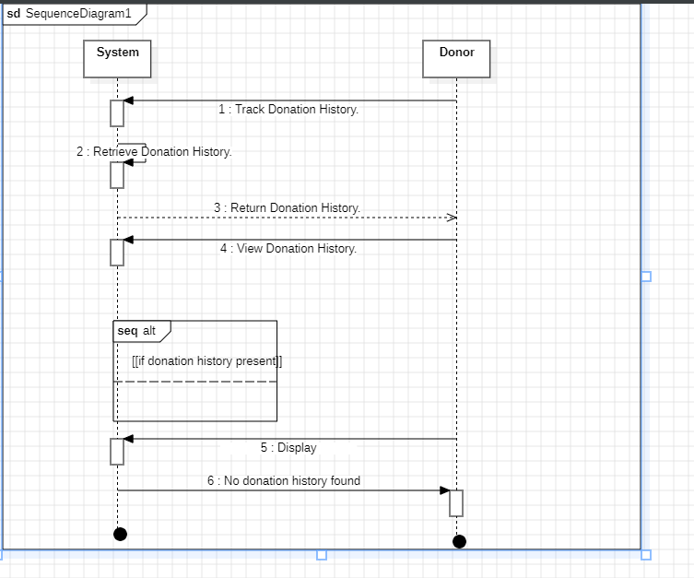

### Manage Donor Database

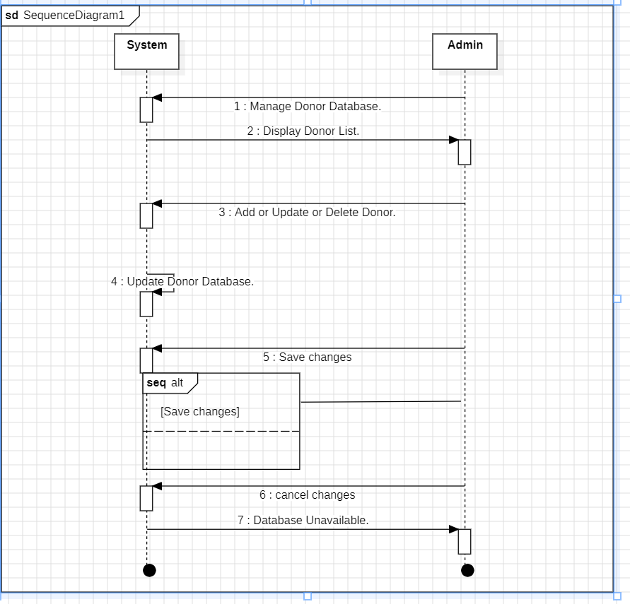

### Manage Blood Inventory

# **Activity Diagram**

## Profile Management

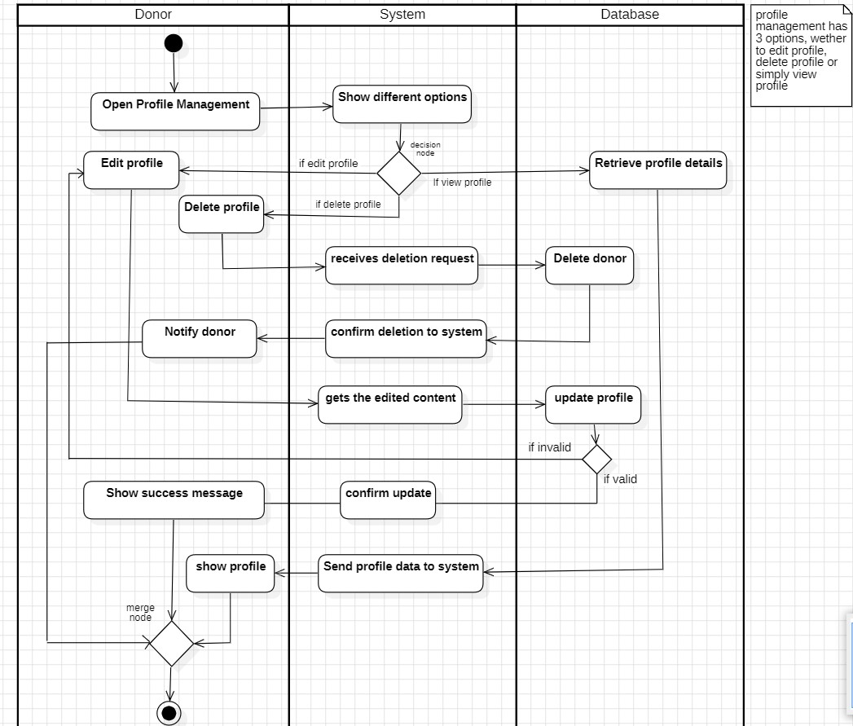

## Login

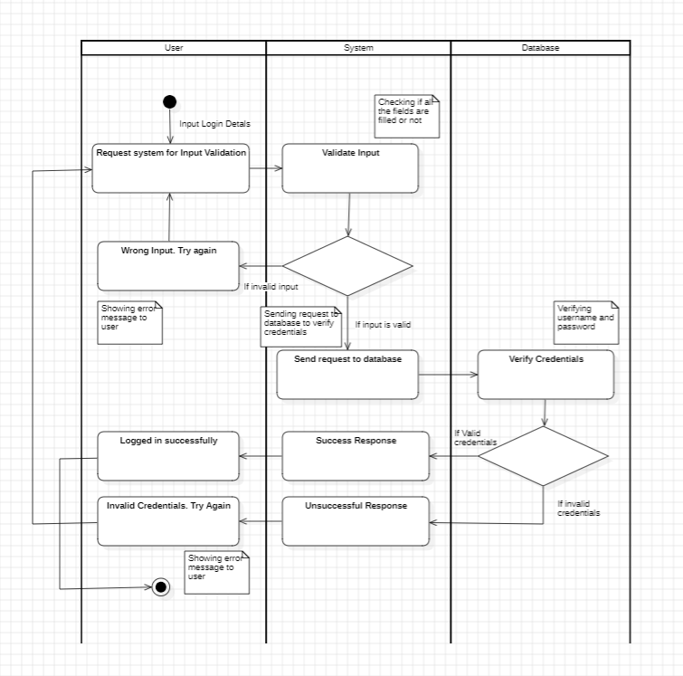

## Verify Password

## Display Error

## Register

## Find Compatible Donor

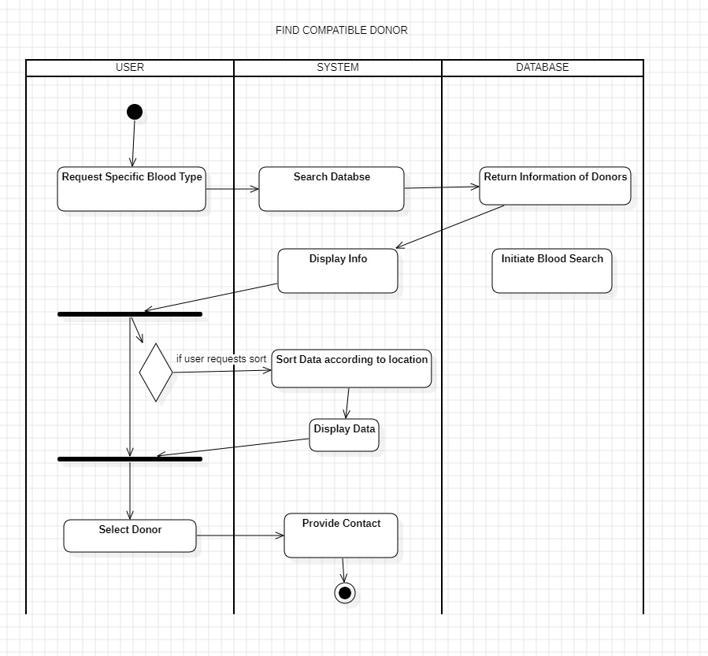

## Request Specific Blood type

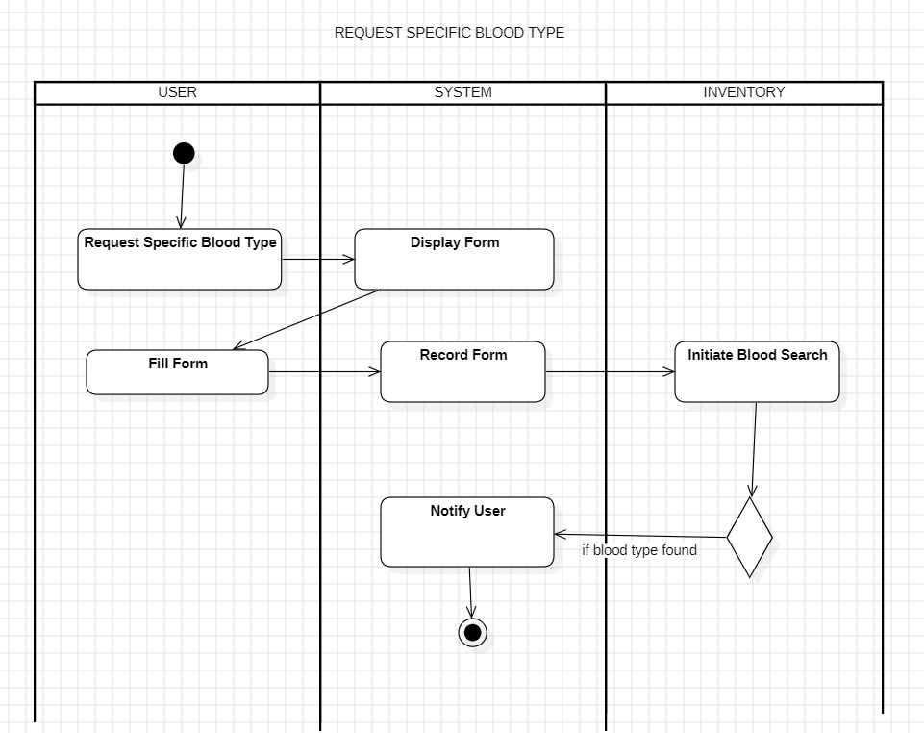

## View Contact Details of Donors

## Contact Donor

## Make Important Announcements

### Track Donation History

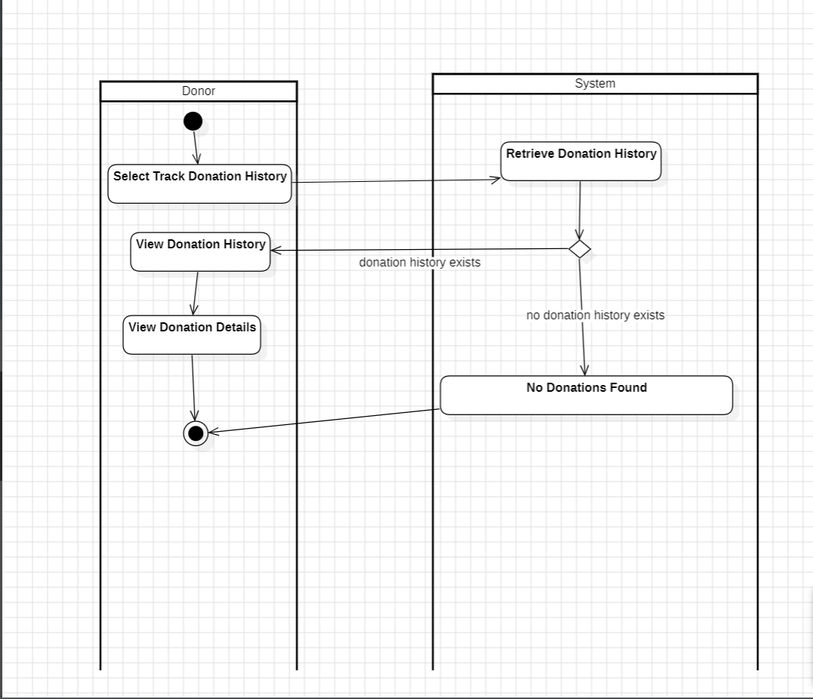

### Manage Donor Database

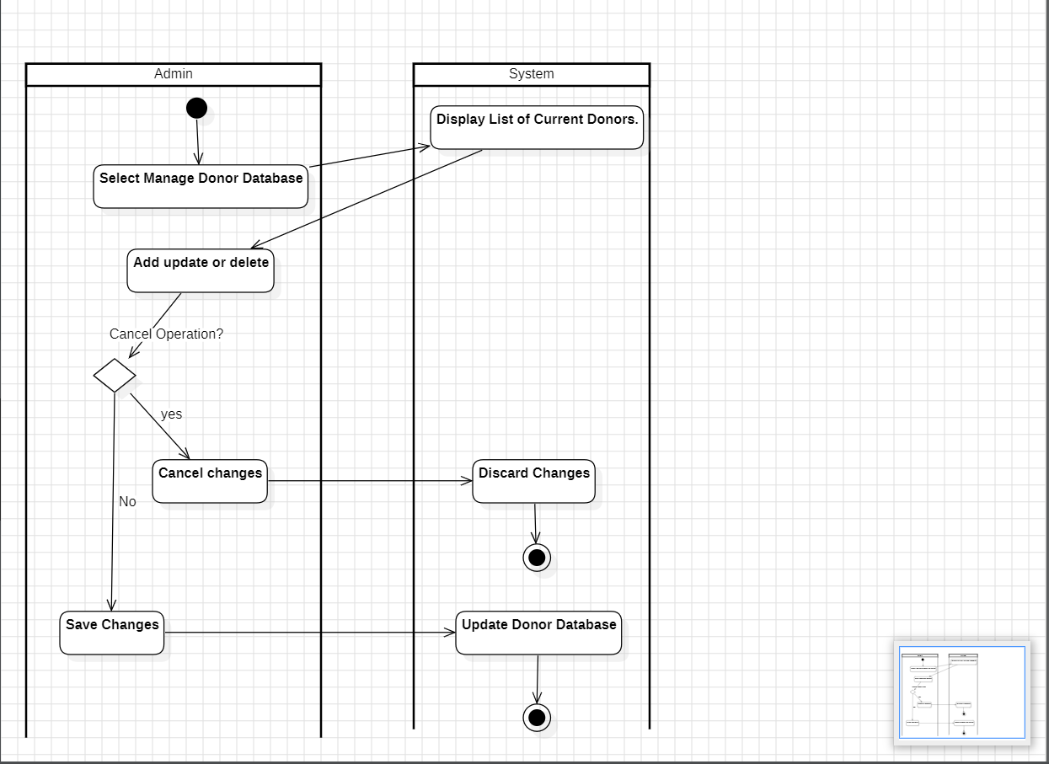

### Manage Blood Inventory

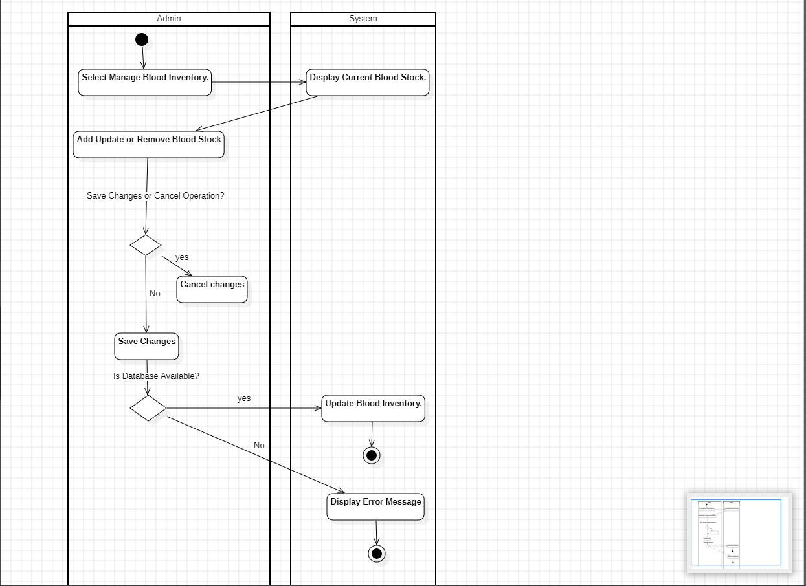

# **State Diagram**

## Profile Management

### View Profile

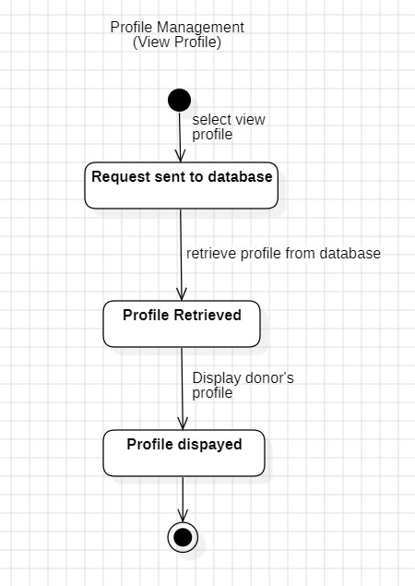

### Edit Profile

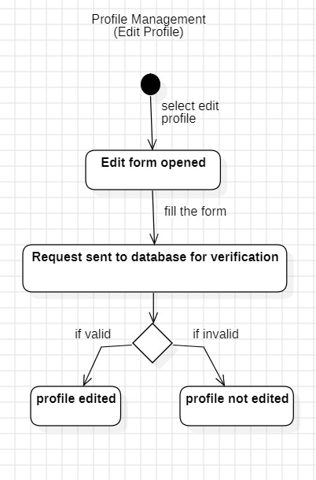

### Delete Profile

## Login/verify Password/Display error

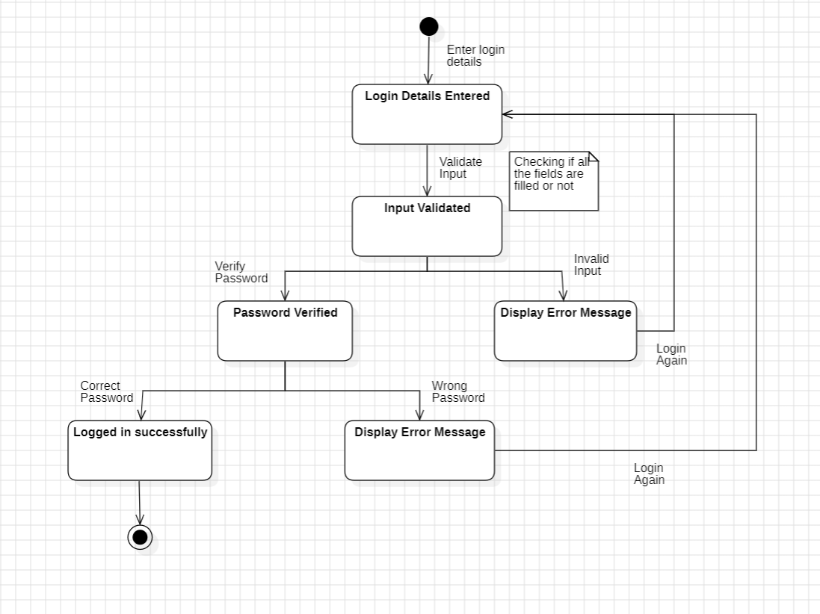

## Register

## Find Compatible Donor

## Request Specific Blood type

## View Contact Details of Donors

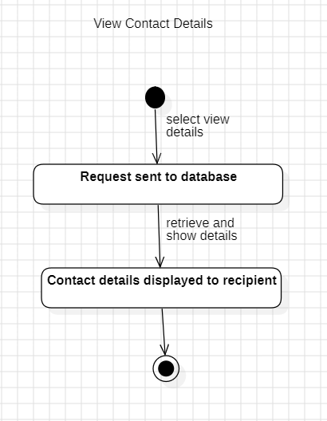

## Contact Donor

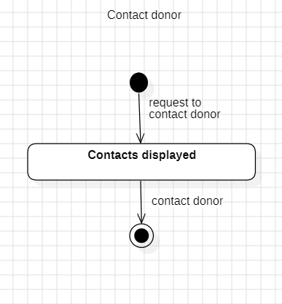

## Make Important Announcements

