Titanic Ship dataset: Survival prediction

Project Phase 3

Logistic regression using “glm() “:

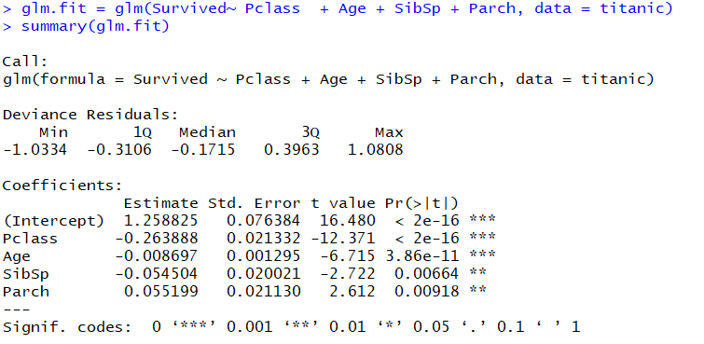

From the above summary it can be inferred that “Pclass” which is the class in which passenger is traveling and his “Age” are significant for predicting his survival. “SibSp” and “Parch” which represent the family size of the passenger on board are not that significant.

**TEST DATA**

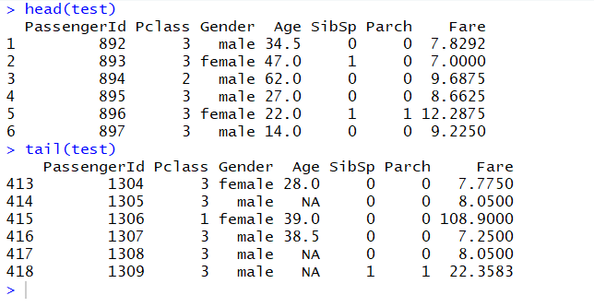

**Predicting the Survival with test data:**

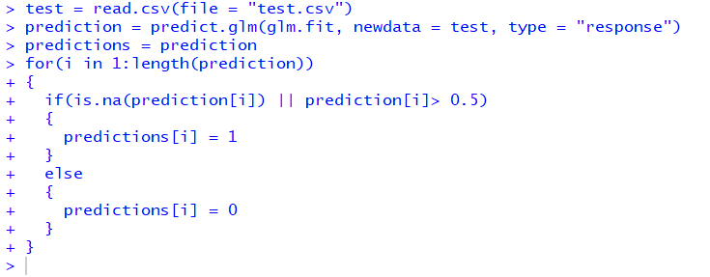

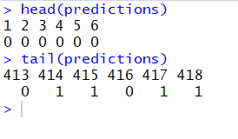

**Interaction term**

