

Microsoft Excel: Advanced   
Participant Guide



**Table of Contents**

**Text to Columns .............................................................................................. 4 Concatenate ........................................................................................................ 5**

The Concatenate Function .................................................................................................................................................................. 5 The Right Function with Concatenation .......................................................................................................................................... 5 **Absolute Cell References .................................................................................................................. 6 Data Validation ................................................................................................................................... 7 Time and Date Calculations .............................................................................................................. 9 Conditional Formatting .................................................................................................................... 10** Exploring Styles and Clearing Formatting ..................................................................................................................................... 10 Using Conditional Formatting to Hide Cells ................................................................................................................................... 11 **The IF Function ................................................................................................................................. 12** Changing the “Value if false” Condition to Text .......................................................................................................................... 12 **3D Formulas ...................................................................................................................................... 13 Pivot Tables ....................................................................................................................................... 14** Creating a Pivot Table ......................................................................................................................................................................... 14 **Specifying PivotTable Data ............................................................................................................. 15** Changing a PivotTables Calculation................................................................................................................................................ 16 Filtering and Sorting a PivotTable .................................................................................................................................................... 17 Creating a PivotChart........................................................................................................................................................................... 18 Grouping Items ...................................................................................................................................................................................... 19 Updating a PivotTable ......................................................................................................................................................................... 21 Formatting a PivotTable ...................................................................................................................................................................... 21 Using Slicers .......................................................................................................................................................................................... 22 **Charts ................................................................................................................................................. 24** Creating a Simple Chart ..................................................................................................................................................................... 24 Chart Terminology ............................................................................................................................................................................... 24 Charting Non-Adjacent Cells ............................................................................................................................................................ 24 Creating a Chart Using the Chart Wizard ...................................................................................................................................... 25 **Modifying Charts .............................................................................................................................. 26**

**OTS Publication: ex1602 • 08/02/19• training@towson.edu**   
© 2019 Towson University. This work is licensed under the   
Creative Commons Attribution-NonCommercial-NoDerivs License.

Details available at http://www.towson.edu/OTStraining



Moving an Embedded Chart ............................................................................................................................................................. 26 Sizing an Embedded Chart ............................................................................................................................................................... 26 Changing the Chart Type .................................................................................................................................................................. 26 Chart Types ........................................................................................................................................................................................... 27 Changing the Way Data is Displayed ............................................................................................................................................. 27 Moving the Legend ............................................................................................................................................................................. 27 **Formatting Charts ............................................................................................................................. 28** Adding Chart Items.............................................................................................................................................................................. 28 Formatting All Text .............................................................................................................................................................................. 29 Formatting and Aligning Numbers .................................................................................................................................................. 29 Formatting the Plot Area .................................................................................................................................................................... 30 Formatting Data Markers ................................................................................................................................................................... 32 **Pie Charts .......................................................................................................................................... 33** Creating a Pie Chart ............................................................................................................................................................................ 33 Moving the Pie Chart to its Own Sheet ......................................................................................................................................... 33 Adding Data Labels ............................................................................................................................................................................. 34 Exploding a Slice of a Pie Chart ....................................................................................................................................................... 35 Rotating and Changing the Elevation of a Pie Chart ................................................................................................................. 35

**OTS Publication: ex1602 • 08/02/19• training@towson.edu**   
© 2019 Towson University. This work is licensed under the   
Creative Commons Attribution-NonCommercial-NoDerivs License.

Details available at http://www.towson.edu/OTStraining

Microsoft Excel Advanced: Participant Guide   
**Text to Columns**

Depending on the way your data is arranged, you can split the cell content based on a delimiter such as a space or a character (comma, a period, or a semicolon) or you can split it based on a specific column break location within your data.

1. Navigate to the **Text to Columns** worksheet.

2.Right click on column **B** and **Insert** a new column. Insert two additional columns.

|  |
| --- |
|  |

**Figure 1**   
**Note:** If you do not insert a new column, the text to columns wizard will replace any content in the adjoining cell. 3.Select the data in column **A**.

4.In the **Data** tab of the ribbon, click the **Text to Columns** button. **The Text to ColumnsWizard** will appear.

|  |
| --- |
|  |

**Figure 2**   
5.Select the **Delimited** radio button (already selected by default) and then click the **Next** button.

6.Click the check boxes beside **Comma** and **Space** from the list of delimiters. The preview of selected data will show the text split. Click the **Next** button.

|  |
| --- |
|  |

**Figure 3**   
7.The final step of the wizard appears. This allows you to pre-format the column before it goes back into the Excel worksheet. In this example, we will leave the default as is.

8.Click the **Finish** button. The Excel worksheet will show the columns split.

4

Microsoft Excel Advanced: Participant Guide

**Concatenate**

The concatenate function joins two or more text strings together into one string. For example, if you have the customer’s first name in column A and the last name in column B, you could use “=concatenate (A3,“ ”,B3)” to produce a string containing first name and last name.

Concatenate text can also be achieved using the “&” symbol. Concatenation works best when combined with other functions like upper, proper, left, and right.

**Note**: When you join two strings, Excel does not insert a space or any punctuation between the two. You must do it by inserting “ ” between the two strings, as shown above, or by replacing that space with a hyphen or other punctuation. The quotation marks are required.

**The Concatenate Function**

1. Navigate to the **Concatenate** spreadsheet.

2.In cell **A2**, type: **=concatenate(C2, “ ”,D2)**.

3.This will join the contents of two cells together and place a space in between them.

|  |
| --- |
|  |

**Figure 4**

**The Right Function with Concatenation**

The right function with concatenation enables you to take sensitive data (credit card numbers, social security numbers, etc.) and replace a portion of it. If you are handling data with sensitive personal identification information, this process will give you the ability to protect that information.

1. In cell **B11**, type: **="xxx-xx-"&right(C11,4)**.

2.This will append the social security number leaving the last four characters.

|  |
| --- |
|  |

**Figure 5**

3.Select cells **B11** through **B14** and copy them.

4.Select cell **A11**.

5

Microsoft Excel Advanced: Participant Guide   
5.In the **Home** tab of the ribbon, click the arrow beneath the **Paste** icon.

6.Select **PasteValues** from the drop down menu. The newly pasted values do not contain the formulas and will not disappear when you delete the original set of Social Security numbers.

|  |
| --- |
|  |

**Figure 6**   
**Absolute Cell References**

When copying a formula, you may want one of more of the cell references to remain unchanged. Unlike a relative cell reference, which preserves the relationship to the formula location, absolute cell references preserve the exact cell address in a formula.

1. Navigate to the **Absolute** spreadsheet.

2.Click in cell **F7**. We are going to find the total of each item including the tax.

|  |
| --- |
|  |

**Figure 7**

3.Type **=D7*E4+E7** and press the **Enter** key. This will add tax to the product then add shipping. No tax is added to the shipping cost.

4.Using the **Autofill** handle, drag the formula down to cell **F10**. Notice the odd looking results. This is because it is using relative cell references.

5.Click back in cell **F7**. Press the **Delete** key and type **=D7*E4+E7**.

6.Highlight the **E4** inside the formula and then press the **F4** function key on your keyboard. Notice the **$** signs around cell **E4**.

|  |
| --- |
|  |

**Figure 8**

7.Press the **Enter** key.

6

Microsoft Excel Advanced: Participant Guide   
8.Using the **Autofill** handle, drag the formula down to **F10**.

|  |
| --- |
|  |

**Figure 9**   
**Data Validation**   
Data validation is an Excel feature that you can use to define restrictions on what data can or should be entered in a cell. You can configure data validation to prevent users from entering data that is not valid.

1. Navigate to the **Data Validation** spreadsheet.

2.Select the range **C6:C12**.

3.From the **Data** tab, select **DataValidation**. The **DataValidation** menu will appear.

4.Select **List** from the **Allow** dropdown.

5.Click in the **Source** box and then select the list of times in column G by dragging down column G starting at cell **G5**.

|  |
| --- |
|  |

**Figure 10**

6.Click on the **InputMessage** tab.

|  |
| --- |
|  |

**Figure 11**

7

Microsoft Excel Advanced: Participant Guide   
7.In the **Title** field, type: **Please select a time.**

8.In the **Inputmessage** box, type: **Allowed time is from 7:00 AM through 12:00 PM.**

|  |
| --- |
|  |

**Figure 12**   
9.Click on the **ErrorAlert** tab.

|  |
| --- |
|  |

**Figure 13**

10.In the **Title** field, type: **Error: Incorrect Time Entered.**

11.In the **Errormessage** box type: **Allowed time is from 7:00 AM through 12:00 PM.** 12.Click the **OK** button.

|  |
| --- |
|  |

**Figure 14**

8

Microsoft Excel Advanced: Participant Guide   
**Time and Date Calculations**

When you type a date into Excel, you may never see the underlying serial number, like 40519, but it is there nonetheless. This is a date serial number and it is used in calculating dates.

Excel uses a numbering system with dates beginning with 1 Jan, 1900 as the serial date number of 1 then continued numbering until this day and beyond. For example, a serial number that is 40519 when converted to a date represents 7 Dec, 2010.

When you type a time into a cell in Excel, the underlying value is a fraction, but Excel interprets this as a time serial number and formats the cell accordingly. You can calculate this fraction for any time value during the day by taking the total number of seconds that have passed from midnight until your time value and dividing by 86,400 seconds in a day.

A time value of 6:00PM will show up in Excel as .75   
When time and dates are combined, they show up as a serial number with a decimal point. For example: 42446.50 is noon on March 17, 2016.

1. Navigate to the **DateandTime** spreadsheet.

2.Enter the current date as a fixed date into cell **C2** using the **Ctrl**+**;** keyboard shortcut.

3.Delete the cell contents and replace them with the current date formula **=TODAY()**. The **TODAY** function is useful when you need to have the current date displayed on a worksheet every time you open the workbook.

|  |
| --- |
|  |

**Figure 15**   
4.In cell **D4**, use a formula to add 30 days to the invoice date. This will determine the **Invoice Due Date**. In this instance type: **=B4+30**. Press the **Enter** key.

5.Use the **Autofill** handle to apply the formula to the remaining cells in that column.

6.Next, calculate how old each invoice is by calculating between two dates. In cell **E4**, type **=$C$2-B4**. The dollar signs are absolute values which lock the cell **C2** into the formula. **Press** the Enter key.

7.Use the **Autofill** handle to apply the formula to the remaining cells in that column.

|  |
| --- |
|  |

**Figure 16**

8.In cell **F4**, type **=E4-30** and then press the Enter key. This will calculate the number of days an invoice is past the deadline.

9.Use the **Autofill** handle to apply the formula to the remaining cells in that column.

9

Microsoft Excel Advanced: Participant Guide   
**Conditional Formatting**

Conditional formatting in Excel enables you to highlight cells with a certain color depending on the cell's value. Using this feature can make analyzing data easier by applying visual styles to the data.

1. Navigate to the **Conditional Formatting** spreadsheet.

2.Select the cell range **D4:G13**.

3.In the **Home** tab of the ribbon, click the arrow beneath **ConditionalFormatting**.

4.In the **Conditional Formatting** drop down menu, hover your mouse over **ColorScales**.

5.Hover over the color scale icons to see a preview of the data with conditional formatting applied. In a three-color scale, the top color represents higher values, the middle color represents medium values, and the bottom color represents lower values. Select the **Green-Yellow-Red** color scale.

|  |
| --- |
|  |

**Figure 17**

|  |
| --- |
|  |

**Figure 18**   
**Exploring Styles and Clearing Formatting**   
In the **Home** tab of the ribbon, click the arrow beneath **ConditionalFormatting** and then experiment with the available styles by completing the following:   
1. Select cell range **H4:H13** and apply a **Solid Fill Blue Data Bar**.

2.Select cell range **I4:I13** and apply a **3 Arrows (Colored)** set from the **IconSet** menu.

3.From the **ConditionalFormatting** dropdown menu, hover over **ClearRules**, then click **Clear Rules from Entire**  **Sheet**.

10

Microsoft Excel Advanced: Participant Guide   
**Using Conditional Formatting to Hide Cells**   
If you have cell contents and you do not want to be visible, you can use conditional formatting to hide them. 1. In the **Conditional Formatting** spreadsheet, select cells **G4** through **G13**.

2.From the **ConditionalFormatting** dropdown menu, select **NewRule**. The **New Formatting Rule** window will appear.

3.Select the **Format only cells that contain** option.

4.Choose **Cell Value is less than or equal to zero** as the criteria.

5.Click the Format button.

|  |
| --- |
|  |

**Figure 19**

6.In the **Format Cells** window, click the **Font** tab and change the font color to **White, Background 1**. This will give the appearance that the cells that do not meet the criteria are hidden.

7.Click the **OK** button and then click the **OK** button in the **New Formatting Rule** window.

|  |
| --- |
|  |

**Figure 20**

11

Microsoft Excel Advanced: Participant Guide   
**The IF Function**

The **IF** function is a logical function that is designed to return one value if a condition you specify evaluates to be **TRUE** and another value if it evaluates to be **FALSE**.

Formula Architecture: =IF(logical_test, value_if_true, value_if_false)   
If the first quarter total is equal to or greater than the 1st quarter quota then the salesman will get the 2% bonus. If not, they get 0.

1. Navigate to the **Bonuses** spreadsheet.

2.Select cell **G6**.

3.Click the **Formulas** tab in the ribbon.

4.Click the down arrow beneath Logical and then click on **IF**.

5.In the **Logical_test** text box, type **E6>=F6**.

6.In the **Value_if_true** text box, type **E6*2%**.

7.In the **Value_if_false** text box, type **0**.

8.Click the **OK** button.

|  |
| --- |
|  |

**Figure 21**

9.Using the **Autofill** handle, apply the formula down to cell **G11**. **Changing the “Value if false” Condition to Text** 1. Click in cell **G6** and then click in the **Formula** bar.

2.Change the **0** to **“No Bonus”** (you must type the quotation marks).

|  |
| --- |
|  |

**Figure 22**

3.Press the **Enter** key and apply the formula down using the **Autofill** handle.

**Note:** If you base other formulas off of a formula that contains a text string, you may receive errors in the calculations.

12

Microsoft Excel Advanced: Participant Guide   
**3D Formulas**

3D formulas typically refer to specific cells across multiple worksheets. This formula is also sometimes called a “cubed formula”. It can, but does not need to, use a function to calculate across worksheets.

Formula Architecture: =Sheet1Name!Cell1Name+ Sheet2Name!Cell2Name Example1: =SUM('Qtr1:Qtr2'!F5)   
1. Navigate to the **Summary** spreadsheet.

2.Select cell **C5**.

3.Type **=SUM(**.

4.Click on the **Qtr1** spreadsheet tab.

5.Hold down the **Shift** key and click on the **Qtr2** spreadsheet tab.

6.Click in cell **F5**, then close the parenthesis in the formula.

7.Press the **Enter** key.

8.Apply the formula down using the **Autofill** handle.

|  |
| --- |
|  |

**Figure 23**

13

Microsoft Excel Advanced: Participant Guide   
**Pivot Tables**

A pivot table is a special Excel tool that allows you to summarize and explore data interactively.

**Table** - A collection of data. It was first coined in MS Access. However, it is commonly used in Excel nowadays. A table in Excel has a header and there are no entirely blank rows or columns. (Example: Home > Format as Table) **Pivot** - The ability to alter the perspective of retrieved data.

**PivotTable** - The ability to create a brand new table based on existing data for the purpose of viewing, reporting and analyzing data.

**Creating a Pivot Table**   
 Navigate to the **PerformanceAppraisals** spreadsheet. 1.

2.Select a cell within the data range.

**Note**: No entirely blank rows or columns can exist. There must be a header row for a PivotTable to work.

3.Click the **Insert** tab in the ribbon and then click the **PivotTable** button. The **Create PivotTable** window will appear.

|  |
| --- |
|  |

**Figure 24**

4.Leave the default settings and click the **OK** button.

|  |
| --- |
|  |

**Figure 25**   
5.A PivotTable will open in a brand new sheet titled **Sheet1** located to the left of the **PerformanceAppraisals**  spreadsheet tab.

14

Microsoft Excel Advanced: Participant Guide   
**Specifying PivotTable Data**

Before creating a PivotTable you must know what you want to analyze. There are three questions you have to ask before proceeding:   
 • What do you want your column headers to be?

• What do you want your row headers to be?

• What data do you want to analyze?

By understanding the layout, you will have a better perspective on how to create a PivotTable.

1. Click back on the **PerformanceAppraisals** sheet and decide if it is possible to determine the average salary for each performance rating.

2.Navigate back to **Sheet1**.

3.In the **PivotTable Fields** pane, drag the **PerformanceRating** field down to the **ROWS** box.

4.Drag the **Salary** field to the **VALUES** box. The PivotTable will begin to show the results of the data analysis. 5.Drag the **PerfRating** field from the **ROWS** box to the **COLUMN** box.

6.Drag the **Position** field to the **ROWS** box. The PivotTable will now show the income for each position separated by **PerformanceRating**.

|  |
| --- |
|  |

**Figure 26**

15

Microsoft Excel Advanced: Participant Guide   
**Changing a PivotTables Calculation**

|  |  |  |
| --- | --- | --- |
| 1. | Click the dropdown arrow beside **Sum of Salary** in the PivotTable **VALUES** box.   |  | | --- | |  | |

**Figure 27**

2.Select **ValueFieldSettings** from the drop down menu. The **Value Field Settings** window will appear.

|  |
| --- |
|  |

**Figure 28**

3.Change the **Summarize value field by**: to **Average**.   
4.Click the **OK** button.

|  |
| --- |
|  |

**Figure 29**

5.Notice the PivotTable now shows the **Average** salary for each position and performance rating.

|  |
| --- |
|  |

**Figure 30**

16

Microsoft Excel Advanced: Participant Guide   
**Filtering and Sorting a PivotTable**   
1. Drag the **Department** field to the **Filters** box. This top-level filter allows filtering data by department only. 2.In cell **B1**, select **Administration** from the dropdown list.

3.Click the **OK** button. The results are filtered to show just those positions that are part of **Administration**.

|  |
| --- |
|  |

**Figure 31**

4.In the cell **B1** dropdown, click the **SelectMultipleItems** checkbox.

5.Add **Executive** to the filter and click the **OK** button.

6.In the cell **B1** dropdown, click the **All** checkbox from the dropdown list and then click the **OK** button. All records are now displayed.

7.Drag **Department** from the **Filters** box to the **Rows** box. Place it above the **Position** field. The positions are now grouped by department.

|  |
| --- |
|  |

**Figure 32**   
8.In the cell **A4** dropdown list, uncheck the box beside **Select All** and then check the box beside **Training**. Click the **OK** button. All other records are filtered.

9.In the cell **A4** dropdown list, click the check box beside **SelectAll** and then click the **OK** button. All records are now returned to view.

10.In the cell **A4** dropdown list, select **Sort A to Z**. The departments are now sorted alphabetically.

11.In the cell **B3** dropdown list, select **Sort Largest to Smallest**. The **PerformanceRatings** now show the highest rating first.

|  |
| --- |
|  |

**Figure 33**

17

Microsoft Excel Advanced: Participant Guide   
**Creating a PivotChart**   
1. Navigate to **Sheet1** (the PivotTable created based on Performance Appraisals). 2.In the **Analyze** contextual tab, click the **PivotChart** icon located in the **Tools** group.

|  |
| --- |
|  |

**Figure 34**

3.Choose the default column chart and then click the **OK** button. A new chart is added on top of the data. 4.Remove **Position** from the **Rows** box. The chart updates accordingly.

5.Click on the chart and then press the **Delete** key.

6.Click on a cell inside the PivotTable and then press the **F11** key. This is another way to create a chart. This time a chart is added to a new sheet titled **Chart1**.

7.Drag **Department** from the **Rows** box (known as **Axis**).

8.Drag **PerformanceRating** from the **Legend** box (**Column**) to the **Axis** box (**Rows**).

9.Change **Sum of Salary** to **Average**.

|  |
| --- |
|  |

**Figure 35**   
10.Click back on the PivotTable and then double-click on cell **B8** (the 1 rating).

**Note**: It is only one person listed and that is why the results may be skewed.

18

Microsoft Excel Advanced: Participant Guide   
**Grouping Items**   
1. Navigate to the **2006Donations** spreadsheet.

2.Select a cell in the data range.

3.Click the **Insert** tab in the ribbon and then click the **PivotTable** button.

4.The **CreatePivotTable** window will appear. Click the **OK** button.

5.A new PivotTable will be created on a new worksheet labeled **Sheet3**.

6.Drag the **Date** PivotTable field to the **Rows** box.

7.Drag the **Amount** field to the **Values** box. The PivotTable will summarize the amounts donated on a particular month. These summaries can be expanded by clicking on the plus icon (**+**) beside the desired month.

|  |
| --- |
|  |

**Figure 36**

8.Click on a cell in column **A** in the data range. **Note**: It must be a cell in the data range and not a label (ie: **A3**). 9.Right-click on the cell and select **Group** from the menu. The **Grouping** window will appear.

|  |
| --- |
|  |

**Figure 37**

19

Microsoft Excel Advanced: Participant Guide

10.In the **Grouping** window, **Months** will already be highlighted. Deselect **Days** and click the **OK** button to group by **Months**.

|  |
| --- |
|  |

**Figure 38**

11.In the **Analyze** tab in the ribbon, click the **Ungroup** button in the **Group** group. The data will be ungrouped by months and now show all individual dates.

|  |
| --- |
|  |

**Figure 39**

|  |
| --- |
|  |

**Figure 40**

20

Microsoft Excel Advanced: Participant Guide   
**Updating a PivotTable**   
PivotTables will not automatically update to reflect data changes. Either the Excel spreadsheet will need to close and re-open (thus forcing an update) or you can manually update the workbook using the refresh button. 1. Navigate to the the **2006Donations** spreadsheet.

2.Right click on row 7 and select **Insert** from the menu. This will insert a row between row 6 and 7.

3.Type the following into the inserted row:

|  |  |  |  |  |  |
| --- | --- | --- | --- | --- | --- |
| 6/5/2006 | New | Property | 87,000 | Ohio | Mail |

4.Save the file.

5.Click the **Sheet3** sheet tab.

6.Click the **Analyze** tab in the **PivotTableTools** contextual menu and then click the **Refresh** button in the **Data**  group.

|  |
| --- |
|  |

**Figure 41**

7.Scroll to **June 5, 2006** (cell **B158**).

8.Double-click cell **B158**. A new sheet will appear showing the results of donations made that day. The new $87000 donation appears on the list.

**Formatting a PivotTable**   
1. Navigate to **Sheet3** (the PivotTable based upon the **2006Donations** spreadsheet).

2.Select column **A**.

3.In the **Home** tab of the ribbon, select **LongDate** from the drop down menu in **Number** group.

|  |
| --- |
|  |

**Figure 42**

4.Select column **B**.

21

Microsoft Excel Advanced: Participant Guide   
5.In the **Home** tab of the ribbon, select **Accounting** from the drop down menu in the **Number** group.

|  |
| --- |
|  |

**Figure 43**   
6.Click the **DecreaseDecimal** icon twice so that just the whole numbers appear in column **B**.

|  |
| --- |
|  |

**Figure 44**

7.Select row **3**.

8.Increase the font size to **14** points.

**Using Slicers**   
Slicers enable you to filter the data within a PivotTable. Inserted Slicers will appear as a set of buttons allowing for rapid filtering of data.

1. Navigate to the **Payments by City** spreadsheet.

2.Select a cell in the data range.

3.Click the **Insert** tab in the ribbon and then click the **PivotTable** button.

4.The **CreatePivotTable** window will appear. Click the **OK** button. A new PivotTable will be created on a new worksheet.

5.Drag the **City** field to the **Rows** box.

6.Drag the **PaymentType** field to the **Columns** box.

7.Drag the **Amount** field to the **Values** box.

22

Microsoft Excel Advanced: Participant Guide   
8.Click the **Analyze** tab in the **PivotTableTools** contextual menu of the ribbon and then click the **InsertSlicer**  button located in the **Filter** group.

|  |
| --- |
|  |

**Figure 45**

9.In the **Insert Slicers** window, click the check boxes beside **City** and **PaymentType** and then click the **OK**  button.

|  |
| --- |
|  |

**Figure 46**

10.Drag the slicers to a clear spot in your PivotTable.

11.Select **Baltimore** from the **City** slicer.

12.Select **Visa** from the **PaymentType** slicer.

13.You can now view a list of Visa Payments made for the City of Baltimore only. 14.Click the **Clear Filter** button in both slicers.

|  |
| --- |
|  |

**Figure 47**

15.Experiment by holding the **Ctrl** key to select multiple slicers:

|  |  |
| --- | --- |
| • • | Select **Baltimore** and **Boston** in the **City** slicer.  Select **Cash**, **Check** and **MoneyOrder** in the **PaymentType** slicer. |

23

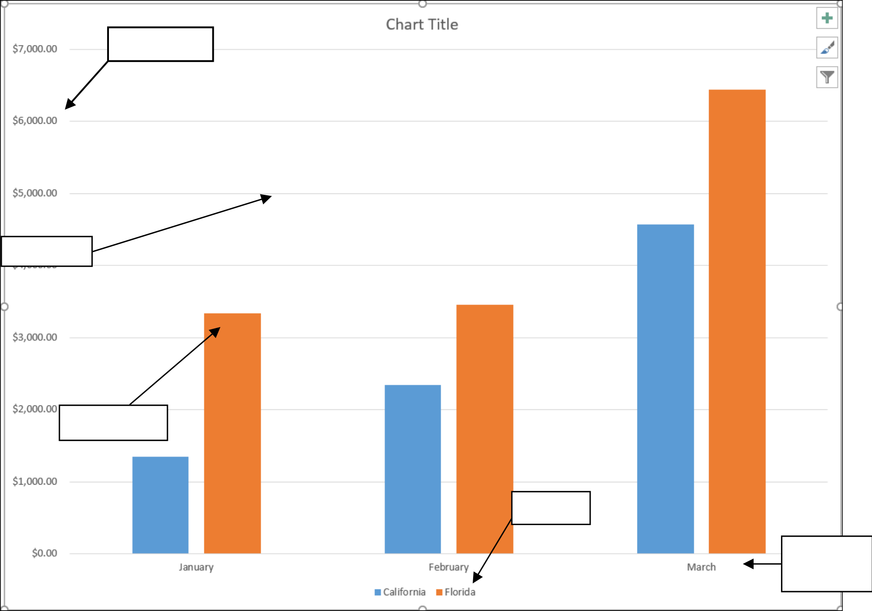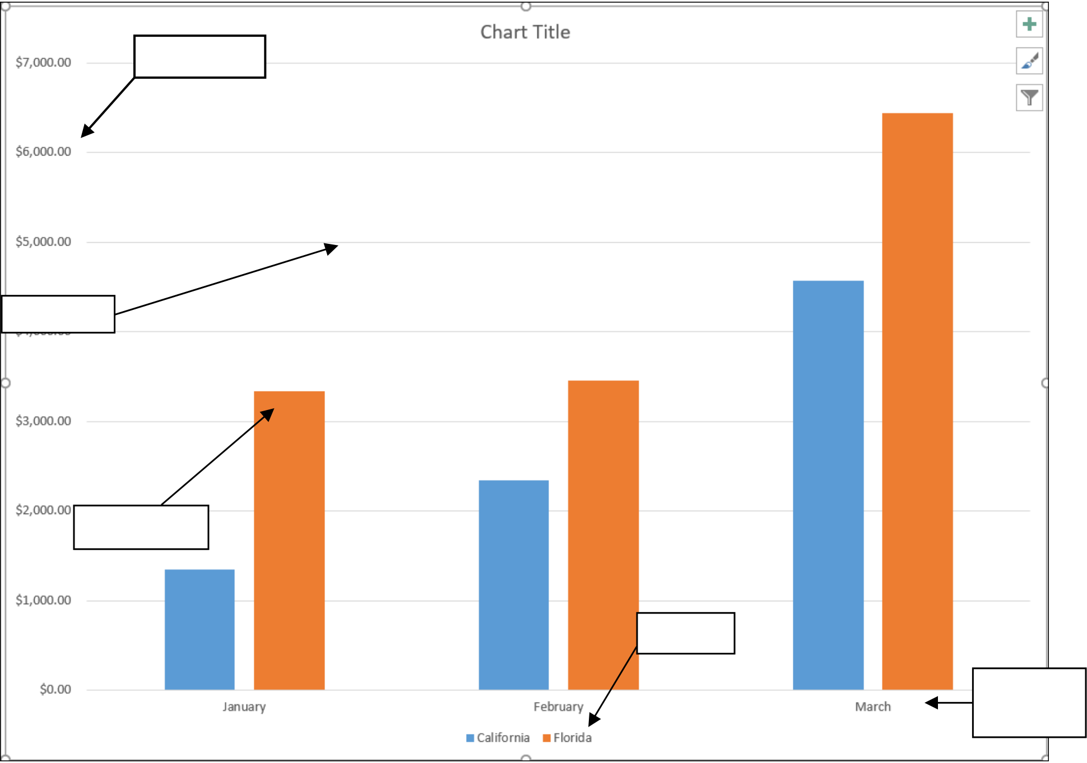

Microsoft Excel Advanced: Participant Guide   
**Charts**

Charts are a great way to visualize your data.

**Creating a Simple Chart**   
1. Navigate to the **Charts** spreadsheet.   
2.Select the range of **B2:E5**.

3.Press the **F11** key.

**Chart Terminology**

Vertical   
Axis

Gridline

Data Marker

Legend

Horizonta   
l Axis

**Figure 48**   
**Charting Non-Adjacent Cells**   
1. Navigate to the **Charts** spreadsheet.

2.Select the range **B3:C5**. Hold down the **Ctrl** key and select the range **E3:E5** (must use the dragging technique when the **Ctrl** key is held down).

3.Press the **F11** key.

24

Microsoft Excel Advanced: Participant Guide   
**Creating a Chart Using the Chart Wizard** 1. Navigate to the **Charts** spreadsheet.

2.Select the range of **B2:E5**.

3.Click the **Insert** tab in the ribbon and then click the **RecommendedCharts** icon.

|  |
| --- |
|  |

**Figure 49**   
4.In the **Insert Chart** window, click the **AllCharts** tab.

5.Select the **Column** chart type.

6.Choose the **3-D Clustered Column** option in the **Column** section. 7.Click the **OK** button.

|  |
| --- |
|  |

**Figure 50**

25

Microsoft Excel Advanced: Participant Guide   
**Modifying Charts**

There are many different ways to modify your charts to best visualize your data.

**Moving an Embedded Chart**   
1. Place your mouse on the chart area of the chart. This is the white area within the perimeter. 2.Hold down the mouse button and drag the chart to cell **B7**.

**Sizing an Embedded Chart**   
1. Select the chart. You know the chart is selected because it has handles around the perimeter.

2.Place your mouse on one of the handles until your mouse turns into a dual headed arrow.

|  |
| --- |
|  |

**Figure 51**   
3.Hold down your left mouse button and drag until the chart becomes larger or smaller.

4.Drag the chart over to the **H** column and down to row **22**.

**Changing the Chart Type**   
1. Click on the chart to select it.

2.Click the **Design** tab in the **ChartTools** contextual menu of the ribbon and then click the **Change Chart Type**  button.

|  |
| --- |
|  |

**Figure 52**

3.Hover over the different chart types to see what they look like and look at the table above to get an idea on how to use the different chart types.

4.End with a **3-D Clustered Column** chart.

26

Microsoft Excel Advanced: Participant Guide   
**Chart Types**

|  |  |
| --- | --- |
| **Chart Type** | **Used For** |
| Area | Displays values over a period of time. Emphasis on amount of change. |
| Bar | Displays values for comparison. |
| Column | Displays values for comparison. |
| Line | Shows trends over time. |
| Pie | Displays only one data series. Each piece of the pie is a percent of the whole. |
| Doughnut | Similar to a pie, except it can display more than one data series. |
| Radar | Displays changes of data relative to a center point and also to each other. |
| XY (Scatter) | Displays the relationship between numeric values in several data series. |
| Bubble | Plot and coordinate values. |

**Changing the Way Data is Displayed**   
1. With the chart still selected, click the **Design** tab in the **ChartTools** contextual menu of the ribbon. 2.Click the **Switch Row/Column** button.

|  |
| --- |
|  |

**Figure 53**   
**Moving the Legend**   
1. Located in the **Chart Layouts** group of the **Design** tab in the ribbon, click the **AddChartElement** icon. 2.Hover your pointer over **Legend** and then select **Right** from the drop down menu.

|  |
| --- |
|  |

**Figure 54**

27

Microsoft Excel Advanced: Participant Guide   
**Formatting Charts**   
**Adding Chart Items**   
1. Navigate to the **MonthlyOrders** spreadsheet.

2.Create a **ClusteredColumn** chart from the data in cells **A4:F9**.

3.Click on the chart to select it.

4.Located in the **ChartLayouts** group of the **Design** tab in the ribbon, click the **QuickLayout** icon. 5.Select **Layout 2** from the list.

|  |
| --- |
|  |

**Figure 55**   
6.Click on **Add Chart Element** in the **ChartLayouts** group.

7.Hover your pointer over **Chart Title** and then click the **AboveChart** option.

|  |
| --- |
|  |

**Figure 56**

8.Type **Sandwich Sales** and then press the **Enter** key.

9.Add the following **AxisTitles** from the **AddChartElement** dropdown menu:

|  |  |
| --- | --- |
| • • | Primary Horizontal Axis = Month  Primary Vertical Axis = Sales in ($) |

28

Microsoft Excel Advanced: Participant Guide   
**Formatting All Text**   
1. Select the entire chart by clicking once in the white chart area.

2.Click on the **Format** contextual tab.

3.Apply the **Colored Outline, Black, Dark 1** theme from the **ShapeStyles** group.

4.Apply the **Fill Black, Text 1, Shadow** style from the **WordArtStyles** group.

|  |
| --- |
|  |

**Figure 57**

|  |
| --- |
|  |

**Figure 58**   
**Formatting and Aligning Numbers**   
1. Located in the **Chart Layouts** group of the **Design** tab in the ribbon, click the **AddChartElement** icon. 2.Hover your pointer over **Axes** and then select **Primary Vertical** from the drop down menu.

|  |
| --- |
|  |

**Figure 59**

29

Microsoft Excel Advanced: Participant Guide   
3.Double-click on the Y axis. The **Format Axis** pane will appear.

4.Click **Number** from the **AxisOptions** tab to expand the menu.

5.Choose **Currency** from the **Category** drop down menu and type **0** in the box beside **Decimalplaces**.

|  |
| --- |
|  |

**Figure 60**

6.In the **Format Axis** pane, click the **Size and Properties** tab.

7.In the **CustomAngle** field, type **-45** to place the Y axis numbers at an angle. 8.Click **X** to close the panel.

|  |
| --- |
|  |

**Figure 61**

9.Make the chart larger by dragging the bottom handle fill the screen.

**Formatting the Plot Area**   
1. Double-click on the white of the chart background. The **Format Chart Area** pane will appear. 2.Click the **Fill** option in the **Fill & Line** section.

|  |
| --- |
|  |

**Figure 62**

30

Microsoft Excel Advanced: Participant Guide   
3.Click the radio button beside **Picture or texture fill**.

4.Beneath **Insert picture** from click the **Online** button. The **Insert Pictures** window will appear.

|  |
| --- |
|  |

**Figure 63**   
5.In the **Insert Pictures** window, type **Cheese Pattern** in the **BingImageSearch** field and then press the **Enter**  key.

6.Select a cheese pattern and then click the **Insert** button.

|  |
| --- |
|  |

**Figure 64**

|  |
| --- |
|  |

**Figure 65**

31

Microsoft Excel Advanced: Participant Guide   
**Formatting Data Markers**   
1. Double-click on the **Swiss** data marker to select. Notice that all the **Swiss** data markers will become selected. The **Format Data Series** pane will open.

2.Click the **Fill** option in the **Fill & Line** section.

3.Click the radio button beside **Picture or texture fill**.

|  |
| --- |
|  |

**Figure 66**

4.Click the **Online** button and type **Swiss Cheese** in the **Bing Image Search** field.

5.In the **Online Pictures** window, click the filter icon and then select **Transparent** from the menu.

|  |
| --- |
|  |

**Figure 67**

6.Select one of the Swiss cheese images and then click the **Insert** button. 7.In the **Format Data Series** pane, click the radio button beside **Stack**.

|  |
| --- |
|  |

**Figure 68**

32

Microsoft Excel Advanced: Participant Guide   
**Pie Charts**

Pie charts can present the relationship of different classes of data in a visually simple way.

**Creating a Pie Chart**   
1. Navigate to the **Pastry Sales by State** spreadsheet.

2.Select the range of **A4:B11**.

3.Click the **Insert** tab on the ribbon.

4.In the **Charts** group, click on the **Insert Pie or Doughnut Chart** icon. 5.Select the **3-D Pie Chart** option.

|  |
| --- |
|  |

**Figure 69**   
**Moving the Pie Chart to its Own Sheet**   
1. With the pie chart selected, click the **Design** contextual tab. 2.Click the **Move Chart** button. The **Move Chart** window will appear.

|  |
| --- |
|  |

**Figure 70**

3.Click the radio button beside **New sheet** and type **Pastry Sales Pie Chart** in the corresponding text box. 4.Click the **OK** button.

|  |
| --- |
|  |

**Figure 71**

33

Microsoft Excel Advanced: Participant Guide   
**Adding Data Labels**   
1. Navigate to the **Pastry Sales Pie Chart**.

2.In the ribbon, click the **Design** contextual tab.

3.Click the **Add Chart Element** button located in the **Chart Layouts** group.

4.Hover your pointer over **Data Labels** and choose **Inside End** from the drop down menu.

|  |
| --- |
|  |

**Figure 72**

5.Click **Add Chart Element** again and hover your pointer over **Data Labels**.

6.Choose **More Data Labels Options** from the drop down menu. The **Format Data Labels** pane will appear. 7.Beneath the **Label Contains** header, make sure only the boxes beside **Category Name** and **Percentage** are checked.

|  |
| --- |
|  |

**Figure 73**

34

Microsoft Excel Advanced: Participant Guide   
**Exploding a Slice of a Pie Chart**   
1. Click directly on top of the pie chart to select the entire chart. 2.Click again on the **California** slice to select only that slice of the pie. 3.Hold down your mouse button and drag the slice towards the right. 4.Press the **Esc** key to deselect the pie.

|  |
| --- |
|  |

**Figure 74**   
**Rotating and Changing the Elevation of a Pie Chart**   
1. Right-click on the chart and select **3-D Rotation** from the dropdown menu. The **3-D Rotation** settings will appear in the **Format Chart Area** pane.

2.Beside **Perspective**, click the up and down arrows.

3.Change the Rotation by adjusting the **X Rotation** and **Y Rotation** input fields.

|  |
| --- |
|  |

**Figure 75**

35