# Task 1:

select CountryCode from countrylanguage where language = 'English' and Percentage > 50;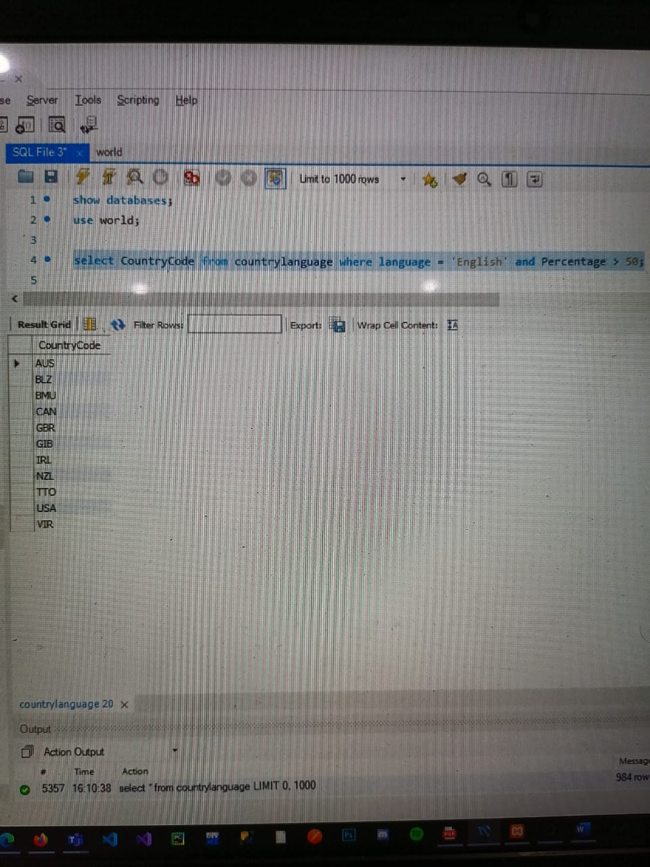

# Task 2:

select CountryCode, Language from countrylanguage where Percentage > 50;

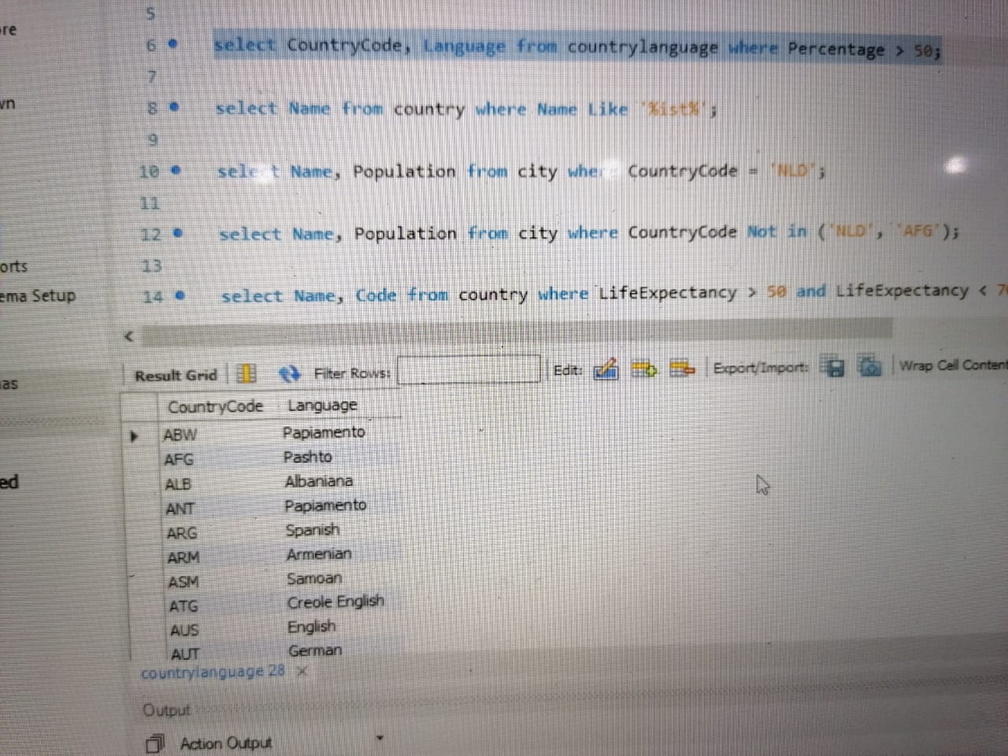

# Task 3:

select Name from country where Name Like '%ist%';

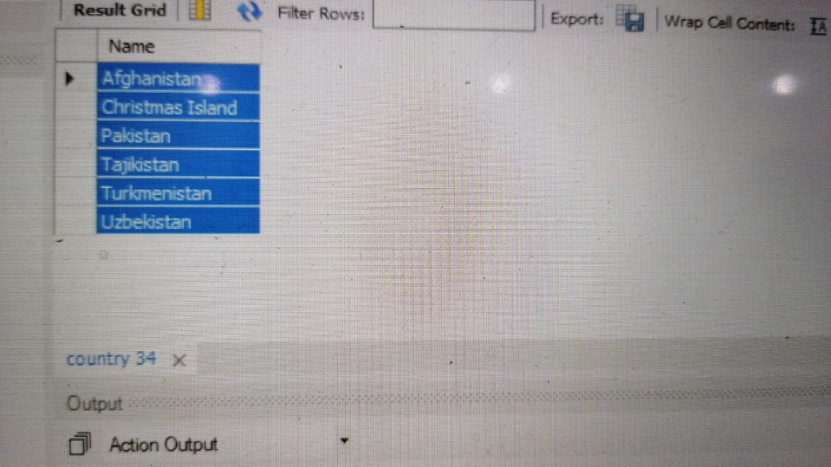

# Task 4:

select Name, Population from city where CountryCode = 'NLD';

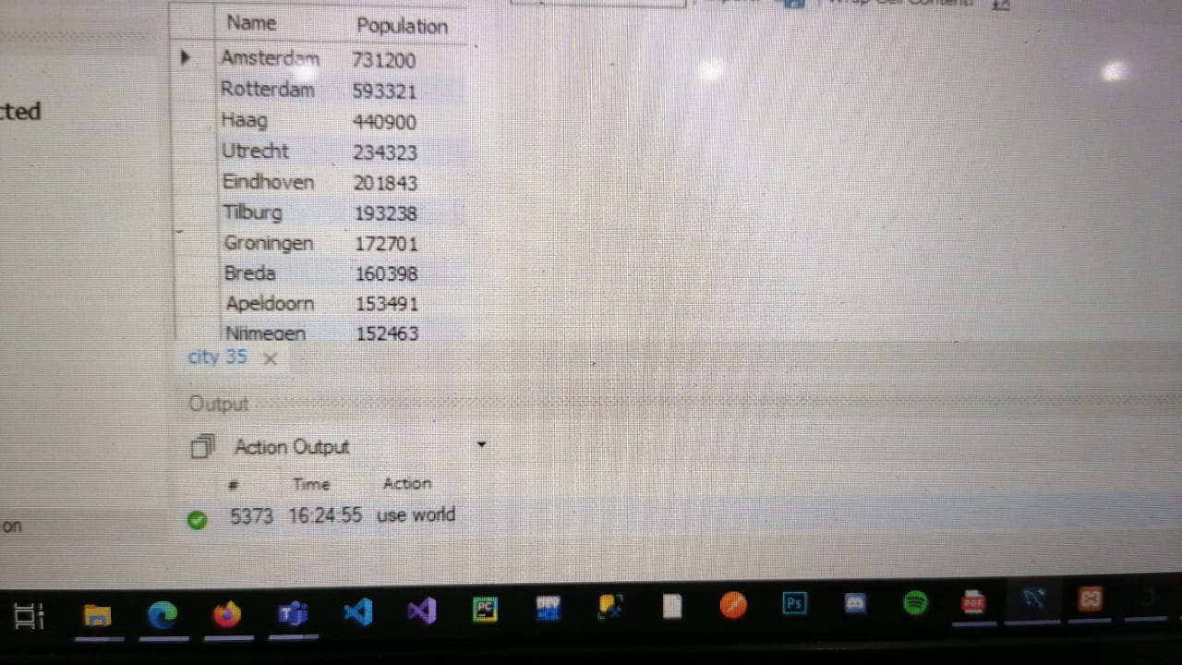

# Task 5:

select Name from city where CountryCode Not in ('NLD', 'AFG');

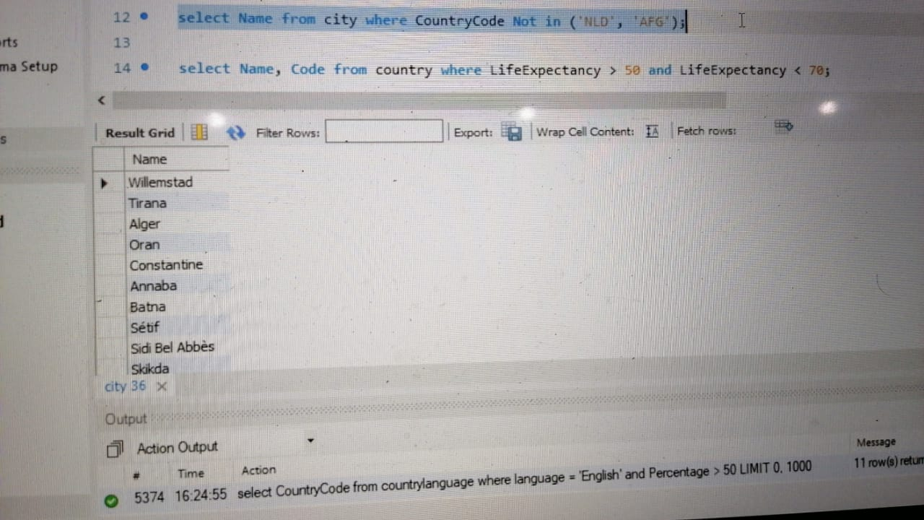

# Task 6:

select Name, Code from country where LifeExpectancy > 50 and LifeExpectancy < 70;

