**Library Used:**

igraph

**Data Set:**

<https://snap.stanford.edu/data/gplus.tar.gz>

**Language Used:**

R

**Install Data:**

library(igraph)

folder_path <- "C:\\Users\\Sherif Tarfa\\Desktop\\gplus"

file_list <- list.files(path = folder_path, full.names = TRUE)

**network:**

node_count <- 0

for (file in file_list) {

file_extension <- tools::file_ext(file)

if (file_extension == "edges") {

edges_data <- read.table(file)

graph <- graph_from_data_frame(edges_data, directed = FALSE)

node_count <- node_count + vcount(graph)

plot(graph, edge.arrow.size = 0.2, vertex.size = 2, vertex.label = NA)

}

}

cat("Total number of nodes:", node_count, "\n")

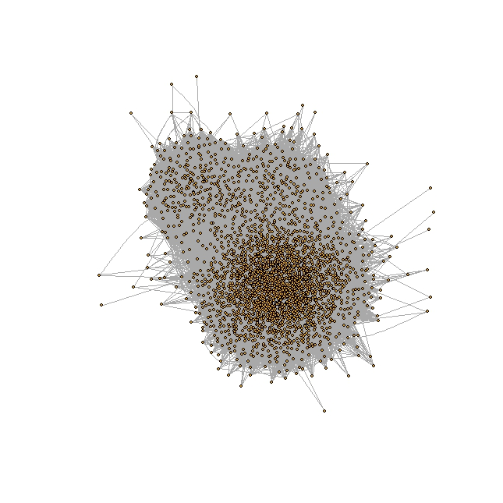

**Number of users in the network”Node”:**



**Top 20 influencers “top 20 degrees”:**

top_nodes <- c()

top_degrees <- c()

for (file in file_list) {

file_extension <- tools::file_ext(file)

if (file_extension == "edges") {

edges_data <- read.table(file)

graph <- graph_from_data_frame(edges_data, directed = FALSE)

degrees <- degree(graph)

top_indices <- order(degrees, decreasing = TRUE)[1:20]

top_nodes <- c(top_nodes, V(graph)[top_indices])

top_degrees <- c(top_degrees, degrees[top_indices])

}

}

cat("Top 20 degrees:\n")

for (i in 1:20) {

cat("Node", top_nodes[i], ": Degree", top_degrees[i], "\n")

}

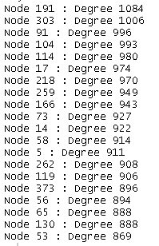

**Average degree in each node :**

total_degrees <- 0

num_nodes <- 0

for (file in file_list) {

file_extension <- tools::file_ext(file)

if (file_extension == "edges") {

edges_data <- read.table(file)

graph <- graph_from_data_frame(edges_data, directed = FALSE)

degrees <- degree(graph)

total_degrees <- total_degrees + sum(degrees)

num_nodes <- num_nodes + vcount(graph)

}

}

average_degree <- total_degrees / num_nodes

cat("Average Degree:", average_degree, "\n")



**Top 20quantify nodes` importance in information flow:**

for (file in file_list) {

file_extension <- tools::file_ext(file)

if (file_extension == "edges") {

edges_data <- read.table(file)

graph <- graph_from_data_frame(edges_data, directed = FALSE)

betweenness_values <- rbind(betweenness_values,

data.frame(Node = 1:vcount(graph),

Betweenness = betweenness(graph)))

}

}

top_20_betweenness <- head(betweenness_values[order(-betweenness_values$Betweenness), ], 20)

cat("Top 20 betweenness centrality values:\n")

print(top_20_betweenness)

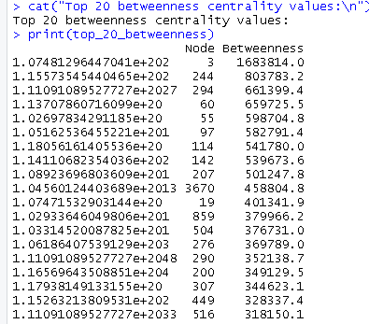

**Top 20 Closeness Centrality of top 20 influencers “higher Closeness Centrality means can reach to other nodes easily ”:**

top_nodes <- c()

top_degrees <- c()

closeness <- c()

for (file in file_list) {

file_extension <- tools::file_ext(file)

if (file_extension == "edges") {

edges_data <- read.table(file)

graph <- graph_from_data_frame(edges_data, directed = FALSE)

degrees <- degree(graph)

closeness_centrality <- closeness(graph)

top_indices <- order(degrees, decreasing = TRUE)[1:20]

top_nodes <- c(top_nodes, V(graph)[top_indices])

top_degrees <- c(top_degrees, degrees[top_indices])

closeness <- c(closeness, closeness_centrality[top_indices])

}

}

cat("Top 20 nodes, degrees, and closeness centrality:\n")

for (i in 1:20) {

cat("Node:", top_nodes[i],"//" , "Closeness Centrality:", closeness[i], "\n")

}

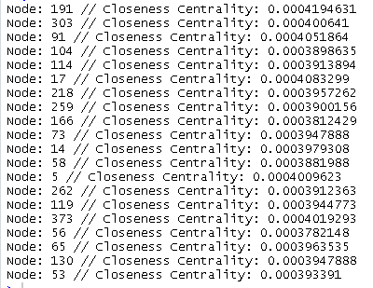

**Top 20 Closeness Centrality “top 20 users can reach other nodes”:**

top_nodes <- c()

closeness <- c()

for (file in file_list) {

file_extension <- tools::file_ext(file)

if (file_extension == "edges") {

edges_data <- read.table(file)

graph <- graph_from_data_frame(edges_data, directed = FALSE)

closeness_centrality <- closeness(graph)

top_indices <- order(closeness_centrality, decreasing = TRUE)[1:20]

top_nodes <- c(top_nodes, V(graph)[top_indices])

closeness <- c(closeness, closeness_centrality[top_indices])

}

}

cat("Top 20 nodes and their closeness centrality:\n")

for (i in 1:20) {

cat("Node:", top_nodes[i], "// Closeness Centrality:", closeness[i], "\n")

}

