***Phonebook project***

Ahmed Tharwat Wagdy 5336

Mostafa Ehab Elzwawy 5311

Omar Ihab El-Hariry 5360

Kyrellos Naeem Adeeb 5566

* ***Introduction***

Adding new records into the memory, listing them, modifying them and updating, search for contacts saved, and deleting the phonebook contacts are the basic functions which make up the main menu of this Phonebook application.

Personal information such as Name, Father’s name, phone number, email and address are asked while adding a record into the Phonebook. After the initial addition of the contacts these records are then be modified, listed, searched for and removed if they are requires a change.

This program uses many functions. These functions are easy to understand as their name only signifies their respective operations. These functions make the program divide into individual modules and hence it makes the program simpler to understand.

void menu() – This function is used to display the main menu.

void load() – This function is used to read contacts including the file.

void Add() – It adds a new Phonebook record.

void Delete() – It deletes record from file.

void search() – It searches for any record by the field chosen by the user.

void sort() – This function is used to display records listed by last name on the screen.

void Modify() – This function is used to modify records.

void save() –It saves records in the file.

* 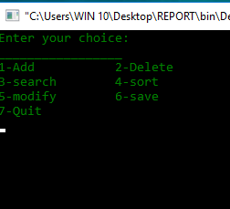***User Manual***

1. The first step in the program is to select a choice from the menu, the user will be prompted to enter a number from 1 to 8 where each number represents different commands. If the user enter any other number it will display invalid choice and asks the user to enter the number again.

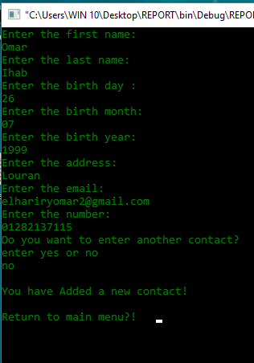

1. If the user chooses first option (Add), It will allow him to add a new contact and he will be prompted the contact info field by field (name, second name, birthdate, address, email and number).
2. 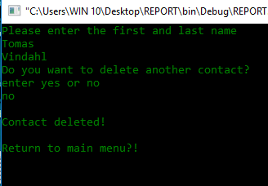If the user chooses the second option (Delete), He will be able to delete a contact from the file by entering the first and last name.

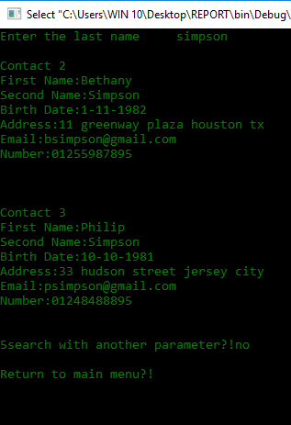

Search by last name (Default search)

1. 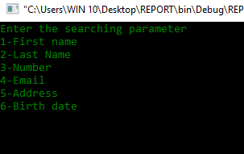If the user chooses the third option (Search), He will have two choices, either to search by last name or by multi-field.

Search by multi-fields

1. 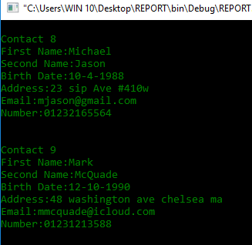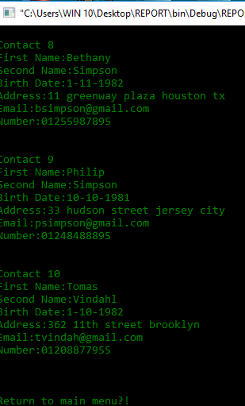If the user chooses the fourth option, He will be able to sort the contacts within the file according to last name or date of birth.

Sort by date

Sort by last name (Default sorting)

1. 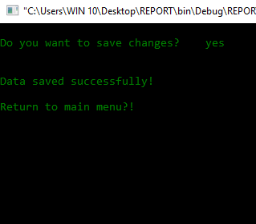If the user chooses the sixth option (Save), the program will automatically save the contacts in the file.
2. 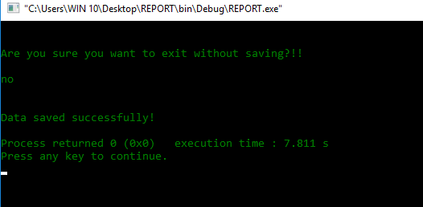If the user chooses the last option (Exit), If he didn’t save before he would be asked again to save then the program should exit.

* ***Algorithms***

1-count function (input:array of chars ,output:integer)

read from file to array

check end of file

return number pf info in file

2-switsh function (input:integer)

Ask user to enter a number from 1 to 6

1-last name

Scan new last name and check its validation by valided function

2-first name

Scan new first name and check its validation by valided function

3-address

Scan new address, accepting space

4-email

Scan new email and check its validation by validedx function

5-phonr number

Scan new phone number and check its validation by validedz function

6-date of birth

Scan new date of birth and check its validation

Day check integer bigger than 0 an smaller than 31 check it countain no chars by validedz function

month check integer bigger than 0 an smaller than 12 check it countain no chars by validedz function

year check integer bigger than 0 an smaller than 2018 check it countain no chars by validedz function

3-valided function (input:array of chars ,output:integer)

Check validation of names

Then check there is no digits

4-validedx function (input:array of chars ,output:integer)

Check validation of email

By checking of existence of the symbol @ and valid for chars numbers and symbols “.”,”_” only

not valid for less than two chars before @ and less than 5 chars aftar @

5-validedz function (input:array of chars ,output:integer)

Check validation of numbers

Then check there is no chars

6- clean function

Clean window

7-load function

Read from file to array till end of file

then call count function to count number of elements in file to be used

8-save function

print from modified array to file an save file

9-search function

Choose searching parameter

Enter contact parameter to search for

Detect number of contacts with that parameter

Case zero tell user contact doesn’t exist

Case one print contact info

Case bigger than one ask user to use other parameter

10-sort function

use bubble sorting by the selected parameter (last name or date of birth)

in case of same last name sort by first name in case of same first name use phone number

11-delet function

Copy main array in other array except the selected element

12-Menu

Main menu of program where user choose the operation to be used

After every single operation user is asked if he want to return to menu then save or no

13-modify

Search contact by last name then first name in case of same last name and phone number in case of same last and first name then edit contact by switch function then loop if user wants to modify another parameter or printing Contact doesn't exist in case of not finding the user input and clean and re call modify function

14-add

Add ne contact to the end of the array then ask user if he want to add another contact or not

In case of yes re call add function

in case of no print You have Added a new contact