Injection 1
Sample Name | Aspartame Batch No. 2306034LP | Acquired By | System
Sample Type | Unknown | Sample Set Name | Asp_Set1
vial | 33 | Acq. Method Set | Asp_M
Injection # | 1 | Processing Method | Aspartame
Injection Volume | 20 µL | Channel Name | 2487Channel 1
Run Time | 15.0 Minutes | Proc. Chnl. Descr. | 2487Channel 1
Date Acquired | 23/09/2025 09:41:46
Date Processed | 23/09/2025 11:37:55
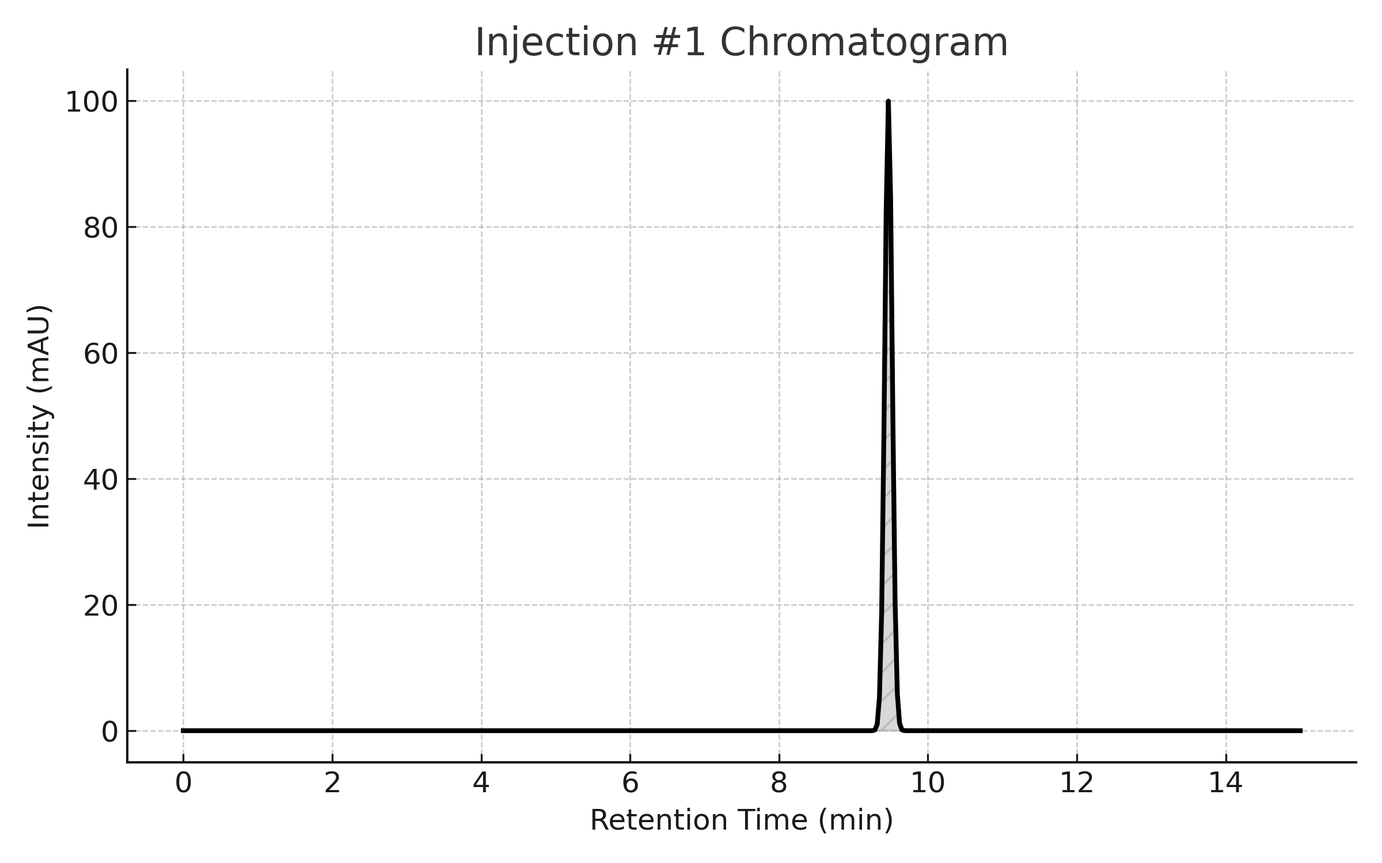

Peaks
Peak Name | RT | Area | % Area | Height | USP Plate Count
Aspartame | 9.50 | 1000234 | 99.93 | 297438 | 7572.38

USP Tailing
Peak | USP Tailing
1 | 1.057

Injection 2
Sample Name | Aspartame Batch No. 2306034LP | Acquired By | System
Sample Type | Unknown | Sample Set Name | Asp_Set1
vial | 33 | Acq. Method Set | Asp_M
Injection # | 2 | Processing Method | Aspartame
Injection Volume | 20 µL | Channel Name | 2487Channel 1
Run Time | 15.0 Minutes | Proc. Chnl. Descr. | 2487Channel 1
Date Acquired | 23/09/2025 09:28:26
Date Processed | 23/09/2025 11:37:50
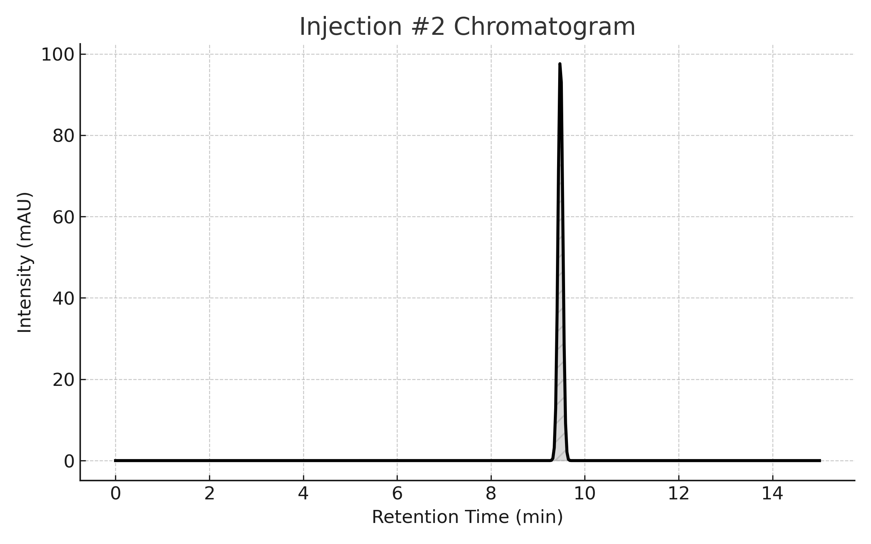

Peaks
Peak Name | RT | Area | % Area | Height | USP Plate Count
Aspartame | 9.50 | 1000234 | 99.93 | 297438 | 7572.38

USP Tailing
Peak | USP Tailing
1 | 1.057

Injection 3
Sample Name | Aspartame Batch No. 2306034LP | Acquired By | System
Sample Type | Unknown | Sample Set Name | Asp_Set1
vial | 33 | Acq. Method Set | Asp_M
Injection # | 3 | Processing Method | Aspartame
Injection Volume | 20 µL | Channel Name | 2487Channel 1
Run Time | 15.0 Minutes | Proc. Chnl. Descr. | 2487Channel 1
Date Acquired | 23/09/2025 09:34:52
Date Processed | 23/09/2025 11:37:50
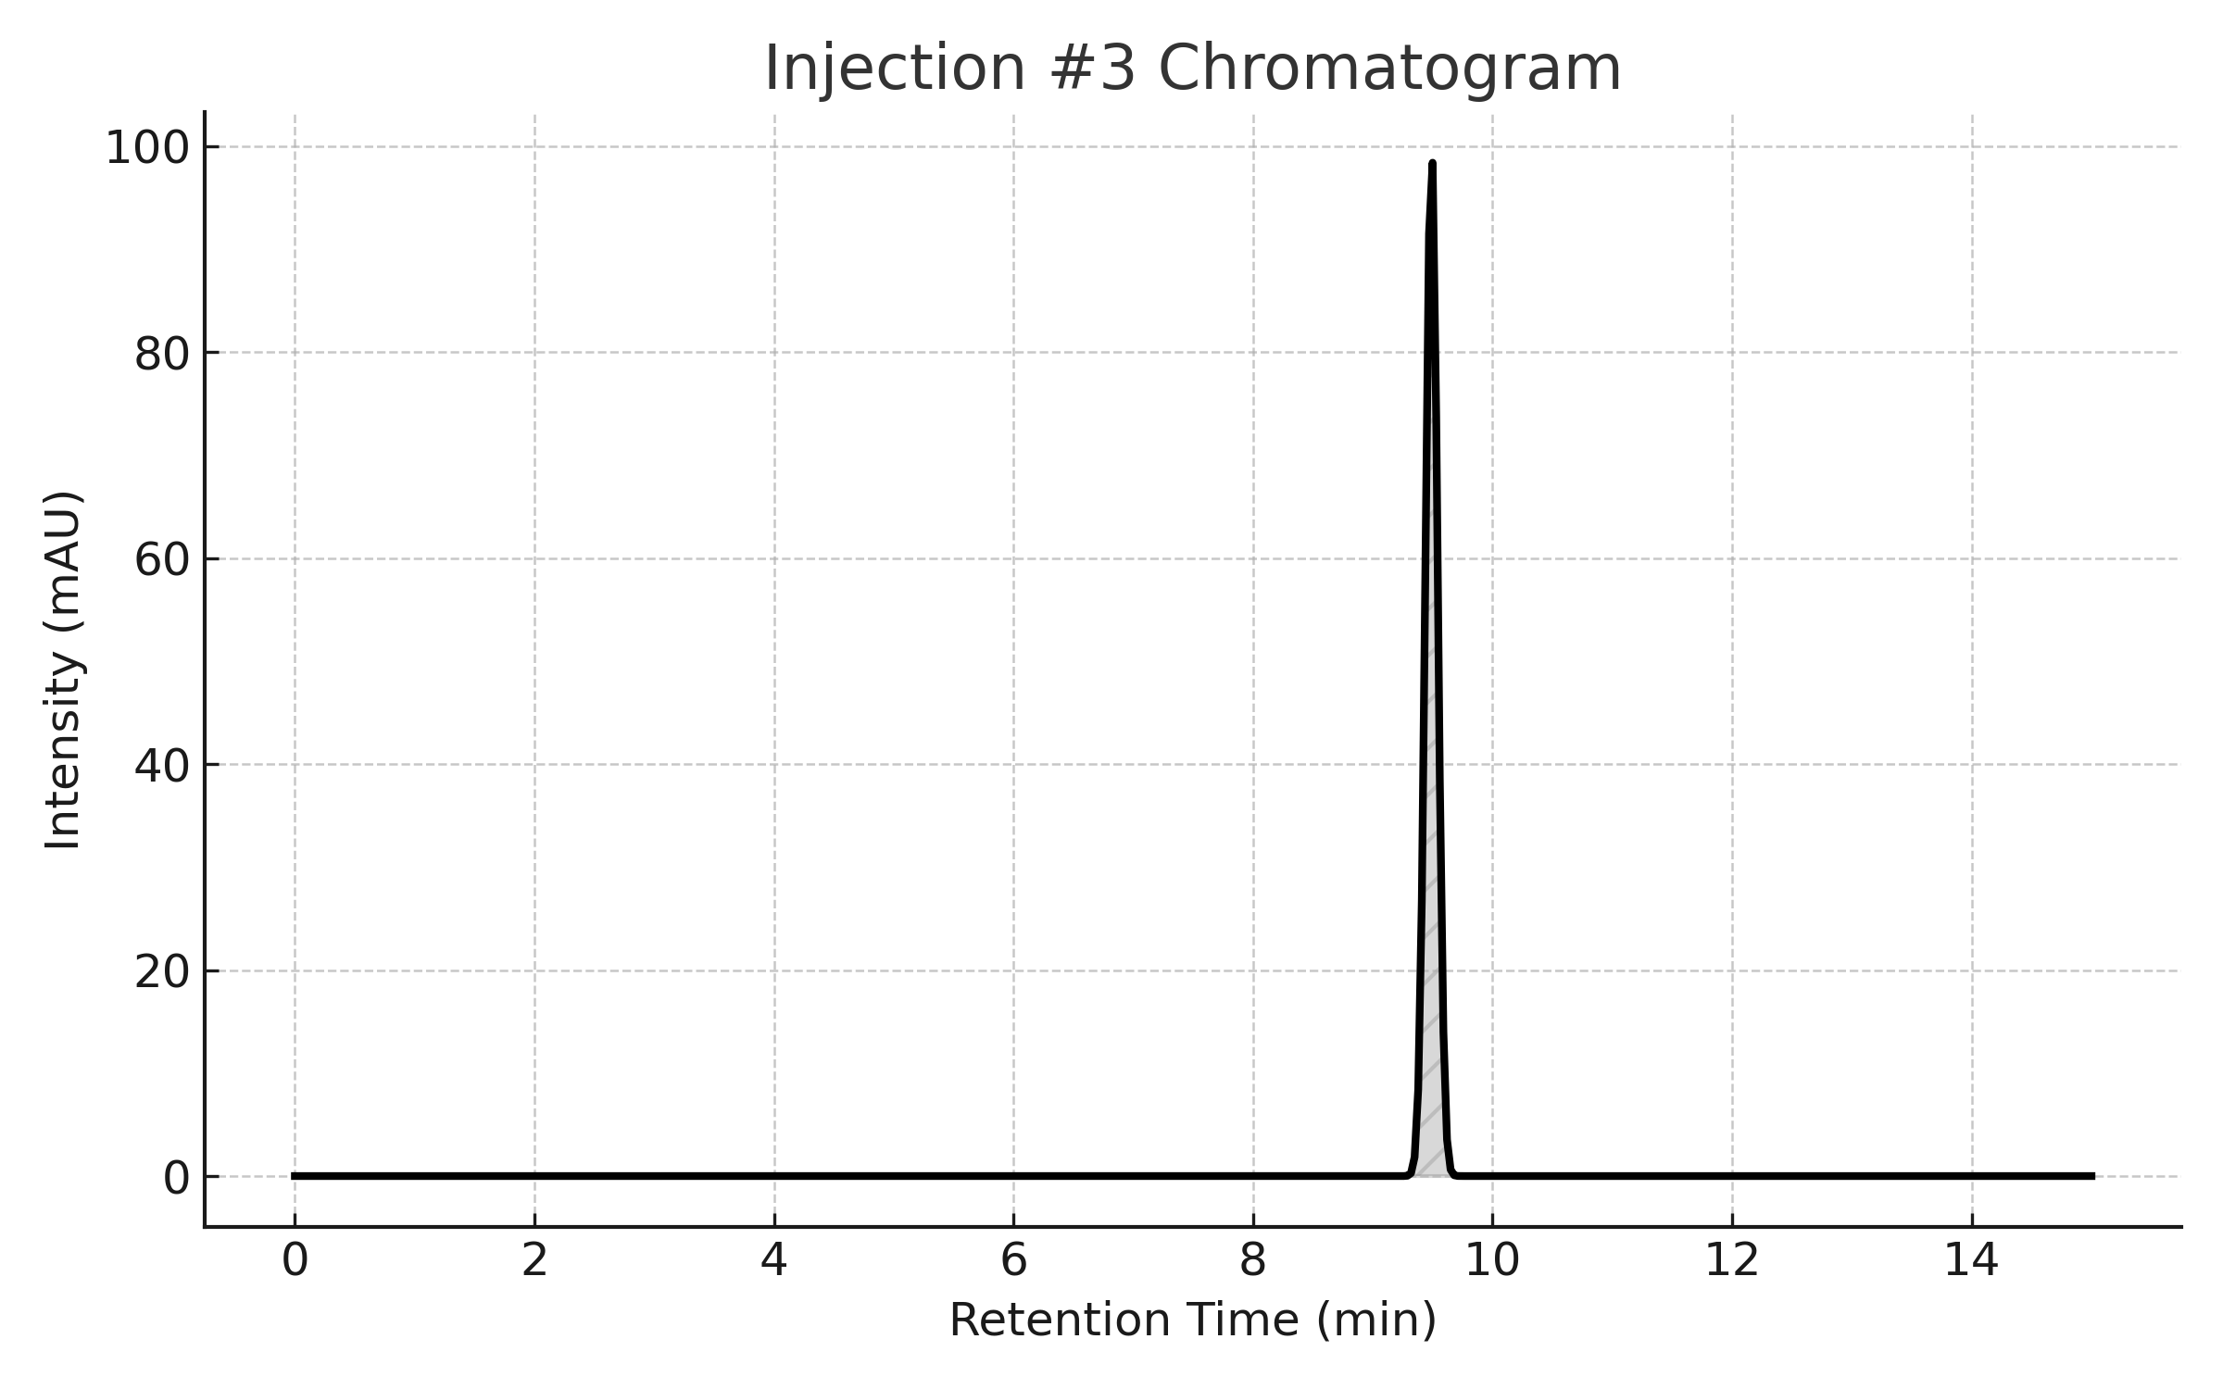

Peaks
Peak Name | RT | Area | % Area | Height | USP Plate Count
Aspartame | 9.50 | 1000234 | 99.93 | 297438 | 7572.38

USP Tailing
Peak | USP Tailing
1 | 1.057

Injection 4
Sample Name | Aspartame Batch No. 2306034LP | Acquired By | System
Sample Type | Unknown | Sample Set Name | Asp_Set1
vial | 33 | Acq. Method Set | Asp_M
Injection # | 4 | Processing Method | Aspartame
Injection Volume | 20 µL | Channel Name | 2487Channel 1
Run Time | 15.0 Minutes | Proc. Chnl. Descr. | 2487Channel 1
Date Acquired | 23/09/2025 10:15:13
Date Processed | 23/09/2025 11:37:50

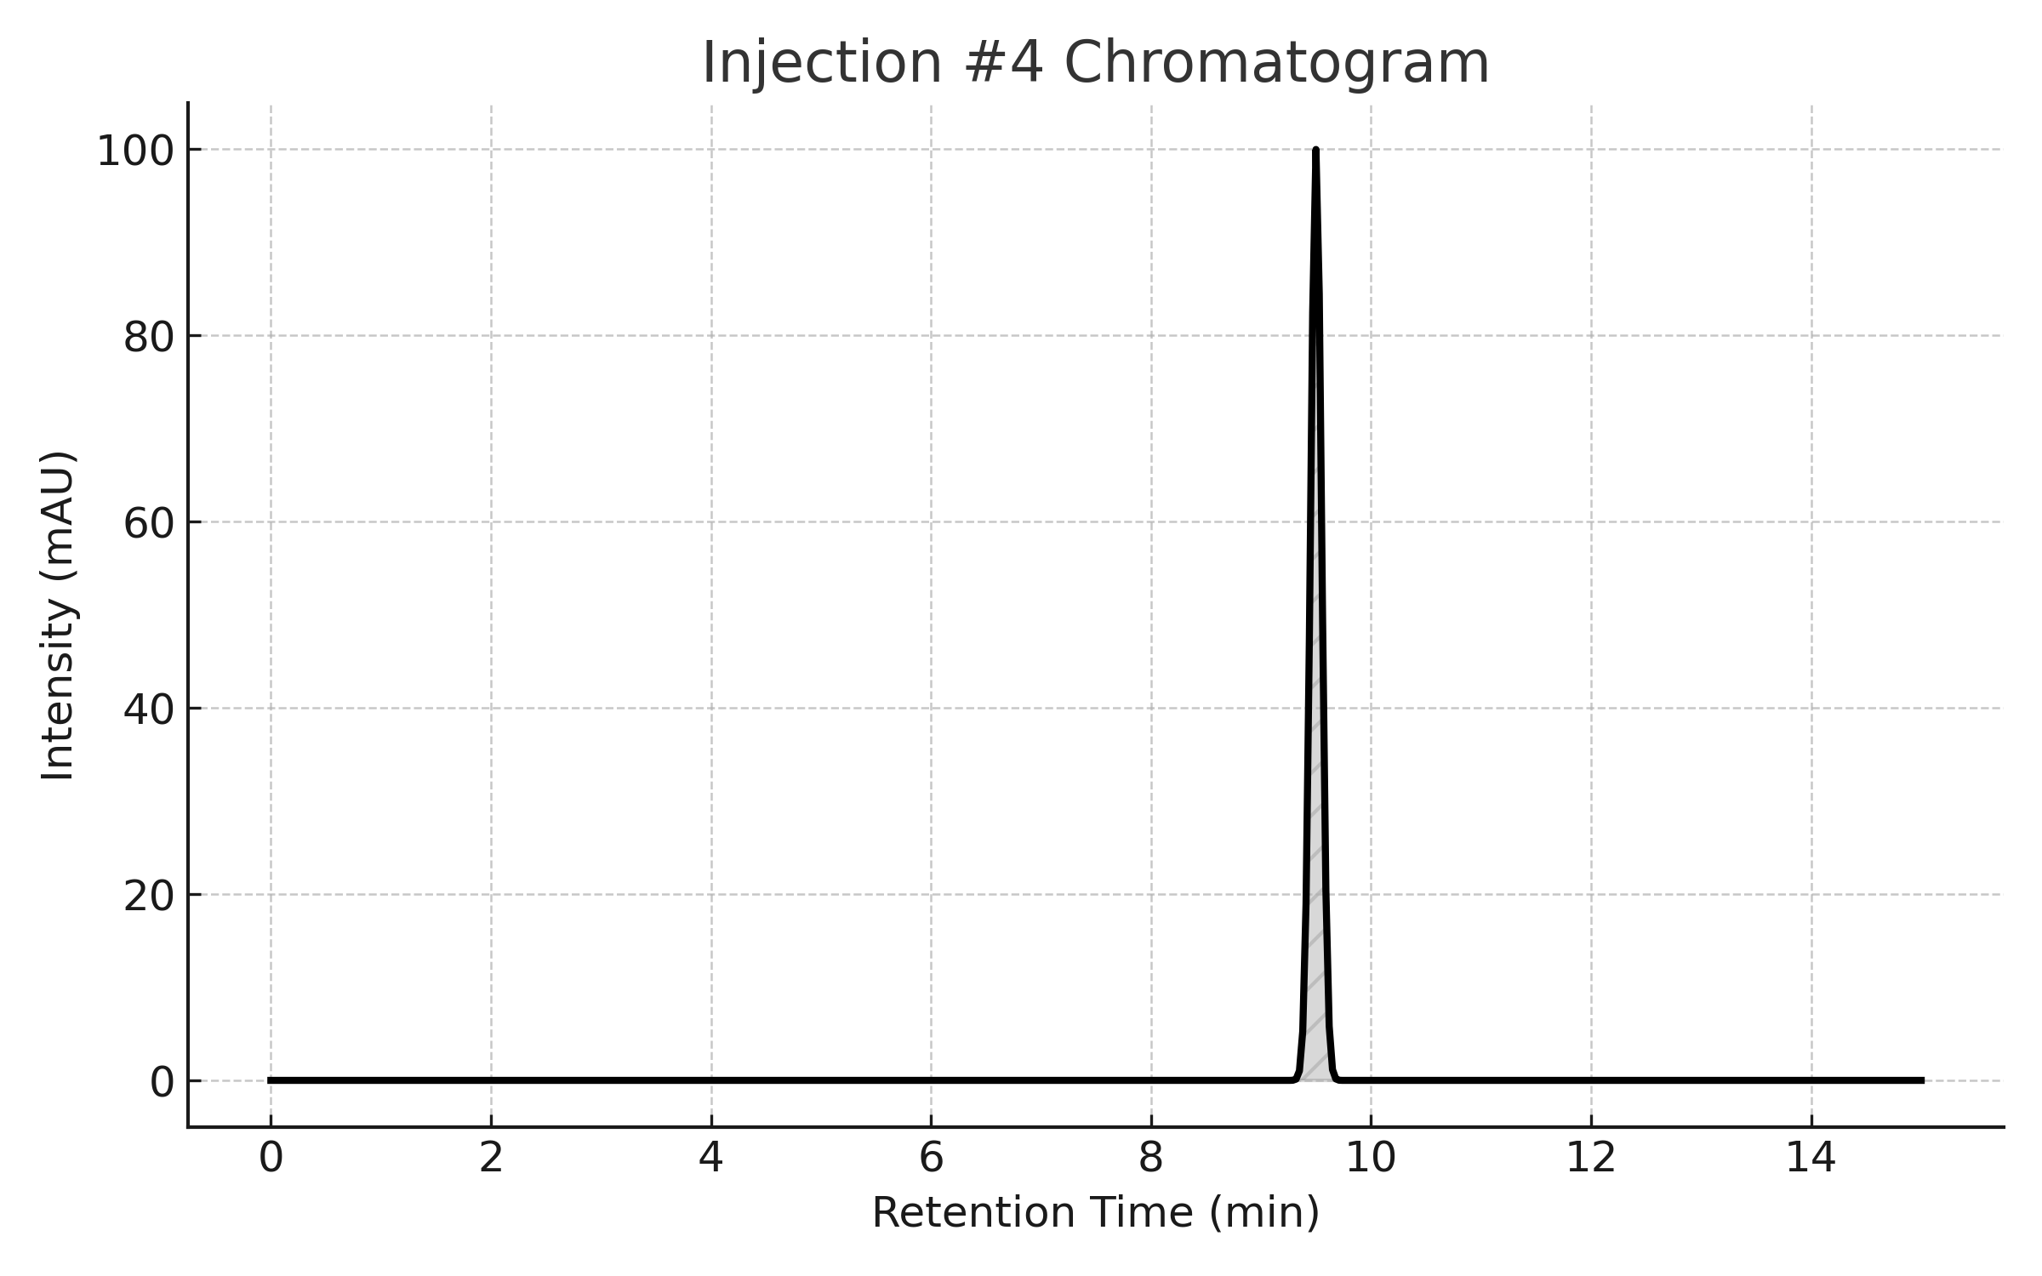

Peaks
Peak Name | RT | Area | % Area | Height | USP Plate Count
Aspartame | 9.50 | 1000234 | 99.93 | 297438 | 7572.38

USP Tailing
Peak | USP Tailing
1 | 1.057

Injection 5
Sample Name | Aspartame Batch No. 2306034LP | Acquired By | System
Sample Type | Unknown | Sample Set Name | Asp_Set1
vial | 33 | Acq. Method Set | Asp_M
Injection # | 5 | Processing Method | Aspartame
Injection Volume | 20 µL | Channel Name | 2487Channel 1
Run Time | 15.0 Minutes | Proc. Chnl. Descr. | 2487Channel 1
Date Acquired | 23/09/2025 10:37:22
Date Processed | 23/09/2025 11:37:50

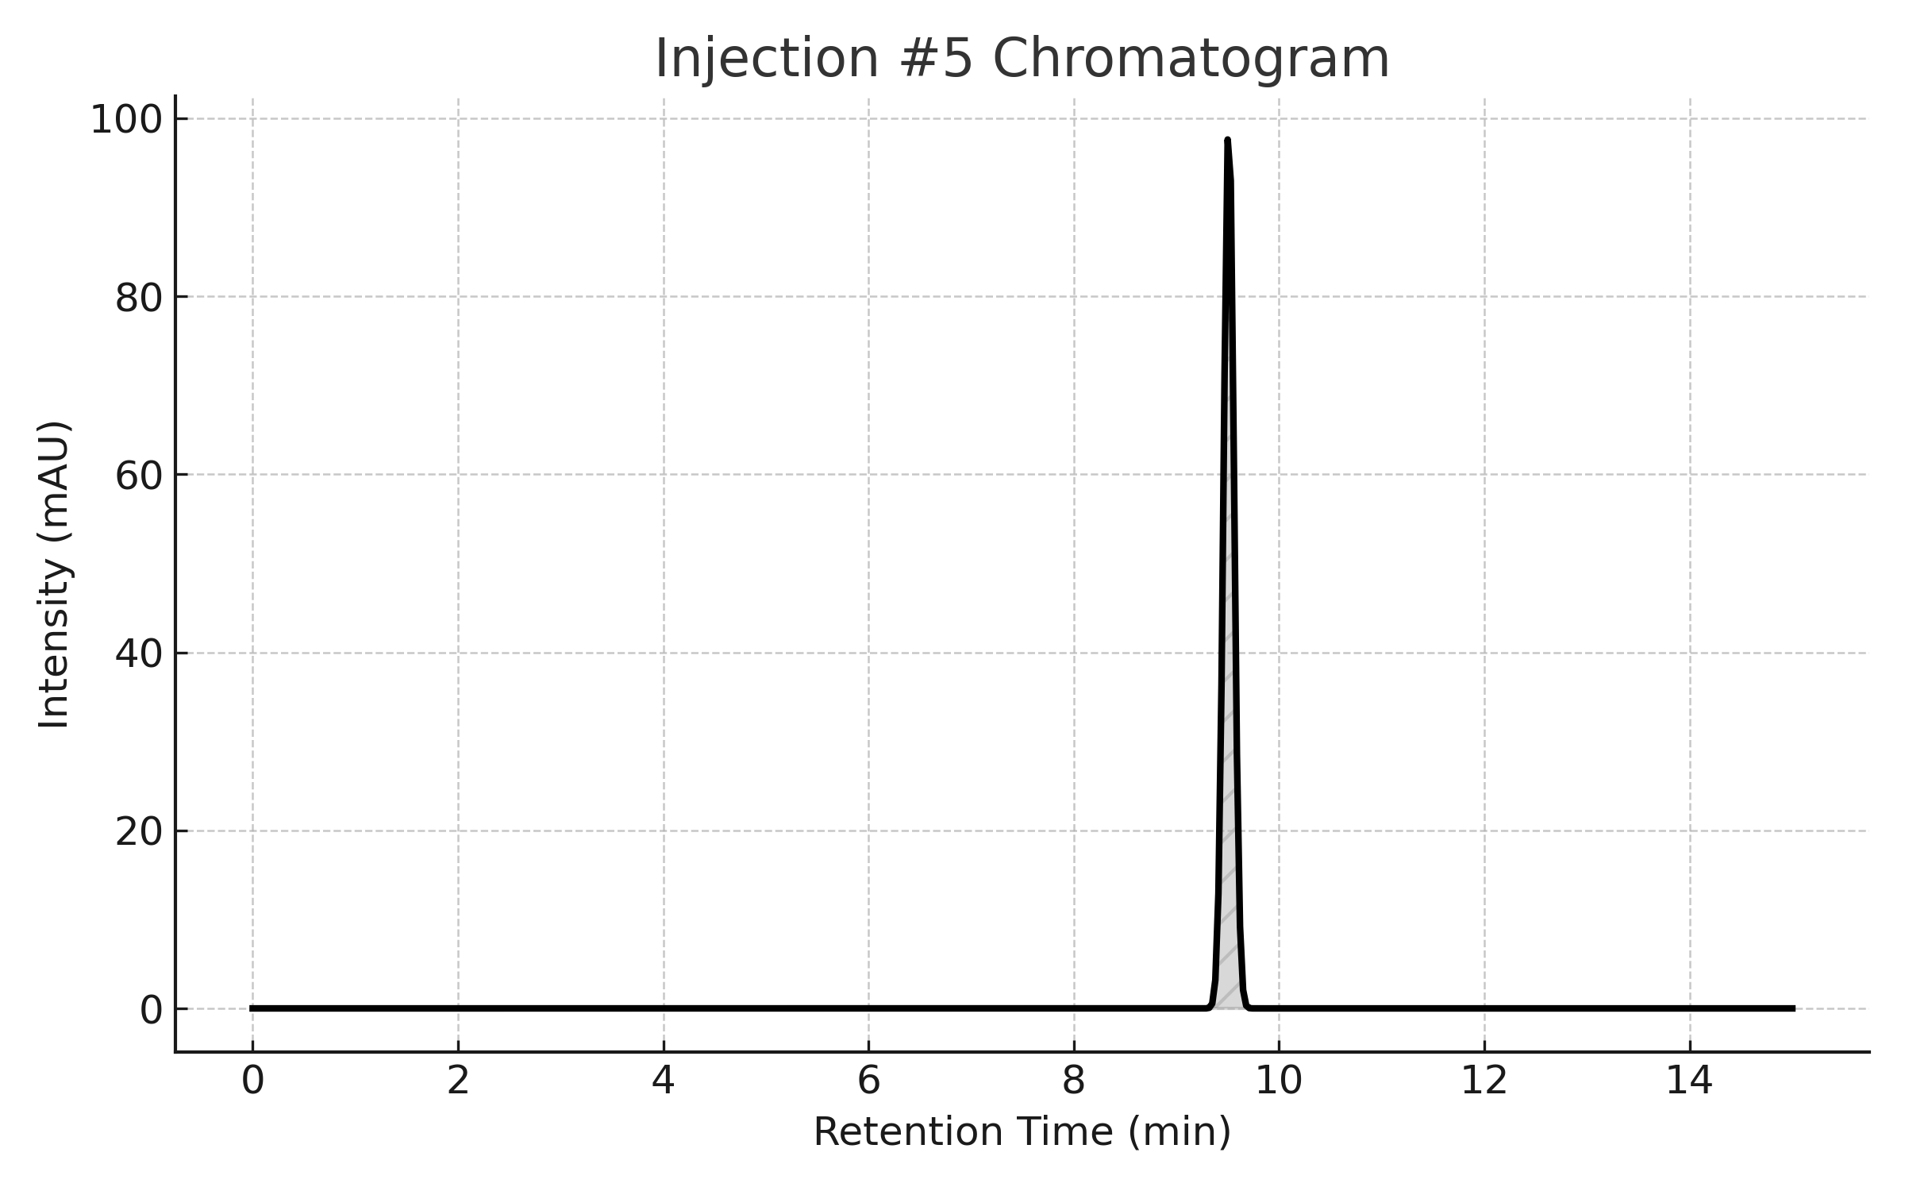

Peaks
Peak Name | RT | Area | % Area | Height | USP Plate Count
Aspartame | 9.50 | 1000234 | 99.93 | 297438 | 7572.38

USP Tailing
Peak | USP Tailing
1 | 1.057

Injection 6
Sample Name | Aspartame Batch No. 2306034LP | Acquired By | System
Sample Type | Unknown | Sample Set Name | Asp_Set1
vial | 33 | Acq. Method Set | Asp_M
Injection # | 6 | Processing Method | Aspartame
Injection Volume | 20 µL | Channel Name | 2487Channel 1
Run Time | 15.0 Minutes | Proc. Chnl. Descr. | 2487Channel 1
Date Acquired | 23/09/2025 09:55:14
Date Processed | 23/09/2025 11:37:50
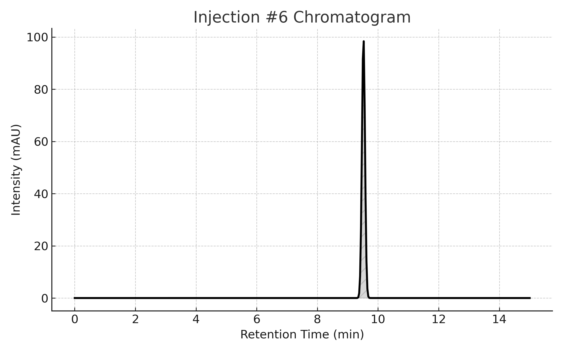

Peaks
Peak Name | RT | Area | % Area | Height | USP Plate Count
Aspartame | 9.50 | 1000234 | 99.93 | 297438 | 7572.38

USP Tailing
Peak | USP Tailing
1 | 1.057

System Precision Overlay
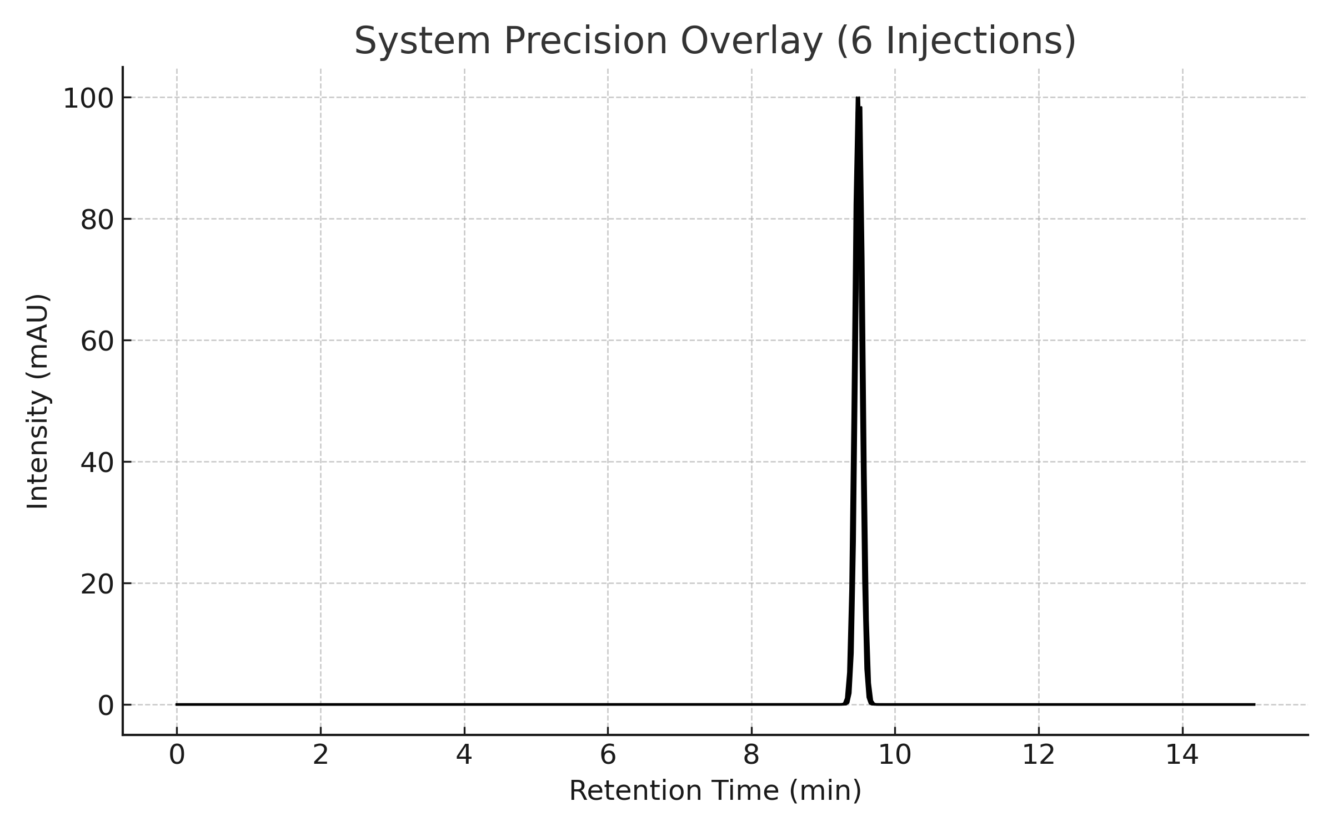

Comprehensive Analysis
Parameter | Result | Specification | Status
Chromatographic Purity | 99.93% | ≥ 98.0% | PASS
5-Benzyl-3,6-dioxo-2-piperazineacetic Acid | 0.07% | ≤ 1.0% | PASS
System Suitability | All Parameters | USP-NF 2024 | PASS
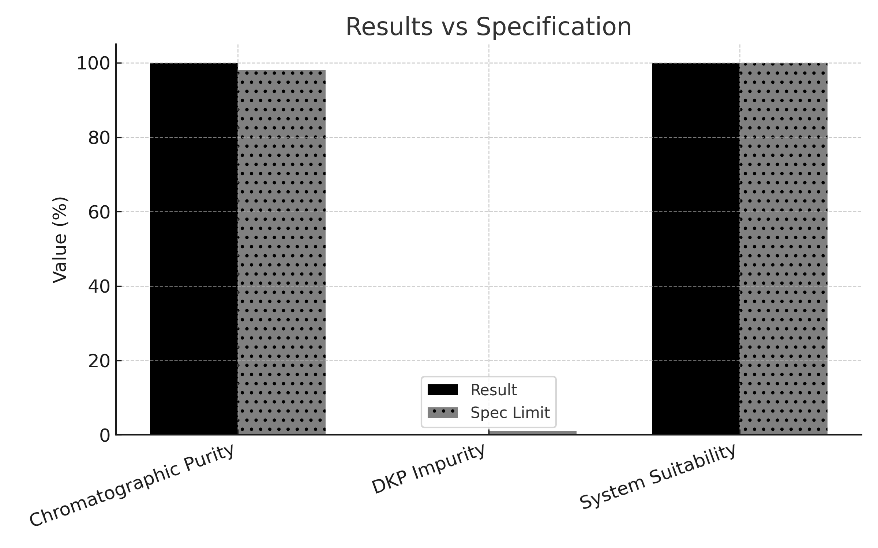

Conclusion & Approval
Batch Approved for Release
All quality parameters meet USP-NF 2024 requirements.

QC Analyst QC Manager
Dr. Naema Lofty Dr. Montaser Elzayaat

