# Injection 1

|  |  |  |  |
| --- | --- | --- | --- |
| Sample Name | Aspartame Batch No. 2306034LP | Acquired By | System |
| Sample Type | Unknown | Sample Set Name | Asp_Set1 |
| vial | 33 | Acq. Method Set | Asp_M |
| Injection # | 1 | Processing Method | Aspartame |
| Injection Volume | 20 µL | Channel Name | 2487Channel 1 |
| Run Time | 15.0 Minutes | Proc. Chnl. Descr. | 2487Channel 1 |
|  |  |  |  |
| Date Acquired | 23/09/2025 09:41:46 |  |  |
| Date Processed | 23/09/2025 11:37:55 |  |  |

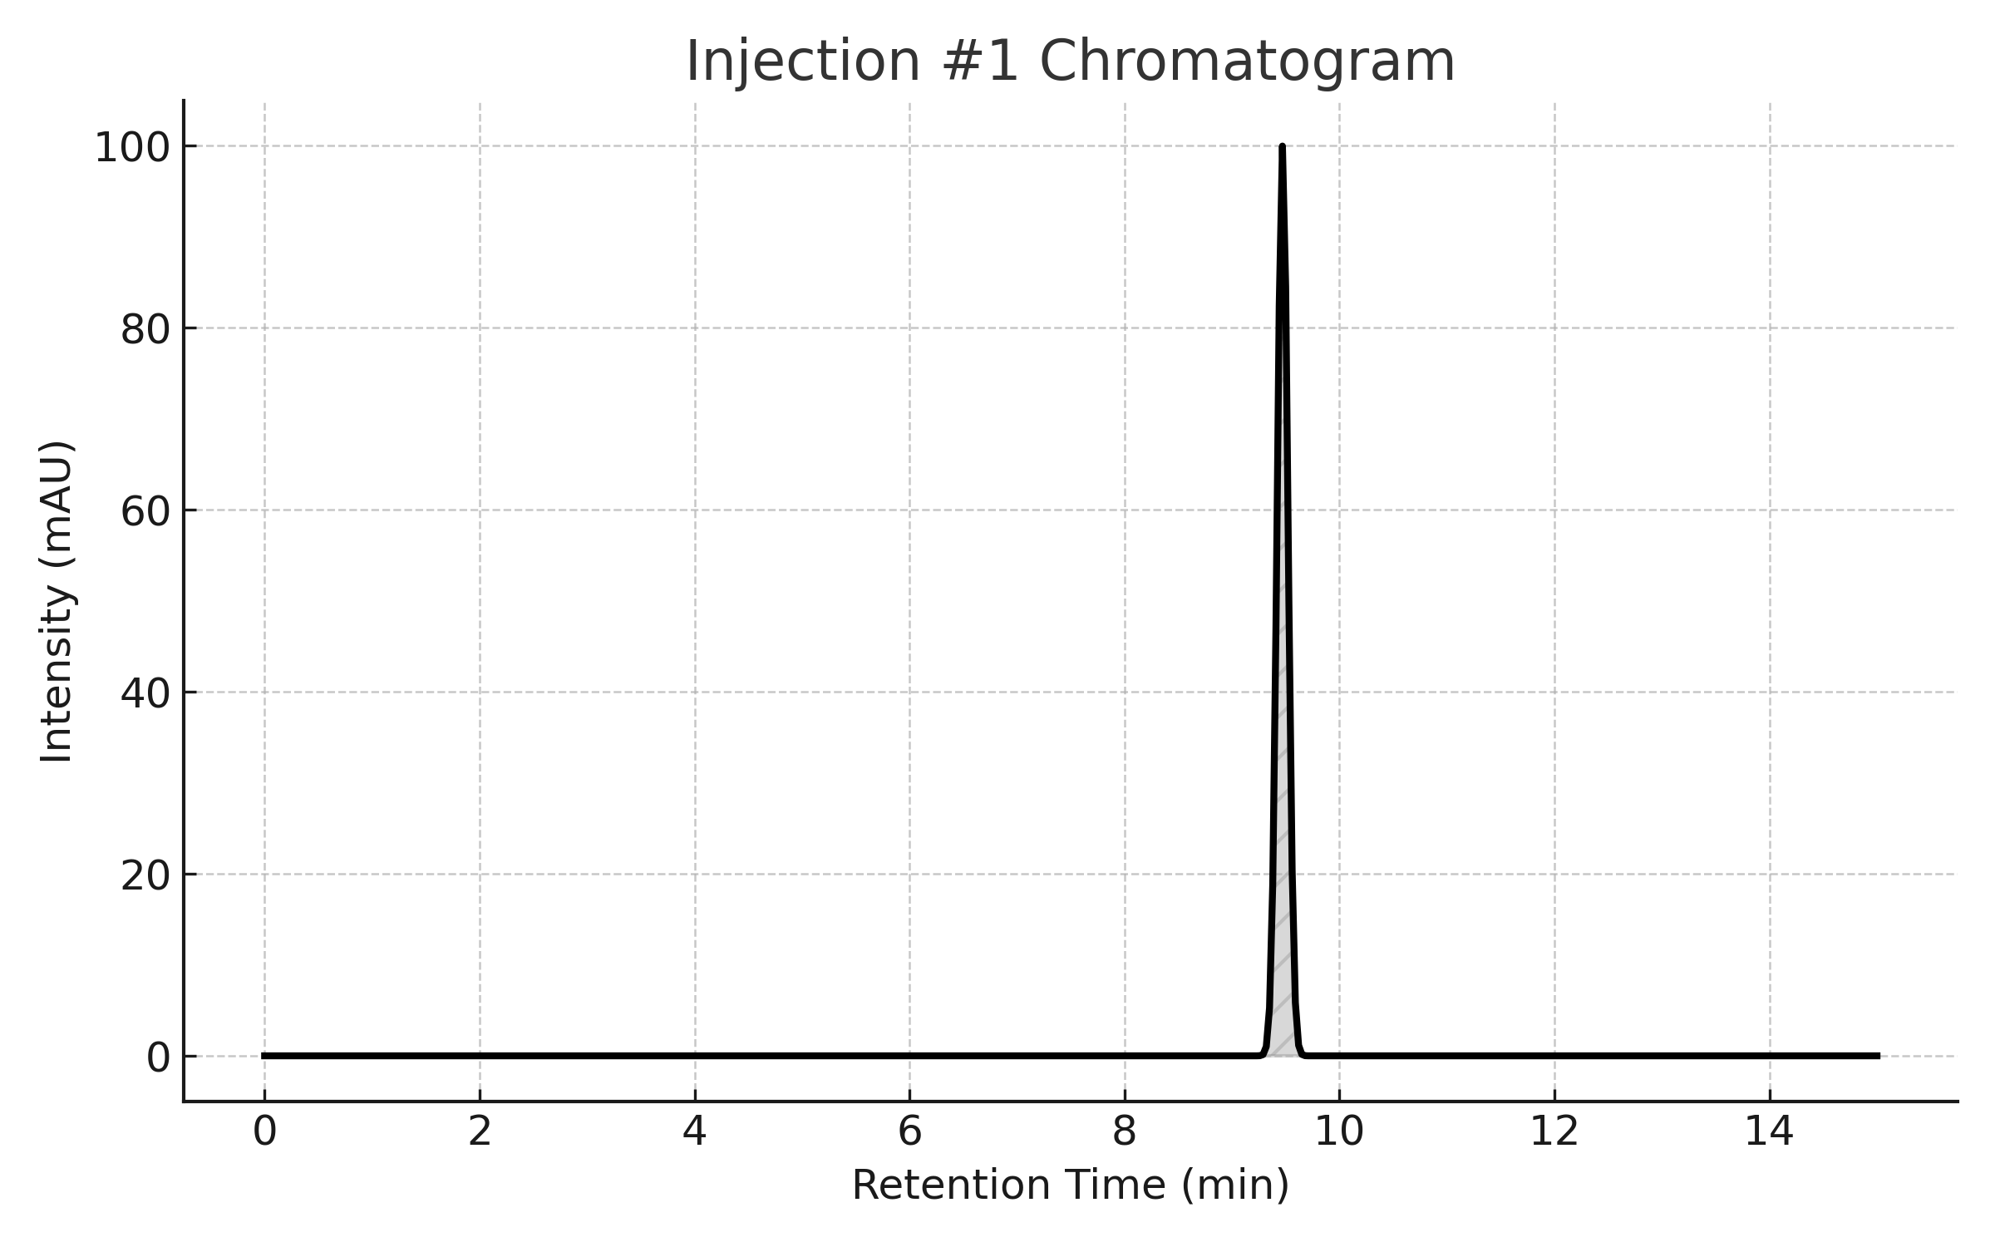

## Peaks

|  |  |  |  |  |  |
| --- | --- | --- | --- | --- | --- |
| Peak Name | RT | Area | % Area | Height | USP Plate Count |
| Aspartame | 9.50 | 1000234 | 99.93 | 297438 | 7572.38 |

## USP Tailing

|  |  |
| --- | --- |
| Peak | USP Tailing |
| 1 | 1.057 |

# Injection 2

|  |  |  |  |
| --- | --- | --- | --- |
| Sample Name | Aspartame Batch No. 2306034LP | Acquired By | System |
| Sample Type | Unknown | Sample Set Name | Asp_Set1 |
| vial | 33 | Acq. Method Set | Asp_M |
| Injection # | 2 | Processing Method | Aspartame |
| Injection Volume | 20 µL | Channel Name | 2487Channel 1 |
| Run Time | 15.0 Minutes | Proc. Chnl. Descr. | 2487Channel 1 |
|  |  |  |  |
| Date Acquired | 23/09/2025 09:28:26 |  |  |
| Date Processed | 23/09/2025 11:37:50 |  |  |

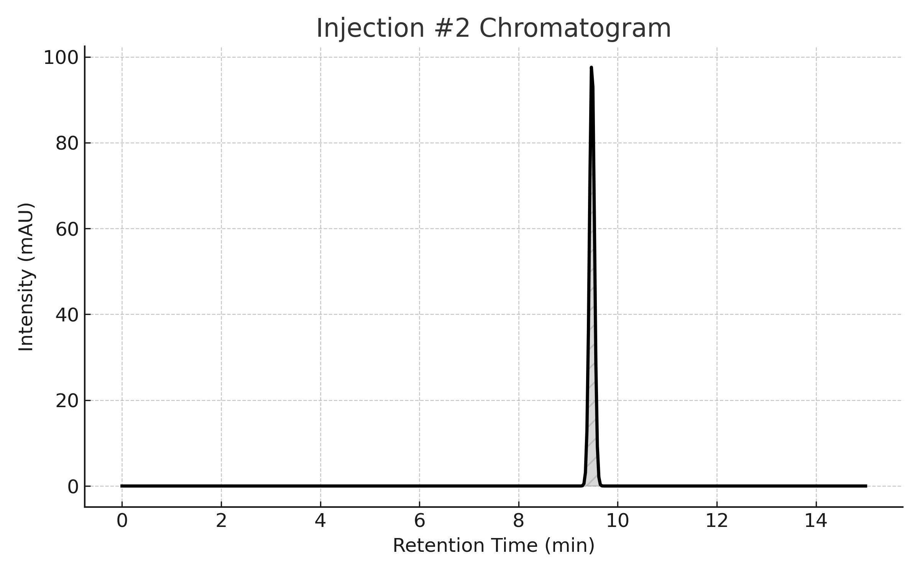

## Peaks

|  |  |  |  |  |  |
| --- | --- | --- | --- | --- | --- |
| Peak Name | RT | Area | % Area | Height | USP Plate Count |
| Aspartame | 9.50 | 1000234 | 99.93 | 297438 | 7572.38 |

## USP Tailing

|  |  |
| --- | --- |
| Peak | USP Tailing |
| 1 | 1.057 |

# Injection 3

|  |  |  |  |
| --- | --- | --- | --- |
| Sample Name | Aspartame Batch No. 2306034LP | Acquired By | System |
| Sample Type | Unknown | Sample Set Name | Asp_Set1 |
| vial | 33 | Acq. Method Set | Asp_M |
| Injection # | 3 | Processing Method | Aspartame |
| Injection Volume | 20 µL | Channel Name | 2487Channel 1 |
| Run Time | 15.0 Minutes | Proc. Chnl. Descr. | 2487Channel 1 |
|  |  |  |  |
| Date Acquired | 23/09/2025 09:34:52 |  |  |
| Date Processed | 23/09/2025 11:37:50 |  |  |

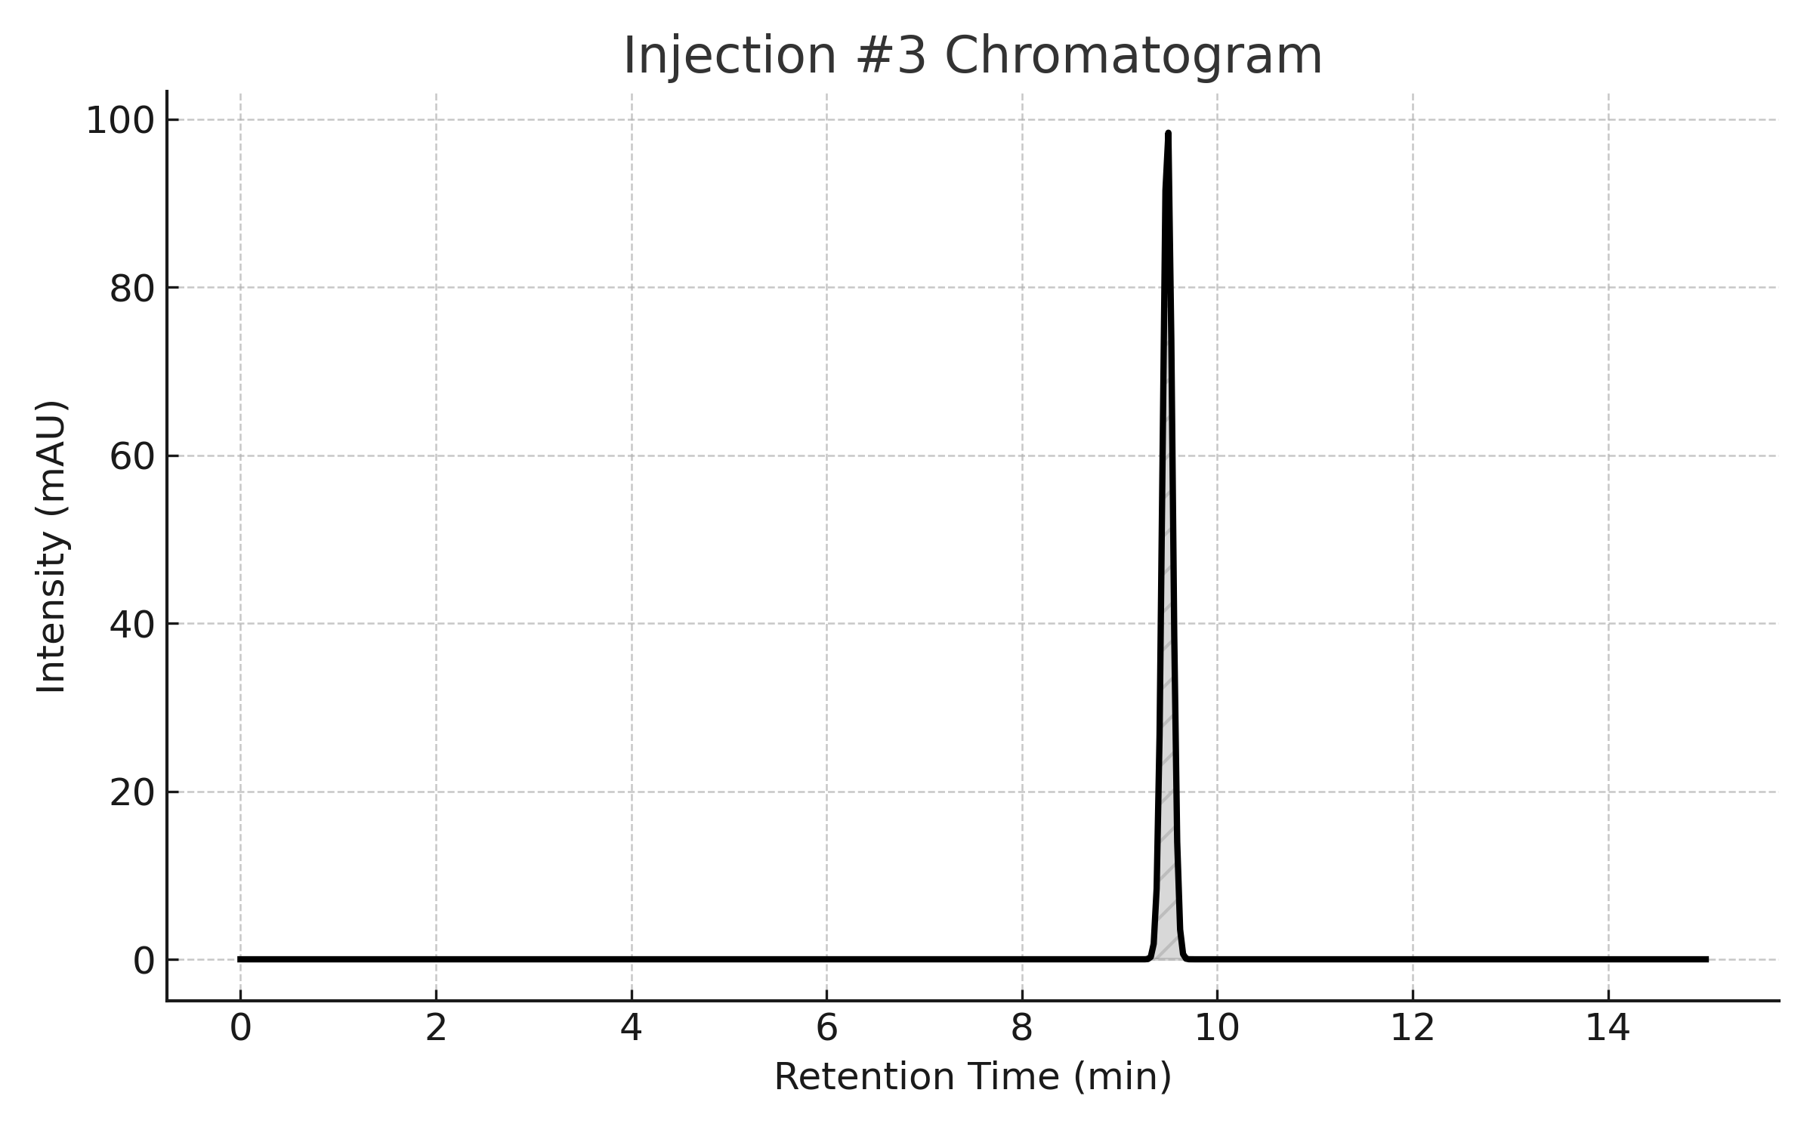

## Peaks

|  |  |  |  |  |  |
| --- | --- | --- | --- | --- | --- |
| Peak Name | RT | Area | % Area | Height | USP Plate Count |
| Aspartame | 9.50 | 1000234 | 99.93 | 297438 | 7572.38 |

## USP Tailing

|  |  |
| --- | --- |
| Peak | USP Tailing |
| 1 | 1.057 |

# Injection 4

|  |  |  |  |  |  |  |  |  |  |  |  |  |  |  |  |  |  |  |  |  |  |  |  |  |  |  |  |  |  |  |  |  |  |  |  |  |  |
| --- | --- | --- | --- | --- | --- | --- | --- | --- | --- | --- | --- | --- | --- | --- | --- | --- | --- | --- | --- | --- | --- | --- | --- | --- | --- | --- | --- | --- | --- | --- | --- | --- | --- | --- | --- | --- | --- |
| |  |  |  |  | | --- | --- | --- | --- | | Sample Name | Aspartame Batch No. 2306034LP | Acquired By | System | | Sample Type | Unknown | Sample Set Name | Asp_Set1 | | vial | 33 | Acq. Method Set | Asp_M | | Injection # | 4 | Processing Method | Aspartame | | Injection Volume | 20 µL | Channel Name | 2487Channel 1 | | Run Time | 15.0 Minutes | Proc. Chnl. Descr. | 2487Channel 1 | |  |  |  |  | | Date Acquired | 23/09/2025 10:15:13 |  |  | | Date Processed | 23/09/2025 11:37:50 |  |  | |  |

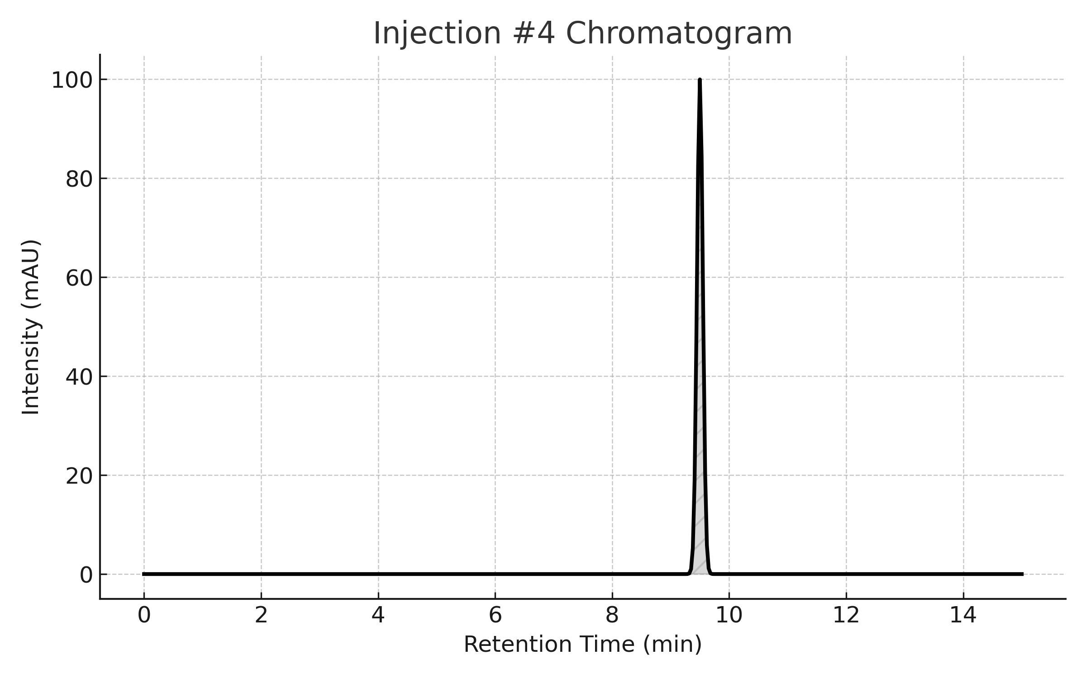

## Peaks

|  |  |  |  |  |  |
| --- | --- | --- | --- | --- | --- |
| Peak Name | RT | Area | % Area | Height | USP Plate Count |
| Aspartame | 9.50 | 1000234 | 99.93 | 297438 | 7572.38 |

## USP Tailing

|  |  |
| --- | --- |
| Peak | USP Tailing |
| 1 | 1.057 |

# Injection 5

|  |  |  |  |  |  |  |  |  |  |  |  |  |  |  |  |  |  |  |  |  |  |  |  |  |  |  |  |  |  |  |  |  |  |  |  |  |  |
| --- | --- | --- | --- | --- | --- | --- | --- | --- | --- | --- | --- | --- | --- | --- | --- | --- | --- | --- | --- | --- | --- | --- | --- | --- | --- | --- | --- | --- | --- | --- | --- | --- | --- | --- | --- | --- | --- |
| |  |  |  |  | | --- | --- | --- | --- | | Sample Name | Aspartame Batch No. 2306034LP | Acquired By | System | | Sample Type | Unknown | Sample Set Name | Asp_Set1 | | vial | 33 | Acq. Method Set | Asp_M | | Injection # | 5 | Processing Method | Aspartame | | Injection Volume | 20 µL | Channel Name | 2487Channel 1 | | Run Time | 15.0 Minutes | Proc. Chnl. Descr. | 2487Channel 1 | |  |  |  |  | | Date Acquired | 23/09/2025 10:37:22 |  |  | | Date Processed | 23/09/2025 11:37:50 |  |  | |  |

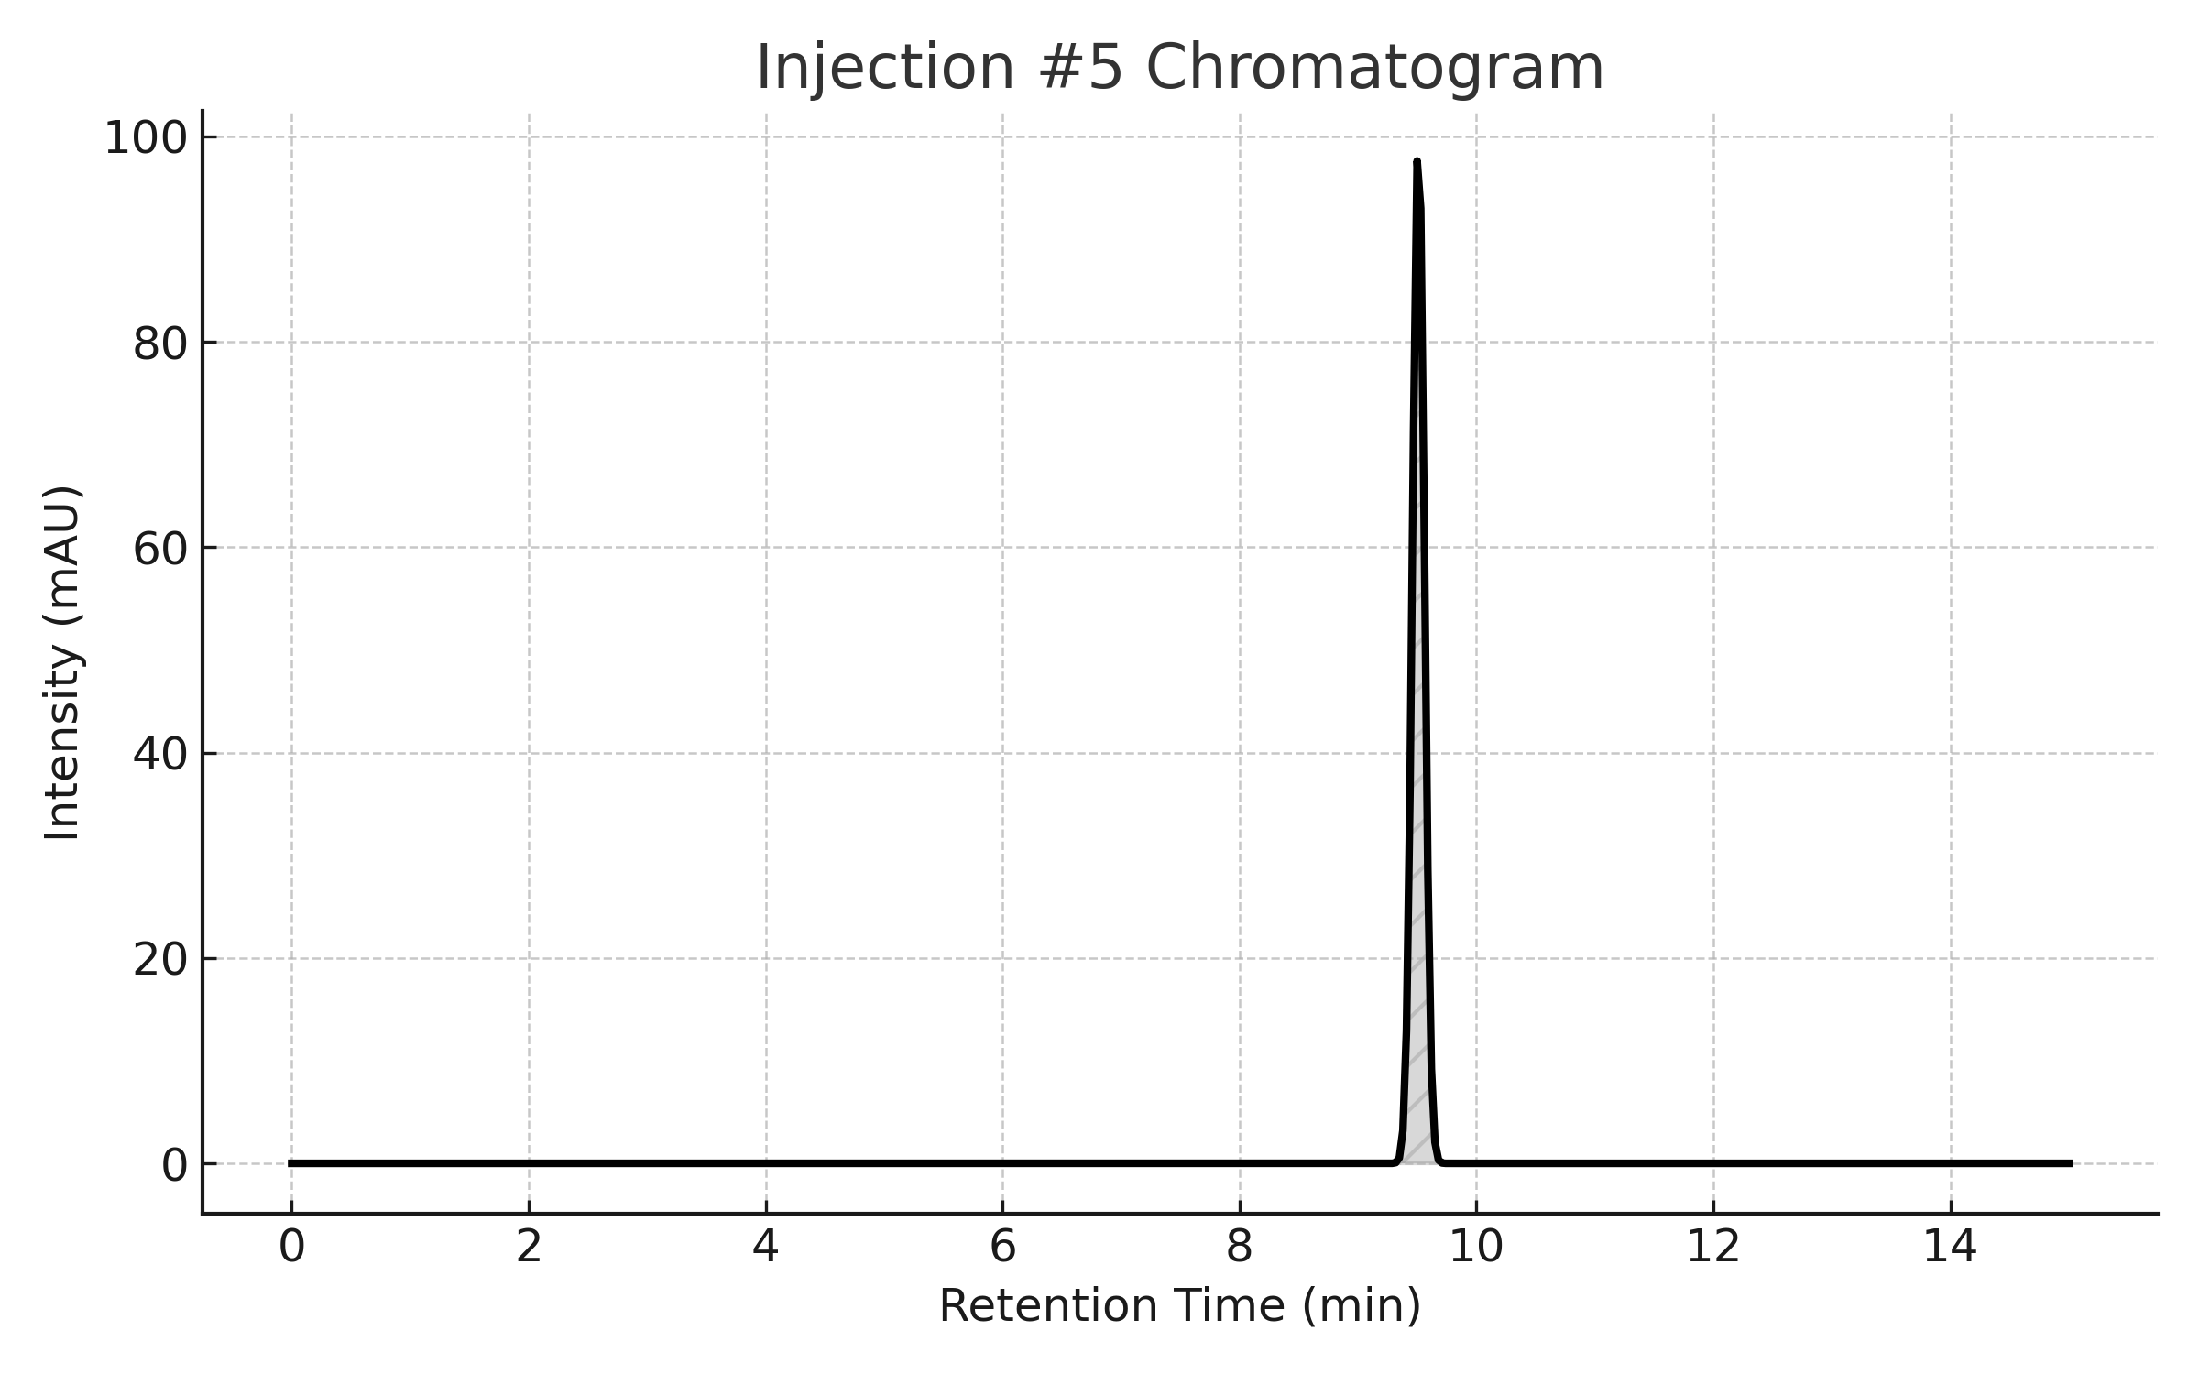

## Peaks

|  |  |  |  |  |  |
| --- | --- | --- | --- | --- | --- |
| Peak Name | RT | Area | % Area | Height | USP Plate Count |
| Aspartame | 9.50 | 1000234 | 99.93 | 297438 | 7572.38 |

## USP Tailing

|  |  |
| --- | --- |
| Peak | USP Tailing |
| 1 | 1.057 |

# Injection 6

|  |  |  |  |
| --- | --- | --- | --- |
| Sample Name | Aspartame Batch No. 2306034LP | Acquired By | System |
| Sample Type | Unknown | Sample Set Name | Asp_Set1 |
| vial | 33 | Acq. Method Set | Asp_M |
| Injection # | 6 | Processing Method | Aspartame |
| Injection Volume | 20 µL | Channel Name | 2487Channel 1 |
| Run Time | 15.0 Minutes | Proc. Chnl. Descr. | 2487Channel 1 |
|  |  |  |  |
| Date Acquired | 23/09/2025 09:55:14 |  |  |
| Date Processed | 23/09/2025 11:37:50 |  |  |

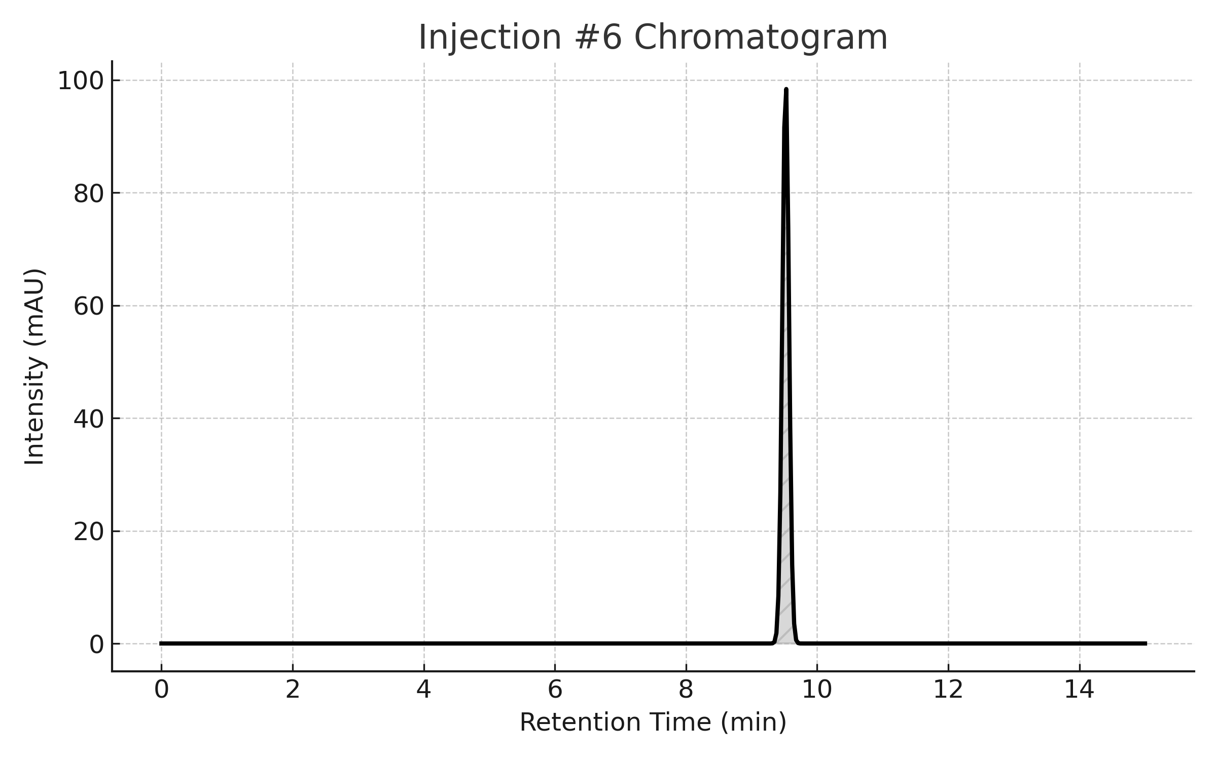

## Peaks

|  |  |  |  |  |  |
| --- | --- | --- | --- | --- | --- |
| Peak Name | RT | Area | % Area | Height | USP Plate Count |
| Aspartame | 9.50 | 1000234 | 99.93 | 297438 | 7572.38 |

## USP Tailing

|  |  |
| --- | --- |
| Peak | USP Tailing |
| 1 | 1.057 |

# System Precision Overlay

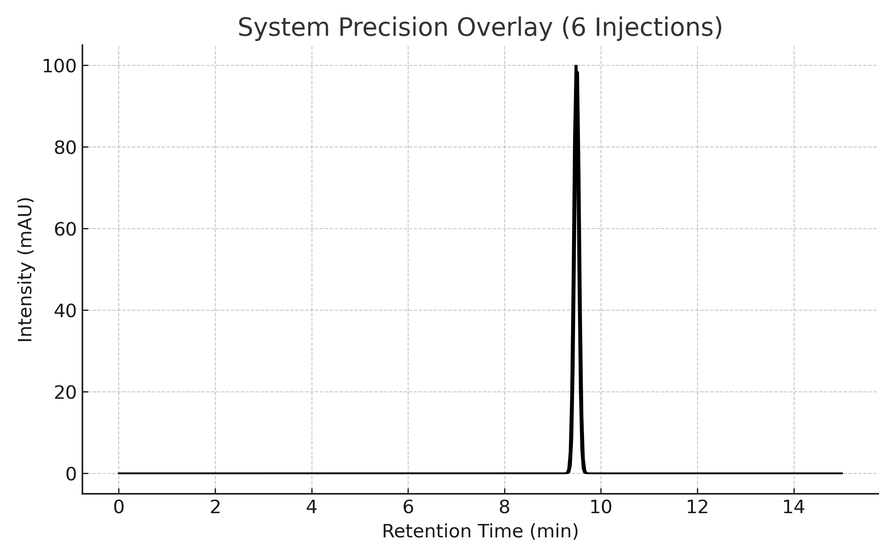

# Comprehensive Analysis

|  |  |  |  |
| --- | --- | --- | --- |
| Parameter | Result | Specification | Status |
| Chromatographic Purity | 99.93% | ≥ 98.0% | PASS |
| 5-Benzyl-3,6-dioxo-2-piperazineacetic Acid | 0.07% | ≤ 1.0% | PASS |
| System Suitability | All Parameters | USP-NF 2024 | PASS |

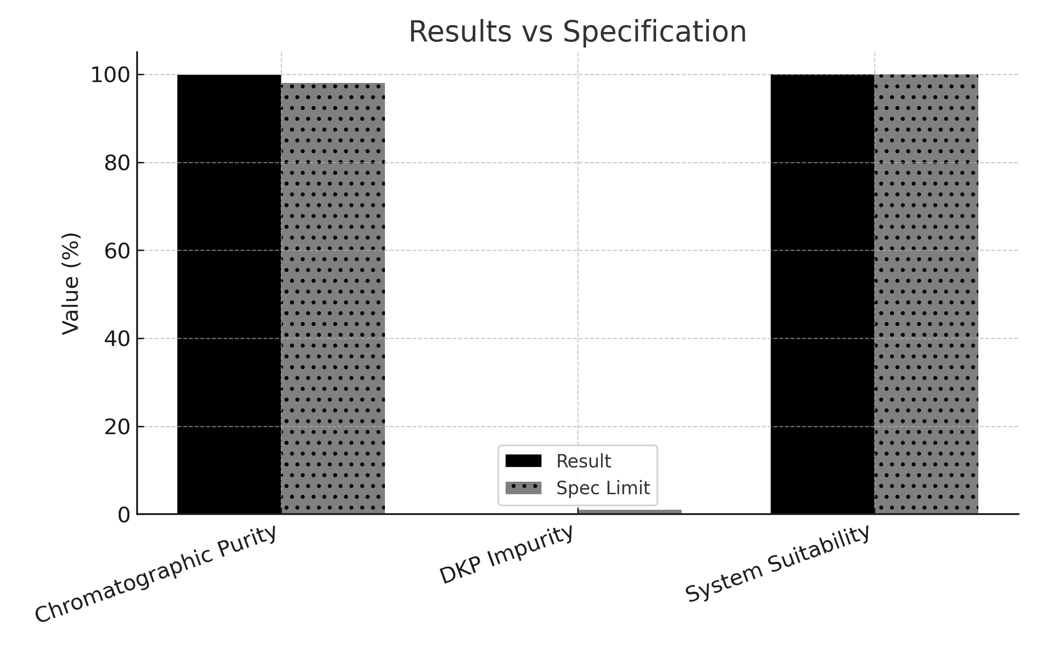

# Conclusion & Approval

Batch Approved for Release  
All quality parameters meet USP-NF 2024 requirements.

QC Analyst QC Manager

Dr. Naema Lofty Dr. Montaser Elzayaat